Problem Statement1 Write a Java program to display the content of a file in HDFS on screen.

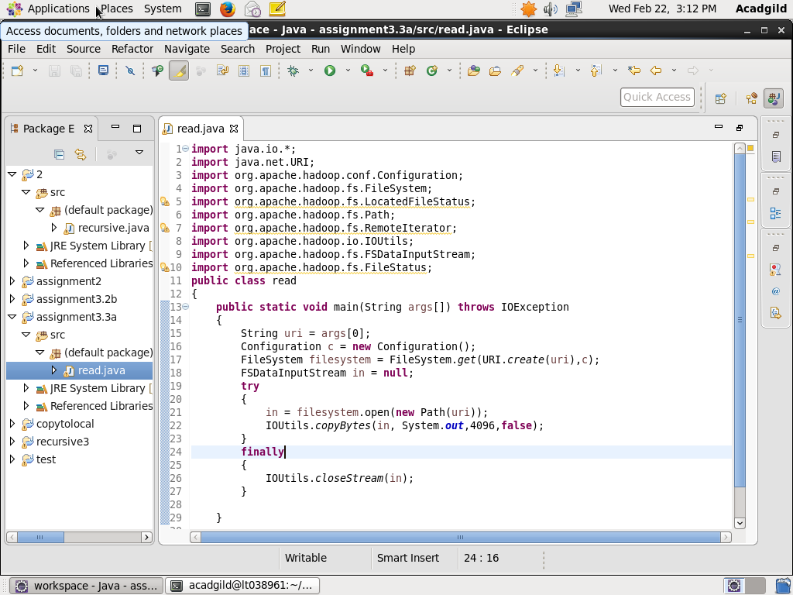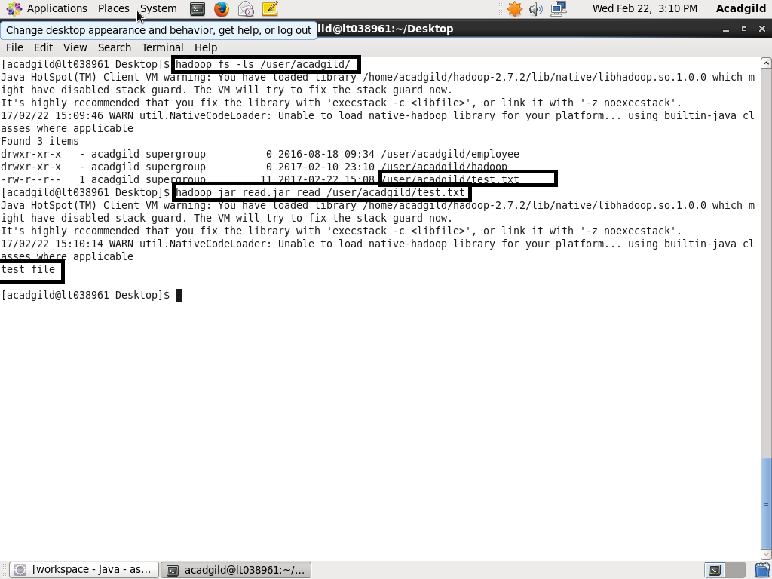

First Checked the path. Test.txt is present then executed the jar file to get the contents “test file”

Write a Java program to copy a file from local filesystem to HDFS.

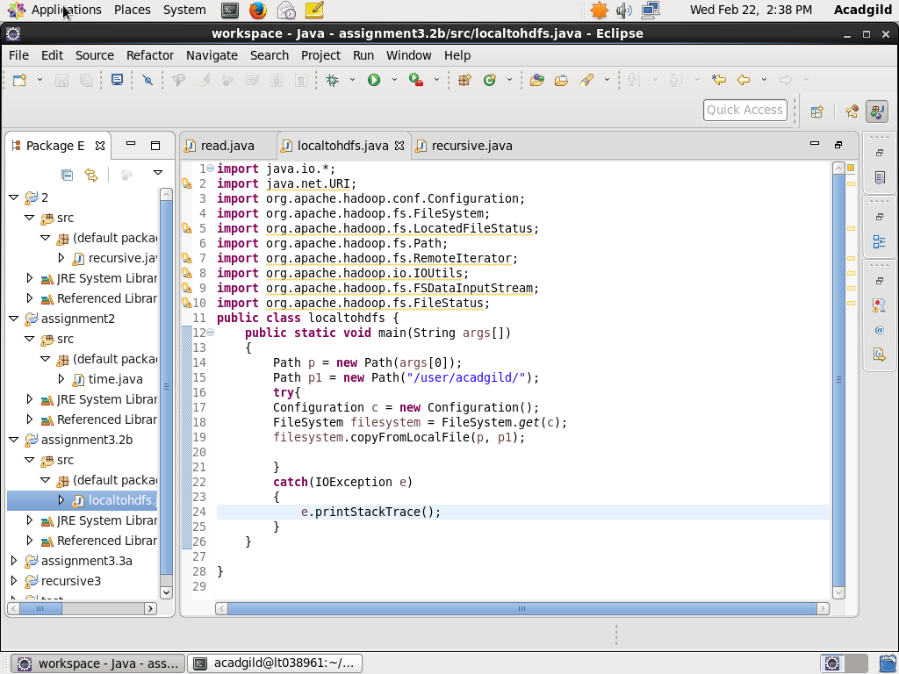

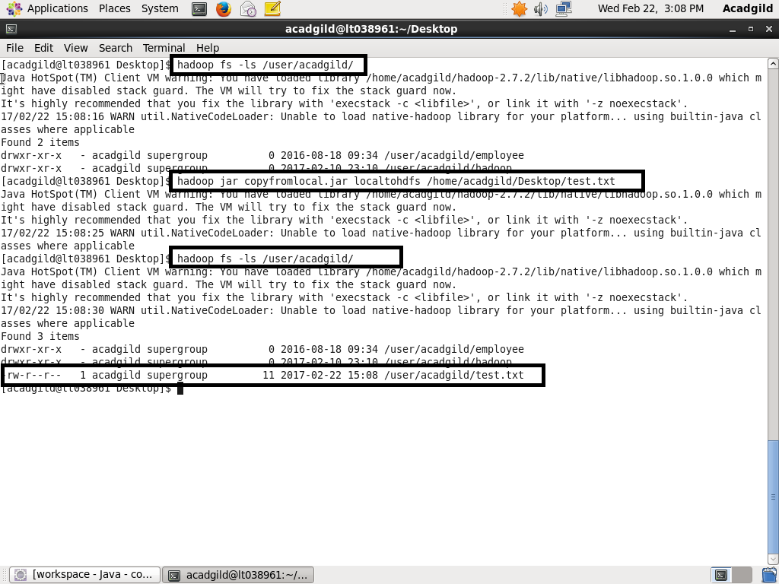

First checked the path no test.txt file the copied from local to Hadoop file system and again checked with “ls” .