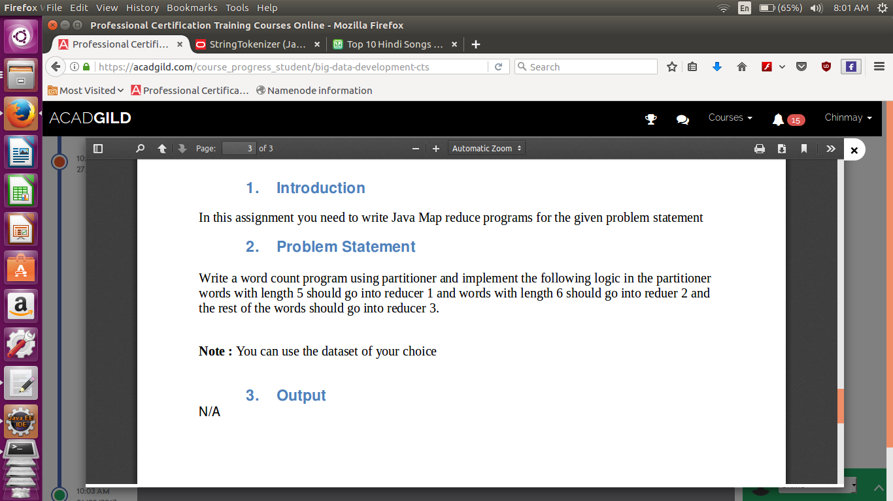

1. Here using the tokinizer to get different words
2. The tokenizer does no split the commas and special character hence they are considered as the character
3. Hence length of the same words with the special characters may vary.

//Mapper Class

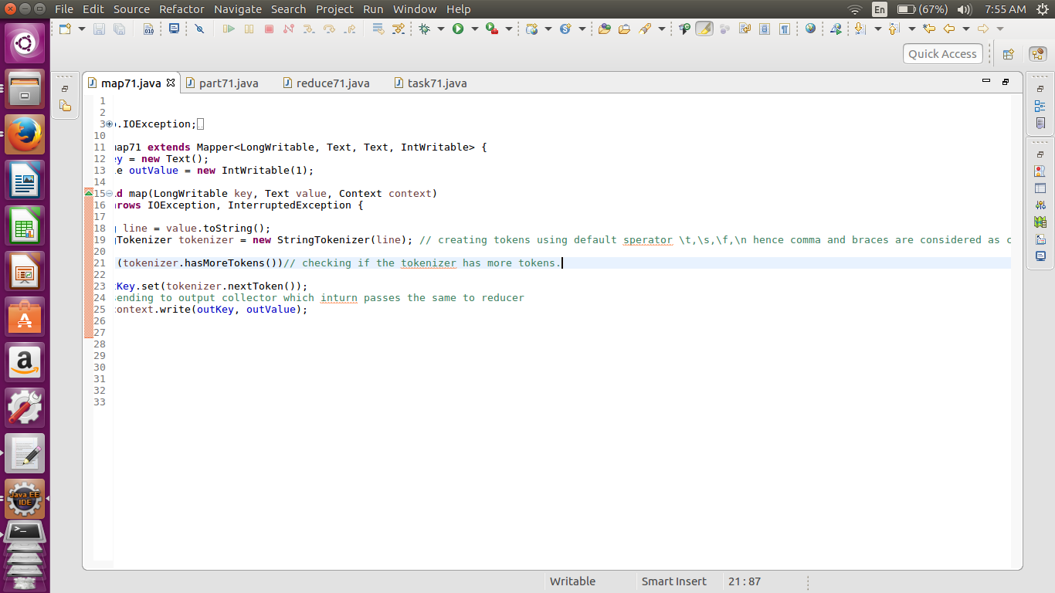

//Reducer Class

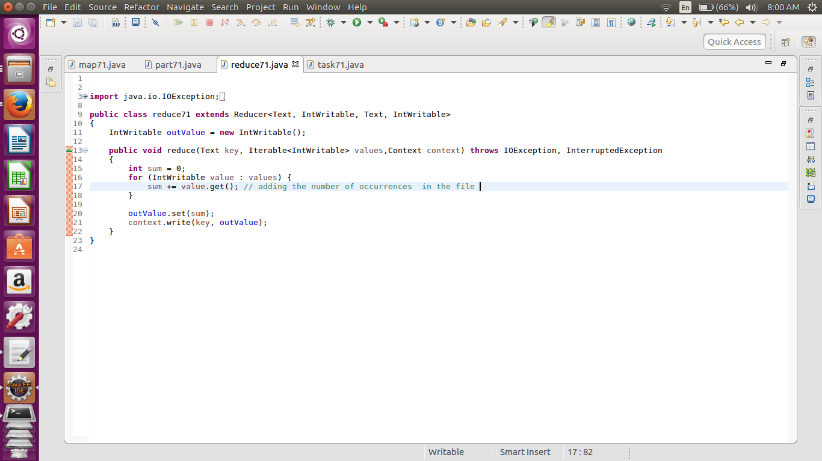

//Driver Class

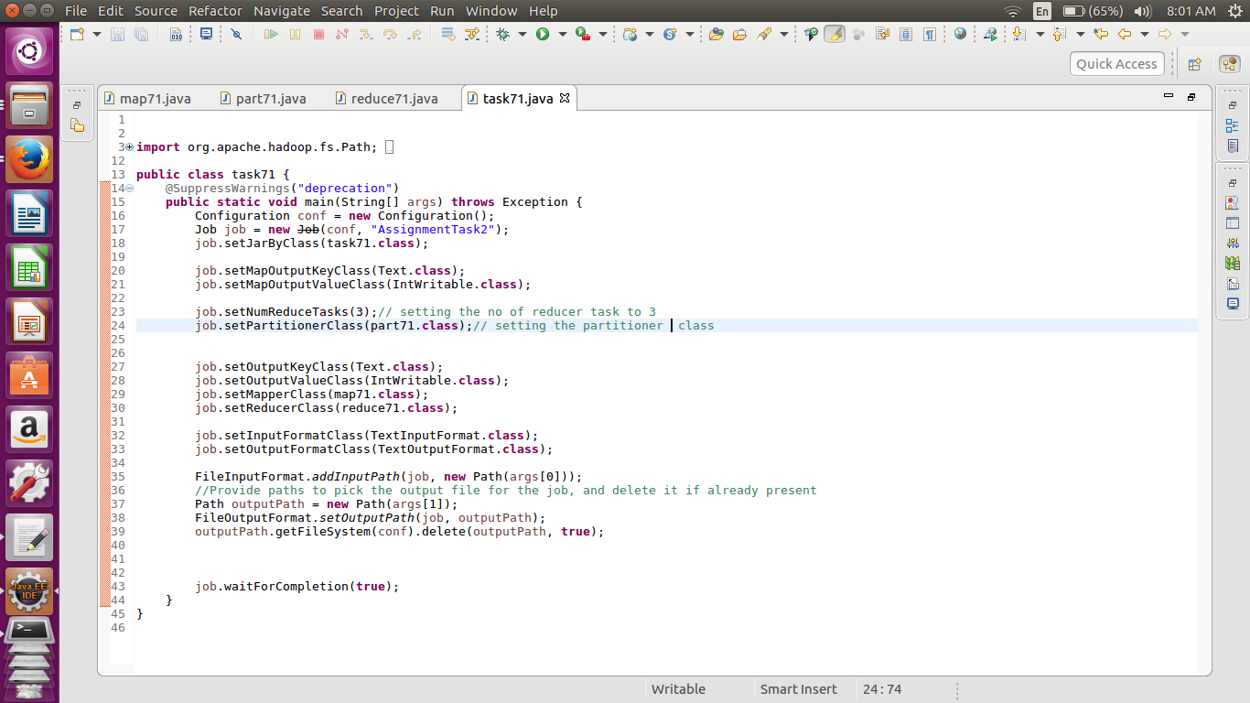

//Partitioner class

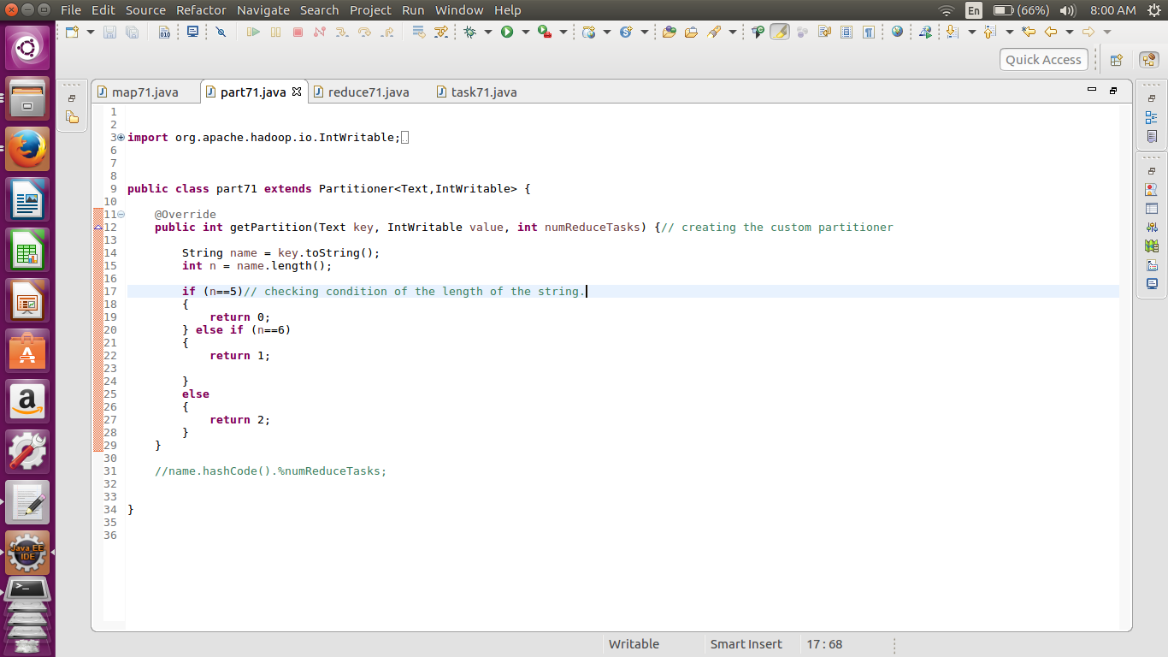

// Output

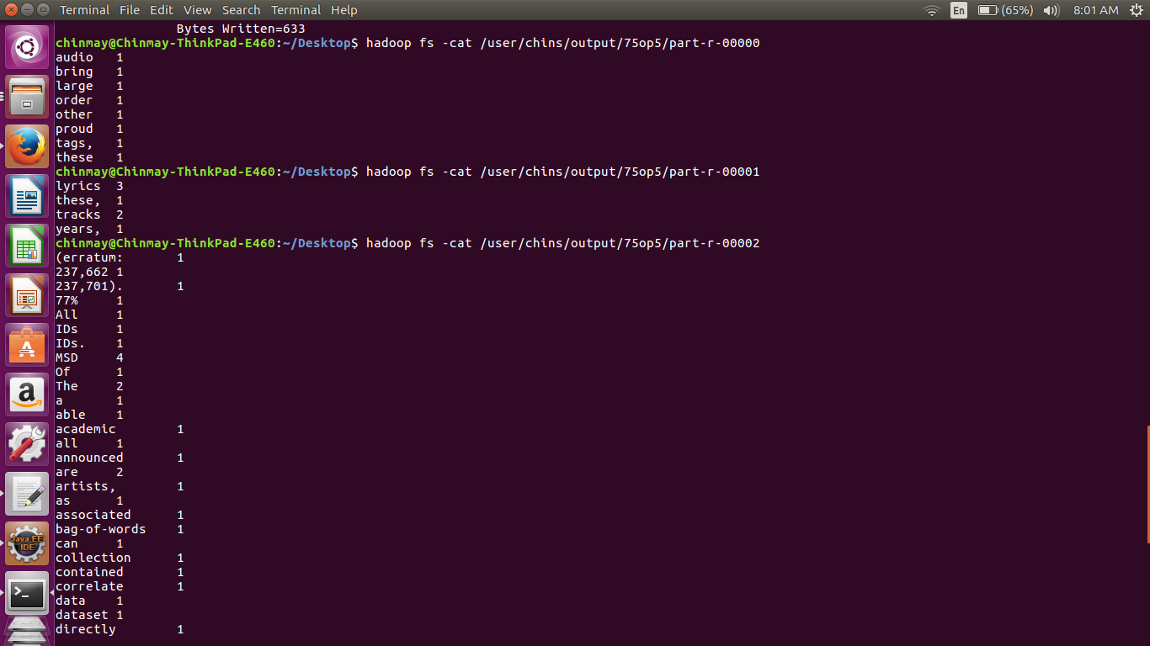

Showing Three reduce files …………………