**# Program to find area of different shapes**

import math

def circle():

r=int(input("Enter redius of circle"))

area = math.pi*r*r

print('Area of circle is : ',area)

def square():

s = int(input('Enter lenght of Side of square'))

a = s*s

print('area of square is : ',a)

def rectangle():

l = int(input('Enter length of rectangle'))

b = int(input('Enter breadth of rectangle'))

a = l*b

print('area of rectangle is : ',a)

def parallelogram():

l = int(input('Enter base of parallelogram'))

b = int(input('Enter height of parallelogram'))

a = l*b

print('area of parallelogram is : ',a)

def triangle():

h = int(input('Enter height of triangle'))

b = int(input('Enter base of triangle'))

area = (h*b)*0.5

print('Area of triangle is : ',area);7

print("This is the program to calculate area of shspes\n")

print('1.Circle\n2.Square\n3.Rectangle\n4.Parallelogram\n5.Triangle')

ch = int(input('Enter Your Choice'))

if ch == 1:

circle()

elif ch == 2:

square()

elif ch == 3:

rectangle()

elif ch == 4:

parallelogram()

elif ch == 5:

triangle()

else:

print('Wrong choice')

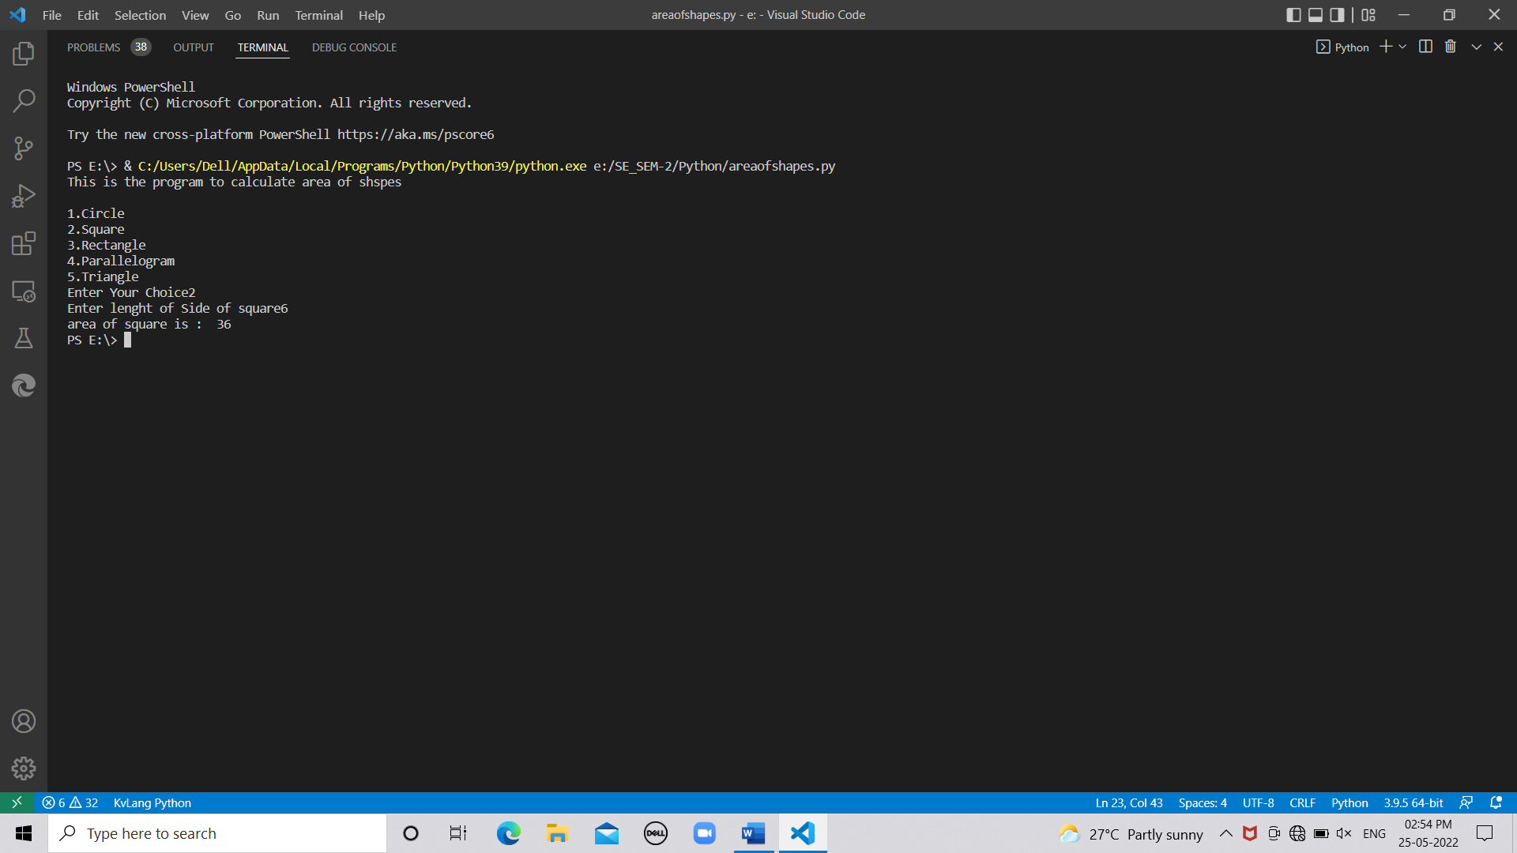

**# Union of lists**

def union(list1,list2):

result = list(set(list1 + list2))

return result

l1 = [1,2,3,4,5]

l2 = [2,4,6,8,10]

l3= union(l1,l2)

print("l1: ",l1)

print("l2: ",l2)

print("Union of two l1 and l2 without repetition : ",l3)

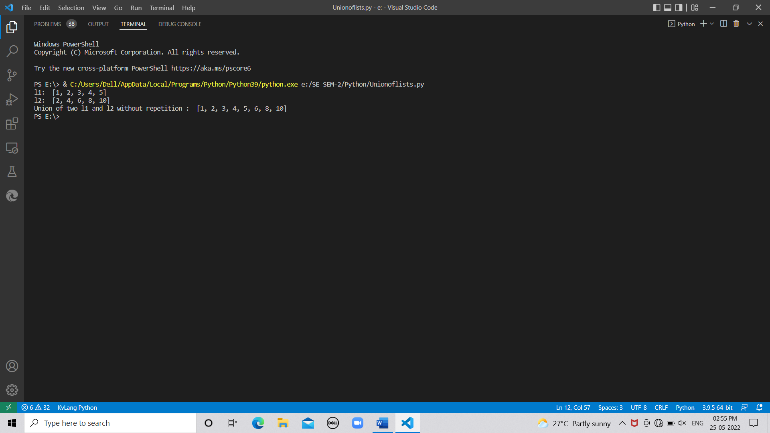

**# program to find intersection of list**

def intersection(lst1, lst2):

lst3 = [value for value in lst1 if value in lst2]

return lst3

list1 = [4, 9, 1, 17, 11, 26, 28, 54, 69]

list2 = [9, 9, 74, 21, 45, 11,]

print(intersection(list1, list2))

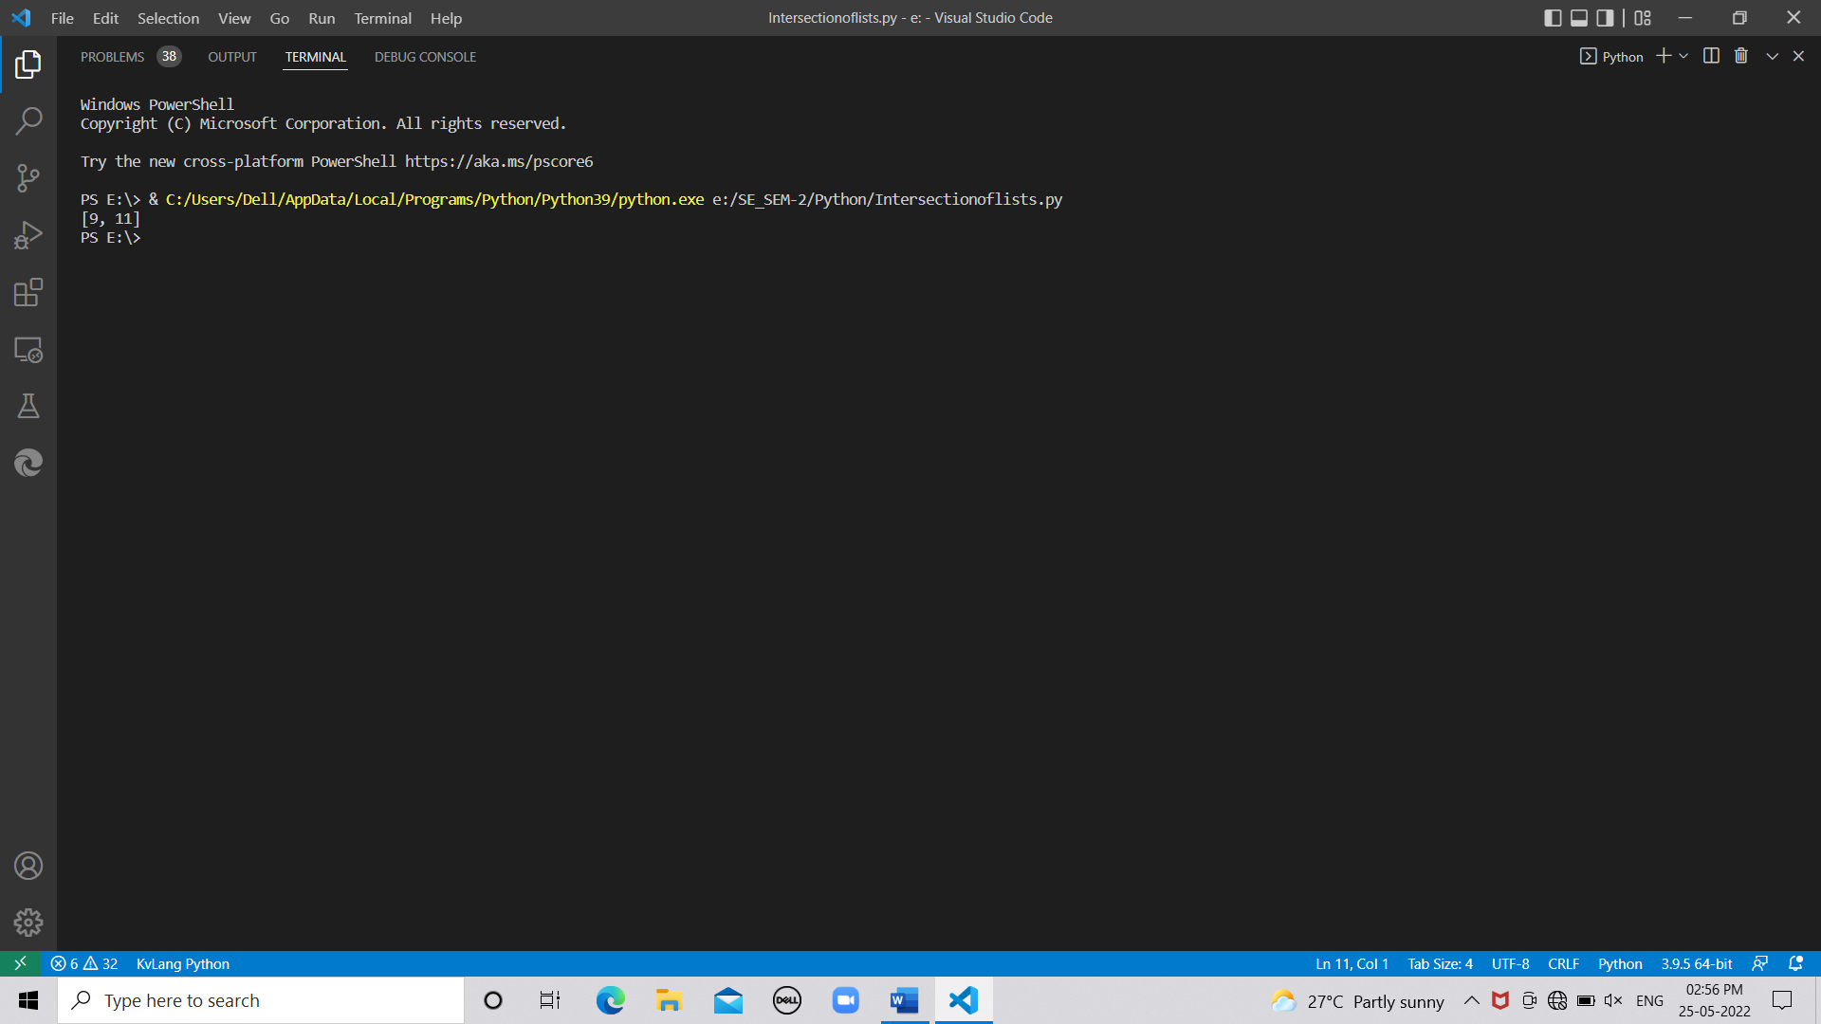

**# Program to find ith occ in list**

test_str = "Hello world this is python "

count = 0

for i in test_str:

if i == 'o':

count = count + 1

print ("Count of o in string is : "+ str(count))

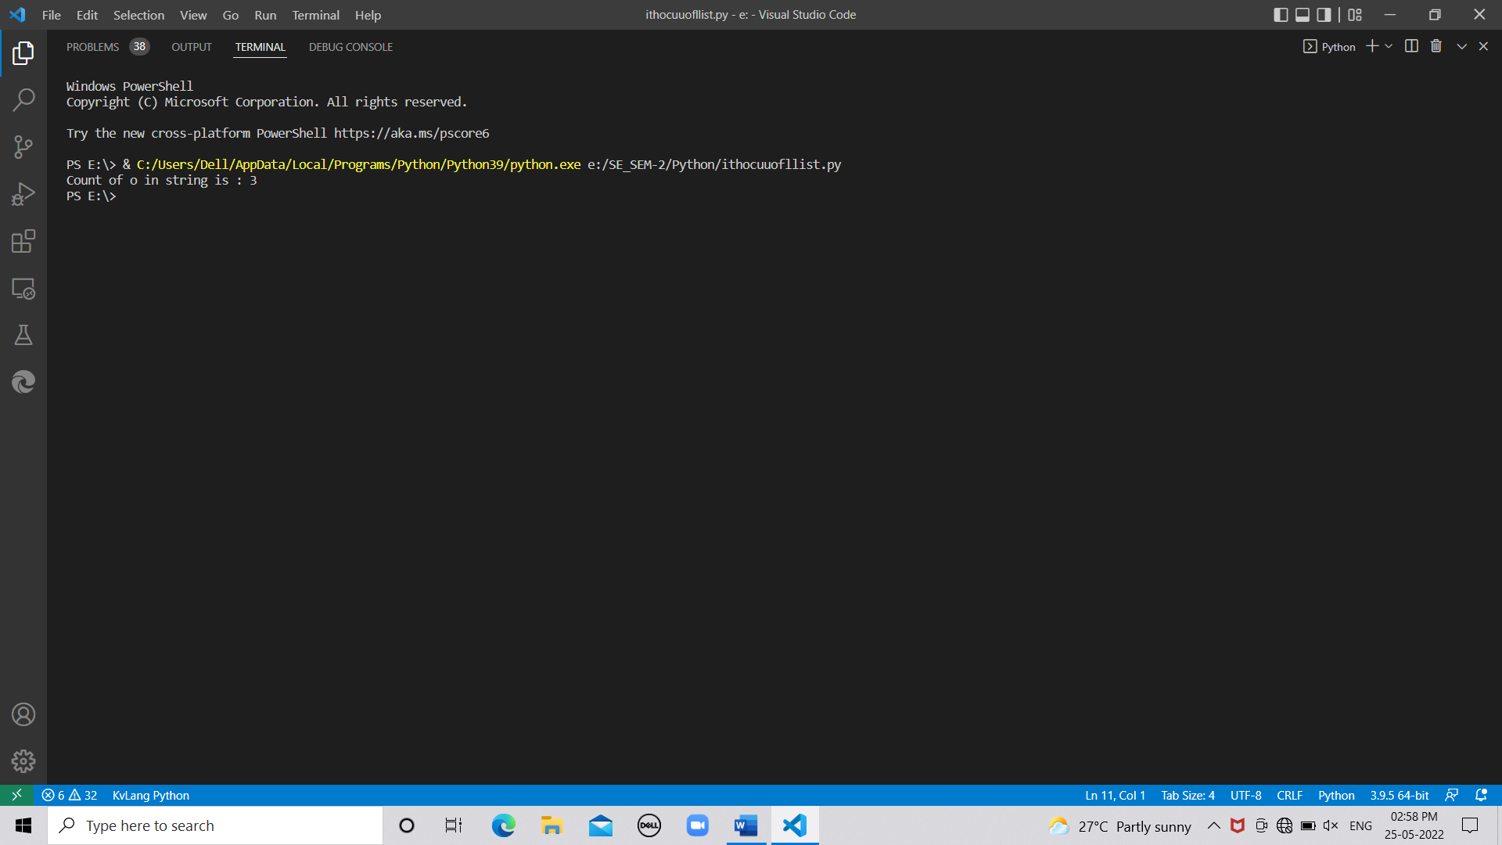

**# Program to count occ of specific word in string**

stri = input('Enter String')

w = input("enter word which you want find")

cou = 0

spli = stri.split(' ')

for i in range (0,len(spli)):

if w == spli[i]:

cou = cou+1

print('The Occurunce os the word is : ',cou)

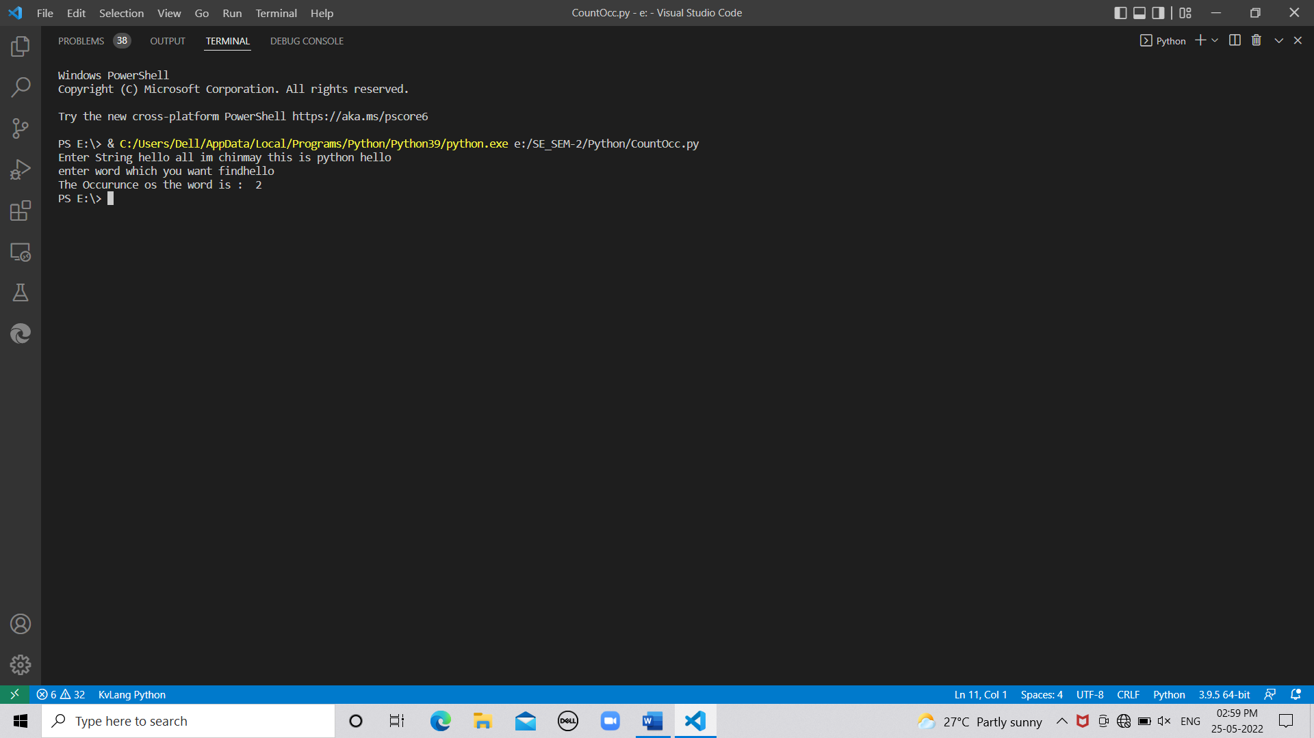

**# program to check if substring is present in string or not**

string_1 = input("Enter a string")

string_2 = input("Enter another string")

if string_2 in string_1:

print('substring found')

else:

print('substring not found')

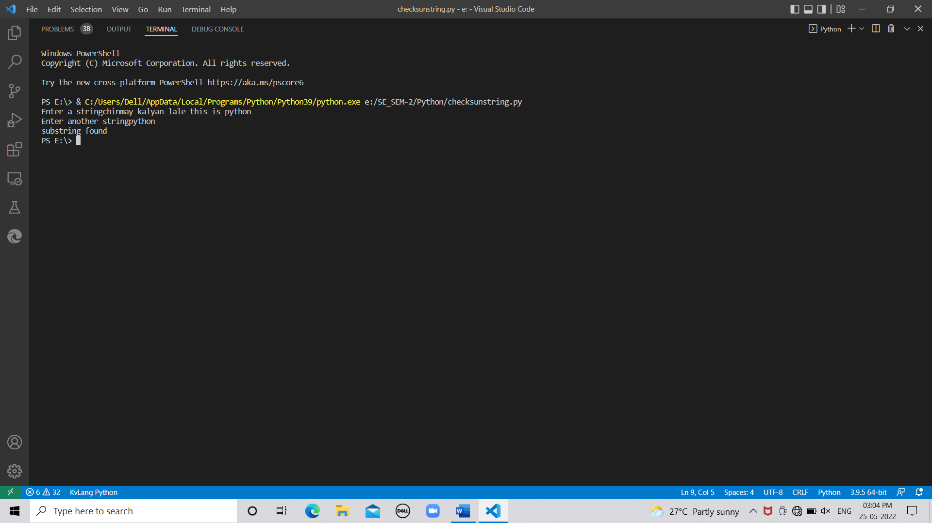

**#Program to map two lists into dict**

name = ['chinmay','hello','python','world']

roll = [32,20,10,28]

zip_of_lists = dict(zip(name,roll))

print(zip_of_lists)

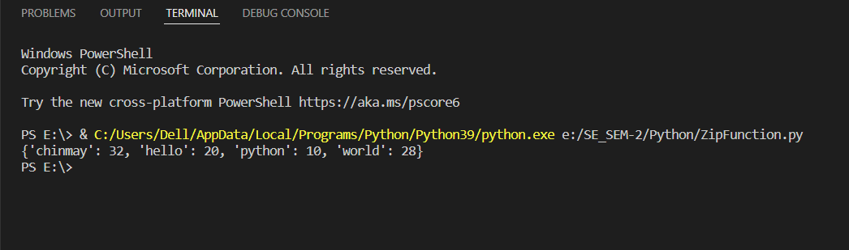

**# Program to count occ of specific word in string**

stri = input('Enter String')

w = input("enter word which you want find")

cou = 0

spli = stri.split(' ')

for i in range (0,len(spli)):

if w == spli[i]:

cou = cou+1

print('The Occurunce os the word is : ',cou)

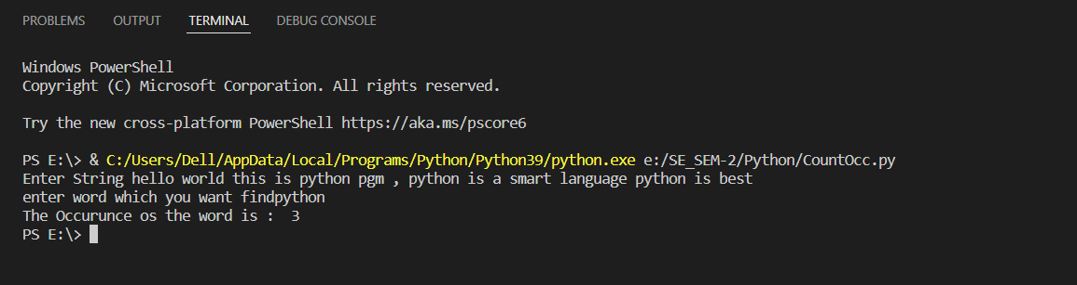

**# Program to store keys and values of string in dict**

w = []

s = input('Enter a string')

d = {}

w = s.split()

for s in w:

chr = s[0]

if chr not in d:

d[chr] = []

d[chr].append(s)

print(d)

for k,v in d.items():

print(k," : ",v)

