**A Project Phase II Report**

**On**

**EDUHUB- COMMUNITY OF LEARNING PHASE II**

**Submitted by**

**Vaishnavi Chavan B-10**

**Ayusha Homkar B- 20**

**Chinmay Lale B- 32**

**In fulfillment for the award of the degree of**

**Bachelor of Technology**

**IN**

**Computer Science & Engineering**



**Pradnya Niketan Education Society, Pune.**

**NAGESH KARAJAGI *ORCHID* COLLEGE OF ENGGINEERING & TECHNOLOGY**

**SOLAPUR.**

**2023-2024**



**Pradnya Niketan Education Society , Pune.**

**NAGESH KARAJAGI *ORCHID* COLLEGE OF ENGG. & TECH., SOLAPUR. \_\_\_\_\_\_\_\_\_\_\_\_\_\_\_\_\_\_\_\_\_\_\_\_\_\_\_\_\_\_\_\_\_\_\_\_\_\_\_\_\_\_\_\_\_\_\_\_\_\_\_\_\_\_\_\_\_\_\_\_\_\_\_**

Gut No. 16, Solapur-Tuljapur Road, Tale Hipparaga, Solapur – 413 002

Phone: (0217) 2735001/02, Fax. (0217) 2735004 \_\_\_\_\_\_\_\_\_\_\_\_\_\_\_\_\_\_\_\_\_\_\_\_\_\_\_\_\_\_\_\_\_\_\_\_\_\_\_\_\_\_\_\_\_\_\_\_\_\_\_\_\_\_\_\_\_\_\_\_\_\_\_\_\_\_\_\_\_\_\_\_\_\_\_\_\_\_\_\_\_\_

**Certificate**

**This is to certify that Mr. / Ms. /Mrs. \_\_\_\_\_\_\_\_\_\_\_\_\_\_\_\_\_\_\_\_\_\_\_\_\_\_\_\_\_\_\_\_\_**

of class \_\_\_\_\_\_\_\_\_\_\_\_\_\_ Roll No. \_\_\_\_\_\_\_\_\_\_ has satisfactorily completed the Seminar work entitled \_\_\_\_\_\_\_\_\_\_\_\_\_\_\_\_\_\_\_\_\_\_\_\_ as prescribed by Dr.Babasaheb Ambedkar Technological University Lonere, Maharashtra, India in the academic year 202X-2X.

Date of Submission:

**Project Guide Head of Department Principal**

Examiners: (Name with Signature & Date)

1 : \_\_\_\_\_\_\_\_\_\_\_\_\_\_\_\_\_\_\_\_\_\_\_\_\_\_\_\_\_\_\_\_\_\_\_\_\_\_\_\_\_\_\_\_\_\_\_\_\_\_\_\_\_\_

2 : \_\_\_\_\_\_\_\_\_\_\_\_\_\_\_\_\_\_\_\_\_\_\_\_\_\_\_\_\_\_\_\_\_\_\_\_\_\_\_\_\_\_\_\_\_\_\_\_\_\_\_\_\_\_

**Code of Ethics for Plagiarism**

1. I/We know that plagiarism means taking and using the ideas, writings, works or inventions of another person as if they were one’s own. I/We know that plagiarism not only includes verbatim copying, but also the extensive use of another person’s ideas without proper acknowledgement (which includes the proper use of quotation marks). I/We know that plagiarism covers this sort of use of material found in textual sources and from the Internet.
2. I/We acknowledge and understand that plagiarism is wrong.
3. I/We understand that my research must be accurately referenced. I/We have followed the rules and convention concerning referencing, citation and the use of quotation as set out in the Departmental Guide.
4. This project work is my/our own work, or my/our group’s unique group project work. I/We acknowledge that copying someone else’s work or part of it, is wrong, and that submitting identical work to others constitutes a form of plagiarism.

5. I/We have not allowed, nor will I/We in the future allow, anyone to copy my/our work with the intention of passing it off as their own work.

……………………………………………………………

……………………………………………………………

……………………………………………………………

……………………………………………………………

(Name & Signature of the Student/s)

Place: NKOCET, Solapur

Date:

|  |  |
| --- | --- |
| **The Orchid School_Logo** | **D E C L A R A T I O N** |

By the UG (B.Tech) Student

I/We hereby declare that the Report of the UG/ Project Work entitled

………………………………………………………………………………………………………

………………………………………………………………………………………………………

………………………………………………………………………………………………………

Which is being submitted to the Dr. Babasaheb Ambedkar Technological University, Lonere in Partial ful-fillment of the requirements for the award of the Degree Bachelor/Master of ………………………………… in the department of …………………………………………………………………..…. , is a bonafide report of the work carried out by me/us. The material contained in this report has not been submitted to any University or Institution for the award of any degree.

……………………………………………………………

……………………………………………………………

……………………………………………………………

……………………………………………………………

(Name & Signature of the Student/s)

Place: NKOCET, Solapur

Date:

**PROJECT APPROVAL SHEET**

The project entitled **EDUHUB - COMMUNITY OF LEARNING** submitted by the following students -

**VAISHNAVI CHAVAN**

**AYUSHA HOMKAR**

**CHINMAY LALE**

is hereby approved in partial fulfillment for the award of Degree of Bachelor of Computer Science & Engineering of DBATU University, Lonere.

EXAMINERS

1. \_\_\_\_\_\_\_\_\_\_\_\_\_\_\_\_\_\_\_\_\_\_\_\_\_\_\_\_\_\_\_\_\_\_
2. \_\_\_\_\_\_\_\_\_\_\_\_\_\_\_\_\_\_\_\_\_\_\_\_\_\_\_\_\_\_\_\_\_\_



**DEPARTMENT OF COMPUTER SCIENCE AND ENGINEERING**

**P.N.E.S.P.’S**

**NAGESH KARAJAGI *ORCHID* COLLEGE OF ENGG. & TECH**

**SOLAPUR – 413 002**



**AFFILIATED TO**

[**DR.BABASAHEB AMBEDKAR TECHNOLOGICAL UNIVERSITY**](https://dbatu.ac.in/) **LONERE**

**ABSTRACT**

EduHub addresses the growing demand for flexible and accessible online learning opportunities. This project outlines the design and development of a comprehensive e-learning platform that caters to students, instructors, and administrators. The platform offers a diverse range of courses, real-time video call doubt-solving sessions, and features that foster community building among geographically dispersed learners.

The report details the chosen technology stack (React, Node.js, MongoDB) and its suitability for building a scalable, performant, and user-friendly platform. A rigorous testing strategy is emphasized to ensure the quality, reliability, and security of EduHub. Cloud-based deployment ensures efficient scaling and management as the platform grows.

Key functionalities include:

* Course browsing and enrollment
* Uploading and managing course content (video lectures, presentations, quizzes)
* Real-time one-on-one video call doubt-solving sessions with instructors
* Location-based services to find nearby users for collaborative learning
* Asynchronous communication through forums or chat functionalities
* Event management for online and offline doubt-solving workshops

The report concludes by highlighting the project's potential to revolutionize the online learning experience. Future aspirations include gamification, AI-powered recommendations, content creation tools for instructors, and integration with existing Learning Management Systems (LMS) for wider adoption.

EduHub strives to create a dynamic and interactive learning environment, empowering students to learn at their own pace and connect with a supportive community.

**ACKNOWLEDGEMENT**

We are thankful to Department of computer science & Engineering, Nagesh Karajgi Orchid College of Engineering & Technology, Solapur for giving us opportunity to undertake project in their organization. We would like to mention our sincere gratitude’s towards our Principal Dr. B.K.Sonage and H.O.D Dr. V. V.Bag, Computer Science and Engineering Department, for giving us this opportunity to carry out this project. We take this opportunity to express our sincere thanks to our guide Prof. A. S. Pawade for his guidance and encouragement.

We are thankful to our guide Dr.V.V. Bag for his guidance at every step throughout our project report. Finally we take this opportunity to mention our sincere thanks to one and all those who helped us directly and indirectly in the completion of this project report.

**Miss. Vaishnavi Chavan**

**Miss. Ayusha Homkar**

**Mr. Chinmay Lale**

**INDEX**

|  |  |  |
| --- | --- | --- |
|  | **LIST OF FIGURES………………………………...………………..…………….** | vii |
|  | **LIST OF SCREENSHOTS………………………………………………….** | viii | |  |
|  |  |  | |  |
| **1)** | **INTRODUCTION** |  |
|  | 1.1 General Introduction……………………………………………………… | 01 | |  |
|  | 1.2 Literature Review………………………………………………………… | 01 | |  |
|  | 1.2.1 Existing System…………………………………………………….. | 01 | |  |
|  | 1.3 Limitations of Existing System…………………………………………… | 02 | |  |
|  | 1.4 Summary………………………………………………………………….. | 02 | |  |
| **2)** | **PROPOSED WORK** |  | |  |
|  | 2.1 Motivation……………………………………………………………….. | 03 | |  |
|  | 2.2 Objective…………………………………………………………………. | 03 | |  |
|  | 2.3 Proposed System………………………………………………………… | 03 | |  |
|  | 2.4 Scope…………………………………………………………………………... | 04 | |  |
|  | 2.5 Project Analysis………………………………………………………………… | 05 | |  |
|  | 2.6 Summary………………………………………………………………... | 05 | |  |
| **3)** | **REQUIREMENTS ANALYSIS AND SRS PREPARATION** |  | |  |
|  | 3.1 Software Requirement Specification…………………………….……… | 06 | |  |
|  | 3.2 Constraints……………………………………………………….……… | 06 | |  |
|  | 3.3 Functional Requirement ………………………………………………… | 06 | |  |
|  | 3.4 Interfaces ……………………………………………………...………… | 06 | |  |
|  | 3.4.1 Hardware Interfaces ……………………………………………… | 06 | |  |
|  | 3.4.2 Software Interfaces………………………………………………… | 07 | |  |
|  | 3.5 Other Requirements……………………………………………………… | 07 | |  |
|  | 3.5.1 Security Recoverability and Usability…………………..………… | 07 | |  |
|  | 3.5.2 Maintainability……………………………………………..……… | 07 | |  |
|  | 3.6 Summary………………………………………………………………….. | 07 | |  |
| **4)** | **DETAILED DESIGN** |  | |  |
|  | 4.1 Class Diagrams ………………………………………………………….. | 08 | |  |
|  | 4.2 Use Case Diagram ………………………………………………………. | 09 | |  |
|  | * 1. Activity Diagrams……………………………………………………….      1. Activity Diagrams for Perchase course….……………………..…      2. Activity Diagrams for Schedule session…………………..……… | 11 | |  |
|  | 4.4 Sequence Diagram………………………………………………………. | 16 | |  |
|  | 4.5 Summary………………………………………………………………… | 19 | |  |
| **5)** | **IMPLEMENTATION AND CODING** |  | |  |
|  | 5.1 Implementation…………………………………………………………… | 20 | |  |
|  | 5.1.1 Technology Endorsed………….…………………………………… | 20 | |  |
|  | 5.1.1.1 Frontend (client side).……………………………………... | 20 | |  |
|  | 5.1.1.2 Backtend (server side) .…………………………………….. | 21 | |  |
|  | 5.1.1.3 Database …………………………………………………… | 21 | |  |
|  | 5.2 Module Description……………………………………………………… | 22 | |  |
|  | 5.2.1 Login Module……………………………………………………… | 22 | |  |
|  | 5.2.2 Registration Module……………………………………………….. | 23 | |  |
|  | 5.2.3 List Generation Module……………………………………………. | 24 | |  |
|  | 5.3 Testing……………………………………………………………………. | 25 | |  |
|  | 5.3.1 Unit Testing ………………………………………………………... | 25 | |  |
|  | 5.3.2 Integration Testing……………………………………………….. ... | 25 | |  |
|  | 5.3.3 Component Interface Testing………………………………………. | 26 | |  |
|  | 5.3.4 System Testing……………………………………………………… | 26 | |  |
|  | 5.4 Testing examples……………………….………………………………… | 27 | |  |
|  | 5.4.1 List generation test case…………………………………………… | 27 | |  |
|  | 5.4.2 Server side interface test case……………………………………… | 27 | |  |
|  | 5.4.3 Login form test cases……………………………………………… | 28 | |  |
|  | 5.5 Summary………………………………………………………………… | 28 | |  |
| **6)** | **DEPLOYMENT** |  | |  |
|  | 6.1 How to Execute and Use………………………………………………… | 29 | |  |
|  | 6.2 Summary………………………………………………………………… | 35 | |  |
| **7)** | **CONCLUSION** |  | |  |
|  | 7.1 Conclusion………………………………………………………………... | 36 | |  |
|  | **REFERENCES.................................................................................................** | 37 | |  |

**LIST OF FIGURE**

|  |  |  |
| --- | --- | --- |
| Fig 4.1 | Usecase diagram for Student……………………………………….… | 02 |
| Fig 4.2 | Usecase diagram for Admin ………………………………………… | 04 |
| Fig 4.3 | Usecase diagram for Instructor ……………………………………… | 09 |
| Fig 4.4 | Activity diagram for purchasing course……………………………… | 10 |
| Fig 4.3 | Activity diagram for scheduling doubt solving session……………… | 11 |
| Fig 4.4 | Sequence ddiagram for attending session…….……………………… | 12 |

**LIST OF SCREENSHOTS**

|  |  |  |
| --- | --- | --- |
| Screenshot 6.1: | Login Screen……………………………………………… | 29 |
| Screenshot 6.2: | Registration form………………………………………….. | 30 |
| Screenshot 6.3: | Provide user id and password……………………………... | 31 |
| Screenshot 6.4: | Retailer list………………………………………………... | 32 |
| Screenshot 6.5: | Farmer list area wise……………………………………… | 33 |
| Screenshot 6.6: | Farmer details……………………………………………... | 34 |
| Screenshot 6.7: | Farmer list product wise…………………………………... | 35 |

**CHAPTER ONE**

**INTRODUCTION**

**1.1General Introduction**

The education sector is witnessing a paradigm shift towards online learning platforms. This trend is fueled by factors like increased internet penetration, growing demand for flexible learning options, and the need for accessible, high-quality education for all. EduHub emerges as a novel online learning platform catering to this evolving educational landscape. This project report comprehensively details the development of EduHub, outlining its features, functionalities, the technologies employed, and its potential impact on the educational ecosystem.

**1.2Literature Review**

**1.2.1 Existing Systems**

The e-learning market is populated by a plethora of existing platforms offering a diverse range of courses and learning materials. Some prominent examples include Udemy, Coursera, edX, and Skillshare. These platforms provide learners with access to on-demand video lectures, downloadable presentations, interactive quizzes, and other learning resources. Additionally, some platforms offer community forums or discussion boards, allowing for limited student interaction and peer-to-peer learning.

**1.3 Limitations of Existing Systems**

While existing e-learning platforms provide valuable resources and contribute significantly to education democratization, they often face limitations. These limitations can be categorized as follows:

Limited Interaction: Traditional platforms often lack real-time, interactive elements. The learning experience primarily revolves around pre-recorded lectures and asynchronous communication methods such as discussion forums. This one-directional approach might not cater to diverse learning styles and hinder the development of critical thinking and problem-solving skills.

Limited Doubt Solving: Existing solutions might not provide adequate options for resolving student doubts. Static resources like FAQs or pre-recorded video explanations might not address the specific learning challenges faced by individual students. This lack of personalized support can impede learning progress and create a sense of isolation for students.

Geographical Restrictions: Existing platforms primarily rely on online, pre-recorded content, potentially neglecting the benefits of face-to-face interaction and collaborative learning environments. Geographically dispersed learners seeking a more interactive and engaging learning experience might not find these platforms fully satisfying.

**1.4 Summary**

EduHub addresses contemporary challenges in online learning by offering a feature-rich platform designed to cater to diverse learners' needs. It provides students with the ability to purchase a wide range of courses, engage in one-on-one doubt-solving sessions via video calling, connect with nearby users on the platform for collaborative learning opportunities, and participate in both online and offline doubt-solving events.

This extended introduction section provides a more in-depth analysis of the existing e-learning landscape, highlighting its limitations and paving the way for a clear understanding of how EduHub aims to provide a more effective learning solution. The subsequent sections of the report will delve deeper into the project's functionalities, technical details, and its projected impact on the learning experience.

**CHAPTER TWO**

**PROPOSED WORK**

**2.1 Motivation**

The motivation behind EduHub stems from a desire to bridge the gap between traditional, instructor-led education and the growing need for flexible, accessible, and interactive online learning. Existing e-learning platforms offer valuable resources but often lack personalized interaction and opportunities for real-time doubt resolution. Furthermore, geographically dispersed learners might miss out on the benefits of collaborative learning environments. EduHub is driven by the following key motivations:

Enhancing Learning Experiences: To create a more engaging and interactive learning experience that caters to diverse learning styles.

Personalized Learning: To provide students with personalized support through one-on-one doubt-solving sessions and access to nearby users for collaborative learning.

Accessibility and Flexibility: To offer a platform that is accessible anytime, anywhere, allowing students to learn at their own pace and convenience.

Bridging the Geographical Divide: To foster a sense of community and collaboration among geographically dispersed learners through online and offline interaction opportunities.

**2.2 Objective**

* The primary objective of EduHub is to develop a comprehensive e-learning platform that addresses the limitations of existing systems by offering the following:
* A diverse range of courses: Catering to various academic disciplines and professional skill development needs.
* Interactive Learning Environment: Facilitating real-time interaction between students and instructors through video calling features.
* Personalized Doubt Resolution: Providing one-on-one doubt-solving sessions to address individual student needs.
* Community Building Features: Enabling students to locate and connect with nearby users for collaborative learning opportunities.
* Hybrid Learning Options: Offering both online and offline doubt-solving events to cater to diverse learning preferences.

**2.3 Proposed System**

EduHub will be a web-based platform accessible through desktop and mobile devices. The core functionalities of the proposed system include:

Course Management System: A comprehensive system for uploading, managing, and delivering courses in various formats (video lectures, presentations, quizzes).

E-commerce Functionality: A secure system for students to browse, purchase, and enroll in courses using integrated payment gateways.

Video Calling Feature: A real-time video calling system using WebRTC technology for one-on-one doubt-solving sessions between students and instructors.

Location-Based Services: A secure system utilizing React Leaflet to display nearby users on the platform, fostering connections for collaborative learning.

Discussion Forums: An integrated forum for asynchronous communication and knowledge sharing among students.

Event Management System: A system for scheduling and managing both online and offline doubt-solving events.

**2.4 Scope**

EduHub's initial scope focuses on developing a user-friendly and feature-rich platform offering core functionalities like course delivery, doubt-solving features, and basic community building tools. Future iterations may expand the scope to include:

Gamification features to enhance user engagement.

AI-powered recommendations for personalized learning paths.

Content creation tools for instructors to develop interactive learning materials.

Integration with Learning Management Systems (LMS) for wider adoption in educational institutions.

**2.5 Project Analysis**

A thorough project analysis will be conducted to assess the feasibility, identify potential risks, and determine strategies for mitigation. This analysis will include:

Cost Analysis: Estimating the development, deployment, and maintenance costs of the platform.

Risk Analysis: Identifying potential technical, security, and user adoption risks and developing mitigation strategies.

Timeline: Creating a realistic timeline for development, testing, and deployment of the platform.

**2.6 Summary**

This chapter outlined the motivation and objectives behind EduHub. It detailed the proposed system functionalities, scope, and a framework for project analysis. By addressing the limitations of existing e-learning platforms, EduHub aims to provide a more comprehensive and interactive learning experience for students, fostering personalized learning, community building, and accessibility.

**CHAPTER THREE  
 REQUIREMENTS ANALYSIS AND SRS PREPARATION**

**3.1 Software Requirement Specification (SRS)**

The Software Requirement Specification (SRS) document will serve as a blueprint for developing EduHub. It will detail the functional and non-functional requirements of the system, ensuring all stakeholders are aligned on the project's goals and functionalities.

**3.2 Constraints**

Several constraints will be considered during development:

* Budgetary Constraints: The project will operate within a defined budget, influencing technology choices and development timelines.
* Technical Constraints: The chosen technologies (React, Node.js, etc.) have inherent limitations that need to be considered during development.
* Security Constraints: Robust security measures must be implemented to protect user data and platform integrity.
* Performance Constraints: The platform should function efficiently with minimal lag or downtime, even with a high user load.

**3.3 Functional Requirements**

The functional requirements define the specific actions and functionalities that EduHub will offer. These can be categorized into user roles:

* Student Requirements:
* Browse and search for courses.
* View course details and instructor profiles.
* Purchase courses using secure payment methods.
* Access and consume course content (video lectures, presentations, quizzes).
* Participate in one-on-one video call doubt-solving sessions with instructors.
* Locate and connect with nearby users on the platform for collaborative learning.
* Participate in online and offline doubt-solving events.
* Engage in discussions through the forum.
* Track learning progress and manage their account information.
* Instructor Requirements:
* Upload and manage courses (content, quizzes).
* Schedule and conduct one-on-one video call doubt-solving sessions.
* Monitor student progress and performance.
* Participate in online and offline doubt-solving events.
* Manage their account information.
* Administrator Requirements:
* Manage user accounts (students, instructors).
* Manage course categories and content.
* Monitor system performance and security.
* Generate reports on platform usage and student progress.

**3.4 Interfaces**

**3.4.1 Hardware Interfaces**

EduHub will be a web-based platform accessible through various devices:

Desktop computers with standard web browsers (Chrome, Firefox, Safari, etc.)

Mobile devices (smartphones and tablets) with internet connectivity and compatible web browsers.

**3.4.2 Software Interfaces**

EduHub will interact with the following software:

* Operating Systems: Compatible with major desktop and mobile operating systems (Windows, macOS, Android, iOS).
* Web Servers: A web server like Node.js or Apache will be used to host the application backend.
* Database: A database management system like MongoDB will store user data, course content, and platform activity logs.
* Payment Gateway: A secure payment gateway will be integrated for processing student course purchases.
* Video Calling Library: A WebRTC library will enable real-time video communication for doubt-solving sessions.
* Mapping Library: React Leaflet will be used for location-based services to display nearby users.

**3.5 Other Requirements**

**3.5.1 Security, Recoverability, and Usability**

* Security: Robust security measures will be implemented to protect user data (login credentials, payment information) and prevent unauthorized access. This includes data encryption, secure authentication protocols, and regular security audits.
* Recoverability: A data backup and recovery plan will be established to ensure system availability in case of outages or data loss.
* Usability: The platform will prioritize user-friendliness with intuitive interfaces, clear navigation, and responsive design for optimal user experience across various devices.

**3.5.2 Maintainability**

The codebase will be well-documented, modular, and follow coding best practices to facilitate future maintenance, updates, and bug fixes.

**3.6 Summary**

This chapter outlined the process of developing a comprehensive Software Requirement Specification document for EduHub. It detailed the constraints, functional requirements, system interfaces, and other essential considerations like security, recoverability, usability, and maintainability. By meticulously defining these aspects, the project ensures a clear direction for development and a platform that meets the needs of students, instructors, and administrators.

**CHAPTER FOUR  
DETAILED DESIGN**

This chapter dives into the detailed design of EduHub, outlining the system architecture using various diagrams to illustrate functionalities and data flow.

**4.1 Class Diagrams**

Class diagrams will depict the system's objects, their attributes (data properties), and the operations (methods) they can perform. Here's an example:

Class: Course

Attributes: courseID, title, description, instructorID, content (array of video lectures, presentations, quizzes)

Operations: getDetails(), enrollStudent(studentID)

This illustrates a basic Course class with attributes and operations relevant to managing course information and student enrollment. Similarly, class diagrams will be created for other key entities like User (student, instructor, admin), DoubtSession, and Event. These diagrams will provide a visual representation of the system's objects and their relationships.

**4.2 Use Case Diagram**

A use case diagram visually represents the different interactions between users (actors) and the system (use cases). For EduHub, this diagram identifies the primary functions of the system and who interacts with them.

Actors

Student: The primary user who can register, browse and purchase courses, schedule and attend doubt-solving sessions, and locate nearby users.

Admin: Manages the platform by adding/removing courses and managing user accounts.

Instructor: Provides course content and conducts doubt-solving sessions.

Use Cases

Register/Login: Students and Admins can register and log in using Auth0 for authentication.

Browse Courses: Students can view available courses.

Purchase Course: Students can buy courses.

Attend Course: Students can access the content of purchased courses.

Schedule Doubt Solving Session: Students can book one-on-one or group doubt-solving sessions.

Attend Doubt Solving Session: Students can join a video call session.

Locate Nearby Users: Students can find other users of the platform using maps.

Manage Courses: Admin can add, update, or remove courses.

Manage Users: Admin can manage user accounts (e.g., approve, block users).

Provide Courses: Instructors can create and update course content.

Provide Doubt Solving Sessions: Instructors can conduct scheduled doubt-solving sessions.  
  
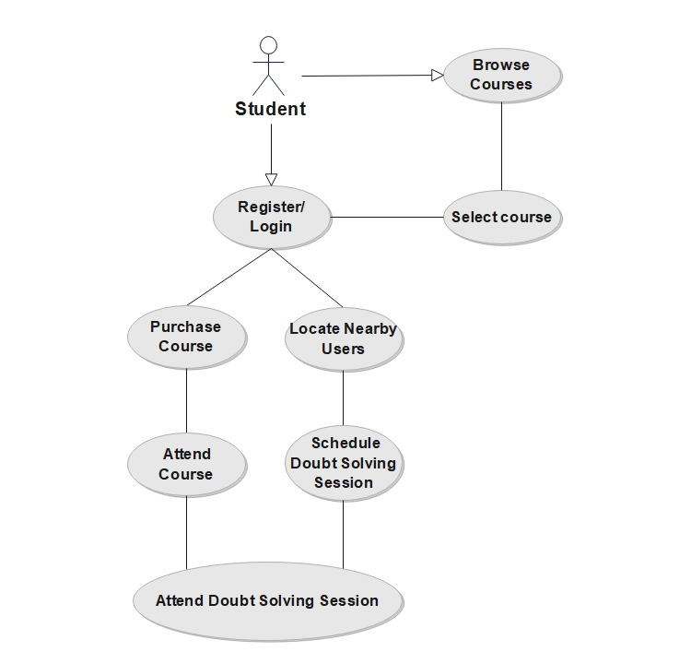

1.1 Use case diagram for student

**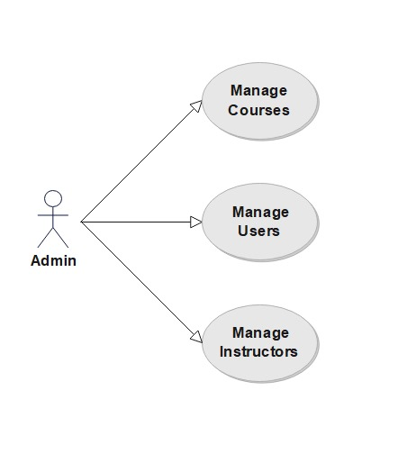**1.2 Use case diagram for Admin **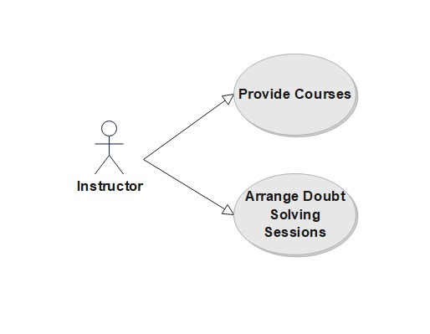**1.3 Use case diagram for instructor

**4.3 Activity Diagram**

An activity diagram shows the flow of activities and actions, detailing the steps involved in a particular process. Here, we'll cover two key activities: "Purchase Course" and "Schedule Doubt Solving Session".

Activity Diagram for "Purchase Course"

Browse Courses: The student views the list of available courses.

Select Course: The student selects a course they are interested in.

Click "Purchase": The student initiates the purchase process.

Auth0 Authentication: The system ensures the student is authenticated.

Enter Payment Details: The student provides necessary payment information.

Confirm Purchase: The student confirms the purchase.

Access Course Material: The student gains access to the course content.

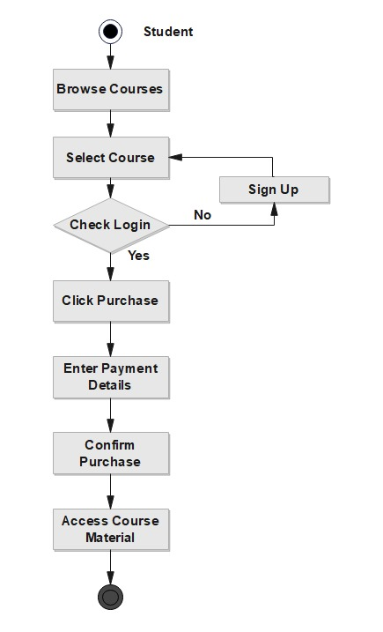

1.4 Activity diagram for purchasing course

**4.3.1Activity Diagram for "Schedule Doubt Solving Session"**

Choose Subject: The student selects the subject for the doubt-solving session.

Select Session Type: The student chooses between an online or offline session.

Check Availability: The system checks for available time slots and instructors.

Book Session: The student books the session.

Confirmation Notification: The system sends a confirmation notification.

Attend Session: The student attends the scheduled session.

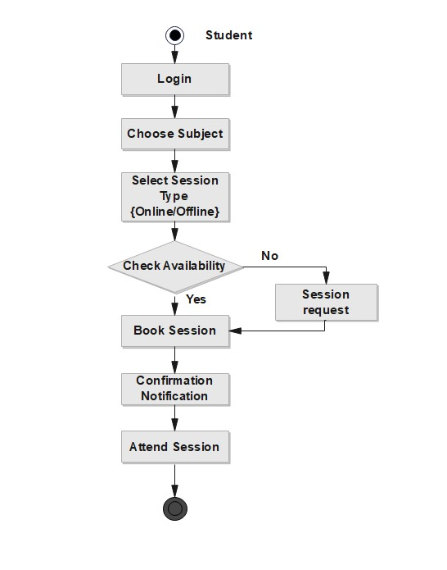

1.5 Activity diagram for scheduling doubt solving session

**4.4 Sequence Diagram**

A sequence diagram details the interactions between different entities (actors and the system) over time for a specific process. Here, we'll focus on "Attend Doubt Solving Session".

Sequence Diagram for "Attend Doubt Solving Session"

Request Session Details: The student requests details for a scheduled session.

Provide Session Details: The system provides the necessary details to the student.

Select Session and Book: The student books a session.

Confirm Booking: The system confirms the booking.

Join Session: The student joins the session.

Start Video Call: The system initiates a video call using WebRTC.

Interactive Session: The student and instructor interact via the video call.

End Session: The session concludes.

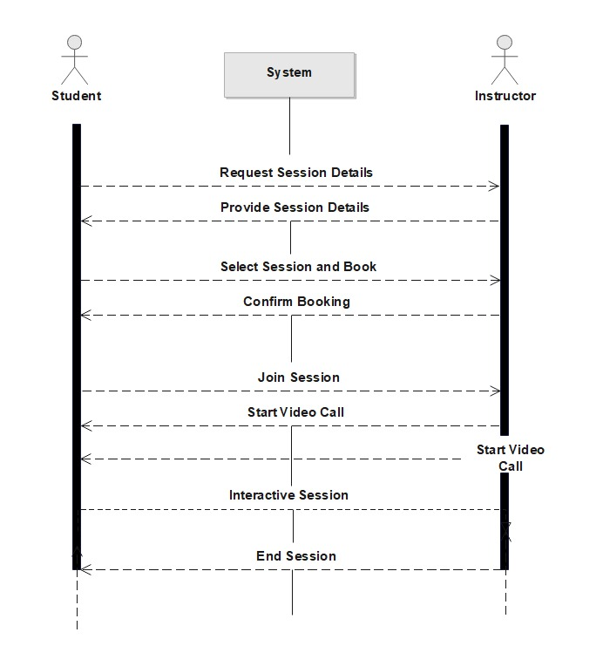

1.6 Sequence diagram for attending session

This chapter emphasized the importance of detailed design using class diagrams, use case diagrams, activity diagrams, and sequence diagrams. By creating these visual representations, the project ensures a clear understanding of the system's architecture, data flow, and user interactions. This detailed design phase lays the groundwork for efficient development and implementation of EduHub.

**CHAPTER FIVE**

**IMPLEMENTATION AND CODING**

**5.1 Implementation**

**5.1.1 Technology Endorsed**

EduHub will be implemented using a combination of the following technologies:

**5.1.1.1 Front-end (Client-side):**

React: A popular JavaScript library for building user interfaces. React will be used to create the interactive and dynamic frontend components of EduHub.

**5.1.1.2 Back-end (Server-side):**

Node.js: A JavaScript runtime environment that allows server-side scripting. Node.js will be used to develop the backend functionalities of EduHub, including handling user requests, managing database interactions, and implementing business logic.

Express.js: A popular web application framework built on top of Node.js. Express.js will provide a structured approach for building the backend API that interacts with the frontend and database.

**5.1.1.3 Database:**

MongoDB: A NoSQL document database. MongoDB will be used to store application data due to its flexibility and scalability, allowing for efficient storage of user information, course content, and platform activity logs.

**5.2 Module Description**

EduHub will be developed as a collection of modular components, each responsible for a specific functionality. Here are some key modules:

**5.2.1 Login Module**

Handles user login attempts by validating credentials against the database.

Implements secure authentication protocols to protect user data.

Redirects users to their respective dashboards (student, instructor, admin) upon successful login.

**5.2.2 Registration Module**

Allows users (students and instructors) to register on the platform.

Validates user information and ensures secure password storage using hashing algorithms.

Sends confirmation emails to registered users.

**5.2.3 List Generation Module**

Retrieves data from the database (e.g., list of courses, nearby users) based on user requests.

Uses efficient querying techniques to optimize data retrieval performance.

Formats and prepares the retrieved data for display on the frontend.

**5.3 Testing**

Rigorous testing is crucial to ensure the quality and functionality of EduHub. Here's a breakdown of the testing strategy:

**5.3.1 Unit Testing**

Individual units of code (functions, classes) will be tested in isolation to verify their correctness.

Unit testing frameworks like Jest or Mocha will be used to automate unit test execution.

**5.3.2 Integration Testing**

Modules will be tested together to ensure seamless interaction and data flow between them.

Integration testing will verify that the different functionalities of the application work cohesively.

**5.3.3 Component Interface Testing**

The interaction between the frontend components and the backend API will be thoroughly tested.

This will ensure that data is exchanged correctly between the client and server.

**5.3.4 System Testing**

The entire EduHub platform will be tested as a complete system under realistic user scenarios.

System testing will identify potential issues with user experience, performance, and overall functionality.

**5.4 Testing Examples**

Here are some specific test case examples:

**5.4.1 List Generation Test Case**

* Test case: Verify that the list generation module retrieves a list of courses with accurate details upon a student's request.
* Expected result: The frontend displays a list of courses with titles, descriptions, and instructor names retrieved from the database.

**5.4.2 Server-side Interface Test Case**

* Test case: Test the login API by sending a valid username and password combination.
* Expected result: The API successfully validates the credentials, generates an authentication token, and returns a success response to the frontend.

**5.4.3 Login Form Test Cases**

* Test case 1: Verify that the login form validates empty username and password fields.
* Expected result: The form displays an error message indicating missing credentials.
* Test case 2: Test the login form with invalid credentials.
* Expected result: The form displays an error message indicating invalid login attempt.

**5.5 Summary**

This chapter outlined the implementation approach for EduHub, highlighting the chosen technologies and the development of modular components. A comprehensive testing strategy was presented, emphasizing unit testing, integration testing, component interface testing, and system testing. With rigorous testing at each stage, EduHub aims to ensure a robust and reliable platform for online learning.

**CHAPTER SIX  
DEPLOYMENT**

**6.1 How to Execute and Use**

Once development and testing are complete, EduHub will be deployed to a production environment to make it accessible to users. Here's a breakdown of the deployment process:

Server Setup:

A cloud-based virtual server instance will be procured from a reputable cloud provider like Amazon Web Services (AWS), Google Cloud Platform (GCP), or Microsoft Azure. This virtual server will host the Node.js backend application and the MongoDB database.

The server will be configured to ensure security, scalability, and optimal performance for handling user traffic.

Code Deployment:

The production-ready code will be version controlled using a platform like Git.

A continuous integration/continuous delivery (CI/CD) pipeline will be established to automate the build, testing, and deployment process. This ensures efficient and reliable deployment of new features and bug fixes.

The code will be deployed to the server using tools like PM2 or a containerization platform like Docker to manage the application lifecycle.

Database Deployment:

A MongoDB database instance will be set up on the cloud server.

Secure authentication and access controls will be implemented to protect the database from unauthorized access.

Initial data (e.g., user roles, system configurations) will be populated in the database.

Domain Name and SSL Certificate:

A unique domain name will be acquired for EduHub to provide users with a professional and branded access point.

A Secure Sockets Layer (SSL) certificate will be installed on the server to encrypt communication between users' web browsers and the platform. This ensures secure data transmission and protects user privacy.

User Access and Management:

A clear user onboarding process will be established, guiding users through registration, account activation, and platform navigation.

User roles (student, instructor, admin) will be clearly defined with designated access permissions to specific functionalities within EduHub.

**6.2 Summary**

This chapter outlined the deployment process for EduHub, ensuring a smooth transition from development to a production environment accessible to users. The focus on cloud-based infrastructure, CI/CD pipelines, and robust security measures will guarantee scalability, reliability, and user data protection. By following these deployment practices, EduHub will be well-positioned for real-world use and continuous improvement.

**CHAPTER SEVEN  
CONCLUSION**

**7.1 Conclusion**

EduHub has been designed as a comprehensive e-learning platform that addresses the limitations of existing solutions. By leveraging modern technologies and focusing on user needs, EduHub aims to create a more engaging and interactive learning experience for students. Here's a summary of the project's key takeaways and future aspirations:

Key Takeaways:

* EduHub addresses the growing demand for flexible and accessible online learning opportunities.
* The platform offers a diverse range of courses, real-time doubt-solving features, and opportunities for community building among geographically dispersed learners.
* The chosen technology stack (React, Node.js, MongoDB) provides a solid foundation for a scalable, performant, and user-friendly platform.
* A rigorous testing strategy ensures the quality, reliability, and security of EduHub.
* Cloud-based deployment facilitates efficient scaling and management as the platform grows.

Future Aspirations:

* Gamification: Integrate features that utilize game mechanics (points, badges, leaderboards) to enhance user engagement and motivation.
* AI-powered Recommendations: Develop AI algorithms to personalize learning paths by recommending courses based on student interests and past performance.
* Content Creation Tools: Provide instructors with tools to create interactive learning materials like quizzes, polls, and interactive presentations within the platform.
* Learning Management System (LMS) Integration: Explore integration with existing Learning Management Systems (LMS) used by educational institutions, facilitating wider adoption of EduHub within the educational landscape.
* In conclusion, EduHub presents a promising solution for the evolving educational landscape. By fostering a dynamic and interactive learning environment, EduHub empowers students to learn at their own pace and connect with a supportive community of educators and peers.

References

[List relevant references used throughout the report. This may include references to specific technologies, frameworks, or research papers]

This report provides a comprehensive overview of the EduHub project, outlining its motivation, objectives, proposed system functionalities, detailed design, implementation approach, testing strategy, deployment plan, and concluding thoughts. With a focus on addressing student needs and utilizing modern technologies, EduHub strives to revolutionize the online learning experience and make education more accessible and engaging for all.