**Acknowledgement**

This satisfaction that accompanies that the successful completion of any task would be incomplete without the mention of people whose ceaseless cooperation made it possible, whose constant guidance and encouragement crown all efforts with success.

We are grateful to our project guide Mrs. Poonam Pandey for the guidance, inspiration and constructive suggestions that helpful to us in the preparation of this project.

**Introduction:**

This Project is a website consists of hefty sum of online movies categorised on the basis of Ratings and the type of movies.

The user log in the site just needs to add the type of movie user wants to watch in the type of movie and the website will search the movie or movies for the database. Returned movie contains the link of the trailer and link to watch it online.

The movie database will be updated by the admin to keep the users entertained throught the weekend the site will not be able to stream but it will link the sites that stream movies. The GUI and the User Interface of this site is made so to made the layman using the site more efficient.

If you like the site and wish for the contributions the site also contains a Paytm Donation module the paytm donation when received will be given shoutout on the page.

**Salient Feature**

* Vaguely Categorised.
* Login and authentication System.
* Contains trailer.
* Gives Ratings.
* Links to watch movie online.
* User can comment its views.

**Requirement Specification:**

* NetBeans 8.2
* Java jdk 1.8.0
* Html/CSS
* Php
* XAMP Server

**About NetBeans:**

NetBeans is an integrated development environment (IDE) for [Java](https://en.wikipedia.org/wiki/Java_(programming_language)). NetBeans allows applications to be developed from a set of modular software components called modules. NetBeans runs on Windows, MacOS, Linux and Solaris. In addition to Java development, it has extensions for other languages like PHP, C, C++, HTML5, and JavaScript. Applications based on NetBeans, including the NetBeans IDE, can be extended by third party developers.

NetBeans began in 1996 as Xelfi (word play on [*Delphi*](https://en.wikipedia.org/wiki/Borland_Delphi)),[[6]](https://en.wikipedia.org/wiki/NetBeans#cite_note-6)[[7]](https://en.wikipedia.org/wiki/NetBeans#cite_note-7) a Java IDE student project under the guidance of the Faculty of Mathematics and Physics at [Charles University](https://en.wikipedia.org/wiki/Charles_University) in [Prague](https://en.wikipedia.org/wiki/Prague). In 1997, Roman Staněk formed a company around the project and produced commercial versions of the NetBeans IDE until it was bought by [Sun Microsystems](https://en.wikipedia.org/wiki/Sun_Microsystems) in 1999. Sun open-sourced the NetBeans IDE in June of the following year. Since then, the NetBeans community has continued to grow.[[8]](https://en.wikipedia.org/wiki/NetBeans#cite_note-8) In 2010, Sun (and thus NetBeans) [was acquired](https://en.wikipedia.org/wiki/Sun_acquisition_by_Oracle) by [Oracle Corporation](https://en.wikipedia.org/wiki/Oracle_Corporation). Under Oracle, NetBeans competed with [JDeveloper](https://en.wikipedia.org/wiki/JDeveloper" \o "JDeveloper), a freeware IDE that has historically been a product of the company.

**HTML/CSS:**

Hypertext Markup Language (HTML) is the standard [markup language](https://en.wikipedia.org/wiki/Markup_language" \o "Markup language) for creating web pages and [web applications](https://en.wikipedia.org/wiki/Web_application). With [Cascading Style Sheets](https://en.wikipedia.org/wiki/Cascading_Style_Sheets) (CSS) and JavaScript, it forms a triad of cornerstone technologies for the [World Wide Web](https://en.wikipedia.org/wiki/World_Wide_Web).[[4]](https://en.wikipedia.org/wiki/HTML#cite_note-4)

[Web browsers](https://en.wikipedia.org/wiki/Web_browser) receive HTML documents from a [web server](https://en.wikipedia.org/wiki/Web_server) or from local storage and [render](https://en.wikipedia.org/wiki/Browser_engine) the documents into multimedia web pages. HTML describes the structure of a web page [semantically](https://en.wikipedia.org/wiki/Semantic_Web) and originally included cues for the appearance of the document.

* Activity Diagram

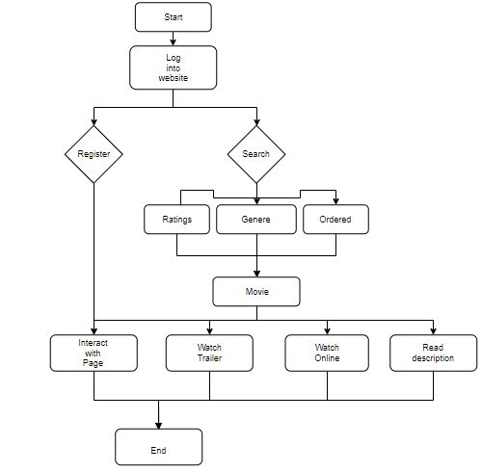

* E-R Diagram

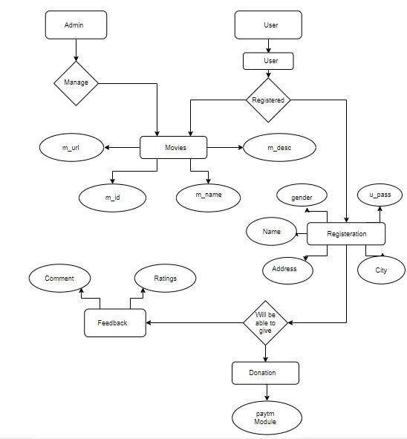

* Class Diagram

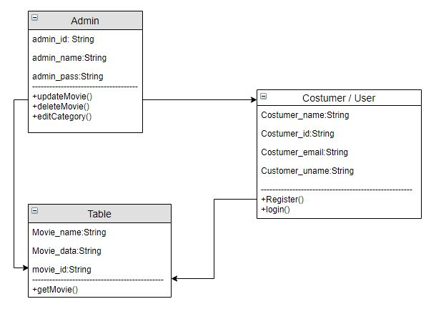

* User Case Diagram

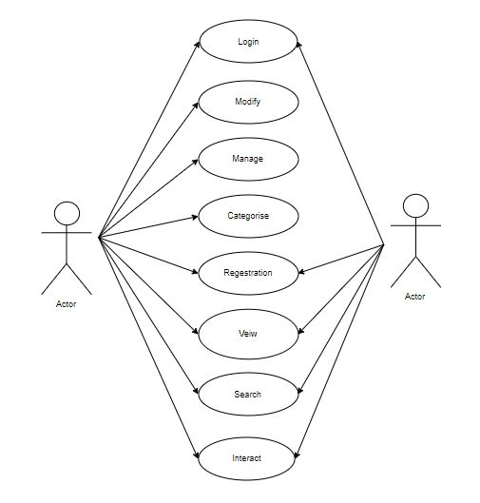

**Database Table:**

|  |  |  |
| --- | --- | --- |
| Name | Variable Name | Datatype |
| First name | fname | varchar(10) |
| Last name | lname | Varchar(10) |
| Age | age | Integer |
| E-Mail | email | Varchar(10) |
| Password | pwd | Varchar(10) |