A

PROJECT REPORT

ON

**“Japanese Domestic Market.”**

**By**

**Manav Jagdish Dave(4114)**

**And**

**Dev Amit Jasani(4132)**

**In partial fulfillment of BBA(CA) Batch(2022-23)**

**Savitribai Phule Pune University**

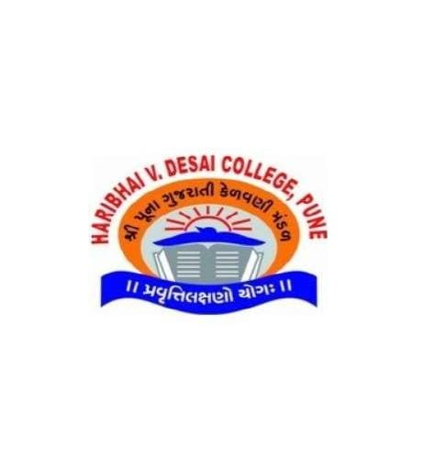

**THE POONA GUJARATI KELVANI MANDAL’s**

**HARIBHAI .V. DESAI COLLEGE,**

**PUNE-411002**

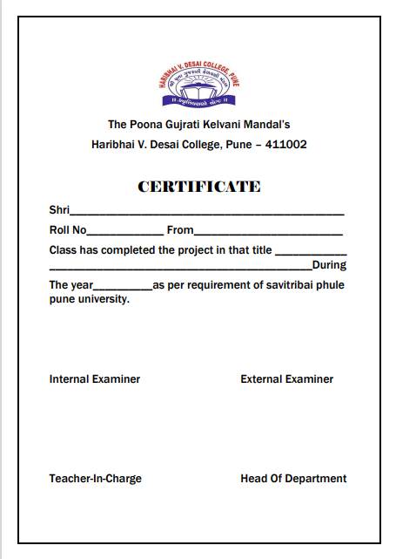

TITLE OF THE PROJECT

**“JDM”**

**Project Documentation**

**SUBMITTED BY: GUIDED BY:**

Manav Dave (4114) Mrs. Jagruti Dagliya

Dev Jasani (4132)

**INDEX**

|  |  |  |
| --- | --- | --- |
| SR.NO | TOPIC | PG NO. |
| 01 | INTRODUCTION |  |
| * MOTIVATION | 05 |
| * PURPOSE/ OBJECTIVES & GOALS | 06 |
| * PROBLEM STATEMENT | 07 |
| * LITERATURE SURVEY | 08 |
| 02 | SYSTEM ANALYSIS |  |
| * EXISITING SYSTEM | 09 |
| * STAKEHOLDERS | 10 |
| * PROJECT PERSPECTIVE & FEATURES | 11 |
| * REQUIREMENT ANALYSIS | 12 |
| 03 | SYSTEM DESIGN | 13 |
| * SYSTEM MODEL [ER] | 13 |
| * DATA FLOW DIAGRAM LVL0 | 15 |
| * DATA FLOW DIAGRAM LVL1 | 16 |
| 04 | IMPLEMENTATION DETAILS |  |
| * SOFTWARE | 17 |
| * HARDWARE | 17 |
| 05 | FUTURE SCOPE | 18 |
| 06 | CONCLUSION | 19 |
| 07 | BIBLIOGRAPHY | 20 |
| 08 | SCREENSHOTS | 21 |

INTRODUCTION

**Motivation**

As a car enthusiast and a lover of all things automotive, We have always been fascinated by the world of JDM cars. These Japanese Domestic Market vehicles are known for their sleek designs, high-performance engines, and unique features that set them apart from cars produced for other markets.

However, we noticed that there was a lack of comprehensive and easy-to-access information about JDM cars online. We realized that there was a need for a website dedicated to JDM cars, where enthusiasts could learn about these amazing vehicles, buy them, connect with other enthusiasts from around world.

That's why we decided to create this website - to provide a platform for JDM car enthusiasts to connect, share their passion, and learn more about these amazing vehicles. Whether you're a seasoned JDM enthusiast or just getting started in the world of Japanese cars, this website is for you.

**WE HOPE THAT THIS WEBSITE WILL INSPIRE YOU TO LEARN MORE ABOUT JDM CARS, CONNECT WITH OTHER ENTHUSIASTS. SO COME JOIN US ON THIS JOURNEY AND DISCOVER THE AMAZING WORLD OF JDM CARS!**

**Purpose/Objectives Goals:**

The main objective of the JDM Car Community is to create a centralized platform for JDM car enthusiasts to access information, news, events, and purchase JDM cars.

Japanese domestic market refers to Japan's home market for vehicles and vehicle parts. Japanese owners contend with a strict motor vehicle inspection and grey markets. There is a common misconception that any Japanese branded car is JDM; however, this is not true.

The average age of JDM cars is 8.7 years, ranking 9th in a survey of 30 of the top 50 countries by gross domestic product.According to the Fédération Internationale de l'Automobile, a car in Japan travels a yearly average of over only 9,300 kilometers (5,800 miles), less than half the U.S. average of 19,200 kilometers (12,000 miles).

**OUR GOAL IS TO PROVIDE A ONE-STOP-SHOP FOR EVERYTHING RELATED TO JDM CARS, FROM HISTORY AND CULTURE TO PERFORMANCE UPGRADES AND CUSTOMIZATION. WE BELIEVE THAT JDM CARS ARE NOT JUST VEHICLES, BUT A WAY OF LIFE, AND WE WANT TO SHARE THAT PASSION WITH THE WORLD.**

**Problem Statement:**

Despite the popularity of JDM cars among enthusiasts, there is a lack of easily accessible information and resources for those interested in these vehicles. This makes it difficult for enthusiasts to connect with one another, learn about JDM cars, and buy these vehicles.

Many JDM enthusiasts have to rely on fragmented and unreliable sources of information, which can be time-consuming and frustrating. There is a need for a comprehensive and reliable resource that provides accurate information about JDM cars, as well as a platform for enthusiasts to connect with one another and share their passion.

Additionally, many JDM car enthusiasts struggle to find a reliable source for purchasing JDM cars. Buying JDM cars can be a complex and risky process, as many cars are located overseas and require importation. There is a need for a trustworthy platform where enthusiasts can purchase JDM cars with confidence, knowing that they are getting a high-quality vehicle and reliable service.

That's why we created this website - to address these problems and provide a one-stop-shop for everything related to JDM cars.

**WE BELIEVE THAT JDM CARS ARE MORE THAN JUST VEHICLES - THEY ARE A WAY OF LIFE. OUR MISSION IS TO MAKE IT EASIER FOR ENTHUSIASTS TO CONNECT, LEARN, AND BUY JDM CARS, SO THAT EVERYONE CAN EXPERIENCE THE THRILL OF OWNING AND DRIVING THESE AMAZING VEHICLES**

**Literature Survey:**

In researching JDM cars, we have reviewed a wide range of literature, including academic articles, books, and online resources. Here are some of the key findings from our literature survey:

* **History and Culture:** JDM cars have a rich history and cultural significance, dating back to the 1960s when Japan emerged as a major player in the global automotive industry. The popularity of JDM cars has grown over the years, and they are now sought after by enthusiasts around the world.
* **Design Features:** JDM cars are known for their unique design features, which set them apart from cars produced for other markets. These features include unique body styles, advanced engine technology, and specialized tuning.
* **Performance Upgrades:** Many JDM enthusiasts are interested in upgrading their cars for better performance, including adding turbochargers, aftermarket suspensions, and custom exhaust systems.
* **Importation and Purchasing:** Buying JDM cars can be a complex process, as many vehicles are located overseas and require importation. There are several online platforms and dealerships that specialize in importing JDM cars, but it's important to be cautious and choose a reliable and trustworthy seller.

**OVERALL, OUR LITERATURE SURVEY HAS HELPED US TO BETTER UNDERSTAND THE HISTORY, CULTURE, AND TECHNICAL ASPECTS OF JDM CARS, AND HAS INFORMED OUR APPROACH TO CREATING A COMPREHENSIVE RESOURCE FOR JDM ENTHUSIASTS AROUND THE WORLD**.

SYSTEM ANALYSIS

**Existing Systems:**

Before developing a new system for JDM car enthusiasts, it's important to review and analyze the existing systems that are already available. This analysis will help us identify the strengths and weaknesses of the existing systems, and determine how we can improve upon them with our own website. There are several existing systems that cater to JDM car enthusiasts. Some of the most popular ones include:

**1. JDM Expo:** This is a website that specializes in the importation and sale of JDM cars. It has a wide selection of vehicles and offers various services to assist customers

**2. Forums:** There are a number of online forums dedicated to JDM cars, where enthusiasts can discuss topics such as modifications, tuning, and purchasing. Some popular JDM car forums include JDM Style Tuning, JDM Chat, and JDM Legend.

**3. Blogs:** There are also a number of JDM car blogs that provide information and news on JDM cars. These blogs often focus on specific models or brands, and provide detailed information on modifications and tuning. Some popular JDM car blogs include Speedhunters, JDM Expo, and Super Street Online.

**4**. **E-commerce websites:** There are several websites that specialize in importing and selling JDM cars to buyers around the world. These websites typically offer a wide range of JDM cars, including popular models such as the Nissan Skyline, Toyota Supra, and Honda NSX. Some popular JDM car e-commerce websites include JDM Expo, J-Spec Auto Sports, and Japanese Classics.

**WHILE THERE ARE A NUMBER OF EXISTING SYSTEMS AND WEBSITES THAT PROVIDE INFORMATION AND RESOURCES ON JDM CARS, WE BELIEVE THAT THERE IS STILL ROOM FOR IMPROVEMENT AND INNOVATION IN THIS SPACE.**

**Stakeholders**

Stakeholders are individuals or groups who have an interest or concern in a project, and who can influence or be influenced by the project's outcomes. In the development of our JDM car website, there are several key stakeholders that we need to consider:

**JDM car enthusiasts:**

The primary stakeholders in our project are JDM car enthusiasts, who will be the primary users of our website. We will need to consider their needs and preferences in terms of the information, e-commerce, and community resources that our website provides.

**JDM car dealers:**

JDM car dealers will also be important stakeholders in our project, as they will be the primary providers of the cars that will be sold on our e-commerce platform. We will need to establish partnerships with reputable JDM car dealers to ensure the quality and authenticity of the cars sold on our platform.

**Third-party service providers:**

We may also need to work with third-party service providers such as web hosting providers, payment gateways, and shipping companies to ensure the smooth operation of our website and e-commerce platform.

**Regulatory bodies:**

We will also need to consider the regulatory requirements and standards for e-commerce websites and car sales in our target markets, and ensure that our website and e-commerce platform comply with these requirements.

**BY CONSIDERING THE NEEDS AND CONCERNS OF THESE STAKEHOLDERS, WE WILL BE ABLE TO DEVELOP A WEBSITE AND E-COMMERCE PLATFORM THAT IS USER-FRIENDLY, SECURE, AND COMPLIANT WITH REGULATORY STANDARDS, WHILE ALSO PROVIDING VALUABLE RESOURCES AND SERVICES FOR JDM CAR ENTHUSIASTS AND DEALERS**

**Project Perspective and Features:**

Our JDM car website will be a comprehensive platform that provides information, e-commerce, and community resources for JDM car enthusiasts. Here are some of the key features and perspectives that our website will offer:

**Information resources:**

Our website will provide comprehensive information resources on JDM cars, including articles, blogs, and user-generated content that covers a range of topics such as history, modifications, and maintenance. We will also provide user-friendly navigation and search tools to help users find the information they need quickly and easily.

**E-commerce platform:**

Our website will also include an e-commerce platform that allows users to browse and purchase JDM cars from reputable dealers. We will ensure that all cars listed on our platform are authentic and meet our quality standards. We will also provide secure payment and shipping options to ensure a seamless buying experience for our users.

**Community resources:**

Our website will offer community resources such as forums, meetups, and event listings that allow JDM car enthusiasts to connect with each other and share their experiences and knowledge. We will provide user-friendly tools for organizing and promoting events, as well as facilitating discussion and networking among users.

**Multilingual support:**

To ensure that our website is accessible to users around the world, we will offer multilingual support in languages such as English, Japanese, and Spanish. This will allow users to access information and resources in their preferred language, and facilitate communication and networking among JDM car enthusiasts from different regions and cultures.

**BY OFFERING THESE FEATURES AND PERSPECTIVES, OUR WEBSITE WILL BE A VALUABLE RESOURCE FOR JDM CAR ENTHUSIASTS, AND A PLATFORM FOR PROMOTING AND SUPPORTING THE JDM CAR CULTURE WORLDWIDE**

**Requirement Analysis:**

To ensure that our JDM car website meets the needs and expectations of our target users, we conducted a thorough requirement analysis. This involved gathering and analyzing information about the user needs, business objectives, and technical requirements for our website. Here are the key findings of our requirement analysis:

1. **User needs:**

Our target users are JDM car enthusiasts who are looking for comprehensive information resources, e-commerce platforms, and community resources related to JDM cars. They expect our website to be user-friendly, accessible, and informative, and to provide a seamless buying experience for purchasing JDM cars.

1. **Business objectives:**

Our business objectives for the website are to provide a comprehensive platform that promotes and supports the JDM car culture, attracts and retains a large user base, and generates revenue through e-commerce sales and advertising

1. **Technical requirements**:

To meet the user needs and business objectives, we identified several technical requirements for the website. These include:

* **Responsive design**: The website must be optimized for different devices and screen sizes, to ensure a seamless user experience on desktop and mobile devices.
* **Content management system (CMS):** We will use a CMS to manage and publish content on the website, to ensure that it is up-to-date and relevant.
* **E-commerce platform:** We will integrate an e-commerce platform with secure payment and shipping options, to enable users to browse and purchase JDM cars online.
* **Forum and community features:** We will integrate forum and community features that allow users to connect, network, and share information and experiences related to JDM cars.
* **Multilingual support:** To ensure that the website is accessible to users around the world, we will provide multilingual support for different languages

**BY ANALYZING AND UNDERSTANDING THESE USER NEEDS, BUSINESS OBJECTIVES, AND TECHNICAL REQUIREMENTS, WE CAN DESIGN AND DEVELOP A JDM CAR WEBSITE THAT MEETS THE NEEDS AND EXPECTATIONS OF OUR TARGET USERS, AND SUPPORTS THE GROWTH AND PROMOTION OF THE JDM CAR CULTURE WORLDWIDE**

**SYSTEM DESIGN**

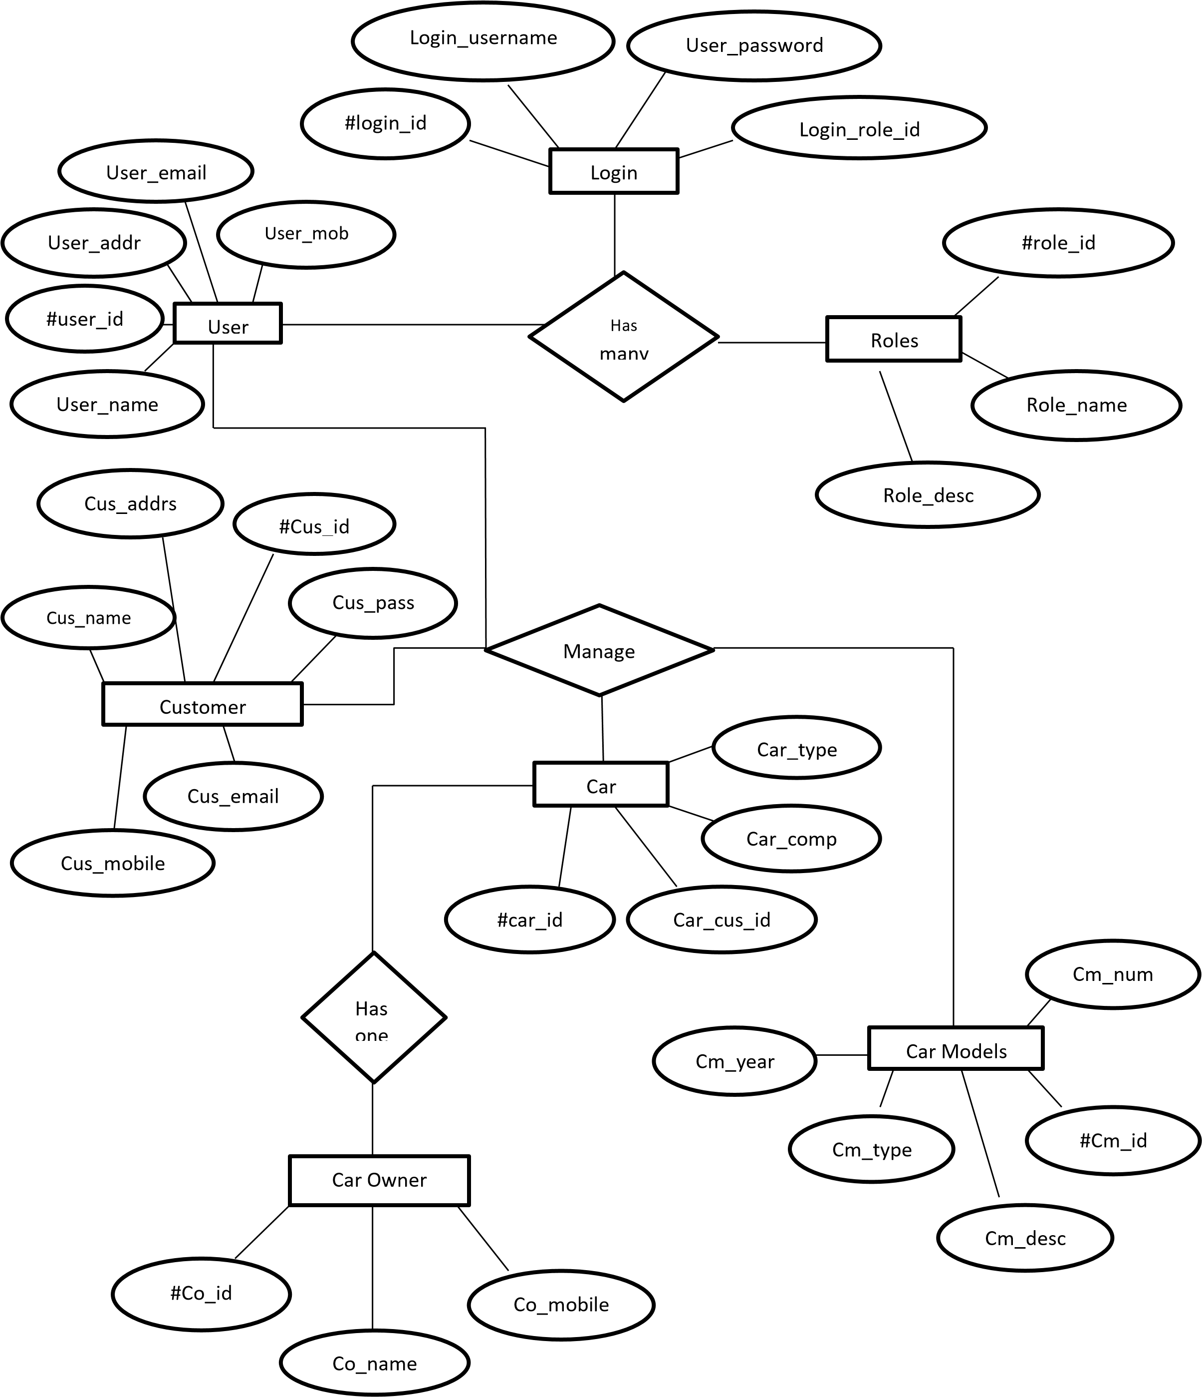**ENTITY RELATIONSHIP DIAGRAM**

DATA FLOW DIAGRAM OF THE PROPOSED SYSTEM

A data flow diagram is a primary graphic tool for the analysis phase of the system development life cycle. Analysts to show what happens to data items, as they flow through the system use it.

An information moves through software, it is modified by a series of transformations. Data flow diagram is a graphical technique that depicts information flow and the transforms the are as data move from input to output. The basic form of a DFD is also known as data flow graph or a bubble chart. The DFD serve two purposes:

(i) To provide and indication of how data are transformed as they move through the system.

(ii) To depict the functions that transforms that data flow.

The DFD provides additional information that is used during the analysis of information domain and serve as a basis for the modeling of function.

Basic notations, which used to create DFD, are as follows:

**RECTANGLE**

It is used to represent an external entity or another system element that produces information for transformation or receive information.

### **CIRCLE**

It used to represent any process or transform which applied on data

**ARROW**

Arrow represents one or more data items or data objects.

### **PARRALEL LINE**

The parallel line used to represent any database

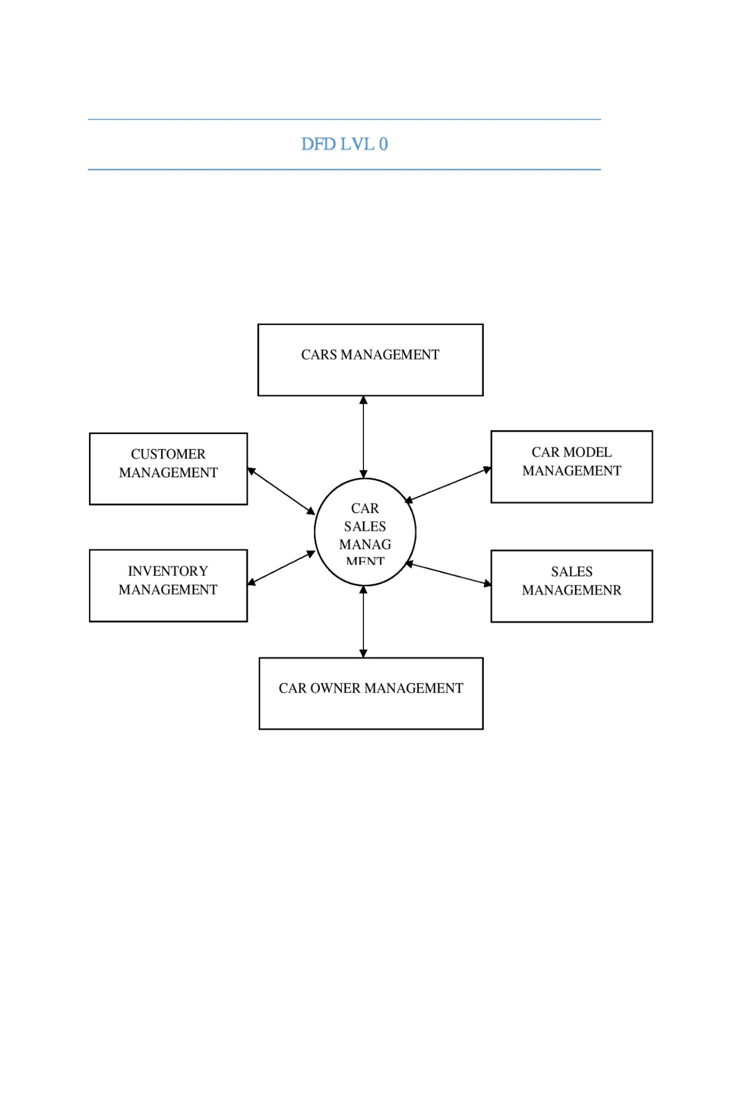

DFD LVL1

Customer Information Customer Information

Sales Information

Sales information

Car category List

Car Information

Chosen Car

Sales Information

Transaction Details

Transaction Services

Payment Details

Price Information



Manage Car

I

nfo



Monitor Car

sales



Manage

Transactions



Manage Customer

Information



Admin



Person/User

Implementation details

* **SOFTWARE**

|  |  |
| --- | --- |
| **OPERATING SYSTEM** | **WINDOWS 7** |
| **BROWSER** | **GOOGLE CHROME** |
| **FRONT END** | **HTML, CSS, JAVASCRIPT** |

* **HARDWARE**

|  |  |
| --- | --- |
| **PROCESSOR** | **INTEL CORE I5** |
| **RAM** | **4 GB AND ABOVE** |
| **HARD DISK SPACE** | **3GB FREE DISK** |

**Future Scope:**

JDM Car Community website has been designed and developed to cater to the needs of JDM car enthusiasts all around the world. However, there is always room for improvement and expansion. In the future, we plan to add more features to the website to make it more user-friendly and interactive.

One of the main areas of improvement will be in the social media integration of the website. Currently, the website has basic social media sharing options. In the future, we plan to add more social media functionalities to enable users to share their JDM car experiences and connect with other JDM car enthusiasts.

Another area of future expansion is to add an e-commerce section to the website. This section will allow users to purchase JDM car parts and accessories directly from the website. We will also include a feature that will allow users to review and rate the products to help other users make informed purchases.

We also plan to expand the JDM car event section of the website. Currently, the website only displays upcoming JDM car events. In the future, we plan to add a section for past JDM car events where users can upload pictures and videos from the events. This will create a space for JDM car enthusiasts to reminisce about past events and get excited for future ones.

**OVERALL, THE JDM CAR COMMUNITY WEBSITE HAS A LOT OF POTENTIAL FOR FUTURE EXPANSION AND WE LOOK FORWARD TO CONTINUING TO IMPROVE AND ENHANCE THE USER EXPERIENCE FOR JDM CAR ENTHUSIASTS.**

**Conclusions**

In conclusion, the JDM Car Community website has been developed with the objective of creating a platform for car enthusiasts to connect, share their passion, and expand their knowledge about JDM cars. Through the development of the website, we were able to achieve the project's goals of building a user-friendly platform that allows users to buy, sell, and showcase their JDM cars, as well as providing a space for users to connect with like-minded individuals, access news, and stay informed about upcoming JDM events.

Overall, the JDM Car Community project has been a success, and we are confident that it will continue to grow and evolve in the future. Our development team has put in a significant amount of effort to ensure that the website is easy to use, secure, and scalable, with room for future features and improvements.

We believe that the JDM Car Community website has the potential to become a leading platform for JDM enthusiasts, and we are excited to see how it will develop in the coming years. We hope that users will continue to engage with the website, share their experiences, and help us to create a thriving community of JDM enthusiasts.

**THANK YOU FOR YOUR SUPPORT THROUGHOUT THIS PROJECT, AND WE LOOK FORWARD TO CONTINUING OUR WORK IN THE JDM CAR COMMUNITY.**

**Bibliography**

1. Sasaki, T. (2016). Japanese sports cars: past and present. Motorbooks.
2. Import Bible. (n.d.). Retrieved from <https://www.importbible.com/>
3. JDM Cars. (n.d.). Retrieved from <https://www.jdmcars.com/>
4. JDM Expo Co Ltd. (n.d.). Retrieved from <https://www.jdm-expo.com/>
5. Tuner Cars. (n.d.). Retrieved from <https://www.tunercars.net/>
6. Yoshida, T. (2019). The Japanese automotive industry and JDM culture. Routledge.
7. JDM Legends. (n.d.). Retrieved from <https://www.jdmlegends.com/>
8. Super Street Online. (n.d.). Retrieved from <https://www.superstreetonline.com/>

SCREENSHOTS

