Ghumi
Design Spec v3 — Unified System
Merges v1 (product system) + v2 (cinematic hero) into one coherent spec, with a bridged palette and defined transition from hero to app. Supersedes v1 and v2 — hand off this file alone.

0. The merge, in one idea
Ghumi has two visual modes that need to feel like one product: a cinematic, photographic landing page (v2) and a flat, structured, boarding-pass-driven app (v1). The fix isn't picking one — it's making the palette and the signature element (the boarding pass card + dotted route line) carry across both, and giving the scroll from one into the other a deliberate transition instead of a hard cut. That transition is the main addition in this version (§3).

1. Unified color system
v1's palette is kept as the source of truth. One addition: a `dusk` tone, pulled from what the hero photo's shadows should grade toward, so the photographic hero and the flat app share a common dark anchor instead of the hero inventing its own grey-fog color world.
Token | Hex | Use
paper | #F6F4EF | App background — all interior/dashboard pages, and the ground the landing page lands on after the hero
ink | #16241F | Primary text everywhere
brand (primary) | #1F5C4A | Deep teal — buttons, deterministic/code data, the CTA pill in both hero and app nav
dusk (new) | #16332B | Darkest anchor — the hero photo's color grade target, the nav-on-photo background, and the transition band between hero and content (§3). This is brand's shadow, not a separate color — keeps hero and app visually related.
brass (accent) | #C98A3B | LLM/reasoning layer, warm light sources in hero photography, logo accent dot
route | #A83E32 | Route/path line motif only — used identically in hero (if shown) and app
line | #D8D3C4 | Hairlines on paper background
muted | #6B7570 | Secondary text on paper
glass (new) | brand at 60% opacity + blur | The frosted floating card in the hero — defined as brand, not a new independent color, so it reads as “the app's teal, translucent” rather than a different palette
Practical result: the hero photo should be graded so its shadow tones sit near `dusk`, not neutral grey. That's the single change that makes the photographic hero feel like it belongs to the same product as the flat teal dashboard — same dark, just one lit by fog and one lit by nothing.

2. Page-by-page: which mode applies where
Page/section | Mode | Background
Landing page — hero | Cinematic (v2) | Full-bleed photo, graded toward `dusk`, dark overlay
Landing page — below hero (how it works, sample itinerary, footer) | Flat (v1) | `paper`, boarding-pass component in its normal flat style
Dashboard / itinerary view | Flat (v1) | `paper` throughout — no photography inside the app
Auth / sign-in | Flat (v1) | `paper`, simple centered card
Only the hero is photographic. Everything else — including the rest of the landing page — is flat `paper`, exactly as v1 specified. This was true in v2 already (§7 of that doc said as much); restated here so it survives the merge as the load-bearing rule it is.

3. The transition: hero → app
This is the new part. Instead of the photographic hero ending in a hard cut to a white section (jarring), the scroll passes through a short `dusk`-colored bridge section before reaching `paper`. Three coordinated moves, all happening as the user scrolls past the hero:
- Gradient handoff: the hero's dark overlay gradient (transparent at top → `dusk` at bottom) continues directly into a solid `dusk` band roughly 15-20vh tall — no visible seam between “photo fading to dark” and “solid dark section.”
- The dotted route line (v1's signature motif) originates inside this `dusk` band — a single light-colored dotted line starts near the glass card's position and draws downward as the user scrolls, animating via stroke-dashoffset exactly as v1 §6 specifies. It's the same line that will go on to connect the “how it works” agent row.
- The `dusk` band contains one short line of mono-set text riding the route line as it draws — e.g. `BUDGET AGENT → SEARCH AGENT → RANKING AGENT` — which then visually resolves into the actual “how it works” cards once the background finishes transitioning to `paper`. This makes the transition itself do narrative work instead of being a blank spacer.
- Color interpolates from `dusk` to `paper` across that same band (simple background gradient, or a 2-3 stop transition if the build chat wants it smoother) — by the time the route line's animation completes, the background has resolved to `paper` and the rest of the page proceeds exactly per v1.
Net effect: hero photo → darkens into dusk → a line of light draws itself downward carrying agent names — background lightens to paper — the drawn line becomes the literal connective line between the how-it-works cards. One continuous gesture, not three unrelated sections stacked on top of each other.

4. Typography — unchanged
Fraunces (display), General Sans/Inter (body/narrative), IBM Plex Mono (data/labels) — exactly as v1 specified, used identically in both the hero and the app. The hero's oversized ghost headline (v2 §2) is Fraunces; the mono agent-name text riding the transition's route line is Plex Mono — both already-approved fonts, no new typographic choices needed.

5. Signature element — confirmed carried through
The boarding-pass component is unchanged and appears in three places, each already specced:
- Hero: inside the frosted glass card (v2 §3) — rounded glass container, boarding-pass fields inside
- How-it-works row: connected by the same dotted route line that originates in the transition band (§3)
- Dashboard: full perforated-stub boarding-pass cards, stacked, per v1 §4–§5
Three appearances, one component, one connective line — that repetition across a photographic hero and a flat app is what makes the merge read as intentional rather than compromise.

6. Combined guardrails
All guardrails from v1 §8 and v2 §8 still apply. Two additional ones specific to the merge:
- Never let photography appear below the hero. If a build chat adds a background image to the how-it-works or dashboard sections, it has broken the flat/cinematic split this document depends on.
- Never skip the `dusk` transition band and cut straight from photo to `paper`. A hard cut is the one thing this version exists to fix — if it's missing, the merge hasn't actually happened, just two documents stapled together.

7. Handoff
Give the build chat this file, the PRD, and the tech stack doc. v1 and v2 are now superseded — no need to pass them separately, everything load-bearing from both is restated here. Build the hero + transition band first, since it's the piece that proves the merge works before the rest of the app (which is otherwise just v1, unchanged) gets built out.

8. New pages — simulated in build
Four additional screens were prototyped after v3 to test whether the palette and signature elements (boarding pass, dotted route line, dusk-to-paper transition) hold up outside the hero/app split described in §2–§3. All four reuse only tokens already defined in §1 — no new colors were introduced. Screenshots below are from working HTML prototypes, not static mockups.

8.1 Landing hero + transition (animated)
Builds directly on §3. In addition to the gradient handoff and drawing route line, a plane glyph now rides the dotted line as it draws, then breaks off and takes off (rotate + scale + fade) right as the band finishes resolving to paper — giving the transition a clear, literal payoff rather than just a color fade. Ghost headline treatment was thickened from the original v3 mock: 600 weight, tight tracking, and a stepped text-shadow (highlight edge + two dusk-colored steps + soft cast shadow) so it reads as extruded/dimensional against the photo rather than flat text sitting on top of it.
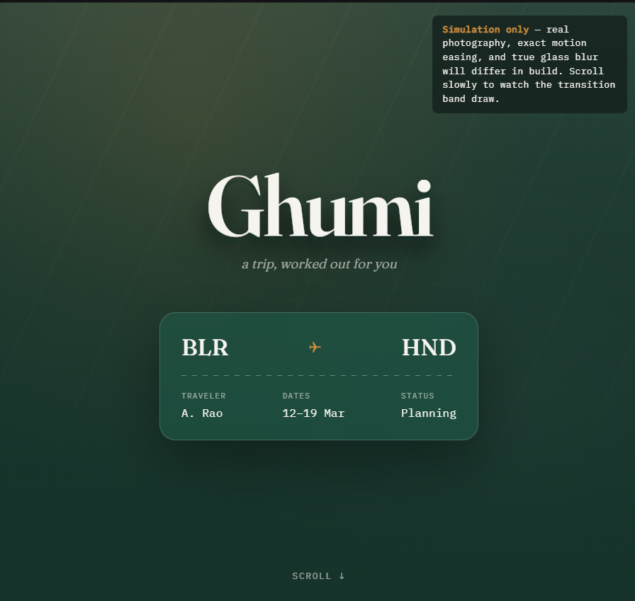
Hero — ghost headline, glass boarding-pass card, dusk gradient background
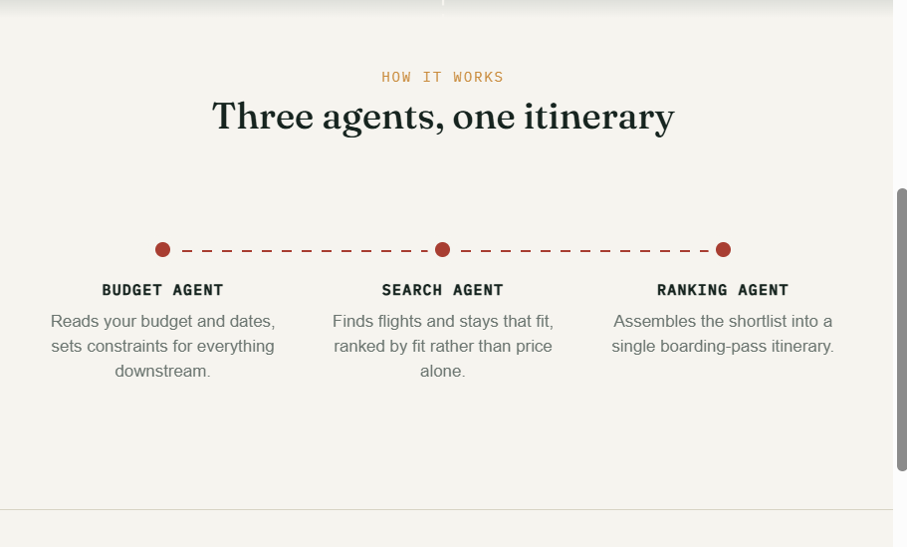
Scrolled further — how-it-works row, connected by the resolved route line
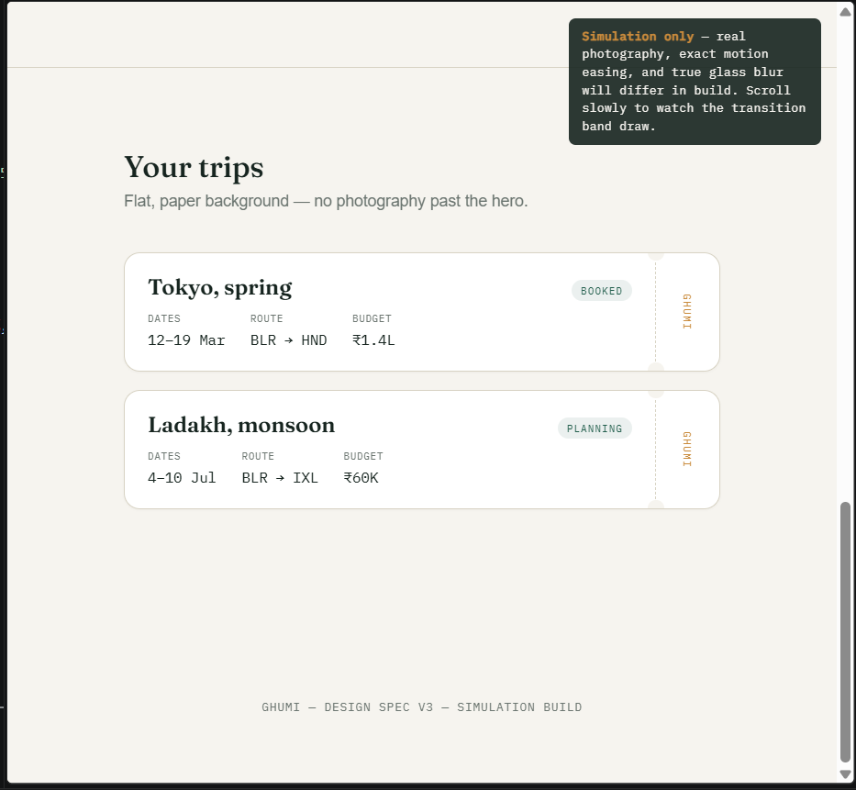
Scrolled to bottom — dashboard/"Your trips" on flat paper

8.2 Trip planning — itinerary builder + agent chat
A new page type not covered in v1/v2/v3: the in-app planning surface. Two panels side by side, both on paper. Left panel is a flat itinerary builder using the same dotted route line motif (brand-colored fields, route-red dotted line between city codes) and option cards that reuse the boarding-pass field/label style from §5. Right panel is a live chat with the three named agents from §3's transition text (Budget, Search, Ranking) — each message is labeled in brass mono type with a small route-colored dot, echoing the agent-name text that rides the transition's route line. This ties the transition band's agent callout directly to a real product surface instead of it only being a hero flourish.
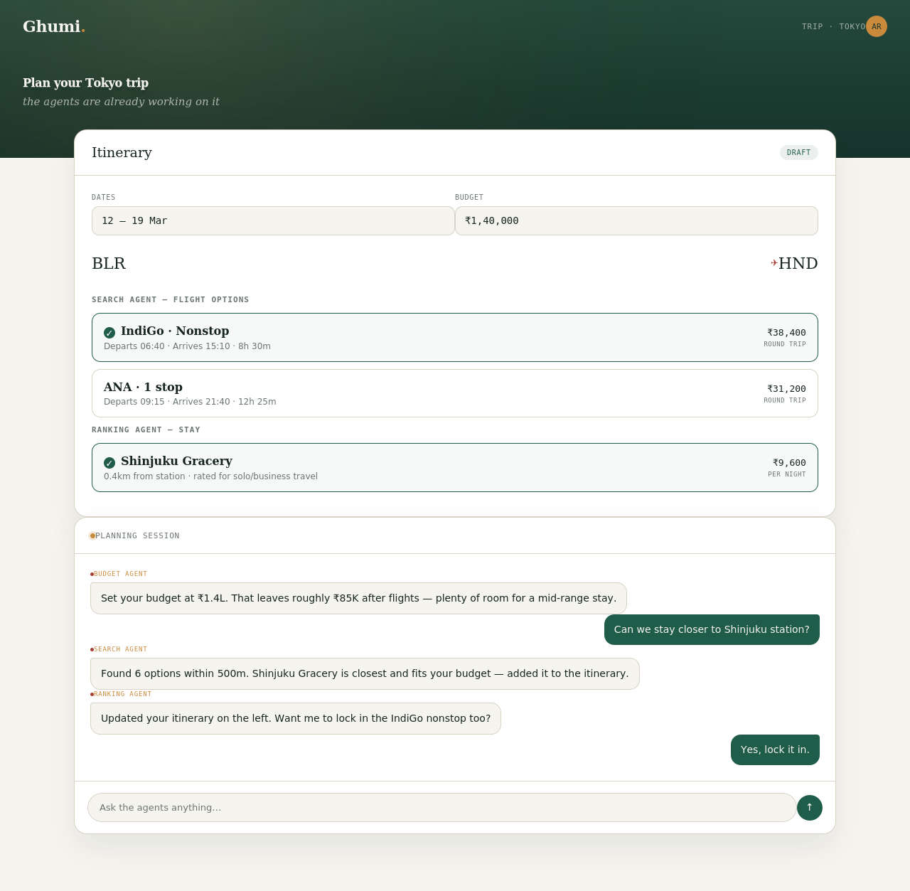
Planning page — itinerary builder (left) and agent chat (right)

8.3 404 — route not found
Dusk-background, hero-style treatment reused for an error state rather than inventing a separate error palette. The boarding-pass route line becomes the joke and the layout: "HERE to THERE" with a stranded plane mid-line, and the line fading out on the right half to signal the route breaks off. Copy stays inside the flight metaphor ("rerouted, cancelled, or never had a gate to begin with") rather than a generic 404 message.
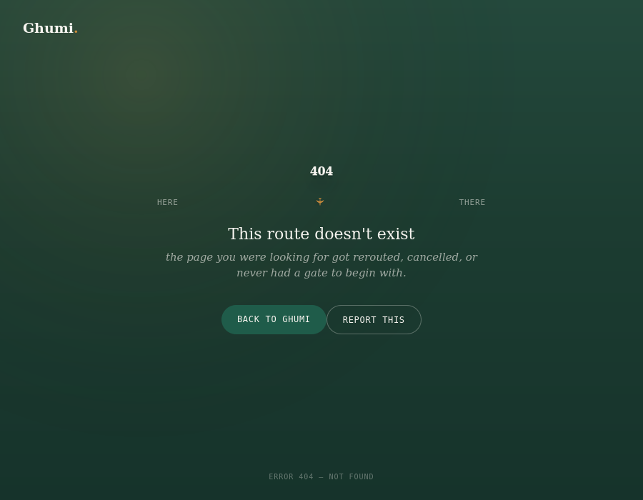
404 page — broken route with stranded plane

8.4 Trip confirmed — success state
Flat/paper mode, since this is a post-booking confirmation inside the app, not a marketing moment. Uses a fully resolved version of the boarding-pass component — dusk card, perforated notches, unbroken route line, plane mid-flight instead of stranded — as the visual payoff for completing planning. Confetti scatter is restrained and pulled only from existing tokens (brass, route, brand, muted) rather than an unrelated rainbow palette, so it doesn't introduce a fifth color story into the system.
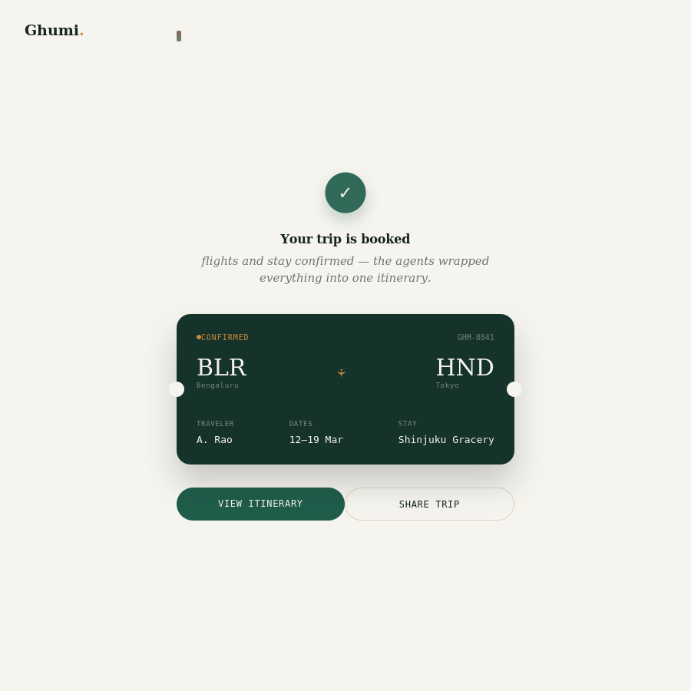
Trip confirmed — completed boarding pass with resolved route line

8.5 Guardrail addendum
Error and success states borrow their background mode from context, not from a separate rulebook: 404 uses the dusk/cinematic treatment because it's an unexpected, out-of-flow moment; success uses flat paper because it's a normal in-app state. Don't invent a third visual mode for edge-case screens.
The plane glyph is now a reusable motif alongside the dotted route line and boarding pass — it should only appear directly on or breaking off the route line (transition band, 404, success card), never as a standalone decorative icon elsewhere.

