Q2.

General Characterisation of the System and part i)

The variables of the system are:

Input (U): (T_env) Temperature of the environment

State Variable (X): (T_cop) Temperature of Copper block

Output (Y): (T_cop) Temperature of Copper block (Same as state variable)

The state space representation of a linear time-invariant (LTI) system can be modelled by,

X_dot = A * X + B * U

Y = C * X + D * U

This being a single input-single output system, all the matrices A, B, C, D are all scalars. Since our output is the same as the state variable, i.e. Y = X, comparing with the sate space equations we get,

C = 1 and D = 0

Our state space equations boil down to,

X_dot = A * X + B * U

Y = X

The block diagram for this is given by:

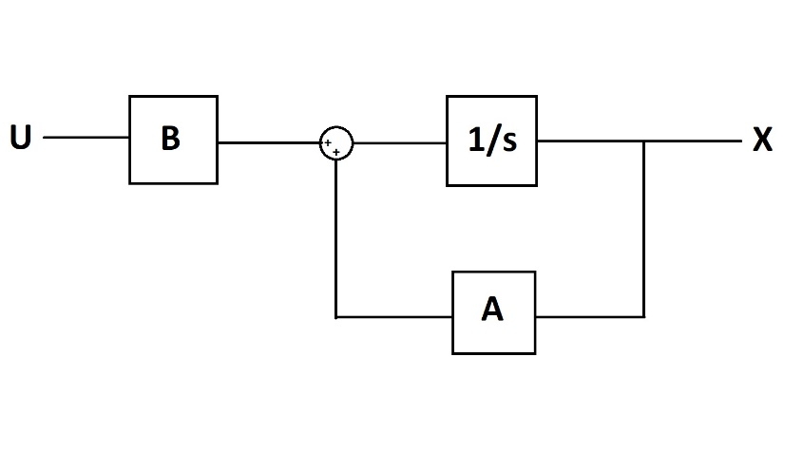

Fig1. Block Diagram for the Cu system

Due to the kryptonite coating, the block is perfectly reflective and non-conductive at the surface. Therefore all energy is conducted to and from the cube via the conducting strip alone (heat cannot escape or reach the cube via its surface)

The dimensions of the copper strap are 1m x 10^-2 m^2. Since the cross-sectional are of the strap is relatively smaller, we can make the assumption that the temperature of copper strap across its cross-section is constant. This implies that the heat flow across the cross-section of the strap is 0 and hence a temperature gradient can only exist along the length of the copper strap.   
In the problem, the temperature of the block has also been taken to be constant.

Our system will consist of copper in a temperature range ϵ [300K, 400K]. The density of copper at room temperature (300K) is 8960 kg/m^3 and at 400K is 8910 kg/m^3. Since these differ by (8960-8910)/8960 = 50/8960 = 0.558 %, we’ll assume that density is at a constant of (8960+8910)/2 = 8935 kg/m^3.

Specific Heat Capacity = (380 + 390)/2 = 385 J/kg K. [1] [2]

Considering the aforementioned model of heat transfer, the following equations are used –

1. Rate of Heat Transfer through strip:

H = \frac{T_{env} – T_{Cu}}{\frac{1}{\sigma}\frac{l}{A}}

Where: H = Rate of Heat Transfer (W)  
T_{env} = Temperature of Environment (K)  
T_{Cu} = Temperature of Cu Block (K)  
\sigma = Conductivity of Cu (W/m K)  
l,A = Dimensions of Cu Strip (m, m^2)

2. Change in Temperature of block due to incoming Heat energy

\Delta E = mC \Delta T_{Cu}

Where: \Delta E = Heat Energy (incoming +ive, outgoing -ive)  
m = Mass of Cu Block  
C = Specific Heat Capacity  
\Delta T_{Cu} = Change in Temperature of Cu block

Considering m and C to be constant over time (and independent of change in Temperature)

= ……..*

\frac{dE}{dt} = mC\frac{dT_{Cu}}(dt} = \sigma\frac{A(T_{env} – T_{Cu}}{l}

In State Space Representation –

T_{cu}dot = -AT_{Cu} + AT_{env}  
where – A = \frac{\sigma A}{mCl} ……**

Part ii) and iii) – Control Package and Simulation

Following is a snippet of the code –

1. Representing the above equation in the State-Space using the python Control library
2. Plotting the output for the given condition: T_{env} = 300 K, T_{Cu} = 400 K

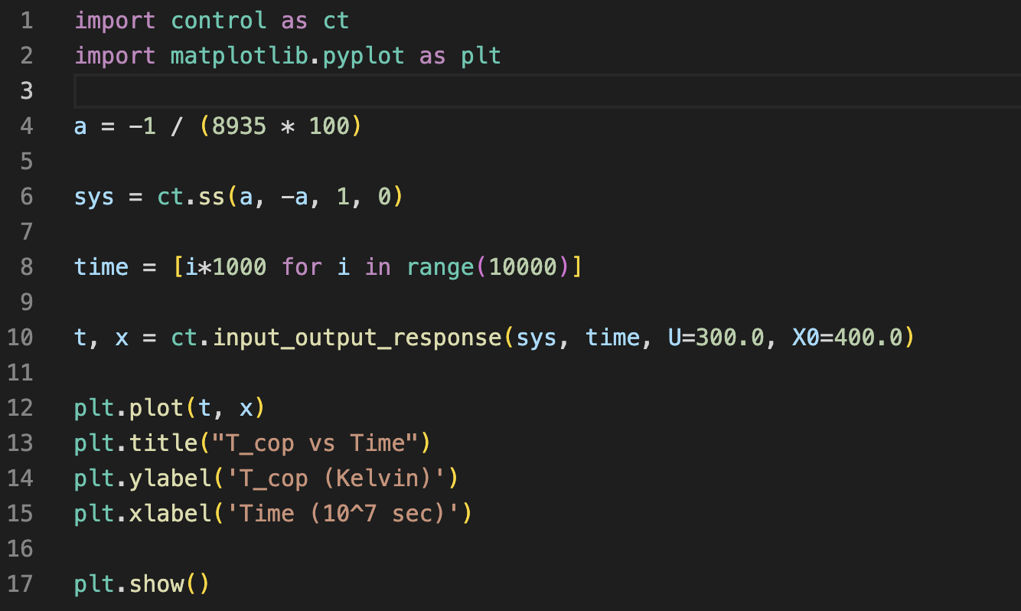

Fig2. Code Snippet for part ii) and iii)

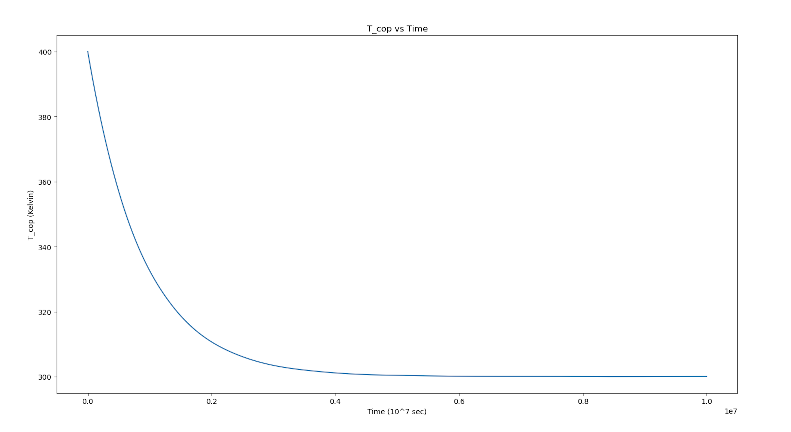

Fig3. Plot of T_{Cu} vs Time

Intuitively, we expect this since the rate of Temperature change is proportional to the difference in Temperature between the block and environment. Therefore, the smaller the temperature difference becomes, slower the rate of Temperature change   
Also note, as expected from the equation (*), the plot of Temperature of the block vs Time shows exponential behaviour.

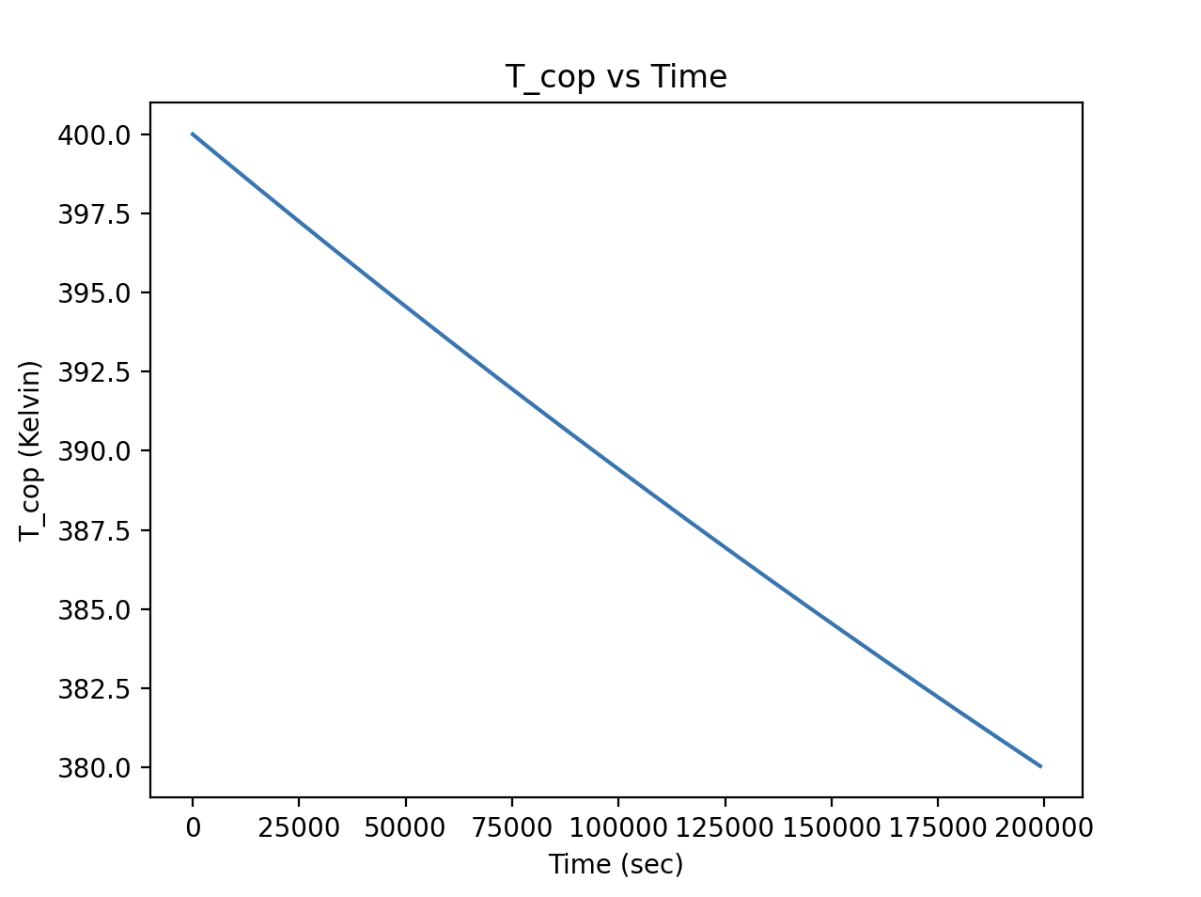

Fig4. A section of the above plot for a smaller \Delta T_{Cu}

In the above plot, we can observe that for small A \Delta T (A as per equation **) (or consequently a small change in Temperature) the plot appears linear.   
This can also be expected by approximating the differentials to \Delta ‘s in the original state equation (as expected this would be valid only for small changes in Temperature of Block i.e small time durations)

iv) Introducing Gaussian Noise

Following is a snippet of the code for the following conditions –

1. T_{env} = 300 K + Gaussian Noise
2. T_{Cu} = 300 K

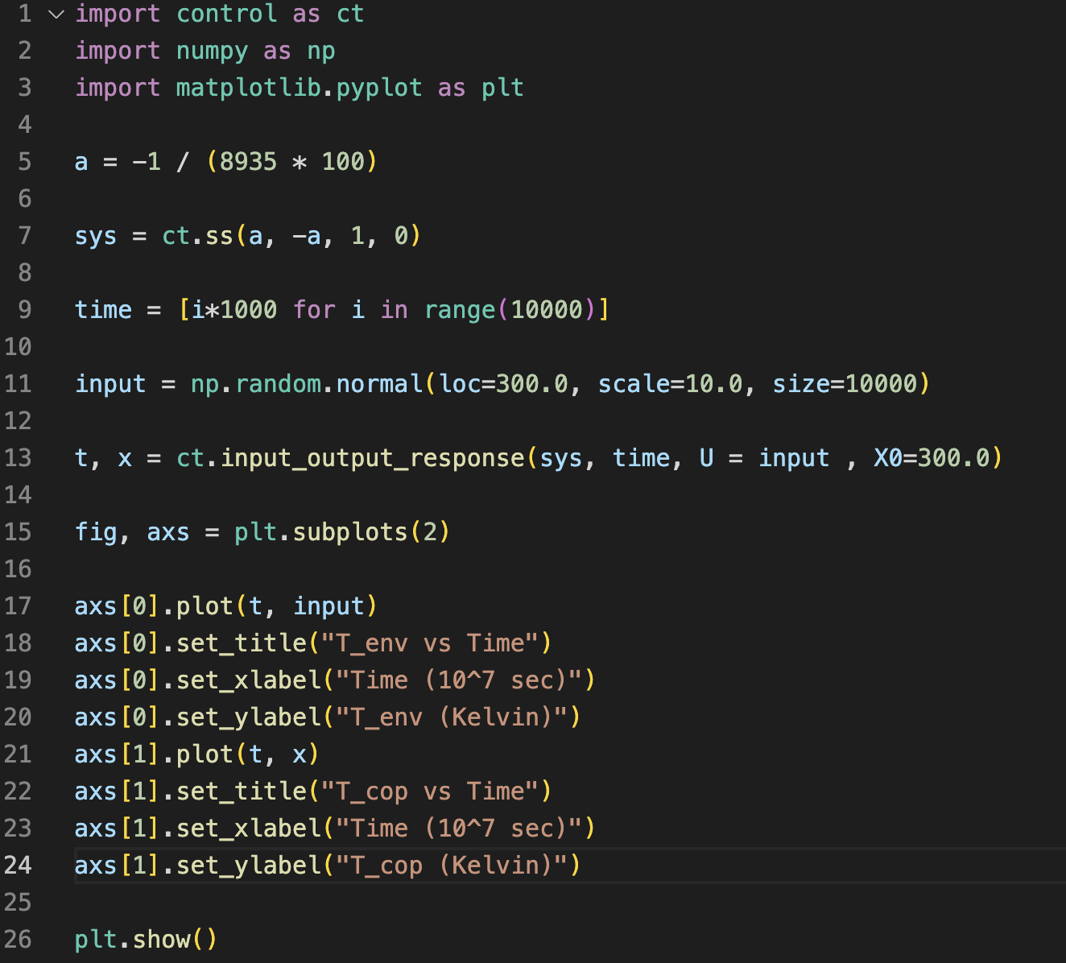

Fig5. Code for part iv)

Sidenote:  
 The input_output_response function takes the following arguments:

1. sys = Defined system of block and strip in state space
2. T = Time array,
3. U = input (an array where each element represents the input at a given time step or a float (constant input))
4. X0 = initial condition

The function by default uses RK45 to numerically solve the given differential equation and plot the output

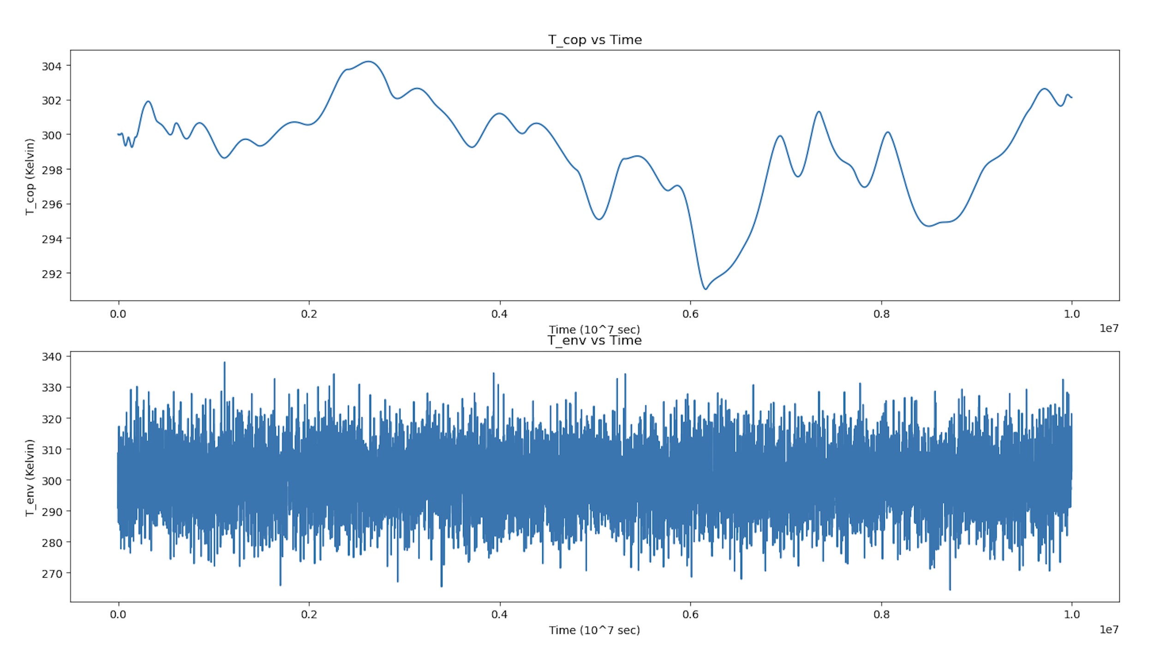

Fig6. Subplots  
 a) T_{Cu} vs time  
b) Input Gaussian Noise vs Time

From the above plot, we see that the Copper Block shows significantly reduced response to the rapidly fluctuating Gaussian Noise. This can be intuited from the fact that the rate of change of Temp is proportional to the difference in Temp between the block and the environment (which is relatively small). Thus, for systems that are sensitive to temperature fluctuations, the above setup can be used as the Temperature source instead of the environment.  
If possible, we can attempt to cascade the above setup, further reducing the fluctuations in Temperature.

References:

[1] Investigations of temperature dependences of electrical resistivity and specific heat capacity of metal - <https://www.sciencedirect.com/science/article/pii/S0921452616301090>

[2] Heat Capacity of Reference Materials: Cu and W - <https://srd.nist.gov/JPCRD/jpcrd263.pdf>

From the results of the papers, we can observe that heat capacity of copper starts saturating near 300K and doesn’t change much from 300-400K. Hence, we take the specific heat of copper to be a constant of 385 J/Kg K