An attempt to measure the viscosity of silly putty using experiments which rely on low viscosity such as Stokes law (F = 6pi*nrv) seem to fail due the high viscosity of silly putty even at zero external stress and strain. [1]

Trying to measure certain solid properties of silly putty will lead to problems due to the it flowing under its own weight. This can be solved by filling the silly putty in a very flimsy balloon so as to conserve its shape to an extent. Care must be taken while filling the silly putty ensuring that it fits snug but not so tight that the balloon exerts a compressive force on the putty.

Shear Stress vs Strain Rate:

Consider a setup with two horizontal plates separated by a distance ‘y’ with silly putty between them. One of the plates is fixed to the ground while the other just rests on top of the material. A mass m is connected to the top plate via a pulley so there is a constant external force (F=mg) acting on it. We measure the displacement of the top plate in the direction of force to find out the instantaneous velocity at each instant. We repeat this experiment for different masses to find the relaxation time of the material. By plugging these values in the viscosity equation for shear-thickening fluids we can calculate various mechanical properties of our silly putty material, like, the time dependence of viscosity, Modulus, etc.

Power-law for viscosity states that 𝝶=K𝞬^(n-1)

Where K is a material-based constant. Silly putty, which is a dilatant fluid, has a characteristic n~ 7 at low strain rates, between 10^-4 and 10^-2 s^-1, but at high strain rates, over 1 s-1, the rheological behavior is approximately linearly viscous [2][3]

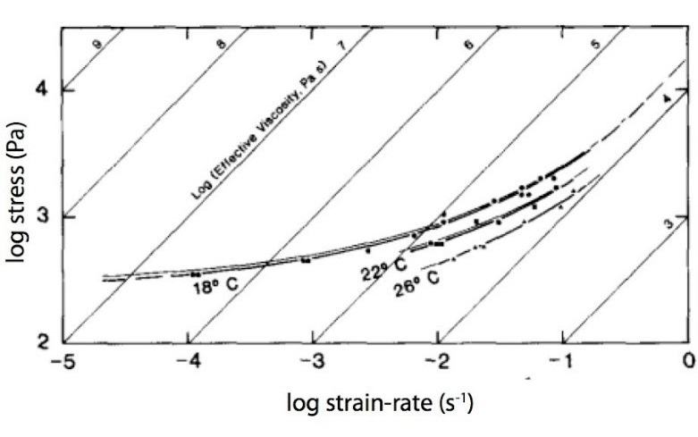

To measure this behavior, we can construct the following setup:

Consider a viscometer-like setup with two coaxial cylinders and the silly putty in the middle. We connect a precise motor to the inner cylinder whose torque can be manually controlled. But instead of the traditional way of maintaining the rotation speed of the motor by current, we maintain the torque and calculate the dependence on viscosity and angular velocity. Thus, by some simple calculations, we obtain the plots of

1. Viscosity vs time for different values of applied torque
2. Angular velocity vs time
3. Relaxation time vs Torque

Most of the mechanical properties of the material can be deduced from these plots.

Spring Constant:

We would need to fill the putty inside the balloon as mentioned above in order measure any effect on oscillations. Based on my intuition, measuring changes from a known oscillation will be easier and more sensitive than measuring the small oscillations due to the silly putty itself.

Hence we will utilise a spring of known spring constant and connect the silly putty balloon in parallel with it. We will now attach a bob of known mass and give a small displacement to it. The time period of oscillation of the bob can be measured and used to derive the effective spring constant of the system.

Using the formula for springs in parallel,

1/k + 1/k’ = 1/k_eq

we can compute the spring constant of the spring.

Impulse required to Break the silly putty:

Upon providing a high enough impulse, the silly putty will break apart. The impulse required to break the silly putty would be inversely related to its size. A

References:

[1] Cross, Rod. (2012). Elastic and viscous properties of Silly Putty. American Journal of Physics. 80. 870-875. 10.1119/1.4732086.

[2] Dixon JM and Summers JM (1985) Recent developments in centrifuge modelling of tectonic processes: equipment, model construction techniques and rheology of model materials. Journal of Structural Geology 7: 83 – 102

[3] Dixon JM and Summers JM (1986) Another word on the rheology of silicone putty: Bingham. Journal of Structural Geology 8: 593 – 595