Effective Management for Blockchain-Based Agri-Food Supply Chains Using Deep Reinforcement Learning

In Agri-Food supply chains there will be two users such as customers who wants to know quality of the product and farmers who wants to maximize their profit by effective management of production details and both this task traceability face huge challenges, for example all supply and food manufacturing and quality details stored at centralized single server and some malicious users (internal employees) can collect bribes from cheap quality manufacturer to make their product details (fake) as super quality and update centralized server and normal customers will view such fake quality details and trust blindly as there is no one to inform customer about its true quality.

Second challenge is how farmers can maximize their profit by efficiently managing their production as there is no one to inform farmers when to sale and when to start production. To overcome from above two challenges author of this paper introduce concept called DR-SCM (Deep Reinforcement learning based Supply Chain Management) which utilizes two different technologies such as Blockchain and Deep Reinforcement learning.

Blockchain: this is decentralized (store data at multiple nodes not in single centralized node) server which maintains product details as block of transaction and each block will generate hash code for product details and maintain this block and its hash code at multiple nodes (decentralized). Before storing any new transaction, Blockchain will verify all existing hash codes of all nodes and if block data not alter then all nodes hash code verification will be successful and new transaction will be stored and if verification failed at any node then Blockchain will consider that node as attacked and instruct it to get recovered with genuine blocks. This process is known as PROOF of Work and by using this techniques we can assured customers will get genuine details on product.

Various users may store or view product details in Blockchain such as Seed Providers, Farmers, Processors, Distributors, Retailers and consumers.

Deep Reinforcement learning: This is a deep learning algorithm which works as human brain and human brain will take decisions by considering 3 operations

1. Environment: environment is the working area which contains Agent and State
2. Agent: Agent is consider as action and this action will be performed based on state
3. State: refers to current scenario

Example: while watching TV humans will perform or take action based on state and environment

TV is the environment and remote or human is the action and running program on TV is the state and if human think current running program is not good then he will take action/decision to change program/channel and this action/decision may continue till he find good program and get rewards

In deep learning DRL (deep reinforcement) will work in similar manner where Production area is the environment and current STOCK quantity is the state and if quantity not sufficient then action/decision will be predicted to START PRODUCING STOCK and if sufficient quantity available then action will be predicted for SALE.

So DRL will inform farmer when to PRODUCE stock and when to SALE.

In this project they have designed above two techniques as simulation so we also implemented this project as simulation and this project consists of following modules

1. Save ASC Details in Blockchain: using this module we will take product details from users such as farmers, providers, and processors and then store all this details in Blockchain and will Blockchain will store this data as blocks of transaction and for each block it will generate hash code and verified with previous block hash code.
2. Get ASC Details from Blockchain: using this module all users can read or extract details from Blockchain
3. Deep Reinforcement Learning Simulation: using this module we will feed current agriculture stock data to DRL algorithm and then this algorithm will trained itself on available stock and then predict STOCK manufacturing or SALE to farmer
4. Rewards Graph: for each correct prediction DRL will rewards to its decision and for each wrong prediction DRL will get 0 or penalty deduction and the higher the reward the correct is the prediction. In DRL we will take current stock quantity as STATE and producing or selling STOCK will be action.
5. Blockchain Computation Graph: using this module we will plot Blockchain hash computation time graph
6. Get All Blockchain Products ID: using this module we can get all product ID’s stored in Blockchain.

We are using below current stock data to TRAIN DRL algorithm

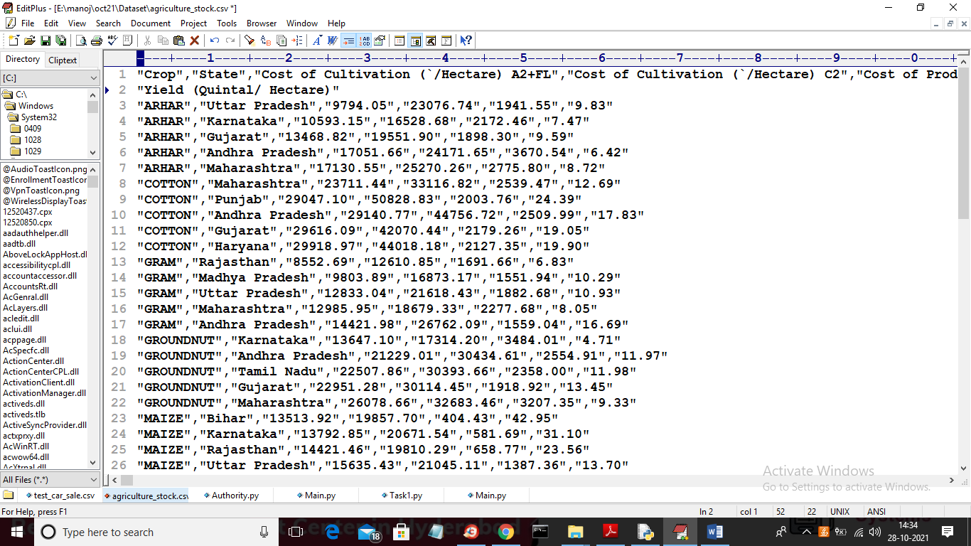

In above screen we are taking last column values as quantity (Yield (Quintal/ Hectare). Below is the Blockchain code use to calculate PROOF of WORK

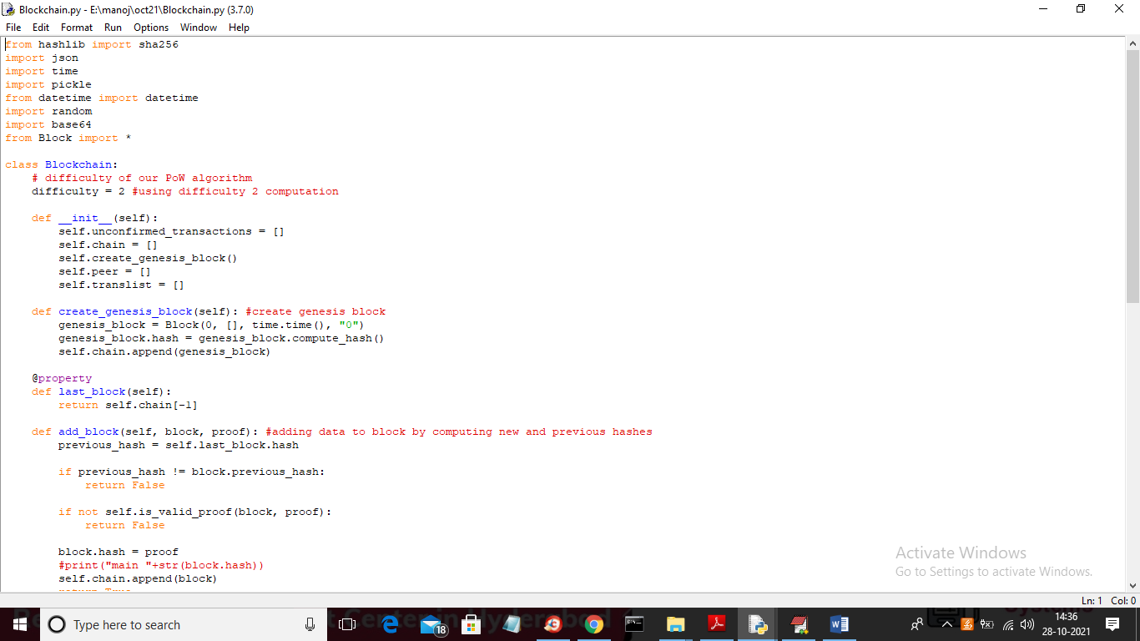

In above screen read red colour comments to know about Blockchain transaction storage

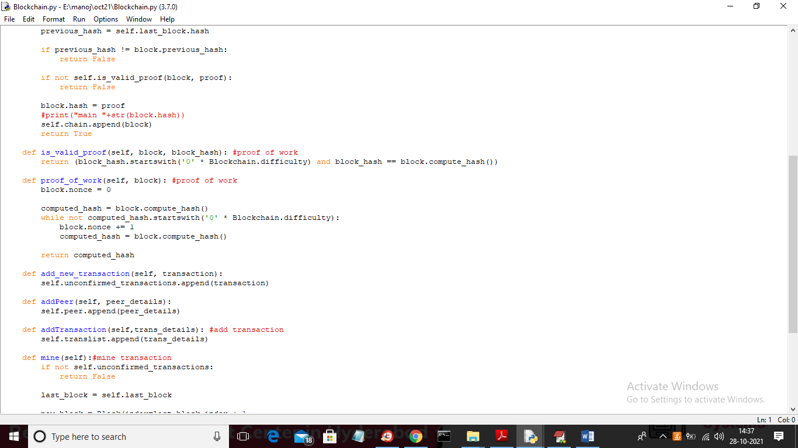

SCREEN SHOTS

To run project double click on ‘run.bat’ file to get below screen

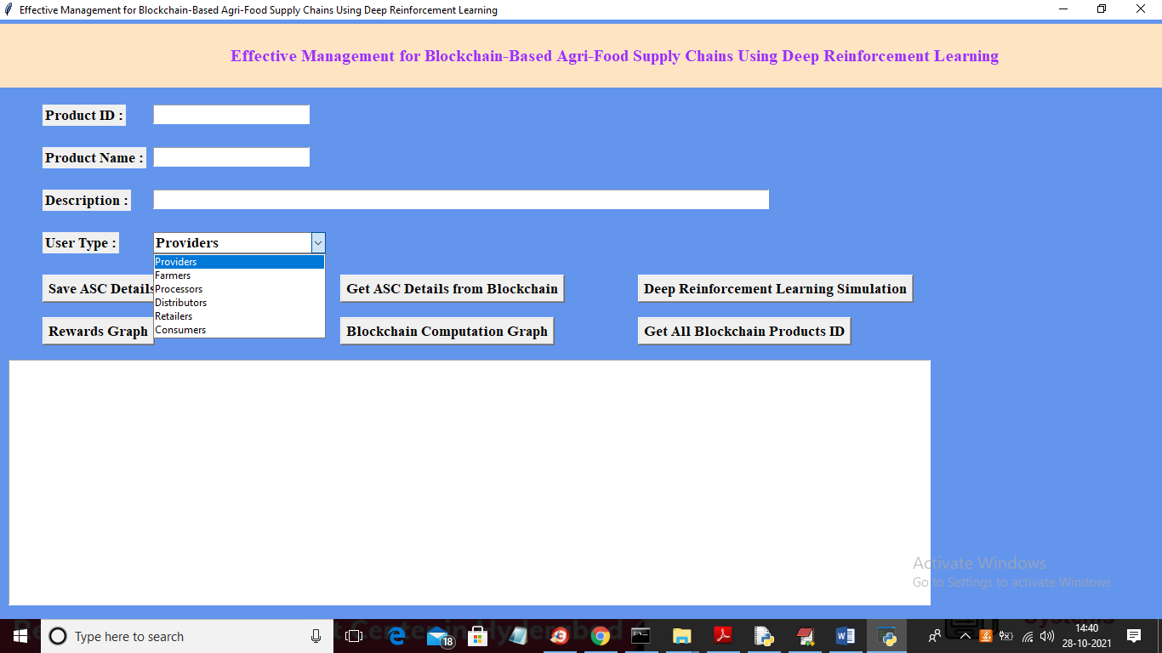

In above screen different users can add their product details and each details will be stored in Blockchain and in above screen enter some details

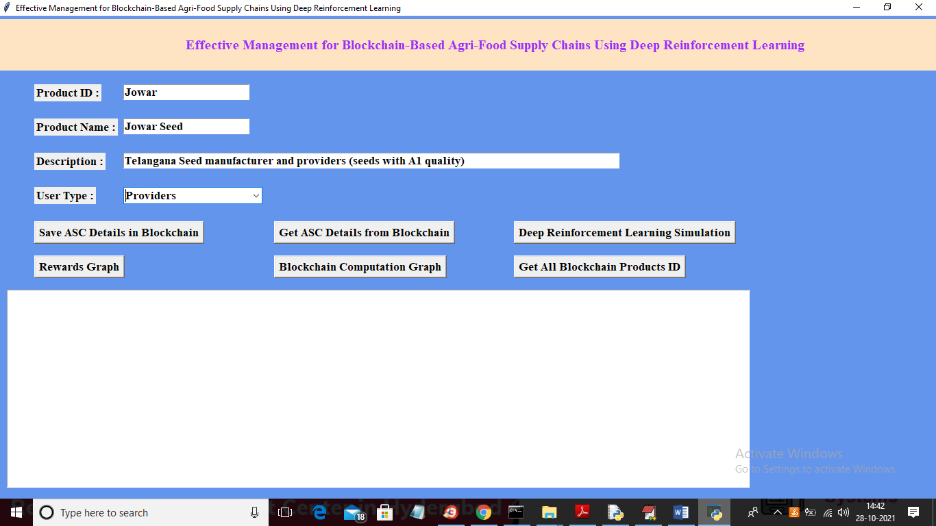

In above screen I entered some product details and then select user type and press ‘Save ASC Details in Blockchain’ button to store data in Blockchain

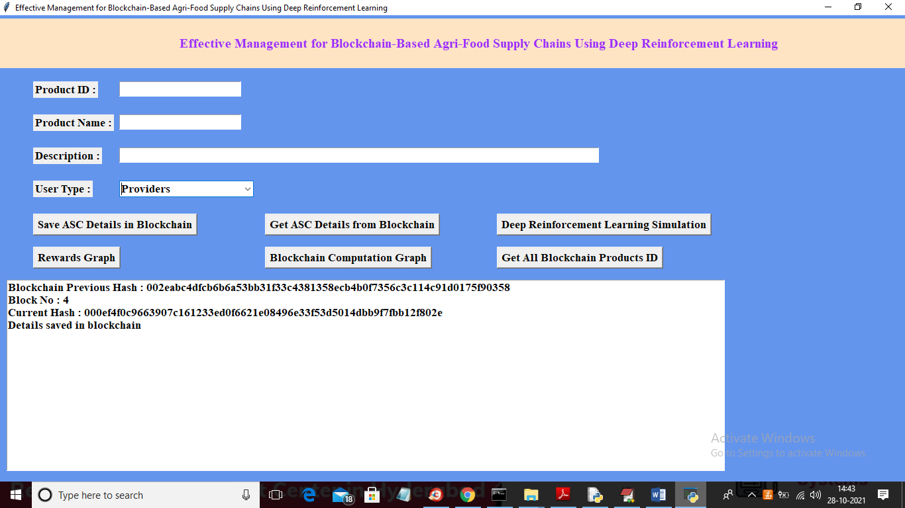

In above screen we can see Hash codes generated for current transaction and we got old block hash code also with current block no. Similarly any user can add their product details and now click on ‘Deep Reinforcement Learning Simulation’ button to predict stock quantity

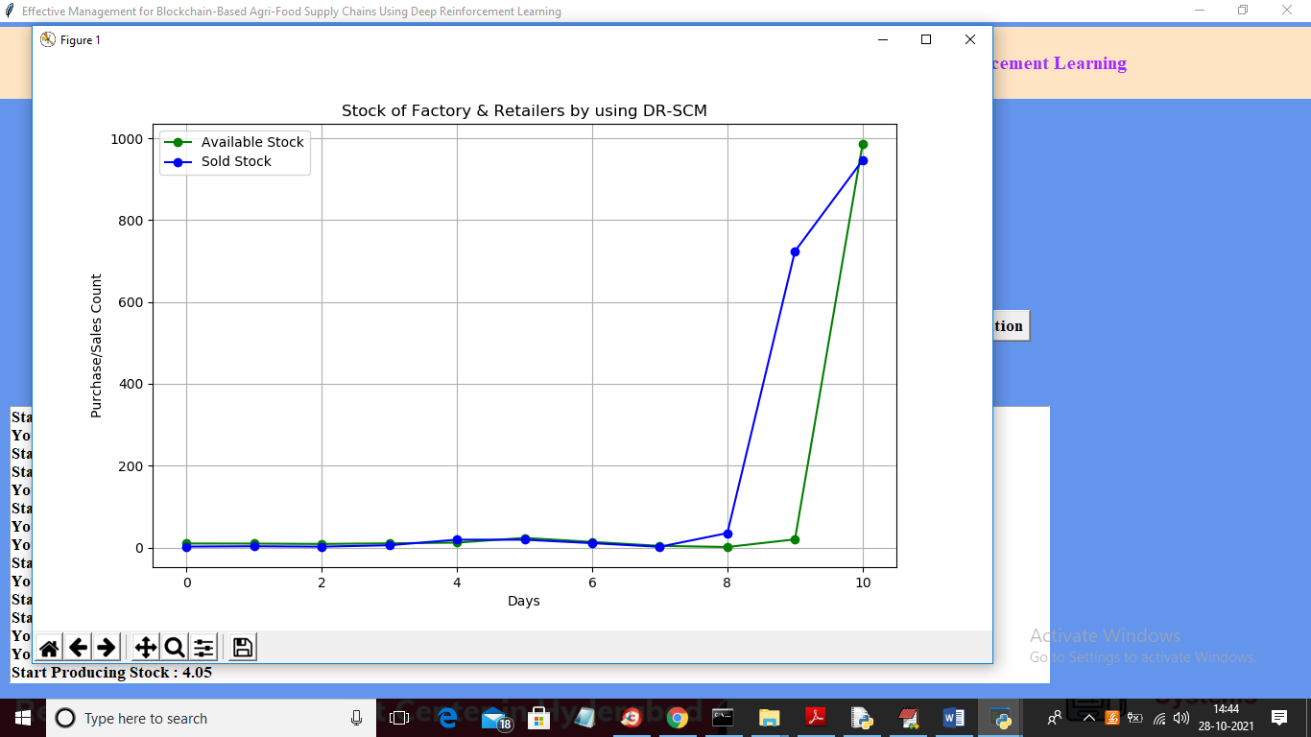

In above graph we can see DR-SCM stock prediction where green line represents available stock and blue line represents sold stock and based on above stock graph Framer will go for stock manufacturing and below screen will give complete details on prediction. In above graph x-axis represents number of days and y-axis represents stock quantity

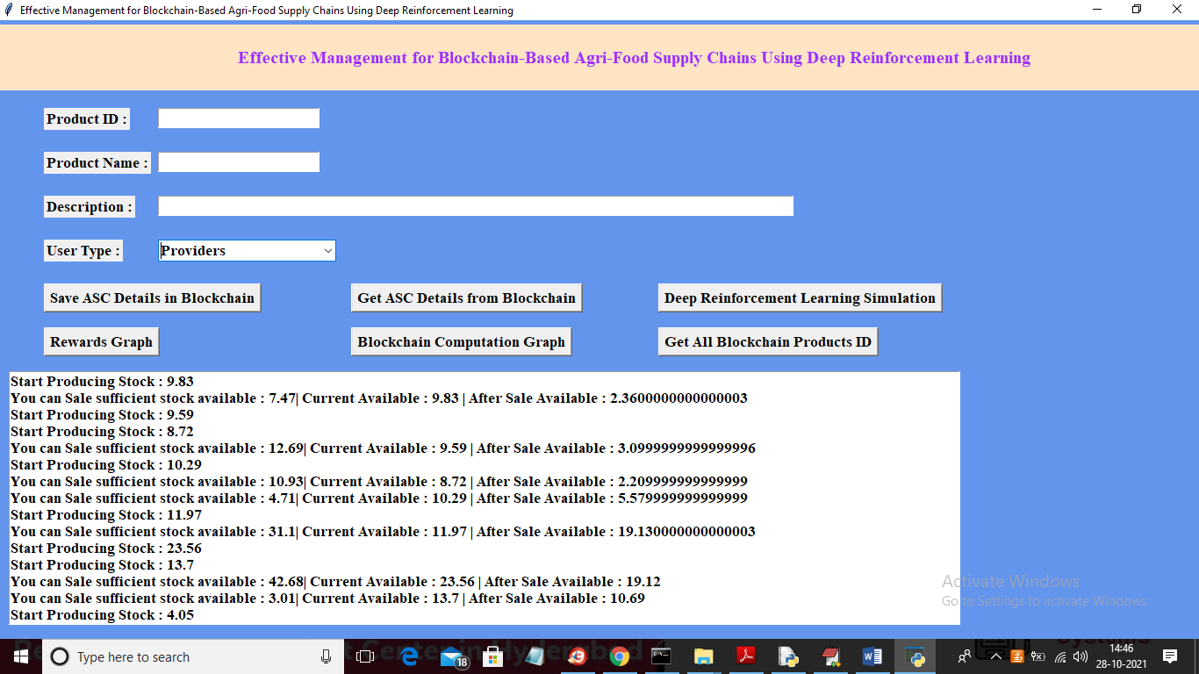

In above screen for next 10 days DRL has given prediction for ‘start producing stock’ or ‘sale stock’ and if available stock less than sale stock then it’s wrong prediction and in above screen we can see more number of times algorithm has predicted correctly. Now click on ‘Rewards Graph’ to get below graph

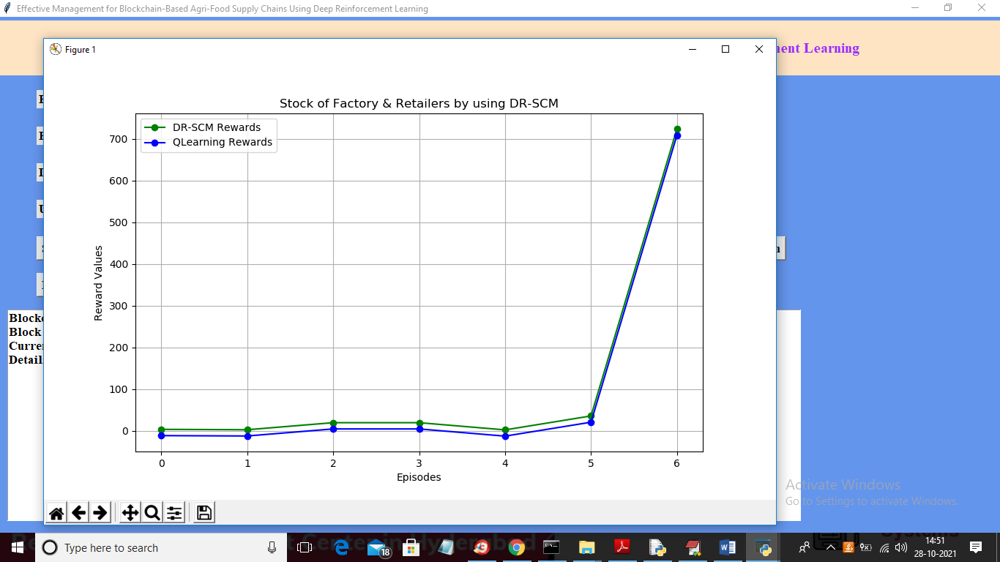

In above graph we can see DR-SCM and QLearning rewards where x-axis represents EPISODES/iteration and y-axis represents rewards and if algorithm predict correctly then its reward values will increase else decrease. In above graph green line represents DR-SCM rewards and blue line represents QLearning and in above graph we can see DR-SCM got more rewards values. Now click on ‘Blockchain Computation Graph’ button to get below Blockchain hash computation graph

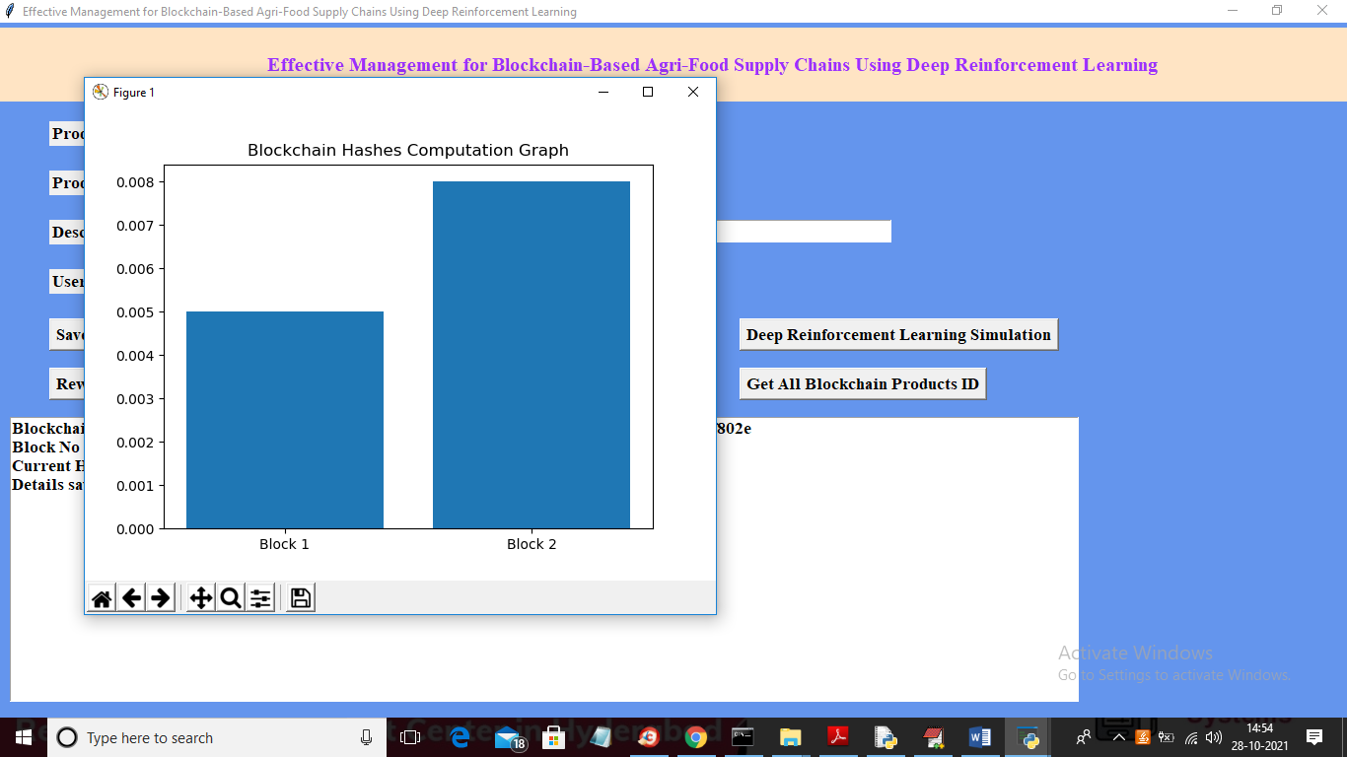

In above graph x-axis represents block numbers and y-axis represents block hash computation time and for each block storage will get computation time value. Now click on ‘Get All Blockchain Products ID’ button to get all product ID’s from Blockchain

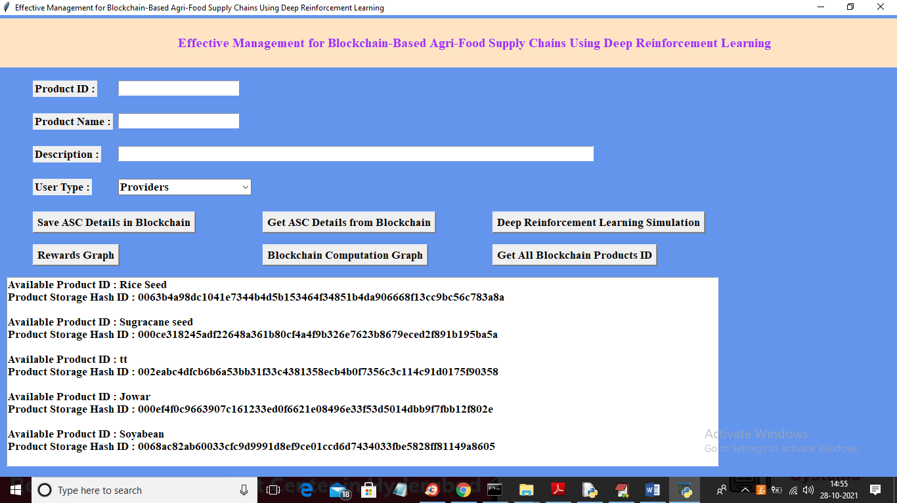

In above screen we can see names of each product ID and its block hash code and now enter any product id in first text field and then click on ‘Get ASC Details from Blockchain’ button to get all details of that product ID

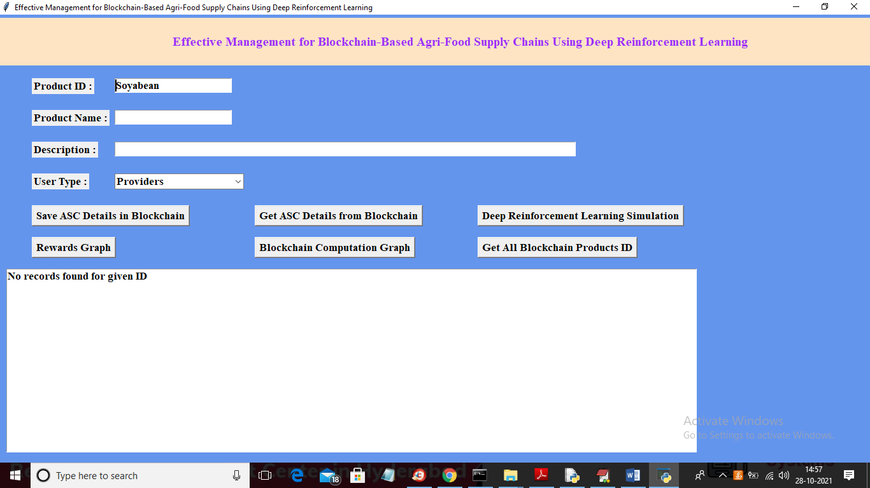

In above screen I entered some product id in text field and now click on ‘Get ASC Details from Blockchain’ button to get below output

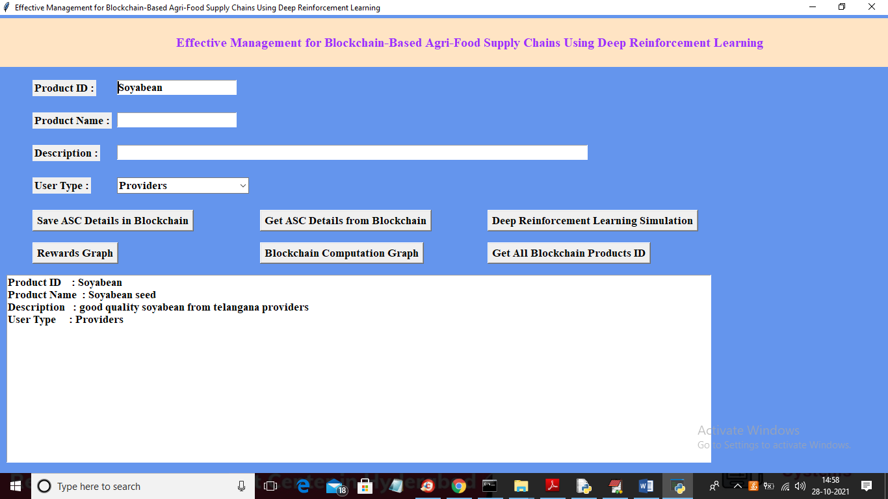

In above screen for given product ID we got details from Blockchain and similarly you can get details for all products you stored