Extension Concept

In this paper author is asking to include advance Reinforcement algorithm to achieve optimal performance and in below screen you can read that extension concept given in paper

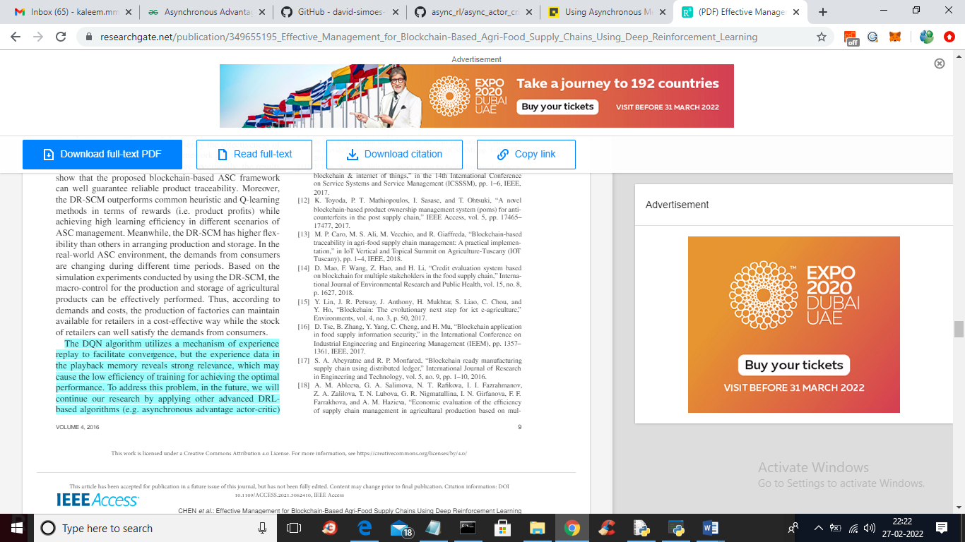

In above screen read light blue colour selected text where author is saying to include asynchronous actor critic which uses multi agent instead of single agent. Multi agent will keep getting knowledge from training model and get optimize performance. It’s similar to human where multiple peoples gain knowledge and then apply that knowledge to get better result.

Asynchronous: Unlike other popular Deep Reinforcement Learning algorithms like Deep Q-Learning which uses a single agent and a single environment, this algorithm uses multiple agents with each agent having its own network parameters and a copy of the environment. This agents interact with their respective environments Asynchronously, learning with each interaction. Each agent is controlled by a global network. As each agent gains more knowledge, it contributes to the total knowledge of the global network. The presence of a global network allows each agent to have more diversified training data. This setup mimics the real-life environment in which humans live as each human gains knowledge from the experiences of some other human thus allowing the whole “global network” to be better.

Now in extension we are adding asynchronous multi agent which keep learning from model to get more rewards which will help in getting optimize performance

In propose work we used single agent and in extension we used multi agent which will help in getting more rewards values.

SCREEN SHOTS

To run project double click on ‘run.bat’ file to get below screen

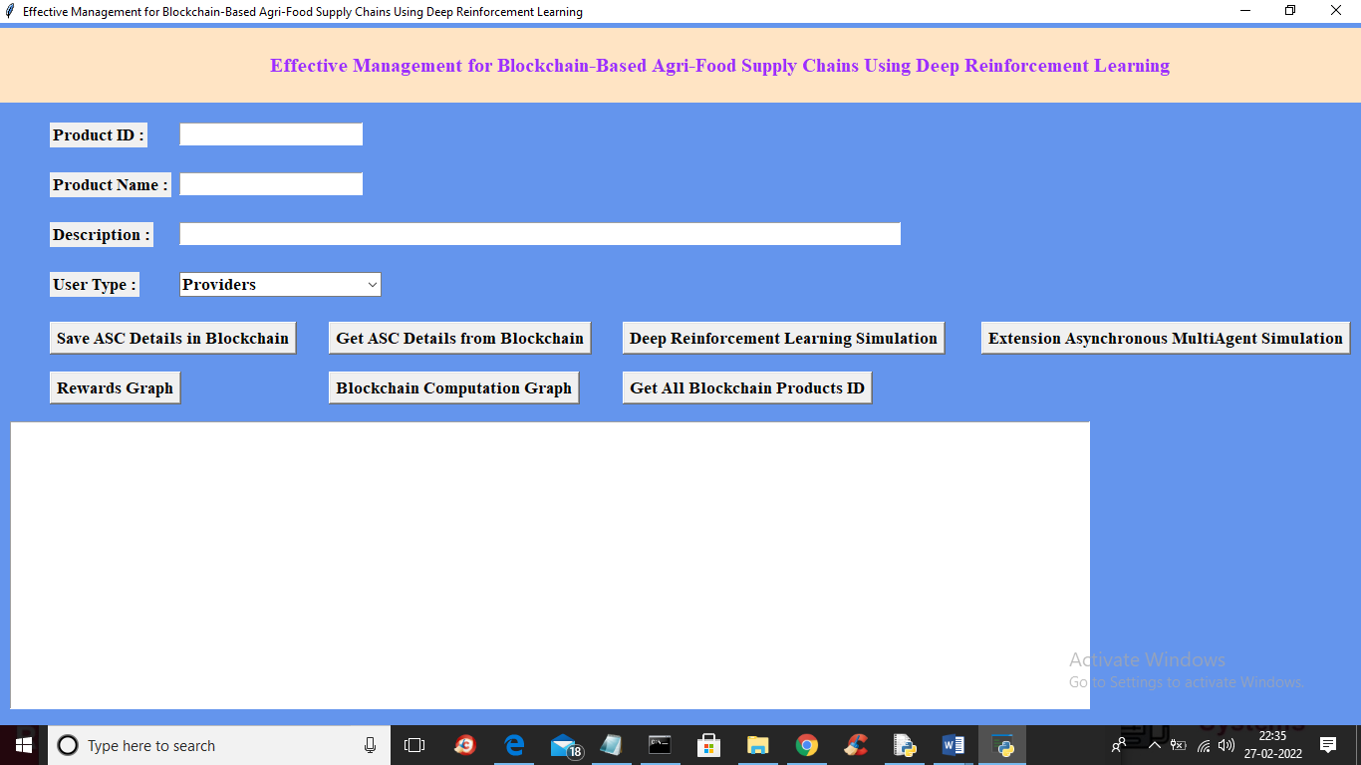

In above screen to run extension concept first double click on ‘Deep Reinforcement Learning Simulation’ button to train model with single agent and get below output

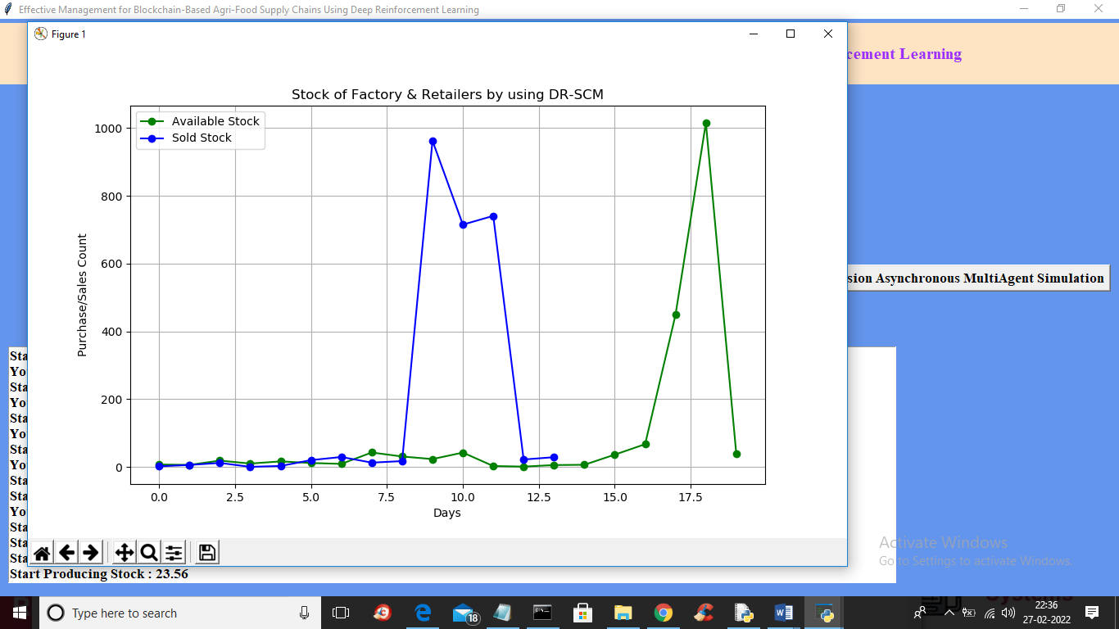

In above screen we got sold and available stock details with single agent and now click on ‘Extension Asynchronous MultiAgent Simulation’ button to train model with multi agent and get below output

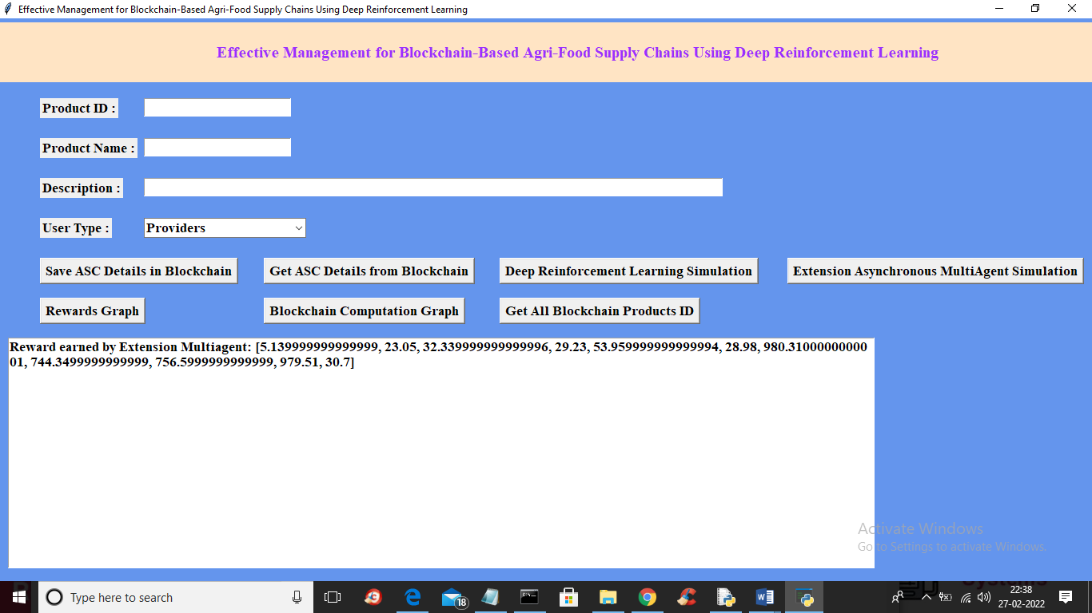

In above screen we can see rewards earned by multi agent to get optimize performance and to get this output it may take some seconds of time as multi agent will keep learning from model to get better performance and now click on ‘Rewards Graph’ button to get below output

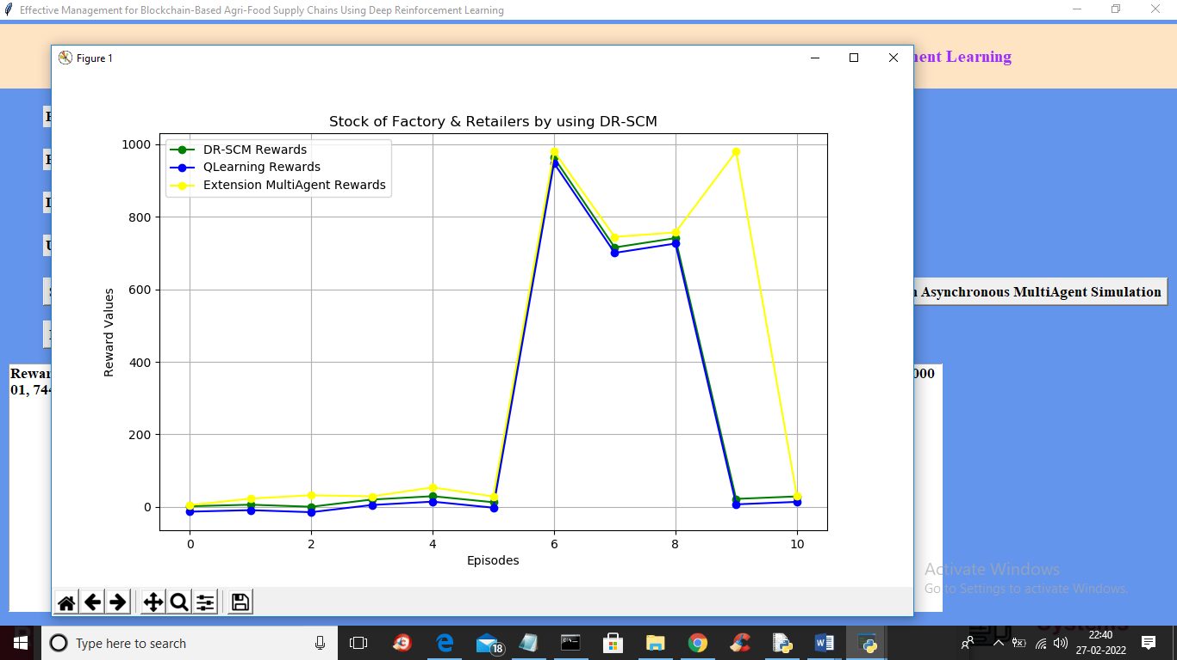

In above graph blue line represents existing QLearning model and green line represents propose DR-SCM algorithm and yellow line represents multi agent learning and in all algorithms extension multi agent got more rewards. In above graph x-axis represents training episodes/epoch and y-axis represents total earned by those algorithms