Loops:

For implementation of any task repeatedly we can use loop.

For loop

While loop

Do while Loop

For Each(Enhanced For Loop)

for(intilisation;condition;update)

{

//body

}

For Loop flow

Do -while loop body will get executed at least once. Since it performs the operations and checks the condition.

In case of for and While loop first condition check will happen then only body will get executed.

Infinite loop

Initially \*\*\*\*\* has been printed using one loop.

The Same pattern has to be repeated 5 times and print in new line.

We can use another loop to repat the pattern in the new line.

For every Pattern make sure you write the indexing then it will be easy to write the conditions

In the below format.

/\*

00 01 02 03

10 11 12 13

20 21 22 23

30 31 32 33

\*/

Like this if we write it will easy for writing the code.

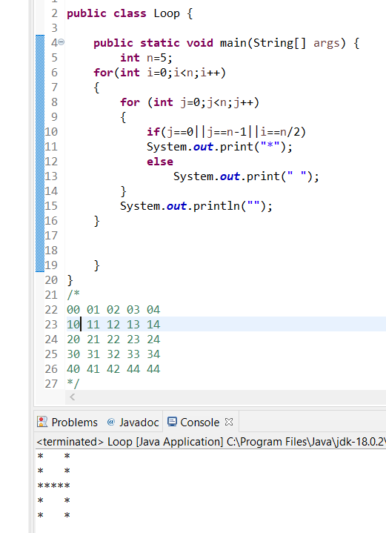

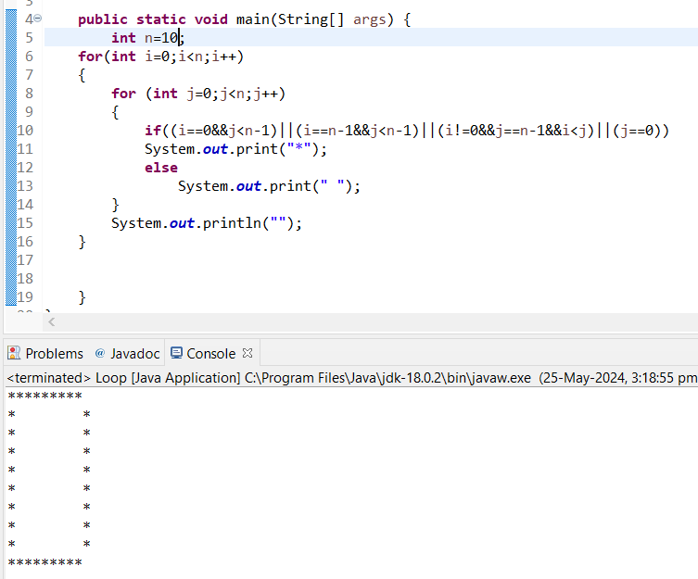

Code Snippets:

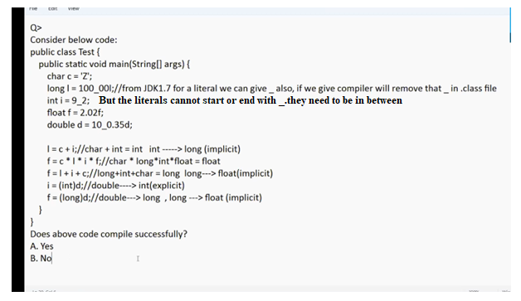

Yes

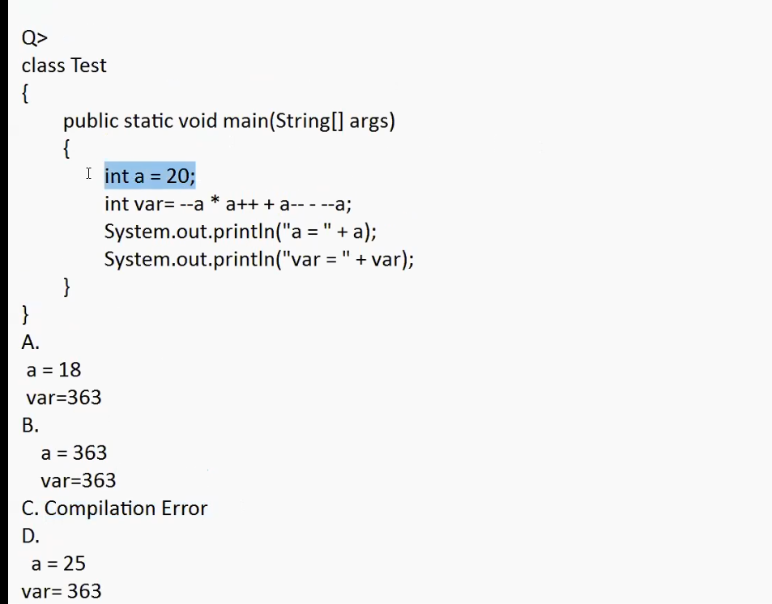

--a \* a++ + a-- - --a //19\*19+20-18=363

a=18

var=363

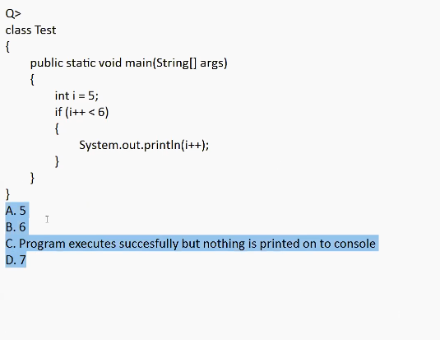

//5<6—true

Ans:6

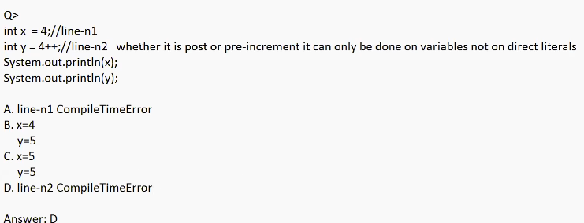

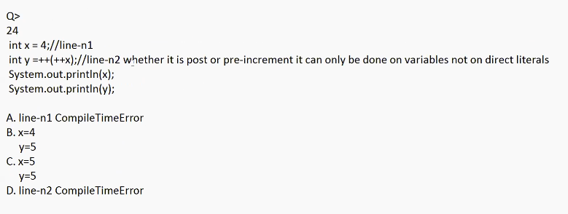

JVM (++x) will return literal and we cannot perform pre/post increment directly on literals.

D.

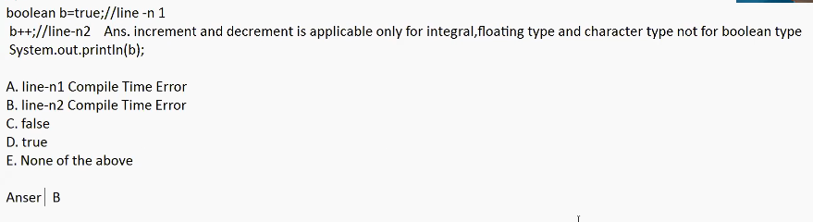

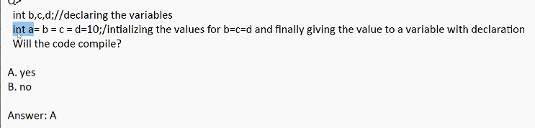

Answer : B

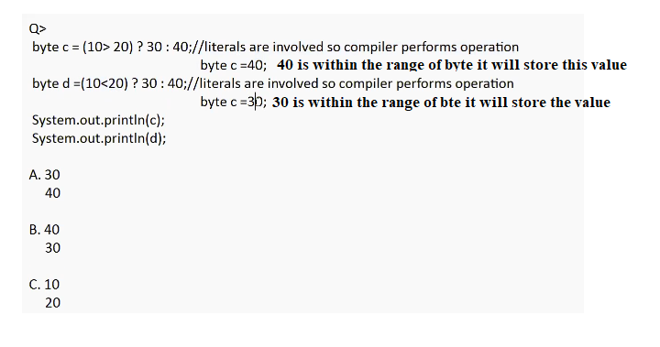

Answer : 40

30

When literals are involved Compiler will perform Operations



