Guesser Game Project:

We will Guesser who tells some number and tells the Umpire and there will Players who needs to tell what is number guessed by Guesser

In the above case we have 3 Objects:

Guesser

Umpire

Players

These Objects will have has part and does part:

In the given Scenario:

We need to determine the has and does part for each.

Guesser:

Has---Need to store number guessed

Does : return the Guess the number

Umpire :

Has— Store the Number guessed by Guesser.

Store the Number guessed by P1.

Store the Number guessed by P2.

Store the Number guessed by P3.

Does:

Get the number from Gusser,players

Compare them and return the Winner.

Player:

Has: Store the Number Guessed

Does: Return the Guessed Number.

Gusser Game Code :

<https://onlinegdb.com/4IAv1Yp3v>

int --Primitive Data type,Reserve Keywords

String -- It is Class Name,String is basically an inbuilt class for which Object can be created.

It is present in java.lang package

String:

Collection of Characters.

Ex:"Chinmay"

We can create the String in any of the below formats:

String s1=”Chinmay”

String s2-new String(“Chinmay”);

We can create the String using new and without new.

String type of data can be categorized into two types:

Mutable - Once create that value can be changed

StringBuffer

StringBuilder(1.5v)

Immutable –Once create that value cannot be changed

We can do it using String Class.

String s1=” Sachin” //It will be Immutable. Strings will be immutable. So, we will not be able to modify.

Memory Map for the above:

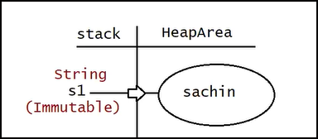

“Sachin” --String object will get created in Heap Memory

S1 reference will be stored in the stack area.

String s1=”Sachin”;

S1.concat(“Tendulkar”);

System.out.println(s1);

The above s1. concat will create a new Object in Heap area in the below way.

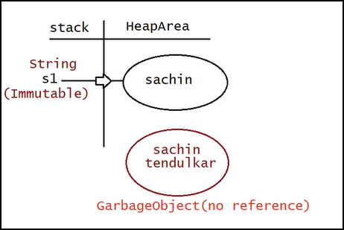

But the object will not have any reference so it will be removed by the Garbage Collector.

So when we print the s1 it will have only Sachin .

<https://onlinegdb.com/gVJXyplpe>

If we want the String to be Mutable then:

StringBuilder s1=new StringBuilder(“Sachin”);

s1.append(“Tendulkar”);

System.out.println(s1)

<https://onlinegdb.com/uFx8npCr1>

Memory Map :

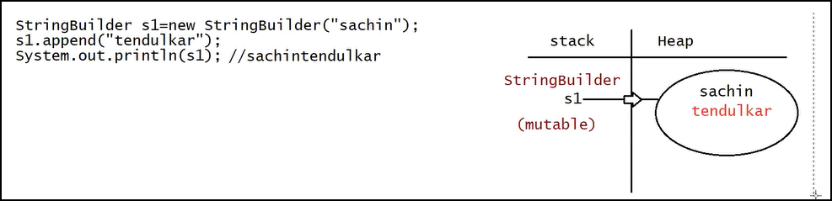

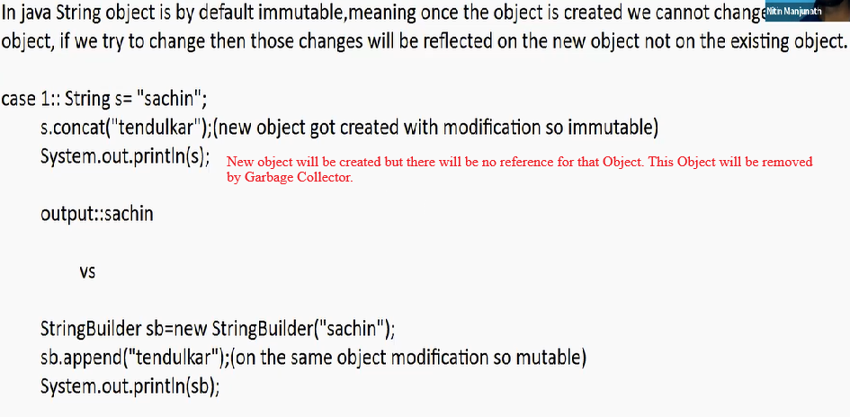

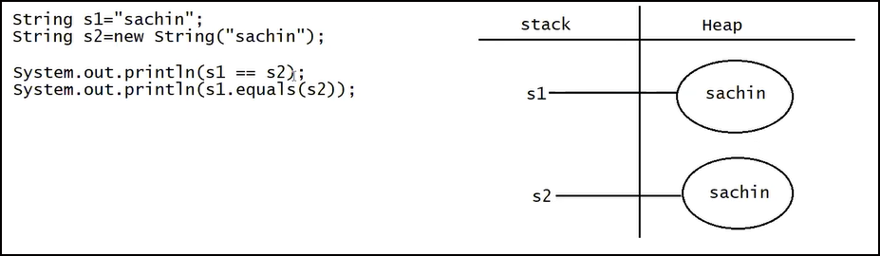

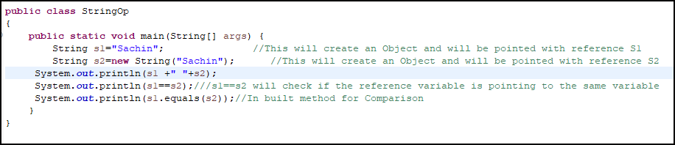

String Class equals method will compare contents of the Object.

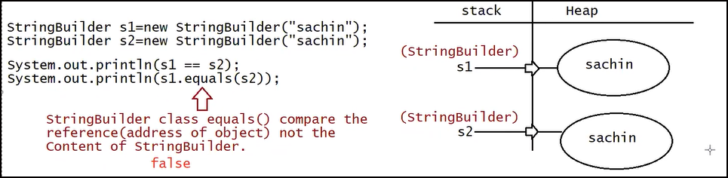

<https://onlinegdb.com/tF2D5CqbT>

