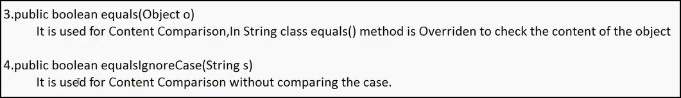

String s2="java";

System.out.println(s2.equals("Java")); //false

System.out.println(s2.equalsIgnoreCase("Java")); //true

For Example :

In Gmail:

Username : Not case sensitive ---equalsIgnoreCase()

Password :Case Sensitive ---equals()

public String substring (int begin):

public String substring (int begin,int end):

https://onlinegdb.com/yNbbyngkW

String s1="SachinIndMI";

System.out.println(s1.substring(9));//MI

System.out.println(s1.substring(0,9));//SachinInd

public String replace(char old,char new):

Replace method will replace every Occurrence of old character with the new character Specified.

toUpperCase() :

String case1="SaChIN";

System.out.println(case1.toUpperCase());//SACHIN

System.out.println(case1.toLowerCase());//sachin

String Methods:

<https://onlinegdb.com/0GjmIrDMB>

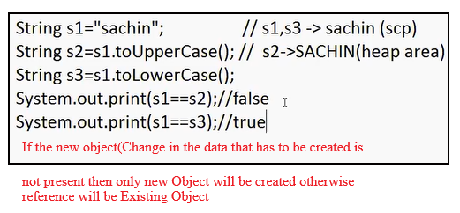

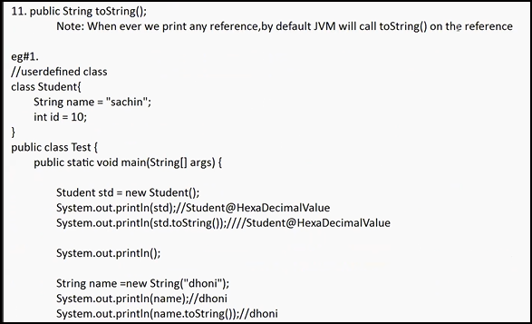

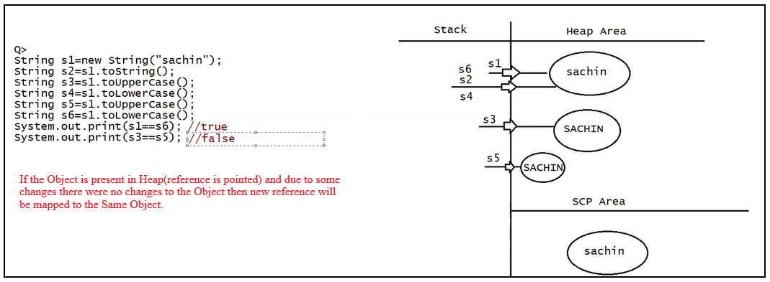

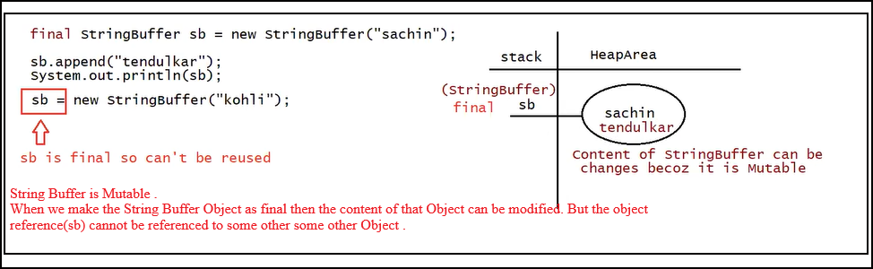

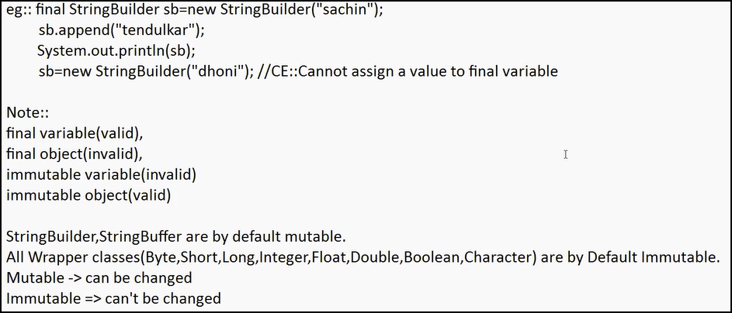

Mutable: can be Changed

Immutable: Can’t be Changed

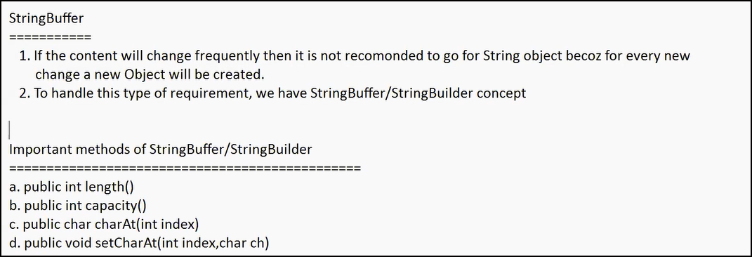

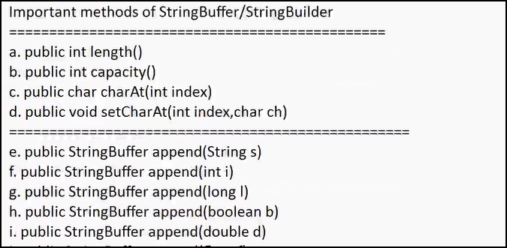

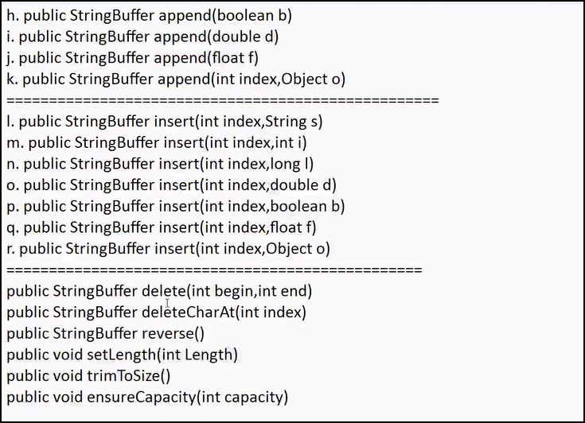

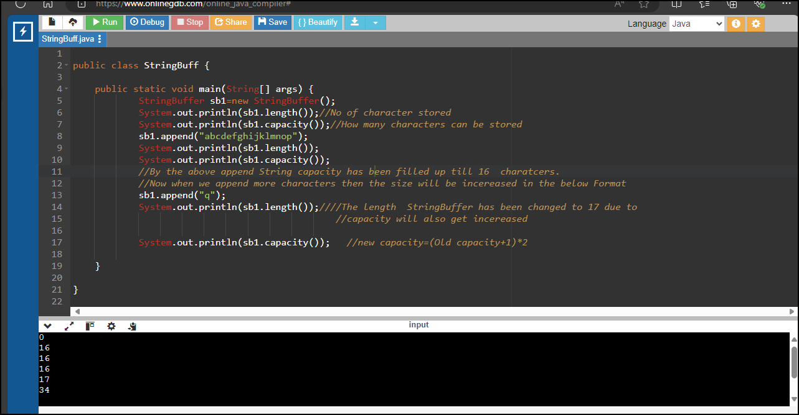

<https://onlinegdb.com/1_Qxrh7qz>

Case 1:

StringBuffer sb1=new StringBuffer();

Creates an Empty String Buffer with initial capacity of 16 characters.

Once the StringBuffer reaches it Maximum Capacity then a new StringBuffer Object will be created .

Newcapacity=(Old capacity+1)\*2

Case 2:

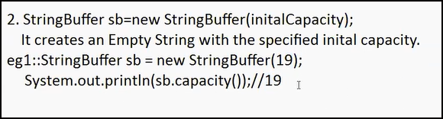

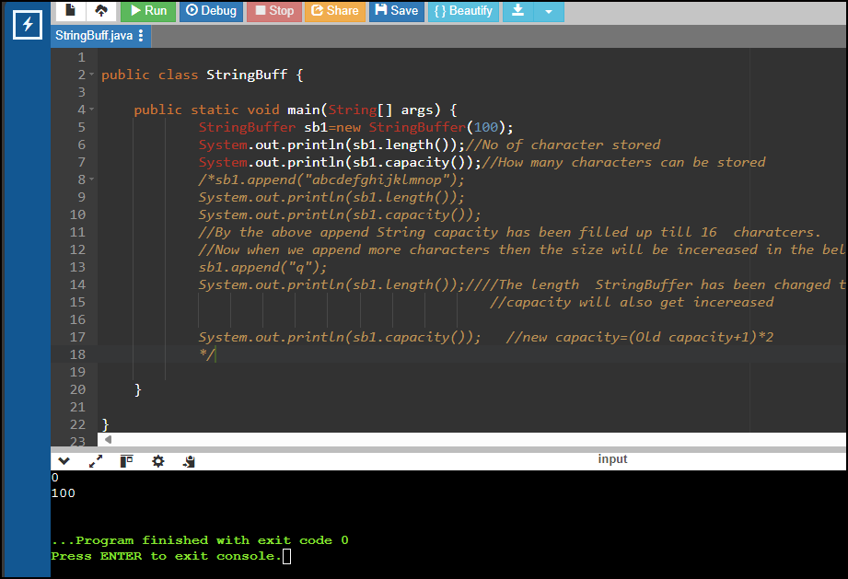

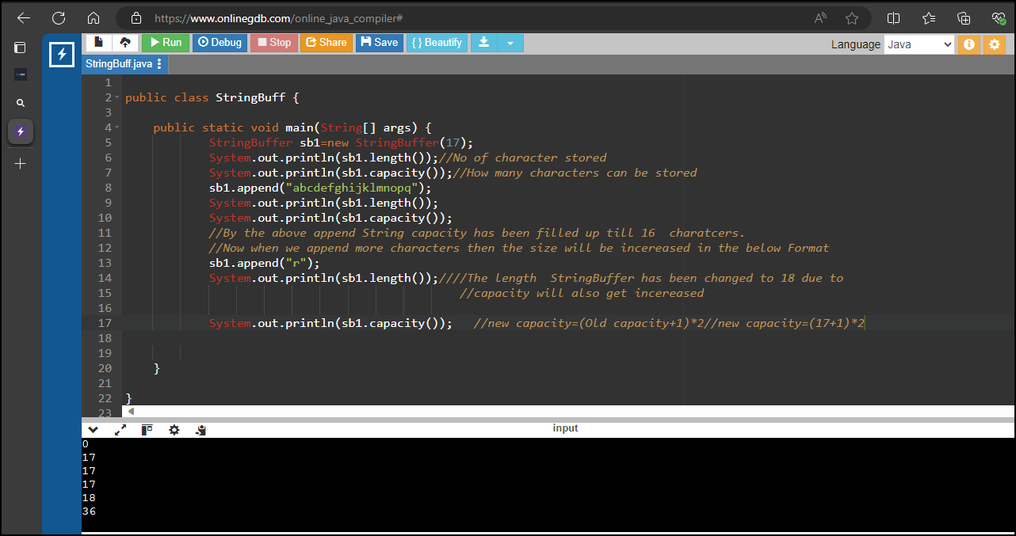

<https://onlinegdb.com/A9e6Wc16AO>

