Generally the Size will be 16 Locations

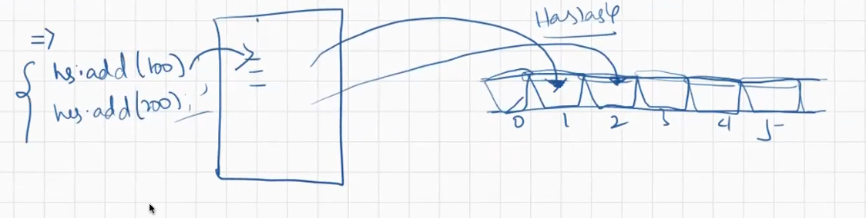

When we want to store the data in the form of Key-Value pair we can go with Map.

For storing the data in the form of key, Value we can go with Key, Value Hierarchy.

Map<K,V>

**Map Hierarchy:**

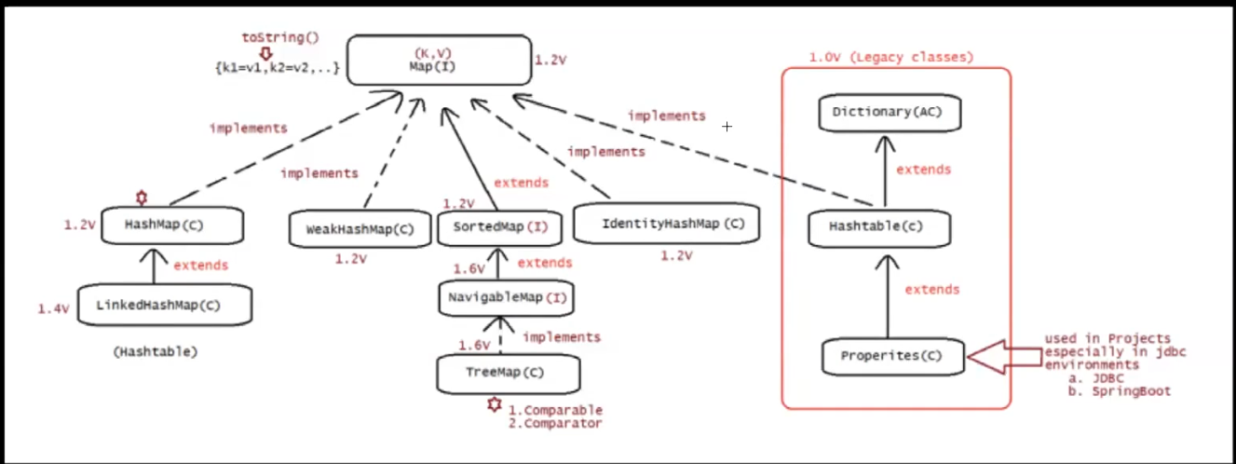

Map is not part of Collection Hierarchy. It is separate Hierarchy.

Each pair is called Entry.

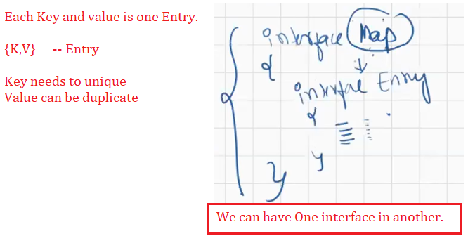

Even though the data is Key,value but they will also be Objects.

HashMap: Does not maintain Order of insertion.

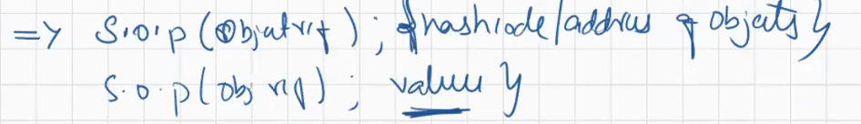

If the toString() is not overridden, then it will display the hash code.

Iterating means: Traversing and Fetching the values.

package com.chinmay.map;

import java.util.Collection;

import java.util.HashMap;

import java.util.Iterator;

import java.util.LinkedHashMap;

import java.util.Map;

import java.util.Map.Entry;

import java.util.Set;

public class HashMapLinkedHashMap {

public static void main(String[] args) {

HashMap hm=new HashMap(); //Does not maintain Order of insertion

hm.put(10,"Sachin");

hm.put(45,"Rohit");

hm.put(7,"Dhoni");

hm.put(18,"Kohli");

System.out.println("HashMap : "+hm);

System.out.println(hm.get(10));

LinkedHashMap lhm=new LinkedHashMap(); //Maintain Order of insertion

lhm.put(10,"Sachin");

lhm.put(45,"Rohit");

lhm.put(7,"Dhoni");

lhm.put(18,"Kohli");

System.out.println("Linked HashMap maintains Order of insertion \nLinked HashMap : "+lhm);

Collection c=hm.values();

Iterator itr=c.iterator();

System.out.println("\nValues Stored in the HashMap : ");

while(itr.hasNext())

{

String i=(String) itr.next();

System.out.println(i);

}

System.out.println("\nKeys Stored in the HashMap : ");

Set s=hm.keySet();

Iterator it=s.iterator();

while(it.hasNext())

{

System.out.println(it.next());

}

System.out.println("\nKey Value Pair Stored in the HashMap : ");

Set s1= hm.entrySet();

Iterator itr2=s1.iterator();

while(itr2.hasNext())

{

//System.out.println(itr2.next());

Map.Entry mp= (Entry)itr2.next();

System.out.println(mp.getKey()+"="+mp.getValue());

// System.out.println(mp); //This will also display the key Value Pair of Map Data.

}

}

}

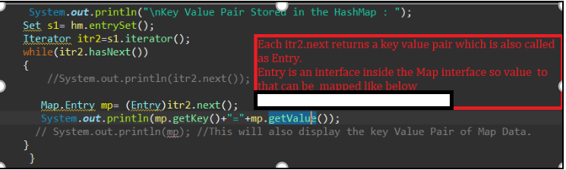

Entry is interface present in the Map

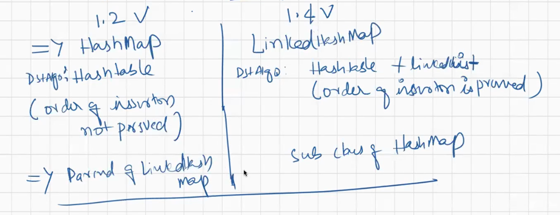

Refer 44-Map from Full Stack Code Objects from Github. That has the comments as well added so it will easier for understanding.