# ACKNOWLEDGEMENT

The satisfaction that accompanies the successful competition of the task would be incomplete without the mention of the people who made it possible, whose constant guidance and encouragement crown all the efforts with success.

I wish to express my deep sense of gratitude to **Mr. Jenish Lavji**, Project Guide, for his able guidance and useful suggestions, which helped us in completing the project work, in time.

I am particularly thankful to **Ms. Palak V. Desai**, Head, Department of Computer Engineering, for his guidance, intense support and encouragement, which helped us to complete the project successfully.

We show gratitude to our honorable Director, **Dr. R. V Patil**, for having provided all the facilities and support.

We would also like to thank all the department faculties who has provided knowledge and support directly or indirectly from their thorough experience in their respected fields.

We would like to thank our family and friends, who were ever so keen to help us whenever we got stuck in any kind of problems for the completion of the project.

#### Chinmay Shringi (201803100810037)

#### Hetarth Sangrajka (201803100810032)

#### Dhruv Desai (201803100910143)

# 

# ABSTRACT

The Internet of things (IoT) is the network of physical devices vehicles home appliances and other items embedded with electronics, software, sensors, actuators and network connectivity which enable these objects to connect and exchange data.

The IoT allows objects to be sensed or controlled remotely across existing network infrastructure, creating opportunities for more direct integration of the physical world into computer-based systems and resulting in improved efficiency, accuracy and economic benefit in addition to reduced human intervention.

We are addressing a wide range of problems being faced by the society due to lack of awareness and sense of responsibility. In the 21st century, with the rise in statistical data for working parents, the most common option opted by them are daycare centers. When parents drop their children off at daycare, they expect that their kids will be safe. This is only possible with the proper security measures in place, such as security cameras, access control and visitor protocol.

# TABLE OF CONTENTS

ACKNOWLEDGEMENT iii

ABSTRACT iv

LIST OF FIGURES vii

LIST OF TABLES viii

Chapter 1 Introduction 1

* 1. Background 1
  2. Problem Definition 1
  3. Motivation 1
  4. Objective 2
  5. Scope 2
  6. Applications 3

Chapter 2 System Planning 4

* 1. System Modules 4
     1. System Registration and Login 4
     2. Audio Recorder 4
     3. Video Recorder 4
     4. Data Analysis 4
     5. Display 4
  2. Functional Requirements 5
  3. Non Functional Requirements 6
  4. Hardware and Software Requirements 7

Chapter 3 System Design 13

* 1. Database Schema 13
  2. Use Case Diagram 14
  3. Sequence Diagram 15
  4. Activity Diagram 16
  5. Component diagram 17

Chapter 4 Implementation and Testing 18

* 1. Snapshots 18
  2. Test Cases 22

Conclusion and Future Scope 24

References 25

# LIST OF FIGURES

Figure 2.4.1: Arduino 7

Figure 2.4.2: ESP32 CAM 7

Figure 2.4.3: Jumper wire 8

Figure 2.4.4: I2S 8

Figure 2.4.5: Audio Recorder 9

Figure 2.4.6: Video Recorder 9

Figure 2.4.7: Arduino IDE 10

Figure 2.4.8: WebRTC 10

Figure 2.4.9: Putty 11

Figure 2.4.10: Google Cloud… 11

Figure 3.3.1: Sequence Diagram 15

Figure 3.4.1: Activity Diagram 16

Figure 3.5.1: Component Diagram 17

Figure 4.1.1: Arduino Sensor Network 18

Figure 4.1.2: Serial Monitor 18

Figure 4.1.3: Arduino to Raspberry pi Connectivity 19

Figure 4.1.4: Sending data to Raspberry pi from Arduino Uno 20

Figure 4.1.5: The sensor data acquired from Arduino 21

Figure 4.1.6: Displayed Sensor data on website 21

# LIST OF TABLES

Table 2.2.1: Functional Requirements 5

Table 2.2.1: Login Table 13

Table 2.2.1: Sensor Data Table 13

Table 4.2.1: Test Case 22

* 1. **Background**

# Chapter 1: Introduction

We are addressing a wide range of problems being faced by the society due to lack of awareness and sense of responsibility. In the 21st century, with the rise in statistical data for working parents, the most common option opted by them are daycare centers. When parents drop their children off at daycare, they expect that their kids will be safe. This is only possible with the proper security measures in place, such as security cameras, access control and visitor protocol. Security breaches can accidentally allow unauthorized people inside the facility, putting children at risk of kidnapping or injury. A few of them are listed below and our product helps in reducing them.

## Problem Definition

The System will collect all the data from the sensors associated with each different segment and send it to the user’s guardian via cloud which will notify him about the situation of the user and what action he must take.

**Child Abuse and bullying:**

According to the data provided by the government, everyday 109 children are abused on daily basis (REPORTED CASES). Our product helps in identifying the voice patterns and send signal to parent if any hate speech, negative or suspicious comments are made by the speaker.

**Human Trafficking and Kidnapping:**

The count of people victim to human trafficking yearly is 6k (5264 in 2018) and are the cases that are reported by their kin. Our product uses geolocation to gain access to the user’s location and if the location is detected outside of safe area provided by their parents, an alert is sent to the customer showing the current location and thereby seeking officials help.

**Allergies:**

Children are allergic to certain food and may be exposed to them by carelessness of the daycare officials. Our product is integrated with OVA2640 camera equipped with image recognition to identify if the food kept in front of them is healthy for them or not, as listed by their parents.

**Temperature and Pollution:**

With the rise in us of air conditioners and air pollution children are subjected to cold temperatures and bad air. Our product will be equipped with IR sensors for temperature measurement and MQ135 to keep the quality of air in check.

## Motivation

In the 21st century, with the rise in statistical data for working parents, the most common option opted by them are daycare centers. When parents drop their children off at daycare, they expect that their kids will be safe. This is only possible with the proper security measures in place, such as security cameras, access control and visitor protocol. Security breaches can accidentally allow unauthorized people inside the facility, putting children at risk of kidnapping or injury. A few of them are listed below and our product helps in reducing them.

## Objective

Objectives of our project are:

* 1. To create the circuit for the ESP32 and its modules.
* 2. To create website for the storage and company UI.
* 3. To create application for service access by the guardian.
* 4. To use a drill to make a hole for the camera lens.
* 5. To apply waterproofing for the electrical components.
* 6. To assemble the components together.

## Scope

With the evolution of technology and the internet, this project will open doors for further advancements in the field of security.

Also, with Artificial intelligence is developing across all the sectors, This project can be made smarter by bringing in artificial intelligence into the picture.

## Applications

### WebRTC

We are using the latest technology for video streaming providing real-time communication (RTC) via simple application programming interfaces (APIs). It allows audio and video communication to work inside web pages by allowing direct peer-to-peer communication, eliminating the need to install plugins or download native apps.

The WebRTC API includes no provisions for signaling, that is discovering peers to connect to and determine how to establish connections among them. Applications use Interactive Connectivity Establishment for connections and somehow manage sessions, possibly relying on any of Session Initiation Protocol, Extensible Messaging and Presence Protocol, Message Queuing Telemetry Transport, Matrix (protocol), or another protocol.

Signaling may depend on one or more servers. No matter how many customers use our services at any given time there is negligible lag of 200ms.

### Flutter

Flutter apps are built using Dart, a simple object-oriented programming language. It provides with great security features.

High productivity. Since Flutter is cross-platform, you can use the same code base for your iOS and Android app. This can definitely save you both time and resources.

Great performance. Dart compiles into native code and there is no need to access OEM widgets as Flutter has its own. This means less mediated communication between the app and the platform.

Fast and simple development. One of the most lauded features of Flutter is hot reload which allows you to instantly view the changes made in the code on emulators, simulators and hardware.

Compatibility. Since widgets are part of the app and not the platform, you’ll likely experience less or no compatibility issues on different OS versions. This in turn means less time spent on testing.

Open-source. Both Flutter and Dart are open-source and free to use, and provide extensive documentation.

### Google Cloud

The Google Cloud Platform (GCP) is a suite of cloud services hosted on Google’s infrastructure. Google Cloud Platform is a suite of public cloud computing services offered by Google. Google Cloud Platform, as the name implies, is a cloud computing platform that provides infrastructure tools and services for users to build applications and services on top of. This will be used to process the data for the AI and send alerts to parents in case of any red flags.

* + 1. Hashing

The stored video recording can only be accessed by key pairs that are available with the parents and are saved using secure hashing algorithm SHA-256.

* + 1. Angular

Angular is a web application development framework developed by Google and uses algorithms to keep the application secure and fast.

# Chapter 2: System Planning

## System Modules

#### System Registration and Login:

Description: The User will be able to register and login to the Monitoring System.

#### Location Detection:

Description: The location will be triangulated via the network towers and the acquired data is sent to the system.

#### Allergy Detection:

Description: The photo is recognized via ML on google cloud and the acquired data is sent to the guardian.

#### Speech recorder:

Description: The audio is detected via microphone and is sent to the google cloud and will be processed via google speech and the acquired data is sent to the guardian.

#### Video Recorder:

Description: The video is recorded via OVA2640 and is sent to the google cloud and will be processed via google vision and the acquired data is sent to the guardian.

#### Sending Sensor Data to Google Cloud:

Description: The Sensors data collected by the ESP32 AI CAM will be sent to Google Cloud which is connected wirelessly..

#### Data Analysis:

Description: -The Data received by the Google cloud channel will be analyzed and displayed in the form of chart.

#### Display:

Description: The result of the Analyzed data will be displayed to the user as a chart and can be accessed remotely as the data is stored on Google cloud platform.

## Functional Requirements

Table: 2.2.1 Functional Requirements.

|  |  |
| --- | --- |
| **ID** | **Title and Description** |
| FR1 | Title: User Registration  Description: The user should be able to register through the Google cloud Application. The user must provide user-name, password or via google also. |
| FR2 | Title: Video Recorder  Description: The video recorder will record video and send the data to system. |
| FR3 | Title: Audio Sensor.  Description: The Audio Sensor will detect the audio from the badge and send the data to the system. |
| FR4 | Title: Sending Data to User.  Description: The Data detected through Various Sensors will be transferred to the user via cloud platform so that he/she would be able to understand the current scenario of situation more precisely hence work accordingly. |
| FR5 | Title: GUI  Description: The Front End of the project, from which guardian can monitor and act accordingly. |

## Non-Functional Requirements.

#### Portability:

The User will be able to shift this system to another user easily and the System will work smoothly without any specific modifications.

#### Security:

The System will provide the data to the verified User and authentication will be provided.

#### Performance:

The System will be completely automatic and user friendly which makes the guardian monitoring task very easy and also the user would be able to monitor on a physical device remotely.

#### Reliability:

The System will provide accurate data of the audio and video, Sensor will act according to the requirement.

#### Serviceability:

The system will provide quality Service to the User by providing accurate data instantly so that guardian can react quickly as per the requirements of the guardian.

## Hardware and Software Requirements:

#### Hardware Requirements:

* + Arduino UNO

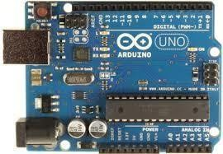

Figure:2.4.1 Arduino Uno

The Arduino Uno is a microcontroller board based on the ATmega328. It has 20 digital input/output pins (of which 6 can be used as PWM outputs and 6 can be used as analog inputs), a 16 MHz resonator, a USB connection, a power jack, an in- circuit system programming (ICSP) header, and a reset button. It contains everything needed to support the microcontroller; simply connect it to a computer with a USB cable or power it with a [AC-to-](https://www.pololu.com/product/1463) [DC adapter](https://www.pololu.com/product/1463) or battery to get started.

* + ESP32 CAM

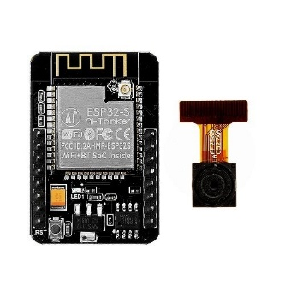

Figure:2.4.2 ESP32 CAM

The ESP32 CAM is a low cost, **small sized computer** that plugs into a

computer

monitor or TV, and uses a standard keyboard and mouse. It is a capable

little device that

enables people of all ages to explore computing, and to learn how

to program in languages

like Scratch and Python. It’s capable of doing everything

you’d expect a desktop computer

high-definition video, to making spreadsheets,

word-processing, and playing games.

to do, from browsing the internet and playing

* + Jump Wires

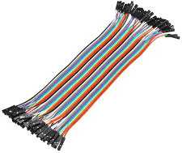

Figure:2.4.3 Jump Wires

* + - Audio Sensor

The INMP441 is a 3.3V MEMS microphone that uses Inter-IC Sound (I2S) to communicate with devices capable of audio recording via the I2S interface. The INMP441 is a great choice for voice inputs, sound localization, and other applications where an array of microphones can be used to identify and characterize acoustic systems. The INMP441 is compatible with Raspberry Pi stereo audio recording.

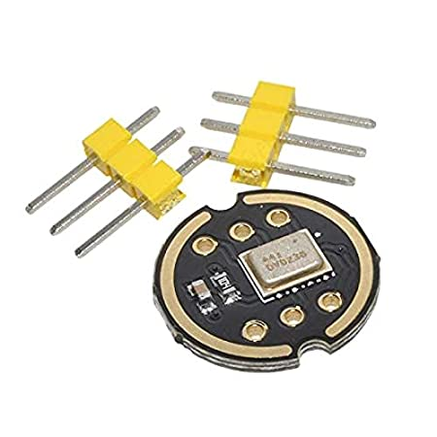

Figure:2.4.4 INMP441 Audio Sensor

#### Software Requirements:

* Arduino IDE

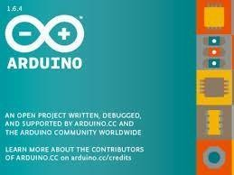

Figure:2.4.7 Arduino IDE

The [Arduino](https://en.wikipedia.org/wiki/Arduino) integrated development environment **(**[IDE](https://en.wikipedia.org/wiki/Integrated_development_environment)**)** is a [cross- platform](https://en.wikipedia.org/wiki/Cross-platform) application (for [Windows,](https://en.wikipedia.org/wiki/Windows) [MacOS,](https://en.wikipedia.org/wiki/MacOS) [Linux](https://en.wikipedia.org/wiki/Linux)) that is written in the programming language [Java.](https://en.wikipedia.org/wiki/Java_(programming_language)) It is used to write and upload programs to Arduino compatible boards, but also, with the help of 3rd party cores, other vendor development boards.

* WebRTC (for peer to peer connection)

Figure:2.4.8 WebRTC

We are using the latest technology for video streaming providing real-time communication (RTC) via simple application programming interfaces (APIs). It allows audio and video communication to work inside web pages by allowing direct peer-to-peer communication, eliminating the need to install plugins or download native apps.

* 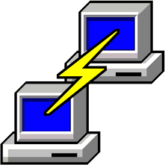Putty

Figure:2.4.9 Putty

Putty is a free and open-source terminal emulator, serial console and network file transfer application. It supports several network protocols, including SCP, SSH, Telnet, rlogin, and raw socket connection. It can also connect to a serial port.

* Google Cloud

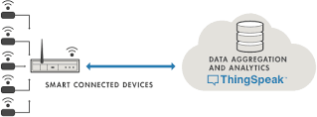

MLTS

Figure: 2.4.10 Google cloud

Google Cloud is a platform providing various services exclusively targeted for building IoT applications. It offers the capabilities of real-time data collection, visualizing the collected data in the form of charts, ability to create plugins and apps for collaborating with web services, social network and other APIs.

# Chapter 3: System Design

## Database Schema:

Table 3.1: Login Table

|  |  |  |  |  |
| --- | --- | --- | --- | --- |
| **Column Name** | **Data Type** | **Size** | **Constraint** | **Description** |
| **Id** | INT | 5 | Primary Key | ID No. |
| **User** | VARCHAR | 50 | --- | Username |
| **Pass** | VARCHAR | 50 | --- | Password |
|  |  |  |  |  |

Table 3.2: Sensor Data Table (Google cloud)

|  |  |  |  |  |
| --- | --- | --- | --- | --- |
| **Column Name** | **Data Type** | **Size** | **Constraint** | **Description** |
| **Video Sensor** | FLOAT | 20 | --- | Video stream |
| **Audio Sensor** | FLOAT | 20 | --- | Audio recordings saved as blob. |
| **Location** | FLOAT | 20 | --- | Location Sensor |

## Use Case Diagram:

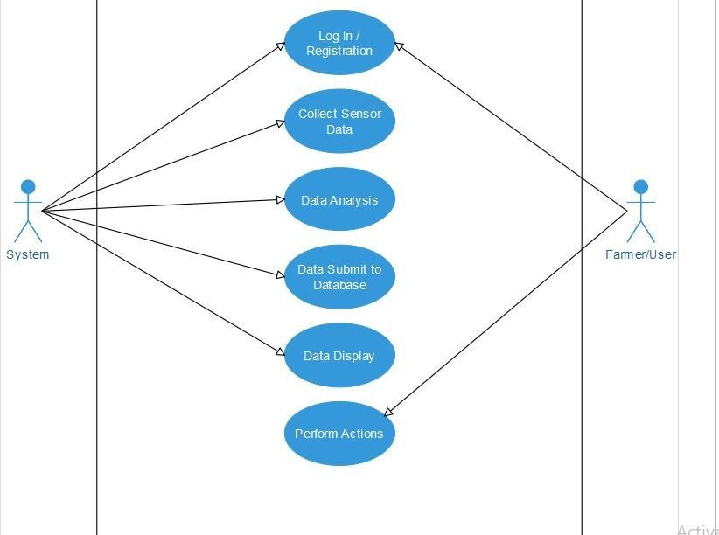

System

Guardian

Figure:3.2.1 Use Case Diagram

## Sequence Diagram:

Figure 3.3.1 Sequence diagram

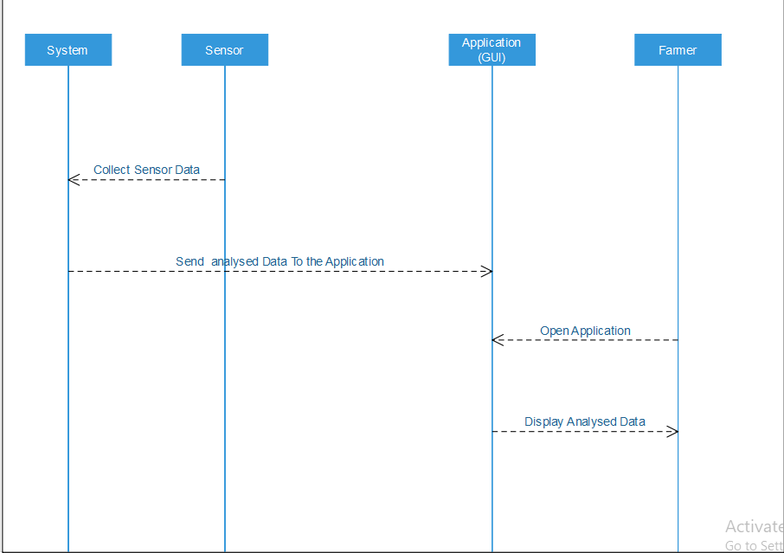

Guardian

## Activity Diagram:

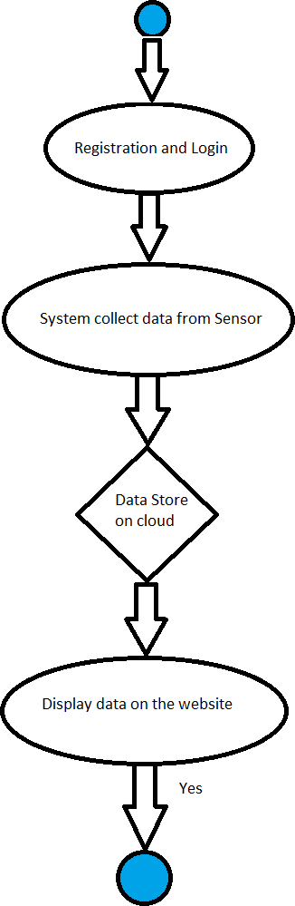

Figure 3.4.1: Activity Diagram

## D:\Parth\Project\IOT Diagram.pngComponent diagram:

Figure 3.5.1 : Component diagram

# Chapter 4 Implementation and Testing:

## Snapshots:

(Phase-1)

#### Arduino IDE Serial Monitor

Figure 4.1.1: Arduino IDE Serial Monitor

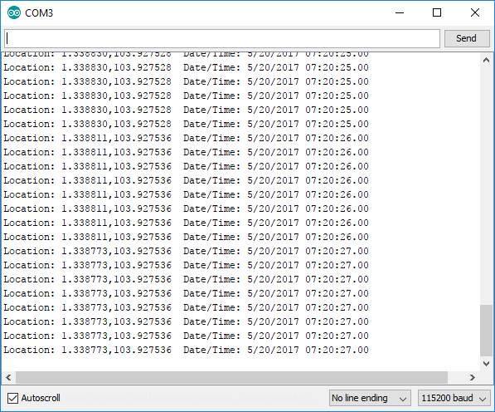

Figure 4.1.2: Serial Monitor

The ESP32 successfully gathers the data from the sensors and displays it in the Serial monitor.

(Phase-2)

* Sending Data to WiFi from ESP32:

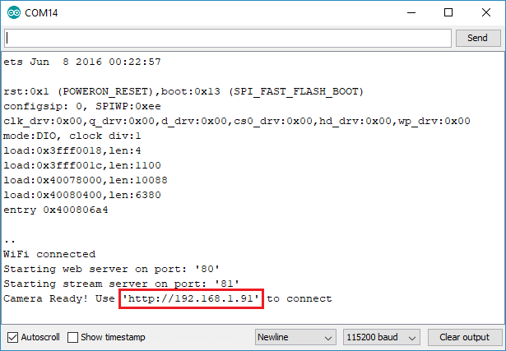

Figure 4.1.4: Sending data to WiFi.

The data from the Arduino was sent to the raspberry pi and it was converted into a text file …. which helps to process the data through Google cloud.

### Sample test cases are given as below: Table 4.2.1: Test Cases

|  |  |  |  |  |  |
| --- | --- | --- | --- | --- | --- |
| **Test ID** | **Case** | **Test Data** | **Expected Result** | **Actual Result** | **Pass/Fail** |
| 1 | Login | Internet- Connectivity Login ID Password | If Login ID & password is empty or invalid and No Internet connectivity then display Error message otherwise Login successfully | If Login ID & password is  empty or invalid and No Internet connectivity then  displa  y Error message. | Pass |
| 2 | Home  (Network) | Swipe down  For Synchronizati on | First time  Synchronization When swipe down, Network report will refresh. | First time  Synchronized. When swipe down, Net worth report refreshed. | Pass |
| 3 | Reports | Select given inputs for particular  reports. | Display report as per selection of inputs. | Report displayed as per selection  of inputs. | Pass |
| 4 | Forgot password | Email Id | If Email Id is valid &Authorized then new password is set by received email. | Password is reset if the Email id is authorized and  valid. | Pass |
| 5 | Logout | Select Logout | User should Logout from the website. | User get Logout from the website. | Pass |

|  |  |  |  |  |  |
| --- | --- | --- | --- | --- | --- |
|  |  |  | and redirected to  Login page. | and redirected  to Login page. |  |
| 6 | Exit | Select Exit | Website should  be closed. | Website is  closed. | Pass |

# Conclusion and Future Scope

#### Conclusion:

Our potential customers are working parents who have little time to attend to their kids while at work. The idea isn’t limited to daycare, our product can be used for safety during carnivals, shopping malls, airports, schools, festivals or any other crowded areas or events.

Our product can be used for old age homes or aged parents at home

# References

**Web references**

1. [Online]

<https://medium.com/biffures/part-5-hashing-with-sha-256-4c2afc191c40>

[Date Accessed: 6th August 2020]

1. [Online]

[https://bloggeek.me/how-many-users-webrtc-call/#:~:text=As%20many%20as%20you%20like,users%20into%20a%20WebRTC%20call.](https://bloggeek.me/how-many-users-webrtc-call/#:~:text=As%20many%20as%20you%20like,users%20into%20a%20WebRTC%20call. )

[Date Accessed: 25th August 2020]

1. [Online]

<https://link.springer.com/article/10.1007/s42979-020-00380->

[Date Accessed: 2nd August 2020]

1. [Online]

https://ieeexplore.ieee.org/abstract/document/7160422/citations#citations [Date Accessed: 20th September 2020]

1. [Online]

[https://medium.com/@ghalfacree/benchmarking-the-raspberry-pi-4- 73e5afbcd54b](https://medium.com/%40ghalfacree/benchmarking-the-raspberry-pi-4-73e5afbcd54b)

[Date Accessed: 20th September 2020 ]

1. [Online]

https://makersportal.com/shop/i2s-mems-microphone-for-raspberry-pi-inmp441

[Date Accessed: 20th September 2020]

1. [Online]

https://randomnerdtutorials.com/esp32-cam-video-streaming-face-recognition-arduino-ide/

[Date Accessed: 20th September 2020]

1. [Online]

https://webrtc.org/support/license

[Date Accessed: 20th September 2020]