**Termite Fabrications**

**Software Requirements Specification**

**Hetarth Sanghrajka**

**(201803100810032)**

**Chinmay Shringi**

**(201803100810032)**

**Mentor:**

**Ms. Palak V. Desai**

**Version: (v0.1.4)** **Date: (04/26/2021)**

**Table of Contents**

1. Introduction 3

1.1 Purpose 3

1.2 Scope 3

2. User Requriment 3

2.1 platform user 3

2.1.1 Customer 3

2.1.2 Architect 4

2.1.3 Admin 4

2.1.4 Supplier 4

3. Functional Requirements 4

4. Non-Functional Requirements 5

4.1 Security 5

4.2 Logging 5

4.3 Storage 5

4.4 Configuration 5

4.5 Performance 5

4.6 Cost 5

4.7 Disaster Recovery 5

5. Hardware and Software Requirement 6

5.1 Software Requirement 6

5.1.1 Operating System 6

5.1.2 Front End 6

5.1.3 Database 6

5.1.4 Technology 6

5.2 Hardware Requirement 6

5.2.1 Hard disk 6

5.2.2 Memory 6

6. Use Case Diagram 7

7. Class Diagram 8

8. Activity Diagram 9

9. Sequence Diagram 10

10. DFD Diagram 11

10. ER Diagram 12

# 1. Introduction

Customers have to explain in great detail regarding the design and structure required by them. Generally, customers don’t have specialisation in this field. We provide a platform for customer to fully customize their home with an interactive GUI and select the material, colour and much more.

## 1.1 Purpose

To help customers build their desired house with just a few clicks away. Their house will be approved by architect to ensure structure stability.

## 1.2 Scope

The scope of the specification includes the following scenarios:

1) Get maximum variety of construction.

2) Easy to create and edit design.

3) Cost effective as customer can compare and select the best house which comes under their budget.

4) User friendly, can be used by anyone (who can read and write).

# 2. User Requirement

## 2.1 Platform User

There are 4 users involved in this system of online construction:

* Customer
* Architect
* Admin
* Supplier

## 2.1.1 Customer

1. Customer is the necessity here as if there is no customer then there won’t be any sell of home from the platform.

2. The customer must be able to have a good facility for building the home online with material and worker payment facility and good choices for the home.

3. The customer should get the tracking details of their home.

## 2.1.2 Architect

1. Architect is necessary to ensure the structure made by the user is stable and can be made with the available technology.

2. After the architect has viewed the design and structure the house is approved and ready to be confirmed by the user.

3. The customer billing will include the details regarding the architecture fees.

## 2.1.3 Admin

1. The admin in this platform is like a root user.

2. Admin has access to all database and platform code and is responsible for its management.

3. The Admin can be requested to perform certain task (e.g. CRUD operations on DB) by other users.

## 2.1.4 Supplier

1. The supplier is an important actor in this platform.

2. Supplier is responsible for the raw materials and workers for the house.

3. The supplier is also responsible to update the materials in stock and approve the house construction when enough workers are available.

# 3. Functional Requirements

This section provides requirements overview of project. This project will be required Angular 10 as the frontend and the backend NodeJS and MySQL database will be used.

|  |  |  |  |
| --- | --- | --- | --- |
| **Sr.No.** | **Id** | **Title** | **Description** |
| 1 | FR1 | Login | The system provides security features through username-password matching where only authorized user can access the system with different authorization level. |
| 2 | FR2 | Admin | The user with highest access level and is responsible for disaster management database management and making changes to the platform code as per requirement |
| 3 | FR3 | My Account | This allows users to view their profile and the data related to it on the platform. |
| 4 | FR4 | CRUD house design | This user allows Create Read Update and Delete (CRUD) operations on house design. |
| 5 | FR5 | Cart | This tab allows the customers to view the items they have added in their carts with the quantity and cost of the house. |
| 6 | FR6 | Checkout | This tab will take the customer to the payment options make the payment for their selected items. Also they will have to enter their billing details and have to choose the delivery options as well. |
| 7 | FR7 | House Status | This tab allows customer to view the status of the house about its approval changes or the time that will be required to get approved. |

# 4. Non-Functional Requirements

## 4.1 Security

The security can be achieved in this online construction by validating that only registered users are able to access their individual accounts with their given passwords.

## 4.2 Storage

The user’s information must be stored and maintained in database so that the record can be easily retrieve whenever necessary. The database must be updated with each old and new record and maintained.

## 4.3 Configuration

The website must be arranged with all elements required.

## 4.4 Performance

The website must be optimized in the performance and also the website must appear flexible a per the user needs.

## 4.5 Cost

Free to make this website on the technologies used.

## 4.6 Disaster Recovery

If the failure of the database or error occurs then proper plan must be implemented by administrator to cope up with such problems.

# 5. Hardware and Software Requirements

For the e-construction the estimated functional requirements include the software and hardware requirements as below:

## 5.1 Software Requirements:

## 5.1.1 Operating System:

Windows XP, Windows 7/8/10 ,Ubuntu-Linux OS

## 5.1.2 Front End

Online website making using Angular 10

## 5.1.3 Database

MySQL

## 5.1.4 Technology

Ivy rendering engine.

## 5.2 Hardware Requirements:

## 5.2.1 Hard Disk

5GB

## 5.2.2 Memory

1 GB RAM

# 6. Use Case Diagram

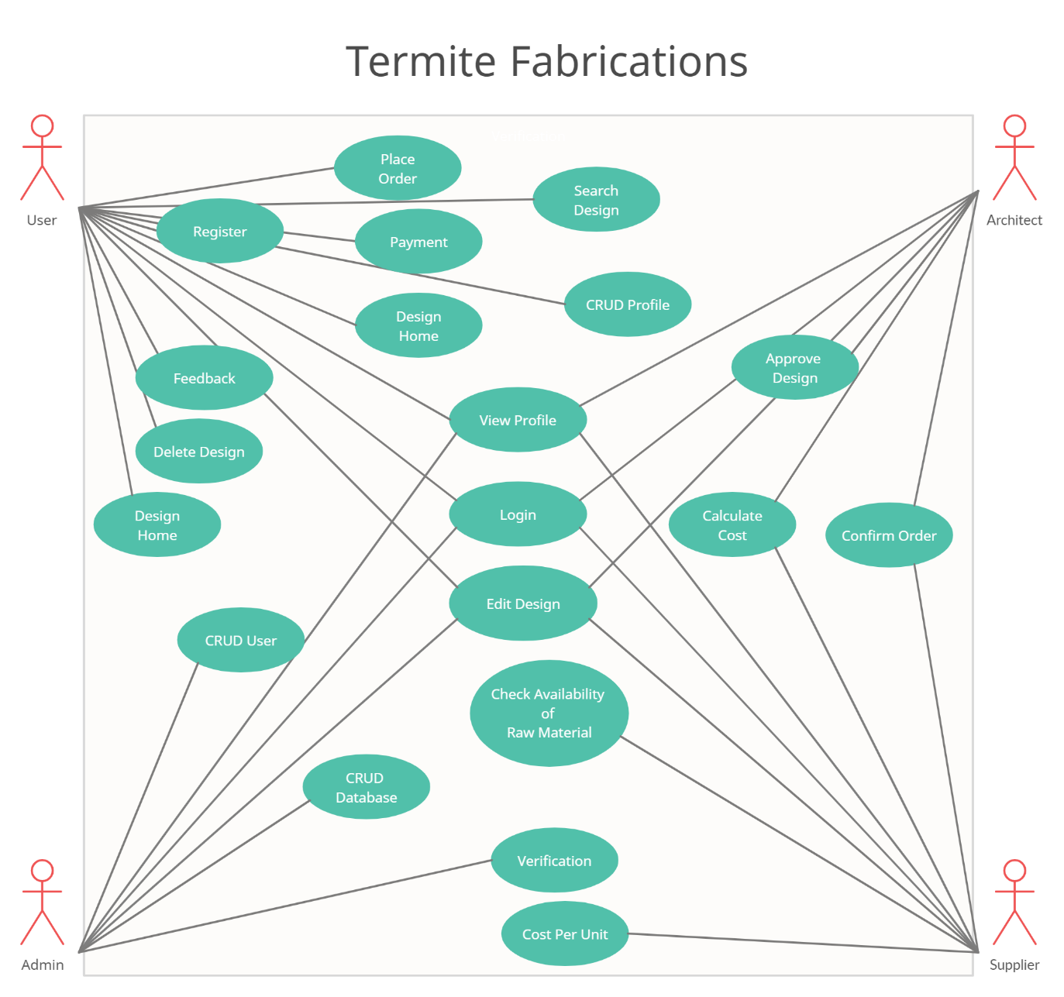

# 7. Class Diagram

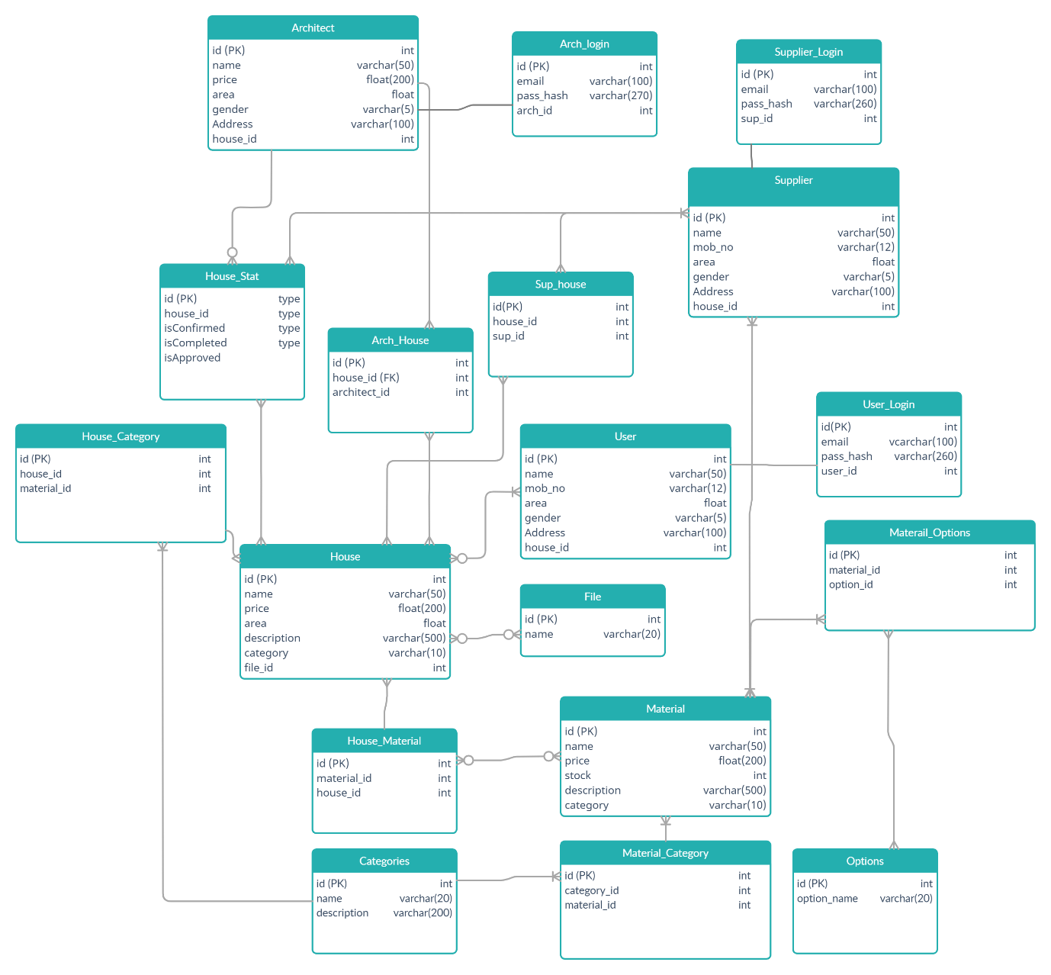

# 8. Activity Diagram

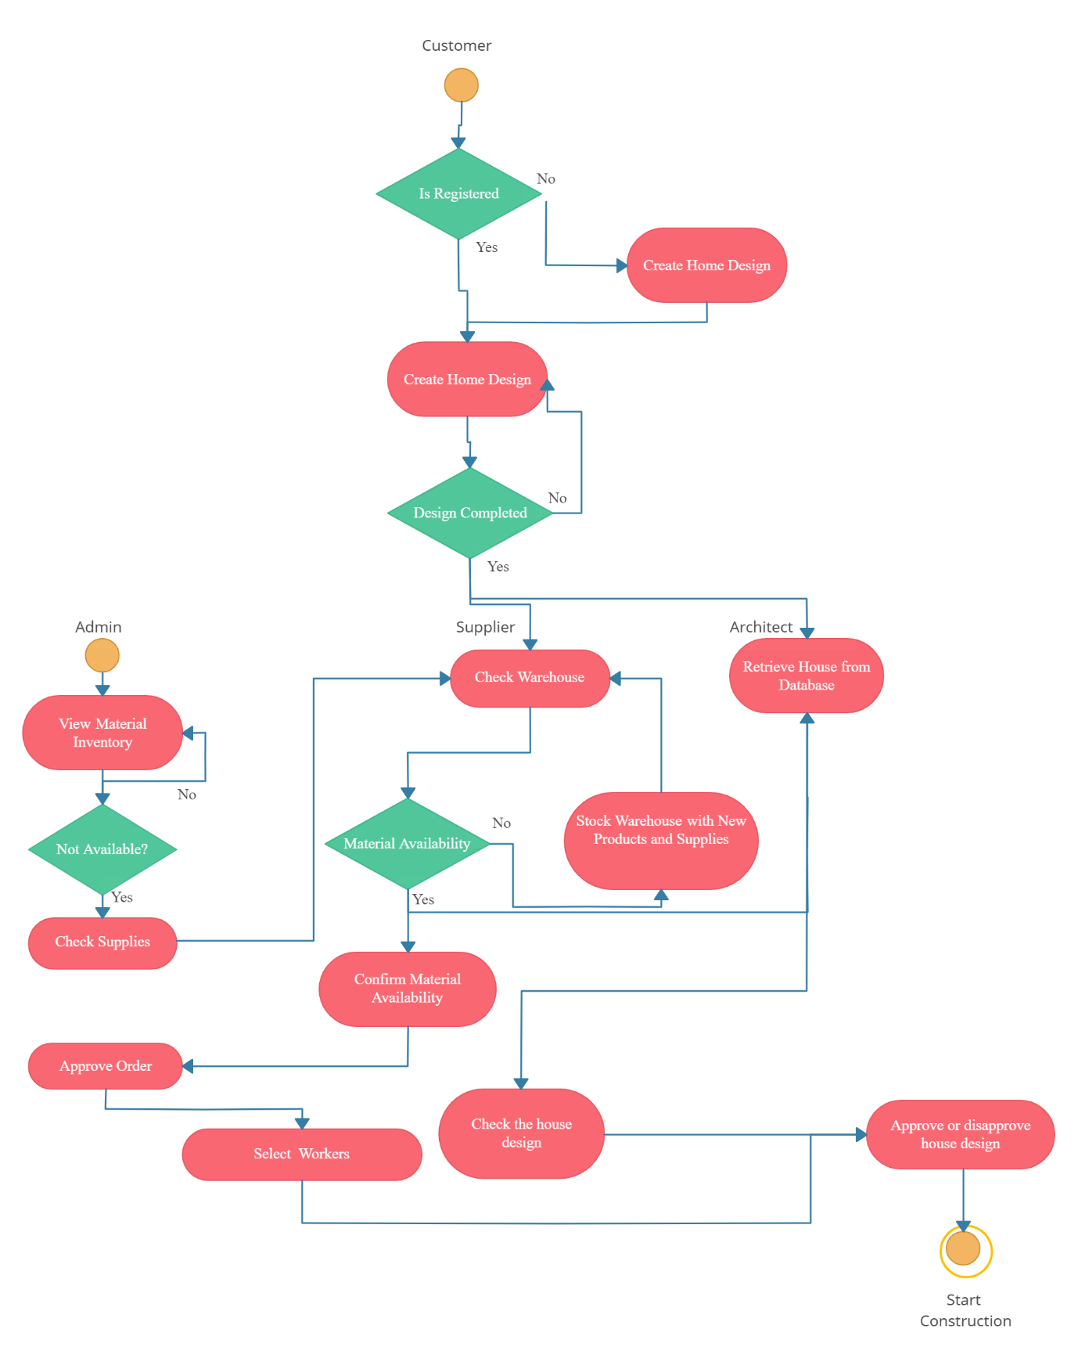

# 9. Sequence Diagram

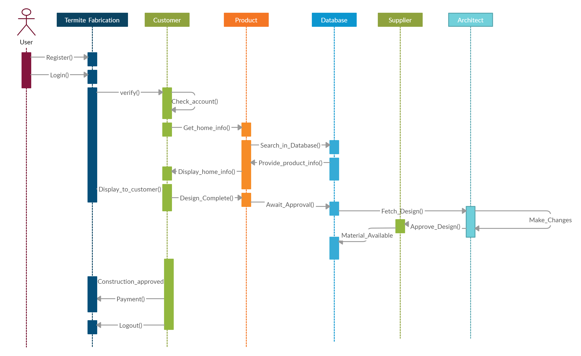

# 10. DFD Diagram

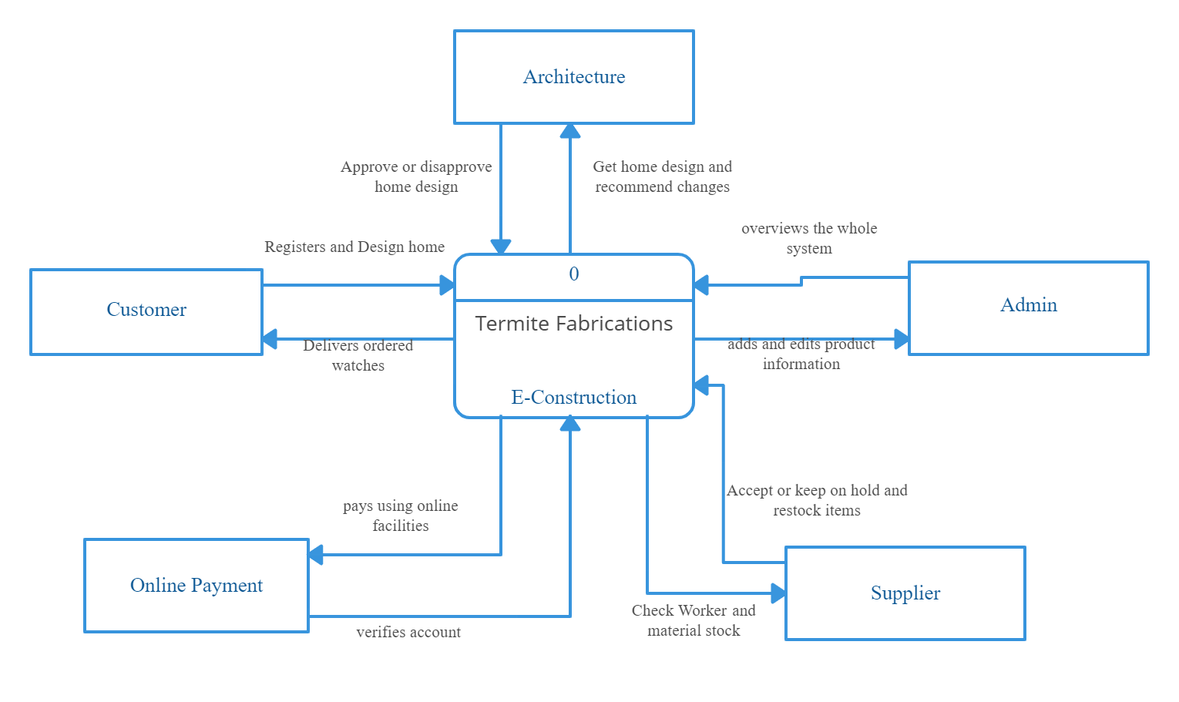

# 11. ER Diagram

