HTML and CSS

To get started with HTML and CSS, please see following videos.
- https://www.youtube.com/watch?v=OZeoiotzPFg - Done watching
https://www.youtube.com/watch?v=yyqvXhu-HOc -Done watching

HTML Task
- What is HTML? Give basic structure of the HTML page.
Ans: HTML stands for Hypertext Markup Language. Its a scripting language used to develop or create webpages. It instructs the browser how to display the webpage. It consist of series of elements and tags that define the structure of the webpage.
The basic structure of the HTML page consists of 3 basic parts:
- HTML declaration: A line containing HTML version information
- Head section: This contains heading , title and links
- Body section: It describes the structural construct of the webpage, contains all the tags and element to build it.
<!DOCTYPE html>
<html>
<head>
<title></title>
</head>
<body>
</body>
</html>

- Difference between inline and block level element.
Block Elements | Inline Elements
Element need their own space hence occupies the full width available. | Element by default run on same line throughout the width and don't need to be set apart.
New element always starts on next line | New element startson same line
Elements displayed individually | Elements displayed together
Eg: <p><div> tags | Eg: links, small highlighted parts in text
Syntax: p{ display:block;} | Syntax: p{ display:inline;}

- Create an HTML page “index.htm” with following content
Ans: Done and uploaded on github
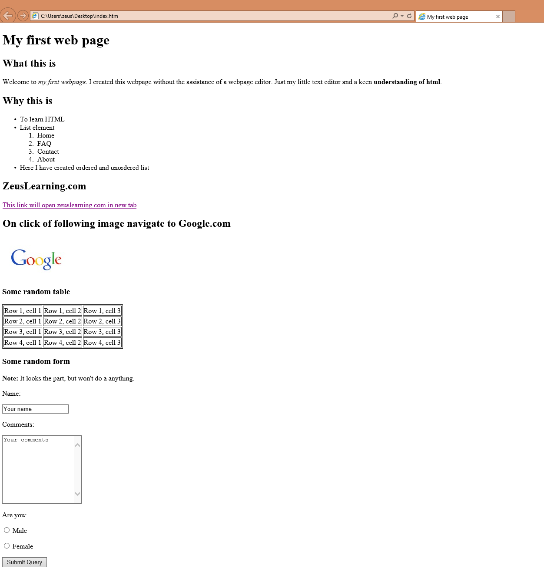

CSS Task
- Explain the different ways in which CSS can be applied to HTML, what is the preferred way and why.
Ans: Three ways css can be added to the document are
- Inline: This uses style attribute inside the HTML element
- Internal: this uses style element inside the head section
- External: this uses link element inside the head section to link external css file
The last i.e. external style sheet method is the most preferred method of styling because maintaining and re-using the css file across different pages is easy and efficient.
- What are different CSS selectors, with example explain Element, Class and Id selectors.
Ans: There are various CSS selectors: Element , id, class, universal and grouping CSS selector
- Element selector: The element selector selects HTML elements based on element name.
- Eg: p{
text-align: left;
color : yellow;
Here all <p> elements on the page will be left-aligned with yellow text color.
- Id selector: the id selector uses the id attribute of an HTML element to select a specific element. It is used to select one unique element. '#' is used before id to select element with specific id.
- Eg: #name{
text-align: center;
color : red;
}
Here the style will be applied to html element with id=”name”.
- Class selector: this selects html element with specific class attribute. To select element with specific class , write a period “.” character followed by the class name
- Eg: .name{
text-align : right;
color : blue;
} Here the elements with class=”name” will be blue and right aligned.
- With the help of a diagram explain CSS Box Model.
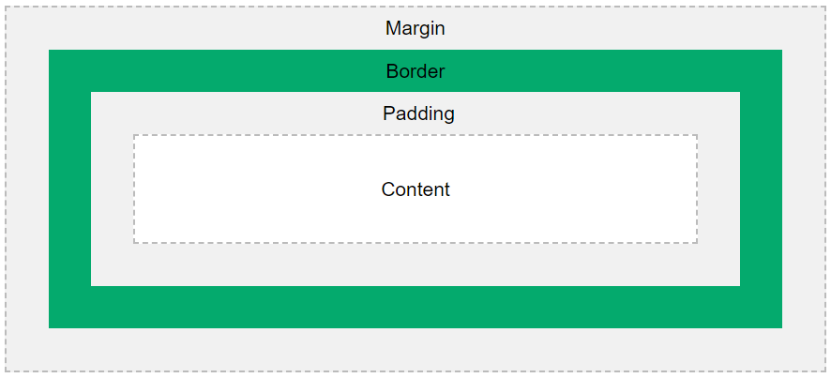
Ans: Image : From W3schools.
The CSS box model is essentially a box that wraps around every HTML element. The box model allows us to add a border around elements and to define space between elements. It consists of margins, borders, padding and the actual content.
- Content: The box where text and image appear , actual content .
- Padding: It clears an area around the content. The padding is transparent.
- Border: A border that goes around the padding and content.
- Margin: Clears an area outside the border. The margin is transparent.

- To HTML page create in the task 1.a, apply following CSS
Ans: Done and uploaded on github
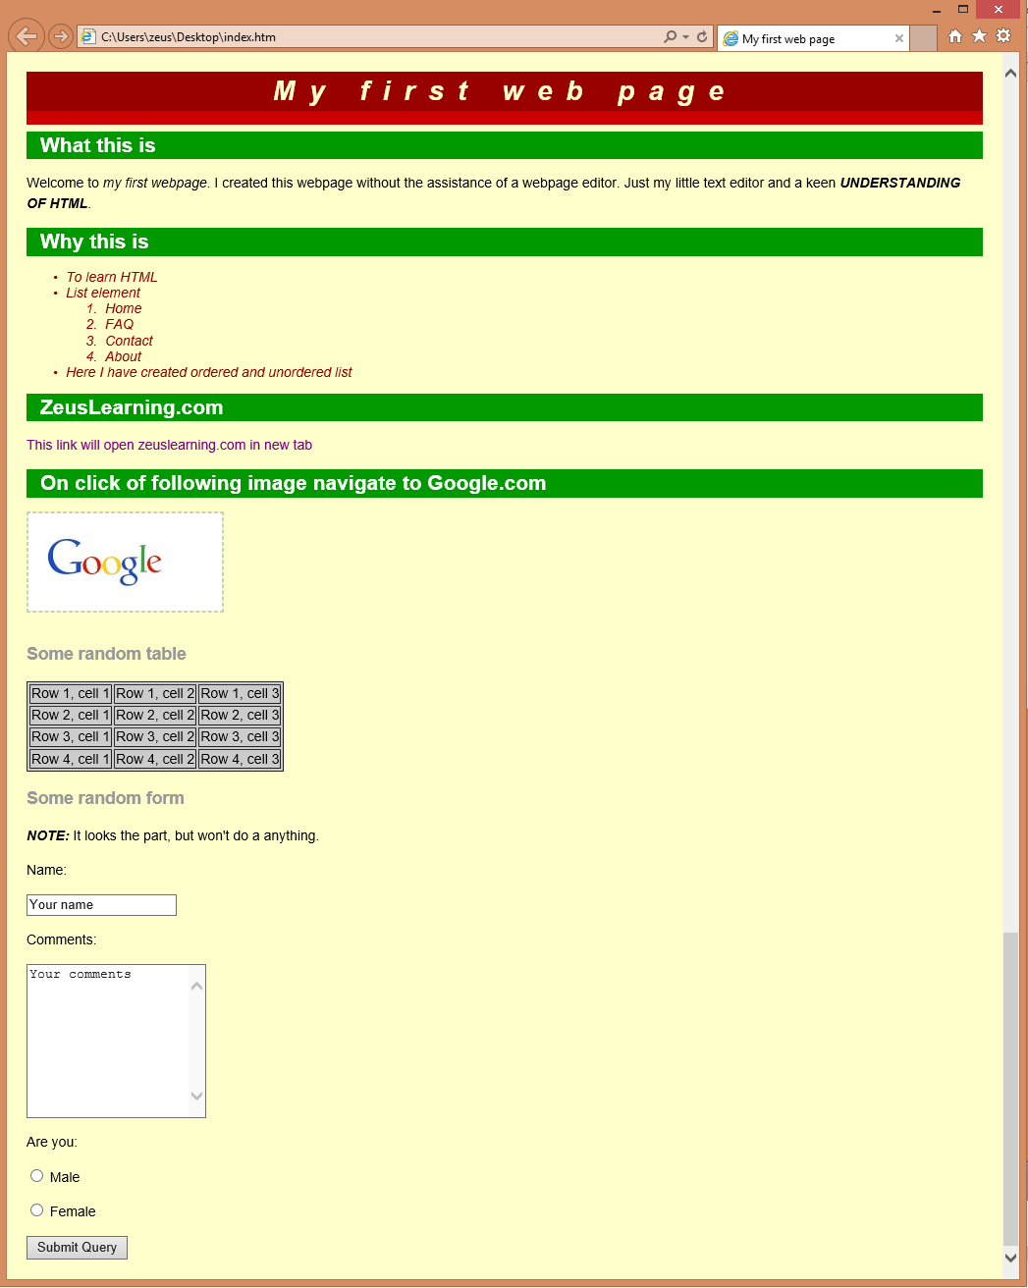

JavaScript
- List down ways in which JavaScript command can be added to a web page, what is the preferred way.
Ans: <script> tag is used to insert javascript code when used in HTML document. There are three ways in which JS can be used in an HTML document.
- Inside body: Scripts can be inserted inside he body section an the function is invoked when button is clicked.
- Inside head: Scripts can be inserted inside the head section and the function is invoked when button is clicked.
- External file : Js can also be added as external files. The file extension is .js . To use an external script put the name of the script file in src attribute of a script tag.
The preferred way of adding javascript to the webpage is external file import, since JS scripts need to be used on multiple pages , so it's best to keep javascript code in separate file and then import when needed.
- To the webpage created in the task 2.d , on click of “Submit” button call JavaScript function to validate:
  - Name and comments fields are not empty.
  - User has selected one entry from male/female radio button
  - In case user has not entered data for name and comment field or not selected anything from male/female radio button – show alert message “All fields are compulsory” and set focus to the first filed that is empty.
Ans: Done and uploaded on github

