In this example, we will take function f(x)= sinc(x) =sin(x)/x;

Given below are first few minima of the function, as we can see clearly at 4.493 we get a global minima (also at -4.493, but from here on we will only consider positive values, however, negative counterpart is also a valid answer).

10.904, 17.221, 23.519, 29.812, 36.101, are some local minima.

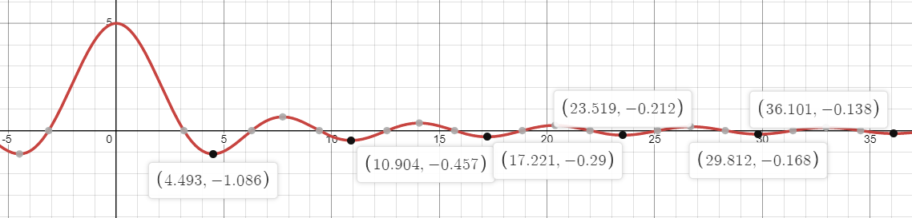

Given a certain initial value (let us assume it to be 20 for this example), our goal is to show that the global minima cannot be reached for any value of alpha.

For every value of alpha, 100 iterations are performed to find minima (local or global). And alpha is being varied from 0.01 to 1 in first case and 1 to 100 in second case.

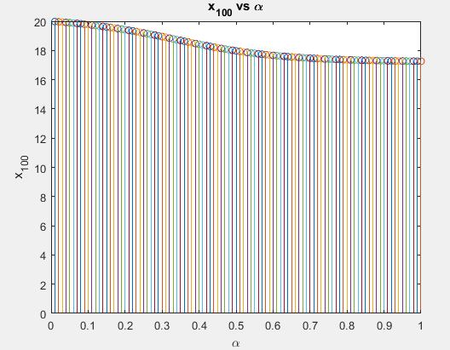

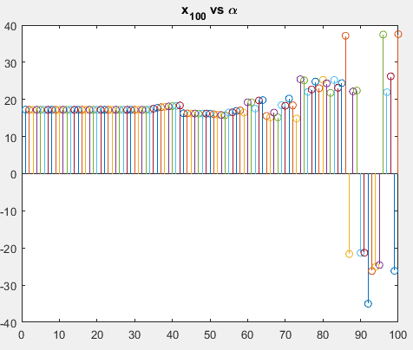

From this we can observe that the x100 converges to its local minima of 17.221 only for 0.5<alpha<40. Alpha less than 0.5, requires more than 100 iterations to converge, and for alpha greater than ~40, x100 doesn’t converge to any minima (this has been verified by changing the number of iterations, the plot of which diverges exponentially and leads to no meaningful data).

We were never able to get a convergent value of global minima for any combination of iterations and alpha.