**WEBPAGE DESIGN**

**FOR LOCATING**

**NATIONAL PARKS IN INDIA**

**M.Tech Module III Mini Project**

Report by

Varsh Rana - ASD

Sushil Kumar Joshi - PRSD

Richa Prajapati - PRSD

Chinmaya Panda - PRSD

April 30, 2015

Guided By

Mr. K. Shiva Reddy

Scientist-SD

Geoinformatics Division

Indian Institute of Remote Sensing



***Abstract:***

In this project we have developed a webpage to show national parks in India (primarily for three states namely Uttarakhand, Madhya Pradesh and Odisha). All the designing work is done through HTML, php, JavaScript, CSS. Google map API is called to show the location of national parks. Along with location, we have also focused on the distance of a particular national park from capital city of the respective state and important attributes associated with the national park which includes its area, flora, fauna etc.

**1. Introduction**

India is one of the 12 mega biodiversity countries in the world. The country is divided into 10 bio-geographic regions. The diverse physical features and climatic situations have formed ecological habitats like forests, grasslands, wetlands, coastal and marine ecosystems and desert ecosystems, which harbor and sustain immense biodiversity. Biogeographically, India is situated at the tri-junction of three realms - Afro-tropical, Indo-Malayan and Paleo-Arctic realms, and therefore, has characteristic elements from each of them. This assemblage of three distinct realms makes the country rich and unique in biological diversity.

National parks in India are IUCN category II protected areas. The strategies for conservation and sustainable utilization of biodiversity have comprised providing special status and protection to biodiversity - rich areas by declaring them as national parks, wildlife sanctuaries, biosphere reserves, ecologically fragile and sensitive areas. India's first national park was established in 1936 as Hailey National Park, now known as Jim Corbett National Park, Uttarakhand. By 1970, India only had five national parks. In 1972, India enacted the Wildlife Protection Act and Project Tiger to safeguard the habitats of conservation reliant species. Further federal legislation strengthening protections for wildlife was introduced in the 1980s. As of April 2012, there were 112 national parks. All national park lands then encompassed a total 39,919 km2 (15,413 sq mi) ,comprising 1.21% of India's total surface area.

India has more than 200 wildlife sanctuaries and about 100 of them are classified as National Parks. However some are better than others and still unexplored. National Parks of India spread across the country offer a fascinating diversity of terrain, which is houses of large number of wild rare and giant animal species. India is a great tourism destination in world. It attracts tourists with its unique cultural and geographical features.

Keeping in mind the importance of national parks, both in terms of economy and bio-diversity conservation, we have developed a webpage which includes the important national parks of Uttarakhand, Madhya Pradesh and Odisha. Along with the location of these national parks on Google map, we have also added the distance of these national parks from their respective capital cities and also the important attribute associated with the national park.

**2. Objective:**

National parks are the assets for a country, especially for a country like India, where there are lot many things to see and admire. This webpage is developed mainly from tourist's point of view, who wants to explore the national parks of India. This webpage provides all possible details, a tourist wants to know, which includes the location, distance from the capital city and the features that make them unique.

**3. Results:**

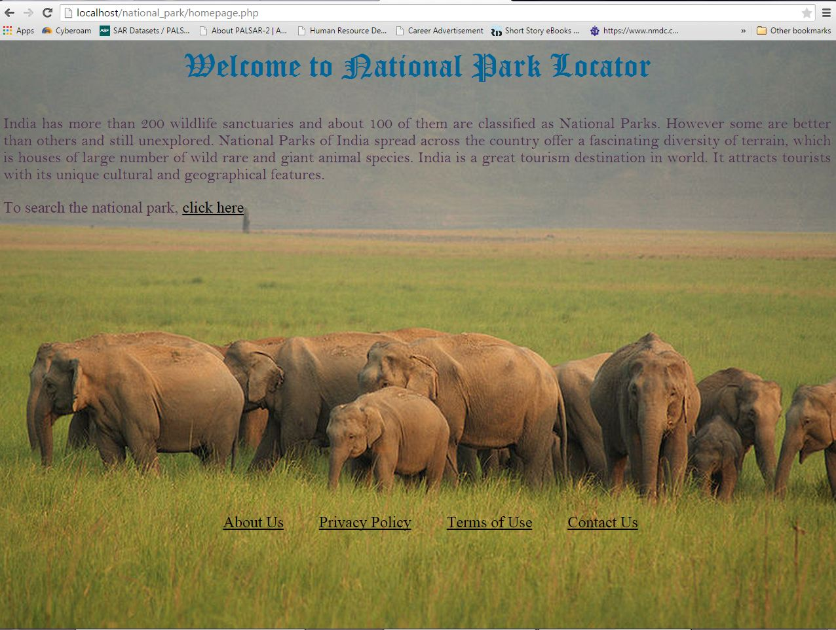The following figures illustrate the results of the web pages developed.

Figure 1. Homepage

Figure 1. shows the homepage includes a short description about national park and a link which navigates to a new page where a state can be selected along with the google map (fig 2).

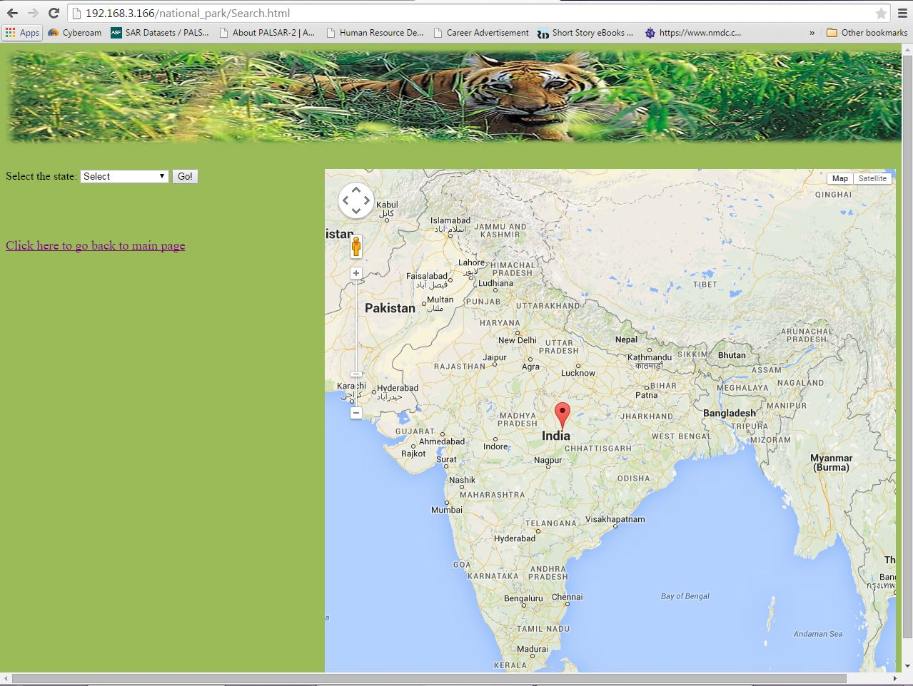

Figure 2. Search page where the state is selected

Once any state is selected, its corresponding national parks are shown on a different page along with its capital and the location of the state on Google map (Figure 3).

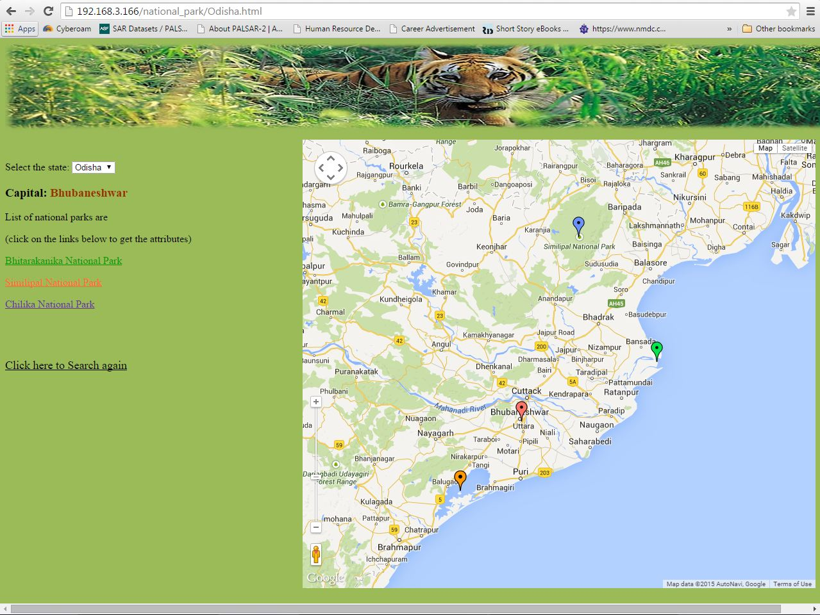

Figure 3. Odisha state with its national parks and capital are shown

Upon selecting any national park, a new webpage opens which includes the important attributes related to that national park and also the distance of the selected national park from its respective capital (Figure 4).

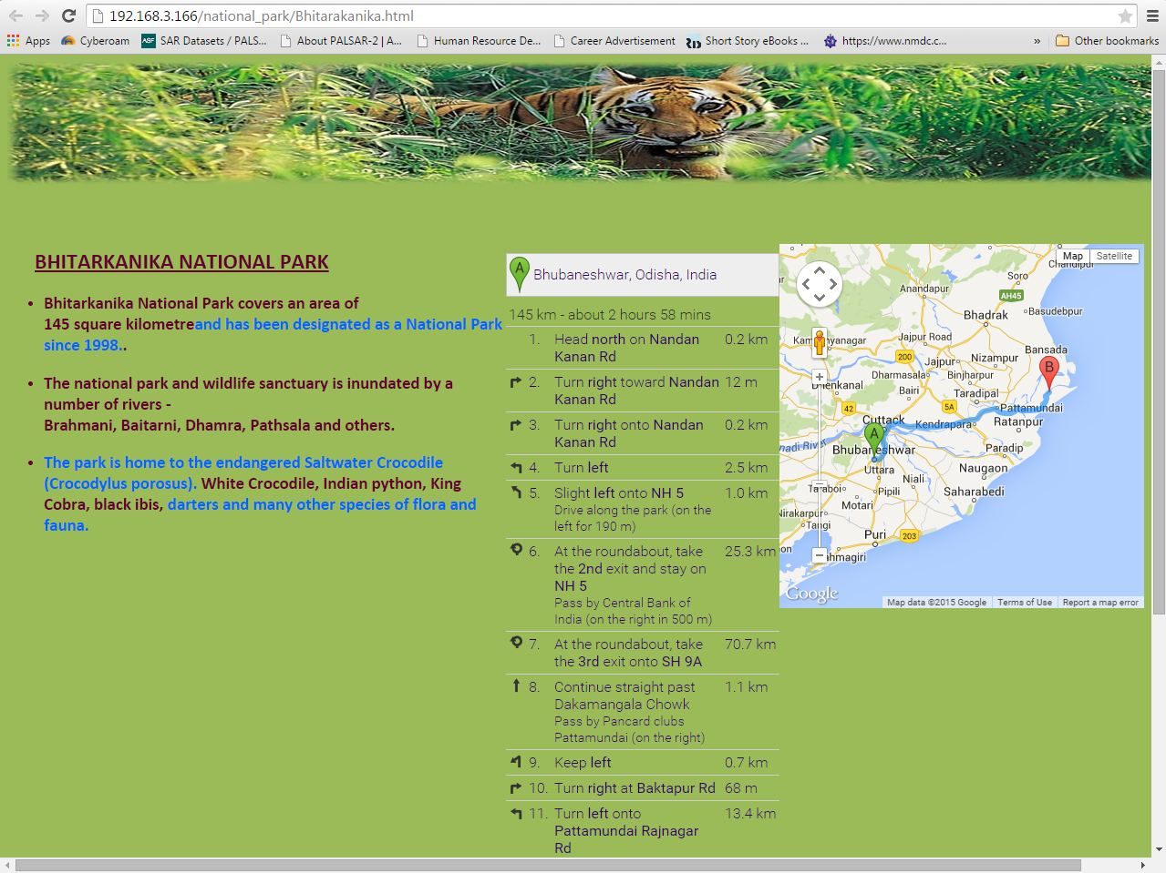

Figure 4. Bhitarkanika national park with its attributes and distance from capital city are shown

**4. Conclusion and future work:**

This webpage is developed for three states though all the states can be included. The pages are static, so the dynamic page can be developed which would make the webpage more simpler. In addition, database can be added so that any user, if wants can add or make any changes on the information provided.