|  |  |  |
| --- | --- | --- |
| ENZYME | FUNCTION | TYPE |
| Cinnamyl alcohol dehydrogenase 5 | The protein is involved in lignin biosynthesis, catalyzing the final step in the synthesis of lignin monomers. Disruption of the cad5 gene causes a reduction in lignin content of the floral stems with a concurrent flaccidity [Sibout05]. | Lignin Biosynthesis |
| Cinnamyl alcohol dehydrogenase 4 | The protein is involved in lignin biosynthesis, catalyzing the final step in the synthesis of lignin monomers.  At-cad4 |  |
| Cellulose J/ endoglucanase J/ endo-1,4-β-xylanase | It hydrolyzed various cellulosic substrates, xylan and lichenan, but not p-nitrophenyl-β-D-cellobioside, p-nitrophenyl-β-D-glucopyranoside, or p-nitrophenyl-β-D-xylopyranoside. The enzyme was active on avicel, a microcrystalline cellulose, and the specific activity with it (0.0078 U/mg protein) was comparable to that of cellulose 1,4-β-cellobiosidase (reducing end), the most important catalytic subunit of the C. thermocellum cellulosome [Ahsan97]. Cel44A also has xyloglucanase activity [Najmudin06]. This broad substrate recognition indicates that Cel44A plays a central role in the early stages of cellulose degradation. The CBM44 carbohydrate-binding module binds with equal affinity to cellulose and xyloglucan. The CBM30 domain has strong affinity for cellulose and β-1,3-1,4-mixed glucan such as barley beta-glucan and lichenan [Arai03]. | Cellulase |
| Cellulose 1,4-β-cellobiosidase (reducing end) | A study of CelS showed that indeed the enzyme liberates cellobiose units from the reducing end of cellulose by hydrolysis of the glycosidic bond following an inverting reaction mechanism. This is different from the celK-encoded exocellulase, which removes cellobiose from the non-reducing end of the molecule [Saharay10]. The structure revealed that the exoglucanase CelS and the endoglucanase CelA utilize the same catalytic machinery to hydrolyze the glycosidic linkage, despite a low sequence similarity and a different endo/exo mode of action. | cellulase |
| Cellulose 1,4-β-cellobiosidase (non-reducing end) | The gene can digest amorphous and crystalline cellulose, as well the soluble polysaccharides lichenan, glucomannan, and barley β-glucan [Kataeva01]. The protein is more abundant in cells grown with cellulose than in cells grown with cellobiose [Gold07]. The recombinant enzyme hydrolyzed p-nitrophenyl-β-D-cellobioside with a Km and a Vmax of 1.67 μM and 15.1 U/mg, respectively [Kataeva99]. | cellulase |
| Feruloyl esterase/ endo-1,4-β-xylanase XynY | Feruloyl esterases are believed to aid in a release of lignin from hemicellulose. | Ligninase (?) |
| Endo-β-1,4-glucanase XghA | The purified enzyme showed a high specific activity with barley β-glucan and with tamarind xyloglucan. The nature of the products of barley β-glucan degradation is not well characterized, but relatively large oligosaccharides were formed and did not degrade any further. The enzyme showed marginal activity with carboxymethyl cellulose and with glucuronoxylan, and no activity with 1,3-β-glucan [Zverlov05a]. The enzyme depolymerized xyloglucan completely, forming mostly cellotetraose units with the composition of the hepta- to nonaglycosides XXXG, XLXG (or XXLG) and XLLG as major products (see a xyloglucan for explanation of this terminology) [Zverlov05a]. Incubation of purified cellulosomes with xylogluca produced identical cellotetraose units, suggesting that these units are not further degraded by any glycosidase present in the cellulosome [Zverlov05a]. | cellulase |
| Β-glucosidase Bgl2 | The bgl2 gene was cloned and expressed in Escherichia coli, and the recombinant protein was purified and analyzed [Saloheimo02]. It was shown to be a specific β-glucosidase, and unlike a previous report, it had no β-galactosidase side activity. It could hydrolyze both cellotriose and cellotetraose. The enzyme also exhibited transglycosylation activity, and produced cellotriose from β-D-cellobiose and sophorose and cellobiose from glucose. Unlike Bgl1, Bgl2 is an intracellular enzyme [Saloheimo02]. | Hemicellulose/cellulase |
| Cellulose VII | Endoglucanases randomly degrades the internal bonds of the amorphous region of cellulose and efficiently degrade substituted substrates like barley β-glucan and carboxymethyl cellulose. The gene contains a glycoside hydrolase family 61 (GH61) domain, the second one found in the organism (the first one is cellulase EG IV). Unlike cellulase EG IV, this enzyme does not contain a cellulose-binding domain [Karkehabadi08]. | cellulase |
| laccase | The role of this enzyme in planta is still under investigation. LAC4 transcripts are expressed in Arabidopsis interfascicular fibers and vascular bundles where this enzyme may play a role in the oxidoreductase reactions required for the polymerization of lignin monomers (see monolignol glucosides biosynthesis). The potential role of this enzyme in lignin biosynthesis is further supported by the observation that lac4 mutants have reduced lignin levels [Berthet11]. | ligninase |
| Lignin peroxidase A | lignin peroxidases (LiPs) are monomeric hemoproteins with molecular masses around 40 kDa, and resemble classical peroxidases in that their Fe3+ is pentacoordinated to the four heme tetrapyrrole nitrogens and to a histidine residue. Like the classical peroxidases, LiPs are oxidized by hydrogen peroxide to give a two electron-oxidized intermediate (known as Compound I) in which the iron is present as Fe+4 and a free radical resides on the tetrapyrrole ring. Compound I then oxidizes a donor substrate by one electron, yielding a substrate-free radical and Compound II, in which the iron is still present as Fe+4, but no radical is present on the tetrapyrrole. The process continues when Compound II oxidizes a second molecule of donor substrate, giving another substrate-free radical and restoring the resting state of the peroxidase. Unlike classical peroxidases, LiPs can oxidize aromatic rings that are only moderately activated by electron-donating substituents, such as the major nonphenolic structures of lignin [Hammel08]. | ligninase |
| Manganese Peroxidase 1 | It is the complexed Mn+3 ion, not the enzyme, that oxidizes lignin and other organic substrates [Glenn86]. The purpose of this design is likey to transfer the oxidizing power of the manganese peroxidase to a small agent (the Mn+3 ion) that can diffuse into the lignified cell wall and attack it from within | Ligninase |
| Β-mannosidase | Homodimeric β mannosidase is involved in the hydrolysis of mannan and galacto(gluco)mannans [Ademark01]. Specifically, it is an exoglycosidase that randomly cleaves single β-1,4-linked mannose residues from the non-reducing end of N-linked glycoprotein oligosaccharides. The products can be further degraded by other enzymes | Auxiliary Enzyme |
| Endo-1,3-β-xylanase | A endo-1,3-β-xylanase has been purified to homogeneity from the marine bacterium Vibrio sp. XY-214. The purified enzyme hydrolyzed β-1,3-xylan to produce mainly (1,3)-β-xylotriose and (1,3)-β-xylobiose [Araki99]. It did not act on (1,3)-β-xylobiose, p-nitrophenyl-β-D-xylopyranoside, a (1→4)-β-D-xylan, a 1,3-β-D-glucan, or carboxymethyl cellulose. | Auxiliary Enzyme |
| Carboxymethyl cellulose | Carboxymethylcellulose (CMC) is a cellulose derivative with carboxymethyl groups bound to some of the hydroxyl groups of the glucopyranose monomers that make up the cellulose backbone. It is often used as its sodium salt, sodium carboxymethyl cellulose. Unlike unmodified cellulose, carboxymethylcellulose is soluble in water. | ? |

Table 1: General enzymes involved in bioethanol production

The enzymes given in Table 1 are not specific to fodder grass as a substrate. I have shown in diagram 1 the enzymes used for fodder grass on the analogy that enzyme requirement is on the basis of the polysaccharide content of fodder grasses. Fodder grasses have (34-42) % Cellulose, (20-25) % Hemicellulose and (18-23) % Lignin. Ash content is between 0.5% and 2%. The following Sunburst shows the division and the enzymes used for their respective substrates.

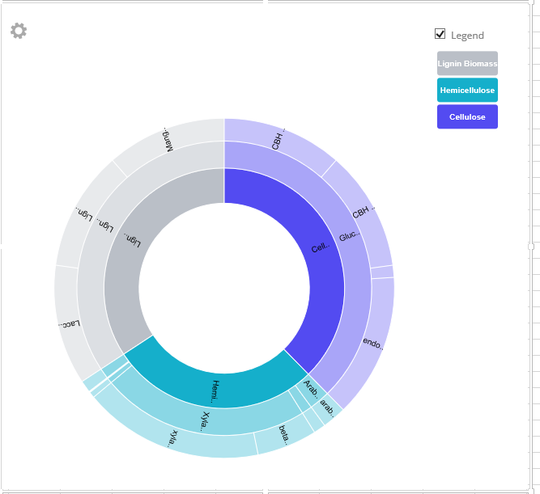

The interactive excel sheet can be downloaded from the website.

Although singular application of enzymes on the basis of composition is effective, it has been seen combinations have resulted in better yield. For example, only endoglucanase for cellulose results in inhibition after some time. It can be prevented by using beta glucosidase along with endoglucanase so as to prevent inhibition. The following flow web provides possible combinations for higher yield of ethanol.

