PROJECT REPORT

Breast Cancer Diagnosis Predictor: An Educational Machine-Learning Classification Application
An Educational Machine-Learning Classification Application

Submitted by:
Chinmaya Pattnaik

Live app link: Breast Cancer Predictor
GitHub repository: Chinmaya1909/AI-and-ML-in-healthcare-project: project submission

6th October 2026

Abstract
This project developed an end-to-end machine-learning application for classifying breast-tumour samples as malignant or benign. The Breast Cancer Wisconsin dataset available within scikit-learn was used because it is a well-structured educational dataset with numerical tumour measurements. The workflow covered data loading, exploratory analysis, missing-value checks, feature scaling, train/test splitting, training Logistic Regression and Random Forest classifiers, evaluating models, saving the selected model, and developing a Streamlit web interface. In the sample run, Logistic Regression achieved 98.25% test accuracy and was selected for deployment. The resulting application provides an interactive educational demonstration of how healthcare-related tabular data can be processed for binary classification.

1. Introduction
Machine learning is increasingly used to support pattern recognition in biological and healthcare data. This capstone project applies supervised learning to breast-tumour measurement data and demonstrates the complete workflow required to transform a dataset into a simple interactive web application. The focus is not on clinical use; rather, it is on understanding data preparation, model training, evaluation, reproducibility, and responsible deployment.

2. Project Objective
The objective was to build a binary classification model that predicts whether a breast-tumour sample is classified as malignant or benign from 30 numerical diagnostic features. A secondary objective was to deploy the selected model through a Streamlit interface so that a user can enter feature values and receive an educational prediction.

3. Dataset Description
The project used scikit-learn’s built-in Breast Cancer Wisconsin dataset, loaded using load_breast_cancer(as_frame=True). The dataset has 569 observations and 30 numerical predictor variables. The measurements describe properties of cell nuclei present in digitised images of a fine-needle aspirate of a breast mass. Examples include radius, texture, perimeter, area, smoothness, compactness, concavity, symmetry, and fractal dimension. The target variable has two classes: 0 = malignant and 1 = benign.

4. Data Preparation
The dataset was inspected using shape, descriptive statistics, class counts, and missing-value checks. No missing values were present. The dataset was separated into input features (X) and target labels (y), then divided into training and test sets using an 80:20 split, random_state=42, and stratification. StandardScaler was fitted only on the training features and then applied to training and test data for the Logistic Regression model. This order is important because fitting the scaler before splitting could leak information from the test set into training.

5. Model Development
Two classification algorithms were compared. Logistic Regression was used as a baseline linear classifier after feature standardisation. Random Forest Classifier was used as a nonlinear ensemble comparison model with 300 trees and class_weight="balanced". Both models were trained on the same train/test split. Performance was measured using accuracy, precision, recall, F1-score, ROC-AUC, a classification report, and a confusion matrix.

6. Results and Interpretation
In the project run, Logistic Regression achieved the strongest overall test-set result and was chosen as the final model. It achieved 98.25% accuracy, with precision, recall, and F1-score of 98.61%, and an ROC-AUC of 99.54%. The Logistic Regression confusion matrix was [[41, 1], [1, 71]], indicating that one malignant and one benign sample were incorrectly classified among 114 test observations. Random Forest also performed strongly but had lower test accuracy in this particular split. These values should be replaced with the exact results printed in the submitted notebook if they differ.

7. Streamlit Application
A Streamlit application, app.py, was created to load the saved model and scaler, collect the 30 tumor-measurement inputs, and display the predicted class with class-probability estimates. The app includes an educational disclaimer to prevent inappropriate interpretation of its output. During development, Streamlit was run in Google Colab for testing; the intended final deployment route is a public GitHub repository connected to Streamlit Community Cloud.
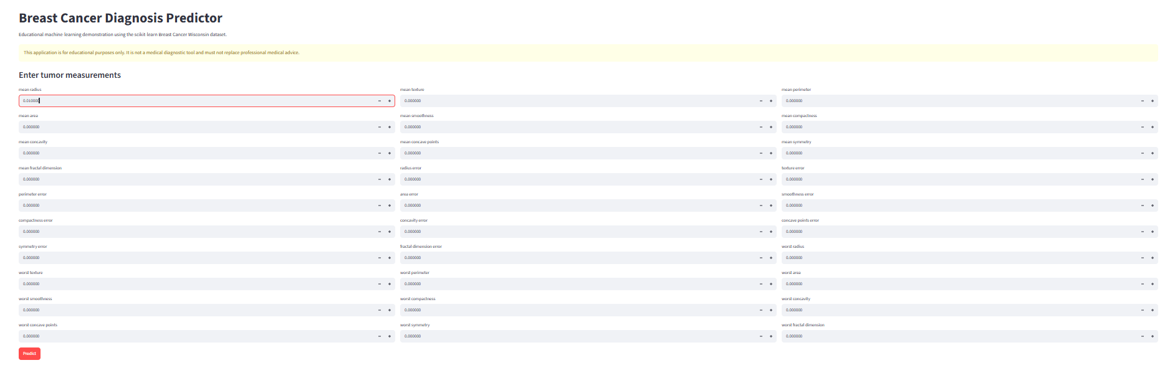

8. Ethical Considerations and Limitations
High test performance on a benchmark dataset does not establish clinical usefulness. The dataset is limited in size and may not represent contemporary, diverse patient populations or clinical workflows. This project has not received external validation, prospective testing, calibration assessment, fairness analysis, regulatory approval, or clinical oversight. Model outputs must never replace pathologist review, clinical examination, laboratory testing, or medical judgment. Any real healthcare implementation would require rigorous privacy protections, governance, validation, monitoring, and compliance with relevant regulations.

9. Conclusion
The project successfully demonstrated the full machine-learning pipeline: data loading, exploration, preprocessing, model comparison, evaluation, serialization, and development of an interactive Streamlit interface. Logistic Regression was selected as the best-performing model in the sample experiment. The project provides a clear foundation for future educational work involving biological, microbiological, drug-screening, or environmental biotechnology datasets.

Dataset Summary
Item | Details
Dataset | Breast Cancer Wisconsin dataset from scikit-learn
Task type | Binary classification
Samples | 569
Input features | 30 numerical diagnostic measurements
Target classes | 0 = malignant; 1 = benign
Data split | 80% training; 20% test
Random seed | 42
Preprocessing | StandardScaler for Logistic Regression

Model Performance
Model | Accuracy | Precision | Recall | F1-score | ROC-AUC
Logistic Regression | 98.25% | 98.61% | 98.61% | 98.61% | 99.54%
Random Forest | 94.74% | 95.83% | 95.83% | 95.83% | 99.37%

References
- scikit-learn. Breast Cancer Wisconsin (Diagnostic) Dataset: load_breast_cancer documentation. https://scikit-learn.org/stable/modules/generated/sklearn.datasets.load_breast_cancer.html
- Streamlit Documentation. https://docs.streamlit.io/
- Wolberg, W. H., Street, W. N., & Mangasarian, O. L. (1995). Machine learning techniques to diagnose breast cancer from fine-needle aspirates. Cancer Letters, 77(2–3), 163–171.

