Andrew Borst

4/11/2016

Instructions for installing git, downloading forked repository (see GitHub instructions), and committing SAS programs to local directory and on github.

1. Download and install git software. No changes to default installation necessary so just click through. This does not require Admin access
   1. <https://git-scm.com/download/win>
2. Open Git Bash program (In Windows 10, type “Bash” in Search panel in the taskbar

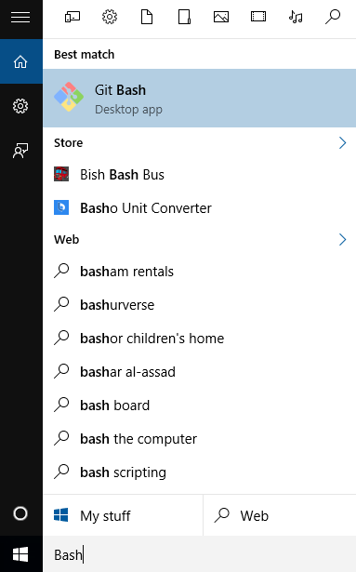

1. Create clone of your forked directory. I did a “cd” command to the H: drive, created a directory using the “mkdir” command, a “git” command to pull from the web url, a “ls” command to see what it created (a SAS folder containing the code), a “cd” command to enter that folder, and a “ls” command to list all of the SAS files.

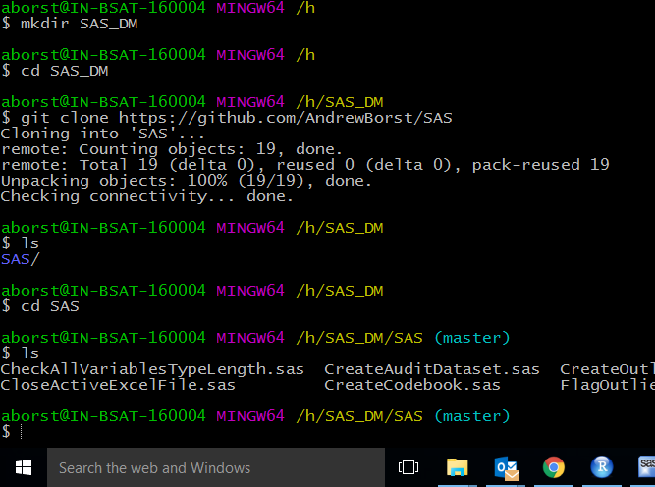

1. Add or edit files to the local repository
   1. In this example, I am adding a file (TREAT_OnCore_Import) to the repository. First copy file over to repository and then issue “git add” command.

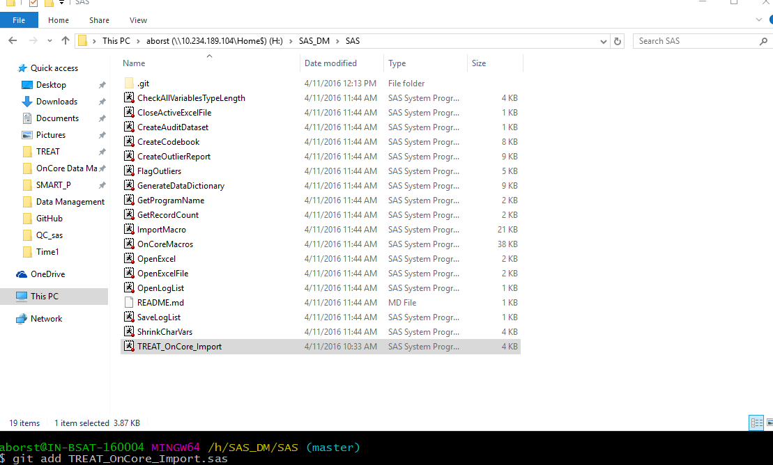

1. Commit changes by issuing “git commit” command. The –m” is to add a message which is used for tracking why you are adding/changing the repository.

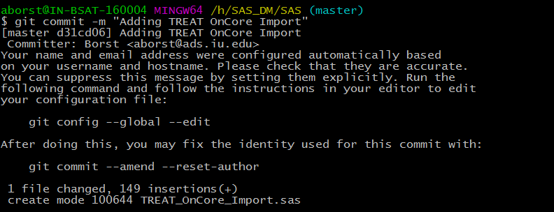

1. Push the changed repository to GitHub. Use “git push origin master” command. It is the second command issued below. The first command checks what URLs are associated with names (in this case origin is associated with my URL for the SAS repository).

