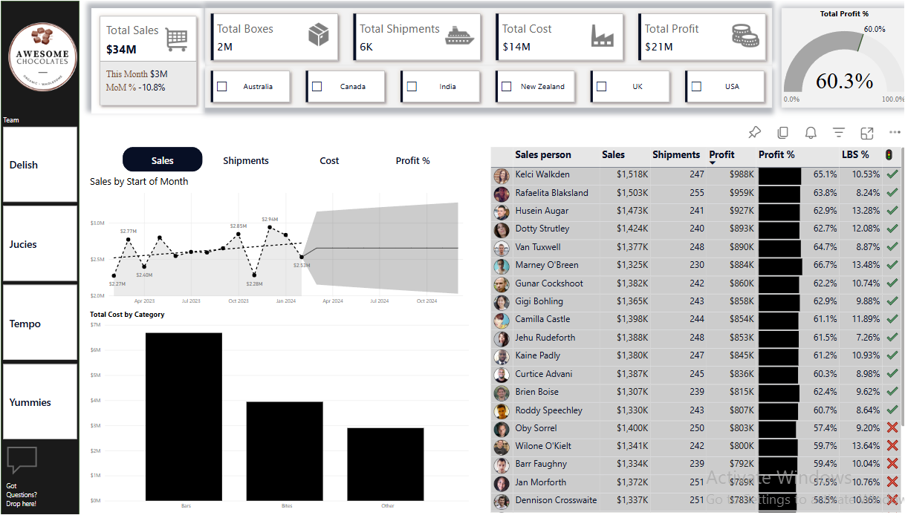

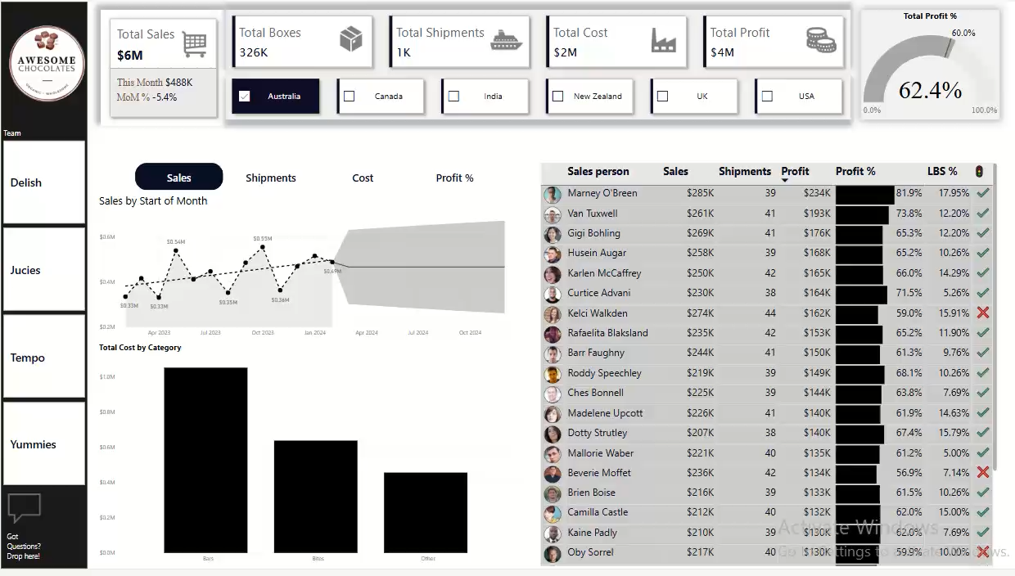

Interactivity of the dashboard:
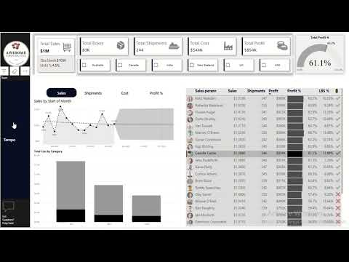

What did I do?
- Dax Measures: 10+ measures created
- Separate space for all the Measures for better accessibility
- Gauge Visual
- 1 slicer for controlling only the line chart consisting of sales, shipment, cost, profit without interactivity for the rest of the dashboard
- Time Series Forecasting: Line Chart with forecasting
- Trendline
- MoM change %
- LBS: LOW BOX SHIPMENTS < 50 boxes (Sample)
- Conditional formatting
- Dynamic trend
- Bar chart
- Field Parameters
- Table Design
- Salesperson Picture in table
- Sales, Profits in “K” (thousand)
- Data Bars inside a column in a table
- Alert Icons
- Consistent Colour throughout the dashboard
- Company Logo for more professional look
- Tooltips
- Slicers
- Cards (new)
- Embedded Images inside Cards
- KPI in Cards
- Q & A button

