Implementation of priority queue:

Included the header files then created a structure student with two structure members i.e. name array of character type and score to integer datatype. Then created the global variables.

Following are the various functions used in the program and a brief on what they do :-

1. insert(): This function first checks for the overflow condition, if there is no space in the queue then it will simply return. Else it takes the student credentials as user input and according to the priority of the GATE score it places the student record in the queue.
2. delete(): This function checks for underflow conditions. If the conditions fail then it will delete one student record with the lowest GATE score among all present in the queue. Else if the condition is true then it returns to the main function.
3. display(): This display function shows the data stored in the queue as per the priority from low to high GATE score.
4. main(): The program execution starts from the main function. The user is given various options to choose and as per their choice the respective actions are done.

OUTPUT :-

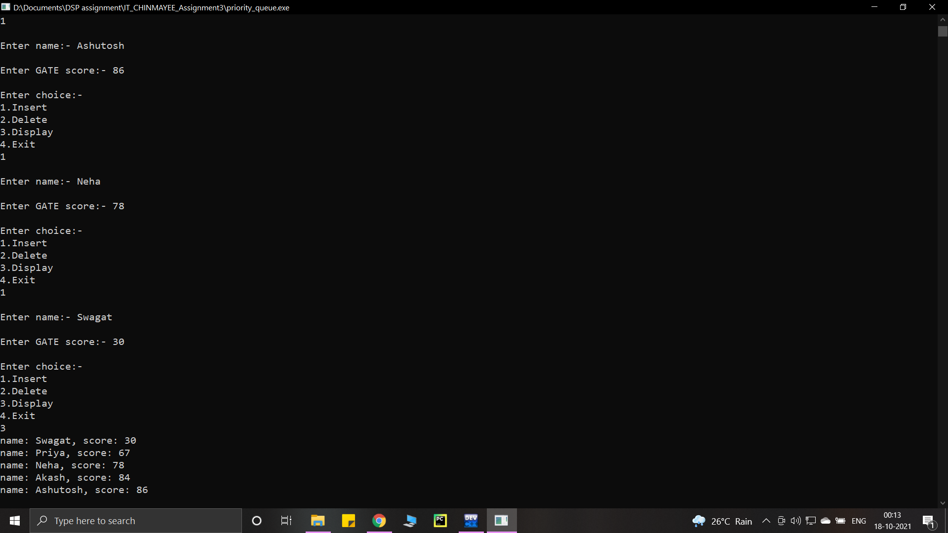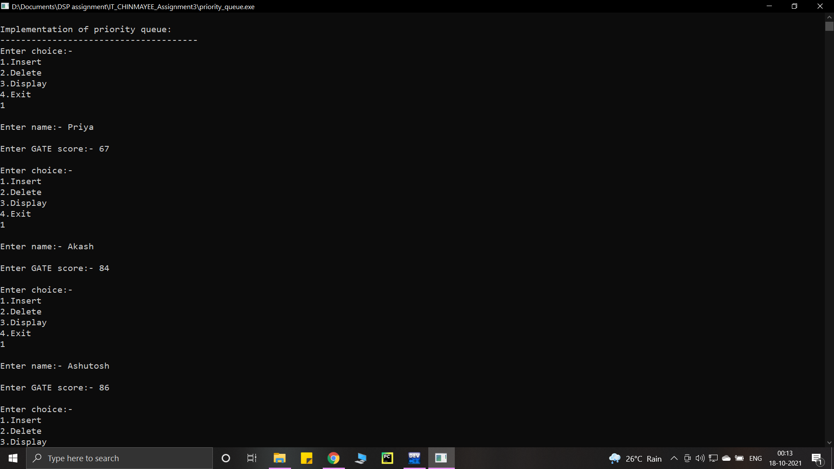

(Boundary cases)

