Indian Institute of Foreign Trade
MA Economics 2025–27 | Investment Theory
Project Assignment
Machine Learning Trading Strategy and Risk-Aware Portfolio Construction
A QuantConnect study of ten NYSE securities (1 January 2023 – 1 January 2026)
Contents
Executive summary
1. Project set-up, data and methodology
2. Security overview and ten key statistics
3. Daily returns of the ten securities
4. Next-day price forecasting with XGBoost and LSTM
5. XGBoost trading strategy on AAPL
6. Equally weighted buy-and-hold portfolio versus the NYSE index
7. Monthly-rebalanced minimum-variance portfolio, choice and improvements
8. Overall conclusions
9. Assumptions and limitations
Appendix A: Monthly minimum-variance weights
Appendix B: Code files submitted

Executive summary
This report answers the Investment Theory project assignment using ten NYSE securities (AAPL, MSFT, JPM, LLY, TGT, AOS, NOG, POR, FDX, PYPL), daily data from 1 January 2023 to 1 January 2026 and an initial capital of $100,000. Analysis and plots were produced in QuantConnect research notebooks (.ipynb) and every trading strategy was tested in a QuantConnect backtest (main.py). The main findings are:
- Data. Each security has 752 daily observations and there are no missing values. All results below use only this window.
- Security comparison (Q1a). LLY delivered the highest return (+201.66%) and JPM the best risk-adjusted return (Sharpe 1.49). TGT (−28.48%), PYPL (−21.54%) and NOG (−13.63%) lost money; NOG was the most volatile (41.87% a year) and POR the least (20.11%).
- Forecasting (Q1c). For AAPL and MSFT the LSTM had mean absolute errors of 5.01 and 17.43 dollars against 11.70 and 53.19 for XGBoost. XGBoost flat-lines once prices move above the range it saw in training.
- Strategy (Q1d). The XGBoost long/short strategy on AAPL earned +5.30% in three years (1.74% a year, Sharpe −0.41 in QuantConnect), far below buy-and-hold AAPL (+120.65%). It is not an attractive strategy as specified.
- Equal-weight portfolio (Q2i). It returned +62.88% against +45.20% for the NYSE Composite, but with higher volatility (16.23% against 13.11%) and a deeper maximum drawdown (−24.72% against −15.22%).
- Minimum-variance portfolio (Q2ii). Rebalanced monthly with a 5% floor per stock, it returned +70.55% with 14.50% volatility, a Sharpe ratio of 1.31 and a maximum drawdown of −18.10%, beating the equal-weight portfolio on every return and risk measure. The QuantConnect backtest confirms this (+69.47%, drawdown 17.9%).
- Choice (Q2iii). We would choose the minimum-variance portfolio, but with a cap on the weight of any single stock, because from mid-2025 it held about 44% of the portfolio in a single utility (POR) and put eight of the ten stocks at the 5% floor.

1. Project set-up, data and methodology

1.1 Objectives and how the report is organised
The assignment has two questions. Question 1 applies machine learning to stock-market decisions: describe and compare the securities, plot their returns, forecast next-day closing prices with XGBoost and LSTM for two securities, and back-test an XGBoost trading strategy on one of them. Question 2 builds portfolios that balance risk and return: an equally weighted buy-and-hold portfolio compared with the NYSE index, and a monthly-rebalanced portfolio built with a technique of our choice. Each section of this report corresponds to one sub-question, explains why each step was taken, and shows every required graph. Appendix B lists the code files that accompany the report.

1.2 Tools and why two kinds of QuantConnect code were used
We used QuantConnect for all work, with two complementary components. Research notebooks (QuantBook, .ipynb) were used for data collection, descriptive statistics, plots and machine-learning model development, because notebooks suit exploratory analysis and charting. Backtests (main.py, run on the LEAN engine) were used for every strategy and portfolio, because a backtest simulates orders, fills, fees and margin through time and therefore answers the question “what would this strategy have earned?” more realistically than a calculation on a price table. Where both exist (Q2), the notebook reproduces the backtest as a cross-check.

1.3 Data collection and quality checks
Daily open, high, low, close and volume data for the ten securities were collected from 1 January 2023 to 1 January 2026 through QuantBook. The collection returned 7,520 rows (752 trading days for each of the 10 securities), with the first observation on 3 January 2023 and the last on 31 December 2025 (1 and 2 January 2023 were market holidays). Observations are time-stamped at the close (16:00, or 13:00 on early-closing days such as 24 December 2025). We then pivoted the table into separate date-by-security matrices of close, open and volume prices and checked for gaps: there are no missing observations for any security (Figures 1 and 2). This matters because every later calculation, especially the covariance matrix in Q2, requires a complete and aligned panel. Prices are QuantConnect’s default adjusted prices, i.e. adjusted for splits and dividends, so returns include dividends.
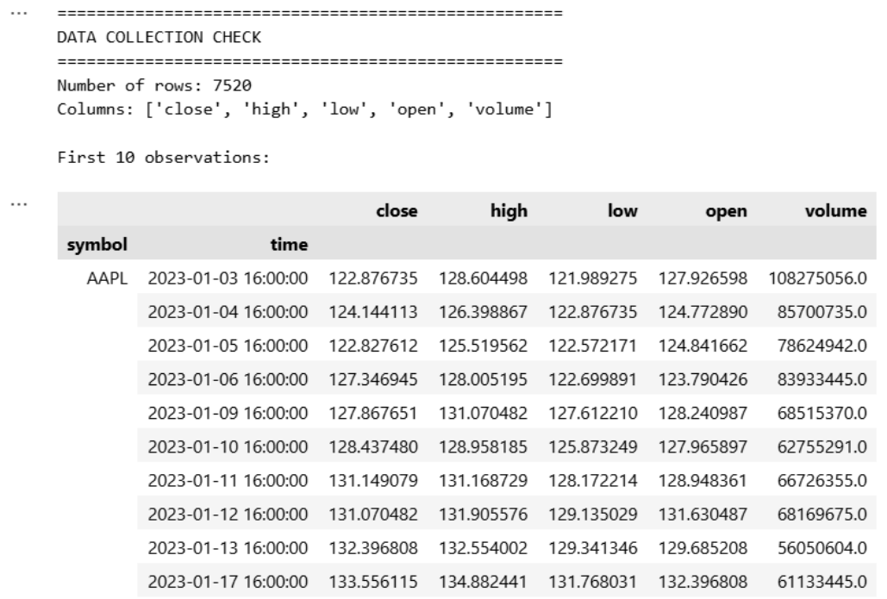
Figure 1: Data collection check: 7,520 rows and the first ten AAPL observations (close, high, low, open, volume).
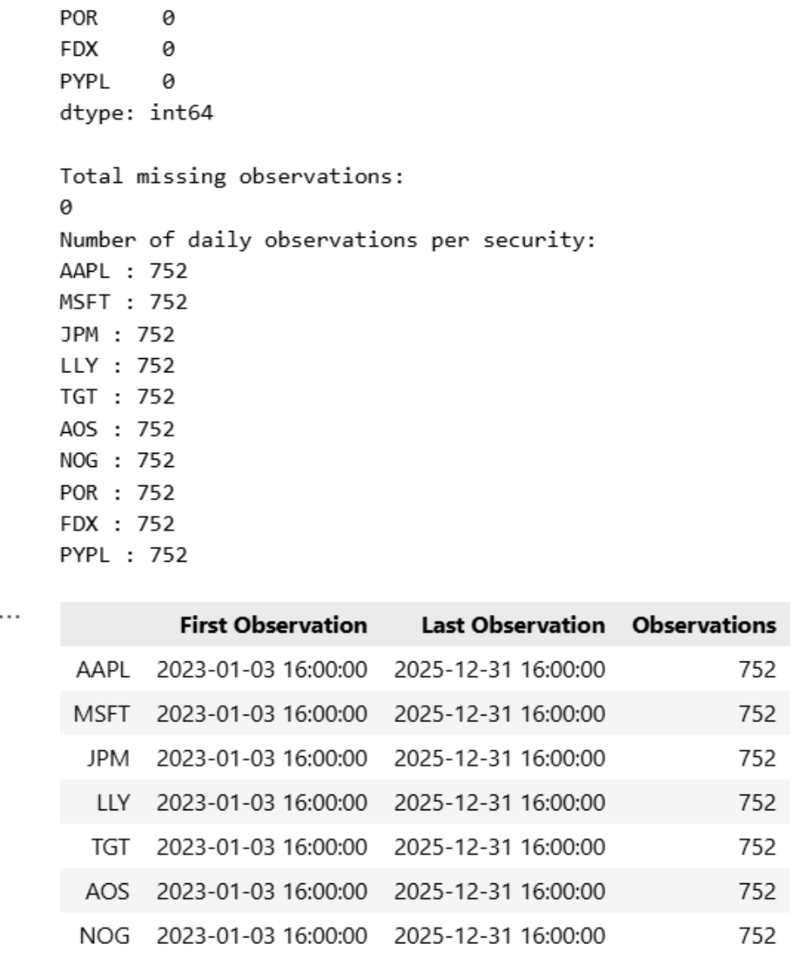
Figure 2: Data quality check: no missing values and 752 observations per security (3 January 2023 to 31 December 2025).

1.4 Two sources of performance statistics
Two kinds of numbers appear in the report and they should not be mixed. The notebook statistics use close-to-close prices, no trading costs, a zero risk-free rate and one common formula for every portfolio and for the NYSE index (definitions are given in Table 2 and in Section 6.1). The QuantConnect backtest statistics come from the official backtest report: they include order fills, fees and QuantConnect’s own calculation conventions (for example, it adjusts for a risk-free rate and measures alpha and beta against its default benchmark, SPY). Therefore the Sharpe ratio, Sortino ratio and volatility in a backtest report differ from the notebook values even for the same portfolio. We compare portfolios against each other within one source and use returns and maximum drawdown, which are largely independent of these conventions, to show that the two sources agree.

2. Question 1(a): Security overview and ten key statistics

2.1 Brief overview of each security
The ten securities cover ten different sectors, which is deliberate in the assignment: it allows diversification effects and sector-specific behaviour to be studied. Table 1 gives a short overview.
Table 1: Overview of the ten securities
Ticker | Company | Sector (assignment) | Business in brief
AAPL | Apple Inc. | Electronic technology | Consumer devices (iPhone, Mac, iPad, wearables) plus software and services such as the App Store and iCloud.
MSFT | Microsoft Corp. | IT | Software and cloud computing (Azure, Microsoft 365) and enterprise services.
JPM | JPMorgan Chase & Co. | Finance | Large US bank: consumer banking, corporate and investment banking, asset management.
LLY | Eli Lilly and Co. | Health | Pharmaceutical company focused on diabetes, obesity and other therapies.
TGT | Target Corp. | Retail | General-merchandise retailer with large-format stores and online sales in the US.
AOS | A. O. Smith Corp. | Electric appliances | Maker of residential and commercial water heaters and water-treatment products.
NOG | Northern Oil and Gas | Energy | Holds non-operated working interests in oil and gas wells in US shale basins.
POR | Portland General Electric | Utility | Regulated electric utility that generates and distributes power in Oregon.
FDX | FedEx Corp. | Transport | Global express, ground and freight logistics.
PYPL | PayPal Holdings | Fintech | Digital payments platform (PayPal, Venmo, Braintree).

2.2 Choice of the ten statistics and why
The assignment lets us choose ten statistics (indicators, ownership, ratios or other factors). We chose ten statistics computed from the same daily price dataset, for three reasons. First, they are directly comparable across sectors, whereas accounting ratios such as price-to-earnings are defined differently for banks, utilities and technology firms and are reported only quarterly. Second, together they describe the level (initial and final price), the reward (total, annualised and mean daily return), the risk (volatility, maximum drawdown, best and worst day) and the risk-adjusted reward (Sharpe ratio) of each security, which is exactly what is needed later to build portfolios. Third, they are reproducible from the data collected in Section 1. Table 2 defines them.
Table 2: Definition of the ten statistics
# | Statistic | Definition | Why it is useful
1 | Initial price | Close on 3 Jan 2023 | Starting point; shows the price scale.
2 | Final price | Close on 31 Dec 2025 | End point of the study period.
3 | Total return | P(T) / P(0) − 1 | Cumulative gain or loss over the period.
4 | Annualised return | (P(T)/P(0))^(1/years) − 1, years = calendar days / 365.25 | Makes returns comparable with annual benchmarks.
5 | Mean daily return | Average of daily simple returns | Average daily reward.
6 | Annualised volatility | Standard deviation of daily returns × √252 | Main measure of total risk.
7 | Sharpe ratio | Mean daily return / daily st. dev. × √252 (risk-free rate = 0) | Return earned per unit of risk.
8 | Maximum drawdown | Largest fall from a previous peak, min(P(t)/running max − 1) | Worst loss an investor would have suffered.
9 | Best daily return | Largest one-day gain | Upside tail.
10 | Worst daily return | Largest one-day loss | Downside tail.

2.3 Results and comparison
Table 3: Ten key statistics of the ten securities (1 Jan 2023 – 31 Dec 2025)
Ticker | Initial price | Final price | Total return | Annual return | Mean daily | Annual vol. | Sharpe | Max draw-down | Best day | Worst day
AAPL | 122.88 | 271.12 | 120.65% | 30.27% | 0.12% | 25.60% | 1.165 | −33.36% | 15.33% | −9.25%
MSFT | 232.51 | 480.57 | 106.69% | 27.46% | 0.11% | 23.20% | 1.166 | −23.73% | 10.13% | −6.18%
JPM | 123.12 | 316.13 | 156.76% | 37.04% | 0.14% | 23.09% | 1.487 | −24.42% | 11.54% | −7.48%
LLY | 354.54 | 1069.51 | 201.66% | 44.62% | 0.17% | 33.53% | 1.273 | −34.39% | 14.80% | −14.14%
TGT | 133.02 | 95.13 | −28.48% | −10.60% | −0.02% | 34.17% | −0.157 | −49.78% | 17.75% | −21.41%
AOS | 54.64 | 65.78 | 20.39% | 6.40% | 0.04% | 25.42% | 0.371 | −34.30% | 13.67% | −9.39%
NOG | 23.45 | 20.25 | −13.63% | −4.78% | 0.02% | 41.87% | 0.092 | −51.35% | 20.14% | −15.18%
POR | 41.29 | 46.44 | 12.47% | 4.01% | 0.02% | 20.11% | 0.297 | −22.62% | 5.26% | −4.94%
FDX | 106.58 | 185.25 | 73.81% | 20.29% | 0.09% | 30.07% | 0.768 | −35.85% | 15.53% | −15.23%
PYPL | 73.76 | 57.87 | −21.54% | −7.79% | −0.01% | 36.07% | −0.043 | −42.05% | 11.39% | −13.17%

The comparison shows five features that shape the rest of the project.
- Large dispersion in outcomes. Total returns range from +201.66% (LLY) to −28.48% (TGT), a spread of about 230 percentage points. Choosing which securities to hold mattered far more than the market as a whole.
- Risk was not always rewarded. NOG was the most volatile stock (41.87%) and had the deepest drawdown (−51.35%) yet lost 13.63%. TGT also fell by almost 50% from peak to trough and ended lower. By contrast JPM had only 23.09% volatility and the best Sharpe ratio (1.487).
- Technology and health care led. AAPL and MSFT each earned about 27–30% a year with a Sharpe ratio near 1.17, and LLY earned 44.62% a year, but with higher volatility (33.53%) than the two technology stocks.
- The utility was the stable asset. POR had the lowest volatility (20.11%), the smallest drawdown (−22.62%) and the narrowest daily range (−4.94% to +5.26%), but only a modest return of 12.47%. This is consistent with a regulated utility and anticipates why a risk-minimising portfolio in Question 2 is attracted to it.
- Fat tails. Single-day moves of 15–21% (TGT −21.41%, NOG +20.14%, TGT +17.75%) are many times the typical daily standard deviation, which warns against treating daily returns as normally distributed.
All statistics describe one three-year period that was favourable to US equities, and the Sharpe ratio assumes a zero risk-free rate, so the rankings should be read as descriptive of this sample rather than as forecasts.

3. Question 1(b): Daily returns of the ten securities
Method and justification. Daily returns were calculated as simple percentage changes of the closing price, r(t) = P(t)/P(t−1) − 1. Simple returns are the natural unit for the portfolio calculations later in the report, and using closing prices keeps one consistent observation per day. The first observation of each security has no previous day, so each series has 751 returns. As the assignment requires, all ten series are plotted on a single graph (Figure 3), and Table 4 summarises them numerically because ten overlapping lines are hard to read individually.
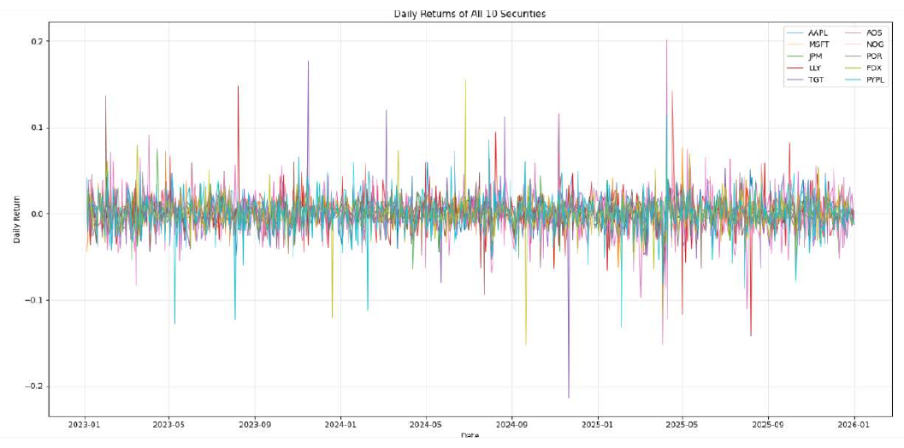
Figure 3: Daily returns of all ten securities, 2023–2025.
Table 4: Summary of daily returns, sorted by volatility
Ticker | Mean daily return | Daily volatility | Minimum | Maximum
NOG | 0.000153 | 0.026373 | −0.151797 | 0.201359
PYPL | −0.000061 | 0.022723 | −0.131661 | 0.113917
TGT | −0.000213 | 0.021526 | −0.214101 | 0.177543
LLY | 0.001694 | 0.021124 | −0.141364 | 0.148033
FDX | 0.000917 | 0.018940 | −0.152302 | 0.155277
AAPL | 0.001183 | 0.016127 | −0.092456 | 0.153288
AOS | 0.000375 | 0.016014 | −0.093908 | 0.136669
MSFT | 0.001073 | 0.014618 | −0.061809 | 0.101337
JPM | 0.001362 | 0.014543 | −0.074838 | 0.115445
POR | 0.000237 | 0.012667 | −0.049449 | 0.052564

Discussion. The returns of all securities fluctuate around zero and are dominated by day-to-day noise, so daily returns on their own say little about the longer-run winners and losers shown in Table 3. Three patterns stand out. First, the ranking by volatility in Table 4 (NOG highest, POR lowest) matches the annualised volatility in Table 3, confirming that the calculations are consistent. Second, the largest spikes are mostly idiosyncratic, for example the −21% day for TGT in late 2024, which is typical of a company-specific event such as an earnings announcement; these appear as isolated spikes of a single colour. Third, there is a cluster of large moves in early April 2025 across many securities at the same time, which indicates a market-wide shock (it coincides with the sharp sell-off and rebound that followed the US tariff announcements) rather than company news. Such common shocks cannot be diversified away completely, which explains why portfolio drawdowns in Question 2 also peak in April 2025.

4. Question 1(c): Next-day price forecasting with XGBoost and LSTM

4.1 Choice of securities
We chose AAPL and MSFT. Both are very large, liquid and heavily traded stocks, which makes their daily prices smoother and less affected by thin trading, and both showed a clear upward trend with a strong later rally, which gives the models a demanding but meaningful test. Choosing two stocks from the same sector also allows a clean comparison of the two algorithms rather than of two industries. AAPL was subsequently used for the trading strategy in Section 5, since the assignment requires the strategy to use one of the securities chosen here.

4.2 Problem set-up and justification of each step
- Prediction target. The next trading day’s closing price, as required.
- Features. The previous 20 daily closing prices (a 20-day look-back, roughly one trading month). A month is long enough to capture short-term momentum and mean reversion but short enough to leave 732 training and test samples out of 752 observations.
- Chronological 80/20 split. The first 80% of samples (585 samples, January 2023 to about the end of May 2025) train the models and the last 20% (147 trading days, early June to 31 December 2025) test them. We did not shuffle the data, because shuffling would let the models see the future when predicting the past; a time-ordered hold-out mimics real forecasting. The same split and dates are used for both algorithms so their errors are comparable.
- Evaluation. Mean absolute error (MAE) and root mean squared error (RMSE), both in dollars. MAE is the average miss; RMSE penalises large misses more heavily.

4.3 XGBoost
XGBoost builds many small decision trees one after another, each correcting the errors of the previous ones. We used it because it handles non-linear relationships, needs no feature scaling and trains quickly. The settings were fixed, conventional values chosen to limit overfitting on a small sample: 300 trees, maximum depth 4, learning rate 0.05, 80% row sampling and 80% column sampling per tree, squared-error objective, and a fixed random seed (42) for reproducibility.

4.4 LSTM
A Long Short-Term Memory network is a recurrent neural network designed for sequences: its gates let it keep or forget information over many time steps, which suits time series. Prices were first scaled to the range 0–1 with a Min–Max scaler, because neural networks train poorly on raw values in the hundreds, and the forecasts were converted back to dollars before computing errors. The network has two LSTM layers (64 units returning sequences, then 32 units), each followed by 20% dropout to reduce overfitting, and a single-neuron output layer. It was trained with the Adam optimiser on squared error for 20 epochs with batch size 32, using the last 10% of the training samples (without shuffling) as a validation set.

4.5 Results
Table 5: Out-of-sample forecast errors (test period: early June to 31 December 2025)
Security | XGBoost MAE ($) | XGBoost RMSE ($) | LSTM MAE ($) | LSTM RMSE ($)
AAPL | 11.70 | 17.00 | 5.01 | 6.53
MSFT | 53.19 | 55.99 | 17.43 | 19.22

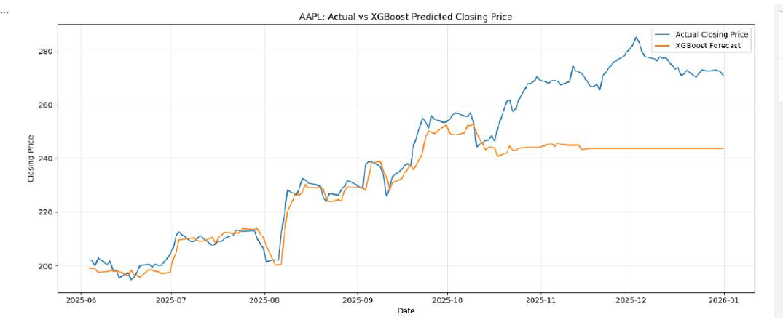
Figure 4: AAPL: actual versus XGBoost-predicted closing price on the test set.
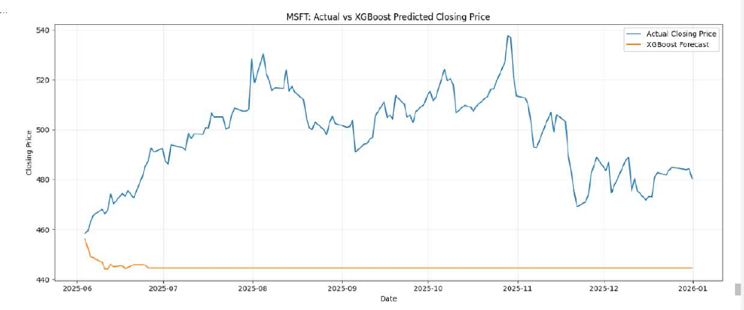
Figure 5: MSFT: actual versus XGBoost-predicted closing price on the test set.
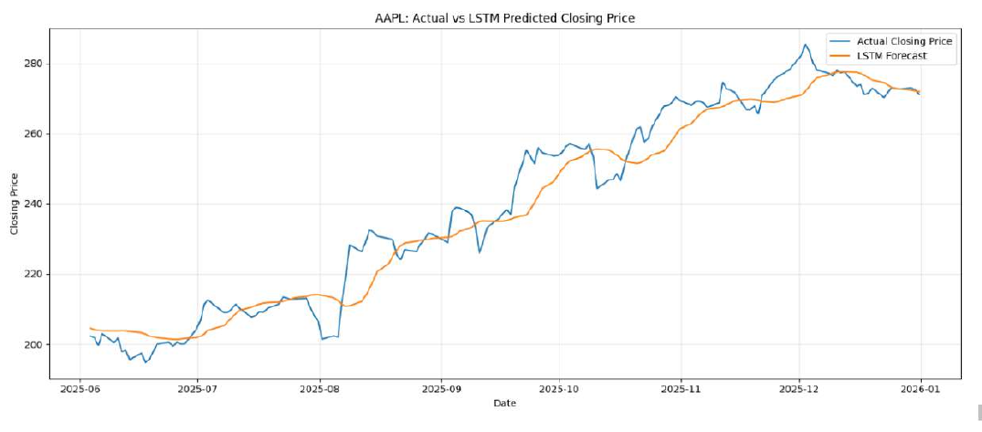
Figure 6: AAPL: actual versus LSTM-predicted closing price on the test set.
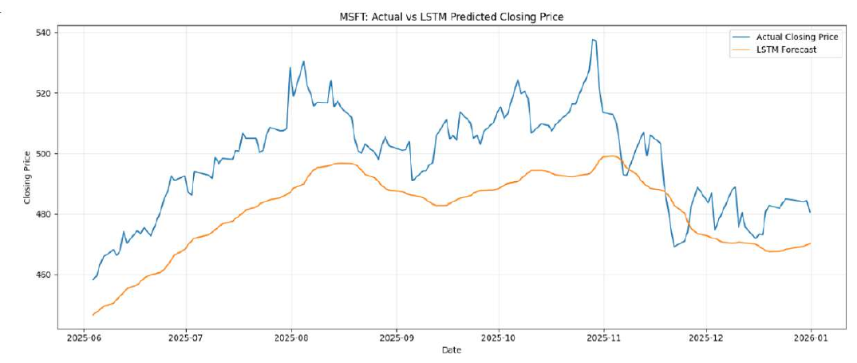
Figure 7: MSFT: actual versus LSTM-predicted closing price on the test set.

4.6 Discussion
The LSTM is clearly more accurate on both stocks. Its MAE is 57% lower than XGBoost’s for AAPL (5.01 against 11.70) and 67% lower for MSFT (17.43 against 53.19); RMSE falls by 62% and 66%.
XGBoost forecasts flat-line when prices leave the training range. For AAPL (Figure 4) the forecast follows the actual price closely until about October 2025 and then stays almost horizontal near 244 while the actual price continues to about 285. For MSFT (Figure 5) the forecast is flat near 444–445 from late June onward while the actual price trades between roughly 470 and 538, which explains the very large error. This is a known property of tree-based models: each prediction is an average of training targets, so a tree model cannot forecast a price higher than the levels it saw in training. Because both stocks reached new highs during the test period, XGBoost could not follow them. The model is therefore good at interpolating within a price range but unreliable for trending prices when raw price levels are used as inputs.
The LSTM tracks the trend but lags and smooths. For AAPL (Figure 6) it follows the rally and converges on the actual price by December, but it reacts late to turning points. For MSFT (Figure 7) it captures the shape of the rise and fall but underestimates the level by roughly 10–25 dollars for much of the period. Lag at turning points is typical: the network learns from the previous 20 days, so it cannot anticipate a reversal.
Interpretation. A small price-level error does not by itself mean that a model can predict the direction of tomorrow’s move, because daily prices are highly persistent and a forecast close to yesterday’s price already looks accurate on a chart. This distinction matters for the trading strategy in Section 5, where only the predicted change of at least 0.5% triggers a trade.
Limitations. The test period is short (147 days), results come from a single split, and we did not compute a naive “tomorrow equals today” benchmark or directional accuracy. The Min–Max scaler for the LSTM was fitted on the full sample, so the LSTM’s scaling range already reflects test-period prices; this may flatter the LSTM relative to XGBoost, and a stricter set-up would fit the scaler on the training data only.

5. Question 1(d): XGBoost trading strategy on AAPL

5.1 Strategy rules and how each was implemented
The strategy trades AAPL every day at the market open. Half of the $100,000 ($50,000) is set aside as the margin reserve and the other half is the trading capital. If XGBoost predicts that today’s close will be at least 0.5% above yesterday’s close, the strategy buys at the open and sells as soon as the price reaches 0.5% above the buying price, however many days that takes. If the prediction is at least 0.5% below, it sells short at the open and buys the position back on the same day. Otherwise it holds cash. Table 6 shows how each rule was implemented in main.py and why.
Table 6: Mapping of the strategy rules to the QuantConnect implementation
Rule | Implementation | Justification
Security | AAPL, minute resolution. | AAPL was one of the two securities forecast in Q1(c). Minute data are needed to detect when the intraday target price is touched and to act at the open and just before the close.
Daily signal | Every day at 09:00, 30 minutes before the open, XGBoost is retrained on all closes since 1 Jan 2023 (at most the latest 504 days). The model uses the previous 20 closes to predict the next close and compares it with yesterday’s close. | Retraining each morning uses only information available at that time, so there is no look-ahead. The data window starts on 1 Jan 2023 as the assignment requires.
Thresholds | Predicted return ≥ +0.5% gives LONG; ≤ −0.5% gives SHORT; otherwise CASH. | Direct translation of the assignment rule.
Entry at the open | A market-on-open order is submitted at 09:25. | A market-on-open order is the order type that executes at the opening price, which is what “at the opening of stock market” requires.
Long exit | When the entry fills, a limit sell order is placed at entry price × 1.005, rounded up to the cent. It stays active across days until filled. | A limit order fills as soon as the price reaches the target. Rounding up ensures the target is never below +0.5%. Keeping it active implements “sell as soon as the price goes above 0.5% in future”.
Short exit | Any short position is bought back with a market order at 15:55, five minutes before the close. | Settles the short on the same day as required; the five-minute margin ensures the order executes before the market closes.
Margin and capital | Margin account; position size is based on $50,000 of trading capital; the other $50,000 remains untouched as the reserve. | Short selling requires a margin account. Using only half the capital for position size follows the assignment and keeps ample collateral.
Position size | Shares = $50,000 / (1.05 × yesterday’s close), rounded down. | The opening price is unknown when the order is submitted; the 5% buffer prevents the order from costing more than $50,000. In practice the average order was about $47.5k.
One position at a time | No new entry while a position is open. | Keeps exposure within the $50,000 limit.

The model needs at least 40 closing prices before it can generate a signal, so the strategy does not trade during roughly the first two months, which is why the equity curve in Figure 8 starts flat.

5.2 Backtest results
Table 7: QuantConnect backtest statistics of the AAPL strategy
Statistic | Value | Statistic | Value
Start equity | $100,000 | End equity | $105,303.42
Net profit (total return) | 5.30% | Compounding annual return | 1.74%
Sharpe ratio (QuantConnect) | −0.407 | Sortino ratio (QuantConnect) | −0.43
Maximum drawdown | 17.6% | Drawdown recovery | 447 days
Total orders | 406 | Total fees | $472.31
Win rate / loss rate | 54% / 46% | Average win / average loss | 0.34% / −0.34%
Profit-loss ratio | 1.01 | Expectancy | 0.078
Portfolio turnover | 17.38% | Beta (vs SPY) | 0.273

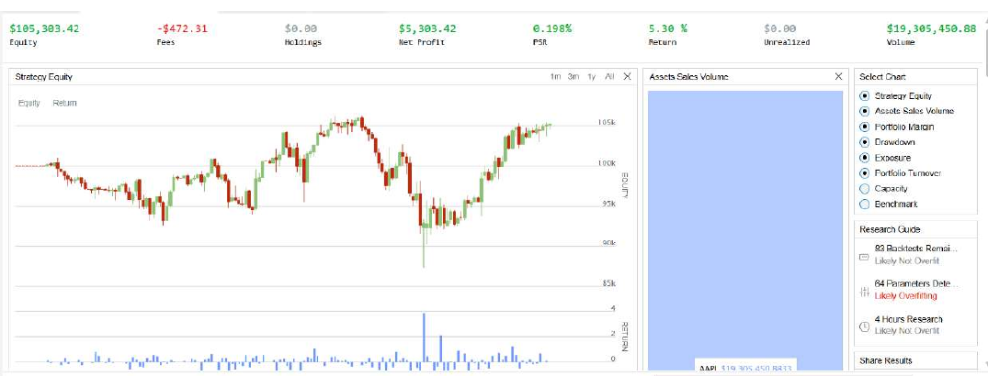
Figure 8: Q1(d) backtest: equity curve and summary (end equity $105,303.42, return 5.30%, fees $472.31).
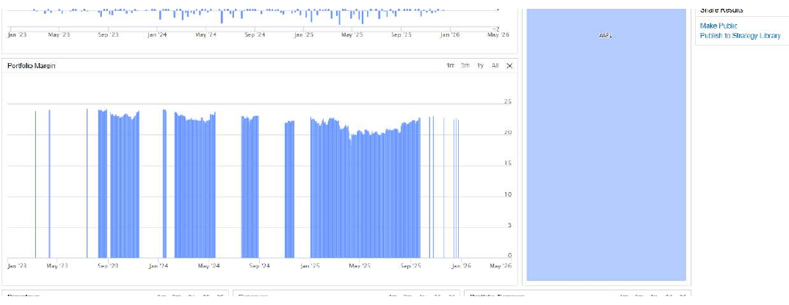
Figure 9: Q1(d) backtest: portfolio margin used over time.
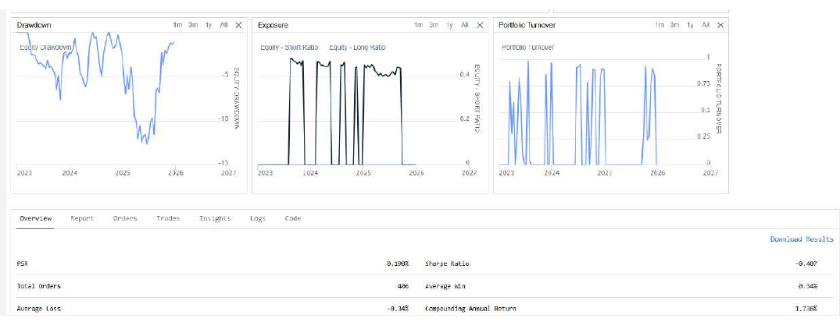
Figure 10: Q1(d) backtest: drawdown, exposure and portfolio turnover.
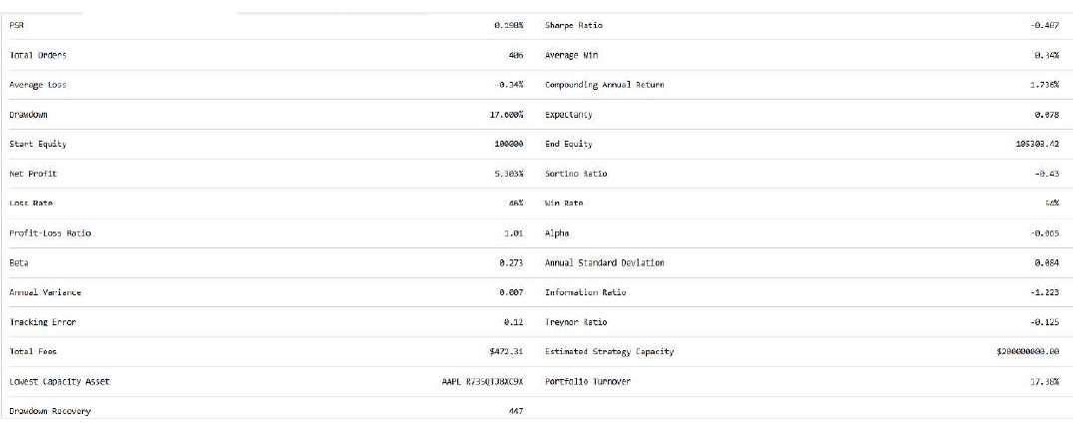
Figure 11: Q1(d) backtest: full statistics report.

5.3 Discussion
Overall performance is weak. The strategy ended with $105,303 (+5.30%), a compound annual return of only 1.74%, a negative Sharpe ratio (−0.41) and a maximum drawdown of 17.6% that took 447 days to recover (Figures 8, 10 and 11). By comparison, simply buying and holding AAPL returned +120.65% over the same period (Table 3). Even measured against the $50,000 actually put at work, a profit of $5,303 is about 10.6% over three years, against a profit of about $60,300 had that same $50,000 been invested in AAPL and held.
There is almost no edge per trade. Wins and losses are nearly symmetric: a 54% win rate, an average win of 0.34% and an average loss of −0.34%, giving a profit-loss ratio of 1.01 and an expectancy close to zero. Fees of $472 over 406 orders absorbed roughly 8–9% of the profit, and the high turnover (17.38%) comes from the daily short trades.
Why the strategy underperforms. We see four structural reasons.
- The take-profit rule caps every winner. Each long trade is closed at +0.5%, so the strategy cannot participate in AAPL’s 120% advance; it can only collect many tiny gains.
- No stop-loss. A long position is held until the price returns to +0.5% above the entry. When AAPL falls after an entry, capital is tied up, which explains the long periods of long exposure in Figure 10 and the long drawdown recovery. The exposure chart shows around 0.45 of equity (one $47.5k position) invested during those periods.
- Shorts earn only the open-to-close move. Shorts are covered the same day, so they profit only if AAPL falls between the open and the close, which is difficult in a strongly rising stock.
- Signal quality. The same XGBoost approach flat-lined when prices reached new highs in Section 4 (Figure 4). A model that under-predicts at new highs can generate predicted falls of 0.5% or more that do not happen. We have not tested this explanation separately, so we present it as a likely contributor rather than a proven cause.
Margin. Figure 9 shows the margin used while a position was open at roughly $20–24 thousand, about half of the position’s value, consistent with the standard 50% initial margin of a US equity margin account (maximum leverage of 2×). This is far below the $50,000 reserve and the account equity, so margin was never binding.
Lesson. A forecast with a small dollar error (Section 4) does not translate into profitable trading: the strategy needs the direction and size of tomorrow’s move to be right by at least 0.5%, and a threshold-based rule with a fixed profit target and no stop-loss limits both the upside and the protection against loss.
Assumptions. One position at a time (a short signal is ignored while a long is open); default QuantConnect fees and slippage; no borrowing cost on the short side; extended-hours data enabled in the subscription while trades were scheduled around the regular session; results apply to AAPL only and to one three-year period.

6. Question 2(i): Equally weighted buy-and-hold portfolio versus the NYSE index

6.1 Construction and justification
On the first trading day (3 January 2023, because 1 and 2 January were holidays) the algorithm invests 10% of the $100,000 in each of the ten stocks and then does nothing until the end date. This is a long-only buy-and-hold portfolio, the simplest diversified benchmark, with no estimation required, and it only needs ten purchase orders. The algorithm waits until all ten securities have a price before placing the orders so that no purchase fails on the first day. The notebook reproduces the portfolio by buying $10,000 of each stock at the first closing price and valuing the shares every day.
For the comparison the NYSE Composite index (NYA) was collected for the same dates. Both series were rebased to $100,000 on the first common date and converted to daily returns, and both are summarised with the same metrics function. Cumulative return is final value divided by initial value minus one; annualised return compounds this over the calendar years in the period; annualised volatility is the standard deviation of daily returns times √252; the Sharpe ratio is the mean daily return divided by its standard deviation times √252 (risk-free rate zero); the Sortino ratio replaces the standard deviation by the downside deviation, the square root of the average of squared negative daily returns; and maximum drawdown is the largest fall from a previous peak. Using one function for all portfolios and the index ensures that differences come from the portfolios and not from the calculation.

6.2 Results
Table 8: Equal-weight portfolio versus NYSE Composite (research notebook, rebased to $100,000)
Metric | Equal-weight portfolio | NYSE Composite
Final value ($) | 162,877.44 | 145,197.60
Cumulative return | 62.88% | 45.20%
Annualised return | 17.71% | 13.27%
Annualised volatility | 16.23% | 13.11%
Sharpe ratio | 1.09 | 1.02
Sortino ratio | 1.58 | 1.48
Maximum drawdown | −24.72% | −15.22%

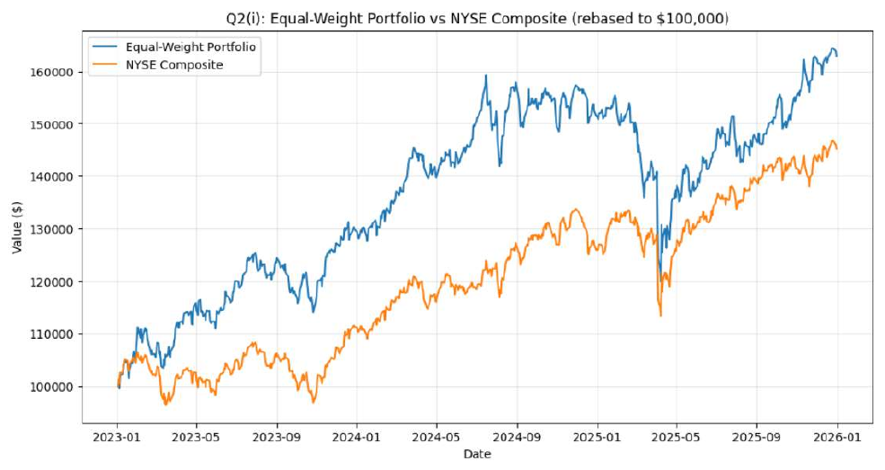
Figure 12: Equal-weight portfolio versus NYSE Composite, both rebased to $100,000.
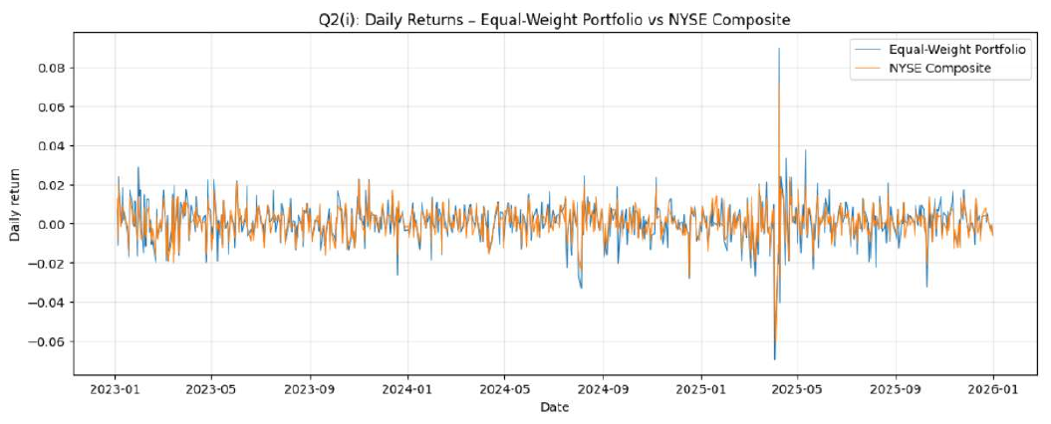
Figure 13: Daily returns: equal-weight portfolio versus NYSE Composite (correlation 0.873).
Table 9: QuantConnect backtest statistics of the equal-weight portfolio
Statistic | Value | Statistic | Value
End equity | $162,259.38 | Net profit (total return) | 62.26%
Compounding annual return | 17.47% | Maximum drawdown | 24.6%
Total orders | 10 | Total fees | $11.33
Sharpe ratio (QuantConnect) | 0.585 | Sortino ratio (QuantConnect) | 0.647

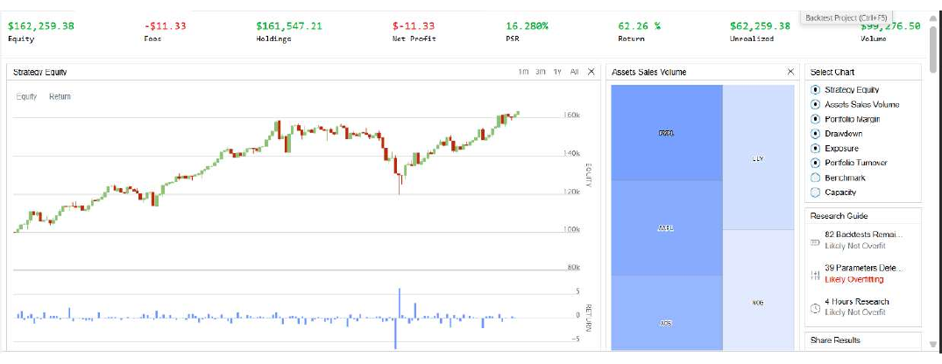
Figure 14: Q2(i) backtest: equity curve and summary (end equity $162,259.38, return 62.26%).
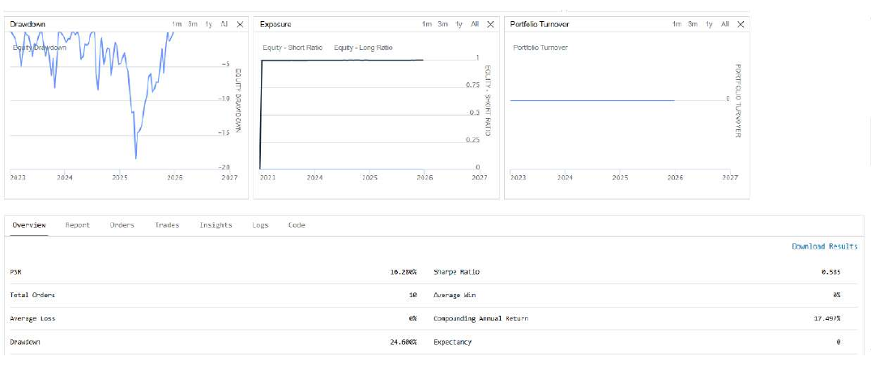
Figure 15: Q2(i) backtest: drawdown, exposure and portfolio turnover.
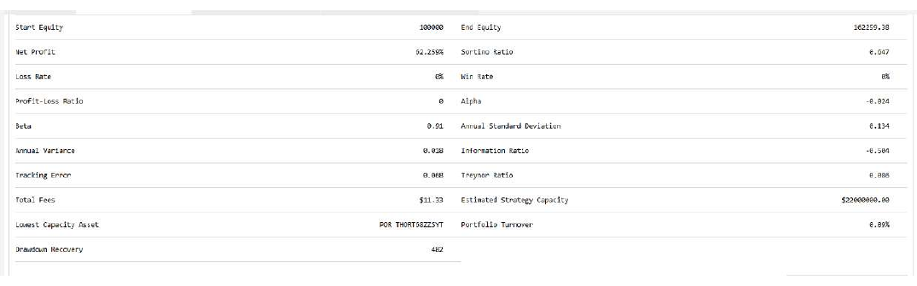
Figure 16: Q2(i) backtest: full statistics report.
The QuantConnect backtest agrees with the notebook: $162,259 against $162,877 in the notebook (a gap of about 0.4%, from fees of $11 and fill timing) and a maximum drawdown of 24.6% against 24.72%. The banner of the backtest shows a net profit of −$11.33 because it counts only realised profit, and nothing was sold; the real return is the 62.26% total.

6.3 Discussion: which is better at the end of the period?
On final wealth the equal-weight portfolio is better. It finished with $162,877 against $145,198 for the NYSE Composite, a cumulative return of 62.88% against 45.20% (17.7 percentage points more) and 17.71% against 13.27% a year. Its Sharpe (1.09 against 1.02) and Sortino (1.58 against 1.48) ratios are also slightly higher, so the extra return more than compensated for the extra risk in this period.
But it was riskier. Volatility was 16.23% against 13.11% and the maximum drawdown was −24.72% against −15.22%. The daily-return chart (Figure 13) shows the portfolio moving more than the index on most large days; around the April 2025 shock its daily swings were roughly −7% and +9%. A daily-return correlation of 0.873 shows that the portfolio mostly moves with the broad market but carries additional stock-specific risk, because it holds only ten stocks and the index holds a very large number.
The outperformance is concentrated. Each stock contributes one-tenth of its return, so four stocks (LLY, JPM, AAPL, MSFT) supply about 58.6 of the 62.9 percentage points of total return (Table 3), while TGT, PYPL and NOG were drags. A portfolio of these ten particular stocks therefore beat the index largely because it happened to contain four strong performers.
Caveats. The NYSE Composite is a price index that excludes dividends, whereas our adjusted stock prices include them, which gives the portfolio a small built-in advantage in this comparison. The ten stocks were given rather than randomly drawn, and the result applies to one three-year window. Our conclusion is therefore that the equal-weight portfolio was better in terms of return and marginally better in risk-adjusted terms, but not unambiguously better, because an investor with a low tolerance for drawdowns could prefer the index.

7. Question 2(ii) and (iii): Monthly-rebalanced minimum-variance portfolio

7.1 Choice of technique and justification
We built a long-only minimum-variance portfolio: at the start of each month we choose the weights that minimise the variance of portfolio returns, subject to the weights summing to one and each stock having at least a 5% weight (the assignment’s constraints). Formally:
minimise wᵀ Σ w subject to Σ wᵢ = 1 and wᵢ ≥ 0.05 for every stock,
where Σ is the covariance matrix of daily returns. We chose this technique for four reasons:
- It targets risk, which can be estimated more reliably than returns. Covariances are estimated far more precisely from past data than expected returns, and optimisers that depend on expected returns tend to magnify estimation errors. The minimum-variance portfolio needs no return forecast.
- It exploits diversification. The weights favour stocks that are low in volatility and low in correlation with the rest, such as the utility POR, which the statistics in Table 3 had already identified as the calmest stock.
- It satisfies the constraints naturally. Long-only weights with a 5% floor are simple bound constraints in the optimiser.
- It is transparent and easy to explain, with one parameter (the estimation window) and a clear objective.

7.2 Implementation and justification of each step
- Estimation window: the previous 252 daily returns (about one trading year), a common compromise between stability (more data) and relevance (recent data).
- Monthly rebalancing. On the first trading day of each month, five minutes after the open, the algorithm re-estimates the covariance matrix and moves the portfolio to the new target weights, as the assignment requires. Only data before the rebalancing day are used, so there is no look-ahead.
- Data restriction and warm-up. The assignment allows only data from 1 January 2023, so the first 252 returns are not available until early 2024. Until then the portfolio is held at equal weights (invested on the first day, like Q2(i)), and the first optimised rebalance is 1 February 2024. This gives 23 optimised rebalances up to 1 December 2025.
- Numerical solution. The optimisation uses the SLSQP method in SciPy. Daily covariances are tiny (about 10⁻⁴), so the covariance matrix is multiplied by 10⁶ for numerical stability, which does not change the optimal weights, and the exact gradient is supplied. A first version that used an extremely tight tolerance failed in 12 of 23 months and left the portfolio on stale weights, so the final code tries progressively looser tolerances and accepts a solution only if the weights sum to one and respect the 5% floor. In the final run no month failed.
- Execution. QuantConnect automatically converts market orders sent during market hours on daily-resolution data into market-on-close orders, so rebalancing trades fill at the day’s close. The notebook mirrors this by rebalancing at the close of the rebalance date.
- Validation. The weights chosen by the notebook match the weights logged by the QuantConnect algorithm on all 23 rebalance dates, with a largest absolute difference of 0.0005 (the log rounds to three decimals). Applying the QuantConnect weights to the notebook prices gives $170,907.90 against $170,549.72 with the notebook’s own weights, so the research replicates the backtest.

7.3 Results
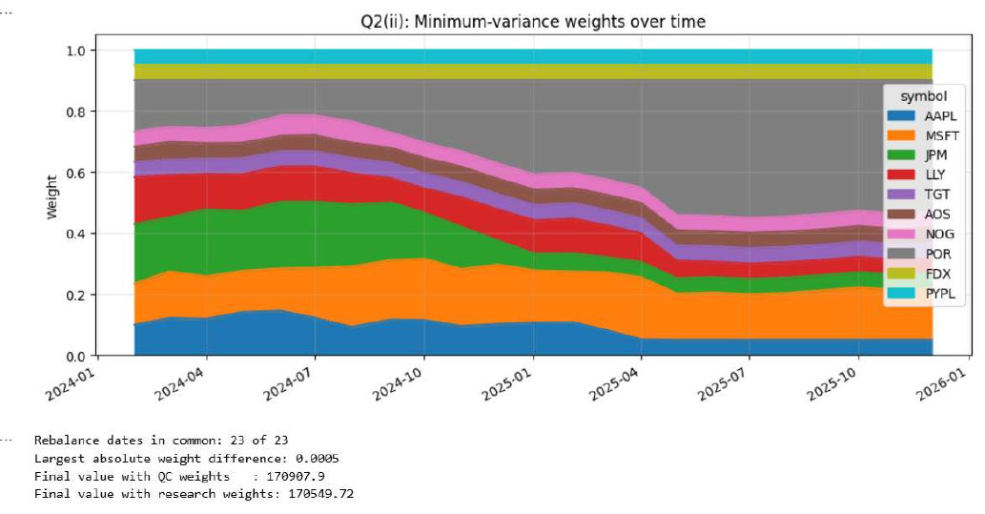
Figure 17: Minimum-variance weights over time (23 monthly rebalances), with the validation against the QuantConnect weights.
Table 10: Minimum-variance, equal-weight and NYSE Composite (research notebook, rebased to $100,000)
Metric | Min-variance (monthly) | Equal-weight | NYSE Composite
Final value ($) | 170,549.72 | 162,877.44 | 145,197.60
Cumulative return | 70.55% | 62.88% | 45.20%
Annualised return | 19.53% | 17.71% | 13.27%
Annualised volatility | 14.50% | 16.23% | 13.11%
Sharpe ratio | 1.31 | 1.09 | 1.02
Sortino ratio | 1.95 | 1.58 | 1.48
Maximum drawdown | −18.10% | −24.72% | −15.22%

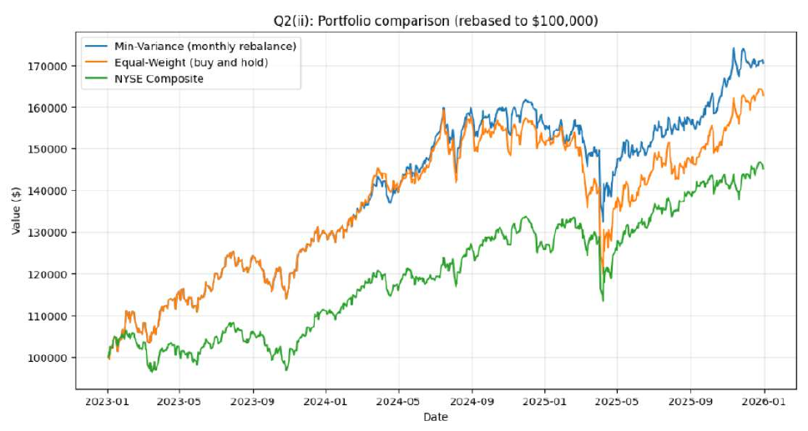
Figure 18: Minimum-variance, equal-weight and NYSE Composite portfolios, rebased to $100,000.
Table 11: QuantConnect backtest statistics: equal-weight versus minimum-variance
Statistic | Equal-weight (Q2i) | Min-variance (Q2ii)
End equity | $162,259.38 | $169,469.30
Net profit (total return) | 62.26% | 69.47%
Compounding annual return | 17.47% | 19.21%
Maximum drawdown | 24.6% | 17.9%
Drawdown recovery | 482 days | 308 days
Total orders | 10 | 223
Total fees | $11.33 | $225.97
Sharpe ratio (QuantConnect) | 0.585 | 0.735
Sortino ratio (QuantConnect) | 0.647 | 0.882
Annual standard deviation (QuantConnect) | 0.134 | 0.119

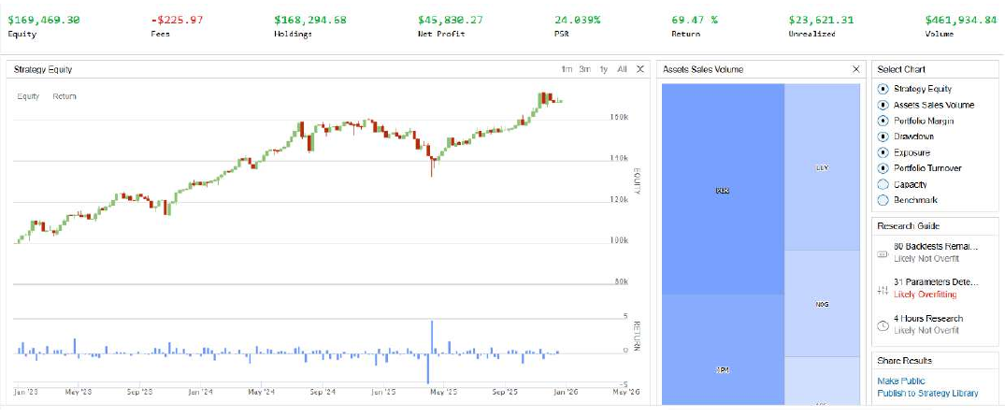
Figure 19: Q2(ii) backtest: equity curve and summary (end equity $169,469.30, return 69.47%).
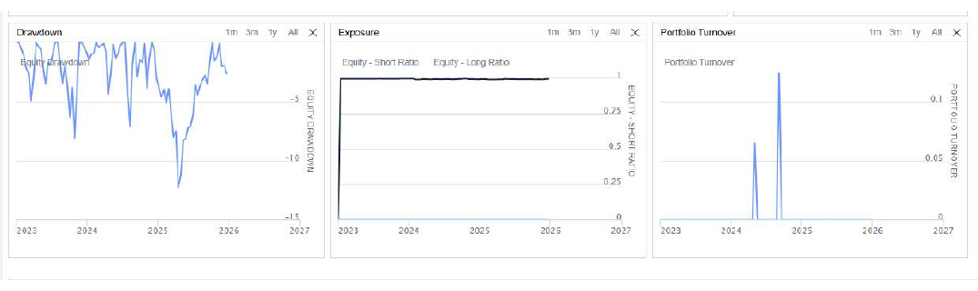
Figure 20: Q2(ii) backtest: drawdown, exposure and portfolio turnover.
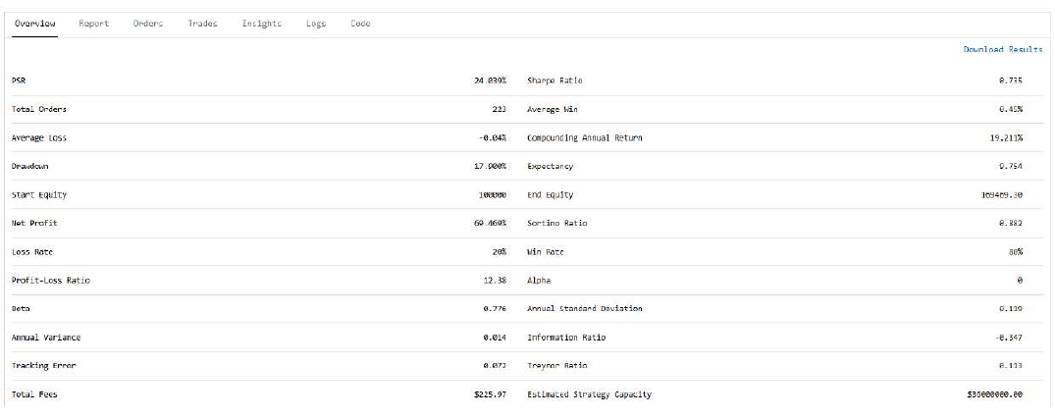
Figure 21: Q2(ii) backtest: full statistics report.

7.4 Comparison with the equal-weight portfolio
The minimum-variance portfolio is better on every return and risk measure. In the notebook it earned 70.55% against 62.88% (19.53% against 17.71% a year) while its volatility was 1.7 percentage points lower (14.50% against 16.23%). Its Sharpe ratio is 1.31 against 1.09, its Sortino ratio is 1.95 against 1.58, and its maximum drawdown is 6.6 percentage points shallower (−18.10% against −24.72%). The QuantConnect backtests give the same ranking: $169,469 against $162,259, a drawdown of 17.9% against 24.6%, a faster drawdown recovery (308 against 482 days) and lower annual standard deviation (0.119 against 0.134).
Timing of the benefit. The two portfolios are identical until February 2024 because of the equal-weight warm-up and move closely together through 2024 (Figure 18). The gap opens mainly in 2025, when the optimiser had moved most of the portfolio into low-volatility stocks and the April 2025 sell-off hurt the equal-weight portfolio more.
How the weights evolved. In 2024 the weights were spread across JPM (up to about 22%), MSFT, AAPL, LLY and POR. As volatility patterns changed, the optimiser steadily raised POR, from 16.8% in February 2024 to about 35% in April 2025 and 43–45% from May 2025, while AAPL, JPM and LLY were pushed down to the 5% minimum. From June 2025 eight of the ten stocks sit at the 5% floor, with POR (about 43–45%) and MSFT (about 15–17%) holding the rest (Figure 17 and Appendix A). TGT, AOS, NOG, FDX and PYPL stayed at or very close to the floor in every month (never above 7%), consistent with their high volatility in Table 3.
Costs. Monthly rebalancing needed 223 orders and $226 in fees against $11 for buy-and-hold, about 0.2% of initial capital, which is negligible next to the 7-percentage-point gain in return.

7.5 Part (iii): which portfolio would we choose, and how to improve it
Our choice: the minimum-variance portfolio, because it earned more, with lower volatility, a shallower drawdown and higher Sharpe and Sortino ratios than the equal-weight portfolio, in both the notebook and the backtest, which is precisely the “balance of risk and return” the question asks for.
Reservations. We would not use it exactly as built, for four reasons:
- Concentration. A single utility held around 44% of the portfolio, so one company-specific or regulatory shock could cause large losses, and the portfolio is effectively a bet on POR plus MSFT.
- Short evidence. The result rests on one three-year period and 23 optimised rebalances, and much of the outperformance arises in one episode (2025), so it may not repeat.
- Backward-looking risk estimates. Low past volatility does not guarantee low future volatility, and the covariance matrix estimated from 252 days is noisy.
- Ignores expected returns. The method does not aim for returns at all, so it can end up in low-return stocks; in this sample it was helped by the low-volatility stocks also doing reasonably well.
Suggestions for improvement.
- Cap each stock’s weight (for example at 20–30%) to prevent over-concentration while keeping most of the risk reduction.
- Bring in expected returns, for instance by maximising the Sharpe ratio or using a mean-variance trade-off with a risk-aversion parameter, or use a risk-parity (equal risk contribution) allocation that does not need return forecasts.
- Improve the covariance estimate with shrinkage towards a structured matrix or exponentially weighted returns, and test other windows (for example 60, 126 and 252 days).
- Model costs and turnover, rebalancing only when weights drift beyond a threshold.
- Test over a longer history and several market regimes (walk-forward evaluation) before relying on the result.

8. Overall conclusions
The ten securities behaved very differently over 2023–2025, with large gaps in return and risk, so security selection and weighting mattered a great deal. The two machine-learning models forecast next-day prices with different strengths: the LSTM was much more accurate and followed trends, whereas XGBoost on raw prices failed to follow rising prices, and neither accuracy result made the XGBoost trading strategy profitable in a meaningful way: it earned only 5.30% over three years against 120.65% for holding AAPL. On the portfolio side, a simple equal-weight portfolio beat the NYSE Composite in return, and a monthly-rebalanced minimum-variance portfolio improved on it in both return and risk, although it needs a cap on single-stock weights before it can be recommended. The consistency between research notebooks and QuantConnect backtests supports the reliability of the results, but every conclusion is conditional on a single, short, favourable sample.

9. Assumptions and limitations
Table 12: Key assumptions and limitations
Area | Assumption or limitation
Data | Daily adjusted prices (splits and dividends) from 1 Jan 2023 to 1 Jan 2026 only; no earlier data used. The NYSE Composite is a price index without dividends.
Metrics | Notebook metrics use zero risk-free rate, no costs and close-to-close prices; QuantConnect reports include fees and use their own conventions, so Sharpe, Sortino and volatility differ between the two sources.
Forecasting | One chronological 80/20 split with a 147-day test period; fixed, conventional hyperparameters; errors measured in dollars only (MAE, RMSE) with no naive benchmark or directional accuracy; the LSTM’s Min–Max scaler was fitted on the full sample.
Strategy (Q1d) | One position at a time; short signals ignored while a long is open; no stop-loss; position size uses a 5% price buffer; default fees and slippage; no short-borrowing cost; no trades during the first two months while the model has too little history.
Portfolio (Q2ii) | 252-day sample covariance; equal-weight until February 2024; 5% floor and no upper limit; monthly rebalance at the close of the first trading day; trading costs are those of QuantConnect’s default model.
Generalisation | Ten pre-selected securities and one three-year, mostly rising market; results are descriptive of this sample and are not a forecast.

Appendix A: Monthly minimum-variance weights
Target weights chosen at each monthly rebalance (QuantConnect backtest log; the research notebook reproduces them to within 0.0005). Before 1 February 2024 the portfolio is held at equal weights.
Table A1: Minimum-variance target weights by rebalance date
Date | AAPL | MSFT | JPM | LLY | TGT | AOS | NOG | POR | FDX | PYPL
2024-02-01 | 0.099 | 0.135 | 0.195 | 0.153 | 0.050 | 0.050 | 0.050 | 0.168 | 0.050 | 0.050
2024-03-01 | 0.122 | 0.153 | 0.176 | 0.139 | 0.050 | 0.058 | 0.050 | 0.153 | 0.050 | 0.050
2024-04-01 | 0.119 | 0.139 | 0.220 | 0.116 | 0.050 | 0.050 | 0.050 | 0.157 | 0.050 | 0.050
2024-05-01 | 0.141 | 0.135 | 0.196 | 0.120 | 0.052 | 0.050 | 0.058 | 0.148 | 0.050 | 0.050
2024-06-03 | 0.145 | 0.138 | 0.219 | 0.115 | 0.050 | 0.050 | 0.067 | 0.115 | 0.050 | 0.050
2024-07-01 | 0.122 | 0.163 | 0.217 | 0.115 | 0.050 | 0.052 | 0.065 | 0.116 | 0.050 | 0.050
2024-08-01 | 0.092 | 0.198 | 0.204 | 0.101 | 0.050 | 0.050 | 0.070 | 0.135 | 0.050 | 0.050
2024-09-03 | 0.116 | 0.195 | 0.189 | 0.079 | 0.050 | 0.050 | 0.050 | 0.171 | 0.050 | 0.050
2024-10-01 | 0.115 | 0.201 | 0.151 | 0.079 | 0.050 | 0.050 | 0.050 | 0.205 | 0.050 | 0.050
2024-11-01 | 0.095 | 0.187 | 0.138 | 0.097 | 0.050 | 0.050 | 0.050 | 0.233 | 0.050 | 0.050
2024-12-02 | 0.102 | 0.195 | 0.078 | 0.102 | 0.050 | 0.050 | 0.050 | 0.273 | 0.050 | 0.050
2025-01-02 | 0.106 | 0.171 | 0.054 | 0.109 | 0.050 | 0.050 | 0.050 | 0.309 | 0.050 | 0.050
2025-02-03 | 0.108 | 0.166 | 0.058 | 0.115 | 0.050 | 0.050 | 0.050 | 0.303 | 0.050 | 0.050
2025-03-03 | 0.082 | 0.190 | 0.050 | 0.104 | 0.050 | 0.050 | 0.050 | 0.325 | 0.050 | 0.050
2025-04-01 | 0.052 | 0.204 | 0.050 | 0.093 | 0.050 | 0.050 | 0.050 | 0.351 | 0.050 | 0.050
2025-05-01 | 0.050 | 0.152 | 0.050 | 0.057 | 0.050 | 0.050 | 0.050 | 0.441 | 0.050 | 0.050
2025-06-02 | 0.050 | 0.156 | 0.050 | 0.050 | 0.050 | 0.050 | 0.050 | 0.444 | 0.050 | 0.050
2025-07-01 | 0.050 | 0.150 | 0.050 | 0.050 | 0.050 | 0.050 | 0.050 | 0.450 | 0.050 | 0.050
2025-08-01 | 0.050 | 0.154 | 0.050 | 0.050 | 0.050 | 0.050 | 0.050 | 0.446 | 0.050 | 0.050
2025-09-02 | 0.050 | 0.162 | 0.050 | 0.050 | 0.050 | 0.050 | 0.050 | 0.438 | 0.050 | 0.050
2025-10-01 | 0.050 | 0.172 | 0.050 | 0.050 | 0.050 | 0.050 | 0.050 | 0.428 | 0.050 | 0.050
2025-11-03 | 0.050 | 0.162 | 0.050 | 0.050 | 0.050 | 0.050 | 0.050 | 0.438 | 0.050 | 0.050
2025-12-01 | 0.050 | 0.168 | 0.050 | 0.050 | 0.050 | 0.050 | 0.050 | 0.432 | 0.050 | 0.050

