1. Write a shell script to print the numbers from 1 to 10.

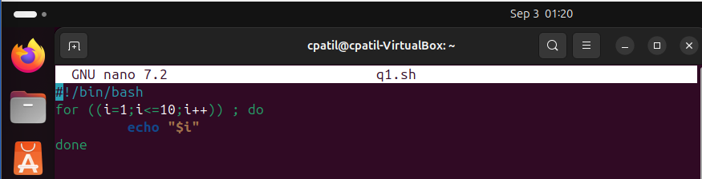

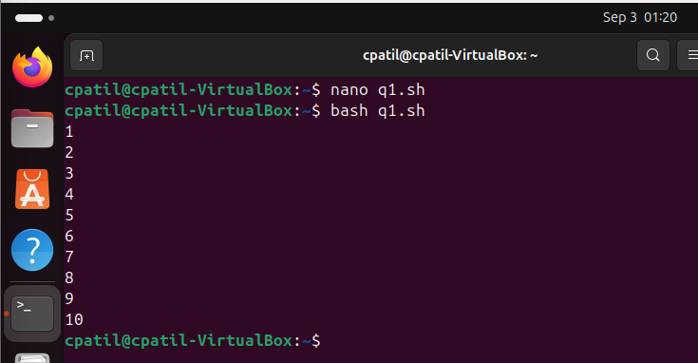

1. Write a shell script to ask the user for their name and print a greeting message.

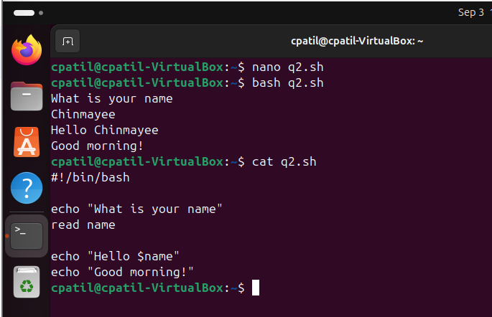

1. Write a shell script to check if a file exists in the current directory and print a message accordingly.

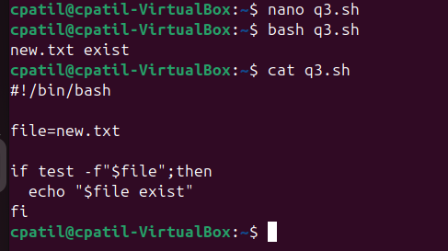

1. Write a shell script to calculate the sum of two numbers entered by the user.

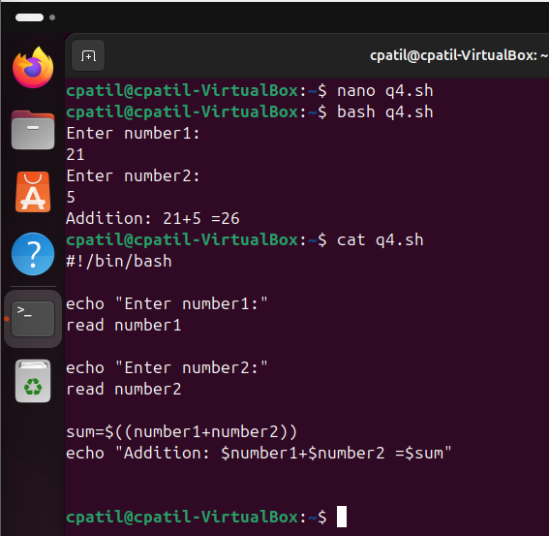

1. Write a shell script to find the largest number among three numbers entered by the user.

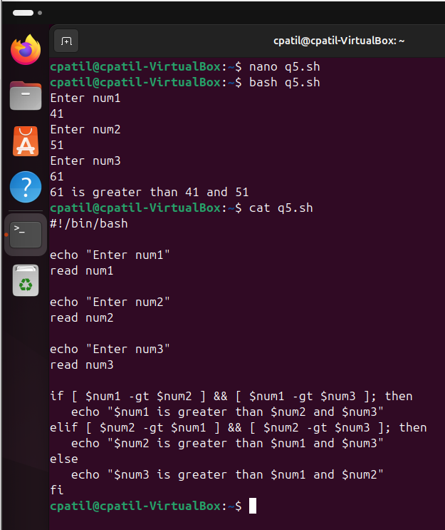

1. Write a shell script to check if a number is odd or even.

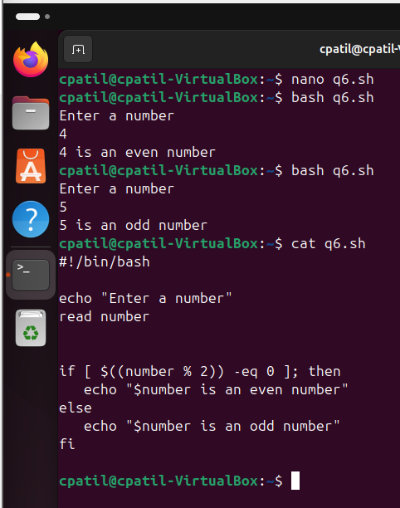

1. Write a shell script to display the contents of a file line by line.

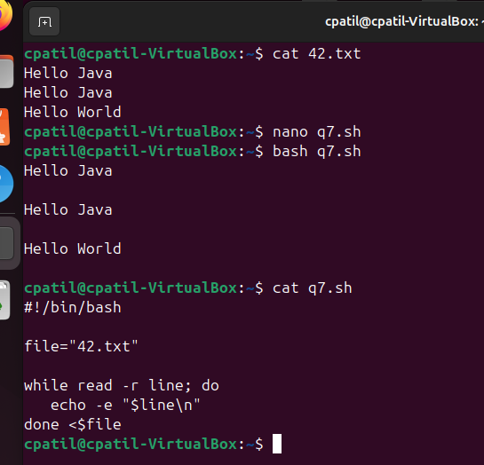

1. Write a shell script to print the current date and time.

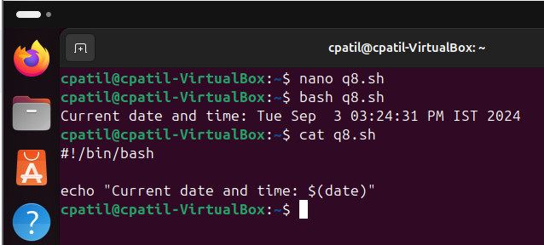

1. Write a shell script to count the number of files in a directory.

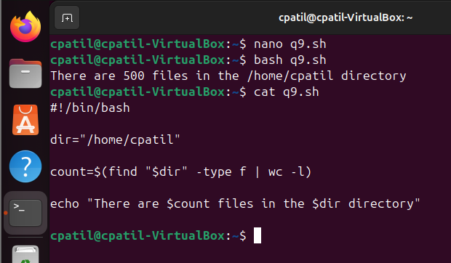

1. Write a shell script to rename all files with a certain extension in a directory.

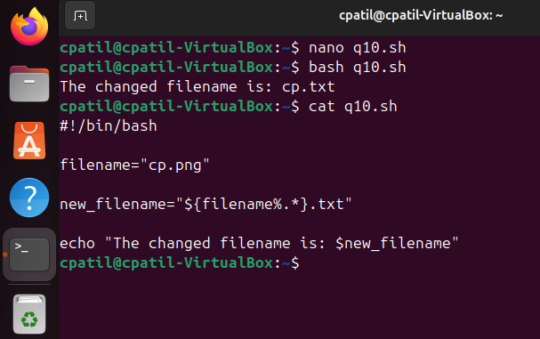

1. Write a shell script to print the even numbers from 1 to 20.

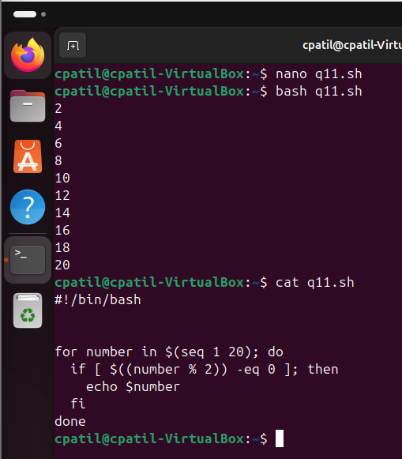

1. Write a shell script to find the factorial of a number entered by the user.

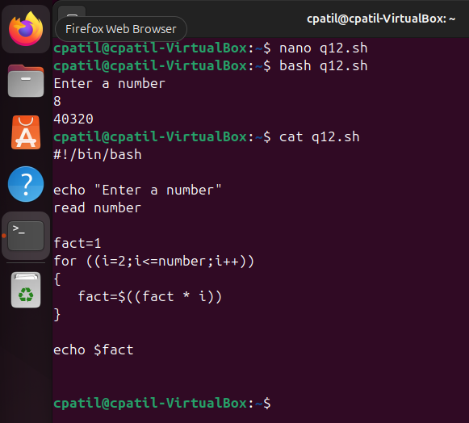

1. Write a shell script to create a backup of a file with a timestamp in the filename.
2. Write a shell script to check if a directory exists and create it if it doesn't.
3. Write a shell script to print the last 10 lines of a file.

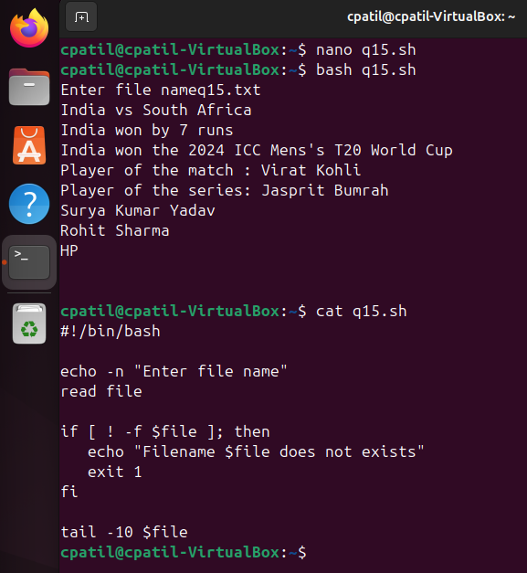

1. Write a shell script to find the sum of all the numbers in file.

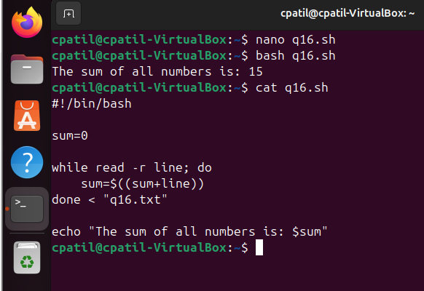

1. Write a shell script to find the average of a list of numbers in a file.

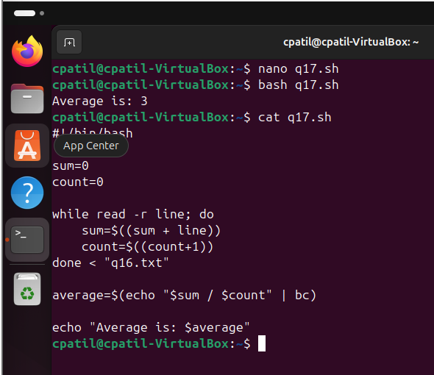

1. Write a shell script to convert all the filenames in a directory to lowercase.

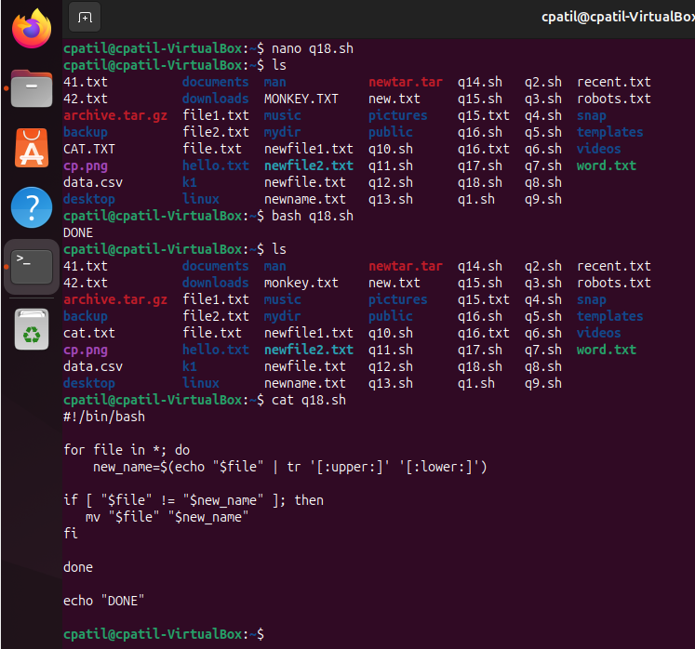

1. Write a shell script to find and replace a string in a file.