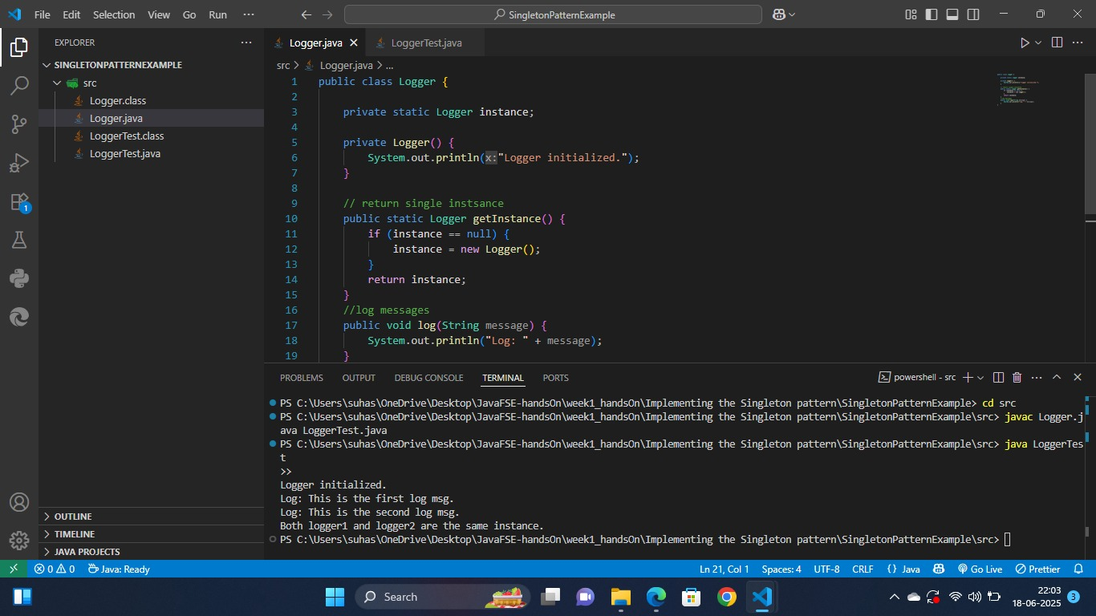SingletonPatternExample (OUTPUT):