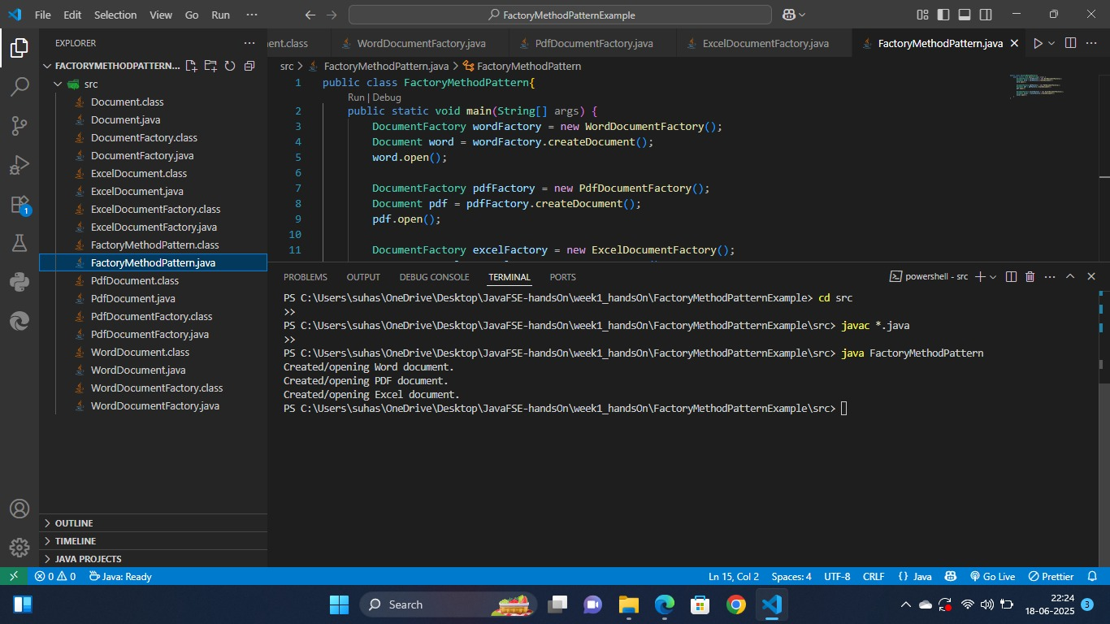FactoryMethodPatternExample (OUTPUT):