**Client-Side App Rubric** <https://github.com/denisecase/pbl-lifeline-links>

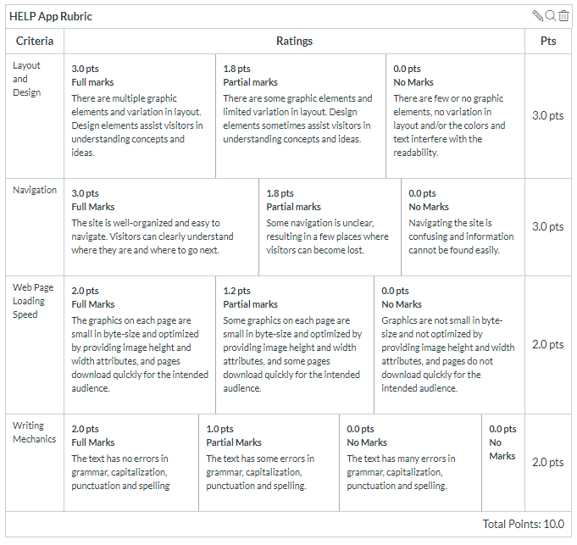

**Team reviewed: Group 02-04**

**Link to the web site:** <https://terry-woosley.github.io/help-app/#bot>

**Layout and Design**

Score: 1.8

Comments: The picture size and header are large making you scroll down to see what the product it. From the initial page there is no title of the website or a landing page, it just links to values and information about the program not really about the product. The size of the banner picture is too large we would suggest making it wider and shorter. The values and program section header is off centered compared to the other headers.

**Navigation**

Score: 0

Comments: The Navigation bar does not work as intended the only site that we can see is the values and program, clicking the contact us just brings you to the footer of the page and there is no contact information there. The search bar in the navigation does not work.

**Loading Speed:**

Score: 2

Comments: The one page that we could load did not have any issues

**Writing Mechanics:**

Score: 1

Comments: Sentence and word flow could be better to make understanding the product easier.

**General remarks: This site just seems incomplete**

**Review performed by: Group 3**

**Date and time performed: 12/2/2019 1:30 PM**