**Client-Side App Rubric** <https://github.com/denisecase/pbl-lifeline-links>

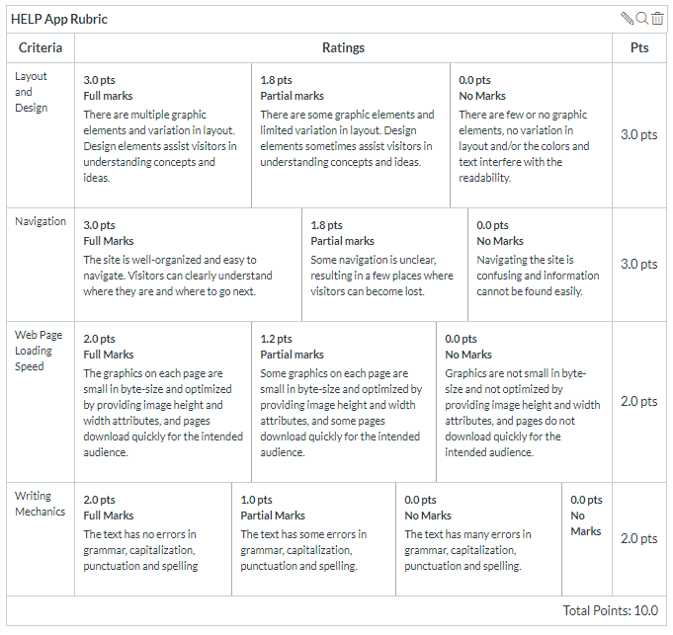

**Team reviewed:**

**Link to the web site:**

**Layout and Design**

Score:

Comments:

**Navigation**

Score:

Comments:

**Loading Speed:**

Score:

Comments:

**Writing Mechanics:**

Score:

Comments:

**General remarks:**

**Review performed by:**

**Date and time performed:**