PROJECT - Advance Statistics
PGP – DSBA

Problem 2:

2.1) Perform Exploratory Data Analysis [both univariate and multivariate analysis to be performed]. What insight do you draw from the EDA?

Basic Data Exploration
In this step, we will perform the below operations to check what the data set comprises of. We will check the below things:
*head of the dataset *hape of the dataset *info of the dataset *summary of the dataset

Univariate Analysis
Example
**Import the dataset
data.head()
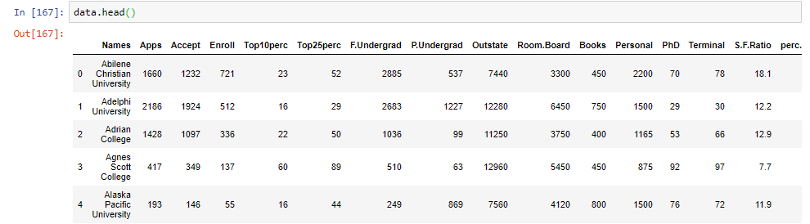
data = data.dropna()
len(data)
777
dataf = data['PhD']
dataf.isnull().sum()
Here we have taken an example of one variable.
sns.distplot(dataf)
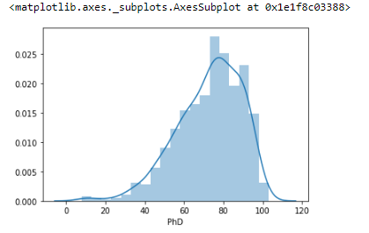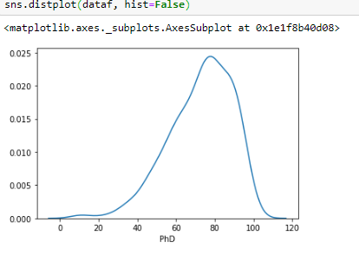data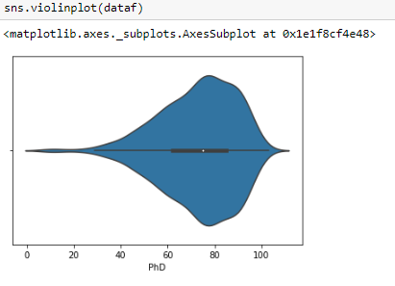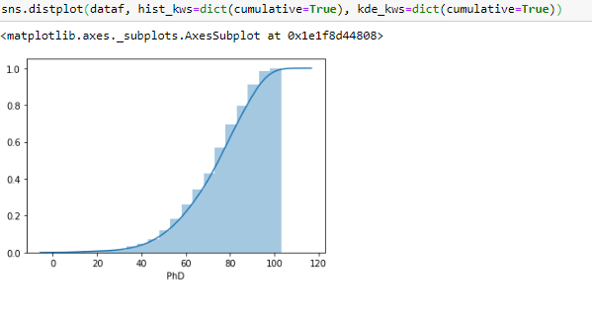

Univariate Analysis

Example 2

Univariate analysis refer to the analysis of a single variable. The main purpose of univariate analysis is to summarize and find patterns in the data. The key point is that there is only one variable involved in the analysis.¶

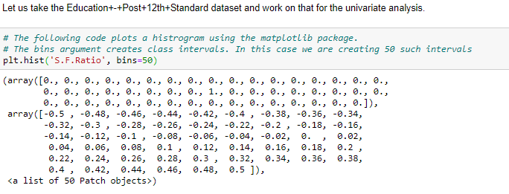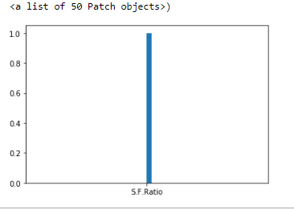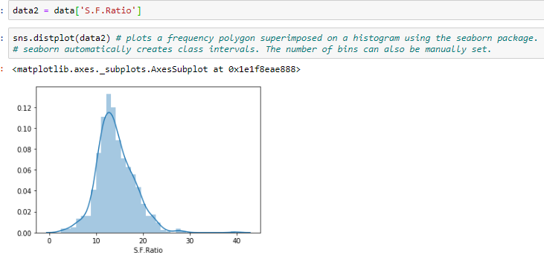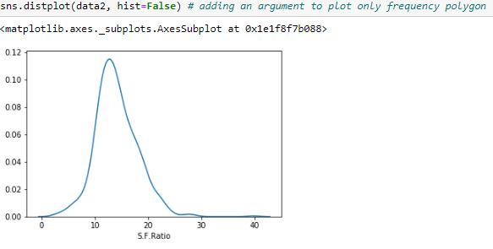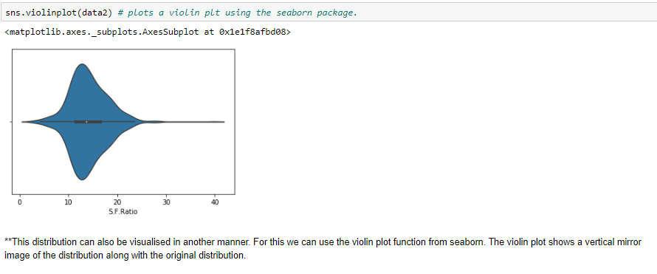
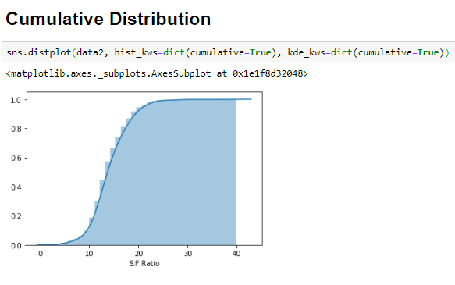

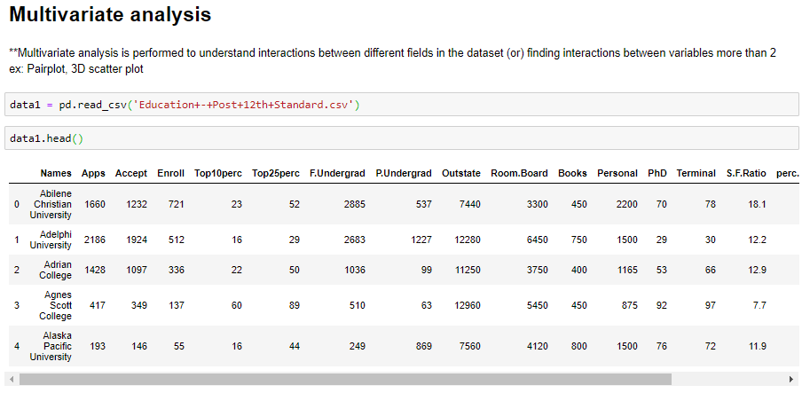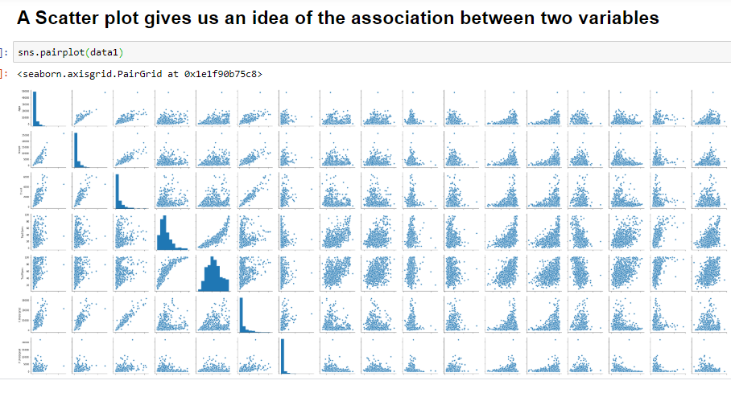

**In the above plot scatter diagrams are plotted for all the numerical columns in the dataset. A scatter plot is a visual representation of the degree of correlation between any two columns. The pair plot function in seaborn makes it very easy to generate joint scatter plots for all the columns in the data.
**A scatter plot can also be plotted for two individual columns
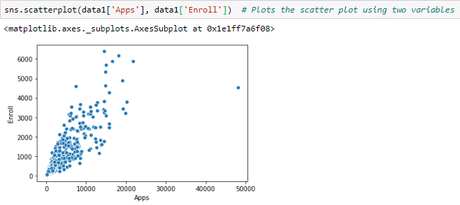
** The scatter plot only offers visual information about the degree of correlation. In order to obtain more precise information we can use the inbuilt .corr() method in Pandas. This returns a table with all the correlations calculated for the numerical columns.
data1.corr() # displays the correlation between every possible pair of attributes as a dataframe

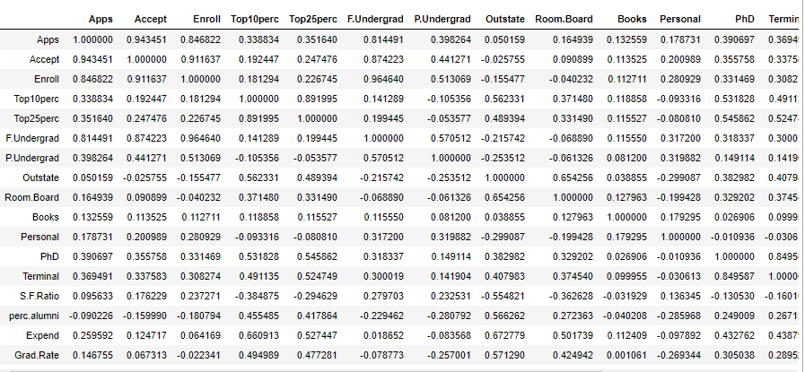Check the data.describe()¶
data1.describe() # the output results provide the five number summary of the data. 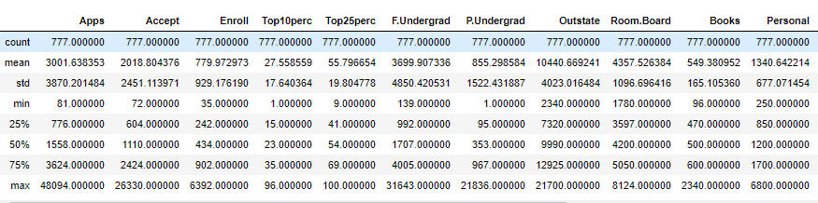
data1.shape # see the shape of the data
There are 777 Observations / Rows and 18 Attributes / Columns

**Check the Information about the data and the datatypes of each respective attributes.
data1.info() # To see the data type of each of the variable, number of values entered in each of the variable
<class 'pandas.core.frame.DataFrame'>
Int64Index: 777 entries, 0 to 776
Data columns (total 18 columns):
Names 777 non-null object
Apps 777 non-null int64
Accept 777 non-null int64
Enroll 777 non-null int64
Top10perc 777 non-null int64
Top25perc 777 non-null int64
F.Undergrad 777 non-null int64
P.Undergrad 777 non-null int64
Outstate 777 non-null int64
Room.Board 777 non-null int64
Books 777 non-null int64
Personal 777 non-null int64
PhD 777 non-null int64
Terminal 777 non-null int64
S.F.Ratio 777 non-null float64
perc.alumni 777 non-null int64
Expend 777 non-null int64
Grad.Rate 777 non-null int64
dtypes: float64(1), int64(16), object(1)
memory usage: 135.3+ KB

data1.columns
Index(['Names', 'Apps', 'Accept', 'Enroll', 'Top10perc', 'Top25perc',
'F.Undergrad', 'P.Undergrad', 'Outstate', 'Room.Board', 'Books',
'Personal', 'PhD', 'Terminal', 'S.F.Ratio', 'perc.alumni', 'Expend',
'Grad.Rate'],
dtype='object')
data1.dtypes.value_counts()
int64 16
float64 1
object 1
dtype: int64

The same can be represented graphically using a the heatmap function in seaborn

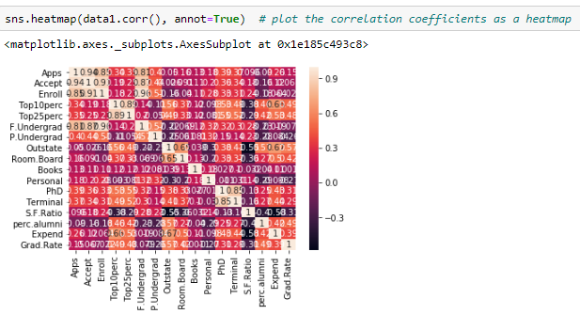Another way of looking at multivariate scatter plot is to use the hue option in the scatterplot() function in seaborn.’’

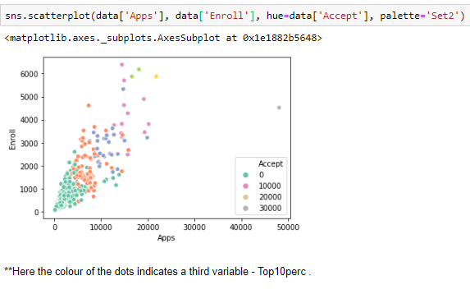

Check the Skewness and Kurtosis
Positively skewed: Most frequent values are low and tail is towards high values.
Negatively skewed: Most frequent values are high and tail is towards low values.
If Mode< Median< Mean then the distribution is positively skewed.
If Mode> Median> Mean then the distribution is negatively skewed.
data.skew() # to measure the skeweness of every attribute
Apps 3.723750
Accept 3.417727
Enroll 2.690465
Top10perc 1.413217
Top25perc 0.259340
F.Undergrad 2.610458
P.Undergrad 5.692353
Outstate 0.509278
Room.Board 0.477356
Books 3.485025
Personal 1.742497
PhD -0.768170
Terminal -0.816542
S.F.Ratio 0.667435
perc.alumni 0.606891
Expend 3.459322
Grad.Rate -0.113777
dtype: float64

2.2 Is scaling necessary for PCA in this case? Give justification and perform scaling.

Normalizing and Scaling
Often the variables of the data set are of different scales i.e. one variable is in millions and other in only 100. For e.g. in our data set other variables are having values as a whole and SF Ratio are in decimals. Since the data in these varaibles are of different scales, it is tough to compare these variables.
Feature scaling (also known as data normalization) is the method used to standardize the range of features of data. Since, the range of values of data may vary widely, it becomes a necessary step in data preprocessing while using machine learning algorithms.
In this method, we convert variables with different scales of measurements into a single scale.
StandardScaler normalizes the data using the formula (x-mean)/standard deviation.
We will be doing this only for the numerical variables.

#Scales the data. Essentially returns the z-scores of every attribute
from sklearn.preprocessing import StandardScaler
std_scale = StandardScaler()
std_scale
StandardScaler(copy=True, with_mean=True, with_std=True)
data1['Apps'].head()
Out[196]:
0 1660
1 2186
2 1428
3 417
4 193
Name: Apps, dtype: int64
data1['Apps_Stdscale'] = std_scale.fit_transform(data1[['Apps']]) # returns z-scores of the values of the attribute
data1['Apps_Stdscale'].head()
Out[198]:
0 -0.346882
1 -0.210884
2 -0.406866
3 -0.668261
4 -0.726176
Name: Apps_Stdscale, dtype: float64
data1['Apps'].min(), data1['Apps'].max() # min and max value
Out[199]:
(81, 48094)
data1['Apps_Stdscale'].min(), data1['Apps_Stdscale'].max() # min and max value
Out[200]:
(-0.7551337089614527, 11.658671216805628)
data1['Apps'].describe() # 5 point summary statistics of the attribute
Out[201]:
count 777.000000
mean 3001.638353
std 3870.201484
min 81.000000
25% 776.000000
50% 1558.000000
75% 3624.000000
max 48094.000000
Name: Apps, dtype: float64
data1['Apps_Stdscale'].describe() # 5 point summary statistics of the attribute
Out[202]:
count 7.770000e+02
mean 6.355797e-17
std 1.000644e+00
min -7.551337e-01
25% -5.754408e-01
50% -3.732540e-01
75% 1.609122e-01
max 1.165867e+01
Name: Apps_Stdscale, dtype: float64

** MinMaxScaler normalizes the data using the formula (x - min)/(max - min)
from sklearn.preprocessing import MinMaxScaler
​
minmax_scale = MinMaxScaler()
​
minmax_scale
Out[203]:
MinMaxScaler(copy=True, feature_range=(0, 1))
data1['Accept_MinMaxScale'] = minmax_scale.fit_transform(data1[['Accept']])
data1['Accept_MinMaxScale'].head(5)
Out[205]:
0 0.044177
1 0.070531
2 0.039036
3 0.010549
4 0.002818
Name: Accept_MinMaxScale, dtype: float64
data1['Accept_MinMaxScale'].min(), data1['Accept_MinMaxScale'].max()
Out[206]:
(0.0, 1.0)
data1['Accept_MinMaxScale'].describe()
Out[207]:
count 777.000000
mean 0.074141
std 0.093347
min 0.000000
25% 0.020260
50% 0.039531
75% 0.089573
max 1.000000
Name: Accept_MinMaxScale, dtype: float64
Log Transformation
We are going to write a custom transformer to perform log transformation
import numpy as np
# Transform an attribute using a mathematical transformation.
# We might want to do that to change the distribution shape of the data
from sklearn.preprocessing import FunctionTransformer
log_transformer = FunctionTransformer(np.log1p)
log_transformer
FunctionTransformer(accept_sparse=False, check_inverse=True,
func=<ufunc 'log1p'>, inv_kw_args=None, inverse_func=None,
kw_args=None, pass_y='deprecated', validate=None)
data1['Accept'].isnull().sum() # Check number of null values
0
data1['Accept']= data1['Accept'].fillna(data1['Accept'].mean()) # impute the null values using the mean
data1['Accept_logtransform'] = log_transformer.fit_transform(data1[['Accept']]) # Log Transform the attribut
data1['Accept_logtransform'].head()
Out[213]:
0 7.117206
1 7.562681
2 7.001246
3 5.857933
4 4.990433
Name: Accept_logtransform, dtype: float64
data1['Accept_logtransform'].describe() # Descriptive statistics
Out[214]:
count 777.000000
mean 7.110960
std 0.988941
min 4.290459
25% 6.405228
50% 7.013016
75% 7.793587
max 10.178502
Name: Accept_logtransform, dtype: float64

Exponential Transformation
exp_transformer = FunctionTransformer(np.exp) # Exponential transform
​
exp_transformer
Out[215]:
FunctionTransformer(accept_sparse=False, check_inverse=True, func=<ufunc 'exp'>,
inv_kw_args=None, inverse_func=None, kw_args=None,
pass_y='deprecated', validate=None)
data1['Accept_exptransform'] = exp_transformer.fit_transform(data1[['Accept']]) #returns the exponential transform of the data
data1['Accept_exptransform'].head(5)
Out[223]:
0 inf
1 inf
2 inf
3 3.704880e+151
4 2.552668e+63
Name: Accept_exptransform, dtype: float64
data1['Enroll_exptransform'] = exp_transformer.fit_transform(data1[['Enroll']]) #returns the exponential transform of the data
data1['Enroll_exptransform'].head(5)
Out[225]:
0 inf
1 2.284414e+222
2 8.374250e+145
3 3.150243e+59
4 7.694785e+23
Name: Enroll_exptransform, dtype: float64
data1['Expend_exptransform'] = exp_transformer.fit_transform(data1[['Expend']]) #returns the exponential transform of the data
data1['Expend_exptransform'].head(5)
Out[227]:
0 inf
1 inf
2 inf
3 inf
4 inf
Name: Expend_exptransform, dtype: float64
data1['S.F.Ratio_exptransform'] = exp_transformer.fit_transform(data1[['S.F.Ratio']]) #returns the exponential transform of the data
data1['S.F.Ratio_exptransform'].head(5)
Out[229]:
0 7.256549e+07
1 1.987892e+05
2 4.003122e+05
3 2.208348e+03
4 1.472666e+05
Name: S.F.Ratio_exptransform, dtype: float64
data1['S.F.Ratio_exptransform'].describe()
Out[230]:
count 7.770000e+02
mean 2.480355e+14
std 6.913689e+15
min 1.218249e+01
25% 9.871577e+04
50% 8.061298e+05
75% 1.465072e+07
max 1.927172e+17
Name: S.F.Ratio_exptransform, dtype: float64

2.3 Comment on the comparison between the covariance and the correlation matrices from this data.
Correlation is scaled version of covariance
data1['Apps_Stdscale'] = std_scale.fit_transform(data1[['Apps']])
data1['Accept_Stdscale'] = std_scale.fit_transform(data1[['Accept']])
data1['Enroll_Stdscale'] = std_scale.fit_transform(data1[['Enroll']])
data1['Top10perc_Stdscale'] = std_scale.fit_transform(data1[['Top10perc']])
data1['Top25perc_Stdscale'] = std_scale.fit_transform(data1[['Top25perc']])
data1['F.Undergrad_Stdscale'] = std_scale.fit_transform(data1[['F.Undergrad']])
data1['P.Undergrad_Stdscale'] = std_scale.fit_transform(data1[['P.Undergrad']])
data1['Outstate_Stdscale'] = std_scale.fit_transform(data1[['Outstate']])
data1['Room.Board_Stdscale'] = std_scale.fit_transform(data1[['Room.Board']])
data1['Books_Stdscale'] = std_scale.fit_transform(data1[['Books']])
data1['Personal_Stdscale'] = std_scale.fit_transform(data1[['Personal']])
data1['PhD_Stdscale'] = std_scale.fit_transform(data1[['PhD']])
data1['Terminal_Stdscale'] = std_scale.fit_transform(data1[['Terminal']])
data1['S.F.Ratio_Stdscale'] = std_scale.fit_transform(data1[['S.F.Ratio']])
data1['perc.alumni_Stdscale'] = std_scale.fit_transform(data1[['perc.alumni']])
data1['Expend_Stdscale'] = std_scale.fit_transform(data1[['Expend']])
data1['Grad.Rate_Stdscale'] = std_scale.fit_transform(data1[['Grad.Rate']])
data1.head()
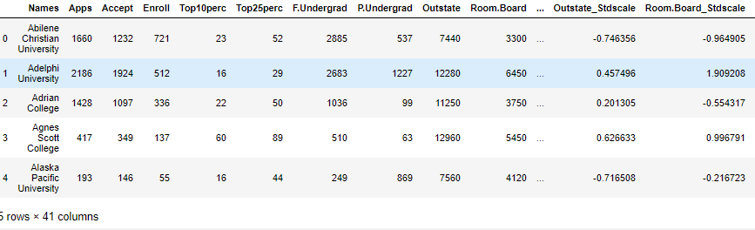data1.cov()
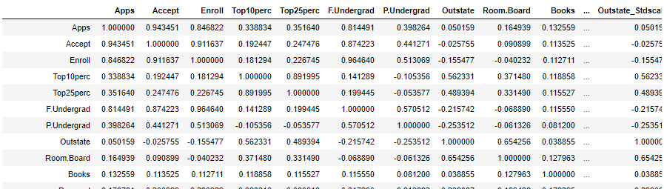

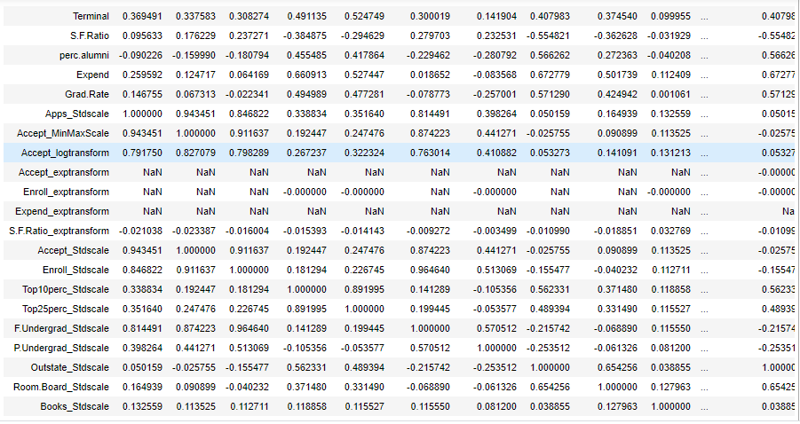
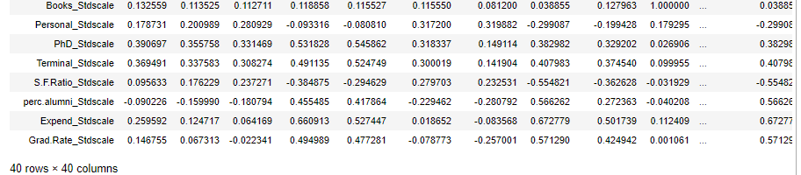
* Finally we can say that after scaling - the covariance and the correlation have the same values correlation value itself is scaled covariance value.
***We can state that the three approaches yield the same eigenvectors and eigenvalue pairs:
1.Eigen decomposition of the covariance matrix after standardizing the data.
2.Eigen decomposition of the correlation matrix.
3.Eigen decomposition of the correlation matrix after standardizing the data.

2.4 Check the dataset for outliers before and after scaling. What insight do you derive here?.
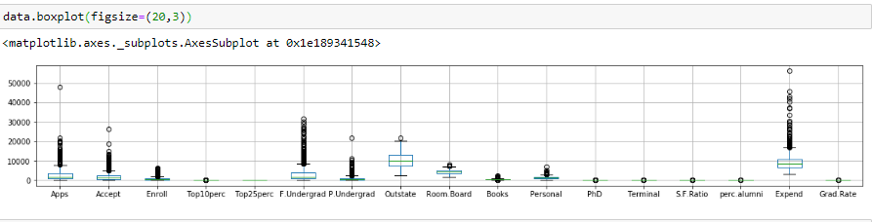
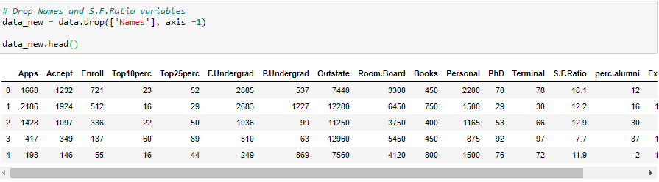
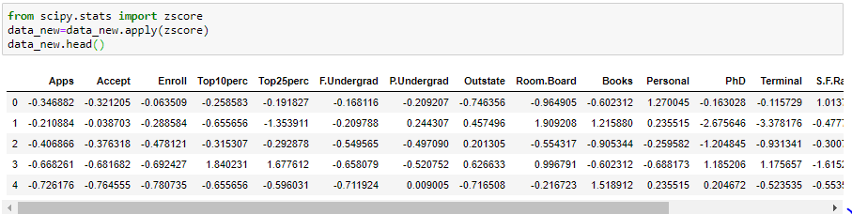
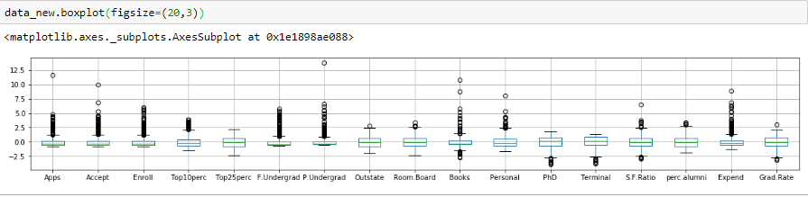
f, a = plt.subplots(figsize=(25,30))
data.boxplot(figsize=(25,20))
a.tick_params(axis = 'x', rotation = 90)
Before scaling
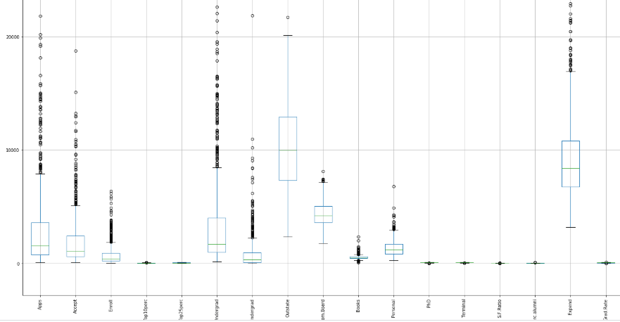 f, a = plt.subplots(figsize=(25,30))
data_new.boxplot(figsize=(25,20))
a.tick_params(axis = 'x', rotation = 90)
After Scaling
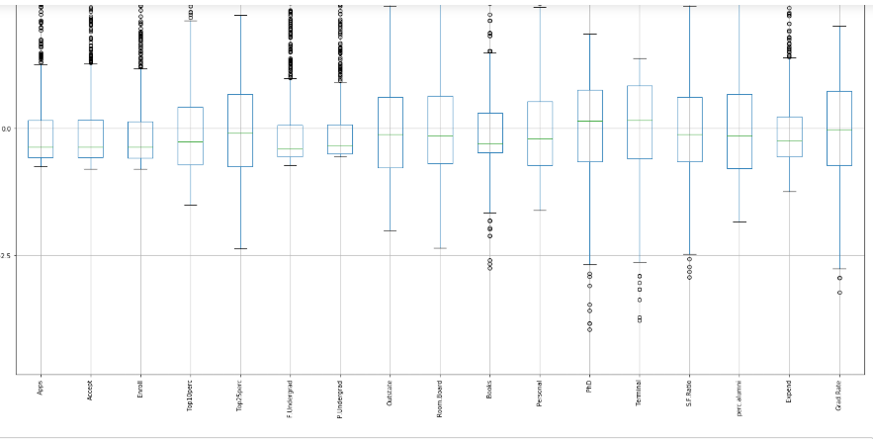
We observe from the plots that al most all the variables have outliers –
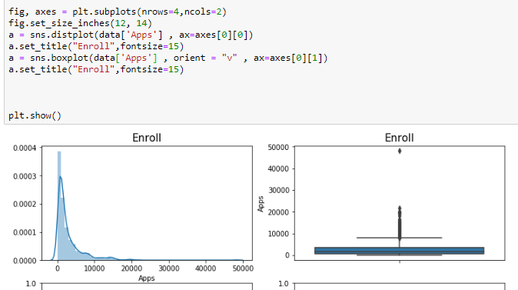
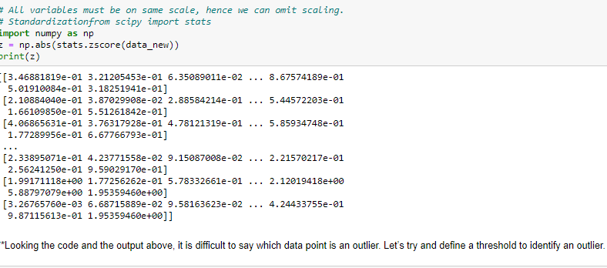
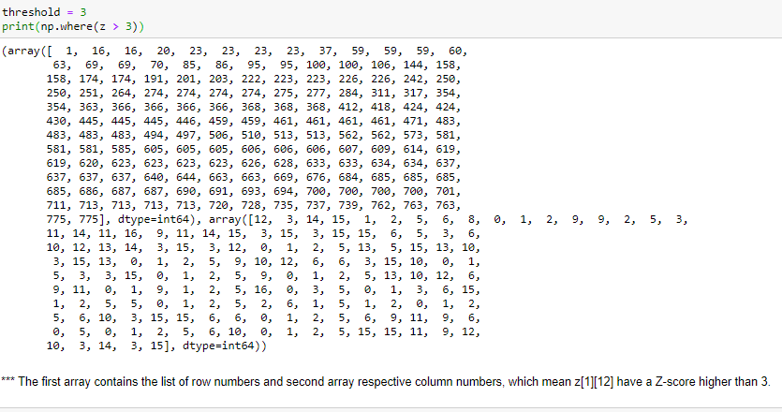
*** The first array contains the list of row numbers and second array respective column numbers, which mean z[1][12] have a Z-score higher than 3.
print(z[1][12])
​
3.3781759379843086
So, the data point — 1st record on column ZN is an outlier.

2.6 Extract the eigenvalues, and eigenvectors.

Create a covariance matrix for identifying Principal components

# PCA- after scaling
# Step 1 - Create covariance matrix
import pandas as pd
import numpy as np
import os
import seaborn as sns
import matplotlib.pyplot as plt
%matplotlib inline
cov_matrix = np.cov(data_new.T)
print('Covariance Matrix \n%s', cov_matrix)

Covariance Matrix
%s [[ 1.00128866 0.94466636 0.84791332 0.33927032 0.35209304 0.81554018
0.3987775 0.05022367 0.16515151 0.13272942 0.17896117 0.39120081
0.36996762 0.09575627 -0.09034216 0.2599265 0.14694372]
[ 0.94466636 1.00128866 0.91281145 0.19269493 0.24779465 0.87534985
0.44183938 -0.02578774 0.09101577 0.11367165 0.20124767 0.35621633
0.3380184 0.17645611 -0.16019604 0.12487773 0.06739929]
[ 0.84791332 0.91281145 1.00128866 0.18152715 0.2270373 0.96588274
0.51372977 -0.1556777 -0.04028353 0.11285614 0.28129148 0.33189629
0.30867133 0.23757707 -0.18102711 0.06425192 -0.02236983]
[ 0.33927032 0.19269493 0.18152715 1.00128866 0.89314445 0.1414708
-0.10549205 0.5630552 0.37195909 0.1190116 -0.09343665 0.53251337
0.49176793 -0.38537048 0.45607223 0.6617651 0.49562711]
[ 0.35209304 0.24779465 0.2270373 0.89314445 1.00128866 0.19970167
-0.05364569 0.49002449 0.33191707 0.115676 -0.08091441 0.54656564
0.52542506 -0.29500852 0.41840277 0.52812713 0.47789622]
[ 0.81554018 0.87534985 0.96588274 0.1414708 0.19970167 1.00128866
0.57124738 -0.21602002 -0.06897917 0.11569867 0.31760831 0.3187472
0.30040557 0.28006379 -0.22975792 0.01867565 -0.07887464]
[ 0.3987775 0.44183938 0.51372977 -0.10549205 -0.05364569 0.57124738
1.00128866 -0.25383901 -0.06140453 0.08130416 0.32029384 0.14930637
0.14208644 0.23283016 -0.28115421 -0.08367612 -0.25733218]
[ 0.05022367 -0.02578774 -0.1556777 0.5630552 0.49002449 -0.21602002
-0.25383901 1.00128866 0.65509951 0.03890494 -0.29947232 0.38347594
0.40850895 -0.55553625 0.56699214 0.6736456 0.57202613]
[ 0.16515151 0.09101577 -0.04028353 0.37195909 0.33191707 -0.06897917
-0.06140453 0.65509951 1.00128866 0.12812787 -0.19968518 0.32962651
0.3750222 -0.36309504 0.27271444 0.50238599 0.42548915]
[ 0.13272942 0.11367165 0.11285614 0.1190116 0.115676 0.11569867
0.08130416 0.03890494 0.12812787 1.00128866 0.17952581 0.0269404
0.10008351 -0.03197042 -0.04025955 0.11255393 0.00106226]
[ 0.17896117 0.20124767 0.28129148 -0.09343665 -0.08091441 0.31760831
0.32029384 -0.29947232 -0.19968518 0.17952581 1.00128866 -0.01094989
-0.03065256 0.13652054 -0.2863366 -0.09801804 -0.26969106]
[ 0.39120081 0.35621633 0.33189629 0.53251337 0.54656564 0.3187472
0.14930637 0.38347594 0.32962651 0.0269404 -0.01094989 1.00128866
0.85068186 -0.13069832 0.24932955 0.43331936 0.30543094]
[ 0.36996762 0.3380184 0.30867133 0.49176793 0.52542506 0.30040557
0.14208644 0.40850895 0.3750222 0.10008351 -0.03065256 0.85068186
1.00128866 -0.16031027 0.26747453 0.43936469 0.28990033]
[ 0.09575627 0.17645611 0.23757707 -0.38537048 -0.29500852 0.28006379
0.23283016 -0.55553625 -0.36309504 -0.03197042 0.13652054 -0.13069832
-0.16031027 1.00128866 -0.4034484 -0.5845844 -0.30710565]
[-0.09034216 -0.16019604 -0.18102711 0.45607223 0.41840277 -0.22975792
-0.28115421 0.56699214 0.27271444 -0.04025955 -0.2863366 0.24932955
0.26747453 -0.4034484 1.00128866 0.41825001 0.49153016]
[ 0.2599265 0.12487773 0.06425192 0.6617651 0.52812713 0.01867565
-0.08367612 0.6736456 0.50238599 0.11255393 -0.09801804 0.43331936
0.43936469 -0.5845844 0.41825001 1.00128866 0.39084571]
[ 0.14694372 0.06739929 -0.02236983 0.49562711 0.47789622 -0.07887464
-0.25733218 0.57202613 0.42548915 0.00106226 -0.26969106 0.30543094
0.28990033 -0.30710565 0.49153016 0.39084571 1.00128866]]

# PCA before scaling
# Step 1 - Create covariance matrix
import pandas as pd
import numpy as np
import os
import seaborn as sns
import matplotlib.pyplot as plt
%matplotlib inline
cov_matrix = np.cov(data_new.T)
print('Covariance Matrix \n%s', cov_matrix)
here it is the data without the column Nnames

Covariance Matrix
%s [[ 1.00128866 1.00128866 0.91281145 0.19269493 0.24779465 0.87534985
0.44183938 -0.02578774 0.09101577 0.11367165 0.20124767 0.35621633
0.3380184 0.17645611 -0.16019604 0.12487773 0.06739929]
[ 1.00128866 1.00128866 0.91281145 0.19269493 0.24779465 0.87534985
0.44183938 -0.02578774 0.09101577 0.11367165 0.20124767 0.35621633
0.3380184 0.17645611 -0.16019604 0.12487773 0.06739929]
[ 0.91281145 0.91281145 1.00128866 0.18152715 0.2270373 0.96588274
0.51372977 -0.1556777 -0.04028353 0.11285614 0.28129148 0.33189629
0.30867133 0.23757707 -0.18102711 0.06425192 -0.02236983]
[ 0.19269493 0.19269493 0.18152715 1.00128866 0.89314445 0.1414708
-0.10549205 0.5630552 0.37195909 0.1190116 -0.09343665 0.53251337
0.49176793 -0.38537048 0.45607223 0.6617651 0.49562711]
[ 0.24779465 0.24779465 0.2270373 0.89314445 1.00128866 0.19970167
-0.05364569 0.49002449 0.33191707 0.115676 -0.08091441 0.54656564
0.52542506 -0.29500852 0.41840277 0.52812713 0.47789622]
[ 0.87534985 0.87534985 0.96588274 0.1414708 0.19970167 1.00128866
0.57124738 -0.21602002 -0.06897917 0.11569867 0.31760831 0.3187472
0.30040557 0.28006379 -0.22975792 0.01867565 -0.07887464]
[ 0.44183938 0.44183938 0.51372977 -0.10549205 -0.05364569 0.57124738
1.00128866 -0.25383901 -0.06140453 0.08130416 0.32029384 0.14930637
0.14208644 0.23283016 -0.28115421 -0.08367612 -0.25733218]
[-0.02578774 -0.02578774 -0.1556777 0.5630552 0.49002449 -0.21602002
-0.25383901 1.00128866 0.65509951 0.03890494 -0.29947232 0.38347594
0.40850895 -0.55553625 0.56699214 0.6736456 0.57202613]
[ 0.09101577 0.09101577 -0.04028353 0.37195909 0.33191707 -0.06897917
-0.06140453 0.65509951 1.00128866 0.12812787 -0.19968518 0.32962651
0.3750222 -0.36309504 0.27271444 0.50238599 0.42548915]
[ 0.11367165 0.11367165 0.11285614 0.1190116 0.115676 0.11569867
0.08130416 0.03890494 0.12812787 1.00128866 0.17952581 0.0269404
0.10008351 -0.03197042 -0.04025955 0.11255393 0.00106226]
[ 0.20124767 0.20124767 0.28129148 -0.09343665 -0.08091441 0.31760831
0.32029384 -0.29947232 -0.19968518 0.17952581 1.00128866 -0.01094989
-0.03065256 0.13652054 -0.2863366 -0.09801804 -0.26969106]
[ 0.35621633 0.35621633 0.33189629 0.53251337 0.54656564 0.3187472
0.14930637 0.38347594 0.32962651 0.0269404 -0.01094989 1.00128866
0.85068186 -0.13069832 0.24932955 0.43331936 0.30543094]
[ 0.3380184 0.3380184 0.30867133 0.49176793 0.52542506 0.30040557
0.14208644 0.40850895 0.3750222 0.10008351 -0.03065256 0.85068186
1.00128866 -0.16031027 0.26747453 0.43936469 0.28990033]
[ 0.17645611 0.17645611 0.23757707 -0.38537048 -0.29500852 0.28006379
0.23283016 -0.55553625 -0.36309504 -0.03197042 0.13652054 -0.13069832
-0.16031027 1.00128866 -0.4034484 -0.5845844 -0.30710565]
[-0.16019604 -0.16019604 -0.18102711 0.45607223 0.41840277 -0.22975792
-0.28115421 0.56699214 0.27271444 -0.04025955 -0.2863366 0.24932955
0.26747453 -0.4034484 1.00128866 0.41825001 0.49153016]
[ 0.12487773 0.12487773 0.06425192 0.6617651 0.52812713 0.01867565
-0.08367612 0.6736456 0.50238599 0.11255393 -0.09801804 0.43331936
0.43936469 -0.5845844 0.41825001 1.00128866 0.39084571]
[ 0.06739929 0.06739929 -0.02236983 0.49562711 0.47789622 -0.07887464
-0.25733218 0.57202613 0.42548915 0.00106226 -0.26969106 0.30543094
0.28990033 -0.30710565 0.49153016 0.39084571 1.00128866]]

Even if we take the transpose of the covariance matrix it results in same value as that of the above

Identify eigen values and eigen vector
# Step 2- Get eigen values and eigen vector
eig_vals, eig_vecs = np.linalg.eig(cov_matrix)
​
print('\n Eigen Values \n%s', eig_vals)
print('Eigen Vectors \n%s', eig_vecs)

Eigen Values
%s [5.45052162 4.48360686 1.17466761 1.00820573 0.93423123 0.84849117
0.6057878 0.58787222 0.53061262 0.4043029 0.02302787 0.03672545
0.31344588 0.08802464 0.1439785 0.16779415 0.22061096]
Eigen Vectors
%s [[-2.48765602e-01 3.31598227e-01 6.30921033e-02 -2.81310530e-01
5.74140964e-03 1.62374420e-02 4.24863486e-02 1.03090398e-01
9.02270802e-02 -5.25098025e-02 3.58970400e-01 -4.59139498e-01
4.30462074e-02 -1.33405806e-01 8.06328039e-02 -5.95830975e-01
2.40709086e-02]
[-2.07601502e-01 3.72116750e-01 1.01249056e-01 -2.67817346e-01
5.57860920e-02 -7.53468452e-03 1.29497196e-02 5.62709623e-02
1.77864814e-01 -4.11400844e-02 -5.43427250e-01 5.18568789e-01
-5.84055850e-02 1.45497511e-01 3.34674281e-02 -2.92642398e-01
-1.45102446e-01]
[-1.76303592e-01 4.03724252e-01 8.29855709e-02 -1.61826771e-01
-5.56936353e-02 4.25579803e-02 2.76928937e-02 -5.86623552e-02
1.28560713e-01 -3.44879147e-02 6.09651110e-01 4.04318439e-01
-6.93988831e-02 -2.95896092e-02 -8.56967180e-02 4.44638207e-01
1.11431545e-02]
[-3.54273947e-01 -8.24118211e-02 -3.50555339e-02 5.15472524e-02
-3.95434345e-01 5.26927980e-02 1.61332069e-01 1.22678028e-01
-3.41099863e-01 -6.40257785e-02 -1.44986329e-01 1.48738723e-01
-8.10481404e-03 -6.97722522e-01 -1.07828189e-01 -1.02303616e-03
3.85543001e-02]
[-3.44001279e-01 -4.47786551e-02 2.41479376e-02 1.09766541e-01
-4.26533594e-01 -3.30915896e-02 1.18485556e-01 1.02491967e-01
-4.03711989e-01 -1.45492289e-02 8.03478445e-02 -5.18683400e-02
-2.73128469e-01 6.17274818e-01 1.51742110e-01 -2.18838802e-02
-8.93515563e-02]
[-1.54640962e-01 4.17673774e-01 6.13929764e-02 -1.00412335e-01
-4.34543659e-02 4.34542349e-02 2.50763629e-02 -7.88896442e-02
5.94419181e-02 -2.08471834e-02 -4.14705279e-01 -5.60363054e-01
-8.11578181e-02 -9.91640992e-03 -5.63728817e-02 5.23622267e-01
5.61767721e-02]
[-2.64425045e-02 3.15087830e-01 -1.39681716e-01 1.58558487e-01
3.02385408e-01 1.91198583e-01 -6.10423460e-02 -5.70783816e-01
-5.60672902e-01 2.23105808e-01 9.01788964e-03 5.27313042e-02
1.00693324e-01 -2.09515982e-02 1.92857500e-02 -1.25997650e-01
-6.35360730e-02]
[-2.94736419e-01 -2.49643522e-01 -4.65988731e-02 -1.31291364e-01
2.22532003e-01 3.00003910e-02 -1.08528966e-01 -9.84599754e-03
4.57332880e-03 -1.86675363e-01 5.08995918e-02 -1.01594830e-01
1.43220673e-01 -3.83544794e-02 -3.40115407e-02 1.41856014e-01
-8.23443779e-01]
[-2.49030449e-01 -1.37808883e-01 -1.48967389e-01 -1.84995991e-01
5.60919470e-01 -1.62755446e-01 -2.09744235e-01 2.21453442e-01
-2.75022548e-01 -2.98324237e-01 1.14639620e-03 2.59293381e-02
-3.59321731e-01 -3.40197083e-03 -5.84289756e-02 6.97485854e-02
3.54559731e-01]
[-6.47575181e-02 5.63418434e-02 -6.77411649e-01 -8.70892205e-02
-1.27288825e-01 -6.41054950e-01 1.49692034e-01 -2.13293009e-01
1.33663353e-01 8.20292186e-02 7.72631963e-04 -2.88282896e-03
3.19400370e-02 9.43887925e-03 -6.68494643e-02 -1.14379958e-02
-2.81593679e-02]
[ 4.25285386e-02 2.19929218e-01 -4.99721120e-01 2.30710568e-01
-2.22311021e-01 3.31398003e-01 -6.33790064e-01 2.32660840e-01
9.44688900e-02 -1.36027616e-01 -1.11433396e-03 1.28904022e-02
-1.85784733e-02 3.09001353e-03 2.75286207e-02 -3.94547417e-02
-3.92640266e-02]
[-3.18312875e-01 5.83113174e-02 1.27028371e-01 5.34724832e-01
1.40166326e-01 -9.12555212e-02 1.09641298e-03 7.70400002e-02
1.85181525e-01 1.23452200e-01 1.38133366e-02 -2.98075465e-02
4.03723253e-02 1.12055599e-01 -6.91126145e-01 -1.27696382e-01
2.32224316e-02]
[-3.17056016e-01 4.64294477e-02 6.60375454e-02 5.19443019e-01
2.04719730e-01 -1.54927646e-01 2.84770105e-02 1.21613297e-02
2.54938198e-01 8.85784627e-02 6.20932749e-03 2.70759809e-02
-5.89734026e-02 -1.58909651e-01 6.71008607e-01 5.83134662e-02
1.64850420e-02]
[ 1.76957895e-01 2.46665277e-01 2.89848401e-01 1.61189487e-01
-7.93882496e-02 -4.87045875e-01 -2.19259358e-01 8.36048735e-02
-2.74544380e-01 -4.72045249e-01 -2.22215182e-03 2.12476294e-02
4.45000727e-01 2.08991284e-02 4.13740967e-02 1.77152700e-02
-1.10262122e-02]
[-2.05082369e-01 -2.46595274e-01 1.46989274e-01 -1.73142230e-02
-2.16297411e-01 4.73400144e-02 -2.43321156e-01 -6.78523654e-01
2.55334907e-01 -4.22999706e-01 -1.91869743e-02 -3.33406243e-03
-1.30727978e-01 8.41789410e-03 -2.71542091e-02 -1.04088088e-01
1.82660654e-01]
[-3.18908750e-01 -1.31689865e-01 -2.26743985e-01 -7.92734946e-02
7.59581203e-02 2.98118619e-01 2.26584481e-01 5.41593771e-02
4.91388809e-02 -1.32286331e-01 -3.53098218e-02 4.38803230e-02
6.92088870e-01 2.27742017e-01 7.31225166e-02 9.37464497e-02
3.25982295e-01]
[-2.52315654e-01 -1.69240532e-01 2.08064649e-01 -2.69129066e-01
-1.09267913e-01 -2.16163313e-01 -5.59943937e-01 5.33553891e-03
-4.19043052e-02 5.90271067e-01 -1.30710024e-02 5.00844705e-03
2.19839000e-01 3.39433604e-03 3.64767385e-02 6.91969778e-02
1.22106697e-01]]

**We see that 4 eigen values are greater than 1, Eigen Values
**%s [5.45052162 4.48360686 1.17466761 1.00820573]
For each Eigen value there is a Eigen Vector
2.6)Write down the explicit form of the first PC (in terms of the eigenvectors. Use values with two places of decimals only).
print(eig_vecs)
[[-2.01050180e-01 3.75667765e-01 1.12537477e-01 2.67320573e-01
2.80981889e-03 6.52945894e-03 1.46015825e-02 7.72625513e-02
-1.45508857e-01 4.17839964e-02 -3.97696853e-02 -7.07106781e-01
7.32551766e-02 1.38902287e-01 -8.59397382e-02 3.80386148e-01
-1.63873616e-01]
[-2.01050180e-01 3.75667765e-01 1.12537477e-01 2.67320573e-01
2.80981889e-03 6.52945894e-03 1.46015825e-02 7.72625513e-02
-1.45508857e-01 4.17839964e-02 -3.97696853e-02 7.07106781e-01
7.32551766e-02 1.38902287e-01 -8.59397382e-02 3.80386148e-01
-1.63873616e-01]
[-1.69381943e-01 4.04391533e-01 8.14900877e-02 1.44494478e-01
9.79335957e-02 5.55149720e-02 4.24799382e-02 -3.28067089e-02
-9.60637593e-02 3.76265493e-02 -2.13233425e-02 -2.22065139e-15
-7.47873560e-01 -1.12360869e-01 3.34579948e-02 -4.00287262e-01
1.42535561e-01]
[-3.57005386e-01 -7.69851694e-02 -5.29031511e-02 -1.26254875e-01
3.82193262e-01 5.24452441e-02 1.51333565e-01 1.28668535e-01
3.36023528e-01 7.15532672e-02 -1.17191181e-02 -1.54089141e-15
4.76593751e-02 -3.15485905e-02 -7.20444449e-01 -1.16815103e-01
-7.40273388e-02]
[-3.47323375e-01 -3.77142778e-02 3.40559795e-03 -1.82298215e-01
4.05862904e-01 -3.39451458e-02 1.11860054e-01 1.07497219e-01
3.86094613e-01 2.98758752e-02 -2.82948337e-01 8.22520910e-16
-4.94722064e-02 1.06867949e-01 6.01298612e-01 2.07485292e-01
7.90871084e-02]
[-1.46944830e-01 4.16199469e-01 5.43739049e-02 8.34194110e-02
7.50368641e-02 5.41476244e-02 4.09359112e-02 -5.88543716e-02
-2.89197522e-02 2.36863369e-02 -3.43611457e-02 8.04062317e-15
6.50107404e-01 -1.64047332e-01 1.49588670e-01 -5.04913176e-01
2.28307871e-01]
[-1.98812122e-02 3.08495268e-01 -1.57855059e-01 -1.14038603e-01
-3.15728744e-01 1.91048713e-01 -4.40448382e-03 -6.00937181e-01
5.35579448e-01 -2.21609356e-01 7.04792882e-02 -1.43356216e-15
-3.52206467e-02 1.05759450e-01 -4.68498492e-02 1.08517784e-01
-4.31657682e-02]
[-3.04174046e-01 -2.34337037e-01 -2.60116682e-02 1.86094480e-01
-1.95750282e-01 3.51190699e-02 -1.04213901e-01 -1.18341513e-02
-9.71065533e-03 1.92190576e-01 1.46303619e-01 9.68791855e-16
1.25090173e-02 7.82364013e-01 3.34715199e-02 -2.86803531e-01
1.12435045e-01]
[-2.54307774e-01 -1.27816997e-01 -1.24167036e-01 2.88155100e-01
-5.17996721e-01 -1.56830255e-01 -2.27096664e-01 1.89000146e-01
2.96370024e-01 3.05056283e-01 -3.43019768e-01 3.77071738e-16
-1.77889396e-02 -3.72354864e-01 -3.07632125e-03 -3.24140579e-02
-4.18026438e-02]
[-6.35189171e-02 5.47057226e-02 -6.67474293e-01 1.43837500e-01
1.39486634e-01 -6.38336565e-01 1.68896135e-01 -1.90978812e-01
-1.45963221e-01 -8.40897298e-02 2.98555656e-02 2.10602546e-16
5.47749858e-04 2.99790673e-02 1.09327910e-02 -2.75480745e-02
-6.15418990e-02]
[ 4.85086962e-02 2.10924621e-01 -5.20931778e-01 -2.31274457e-01
1.70617605e-01 3.22373995e-01 -6.55931632e-01 1.74537026e-01
-1.06083138e-01 1.35834906e-01 -2.26244219e-02 -3.63102498e-16
-5.68518709e-03 4.82705067e-02 -6.20887429e-03 4.36283552e-02
5.84079305e-03]
[-3.21837660e-01 6.66010026e-02 9.31137029e-02 -5.01520450e-01
-2.28135719e-01 -1.09970903e-01 -1.28752356e-02 7.40362826e-02
-1.92887401e-01 -1.27810756e-01 3.34925895e-02 -8.06783883e-16
3.27261374e-03 -8.60291047e-03 1.18303353e-01 -2.34203450e-01
-6.62125897e-01]
[-3.21076980e-01 5.53296027e-02 3.62929478e-02 -4.66020406e-01
-2.89298653e-01 -1.73316880e-01 2.02500742e-02 1.46320070e-02
-2.64305641e-01 -9.34071824e-02 -6.16547390e-02 3.18546737e-16
-1.61579769e-02 -2.13069186e-02 -1.62240748e-01 2.40975254e-01
6.27303371e-01]
[ 1.83915453e-01 2.37510960e-01 2.69216757e-01 -1.97195519e-01
5.96160665e-02 -4.90891529e-01 -2.29712752e-01 3.66019231e-02
2.81023026e-01 4.67245410e-01 4.46241273e-01 5.42347414e-16
-1.07739847e-02 2.18997699e-02 1.11734183e-02 4.25994654e-02
2.83720156e-02]
[-2.13422901e-01 -2.35094084e-01 1.50409954e-01 -8.40720379e-03
2.19739464e-01 5.14738395e-02 -1.79429240e-01 -6.90413142e-01
-2.93627951e-01 4.14538503e-01 -1.32276954e-01 -2.46609991e-16
2.04720346e-02 -1.69632594e-01 -8.59426572e-03 7.62793292e-02
-7.77431645e-02]
[-3.22679613e-01 -1.24667992e-01 -2.21787467e-01 9.33840331e-02
-6.61060344e-02 2.99432452e-01 2.20993698e-01 7.67018386e-02
-3.33561893e-02 1.23310989e-01 7.07052077e-01 1.01122596e-15
-2.41265490e-03 -3.14689219e-01 1.92604692e-01 1.42979706e-01
2.93010110e-02]
[-2.58156311e-01 -1.58182623e-01 2.23788227e-01 2.42585045e-01
1.64702360e-01 -2.02125319e-01 -5.52337650e-01 -4.35696122e-02
7.00584483e-02 -5.94527509e-01 2.19299443e-01 -7.52646511e-16
5.92563697e-03 -1.24467620e-01 6.03998970e-03 -2.73563432e-03
4.91278106e-02]]
"""4. Find the eigenvalues and eigenvectors of the covariance matrix"""
​
eig_val,eig_vec = np.linalg.eig(cov_matrix)
print(np.cumsum([i*(100/sum(eig_val)) for i in eig_val])) # As you can see, the first two principal components contain 55% of
# the total variation while the first 8 PC contain 90%
[ 31.45552717 58.61488242 65.56532482 71.49861608 76.9877395
81.96992684 85.52415211 88.95470969 92.14089436 94.51486223
96.35681185 96.35681185 96.52232828 97.84496734 98.33622527
99.14443974 100. ]
Variance explained by Eigen vector is eigen value. the values are loadings coefficients of all the x variables in the data. PC1.
# Using scikit learn PCA here. It does all the above steps and maps data to PCA dimensions in one shot
​
from sklearn.decomposition import PCA
​
# NOTE - we are generating only 4 PCA dimensions (dimensionality reduction from 18 to 4)
​
pca = PCA(n_components=4)
data_reduced = pca.fit_transform(data_new)
data_reduced.transpose()
Out[162]:
array([[-1.60534055e+00, -2.16709596e+00, -1.39790942e+00, ...,
-6.91801180e-01, 7.57330603e+00, -4.94454171e-01],
[ 6.99178416e-01, -5.75291463e-01, -1.11667408e+00, ...,
-3.82343964e-02, -2.44957084e+00, 3.23761886e-01],
[-2.23322666e-03, 1.97780775e+00, -4.94775001e-01, ...,
-1.00891382e-02, 2.17831971e+00, -1.26853367e+00],
[-1.08175262e+00, 3.87430192e+00, 5.55419086e-01, ...,
3.78853640e-03, 3.73610164e-01, -4.15372481e-01]])
# Using scikit learn PCA here. It does all the above steps and maps data to PCA dimensions in one shot
from sklearn.decomposition import PCA
​
# NOTE - we are generating only 4 PCA dimensions (dimensionality reduction from 18 to 4)
​
pca = PCA(n_components=4)
data_reduced = pca.fit_transform(data_new)
data_reduced.transpose()
array([[-1.59285540e+00, -2.19240180e+00, -1.43096371e+00, ...,
-7.32560598e-01, 7.91932736e+00, -4.69508068e-01],
[ 7.67333509e-01, -5.78829983e-01, -1.09281889e+00, ...,
-7.72352408e-02, -2.06832885e+00, 3.66660940e-01],
[-1.01073121e-01, 2.27879861e+00, -4.38092875e-01, ...,
-4.04541663e-04, 2.07356427e+00, -1.32891520e+00],
[-9.21749106e-01, 3.58891643e+00, 6.77240920e-01, ...,
5.43156886e-02, 8.52045744e-01, -1.08019781e-01]])
Final = pd.DataFrame(data_reduced, columns=['P1', 'P2', 'P3', 'P4'])
Final.head()
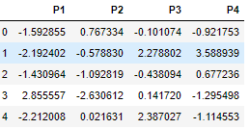
Final.shape
(777, 4)The 18 variables are decomposed to 4 variables

pca.components_
array([[ 0.2487656 , 0.2076015 , 0.17630359, 0.35427395, 0.34400128,
0.15464096, 0.0264425 , 0.29473642, 0.24903045, 0.06475752,
-0.04252854, 0.31831287, 0.31705602, -0.17695789, 0.20508237,
0.31890875, 0.25231565],
[ 0.33159823, 0.37211675, 0.40372425, -0.08241182, -0.04477866,
0.41767377, 0.31508783, -0.24964352, -0.13780888, 0.05634184,
0.21992922, 0.05831132, 0.04642945, 0.24666528, -0.24659527,
-0.13168986, -0.16924053],
[-0.06309211, -0.10124905, -0.08298551, 0.03505578, -0.02414814,
-0.06139305, 0.13968173, 0.04659887, 0.14896739, 0.67741165,
0.49972112, -0.12702841, -0.06603749, -0.28984841, -0.14698928,
0.22674392, -0.20806465],
[ 0.28131021, 0.26781766, 0.16182679, -0.05154849, -0.10976544,
0.10041226, -0.15855852, 0.13129128, 0.184996 , 0.08708924,
-0.23071056, -0.53472461, -0.51944332, -0.16118945, 0.01731424,
0.07927391, 0.26912908]])

Based on the final data the pca components are given with 4 variables
Here we reduced the dimensions using 4 principal components and here we have 4 eigen vectors, but have loadings for all 18 variables
*array([[ 0.2487656 , 0.2076015 , 0.17630359, 0.35427395, 0.34400128, 0.15464096, 0.0264425 , 0.29473642, 0.24903045, 0.06475752, -0.04252854, 0.31831287, 0.31705602, -0.17695789, 0.20508237, 0.31890875, 0.25231565]
This is to read the Eigen Vector. and this is eigen vector 1.
each PC is having loadings for all variables and it can be 0 also. these are the coefficients of each variable.eg: this first PC these are the combinations of all variables with these weights.
**Eigenvectors are basis vectors that capture the inherent patterns that make up a dataset. By convention these are unit vectors, with norm = 1 so that they are the linear algebra equivalent of 1. Eigenvectors come in pairs, 'left' and 'right'

2.8 Consider the cumulative values of the eigenvalues. How does it help you to decide on the optimum number of principal components? What do the eigenvectors indicate?
Perform PCA and export the data of the Principal Component scores into a data frame.

Cummulative Distribution of Eigen values
tot = sum(eig_vals)
var_exp = [( i /tot ) * 100 for i in sorted(eig_vals, reverse=True)]
cum_var_exp = np.cumsum(var_exp)
print("Cumulative Variance Explained", cum_var_exp)
Cumulative Variance Explained [ 31.45552717 58.61488242 65.56532482 71.49861608 76.9877395
81.96992684 85.52415211 88.95470969 92.14089436 94.51486223
96.35681185 97.67945091 98.53501117 99.34322564 99.83448357
100. 100. ]

** when we have 18 variables to understand 90% of variables we need to cover atleast the first 5 PC. Curse of dimensions, if we have 18 variables we need to covefr a large data. if we reduce 18 to 4 or 5 we have the variations

SCREEPLOT
plt.plot(var_exp)
Out[288]:
[<matplotlib.lines.Line2D at 0x1e18a1ee208>]
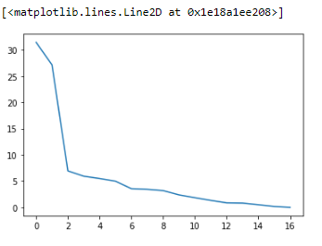

Visually we can observe that their is steep drop in variance explained with increase in number of PC's.
We will proceed with 17 components here. But depending on requirement 90% variation or 5 or 6 components will also do good
This also called Elbow curve, Based on this graph we will take a decision on how many PC can be taken. where ever there is a sudden change in the graph that is taken as the principal component
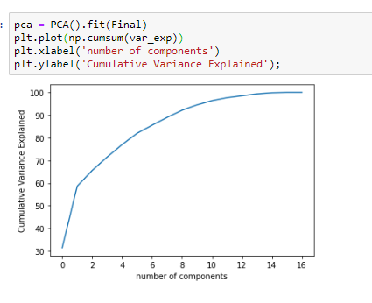
*##This curve quantifies how much of the total, 18-dimensional variance is contained within the first N components. For example, we see that with the first 2 components contain approximately 60% of the variance, while you need around 16 components to describe close to 100% of the variance.
Here we see that our two-dimensional projection loses a lot of information (as measured by the explained variance) and that we'd need about 20 components to retain 90% of the variance. Looking at this plot for a high-dimensional dataset can help you understand the level of redundancy present in multiple observations.
plt.figure(figsize=(10 , 5))
plt.bar(range(1, eig_vals.size + 1), var_exp, alpha = 0.5, align = 'center', label = 'Individual explained variance')
plt.step(range(1, eig_vals.size + 1), cum_var_exp, where='mid', label = 'Cumulative explained variance')
plt.ylabel('Explained Variance Ratio')
plt.xlabel('Principal Components')
plt.legend(loc = 'best')
plt.tight_layout()
plt.show()
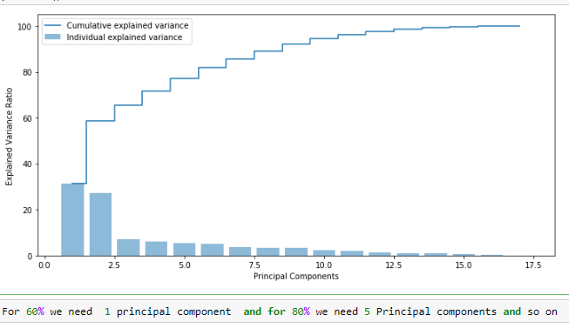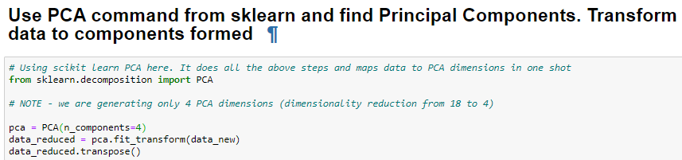
array([[-1.59285540e+00, -2.19240179e+00, -1.43096371e+00, ...,
-7.32560593e-01, 7.91932737e+00, -4.69508071e-01],
[ 7.67333510e-01, -5.78829995e-01, -1.09281889e+00, ...,
-7.72352459e-02, -2.06832889e+00, 3.66660956e-01],
[-1.01073561e-01, 2.27879606e+00, -4.38092392e-01, ...,
-4.06876784e-04, 2.07355785e+00, -1.32891292e+00],
[-9.21749461e-01, 3.58891765e+00, 6.77240663e-01, ...,
5.43159116e-02, 8.52051927e-01, -1.08021829e-01]])

2.5)Perform PCA and export the data of the Principal Component scores into a data frame.
pca.components_
Out[290]:
array([[ 0.2487656 , 0.2076015 , 0.17630359, 0.35427395, 0.34400128,
0.15464096, 0.0264425 , 0.29473642, 0.24903045, 0.06475752,
-0.04252854, 0.31831287, 0.31705602, -0.17695789, 0.20508237,
0.31890875, 0.25231565],
[ 0.33159823, 0.37211675, 0.40372425, -0.08241182, -0.04477865,
0.41767377, 0.31508783, -0.24964352, -0.13780888, 0.05634184,
0.21992922, 0.05831132, 0.04642945, 0.24666528, -0.24659527,
-0.13168986, -0.16924053],
[-0.06309224, -0.10124886, -0.08298564, 0.03505462, -0.02414713,
-0.06139302, 0.1396817 , 0.0465988 , 0.14896738, 0.67741166,
0.49972113, -0.12702822, -0.06603775, -0.28984837, -0.14698926,
0.22674428, -0.20806464],
[ 0.28131048, 0.26781743, 0.16182674, -0.0515476 , -0.10976623,
0.10041232, -0.15855849, 0.13129134, 0.18499599, 0.08708923,
-0.23071057, -0.53472477, -0.5194431 , -0.16118948, 0.01731423,
0.07927361, 0.26912907]])
data_comp = pd.DataFrame(pca.components_,columns=list(data_new))
data_comp.head()
Out[291]:
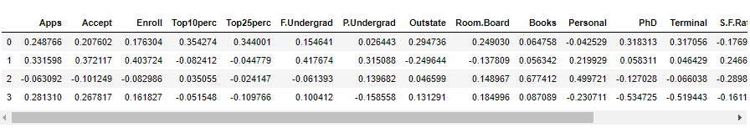
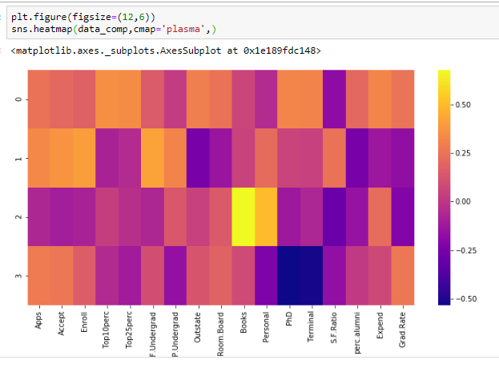
pca.explained_variance_ratio_
array([0.32020628, 0.26340214, 0.06900917, 0.05922989])
sns
var=np.cumsum(np.round(pca.explained_variance_ratio_, decimals=3)*100)
var #cumulative sum of variance explained with [n] features
array([32. , 58.3, 65.2, 71.1])

**The Cumulative % gives the percentage of variance accounted for by the n components. For example, the cumulative percentage for the second component is the sum of the percentage of variance for the first and second components. It helps in deciding the number of components by selecting the components which explained the high variance

2.9 Explain the business implication of using the Principal Component Analysis for this case study. How may PCs help in the further analysis? [Hint: Write Interpretations of the Principal Components Obtained]
**PCA is a statistical technique and uses orthogonal transformation to convert a set of observations of possibly correlated variables into a set of values of linearly uncorrelated variables. PCA also is a tool to reduce multidimensional data to lower dimensions while retaining most of the information. Principal Component Analysis (PCA) is a well-established mathematical technique for reducing the dimensionality of data, while keeping as much variation as possible.
This PCA can only be done on continous variables
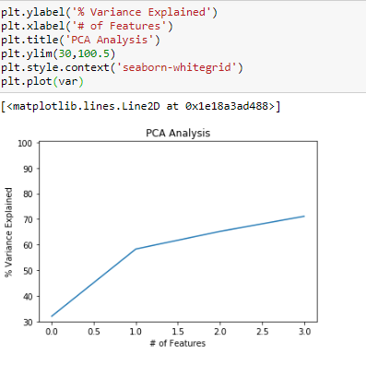
in this case study it helped us reduce the 18 variables into 4 components for easy analysis.
PCA clubs variables and creates new variables.
Another method of analysis is factor analysis.
Principal components are the key to PCA; they represent what's underneath the hood of your data. In a layman term, when the data is projected into a lower dimension (assume three dimensions) from a higher space, the three dimensions are nothing but the three Principal Components that captures (or holds) most of the variance (information) of your data.
We start by standardizing the data since PCA's output is influenced based on the scale of the features of the data.
It is a common practice to normalize the data

PCA basically search a linear combination of variables so that we can extract maximum variance from the variables. Once this process completes it removes it and search for another linear combination which gives an explanation about the maximum proportion of remaining variance which basically leads to orthogonal factors. In this method, we analyze total variance.
Eigenvector: It is a non-zero vector that stays parallel after matrix multiplication. Let’s suppose x is eigen vector of dimension r of matrix M with dimension r*r if Mx and x are parallel. Then we need to solve Mx=Ax where both x and A are unknown to get eigen vector and eigen values.
Under Eigen-Vectors we can say that Principal components show both common and unique variance of the variable. Basically, it is variance focused approach seeking to reproduce total variance and correlation with all components. The principal components are basically the linear combinations of the original variables weighted by their contribution to explain the variance in a particular orthogonal dimension.
Eigen Values: It is basically known as characteristic roots. It basically measures the variance in all variables which is accounted for by that factor. The ratio of eigenvalues is the ratio of explanatory importance of the factors with respect to the variables. If the factor is low then it is contributing less in explanation of variables. In simple words, it measures the amount of variance in the total given database accounted by the factor. We can calculate the factor’s eigen value as the sum of its squared factor loading for all the variables.
Principal components analysis is a procedure for identifying a smaller number of uncorrelated variables, called "principal components", from a large set of data. The goal of principal components analysis is to explain the maximum amount of variance with the fewest number of principal components. Principal components analysis is commonly used in the social sciences, market research, and other industries that use large data sets.
Principal components analysis is commonly used as one step in a series of analyses. You can use principal components analysis to reduce the number of variables and avoid multicollinearity, or when you have too many predictors relative to the number of observations.

