Assignment on Statistical Methods for Decision Making
Student Name: Chinmay Nikhal
Problem 1: Wholesale Customers Analysis
Problem Statement: A wholesale distributor operating in different regions of Portugal has information on annual spending of several items in their stores across different regions and channels. The data consists of 440 large retailers’ annual spending on 6 different varieties of products in 3 different regions (Lisbon, Oporto, Other) and across different sales channel (Hotel, Retail).
Use methods of descriptive statistics to summarize data. Which Region and which Channel seems to spend more? Which Region and which Channel seems to spend less?
As per the max and min function applied to Channel and Region we have:
Retail: Spending max in Channel.
Hotel: Spending least in Channel.
Other: Spending max in Region.
Lisbon: Spending least in Region.
PFB screenshot below from the Jupyter Notebook for the code of above.

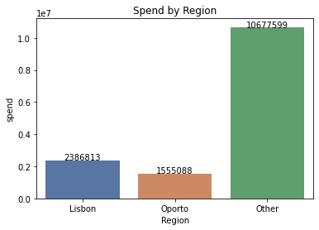

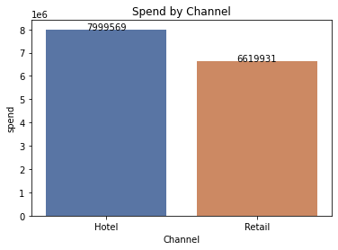
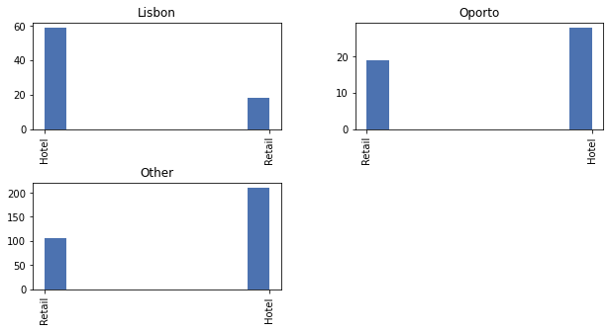

#OBSERVATIONS
#1. Regions- "Other" category has the highest spending; Oporto has the lowest spending
#2. Hoetls have higher spend compared to retail (Overall and regional level)

  - There are 6 different varieties of items are considered. Do all varieties show similar behavior across Region and Channel?
Most of the items show similar behavior across the Region and Channel as per the histogram shown below.

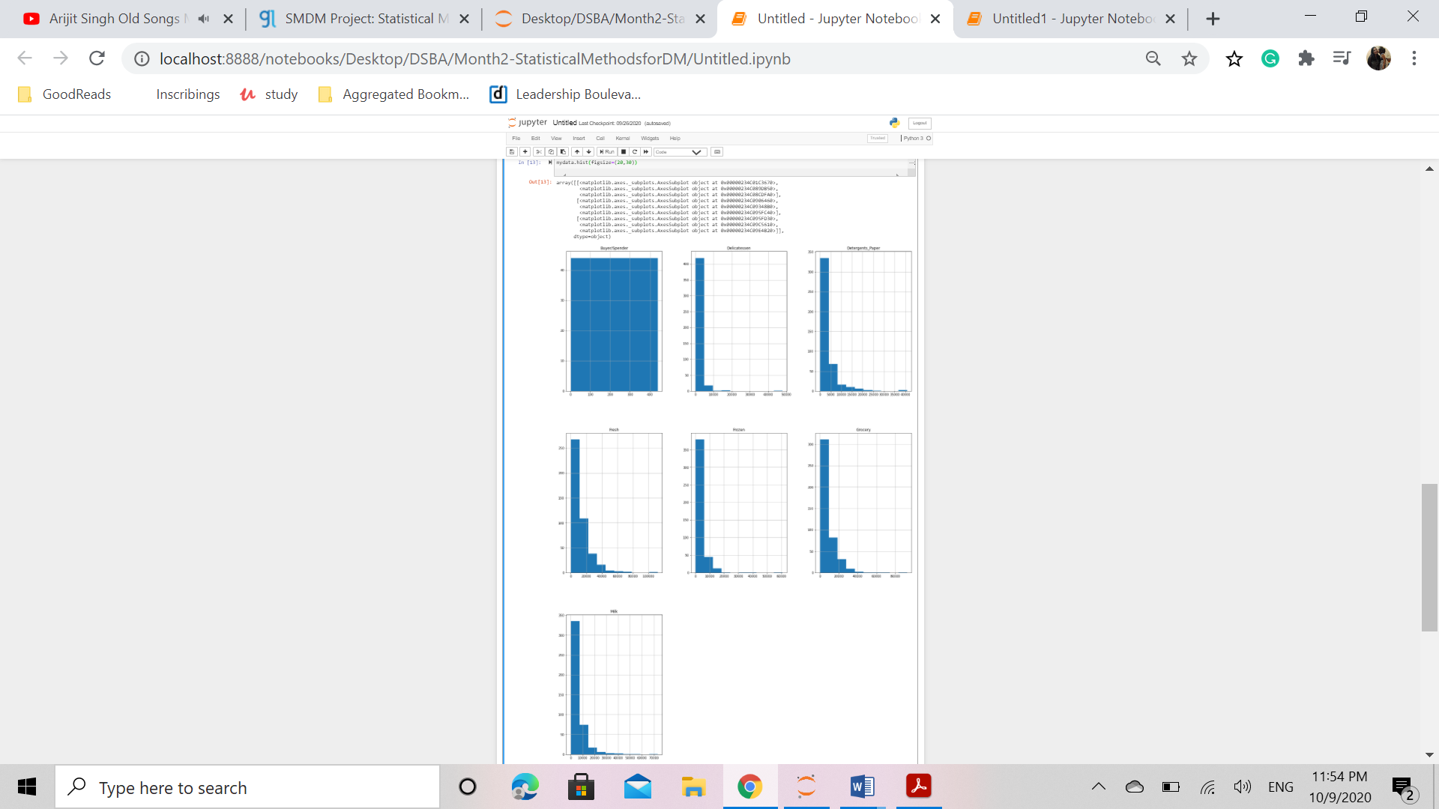
Also, if one sees as per the pairplot, then too we see a similar outcome. Most of the items show similar behavior across both the region and channel.
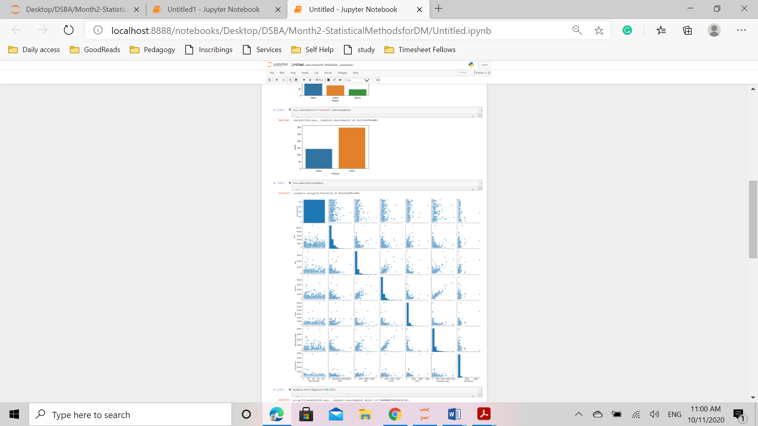

  - On the basis of descriptive measure of variability, which item shows the most inconsistent behavior? Which items show the least inconsistent behavior?
- Buyer/Spender 127.161315
- Fresh 12647.328865
- Milk 7380.377175
- Grocery 9503.162829
- Frozen 4854.673333
- Detergents_Paper 4767.854448
- Delicatessen 2820.105937
- dtype: float64

Fresh - Most Inconsistant (Highest Std Dev)
#Delicatessen - Least Inconsistant (Lowest Std Dev) The coefficient of variation will help to determine the degree of variation in the data even if means are drastically different.This can be used to determine the consistency across the items. Below is the coefficient of variation(calculated with the formula standard deviation/mean) for the data showing that the item with the least inconsistent behaviour is ‘Fresh’ whereas the item showing the most inconsistent behaviour is ‘Delicatessen’.

  - Are there any outliers in the data?

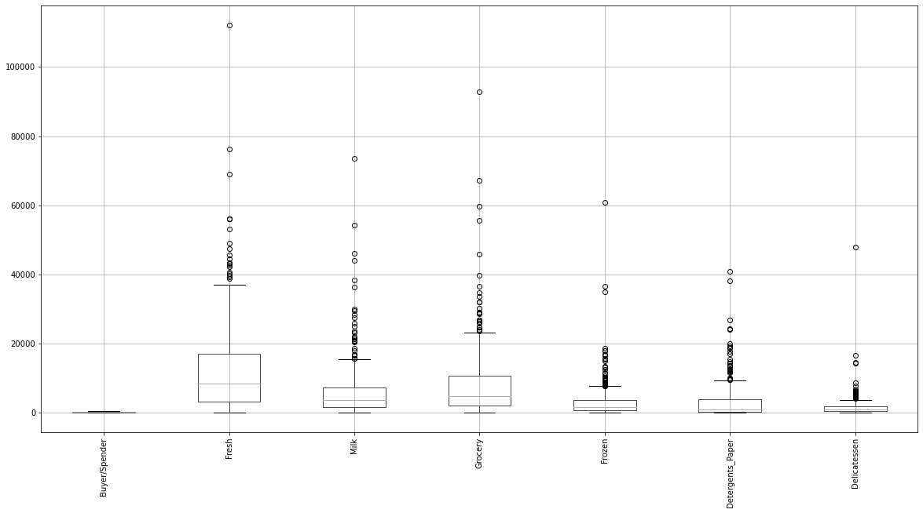
As seen in the above plot, all the above items have outliers present in the data and also we can notice data for median and IQR also not evenly placed for few such as Detergents Paper.There are extreme outlier occurrences for all of these items.

  - On the basis of this report, what are the recommendations?
There are many max outliers in the data for each of the items in each region across every channel.This indicates that a large no of sales can be attributed to some specific buyers.Additional consideration in the business should be taken for these buyers to ensure long term retention. -It can be noticed that the overall sales in Hotels is much higher CoMpared to the sales in Retail.The distributor may consider Retail channel as a target area for further expansion on growth. -As the skewness of delicatessen is very high, it indicates the dependency of sales on few buyers depicting a high risk and high dependency

Problem 2
The Student News Service at Clear Mountain State University (CMSU) has decided to gather data about the undergraduate students that attend CMSU. CMSU creates and distributes a survey of 14 questions and receives responses from 62 undergraduates.
2.1. For this data, construct the following contingency tables (Keep Gender as row variable)
2.1.1. Gender and Major (refer below screenshot)
2.1.2. Gender and Grad Intention (refer below screenshot)
2.1.3. Gender and Employment (refer below screenshot)
2.1.4. Gender and Computer (refer below screenshot)
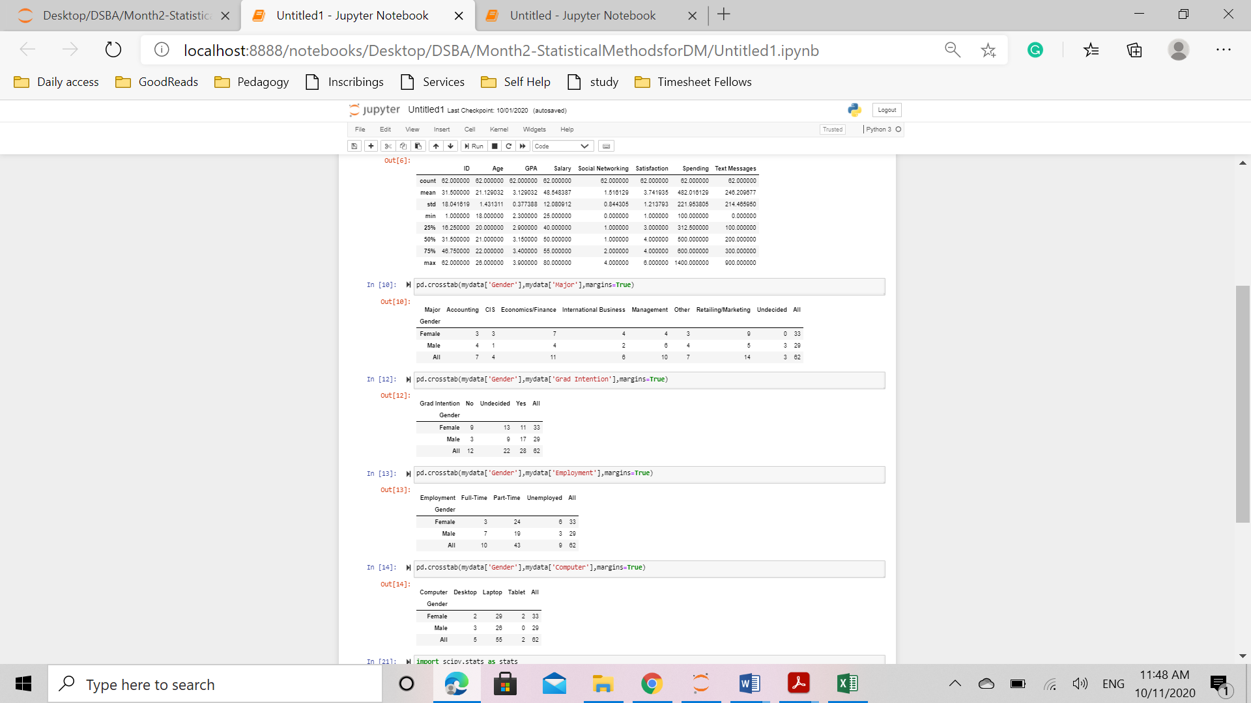
2.2. Assume that the sample is representative of the population of CMSU. Based on the data, answer the following question:
2.2.1. What is the probability that a randomly selected CMSU student will be male?
Total sample size = 62
Total number of male = 29
Probability (M) = Total number of male/ total sample size = 29/62 = 0.4677
2.2.2. What is the probability that a randomly selected CMSU student will be female?
Total sample size = 62
Total number of male = 33
Probability (M) = Total number of male/ total sample size = 33/62 = 0.5322

2.3. Assume that the sample is representative of the population of CMSU. Based on the data, answer the following question:
2.3.1. Find the conditional probability of different majors among the male students in CMSU.
Conditional probability is found when one is condition is given and the probability of occurring of other is then calculated.
P(B)= Probability of student been a male.
P(A)= Probability of student in different majors.
P(B/A)= Probability of majors given that they are male.
Statistically, P(B/A) = P[ P(B intersection A) / P B) ]
P B Intersection A can be derived from the contingency table. P B is 29 i.e. total number of males.
This can be measured from the contingency table derived from crosstabs of gender and majors. The conditional probability is calculated as below:
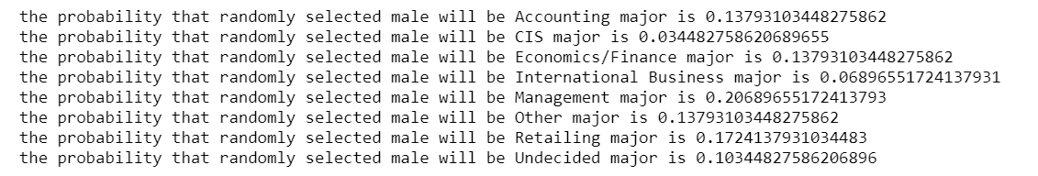

2.3.2 Find the conditional probability of different majors among the female students of CMSU.
P(B)= Probability of student been a female.
P(A)= Probability of student in different majors.
P(B/A)= Probability of majors given that they are female.
Statistically, P(B/A) = P[ P(B intersection A) / P B) ]
P B Intersection A can be derived from the contingency table. P B is 33 i.e. total number of females.
This can be measured from the contingency table derived from crosstabs of gender and majors. The conditional probability is calculated as below:
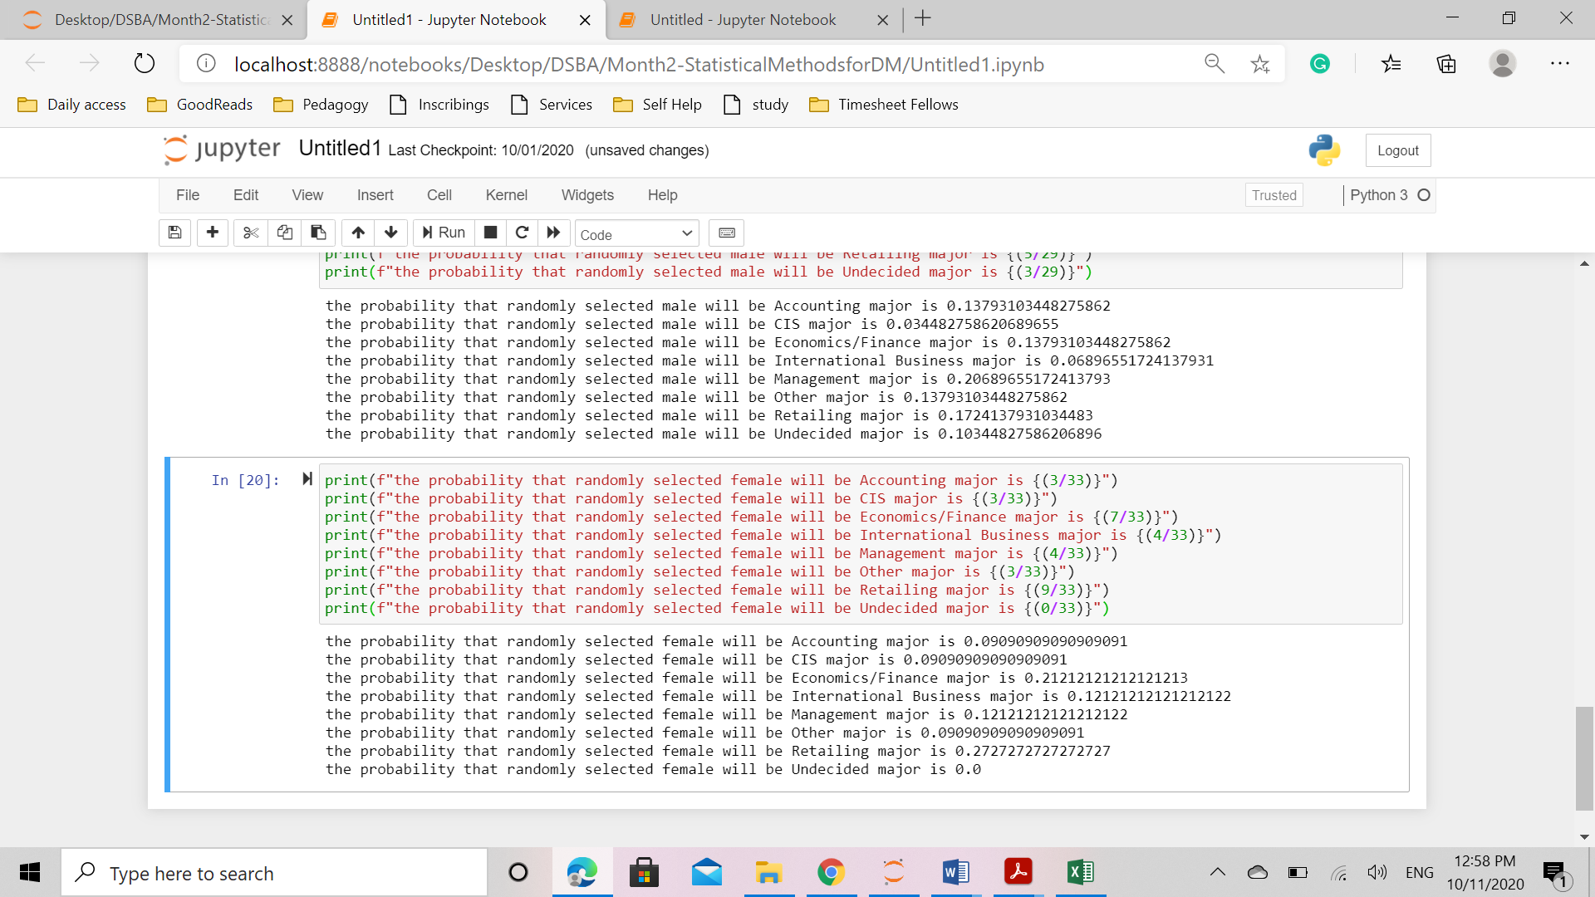
2.4. Assume that the sample is a representative of the population of CMSU. Based on the data, answer the following question:
2.4.1. Find the probability That a randomly chosen student is a male and intends to graduate.
Its says that a randomly chosen student is a male and intends to graduate.
This means, conditional probability of a male + intend to graduate, when they are randomly chosen.
P(B)= Probability of randomly chosen student
P(A)= Probability of student is major and intends to graduate.
P(B/A)= Probability of male+ intends to graduate give that they are randomly chosen.
Statistically, P(B/A) = P[ P(B intersection A) / P B) ]
P B Intersection A can be derived from the contingency table. P B is 62 i.e. total number of students.
This can be measured from the contingency table derived from crosstabs of grad intent and gender. Males of intention to graduate is 17. The conditional probability is calculated as below:
the probability that randomly selected student will be male who intents to graduate is 0.27419354838709675
2.4.2 Find the probability that a randomly selected student is a female and does NOT have a laptop.
Its says that a randomly chosen student is a female and does not have a laptop.
This means, conditional probability of a female + does not have laptop, when they are randomly chosen.
P(B)= Probability of randomly chosen student
P(A)= Probability of student is female not owning a laptop.
P(B/A)= Probability of female+ does not own laptop
Statistically, P(B/A) = P[ P(B intersection A) / P B) ]
P B Intersection A can be derived from the contingency table. P B is 62 i.e. total number of students.
This can be measured from the contingency table derived from crosstabs of laptop and gender. Females not owning laptop is 4 (desktop + tablet) The conditional probability is calculated as below:
the probability that randomly selected student will be female who doesnot own a laptop is 0.06451612903225806
2.5. Assume that the sample is representative of the population of CMSU. Based on the data, answer the following question:
2.5.1. Find the probability that a randomly chosen student is either a male or has full-time employment?
In this case, we have to apply the addition rule of probability. First we have to find that if a randomly chosen student is male, and then add probability of a randomly chosen student having full time employment.
Total students = 62 = P(T)
Males = 29 = P(M)
Students having full time employment = 10 = P(FTE)
Asked probability = P(M)/P(T) + P(FTE)/P(T)
the probability that randomly selected student will be either male or will have full time employment is 0.6290322580645161
2.5.2. Find the conditional probability that given a female student is randomly chosen, she is majoring in international business or management.
In this question, conditional probability is asked.
First we have to find conditional probability of given a female student, she is majoring in international business.
Then we have to find the conditional probability of given a female student, she is majoring in management.
Third step will be to add both together.
the probability that the student will be majoring in international business given it is a female, will be 0.12121212121212122
the probability that the student will be majoring in management given it is a female, will be 0.12121212121212122
the probability that the female will be majoring in international business or management given will be 0.24242424242424243

2.6. Construct a contingency table of Gender and Intent to Graduate at 2 levels (Yes/No). The Undecided students are not considered now and the table is a 2x2 table. Do you think the graduate intention and being female are independent events?
Based on the contingency table it is evident that the been graduate and being female are independent events.
2.7. Note that there are four numerical (continuous) variables in the data set, GPA, Salary, Spending, and Text Messages.
Answer the following questions based on the data
2.7.1. If a student is chosen randomly, what is the probability that his/her GPA is less than 3?
Here we have to find the probability density function since the value is a numerical continuous variable.

2.7.2. Find the conditional probability that a randomly selected male earns 50 or more. Find the conditional probability that a randomly selected female earns 50 or more.
2.8. Note that there are four numerical (continuous) variables in the data set, GPA, Salary, Spending, and Text Messages. For each of them comment whether they follow a normal distribution. Write a note summarizing your conclusions.
To know whether its normal distribution or not, we will plot the histogram of the numerical continuous variables. From the patterns we can see that the variables are not normally distributed.
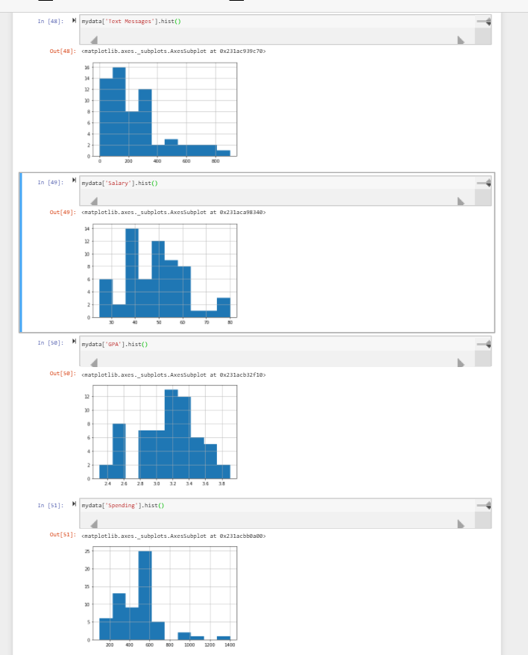
Problem 3
An important quality characteristic used by the manufacturers of ABC asphalt shingles is the amount of moisture the shingles contain when they are packaged. Customers may feel that they have purchased a product lacking in quality if they find moisture and wet shingles inside the packaging. In some cases, excessive moisture can cause the granules attached to the shingles for texture and colouring purposes to fall off the shingles resulting in appearance problems. To monitor the amount of moisture present, the company conducts moisture tests. A shingle is weighed and then dried. The shingle is then reweighed, and based on the amount of moisture taken out of the product, the pounds of moisture per 100 square feet are calculated. The company would like to show that the mean moisture content is less than 0.35 pound per 100 square feet.
The file includes 36 measurements (in pounds per 100 square feet) for A shingles and 31 for B shingles.
3.1 Do you think there is evidence that mean moisture contents in both types of shingles are within the permissible limits? State your conclusions clearly showing all steps.
There are 36 count in column A and 31 in column B. Mean and standard deviation can be found using the describe function.
Mean A =0.3166
Mean B= 0.2735
Standard deviation A = 0.135731
Standard Deviation B = 0.137296
The company would like to show that the mean moisture content is less than 0.35 pound per 100 square feet. Hypothesis is as below:
H₀ = $μ ≥$ 0.35 pounds per 100 square feet.
H₁= $μ <0.35$ pounds per 100 square feet.
Now we have to calculate Test Statistic for A and B.
Test statistic = xbar- $μ$/ SD/$\sqrt{n}$
From the python codebook, we see that test statistic is -1.4557990787331345
This is not less than -1.69. Hence, there is not enough evidence to conclude that mean moisture is less than
0.35pounds per 100 square feet. Therefore, we reject the alternate hypothesis and accept the null hypothesis.

Similarly, in case of B,
Test statistic is -3.0499420934612034
This is very less than -1.69. Hence, we reject the null hypothesis and accept the alternate hypothesis.
Therefore, in case of B, mean moisture is less than 0.35 pounds per 100 square feet.

3.2 Do you think that the population mean for shingles A and B are equal? Form the hypothesis and conduct the test of the hypothesis. What assumption do you need to check before the test for equality of means is performed?
The population mean for both the shingles are not equal. For t test to be valid, data is assumed to be independently drawn from a population that is normally distributed. Since the sample sizes are 36 and 31 respectively, they are very huge. T distribution can provide approximation to the sampling distribution till the population distribution is not very skewed.
Assumptions that need to be checked before test of equality:
- Sample must be reasonably random
- Sample size must be large enough.
Following assumptions are made about population distribution:
- Two population have same variance
- Population is normally distributed
- Each value is sampled individually from other value.

