  - Read the dataset. Describe the data briefly. Interpret the inferences for each. Initial steps like head() .info(), Data Types, etc . Null value check, Summary stats, Skewness must be discussed.
Out[3]:

df_data_dic.head(10)
Out[3]:
 | **Data Dictionary**
0 | 1. vote: Party choice: Conservative or Labour
1 | 2. age: in years
2 | 3. economic.cond.national: Assessment of curre...
3 | 4. economic.cond.household: Assessment of curr...
4 | 5. Blair: Assessment of the Labour leader, 1 t...
5 | 6. Hague: Assessment of the Conservative leade...
6 | 7. Europe: an 11-point scale that measures res...
7 | 8. political.knowledge: Knowledge of parties' ...
8 | 9. gender: female or male.

# Check top few records to get a feel of the data structure
df.head()
Out[4]:
 | Unnamed: 0 | vote | age | economic.cond.national | economic.cond.household | Blair | Hague | Europe | political.knowledge | gender
0 | 1 | Labour | 43 | 3 | 3 | 4 | 1 | 2 | 2 | female
1 | 2 | Labour | 36 | 4 | 4 | 4 | 4 | 5 | 2 | male
2 | 3 | Labour | 35 | 4 | 4 | 5 | 2 | 3 | 2 | male
3 | 4 | Labour | 24 | 4 | 2 | 2 | 1 | 4 | 0 | female
4 | 5 | Labour | 41 | 2 | 2 | 1 | 1 | 6 | 2 | male

Shape
In [5]:
print("no. of rows: ",df.shape[0], "\n""no. of columns: ",df.shape[1])
no. of rows: 1525
no. of columns: 10
In [6]:
df.info()
<class 'pandas.core.frame.DataFrame'>
RangeIndex: 1525 entries, 0 to 1524
Data columns (total 10 columns):
# Column Non-Null Count Dtype
--- ------ -------------- -----
0 Unnamed: 0 1525 non-null int64
1 vote 1525 non-null object
2 age 1525 non-null int64
3 economic.cond.national 1525 non-null int64
4 economic.cond.household 1525 non-null int64
5 Blair 1525 non-null int64
6 Hague 1525 non-null int64
7 Europe 1525 non-null int64
8 political.knowledge 1525 non-null int64
9 gender 1525 non-null object
dtypes: int64(8), object(2)
memory usage: 119.3+ KB
checking for Possible columns which are categorical but are not having data type "object"
In [7]:
df['economic.cond.national'].value_counts()
Out[7]:
3 607
4 542
2 257
5 82
1 37
Name: economic.cond.national, dtype: int64
In [8]:
df['economic.cond.household'].value_counts()
Out[8]:
3 648
4 440
2 280
5 92
1 65
Name: economic.cond.household, dtype: int64
In [9]:
df['Blair'].value_counts()
Out[9]:
4 836
2 438
5 153
1 97
3 1
Name: Blair, dtype: int64
In [10]:
df['Hague'].value_counts()
Out[10]:
2 624
4 558
1 233
5 73
3 37
Name: Hague, dtype: int64
In [11]:
df['Europe'].value_counts()
Out[11]:
11 338
6 209
3 129
4 127
5 124
8 112
9 111
1 109
10 101
7 86
2 79
Name: Europe, dtype: int64
In [12]:
df['political.knowledge'].value_counts()
Out[12]:
2 782
0 455
3 250
1 38
Name: political.knowledge, dtype: int64
In [13]:
## Change the data types of these 6 features
In [14]:
cat=["economic.cond.national","economic.cond.household","Blair","Hague","Europe","political.knowledge"]
In [15]:
for i in cat:
df[i]=df[i].astype("object")
In [16]:
df.info()
<class 'pandas.core.frame.DataFrame'>
RangeIndex: 1525 entries, 0 to 1524
Data columns (total 10 columns):
# Column Non-Null Count Dtype
--- ------ -------------- -----
0 Unnamed: 0 1525 non-null int64
1 vote 1525 non-null object
2 age 1525 non-null int64
3 economic.cond.national 1525 non-null object
4 economic.cond.household 1525 non-null object
5 Blair 1525 non-null object
6 Hague 1525 non-null object
7 Europe 1525 non-null object
8 political.knowledge 1525 non-null object
9 gender 1525 non-null object
dtypes: int64(2), object(8)
memory usage: 119.3+ KB
Making different list for categorical columns and numerical columns
In [19]:
cat=[]
num=[]
for i in df.columns:
if df[i].dtype=="object":
cat.append(i)
else:
num.append(i)
print(cat)
print(num)
['vote', 'economic.cond.national', 'economic.cond.household', 'Blair', 'Hague', 'Europe', 'political.knowledge', 'gender']
['Unnamed: 0', 'age']
Describe for numerical and categorical columns
In [18]:
df[num].describe().T
Out[18]:
 | count | mean | std | min | 25% | 50% | 75% | max
Unnamed: 0 | 1525.0 | 763.000000 | 440.373894 | 1.0 | 382.0 | 763.0 | 1144.0 | 1525.0
age | 1525.0 | 54.182295 | 15.711209 | 24.0 | 41.0 | 53.0 | 67.0 | 93.0
In [20]:
df[cat].describe().T
Out[20]:
 | count | unique | top | freq
vote | 1525 | 2 | Labour | 1063
economic.cond.national | 1525 | 5 | 3 | 607
economic.cond.household | 1525 | 5 | 3 | 648
Blair | 1525 | 5 | 4 | 836
Hague | 1525 | 5 | 2 | 624
Europe | 1525 | 11 | 11 | 338
political.knowledge | 1525 | 4 | 2 | 782
gender | 1525 | 2 | female | 812
unique values for categorical variables
In [21]:
for column in df.columns:
if df[column].dtype == 'object':
print(column.upper(),': ',df[column].nunique())
print(df[column].value_counts().sort_values())
print('\n')
VOTE : 2
Conservative 462
Labour 1063
Name: vote, dtype: int64

ECONOMIC.COND.NATIONAL : 5
1 37
5 82
2 257
4 542
3 607
Name: economic.cond.national, dtype: int64

ECONOMIC.COND.HOUSEHOLD : 5
1 65
5 92
2 280
4 440
3 648
Name: economic.cond.household, dtype: int64

BLAIR : 5
3 1
1 97
5 153
2 438
4 836
Name: Blair, dtype: int64

HAGUE : 5
3 37
5 73
1 233
4 558
2 624
Name: Hague, dtype: int64

EUROPE : 11
2 79
7 86
10 101
1 109
9 111
8 112
5 124
4 127
3 129
6 209
11 338
Name: Europe, dtype: int64

POLITICAL.KNOWLEDGE : 4
1 38
3 250
0 455
2 782
Name: political.knowledge, dtype: int64

GENDER : 2
male 713
female 812
Name: gender, dtype: int64

In [22]:
# Are there any missing values ?
df.isnull().sum()
Out[22]:
Unnamed: 0 0
vote 0
age 0
economic.cond.national 0
economic.cond.household 0
Blair 0
Hague 0
Europe 0
political.knowledge 0
gender 0
dtype: int64
In [23]:
## Are there any duplicate records

# Check for duplicate data

dups = df.duplicated()
print('Number of duplicate rows = %d' % (dups.sum()))

df[dups]
Number of duplicate rows = 0
Out[23]:
 | Unnamed: 0 | vote | age | economic.cond.national | economic.cond.household | Blair | Hague | Europe | political.knowledge | gender
In [25]:
  - Perform EDA (Check the null values, Data types, shape, Univariate, bivariate analysis). Also check for outliers (4 pts). Interpret the inferences for each (3 pts) Distribution plots(histogram) or similar plots for the continuous columns. Box plots, Correlation plots. Appropriate plots for categorical variables. Inferences on each plot. Outliers proportion should be discussed, and inferences from above used plots should be there. There is no restriction on how the learner wishes to implement this but the code should be able to represent the correct output and inferences should be logical and correct.

Univariate Analysis
In [29]:
sns.distplot(df['age'], kde=True, bins=10);
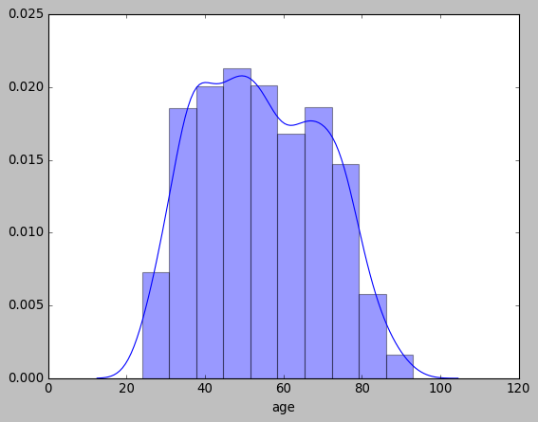
In [30]:
sns.catplot(x='vote', data=df , kind='count',aspect=2)
Out[30]:
<seaborn.axisgrid.FacetGrid at 0x24f3c694190>
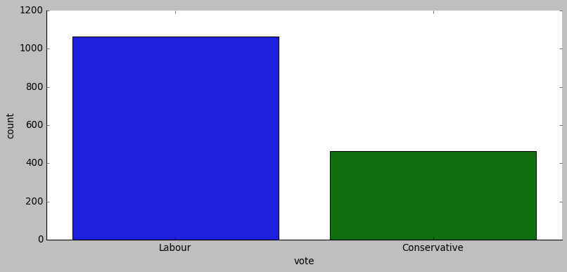
In [31]:
sns.catplot(x='economic.cond.national', data=df , kind='count',aspect=2)
Out[31]:
<seaborn.axisgrid.FacetGrid at 0x24f4202f640>
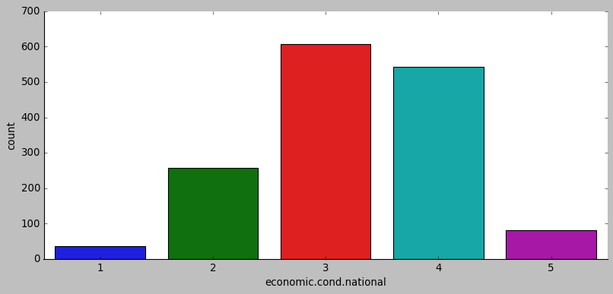
In [32]:
sns.catplot(x='economic.cond.household', data=df , kind='count',aspect=2)
Out[32]:
<seaborn.axisgrid.FacetGrid at 0x24f42071a00>
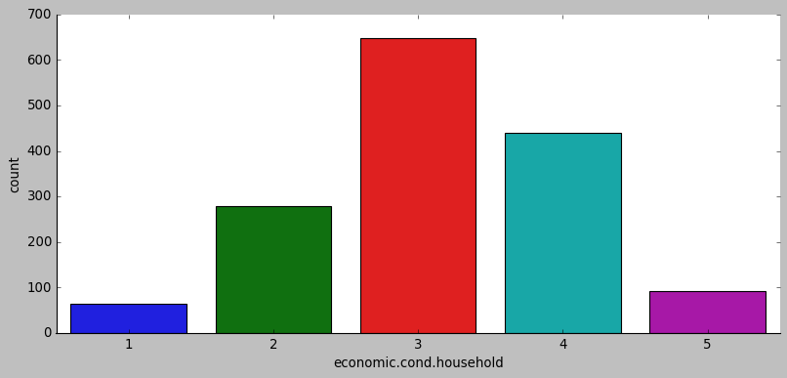
In [33]:
sns.catplot(x='Blair', data=df , kind='count',aspect=2)
Out[33]:
<seaborn.axisgrid.FacetGrid at 0x24f420e69d0>
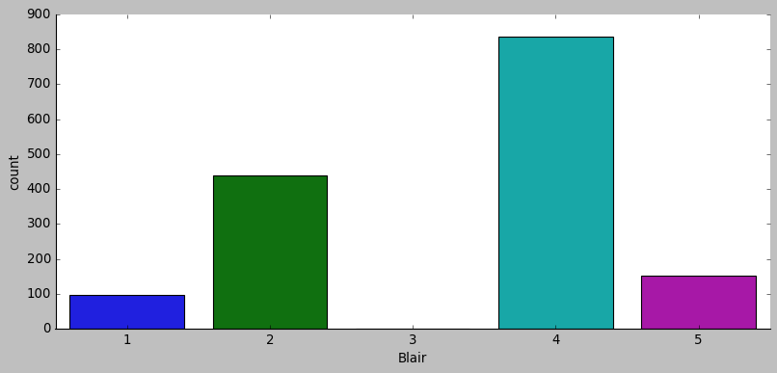
In [34]:
sns.catplot(x='Hague', data=df , kind='count',aspect=2)
Out[34]:
<seaborn.axisgrid.FacetGrid at 0x24f42aef9a0>
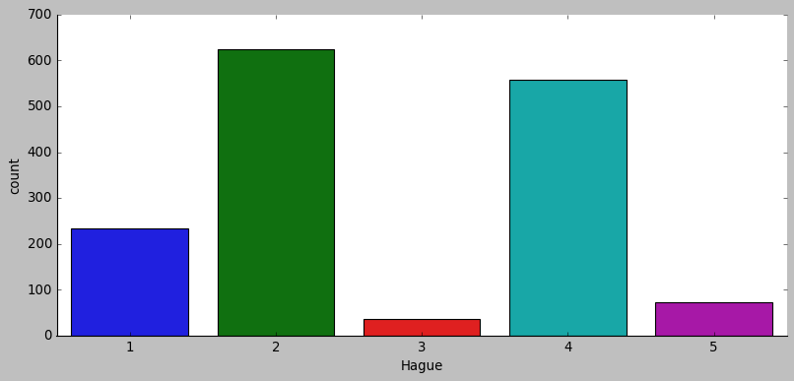
In [35]:
sns.catplot(x='Europe', data=df , kind='count',aspect=2)
Out[35]:
<seaborn.axisgrid.FacetGrid at 0x24f42b026a0>
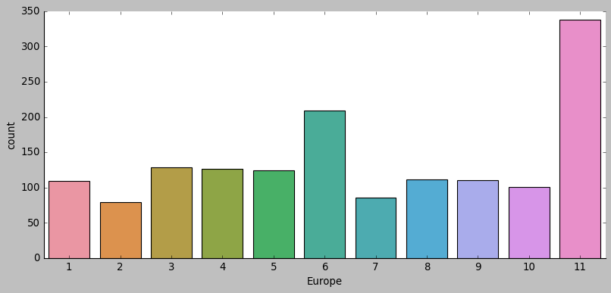
In [36]:
sns.catplot(x='political.knowledge', data=df , kind='count',aspect=2)
Out[36]:
<seaborn.axisgrid.FacetGrid at 0x24f42071970>
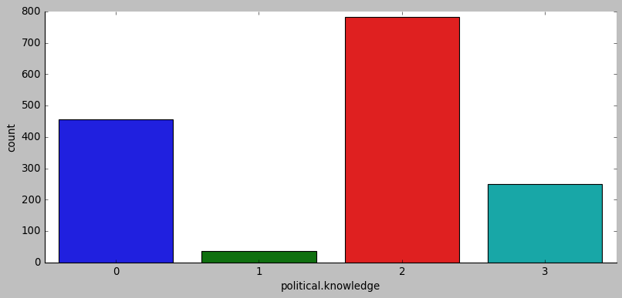
In [37]:
sns.catplot(x='gender', data=df , kind='count',aspect=2)
Out[37]:
<seaborn.axisgrid.FacetGrid at 0x24f42071430>
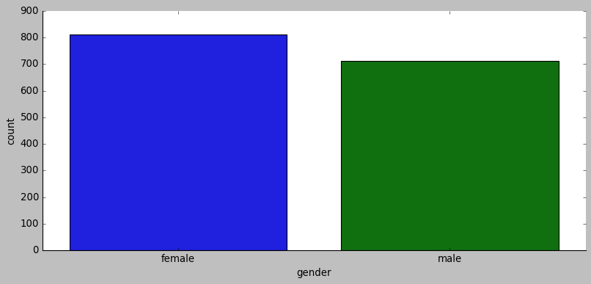
Bivariate Analysis with Target variable
In [38]:
['vote', 'economic.cond.national', 'economic.cond.household', 'Blair', 'Hague', 'Europe', 'political.knowledge', 'gender']
Out[38]:
['vote',
'economic.cond.national',
'economic.cond.household',
'Blair',
'Hague',
'Europe',
'political.knowledge',
'gender']
In [39]:
plt.figure(figsize=(8,5))
sns.stripplot(df["vote"], df['age'], jitter=True)
plt.show()
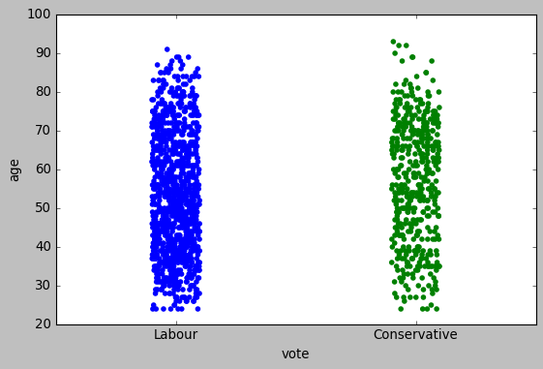
In [40]:
sns.countplot(df['economic.cond.national'],hue=df['vote'])
Out[40]:
<matplotlib.axes._subplots.AxesSubplot at 0x24f43534df0>
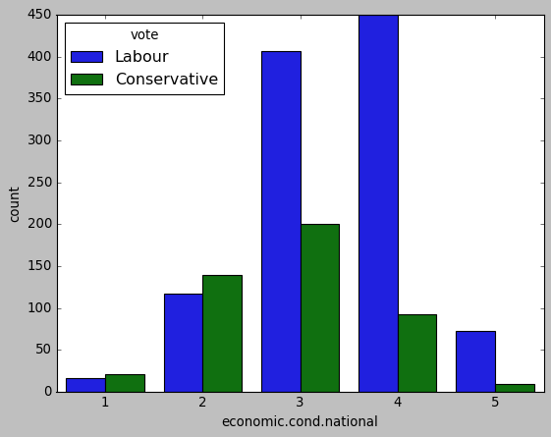
In [41]:
sns.countplot(df['economic.cond.household'],hue=df['vote'])
Out[41]:
<matplotlib.axes._subplots.AxesSubplot at 0x24f437343a0>
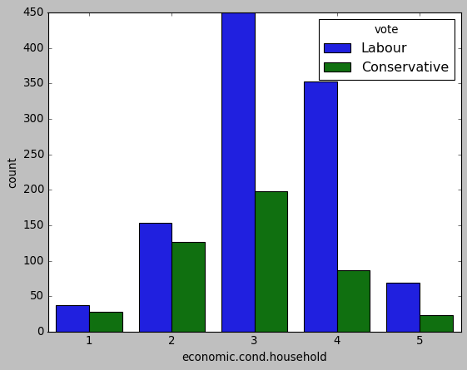
In [42]:
sns.countplot(df['Blair'],hue=df['vote'])
Out[42]:
<matplotlib.axes._subplots.AxesSubplot at 0x24f437b2d00>
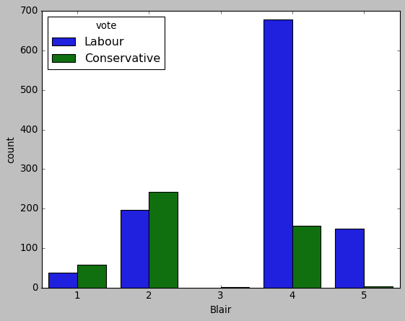
In [43]:
sns.countplot(df['Hague'],hue=df['vote'])
Out[43]:
<matplotlib.axes._subplots.AxesSubplot at 0x24f4382aa30>
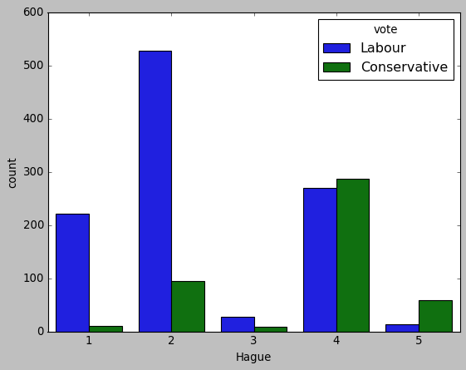
In [44]:
sns.countplot(df['Europe'],hue=df['vote'])
Out[44]:
<matplotlib.axes._subplots.AxesSubplot at 0x24f439d3940>
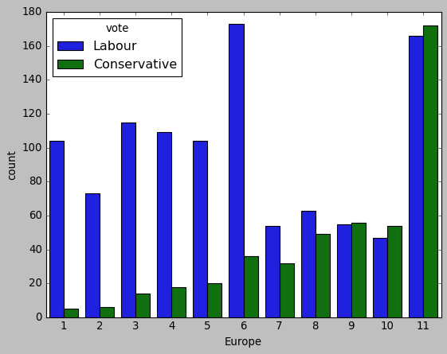
In [45]:
sns.countplot(df['political.knowledge'],hue=df['vote'])
Out[45]:
<matplotlib.axes._subplots.AxesSubplot at 0x24f43912a00>
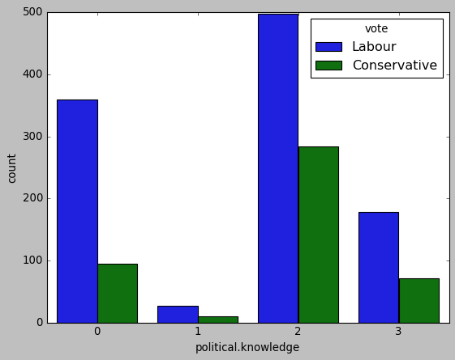
In [46]:
sns.countplot(df['gender'],hue=df['vote'])
Out[46]:
<matplotlib.axes._subplots.AxesSubplot at 0x24f43718460>
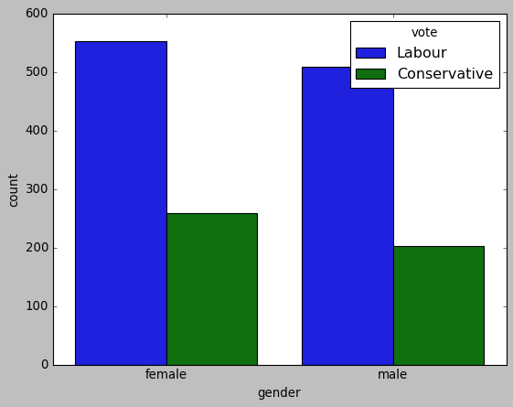
Bi-Variate Analysis
In [47]:
sns.countplot(df['political.knowledge'],hue=df['Europe'])
Out[47]:
<matplotlib.axes._subplots.AxesSubplot at 0x24f43b7bc40>
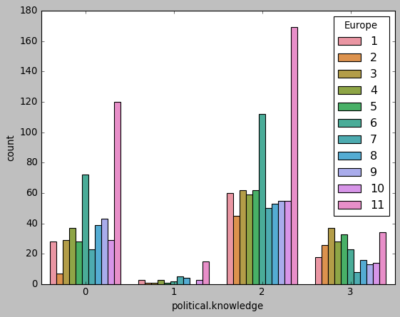
In [48]:
sns.countplot(df['political.knowledge'],hue=df['gender'])
Out[48]:
<matplotlib.axes._subplots.AxesSubplot at 0x24f43ad8eb0>
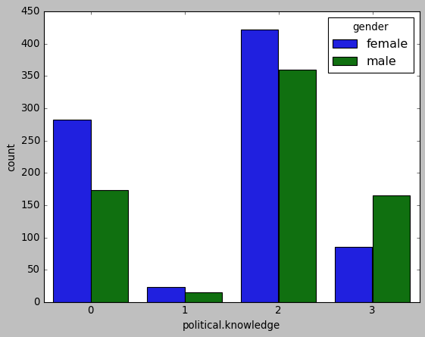
In [49]:
sns.countplot(df['Blair'],hue=df['gender'])
Out[49]:
<matplotlib.axes._subplots.AxesSubplot at 0x24f43877670>
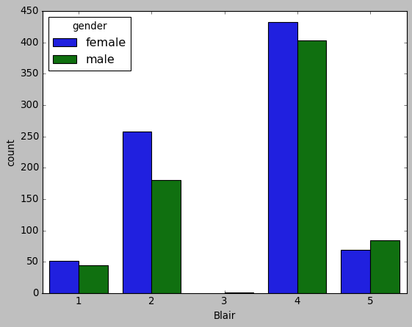
In [50]:
sns.countplot(df['Hague'],hue=df['gender'])
Out[50]:
<matplotlib.axes._subplots.AxesSubplot at 0x24f42170d00>
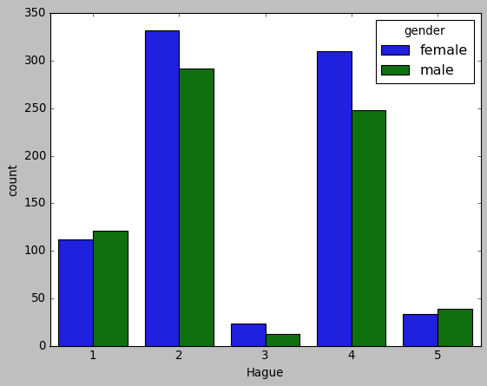
In [51]:
plt.figure(figsize=(8,5))
sns.stripplot(df["Blair"], df['age'], jitter=True)
plt.show()
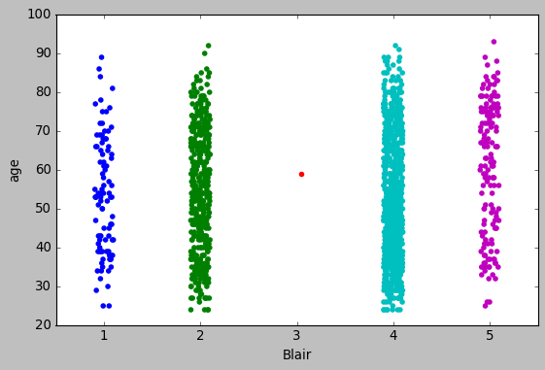
In [52]:
plt.figure(figsize=(8,5))
sns.stripplot(df["Hague"], df['age'], jitter=True)
plt.show()
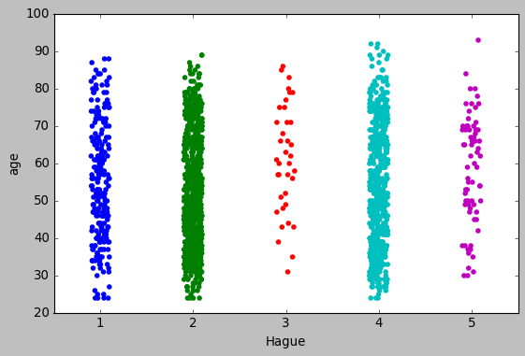
In [53]:
sns.countplot(df['economic.cond.national'],hue=df['Blair'])
Out[53]:
<matplotlib.axes._subplots.AxesSubplot at 0x24f43cc5040>
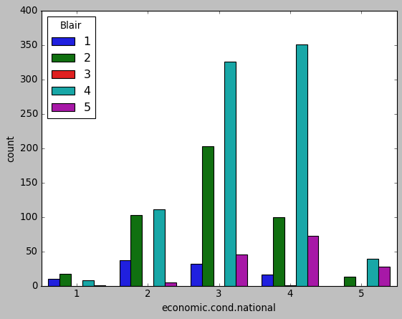
In [54]:
sns.countplot(df['economic.cond.household'],hue=df['Hague'])
Out[54]:
<matplotlib.axes._subplots.AxesSubplot at 0x24f43a1c520>
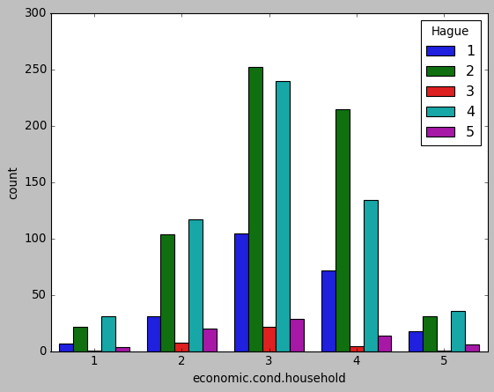
In [55]:
sns.pairplot(df)
Out[55]:
<seaborn.axisgrid.PairGrid at 0x24f44db1160>
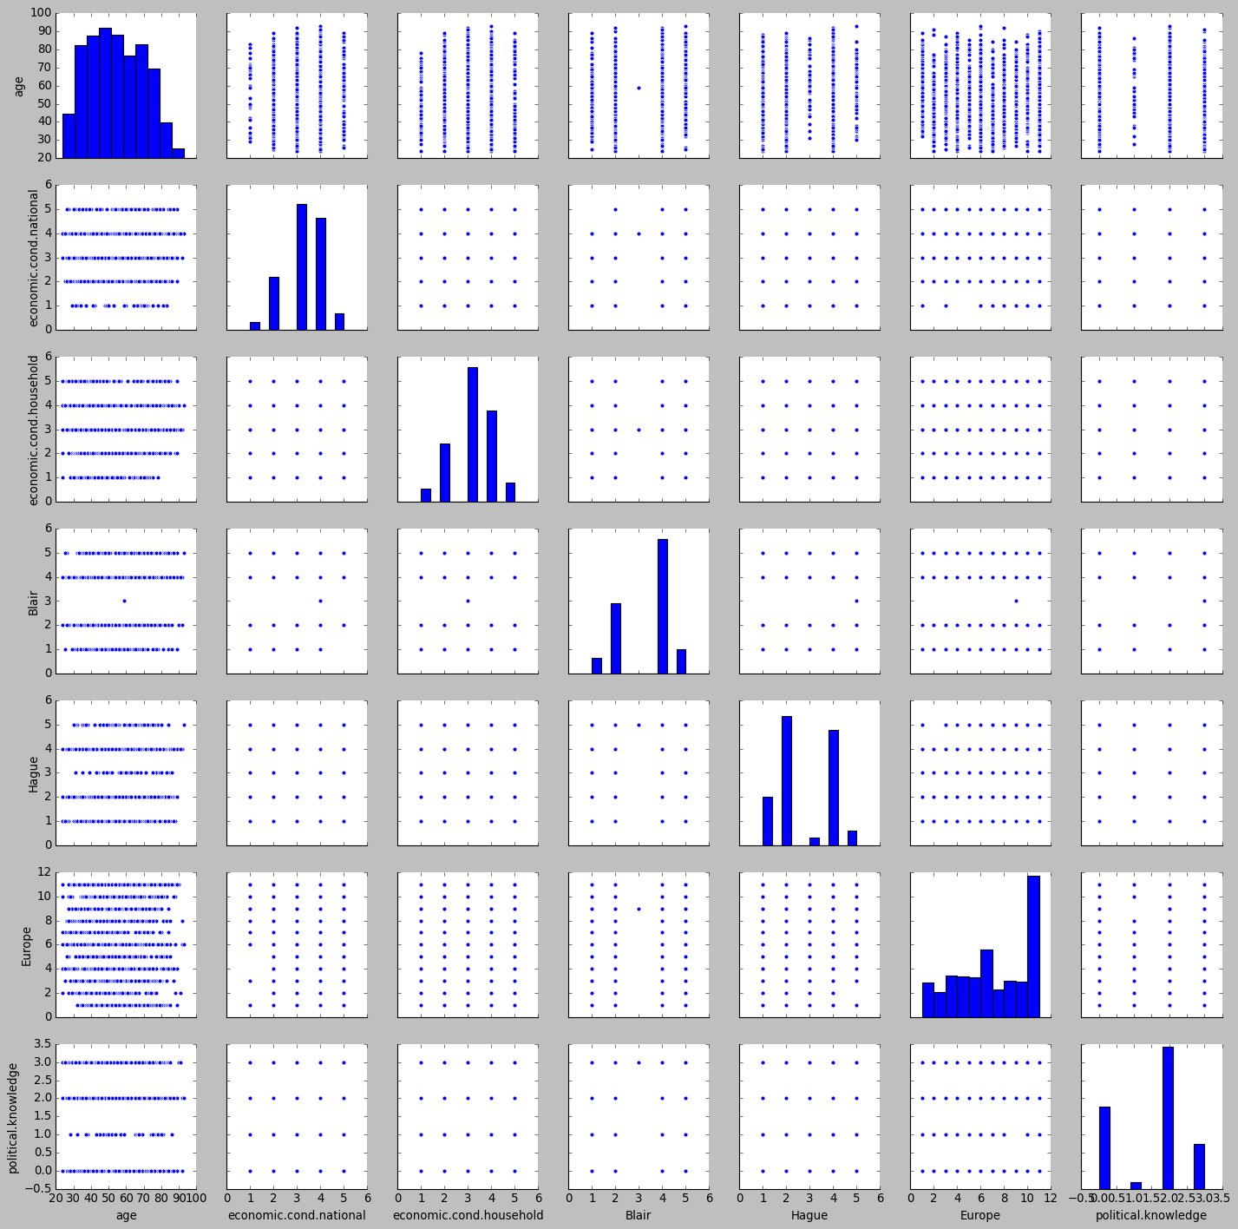
Outlier Check
In [56]:
continuous=df.dtypes[(df.dtypes=='int64')|(df.dtypes=='float64')].index
data_plot=df[continuous]
fig=plt.figure(figsize=(20,15))
for i in range(0,len(data_plot.columns)):
ax=fig.add_subplot(4,3,i+1)
sns.boxplot(y=data_plot[data_plot.columns[i]])
ax.set_title(data_plot.columns[i],color='Blue')
plt.grid()
plt.tight_layout()
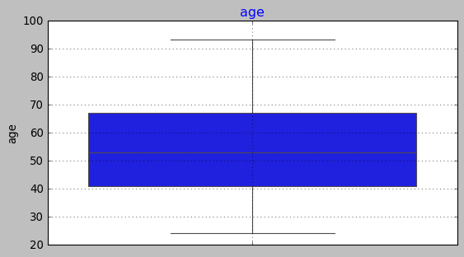
The only continous column "age" does not seem to have any outliers
In [57]:
#### get_dummies of the object variables
In [58]:
print(cat)
['vote', 'economic.cond.national', 'economic.cond.household', 'Blair', 'Hague', 'Europe', 'political.knowledge', 'gender']
In [59]:
cat.remove('vote')
Drop First is used to ensure that multiple columns created based on the levels of categorical variable are not included else it will result in to multicollinearity . This is done to ensure that we do not land in to dummy trap.
In [60]:
for feature in df.columns:
if df[feature].dtype == 'object':
print('\n')
print('feature:',feature)
print(pd.Categorical(df[feature].unique()))
print(pd.Categorical(df[feature].unique()).codes)
df[feature] = pd.Categorical(df[feature]).codes

feature: vote
[Labour, Conservative]
Categories (2, object): [Conservative, Labour]
[1 0]

feature: economic.cond.national
[3, 4, 2, 1, 5]
Categories (5, int64): [1, 2, 3, 4, 5]
[2 3 1 0 4]

feature: economic.cond.household
[3, 4, 2, 1, 5]
Categories (5, int64): [1, 2, 3, 4, 5]
[2 3 1 0 4]

feature: Blair
[4, 5, 2, 1, 3]
Categories (5, int64): [1, 2, 3, 4, 5]
[3 4 1 0 2]

feature: Hague
[1, 4, 2, 5, 3]
Categories (5, int64): [1, 2, 3, 4, 5]
[0 3 1 4 2]

feature: Europe
[2, 5, 3, 4, 6, ..., 1, 7, 9, 10, 8]
Length: 11
Categories (11, int64): [1, 2, 3, 4, ..., 8, 9, 10, 11]
[ 1 4 2 3 5 10 0 6 8 9 7]

feature: political.knowledge
[2, 0, 3, 1]
Categories (4, int64): [0, 1, 2, 3]
[2 0 3 1]

feature: gender
[female, male]
Categories (2, object): [female, male]
[0 1]
In [61]:
df.head()
Out[61]:
 | vote | age | economic.cond.national | economic.cond.household | Blair | Hague | Europe | political.knowledge | gender
0 | 1 | 43 | 2 | 2 | 3 | 0 | 1 | 2 | 0
1 | 1 | 36 | 3 | 3 | 3 | 3 | 4 | 2 | 1
2 | 1 | 35 | 3 | 3 | 4 | 1 | 2 | 2 | 1
3 | 1 | 24 | 3 | 1 | 1 | 0 | 3 | 0 | 0
4 | 1 | 41 | 1 | 1 | 0 | 0 | 5 | 2 | 1
Scaling the variables as continuous variables have different weightage using min-max technique
In [62]:
num.remove('Unnamed: 0')
In [63]:
print(num)
['age']
In [64]:
df[num] = df[num].apply(lambda x:(x-x.min()) / (x.max()-x.min()))
In [65]:
## Check if the variables have been scaled or not
df.head()
Out[65]:
 | vote | age | economic.cond.national | economic.cond.household | Blair | Hague | Europe | political.knowledge | gender
0 | 1 | 0.275362 | 2 | 2 | 3 | 0 | 1 | 2 | 0
1 | 1 | 0.173913 | 3 | 3 | 3 | 3 | 4 | 2 | 1
2 | 1 | 0.159420 | 3 | 3 | 4 | 1 | 2 | 2 | 1
3 | 1 | 0.000000 | 3 | 1 | 1 | 0 | 3 | 0 | 0
4 | 1 | 0.246377 | 1 | 1 | 0 | 0 | 5 | 2 | 1
In [69]:
df.info()
<class 'pandas.core.frame.DataFrame'>
RangeIndex: 1525 entries, 0 to 1524
Data columns (total 9 columns):
# Column Non-Null Count Dtype
--- ------ -------------- -----
0 vote 1525 non-null int8
1 age 1525 non-null float64
2 economic.cond.national 1525 non-null int8
3 economic.cond.household 1525 non-null int8
4 Blair 1525 non-null int8
5 Hague 1525 non-null int8
6 Europe 1525 non-null int8
7 political.knowledge 1525 non-null int8
8 gender 1525 non-null int8
dtypes: float64(1), int8(8)
memory usage: 24.0 KB
Train-Test Split
In [67]:
df.columns
Out[67]:
Index(['vote', 'age', 'economic.cond.national', 'economic.cond.household',
'Blair', 'Hague', 'Europe', 'political.knowledge', 'gender'],
dtype='object')
In [71]:
# Copy all the predictor variables into X dataframe
X = df.drop('vote', axis=1)

# Copy target into the y dataframe.
y = df['vote']
In [74]:
X.head()
Out[74]:
 | age | economic.cond.national | economic.cond.household | Blair | Hague | Europe | political.knowledge | gender
0 | 0.275362 | 2 | 2 | 3 | 0 | 1 | 2 | 0
1 | 0.173913 | 3 | 3 | 3 | 3 | 4 | 2 | 1
2 | 0.159420 | 3 | 3 | 4 | 1 | 2 | 2 | 1
3 | 0.000000 | 3 | 1 | 1 | 0 | 3 | 0 | 0
4 | 0.246377 | 1 | 1 | 0 | 0 | 5 | 2 | 1
In [72]:
y.head()
Out[72]:
0 1
1 1
2 1
3 1
4 1
Name: vote, dtype: int8
In [73]:
# Encode for string labels
from sklearn import preprocessing
label_encoder = preprocessing.LabelEncoder().fit(y)
y = pd.DataFrame(label_encoder.transform(y),columns = ["vote"])
In [80]:
y.tail(5)
Out[80]:
 | vote
1520 | 0
1521 | 0
1522 | 1
1523 | 0
1524 | 0
In [77]:

Models
Logistic Regression
In [83]:
from sklearn.linear_model import LogisticRegression
from sklearn import metrics
In [84]:
LR_model = LogisticRegression()
LR_model.fit(X_train, y_train)
C:\ProgramData\Anaconda3\lib\site-packages\sklearn\utils\validation.py:73: DataConversionWarning: A column-vector y was passed when a 1d array was expected. Please change the shape of y to (n_samples, ), for example using ravel().
return f(**kwargs)
Out[84]:
LogisticRegression()
In [85]:
print(LR_model.coef_, LR_model.intercept_)
[[-1.23211617 0.33297713 0.16084573 0.56716628 -0.8300607 -0.23826143
-0.47465778 0.29183078]] [2.8343617]
In [87]:
X.columns
Out[87]:
Index(['age', 'economic.cond.national', 'economic.cond.household', 'Blair',
'Hague', 'Europe', 'political.knowledge', 'gender'],
dtype='object')
In [88]:
## Performance Matrix on train data set
y_train_predict = LR_model.predict(X_train)
model_score = LR_model.score(X_train, y_train)
print(model_score)
print(metrics.confusion_matrix(y_train, y_train_predict))
print(metrics.classification_report(y_train, y_train_predict))
0.8406747891283973
[[230 102]
[ 68 667]]
precision recall f1-score support

0 0.77 0.69 0.73 332
1 0.87 0.91 0.89 735

accuracy 0.84 1067
macro avg 0.82 0.80 0.81 1067
weighted avg 0.84 0.84 0.84 1067

In [104]:
from sklearn.metrics import roc_auc_score,roc_curve
In [105]:
#AUC and ROC for the training data
# predict probabilities
probs = LR_model.predict_proba(X_train)
# keep probabilities for the positive outcome only
probs = probs[:, 1]
# calculate AUC
lr_train_auc = roc_auc_score(y_train, probs)
print('AUC: %.3f' % lr_train_auc)
# calculate roc curve
lr_train_fpr, lr_train_tpr, lr_train_thresholds = roc_curve(y_train, probs)
plt.plot([0, 1], [0, 1], linestyle='--')
# plot the roc curve for the model
plt.plot(lr_train_fpr, lr_train_tpr)
AUC: 0.889
Out[105]:
[<matplotlib.lines.Line2D at 0x24f48285580>]
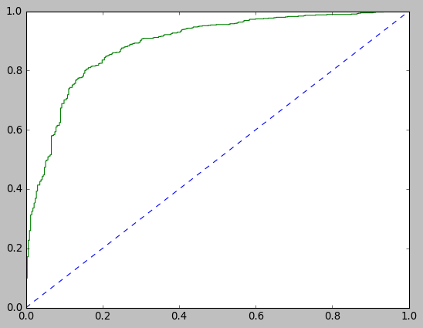
In [106]:
## Performance Matrix on test data set
y_test_predict = LR_model.predict(X_test)
model_score = LR_model.score(X_test, y_test)
print(model_score)
print(metrics.confusion_matrix(y_test, y_test_predict))
print(metrics.classification_report(y_test, y_test_predict))
0.8231441048034934
[[ 85 45]
[ 36 292]]
precision recall f1-score support

0 0.70 0.65 0.68 130
1 0.87 0.89 0.88 328

accuracy 0.82 458
macro avg 0.78 0.77 0.78 458
weighted avg 0.82 0.82 0.82 458

In [100]:
from sklearn.metrics import roc_auc_score
In [107]:
# AUC and ROC for the test data
# predict probabilities
probs = LR_model.predict_proba(X_test)
# keep probabilities for the positive outcome only
probs = probs[:, 1]
# calculate AUC
lr_test_auc = roc_auc_score(y_test, probs)
print('AUC: %.3f' % lr_test_auc)
# calculate roc curve
lr_test_fpr, lr_test_tpr, lr_testthresholds = roc_curve(y_test, probs)
plt.plot([0, 1], [0, 1], linestyle='--')
# plot the roc curve for the model
plt.plot(lr_test_fpr, lr_test_tpr)
AUC: 0.883
Out[107]:
[<matplotlib.lines.Line2D at 0x24f4841e280>]
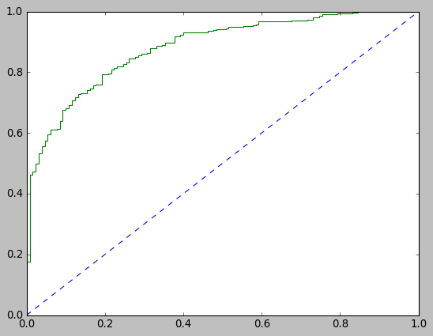
Linear Discriminant Analysis
In [108]:
from sklearn.discriminant_analysis import LinearDiscriminantAnalysis
LDA_model= LinearDiscriminantAnalysis()
LDA_model.fit(X_train, y_train)
C:\ProgramData\Anaconda3\lib\site-packages\sklearn\utils\validation.py:73: DataConversionWarning: A column-vector y was passed when a 1d array was expected. Please change the shape of y to (n_samples, ), for example using ravel().
return f(**kwargs)
Out[108]:
LinearDiscriminantAnalysis()
In [109]:
## Performance Matrix on train data set
y_train_predict = LDA_model.predict(X_train)
model_score = LDA_model.score(X_train, y_train)
print(model_score)
print(metrics.confusion_matrix(y_train, y_train_predict))
print(metrics.classification_report(y_train, y_train_predict))
0.8369259606373008
[[233 99]
[ 75 660]]
precision recall f1-score support

0 0.76 0.70 0.73 332
1 0.87 0.90 0.88 735

accuracy 0.84 1067
macro avg 0.81 0.80 0.81 1067
weighted avg 0.83 0.84 0.84 1067

In [110]:
#AUC and ROC for the training data
# predict probabilities
probs = LDA_model.predict_proba(X_train)
# keep probabilities for the positive outcome only
probs = probs[:, 1]
# calculate AUC
lda_train_auc = roc_auc_score(y_train, probs)
print('AUC: %.3f' % lda_train_auc)
# calculate roc curve
lda_train_fpr, lda_train_tpr, lda_train_thresholds = roc_curve(y_train, probs)
plt.plot([0, 1], [0, 1], linestyle='--')
# plot the roc curve for the model
plt.plot(lda_train_fpr, lda_train_tpr)
AUC: 0.889
Out[110]:
[<matplotlib.lines.Line2D at 0x24f4844bca0>]
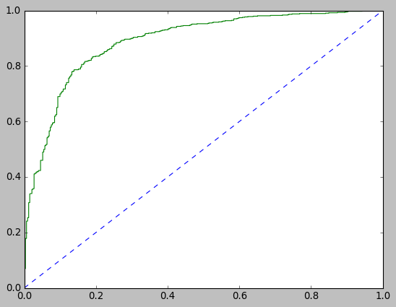
In [111]:
## Performance Matrix on test data set
y_test_predict = LDA_model.predict(X_test)
model_score = LDA_model.score(X_test, y_test)
print(model_score)
print(metrics.confusion_matrix(y_test, y_test_predict))
print(metrics.classification_report(y_test, y_test_predict))
0.8187772925764192
[[ 86 44]
[ 39 289]]
precision recall f1-score support

0 0.69 0.66 0.67 130
1 0.87 0.88 0.87 328

accuracy 0.82 458
macro avg 0.78 0.77 0.77 458
weighted avg 0.82 0.82 0.82 458

In [112]:
# AUC and ROC for the test data
# predict probabilities
probs = LDA_model.predict_proba(X_test)
# keep probabilities for the positive outcome only
probs = probs[:, 1]
# calculate AUC
lda_test_auc = roc_auc_score(y_test, probs)
print('AUC: %.3f' % lda_test_auc)
# calculate roc curve
lda_test_fpr, lda_test_tpr, lda_testthresholds = roc_curve(y_test, probs)
plt.plot([0, 1], [0, 1], linestyle='--')
# plot the roc curve for the model
plt.plot(lda_test_fpr, lda_test_tpr)
AUC: 0.884
Out[112]:
[<matplotlib.lines.Line2D at 0x24f484a4af0>]
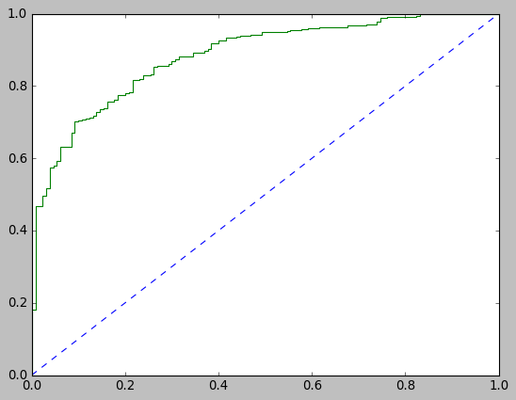
KNN Model
In [113]:
from sklearn.neighbors import KNeighborsClassifier

KNN_model=KNeighborsClassifier()
KNN_model.fit(X_train,y_train)
<ipython-input-113-86c9f448a5fe>:4: DataConversionWarning: A column-vector y was passed when a 1d array was expected. Please change the shape of y to (n_samples, ), for example using ravel().
KNN_model.fit(X_train,y_train)
Out[113]:
KNeighborsClassifier()
In [114]:
## Performance Matrix on train data set
y_train_predict = KNN_model.predict(X_train)
model_score = KNN_model.score(X_train, y_train)
print(model_score)
print(metrics.confusion_matrix(y_train, y_train_predict))
print(metrics.classification_report(y_train, y_train_predict))
0.8612933458294283
[[250 82]
[ 66 669]]
precision recall f1-score support

0 0.79 0.75 0.77 332
1 0.89 0.91 0.90 735

accuracy 0.86 1067
macro avg 0.84 0.83 0.84 1067
weighted avg 0.86 0.86 0.86 1067

In [115]:
#AUC and ROC for the training data
# predict probabilities
probs = KNN_model.predict_proba(X_train)
# keep probabilities for the positive outcome only
probs = probs[:, 1]
# calculate AUC
knn_train_auc = roc_auc_score(y_train, probs)
print('AUC: %.3f' % knn_train_auc)
# calculate roc curve
knn_train_fpr, knn_train_tpr, knn_train_thresholds = roc_curve(y_train, probs)
plt.plot([0, 1], [0, 1], linestyle='--')
# plot the roc curve for the model
plt.plot(knn_train_fpr, knn_train_tpr)
AUC: 0.933
Out[115]:
[<matplotlib.lines.Line2D at 0x24f48629940>]
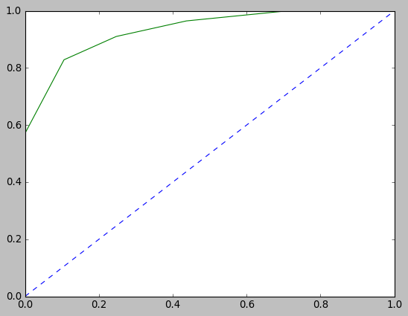
In [116]:
## Performance Matrix on test data set
y_test_predict = KNN_model.predict(X_test)
model_score = KNN_model.score(X_test, y_test)
print(model_score)
print(metrics.confusion_matrix(y_test, y_test_predict))
print(metrics.classification_report(y_test, y_test_predict))
0.8013100436681223
[[ 91 39]
[ 52 276]]
precision recall f1-score support

0 0.64 0.70 0.67 130
1 0.88 0.84 0.86 328

accuracy 0.80 458
macro avg 0.76 0.77 0.76 458
weighted avg 0.81 0.80 0.80 458

In [117]:
# AUC and ROC for the test data
# predict probabilities
probs = KNN_model.predict_proba(X_test)
# keep probabilities for the positive outcome only
probs = probs[:, 1]
# calculate AUC
knn_test_auc = roc_auc_score(y_test, probs)
print('AUC: %.3f' % knn_test_auc)
# calculate roc curve
knn_test_fpr, knn_test_tpr, knn_testthresholds = roc_curve(y_test, probs)
plt.plot([0, 1], [0, 1], linestyle='--')
# plot the roc curve for the model
plt.plot(knn_test_fpr, knn_test_tpr)
AUC: 0.855
Out[117]:
[<matplotlib.lines.Line2D at 0x24f486c57c0>]
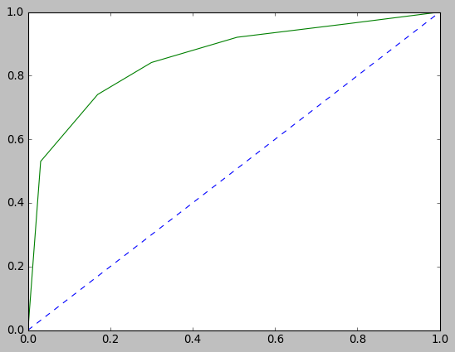
Naive Bayes Model
In [119]:
from sklearn.naive_bayes import GaussianNB
from sklearn import metrics
In [120]:
NB_model = GaussianNB()
NB_model.fit(X_train, y_train)
C:\ProgramData\Anaconda3\lib\site-packages\sklearn\utils\validation.py:73: DataConversionWarning: A column-vector y was passed when a 1d array was expected. Please change the shape of y to (n_samples, ), for example using ravel().
return f(**kwargs)
Out[120]:
GaussianNB()
In [121]:
## Performance Matrix on train data set
y_train_predict = NB_model.predict(X_train)
model_score = NB_model.score(X_train, y_train)
print(model_score)
print(metrics.confusion_matrix(y_train, y_train_predict))
print(metrics.classification_report(y_train, y_train_predict))
0.8331771321462043
[[240 92]
[ 86 649]]
precision recall f1-score support

0 0.74 0.72 0.73 332
1 0.88 0.88 0.88 735

accuracy 0.83 1067
macro avg 0.81 0.80 0.80 1067
weighted avg 0.83 0.83 0.83 1067

In [122]:
#AUC and ROC for the training data
# predict probabilities
probs = NB_model.predict_proba(X_train)
# keep probabilities for the positive outcome only
probs = probs[:, 1]
# calculate AUC
nb_train_auc = roc_auc_score(y_train, probs)
print('AUC: %.3f' % nb_train_auc)
# calculate roc curve
nb_train_fpr, nb_train_tpr, nb_train_thresholds = roc_curve(y_train, probs)
plt.plot([0, 1], [0, 1], linestyle='--')
# plot the roc curve for the model
plt.plot(nb_train_fpr, nb_train_tpr)
AUC: 0.886
Out[122]:
[<matplotlib.lines.Line2D at 0x24f486eda30>]
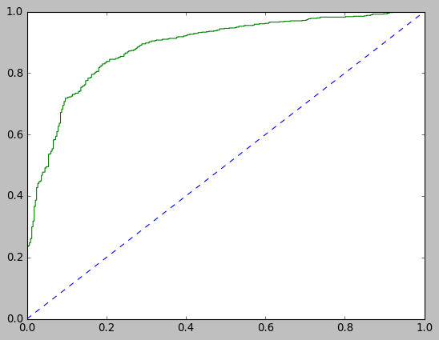
In [123]:
y_test.value_counts()
---------------------------------------------------------------------------
AttributeError Traceback (most recent call last)
<ipython-input-123-2820df361543> in <module>
----> 1 y_test.value_counts()

C:\ProgramData\Anaconda3\lib\site-packages\pandas\core\generic.py in __getattr__(self, name)
5272 if self._info_axis._can_hold_identifiers_and_holds_name(name):
5273 return self[name]
-> 5274 return object.__getattribute__(self, name)
5275
5276 def __setattr__(self, name: str, value) -> None:

AttributeError: 'DataFrame' object has no attribute 'value_counts'
In [124]:
## Performance Matrix on test data set
y_test_predict = NB_model.predict(X_test)
model_score = NB_model.score(X_test, y_test)
print(model_score)
print(metrics.confusion_matrix(y_test, y_test_predict))
print(metrics.classification_report(y_test, y_test_predict))
0.8253275109170306
[[ 94 36]
[ 44 284]]
precision recall f1-score support

0 0.68 0.72 0.70 130
1 0.89 0.87 0.88 328

accuracy 0.83 458
macro avg 0.78 0.79 0.79 458
weighted avg 0.83 0.83 0.83 458

In [125]:
# AUC and ROC for the test data
# predict probabilities
probs = NB_model.predict_proba(X_test)
# keep probabilities for the positive outcome only
probs = probs[:, 1]
# calculate AUC
nb_test_auc = roc_auc_score(y_test, probs)
print('AUC: %.3f' % nb_test_auc)
# calculate roc curve
nb_test_fpr, nb_test_tpr, nb_testthresholds = roc_curve(y_test, probs)
plt.plot([0, 1], [0, 1], linestyle='--')
# plot the roc curve for the model
plt.plot(nb_test_fpr, nb_test_tpr)
AUC: 0.885
Out[125]:
[<matplotlib.lines.Line2D at 0x24f4874d9a0>]
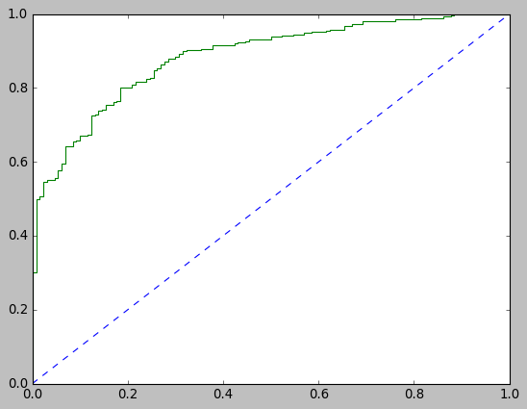
SVM
In [126]:
from sklearn import svm

SVM_model= svm.SVC(random_state=1,probability=True)
SVM_model.fit(X_train, y_train)
C:\ProgramData\Anaconda3\lib\site-packages\sklearn\utils\validation.py:73: DataConversionWarning: A column-vector y was passed when a 1d array was expected. Please change the shape of y to (n_samples, ), for example using ravel().
return f(**kwargs)
Out[126]:
SVC(probability=True, random_state=1)
In [127]:
## Performance Matrix on train data set
y_train_predict = SVM_model.predict(X_train)
model_score = SVM_model.score(X_train, y_train)
print(model_score)
print(metrics.confusion_matrix(y_train, y_train_predict))
print(metrics.classification_report(y_train, y_train_predict))
0.8388003748828491
[[221 111]
[ 61 674]]
precision recall f1-score support

0 0.78 0.67 0.72 332
1 0.86 0.92 0.89 735

accuracy 0.84 1067
macro avg 0.82 0.79 0.80 1067
weighted avg 0.84 0.84 0.83 1067

In [128]:
#AUC and ROC for the training data
# predict probabilities
probs = SVM_model.predict_proba(X_train)
# keep probabilities for the positive outcome only
probs = probs[:, 1]
# calculate AUC
svm_train_auc = roc_auc_score(y_train, probs)
print('AUC: %.3f' % svm_train_auc)
# calculate roc curve
svm_train_fpr, svm_train_tpr, svm_train_thresholds = roc_curve(y_train, probs)
plt.plot([0, 1], [0, 1], linestyle='--')
# plot the roc curve for the model
plt.plot(svm_train_fpr, svm_train_tpr)
AUC: 0.900
Out[128]:
[<matplotlib.lines.Line2D at 0x24f487a8880>]
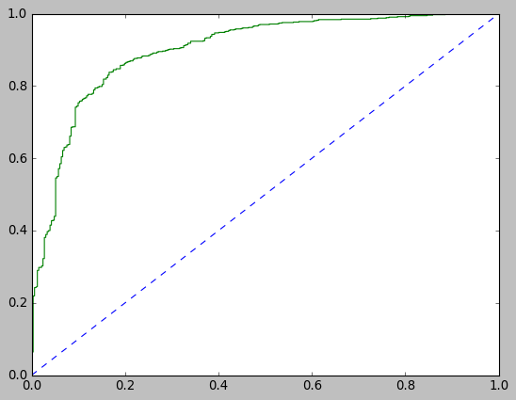
In [129]:
## Performance Matrix on test data set
y_test_predict = SVM_model.predict(X_test)
model_score = SVM_model.score(X_test, y_test)
print(model_score)
print(metrics.confusion_matrix(y_test, y_test_predict))
print(metrics.classification_report(y_test, y_test_predict))
0.8187772925764192
[[ 83 47]
[ 36 292]]
precision recall f1-score support

0 0.70 0.64 0.67 130
1 0.86 0.89 0.88 328

accuracy 0.82 458
macro avg 0.78 0.76 0.77 458
weighted avg 0.81 0.82 0.82 458

In [130]:
# AUC and ROC for the test data
# predict probabilities
probs = SVM_model.predict_proba(X_test)
# keep probabilities for the positive outcome only
probs = probs[:, 1]
# calculate AUC
svm_test_auc = roc_auc_score(y_test, probs)
print('AUC: %.3f' % svm_test_auc)
# calculate roc curve
svm_test_fpr, svm_test_tpr, svm_testthresholds = roc_curve(y_test, probs)
plt.plot([0, 1], [0, 1], linestyle='--')
# plot the roc curve for the model
plt.plot(svm_test_fpr, svm_test_tpr)
AUC: 0.888
Out[130]:
[<matplotlib.lines.Line2D at 0x24f488016d0>]
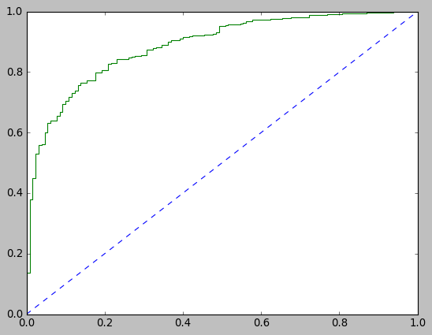
Model Tuninig
Logistic Regression
In [133]:
X_train_fs = X_train.drop(['economic.cond.national', 'gender'], axis=1)

X_test_fs = X_test.drop(['economic.cond.national', 'gender'], axis=1)
In [134]:
from sklearn.model_selection import GridSearchCV
In [135]:
# LogisticRegression Parameters tunning
LRM = LogisticRegression(random_state = 1)

## Search grid for optimal parameters
lr_param_grid = {"penalty" : ["l2","l1"],
"tol" : [0.01,0.001,0.5],
"max_iter": [100,110],
"C" :[50,100,150],
"intercept_scaling": [1, 2, 3, 4],
"solver":['liblinear']}

gsLRM = GridSearchCV(LRM, param_grid = lr_param_grid, scoring="accuracy", n_jobs= 2, verbose = 1, cv = 5)
In [136]:
# Fit the Logistic Regression model
#lr_model = LogisticRegression(solver='liblinear',max_iter=100,verbose=True,n_jobs=1)
#model = LogisticRegression()
gsLRM.fit(X_train_fs, y_train)
lr_model_tun = gsLRM.best_estimator_
lr_model_tun
Fitting 5 folds for each of 144 candidates, totalling 720 fits
[Parallel(n_jobs=2)]: Using backend LokyBackend with 2 concurrent workers.
[Parallel(n_jobs=2)]: Done 120 tasks | elapsed: 28.2s
[Parallel(n_jobs=2)]: Done 720 out of 720 | elapsed: 32.4s finished
C:\ProgramData\Anaconda3\lib\site-packages\sklearn\utils\validation.py:73: DataConversionWarning: A column-vector y was passed when a 1d array was expected. Please change the shape of y to (n_samples, ), for example using ravel().
return f(**kwargs)
Out[136]:
LogisticRegression(C=50, intercept_scaling=2, random_state=1,
solver='liblinear', tol=0.01)
In [137]:
## Performance Matrix on train data set
y_train_predict = lr_model_tun.predict(X_train_fs)
model_score = lr_model_tun.score(X_train_fs, y_train)
print(model_score)
print(metrics.confusion_matrix(y_train, y_train_predict))
print(metrics.classification_report(y_train, y_train_predict))
0.8406747891283973
[[227 105]
[ 65 670]]
precision recall f1-score support

0 0.78 0.68 0.73 332
1 0.86 0.91 0.89 735

accuracy 0.84 1067
macro avg 0.82 0.80 0.81 1067
weighted avg 0.84 0.84 0.84 1067

In [138]:
print(lr_model_tun.coef_, lr_model_tun.intercept_)
[[-1.41075653 0.25889435 0.62646704 -0.85088218 -0.24278197 -0.46412891]] [3.47449786]
In [139]:
X_train_fs.columns
Out[139]:
Index(['age', 'economic.cond.household', 'Blair', 'Hague', 'Europe',
'political.knowledge'],
dtype='object')
In [140]:
#AUC and ROC for the training data
# predict probabilities
probs = lr_model_tun.predict_proba(X_train_fs)
# keep probabilities for the positive outcome only
probs = probs[:, 1]
# calculate AUC
lr_tun_train_auc = roc_auc_score(y_train, probs)
print('AUC: %.3f' % lr_tun_train_auc)
# calculate roc curve
lr_tun_train_fpr, lr_tun_train_tpr, lr_tun_train_thresholds = roc_curve(y_train, probs)
plt.plot([0, 1], [0, 1], linestyle='--')
# plot the roc curve for the model
plt.plot(lr_tun_train_fpr, lr_tun_train_tpr)
AUC: 0.886
Out[140]:
[<matplotlib.lines.Line2D at 0x24f4824b5b0>]
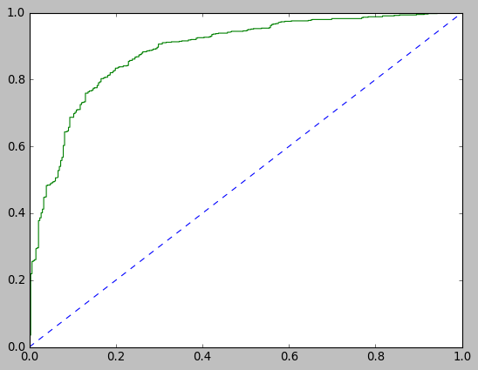
In [141]:
## Performance Matrix on test data set
y_test_predict = lr_model_tun.predict(X_test_fs)
model_score = lr_model_tun.score(X_test_fs, y_test)
print(model_score)
print(metrics.confusion_matrix(y_test, y_test_predict))
print(metrics.classification_report(y_test, y_test_predict))
0.8231441048034934
[[ 85 45]
[ 36 292]]
precision recall f1-score support

0 0.70 0.65 0.68 130
1 0.87 0.89 0.88 328

accuracy 0.82 458
macro avg 0.78 0.77 0.78 458
weighted avg 0.82 0.82 0.82 458

In [142]:
# AUC and ROC for the test data
# predict probabilities
probs = lr_model_tun.predict_proba(X_test_fs)
# keep probabilities for the positive outcome only
probs = probs[:, 1]
# calculate AUC
lr_tun_test_auc = roc_auc_score(y_test, probs)
print('AUC: %.3f' % lr_tun_test_auc)
# calculate roc curve
lr_tun_test_fpr, lr_tun_test_tpr, lr_tun_testthresholds = roc_curve(y_test, probs)
plt.plot([0, 1], [0, 1], linestyle='--')
# plot the roc curve for the model
plt.plot(lr_tun_test_fpr, lr_tun_test_tpr)
AUC: 0.878
Out[142]:
[<matplotlib.lines.Line2D at 0x24f49976220>]
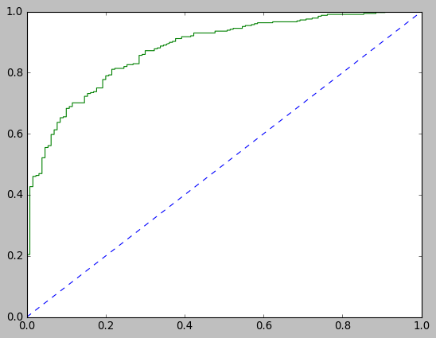
Linear Discriminant Analysis
In [145]:
LDAM = LinearDiscriminantAnalysis()

lda_param_grid = {"solver" : ["svd","lsqr", "eigen"],
"tol" : [0.0001,0.0002,0.0003]
}

gsLDAM = GridSearchCV(LDAM, param_grid = lda_param_grid, scoring="accuracy", n_jobs= 2, verbose = 1, cv = 5)
In [144]:
gsLDAM.fit(X_train, y_train)
lda_model_tun = gsLDAM.best_estimator_
lda_model_tun
Fitting 5 folds for each of 9 candidates, totalling 45 fits
[Parallel(n_jobs=2)]: Using backend LokyBackend with 2 concurrent workers.
[Parallel(n_jobs=2)]: Done 45 out of 45 | elapsed: 20.0s finished
C:\ProgramData\Anaconda3\lib\site-packages\sklearn\utils\validation.py:73: DataConversionWarning: A column-vector y was passed when a 1d array was expected. Please change the shape of y to (n_samples, ), for example using ravel().
return f(**kwargs)
Out[144]:
LinearDiscriminantAnalysis()
In [146]:
## Performance Matrix on train data set
y_train_predict = lda_model_tun.predict(X_train)
model_score = lda_model_tun.score(X_train, y_train)
print(model_score)
print(metrics.confusion_matrix(y_train, y_train_predict))
print(metrics.classification_report(y_train, y_train_predict))
0.8369259606373008
[[233 99]
[ 75 660]]
precision recall f1-score support

0 0.76 0.70 0.73 332
1 0.87 0.90 0.88 735

accuracy 0.84 1067
macro avg 0.81 0.80 0.81 1067
weighted avg 0.83 0.84 0.84 1067

In [147]:
#AUC and ROC for the training data
# predict probabilities
probs = lda_model_tun.predict_proba(X_train)
# keep probabilities for the positive outcome only
probs = probs[:, 1]
# calculate AUC
lda_tun_train_auc = roc_auc_score(y_train, probs)
print('AUC: %.3f' % lda_tun_train_auc)
# calculate roc curve
lda_tun_train_fpr, lda_tun_train_tpr, lda_tun_train_thresholds = roc_curve(y_train, probs)
plt.plot([0, 1], [0, 1], linestyle='--')
# plot the roc curve for the model
plt.plot(lda_tun_train_fpr, lda_tun_train_tpr)
AUC: 0.889
Out[147]:
[<matplotlib.lines.Line2D at 0x24f45742790>]
In [148]:
# Performance Matrix on test data set
y_test_predict = lda_model_tun.predict(X_test)
model_score = lda_model_tun.score(X_test, y_test)
print(model_score)
print(metrics.confusion_matrix(y_test, y_test_predict))
print(metrics.classification_report(y_test, y_test_predict))
0.8187772925764192
[[ 86 44]
[ 39 289]]
precision recall f1-score support

0 0.69 0.66 0.67 130
1 0.87 0.88 0.87 328

accuracy 0.82 458
macro avg 0.78 0.77 0.77 458
weighted avg 0.82 0.82 0.82 458

In [149]:
# AUC and ROC for the test data
# predict probabilities
probs = lda_model_tun.predict_proba(X_test)
# keep probabilities for the positive outcome only
probs = probs[:, 1]
# calculate AUC
lda_tun_test_auc = roc_auc_score(y_test, probs)
print('AUC: %.3f' % lda_tun_test_auc)
# calculate roc curve
lda_tun_test_fpr, lda_tun_test_tpr, lda_tun_testthresholds = roc_curve(y_test, probs)
plt.plot([0, 1], [0, 1], linestyle='--')
# plot the roc curve for the model
plt.plot(lda_tun_test_fpr, lda_tun_test_tpr)
AUC: 0.884
Out[149]:
[<matplotlib.lines.Line2D at 0x24f457950a0>]
KNN Model
In [152]:
KNNM = KNeighborsClassifier()

knn_param_grid = {
'n_neighbors': [6,7,8],
'weights': ['uniform', 'distance'],
'algorithm' : ['auto', 'ball_tree', 'kd_tree', 'brute'],
'leaf_size' : [1,2,3] ,
'p' : [1,2]
}

gsKNNM = GridSearchCV(KNNM, param_grid = knn_param_grid, scoring="accuracy", n_jobs= 2, verbose = 1, cv =5)
In [153]:
gsKNNM.fit(X_train, y_train)
knn_model_tun = gsKNNM.best_estimator_
knn_model_tun
Fitting 5 folds for each of 144 candidates, totalling 720 fits
[Parallel(n_jobs=2)]: Using backend LokyBackend with 2 concurrent workers.
[Parallel(n_jobs=2)]: Done 104 tasks | elapsed: 6.3s
[Parallel(n_jobs=2)]: Done 704 tasks | elapsed: 16.7s
[Parallel(n_jobs=2)]: Done 720 out of 720 | elapsed: 16.9s finished
C:\ProgramData\Anaconda3\lib\site-packages\sklearn\model_selection\_search.py:765: DataConversionWarning: A column-vector y was passed when a 1d array was expected. Please change the shape of y to (n_samples, ), for example using ravel().
self.best_estimator_.fit(X, y, **fit_params)
Out[153]:
KNeighborsClassifier(leaf_size=1, n_neighbors=7)
In [154]:
## Performance Matrix on train data set
y_train_predict = knn_model_tun.predict(X_train)
model_score = knn_model_tun.score(X_train, y_train)
print(model_score)
print(metrics.confusion_matrix(y_train, y_train_predict))
print(metrics.classification_report(y_train, y_train_predict))
0.8556701030927835
[[245 87]
[ 67 668]]
precision recall f1-score support

0 0.79 0.74 0.76 332
1 0.88 0.91 0.90 735

accuracy 0.86 1067
macro avg 0.84 0.82 0.83 1067
weighted avg 0.85 0.86 0.85 1067

In [155]:
#AUC and ROC for the training data
# predict probabilities
probs = knn_model_tun.predict_proba(X_train)
# keep probabilities for the positive outcome only
probs = probs[:, 1]
# calculate AUC
knn_tun_train_auc = roc_auc_score(y_train, probs)
print('AUC: %.3f' % knn_tun_train_auc)
# calculate roc curve
knn_tun_train_fpr, knn_tun_train_tpr, knn_tun_train_thresholds = roc_curve(y_train, probs)
plt.plot([0, 1], [0, 1], linestyle='--')
# plot the roc curve for the model
plt.plot(knn_tun_train_fpr, knn_tun_train_tpr)
AUC: 0.925
Out[155]:
[<matplotlib.lines.Line2D at 0x24f45824a60>]
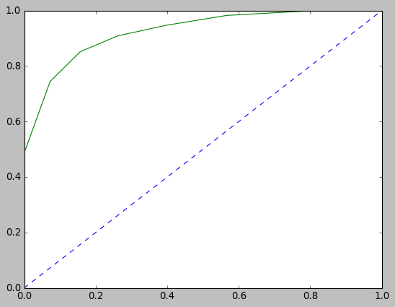
In [156]:
## Performance Matrix on test data set
y_test_predict = knn_model_tun.predict(X_test)
model_score = knn_model_tun.score(X_test, y_test)
print(model_score)
print(metrics.confusion_matrix(y_test, y_test_predict))
print(metrics.classification_report(y_test, y_test_predict))
0.7969432314410481
[[ 87 43]
[ 50 278]]
precision recall f1-score support

0 0.64 0.67 0.65 130
1 0.87 0.85 0.86 328

accuracy 0.80 458
macro avg 0.75 0.76 0.75 458
weighted avg 0.80 0.80 0.80 458

In [157]:
# AUC and ROC for the test data
# predict probabilities
probs = knn_model_tun.predict_proba(X_test)
# keep probabilities for the positive outcome only
probs = probs[:, 1]
# calculate AUC
knn_tun_test_auc = roc_auc_score(y_test, probs)
print('AUC: %.3f' % knn_tun_test_auc)
# calculate roc curve
knn_tun_test_fpr, knn_tun_test_tpr, knn_tun_testthresholds = roc_curve(y_test, probs)
plt.plot([0, 1], [0, 1], linestyle='--')
# plot the roc curve for the model
plt.plot(knn_tun_test_fpr, knn_tun_test_tpr)
AUC: 0.870
Out[157]:
[<matplotlib.lines.Line2D at 0x24f45846fa0>]
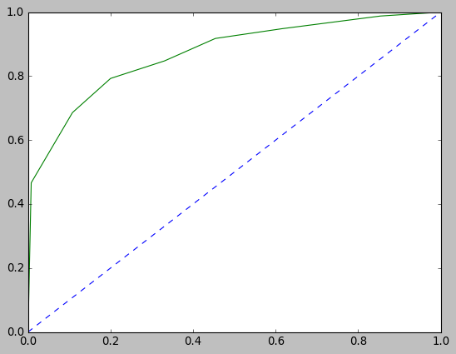
Naive Bayes Model
There are no parameters to tune for Naive Bayes
SVM
In [162]:
SVMM= svm.SVC(random_state=1,probability=True)

svm_param_grid = {
'C': [0.01, 0.1, 1.0],
'kernel': ['linear'],
'gamma': [0.1,0.05,0.2],
'tol' : [0.01,0.05]
}

gsSVMM = GridSearchCV(SVMM, param_grid = svm_param_grid, scoring="accuracy", n_jobs= 2, verbose = 1, cv =5)
In [161]:
gsSVMM.fit(X_train, y_train)
svm_model_tun = gsSVMM.best_estimator_
svm_model_tun
Fitting 5 folds for each of 18 candidates, totalling 90 fits
[Parallel(n_jobs=2)]: Using backend LokyBackend with 2 concurrent workers.
[Parallel(n_jobs=2)]: Done 90 out of 90 | elapsed: 4.2s finished
C:\ProgramData\Anaconda3\lib\site-packages\sklearn\utils\validation.py:73: DataConversionWarning: A column-vector y was passed when a 1d array was expected. Please change the shape of y to (n_samples, ), for example using ravel().
return f(**kwargs)
Out[161]:
SVC(C=0.1, gamma=0.1, kernel='linear', probability=True, random_state=1,
tol=0.01)
In [164]:
## Performance Matrix on train data set
y_train_predict = svm_model_tun.predict(X_train)
model_score = svm_model_tun.score(X_train, y_train)
print(model_score)
print(metrics.confusion_matrix(y_train, y_train_predict))
print(metrics.classification_report(y_train, y_train_predict))
0.8416119962511716
[[234 98]
[ 71 664]]
precision recall f1-score support

0 0.77 0.70 0.73 332
1 0.87 0.90 0.89 735

accuracy 0.84 1067
macro avg 0.82 0.80 0.81 1067
weighted avg 0.84 0.84 0.84 1067

In [165]:
#AUC and ROC for the training data
# predict probabilities
probs = svm_model_tun.predict_proba(X_train)
# keep probabilities for the positive outcome only
probs = probs[:, 1]
# calculate AUC
svm_tun_train_auc = roc_auc_score(y_train, probs)
print('AUC: %.3f' % svm_tun_train_auc)
# calculate roc curve
svm_tun_train_fpr, svm_tun_train_tpr, svm_tun_train_thresholds = roc_curve(y_train, probs)
plt.plot([0, 1], [0, 1], linestyle='--')
# plot the roc curve for the model
plt.plot(svm_tun_train_fpr, svm_tun_train_tpr)
AUC: 0.888
Out[165]:
[<matplotlib.lines.Line2D at 0x24f4589c700>]
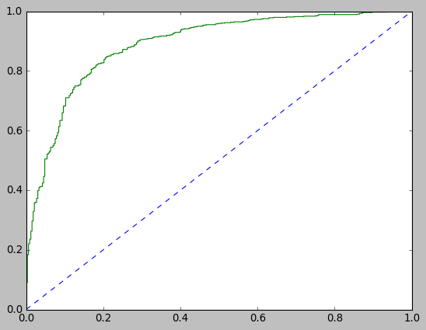
In [166]:
## Performance Matrix on test data set
y_test_predict = svm_model_tun.predict(X_test)
model_score = svm_model_tun.score(X_test, y_test)
print(model_score)
print(metrics.confusion_matrix(y_test, y_test_predict))
print(metrics.classification_report(y_test, y_test_predict))
0.8231441048034934
[[ 87 43]
[ 38 290]]
precision recall f1-score support

0 0.70 0.67 0.68 130
1 0.87 0.88 0.88 328

accuracy 0.82 458
macro avg 0.78 0.78 0.78 458
weighted avg 0.82 0.82 0.82 458

In [167]:
# AUC and ROC for the test data
# predict probabilities
probs = svm_model_tun.predict_proba(X_test)
# keep probabilities for the positive outcome only
probs = probs[:, 1]
# calculate AUC
svm_tun_test_auc = roc_auc_score(y_test, probs)
print('AUC: %.3f' % svm_tun_test_auc)
# calculate roc curve
svm_tun_test_fpr, svm_tun_test_tpr, svm_tun_testthresholds = roc_curve(y_test, probs)
plt.plot([0, 1], [0, 1], linestyle='--')
# plot the roc curve for the model
plt.plot(svm_tun_test_fpr, svm_tun_test_tpr)
AUC: 0.880
Out[167]:
[<matplotlib.lines.Line2D at 0x24f458e1f10>]
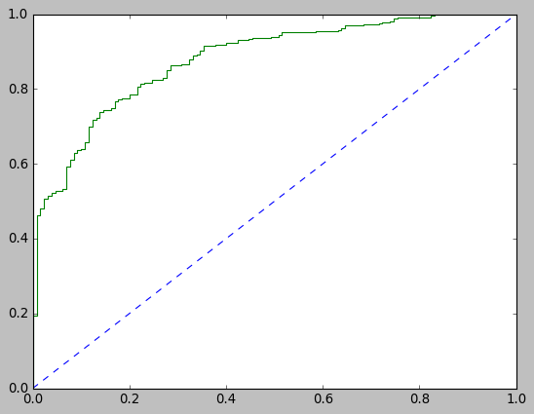
Basic Bagging and Boosting Models
Bagging
In [170]:
from sklearn.ensemble import BaggingClassifier
from sklearn.ensemble import RandomForestClassifier
RF_model=RandomForestClassifier(random_state=1)
Bagging_model=BaggingClassifier(base_estimator=RF_model,n_estimators=50,random_state=1)
Bagging_model.fit(X_train, y_train)
C:\ProgramData\Anaconda3\lib\site-packages\sklearn\utils\validation.py:73: DataConversionWarning: A column-vector y was passed when a 1d array was expected. Please change the shape of y to (n_samples, ), for example using ravel().
return f(**kwargs)
Out[170]:
BaggingClassifier(base_estimator=RandomForestClassifier(random_state=1),
n_estimators=50, random_state=1)
In [171]:
## Performance Matrix on train data set
y_train_predict = Bagging_model.predict(X_train)
model_score =Bagging_model.score(X_train, y_train)
print(model_score)
print(metrics.confusion_matrix(y_train, y_train_predict))
print(metrics.classification_report(y_train, y_train_predict))
0.9643861293345829
[[301 31]
[ 7 728]]
precision recall f1-score support

0 0.98 0.91 0.94 332
1 0.96 0.99 0.97 735

accuracy 0.96 1067
macro avg 0.97 0.95 0.96 1067
weighted avg 0.96 0.96 0.96 1067

In [172]:
#AUC and ROC for the training data
# predict probabilities
probs = Bagging_model.predict_proba(X_train)
# keep probabilities for the positive outcome only
probs = probs[:, 1]
# calculate AUC
bag_train_auc = roc_auc_score(y_train, probs)
print('AUC: %.3f' % bag_train_auc)
# calculate roc curve
bag_train_fpr, bag_train_tpr, bag_train_thresholds = roc_curve(y_train, probs)
plt.plot([0, 1], [0, 1], linestyle='--')
# plot the roc curve for the model
plt.plot(bag_train_fpr, bag_train_tpr)
AUC: 0.997
Out[172]:
[<matplotlib.lines.Line2D at 0x24f49956b20>]
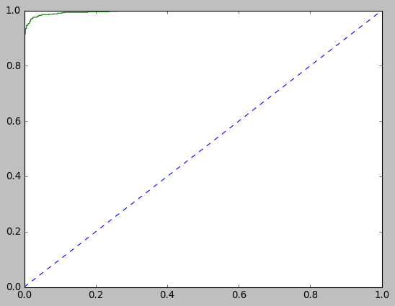
In [173]:
## Performance Matrix on test data set
y_test_predict = Bagging_model.predict(X_test)
model_score = Bagging_model.score(X_test, y_test)
print(model_score)
print(metrics.confusion_matrix(y_test, y_test_predict))
print(metrics.classification_report(y_test, y_test_predict))
0.834061135371179
[[ 92 38]
[ 38 290]]
precision recall f1-score support

0 0.71 0.71 0.71 130
1 0.88 0.88 0.88 328

accuracy 0.83 458
macro avg 0.80 0.80 0.80 458
weighted avg 0.83 0.83 0.83 458

In [174]:
# AUC and ROC for the test data
# predict probabilities
probs = Bagging_model.predict_proba(X_test)
# keep probabilities for the positive outcome only
probs = probs[:, 1]
# calculate AUC
bag_test_auc = roc_auc_score(y_test, probs)
print('AUC: %.3f' % bag_test_auc)
# calculate roc curve
bag_test_fpr, bag_test_tpr, bag_testthresholds = roc_curve(y_test, probs)
plt.plot([0, 1], [0, 1], linestyle='--')
# plot the roc curve for the model
plt.plot(bag_test_fpr, bag_test_tpr)
AUC: 0.897
Out[174]:
[<matplotlib.lines.Line2D at 0x24f56745910>]
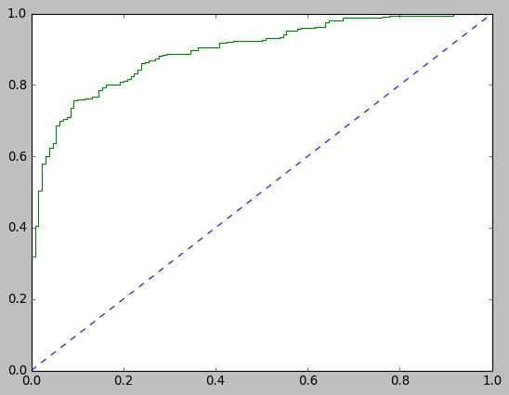
XGBoost
In [184]:
X_train_fs = X_train.drop(['economic.cond.national', 'economic.cond.household',
'Europe', 'political.knowledge', 'gender'], axis=1)

X_test_fs = X_test.drop(['economic.cond.national', 'economic.cond.household',
'Europe', 'political.knowledge', 'gender'], axis=1)
In [187]:
pip install xgboost
Note: you may need to restart the kernel to use updated packages.Collecting xgboost

Using cached xgboost-1.4.2-py3-none-win_amd64.whl (97.8 MB)
Requirement already satisfied: numpy in c:\programdata\anaconda3\lib\site-packages (from xgboost) (1.18.5)
Requirement already satisfied: scipy in c:\programdata\anaconda3\lib\site-packages (from xgboost) (1.5.0)
Installing collected packages: xgboost
Successfully installed xgboost-1.4.2
In [188]:
import xgboost as xgb
XGB_model=xgb.XGBClassifier(random_state=1)
XGB_model.fit(X_train_fs, y_train)
C:\ProgramData\Anaconda3\lib\site-packages\xgboost\sklearn.py:1146: UserWarning: The use of label encoder in XGBClassifier is deprecated and will be removed in a future release. To remove this warning, do the following: 1) Pass option use_label_encoder=False when constructing XGBClassifier object; and 2) Encode your labels (y) as integers starting with 0, i.e. 0, 1, 2, ..., [num_class - 1].
warnings.warn(label_encoder_deprecation_msg, UserWarning)
C:\ProgramData\Anaconda3\lib\site-packages\sklearn\utils\validation.py:73: DataConversionWarning: A column-vector y was passed when a 1d array was expected. Please change the shape of y to (n_samples, ), for example using ravel().
return f(**kwargs)
[19:30:59] WARNING: C:/Users/Administrator/workspace/xgboost-win64_release_1.4.0/src/learner.cc:1095: Starting in XGBoost 1.3.0, the default evaluation metric used with the objective 'binary:logistic' was changed from 'error' to 'logloss'. Explicitly set eval_metric if you'd like to restore the old behavior.
Out[188]:
XGBClassifier(base_score=0.5, booster='gbtree', colsample_bylevel=1,
colsample_bynode=1, colsample_bytree=1, gamma=0, gpu_id=-1,
importance_type='gain', interaction_constraints='',
learning_rate=0.300000012, max_delta_step=0, max_depth=6,
min_child_weight=1, missing=nan, monotone_constraints='()',
n_estimators=100, n_jobs=4, num_parallel_tree=1, random_state=1,
reg_alpha=0, reg_lambda=1, scale_pos_weight=1, subsample=1,
tree_method='exact', validate_parameters=1, verbosity=None)
In [189]:
## Performance Matrix on train data set
y_train_predict = XGB_model.predict(X_train_fs)
model_score = XGB_model.score(X_train_fs, y_train)
print(model_score)
print(metrics.confusion_matrix(y_train, y_train_predict))
print(metrics.classification_report(y_train, y_train_predict))
0.8528584817244611
[[244 88]
[ 69 666]]
precision recall f1-score support

0 0.78 0.73 0.76 332
1 0.88 0.91 0.89 735

accuracy 0.85 1067
macro avg 0.83 0.82 0.83 1067
weighted avg 0.85 0.85 0.85 1067

In [190]:
#AUC and ROC for the training data
# predict probabilities
probs = XGB_model.predict_proba(X_train_fs)
# keep probabilities for the positive outcome only
probs = probs[:, 1]
# calculate AUC
xgb_train_auc = roc_auc_score(y_train, probs)
print('AUC: %.3f' % xgb_train_auc)
# calculate roc curve
xgb_train_fpr, xgb_train_tpr, xgb_train_thresholds = roc_curve(y_train, probs)
plt.plot([0, 1], [0, 1], linestyle='--')
# plot the roc curve for the model
plt.plot(xgb_train_fpr, xgb_train_tpr)
AUC: 0.931
Out[190]:
[<matplotlib.lines.Line2D at 0x24f57d14f10>]
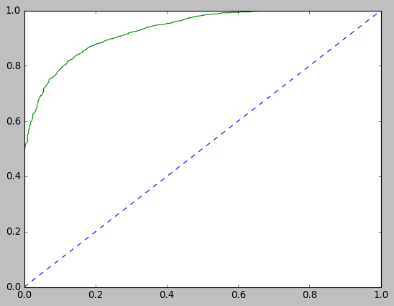
In [192]:
## Performance Matrix on test data set
y_test_predict = XGB_model.predict(X_test_fs)
model_score = XGB_model.score(X_test_fs, y_test)
print(model_score)
print(metrics.confusion_matrix(y_test, y_test_predict))
print(metrics.classification_report(y_test, y_test_predict))
0.7947598253275109
[[ 82 48]
[ 46 282]]
precision recall f1-score support

0 0.64 0.63 0.64 130
1 0.85 0.86 0.86 328

accuracy 0.79 458
macro avg 0.75 0.75 0.75 458
weighted avg 0.79 0.79 0.79 458

In [193]:
# AUC and ROC for the test data
# predict probabilities
probs = XGB_model.predict_proba(X_test_fs)
# keep probabilities for the positive outcome only
probs = probs[:, 1]
# calculate AUC
xgb_test_auc = roc_auc_score(y_test, probs)
print('AUC: %.3f' % xgb_test_auc)
# calculate roc curve
xgb_test_fpr, xgb_test_tpr, xgb_testthresholds = roc_curve(y_test, probs)
plt.plot([0, 1], [0, 1], linestyle='--')
# plot the roc curve for the model
plt.plot(xgb_test_fpr, xgb_test_tpr)
AUC: 0.835
Out[193]:
[<matplotlib.lines.Line2D at 0x24f57d64d60>]
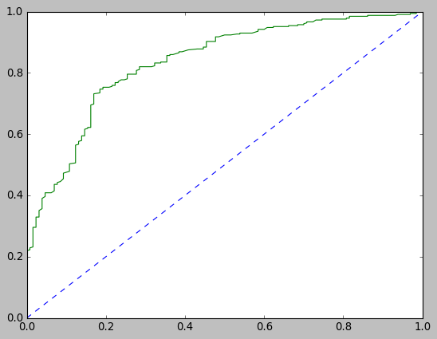
In [194]:
pd.DataFrame({'Variable':X_train_fs.columns,
'Importance':XGB_model.feature_importances_}).sort_values('Importance', ascending=False)
Out[194]:
 | Variable | Importance
2 | Hague | 0.557733
1 | Blair | 0.353927
0 | age | 0.088340
Ada Boost
In [226]:
from sklearn.ensemble import AdaBoostClassifier

ADB_model = AdaBoostClassifier(n_estimators=100,random_state=1)
ADB_model.fit(X_train,y_train)
C:\ProgramData\Anaconda3\lib\site-packages\sklearn\utils\validation.py:73: DataConversionWarning: A column-vector y was passed when a 1d array was expected. Please change the shape of y to (n_samples, ), for example using ravel().
return f(**kwargs)
Out[226]:
AdaBoostClassifier(n_estimators=100, random_state=1)
In [227]:
## Performance Matrix on train data set
y_train_predict = ADB_model.predict(X_train)
model_score = ADB_model.score(X_train, y_train)
print(model_score)
print(metrics.confusion_matrix(y_train, y_train_predict))
print(metrics.classification_report(y_train, y_train_predict))
0.8472352389878163
[[238 94]
[ 69 666]]
precision recall f1-score support

0 0.78 0.72 0.74 332
1 0.88 0.91 0.89 735

accuracy 0.85 1067
macro avg 0.83 0.81 0.82 1067
weighted avg 0.84 0.85 0.85 1067

In [229]:
#AUC and ROC for the training data
# predict probabilities
probs = ADB_model.predict_proba(X_train)
# keep probabilities for the positive outcome only
probs = probs[:, 1]
# calculate AUC
adb_train_auc = roc_auc_score(y_train, probs)
print('AUC: %.3f' % adb_train_auc)
# calculate roc curve
adb_train_fpr, adb_train_tpr, adb_train_thresholds = roc_curve(y_train, probs)
plt.plot([0, 1], [0, 1], linestyle='--')
# plot the roc curve for the model
plt.plot(adb_train_fpr, adb_train_tpr)
AUC: 0.913
Out[229]:
[<matplotlib.lines.Line2D at 0x24f5a155a60>]
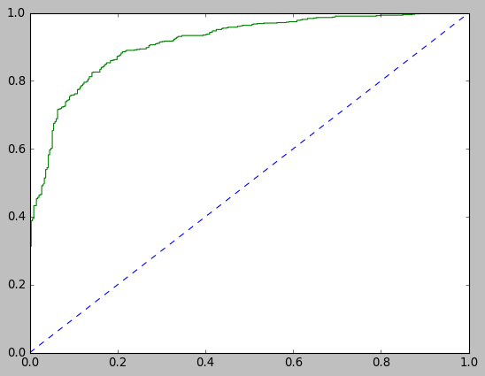
In [230]:
## Performance Matrix on test data set
y_test_predict = ADB_model.predict(X_test)
model_score = ADB_model.score(X_test, y_test)
print(model_score)
print(metrics.confusion_matrix(y_test, y_test_predict))
print(metrics.classification_report(y_test, y_test_predict))
0.8187772925764192
[[ 90 40]
[ 43 285]]
precision recall f1-score support

0 0.68 0.69 0.68 130
1 0.88 0.87 0.87 328

accuracy 0.82 458
macro avg 0.78 0.78 0.78 458
weighted avg 0.82 0.82 0.82 458

In [231]:
# AUC and ROC for the test data
# predict probabilities
probs = ADB_model.predict_proba(X_test)
# keep probabilities for the positive outcome only
probs = probs[:, 1]
# calculate AUC
adb_test_auc = roc_auc_score(y_test, probs)
print('AUC: %.3f' % adb_test_auc)
# calculate roc curve
adb_test_fpr, adb_test_tpr, adb_testthresholds = roc_curve(y_test, probs)
plt.plot([0, 1], [0, 1], linestyle='--')
# plot the roc curve for the model
plt.plot(adb_test_fpr, adb_test_tpr)
AUC: 0.879
Out[231]:
[<matplotlib.lines.Line2D at 0x24f5a08e6a0>]
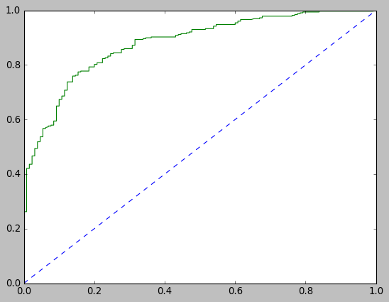
Observing the feature importance
In [232]:
pd.DataFrame({'Variable':X_train.columns,
'Importance':xgbm_model_tun.feature_importances_}).sort_values('Importance', ascending=False)
Out[232]:
 | Variable | Importance
4 | Hague | 0.320234
3 | Blair | 0.158256
5 | Europe | 0.138685
6 | political.knowledge | 0.114458
1 | economic.cond.national | 0.086892
0 | age | 0.065085
2 | economic.cond.household | 0.062624
7 | gender | 0.053766
Tuned Bagging and Boosting models
Bagging Model
In [197]:
BAGGING = BaggingClassifier(RandomForestClassifier(random_state=1))

bagging_param_grid = {
'base_estimator__max_depth' : [1, 5],
'max_samples' : [0.05, 0.1, 0.2],
'n_estimators' : [50,100,200]
}

gsBagging= GridSearchCV(BAGGING,
bagging_param_grid, scoring = "accuracy", n_jobs= 2, cv = 5, verbose=1)
In [207]:
gsBagging.fit(X_train, y_train)
bagging_model_tun = gsBagging.best_estimator_
Fitting 5 folds for each of 18 candidates, totalling 90 fits
[Parallel(n_jobs=2)]: Using backend LokyBackend with 2 concurrent workers.
[Parallel(n_jobs=2)]: Done 46 tasks | elapsed: 10.7min
[Parallel(n_jobs=2)]: Done 90 out of 90 | elapsed: 21.5min finished
C:\ProgramData\Anaconda3\lib\site-packages\sklearn\utils\validation.py:73: DataConversionWarning: A column-vector y was passed when a 1d array was expected. Please change the shape of y to (n_samples, ), for example using ravel().
return f(**kwargs)
In [208]:
## Performance Matrix on train data set
y_train_predict = bagging_model_tun.predict(X_train)
model_score =bagging_model_tun.score(X_train, y_train)
print(model_score)
print(metrics.confusion_matrix(y_train, y_train_predict))
print(metrics.classification_report(y_train, y_train_predict))
0.8603561387066542
[[221 111]
[ 38 697]]
precision recall f1-score support

0 0.85 0.67 0.75 332
1 0.86 0.95 0.90 735

accuracy 0.86 1067
macro avg 0.86 0.81 0.83 1067
weighted avg 0.86 0.86 0.86 1067

In [209]:
#AUC and ROC for the training data
# predict probabilities
probs = bagging_model_tun.predict_proba(X_train)
# keep probabilities for the positive outcome only
probs = probs[:, 1]
# calculate AUC
bag_tun_train_auc = roc_auc_score(y_train, probs)
print('AUC: %.3f' % bag_tun_train_auc)
# calculate roc curve
bag_tun_train_fpr, bag_tun_train_tpr, bag_tun_train_thresholds = roc_curve(y_train, probs)
plt.plot([0, 1], [0, 1], linestyle='--')
# plot the roc curve for the model
plt.plot(bag_tun_train_fpr, bag_tun_train_tpr)
AUC: 0.917
Out[209]:
[<matplotlib.lines.Line2D at 0x24f57d38a00>]
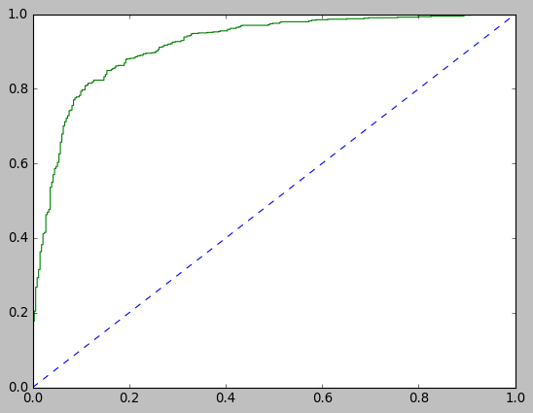
In [210]:
## Performance Matrix on test data set
y_test_predict = bagging_model_tun.predict(X_test)
model_score = bagging_model_tun.score(X_test, y_test)
print(model_score)
print(metrics.confusion_matrix(y_test, y_test_predict))
print(metrics.classification_report(y_test, y_test_predict))
0.8362445414847162
[[ 84 46]
[ 29 299]]
precision recall f1-score support

0 0.74 0.65 0.69 130
1 0.87 0.91 0.89 328

accuracy 0.84 458
macro avg 0.81 0.78 0.79 458
weighted avg 0.83 0.84 0.83 458

In [211]:
# AUC and ROC for the test data
# predict probabilities
probs = bagging_model_tun.predict_proba(X_test)
# keep probabilities for the positive outcome only
probs = probs[:, 1]
# calculate AUC
bag_tun_test_auc = roc_auc_score(y_test, probs)
print('AUC: %.3f' % bag_tun_test_auc)
# calculate roc curve
bag_tun_test_fpr, bag_tun_test_tpr, bag_tun_testthresholds = roc_curve(y_test, probs)
plt.plot([0, 1], [0, 1], linestyle='--')
# plot the roc curve for the model
plt.plot(bag_tun_test_fpr, bag_tun_test_tpr)
AUC: 0.899
Out[211]:
[<matplotlib.lines.Line2D at 0x24f57eedc40>]
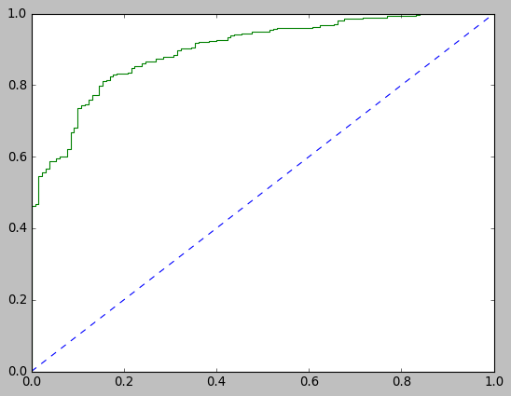
AdaBoost
In [212]:
from sklearn.tree import DecisionTreeClassifier
from sklearn.ensemble import RandomForestClassifier
from sklearn.ensemble import AdaBoostClassifier

RF = RandomForestClassifier(random_state=1)
DT = DecisionTreeClassifier(random_state=1)

ABCM = AdaBoostClassifier()

abcm_param_grid = {"n_estimators": [300,400,500],
"learning_rate" : [0.03,0.04,0.05]
}

gsABCM = GridSearchCV(ABCM, param_grid = abcm_param_grid, scoring="accuracy", n_jobs= 2, verbose = 1, cv =5)
In [213]:
gsABCM.fit(X_train, y_train)
abcm_model_tun = gsABCM.best_estimator_
abcm_model_tun
Fitting 5 folds for each of 9 candidates, totalling 45 fits
[Parallel(n_jobs=2)]: Using backend LokyBackend with 2 concurrent workers.
[Parallel(n_jobs=2)]: Done 45 out of 45 | elapsed: 1.5min finished
C:\ProgramData\Anaconda3\lib\site-packages\sklearn\utils\validation.py:73: DataConversionWarning: A column-vector y was passed when a 1d array was expected. Please change the shape of y to (n_samples, ), for example using ravel().
return f(**kwargs)
Out[213]:
AdaBoostClassifier(learning_rate=0.03, n_estimators=400)
In [214]:
## Performance Matrix on train data set
y_train_predict = abcm_model_tun.predict(X_train)
model_score = abcm_model_tun.score(X_train, y_train)
print(model_score)
print(metrics.confusion_matrix(y_train, y_train_predict))
print(metrics.classification_report(y_train, y_train_predict))
0.8369259606373008
[[219 113]
[ 61 674]]
precision recall f1-score support

0 0.78 0.66 0.72 332
1 0.86 0.92 0.89 735

accuracy 0.84 1067
macro avg 0.82 0.79 0.80 1067
weighted avg 0.83 0.84 0.83 1067

In [215]:
#AUC and ROC for the training data
# predict probabilities
probs = abcm_model_tun.predict_proba(X_train)
# keep probabilities for the positive outcome only
probs = probs[:, 1]
# calculate AUC
adb_tun_train_auc = roc_auc_score(y_train, probs)
print('AUC: %.3f' % adb_tun_train_auc)
# calculate roc curve
adb_tun_train_fpr, adb_tun_train_tpr, adb_tun_train_thresholds = roc_curve(y_train, probs)
plt.plot([0, 1], [0, 1], linestyle='--')
# plot the roc curve for the model
plt.plot(adb_tun_train_fpr, adb_tun_train_tpr)
AUC: 0.902
Out[215]:
[<matplotlib.lines.Line2D at 0x24f5b1fd310>]
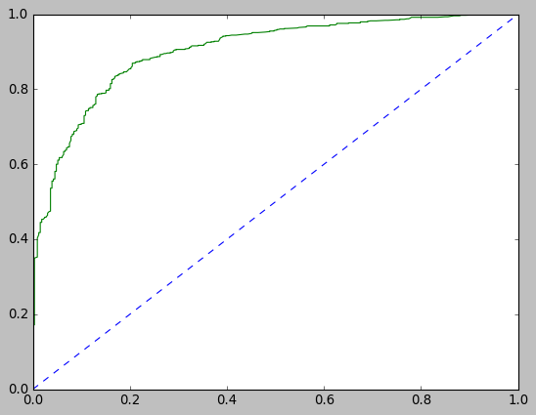
In [216]:
## Performance Matrix on test data set
y_test_predict = abcm_model_tun.predict(X_test)
model_score = abcm_model_tun.score(X_test, y_test)
print(model_score)
print(metrics.confusion_matrix(y_test, y_test_predict))
print(metrics.classification_report(y_test, y_test_predict))
0.8275109170305677
[[ 85 45]
[ 34 294]]
precision recall f1-score support

0 0.71 0.65 0.68 130
1 0.87 0.90 0.88 328

accuracy 0.83 458
macro avg 0.79 0.78 0.78 458
weighted avg 0.82 0.83 0.83 458

In [217]:
# AUC and ROC for the test data
# predict probabilities
probs = abcm_model_tun.predict_proba(X_test)
# keep probabilities for the positive outcome only
probs = probs[:, 1]
# calculate AUC
adb_tun_test_auc = roc_auc_score(y_test, probs)
print('AUC: %.3f' % adb_tun_test_auc)
# calculate roc curve
adb_tun_test_fpr, adb_tun_test_tpr, adb_tun_testthresholds = roc_curve(y_test, probs)
plt.plot([0, 1], [0, 1], linestyle='--')
# plot the roc curve for the model
plt.plot(adb_tun_test_fpr, adb_tun_test_tpr)
AUC: 0.892
Out[217]:
[<matplotlib.lines.Line2D at 0x24f5b181be0>]
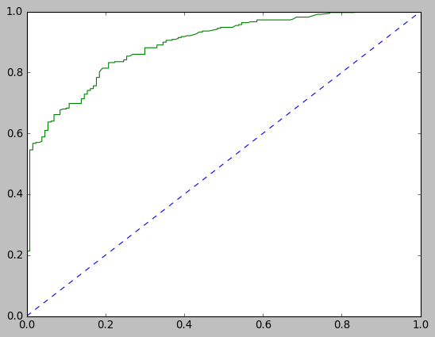
In [218]:
pd.DataFrame({'Variable':X_train.columns,
'Importance':abcm_model_tun.feature_importances_}).sort_values('Importance', ascending=False)
Out[218]:
 | Variable | Importance
4 | Hague | 0.2225
3 | Blair | 0.2075
5 | Europe | 0.1775
0 | age | 0.1425
6 | political.knowledge | 0.1000
1 | economic.cond.national | 0.0975
2 | economic.cond.household | 0.0525
7 | gender | 0.0000
XGBoost
In [219]:
import xgboost as xgb
XGBM = xgb.XGBClassifier(random_state=1)

xgbm_param_grid = {'learning_rate': [0.01,0.05,0.1],
'max_depth': [4],
'min_child_weight': [11],
'subsample': [0.8],
'colsample_bytree': [0.7,1],
'n_estimators': [2000,2500,3000],
'gamma': [0,1,5]}

gsXGBM = GridSearchCV(XGBM, param_grid = xgbm_param_grid, scoring="accuracy", n_jobs= 2, verbose = 1, cv =5)
In [220]:
gsXGBM.fit(X_train, y_train)
xgbm_model_tun = gsXGBM.best_estimator_
xgbm_model_tun
Fitting 5 folds for each of 54 candidates, totalling 270 fits
[Parallel(n_jobs=2)]: Using backend LokyBackend with 2 concurrent workers.
[Parallel(n_jobs=2)]: Done 46 tasks | elapsed: 1.9min
[Parallel(n_jobs=2)]: Done 196 tasks | elapsed: 7.3min
[Parallel(n_jobs=2)]: Done 270 out of 270 | elapsed: 10.2min finished
C:\ProgramData\Anaconda3\lib\site-packages\xgboost\sklearn.py:1146: UserWarning: The use of label encoder in XGBClassifier is deprecated and will be removed in a future release. To remove this warning, do the following: 1) Pass option use_label_encoder=False when constructing XGBClassifier object; and 2) Encode your labels (y) as integers starting with 0, i.e. 0, 1, 2, ..., [num_class - 1].
warnings.warn(label_encoder_deprecation_msg, UserWarning)
C:\ProgramData\Anaconda3\lib\site-packages\sklearn\utils\validation.py:73: DataConversionWarning: A column-vector y was passed when a 1d array was expected. Please change the shape of y to (n_samples, ), for example using ravel().
return f(**kwargs)
[22:02:34] WARNING: C:/Users/Administrator/workspace/xgboost-win64_release_1.4.0/src/learner.cc:1095: Starting in XGBoost 1.3.0, the default evaluation metric used with the objective 'binary:logistic' was changed from 'error' to 'logloss'. Explicitly set eval_metric if you'd like to restore the old behavior.
Out[220]:
XGBClassifier(base_score=0.5, booster='gbtree', colsample_bylevel=1,
colsample_bynode=1, colsample_bytree=0.7, gamma=5, gpu_id=-1,
importance_type='gain', interaction_constraints='',
learning_rate=0.1, max_delta_step=0, max_depth=4,
min_child_weight=11, missing=nan, monotone_constraints='()',
n_estimators=2500, n_jobs=4, num_parallel_tree=1, random_state=1,
reg_alpha=0, reg_lambda=1, scale_pos_weight=1, subsample=0.8,
tree_method='exact', validate_parameters=1, verbosity=None)
In [221]:
## Performance Matrix on train data set
y_train_predict = xgbm_model_tun.predict(X_train)
model_score = xgbm_model_tun.score(X_train, y_train)
print(model_score)
print(metrics.confusion_matrix(y_train, y_train_predict))
print(metrics.classification_report(y_train, y_train_predict))
0.8566073102155577
[[235 97]
[ 56 679]]
precision recall f1-score support

0 0.81 0.71 0.75 332
1 0.88 0.92 0.90 735

accuracy 0.86 1067
macro avg 0.84 0.82 0.83 1067
weighted avg 0.85 0.86 0.85 1067

In [222]:
#AUC and ROC for the training data
# predict probabilities
probs = xgbm_model_tun.predict_proba(X_train)
# keep probabilities for the positive outcome only
probs = probs[:, 1]
# calculate AUC
xgb_tun_train_auc = roc_auc_score(y_train, probs)
print('AUC: %.3f' % xgb_tun_train_auc)
# calculate roc curve
xgb_tun_train_fpr, xgb_tun_train_tpr, xgb_tun_train_thresholds = roc_curve(y_train, probs)
plt.plot([0, 1], [0, 1], linestyle='--')
# plot the roc curve for the model
plt.plot(xgb_tun_train_fpr, xgb_tun_train_tpr)
AUC: 0.915
Out[222]:
[<matplotlib.lines.Line2D at 0x24f5a1a95e0>]
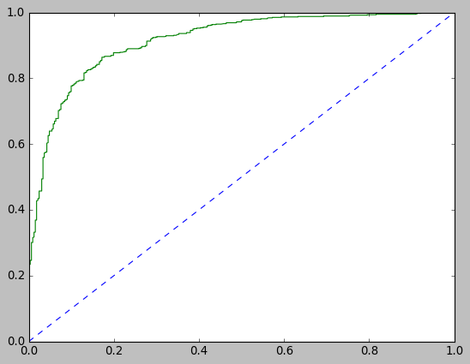
In [223]:
## Performance Matrix on test data set
y_test_predict = xgbm_model_tun.predict(X_test)
model_score = xgbm_model_tun.score(X_test, y_test)
print(model_score)
print(metrics.confusion_matrix(y_test, y_test_predict))
print(metrics.classification_report(y_test, y_test_predict))
0.8318777292576419
[[ 92 38]
[ 39 289]]
precision recall f1-score support

0 0.70 0.71 0.70 130
1 0.88 0.88 0.88 328

accuracy 0.83 458
macro avg 0.79 0.79 0.79 458
weighted avg 0.83 0.83 0.83 458

In [224]:
# AUC and ROC for the test data
# predict probabilities
probs = xgbm_model_tun.predict_proba(X_test)
# keep probabilities for the positive outcome only
probs = probs[:, 1]
# calculate AUC
xgb_tun_test_auc = roc_auc_score(y_test, probs)
print('AUC: %.3f' % xgb_tun_test_auc)
# calculate roc curve
xgb_tun_test_fpr, xgb_tun_test_tpr, xgb_tun_testthresholds = roc_curve(y_test, probs)
plt.plot([0, 1], [0, 1], linestyle='--')
# plot the roc curve for the model
plt.plot(xgb_tun_test_fpr, xgb_tun_test_tpr)
AUC: 0.894
Out[224]:
[<matplotlib.lines.Line2D at 0x24f5901fbb0>]
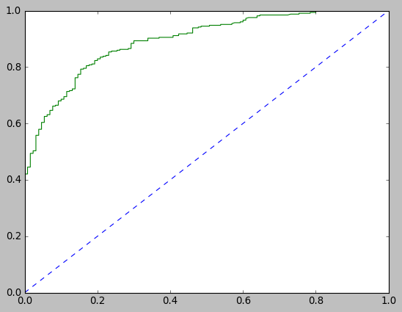
In [225]:
pd.DataFrame({'Variable':X_train.columns,
'Importance':xgbm_model_tun.feature_importances_}).sort_values('Importance', ascending=False)
Out[225]:
 | Variable | Importance
4 | Hague | 0.320234
3 | Blair | 0.158256
5 | Europe | 0.138685
6 | political.knowledge | 0.114458
1 | economic.cond.national | 0.086892
0 | age | 0.065085
2 | economic.cond.household | 0.062624
7 | gender | 0.053766
Comparison of Different Models
ROC Curve for all the basic models on the Training data
In [233]:
plt.plot([0, 1], [0, 1], linestyle='--')
plt.plot(lr_train_fpr, lr_train_tpr,color='red',label="LR")
plt.plot(lda_train_fpr,lda_train_tpr,color='green',label="LDA")
plt.plot(knn_train_fpr,knn_train_tpr,color='blue',label="KNN")
plt.plot(nb_train_fpr,nb_train_tpr,color='orange',label="NB")
plt.plot(svm_train_fpr,svm_train_tpr,color='violet',label="SVM")
plt.plot(bag_train_fpr,bag_train_tpr,color='cyan',label="BAG")
plt.plot(adb_train_fpr,adb_train_tpr,color='magenta',label="ADB")
plt.plot(xgb_train_fpr,xgb_train_tpr,color='yellow',label="XGB")
plt.xlabel('False Positive Rate')
plt.ylabel('True Positive Rate')
plt.title('ROC')
plt.legend(bbox_to_anchor=(0., 1.), loc='best')
Out[233]:
<matplotlib.legend.Legend at 0x24f59047fd0>
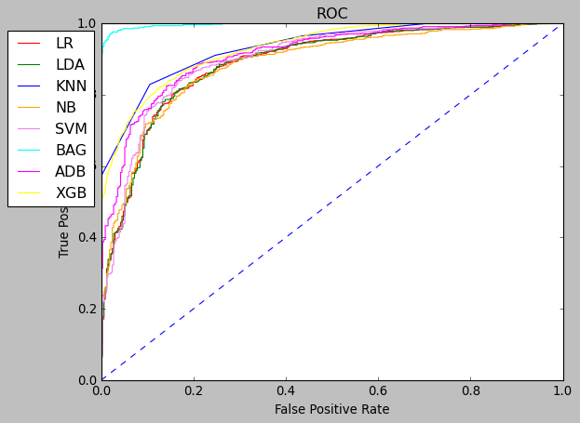
ROC Curve for all the basic models on the Test data
In [234]:
plt.plot([0, 1], [0, 1], linestyle='--')
plt.plot(lr_test_fpr, lr_test_tpr,color='red',label="LR")
plt.plot(lda_test_fpr,lda_test_tpr,color='green',label="LDA")
plt.plot(knn_test_fpr,knn_test_tpr,color='blue',label="KNN")
plt.plot(nb_test_fpr,nb_test_tpr,color='orange',label="NB")
plt.plot(svm_test_fpr,svm_test_tpr,color='violet',label="SVM")
plt.plot(bag_test_fpr,bag_test_tpr,color='cyan',label="BAG")
plt.plot(adb_test_fpr,adb_test_tpr,color='magenta',label="ADB")
plt.plot(xgb_test_fpr,xgb_test_tpr,color='yellow',label="XGB")
plt.xlabel('False Positive Rate')
plt.ylabel('True Positive Rate')
plt.title('ROC')
plt.legend(bbox_to_anchor=(0., 1.), loc='best')
Out[234]:
<matplotlib.legend.Legend at 0x24f5a10cf40>
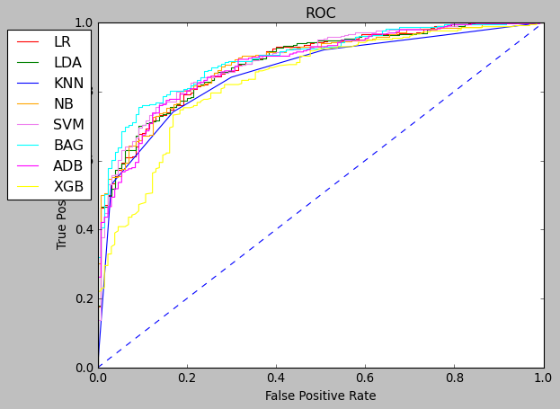
ROC Curve for all the tuned models on the Training data
In [236]:
plt.plot([0, 1], [0, 1], linestyle='--')
plt.plot(lr_tun_train_fpr, lr_tun_train_tpr,color='red',label="LR")
plt.plot(lda_tun_train_fpr,lda_tun_train_tpr,color='green',label="LDA")
plt.plot(knn_tun_train_fpr,knn_tun_train_tpr,color='blue',label="KNN")
plt.plot(svm_tun_train_fpr,svm_tun_train_tpr,color='violet',label="SVM")
plt.plot(bag_tun_train_fpr,bag_tun_train_tpr,color='cyan',label="BAG")
plt.plot(adb_tun_train_fpr,adb_tun_train_tpr,color='magenta',label="ADB")
plt.plot(xgb_tun_train_fpr,xgb_tun_train_tpr,color='yellow',label="XGB")
plt.xlabel('False Positive Rate')
plt.ylabel('True Positive Rate')
plt.title('ROC')
plt.legend(bbox_to_anchor=(0., 1.), loc='best')
Out[236]:
<matplotlib.legend.Legend at 0x24f5d67ffd0>
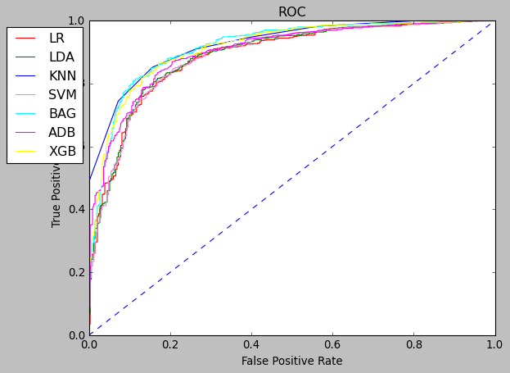
ROC Curve for all the tuned models on the Test data
In [237]:
plt.plot([0, 1], [0, 1], linestyle='--')
plt.plot(lr_tun_test_fpr, lr_tun_test_tpr,color='red',label="LR")
plt.plot(lda_tun_test_fpr,lda_tun_test_tpr,color='green',label="LDA")
plt.plot(knn_tun_test_fpr,knn_tun_test_tpr,color='blue',label="KNN")
plt.plot(svm_tun_test_fpr,svm_tun_test_tpr,color='violet',label="SVM")
plt.plot(bag_tun_test_fpr,bag_tun_test_tpr,color='cyan',label="BAG")
plt.plot(adb_tun_test_fpr,adb_tun_test_tpr,color='magenta',label="ADB")
plt.plot(xgb_tun_test_fpr,xgb_tun_test_tpr,color='yellow',label="XGB")
plt.xlabel('False Positive Rate')
plt.ylabel('True Positive Rate')
plt.title('ROC')
plt.legend(bbox_to_anchor=(0., 1.), loc='best')
Out[237]:
<matplotlib.legend.Legend at 0x24f5d70cfd0>
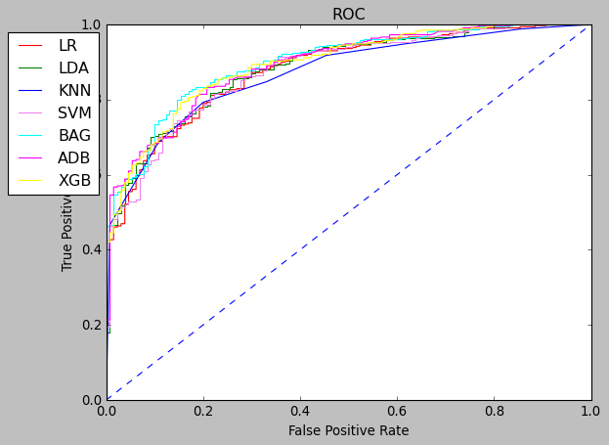
In this case we are not interested in any particular class as both the classes are of equal importance. We will consider accuracy for comparing the models.
Let's look at the performance of basic and tuned models. Below table shows the accuracy of train and test set for basic and tuned models.
Basic Tuned
Model Train Test Train Test LR 0.8406 0.8231 0.8406 0.8231 LDA 0.8369 0.8187 0.8369 0.8187 KNN 0.8612 0.8013 0.8556 0.7969 NB 0.8331 0.8253 NA NA SVM 0.8388 0.8187 0.8416 0.8231 BAG 0.9643 0.8340 0.8556 0.8340 AdaB 0.8472 0.8187 0.8369 0.8275 XgB 0.8528 0.7947 0.8566 0.8318
Basic Model Tuned
AUC-ROC Score AUC-ROC Score
Model Train Test Train Test LR 0.889 0.883 0.886 0.878 LDA 0.889 0.884 0.889 0.884 KNN 0.933 0.855 0.925 0.870 NB 0.886 0.885 NA NA SVM 0.900 0.888 0.888 0.880 BAG 0.997 0.897 0.917 0.897 AdaBoost 0.913 0.879 0.902 0.892 XGBoost 0.931 0.835 0.915 0.894
Conclusion From the above table it can be observed that apart from the basic bagging models all models look quite decent and can be deployed in production. For basic bagging model the train accuracy is 0.9643 while the test accuracy is 0.8340 which is very less than the train accuracy. This clearly indicates that the basic bagging model is highly overfit.However, top 3 performaing models seem to be KNN with an accuracy of 86%,XgBoost and Bagging models both with an accuracy of 85.66% stand at the second position while AdaBoost with 84.72 bags the third position
SMOTE
In [246]:
pip install --user imbalanced-learn
Collecting imbalanced-learnNote: you may need to restart the kernel to use updated packages.
Using cached imbalanced_learn-0.8.0-py3-none-any.whl (206 kB)
Requirement already satisfied: scipy>=0.19.1 in c:\programdata\anaconda3\lib\site-packages (from imbalanced-learn) (1.5.0)
Requirement already satisfied: joblib>=0.11 in c:\programdata\anaconda3\lib\site-packages (from imbalanced-learn) (0.16.0)
Requirement already satisfied: numpy>=1.13.3 in c:\programdata\anaconda3\lib\site-packages (from imbalanced-learn) (1.18.5)
Collecting scikit-learn>=0.24
Using cached scikit_learn-0.24.2-cp38-cp38-win_amd64.whl (6.9 MB)
Requirement already satisfied: threadpoolctl>=2.0.0 in c:\programdata\anaconda3\lib\site-packages (from scikit-learn>=0.24->imbalanced-learn) (2.1.0)
Installing collected packages: scikit-learn, imbalanced-learn
Successfully installed imbalanced-learn-0.8.0 scikit-learn-0.24.2

In [253]:
pip install imblearn -U
Collecting imblearnNote: you may need to restart the kernel to use updated packages.

Downloading imblearn-0.0-py2.py3-none-any.whl (1.9 kB)
Requirement already satisfied, skipping upgrade: imbalanced-learn in c:\users\chinmay nikhal\appdata\roaming\python\python38\site-packages (from imblearn) (0.8.0)
Requirement already satisfied, skipping upgrade: scipy>=0.19.1 in c:\programdata\anaconda3\lib\site-packages (from imbalanced-learn->imblearn) (1.5.0)
Requirement already satisfied, skipping upgrade: scikit-learn>=0.24 in c:\users\chinmay nikhal\appdata\roaming\python\python38\site-packages (from imbalanced-learn->imblearn) (0.24.2)
Requirement already satisfied, skipping upgrade: numpy>=1.13.3 in c:\programdata\anaconda3\lib\site-packages (from imbalanced-learn->imblearn) (1.18.5)
Requirement already satisfied, skipping upgrade: joblib>=0.11 in c:\programdata\anaconda3\lib\site-packages (from imbalanced-learn->imblearn) (0.16.0)
Requirement already satisfied, skipping upgrade: threadpoolctl>=2.0.0 in c:\programdata\anaconda3\lib\site-packages (from scikit-learn>=0.24->imbalanced-learn->imblearn) (2.1.0)
Installing collected packages: imblearn
Successfully installed imblearn-0.0
In [254]:
from imblearn.over_sampling import SMOTE
SMOTE is only applied on the train data set
In [256]:
sm = SMOTE(random_state=2)
X_train_res, y_train_res = sm.fit_resample(X_train, y_train.values.ravel())
In [257]:
X_train_res.shape
Out[257]:
(1470, 8)
XGBoost with SMOTE
In [258]:
import xgboost as xgb
XGB_SM_model=xgb.XGBClassifier(random_state=1,learning_rate=0.01)
XGB_SM_model.fit(X_train_res, y_train_res)
C:\ProgramData\Anaconda3\lib\site-packages\xgboost\sklearn.py:1146: UserWarning: The use of label encoder in XGBClassifier is deprecated and will be removed in a future release. To remove this warning, do the following: 1) Pass option use_label_encoder=False when constructing XGBClassifier object; and 2) Encode your labels (y) as integers starting with 0, i.e. 0, 1, 2, ..., [num_class - 1].
warnings.warn(label_encoder_deprecation_msg, UserWarning)
[08:17:59] WARNING: C:/Users/Administrator/workspace/xgboost-win64_release_1.4.0/src/learner.cc:1095: Starting in XGBoost 1.3.0, the default evaluation metric used with the objective 'binary:logistic' was changed from 'error' to 'logloss'. Explicitly set eval_metric if you'd like to restore the old behavior.
Out[258]:
XGBClassifier(base_score=0.5, booster='gbtree', colsample_bylevel=1,
colsample_bynode=1, colsample_bytree=1, gamma=0, gpu_id=-1,
importance_type='gain', interaction_constraints='',
learning_rate=0.01, max_delta_step=0, max_depth=6,
min_child_weight=1, missing=nan, monotone_constraints='()',
n_estimators=100, n_jobs=4, num_parallel_tree=1, random_state=1,
reg_alpha=0, reg_lambda=1, scale_pos_weight=1, subsample=1,
tree_method='exact', validate_parameters=1, verbosity=None)
In [259]:
## Performance Matrix on train data set
y_train_predict = XGB_SM_model.predict(X_train_res)
model_score = XGB_SM_model.score(X_train_res, y_train_res)
print(model_score)
print(metrics.confusion_matrix(y_train_res, y_train_predict))
print(metrics.classification_report(y_train_res, y_train_predict))
0.8850340136054422
[[648 87]
[ 82 653]]
precision recall f1-score support

0 0.89 0.88 0.88 735
1 0.88 0.89 0.89 735

accuracy 0.89 1470
macro avg 0.89 0.89 0.89 1470
weighted avg 0.89 0.89 0.89 1470

In [260]:
## Performance Matrix on test data set
y_test_predict = XGB_SM_model.predict(X_test)
model_score = XGB_SM_model.score(X_test, y_test)
print(model_score)
print(metrics.confusion_matrix(y_test, y_test_predict))
print(metrics.classification_report(y_test, y_test_predict))
0.8165938864628821
[[102 28]
[ 56 272]]
precision recall f1-score support

0 0.65 0.78 0.71 130
1 0.91 0.83 0.87 328

accuracy 0.82 458
macro avg 0.78 0.81 0.79 458
weighted avg 0.83 0.82 0.82 458

KNN With SMOTE
In [261]:
from sklearn.neighbors import KNeighborsClassifier

KNN_SM_model=KNeighborsClassifier()
KNN_SM_model.fit(X_train_res,y_train_res)
Out[261]:
KNeighborsClassifier()
In [262]:
## Performance Matrix on train data set
y_train_predict = KNN_SM_model.predict(X_train_res)
model_score = KNN_SM_model.score(X_train_res, y_train_res)
print(model_score)
print(metrics.confusion_matrix(y_train_res, y_train_predict))
print(metrics.classification_report(y_train_res, y_train_predict))
0.882312925170068
[[686 49]
[124 611]]
precision recall f1-score support

0 0.85 0.93 0.89 735
1 0.93 0.83 0.88 735

accuracy 0.88 1470
macro avg 0.89 0.88 0.88 1470
weighted avg 0.89 0.88 0.88 1470

In [263]:
## Performance Matrix on test data set
y_test_predict = KNN_SM_model.predict(X_test)
model_score = KNN_SM_model.score(X_test, y_test)
print(model_score)
print(metrics.confusion_matrix(y_test, y_test_predict))
print(metrics.classification_report(y_test, y_test_predict))
0.759825327510917
[[102 28]
[ 82 246]]
precision recall f1-score support

0 0.55 0.78 0.65 130
1 0.90 0.75 0.82 328

accuracy 0.76 458
macro avg 0.73 0.77 0.73 458
weighted avg 0.80 0.76 0.77 458

AdaBoost With SMOTE
In [264]:
from sklearn.ensemble import AdaBoostClassifier

ADB_SM_model = AdaBoostClassifier(n_estimators=100,random_state=1)
ADB_SM_model.fit(X_train_res,y_train_res)
Out[264]:
AdaBoostClassifier(n_estimators=100, random_state=1)
In [265]:
## Performance Matrix on train data set
y_train_predict = ADB_SM_model.predict(X_train_res)
model_score = ADB_SM_model.score(X_train_res, y_train_res)
print(model_score)
print(metrics.confusion_matrix(y_train_res, y_train_predict))
print(metrics.classification_report(y_train_res, y_train_predict))
0.8448979591836735
[[628 107]
[121 614]]
precision recall f1-score support

0 0.84 0.85 0.85 735
1 0.85 0.84 0.84 735

accuracy 0.84 1470
macro avg 0.85 0.84 0.84 1470
weighted avg 0.85 0.84 0.84 1470

In [266]:
## Performance Matrix on test data set
y_test_predict = ADB_SM_model.predict(X_test)
model_score = ADB_SM_model.score(X_test, y_test)
print(model_score)
print(metrics.confusion_matrix(y_test, y_test_predict))
print(metrics.classification_report(y_test, y_test_predict))
0.7925764192139738
[[103 27]
[ 68 260]]
precision recall f1-score support

0 0.60 0.79 0.68 130
1 0.91 0.79 0.85 328

accuracy 0.79 458
macro avg 0.75 0.79 0.76 458
weighted avg 0.82 0.79 0.80 458

Conclusion after SMOTE Train Data Set Test Data Set
XGBoost .89 .82 KNN .88 .76 AdaBoost .84 .79
Using SMOTE, I think XGBoost still stands out and seems to be the best performing model.
Cross Validation on XGBoost Model
In [269]:
from sklearn.model_selection import cross_val_score
scores = cross_val_score(XGB_SM_model, X_train_res, y_train_res, cv=10)
scores
C:\ProgramData\Anaconda3\lib\site-packages\xgboost\sklearn.py:1146: UserWarning: The use of label encoder in XGBClassifier is deprecated and will be removed in a future release. To remove this warning, do the following: 1) Pass option use_label_encoder=False when constructing XGBClassifier object; and 2) Encode your labels (y) as integers starting with 0, i.e. 0, 1, 2, ..., [num_class - 1].
warnings.warn(label_encoder_deprecation_msg, UserWarning)
[08:25:10] WARNING: C:/Users/Administrator/workspace/xgboost-win64_release_1.4.0/src/learner.cc:1095: Starting in XGBoost 1.3.0, the default evaluation metric used with the objective 'binary:logistic' was changed from 'error' to 'logloss'. Explicitly set eval_metric if you'd like to restore the old behavior.
[08:25:11] WARNING: C:/Users/Administrator/workspace/xgboost-win64_release_1.4.0/src/learner.cc:1095: Starting in XGBoost 1.3.0, the default evaluation metric used with the objective 'binary:logistic' was changed from 'error' to 'logloss'. Explicitly set eval_metric if you'd like to restore the old behavior.
[08:25:12] WARNING: C:/Users/Administrator/workspace/xgboost-win64_release_1.4.0/src/learner.cc:1095: Starting in XGBoost 1.3.0, the default evaluation metric used with the objective 'binary:logistic' was changed from 'error' to 'logloss'. Explicitly set eval_metric if you'd like to restore the old behavior.
[08:25:12] WARNING: C:/Users/Administrator/workspace/xgboost-win64_release_1.4.0/src/learner.cc:1095: Starting in XGBoost 1.3.0, the default evaluation metric used with the objective 'binary:logistic' was changed from 'error' to 'logloss'. Explicitly set eval_metric if you'd like to restore the old behavior.
[08:25:13] WARNING: C:/Users/Administrator/workspace/xgboost-win64_release_1.4.0/src/learner.cc:1095: Starting in XGBoost 1.3.0, the default evaluation metric used with the objective 'binary:logistic' was changed from 'error' to 'logloss'. Explicitly set eval_metric if you'd like to restore the old behavior.
[08:25:13] WARNING: C:/Users/Administrator/workspace/xgboost-win64_release_1.4.0/src/learner.cc:1095: Starting in XGBoost 1.3.0, the default evaluation metric used with the objective 'binary:logistic' was changed from 'error' to 'logloss'. Explicitly set eval_metric if you'd like to restore the old behavior.
[08:25:14] WARNING: C:/Users/Administrator/workspace/xgboost-win64_release_1.4.0/src/learner.cc:1095: Starting in XGBoost 1.3.0, the default evaluation metric used with the objective 'binary:logistic' was changed from 'error' to 'logloss'. Explicitly set eval_metric if you'd like to restore the old behavior.
[08:25:15] WARNING: C:/Users/Administrator/workspace/xgboost-win64_release_1.4.0/src/learner.cc:1095: Starting in XGBoost 1.3.0, the default evaluation metric used with the objective 'binary:logistic' was changed from 'error' to 'logloss'. Explicitly set eval_metric if you'd like to restore the old behavior.
[08:25:15] WARNING: C:/Users/Administrator/workspace/xgboost-win64_release_1.4.0/src/learner.cc:1095: Starting in XGBoost 1.3.0, the default evaluation metric used with the objective 'binary:logistic' was changed from 'error' to 'logloss'. Explicitly set eval_metric if you'd like to restore the old behavior.
[08:25:16] WARNING: C:/Users/Administrator/workspace/xgboost-win64_release_1.4.0/src/learner.cc:1095: Starting in XGBoost 1.3.0, the default evaluation metric used with the objective 'binary:logistic' was changed from 'error' to 'logloss'. Explicitly set eval_metric if you'd like to restore the old behavior.
Out[269]:
array([0.7755102 , 0.80952381, 0.87755102, 0.82312925, 0.84353741,
0.84353741, 0.9047619 , 0.87755102, 0.83673469, 0.86394558])
In [270]:
scores = cross_val_score(XGB_SM_model, X_test, y_test, cv=10)
scores
C:\ProgramData\Anaconda3\lib\site-packages\xgboost\sklearn.py:1146: UserWarning: The use of label encoder in XGBClassifier is deprecated and will be removed in a future release. To remove this warning, do the following: 1) Pass option use_label_encoder=False when constructing XGBClassifier object; and 2) Encode your labels (y) as integers starting with 0, i.e. 0, 1, 2, ..., [num_class - 1].
warnings.warn(label_encoder_deprecation_msg, UserWarning)
C:\ProgramData\Anaconda3\lib\site-packages\sklearn\utils\validation.py:73: DataConversionWarning: A column-vector y was passed when a 1d array was expected. Please change the shape of y to (n_samples, ), for example using ravel().
return f(**kwargs)
[08:25:24] WARNING: C:/Users/Administrator/workspace/xgboost-win64_release_1.4.0/src/learner.cc:1095: Starting in XGBoost 1.3.0, the default evaluation metric used with the objective 'binary:logistic' was changed from 'error' to 'logloss'. Explicitly set eval_metric if you'd like to restore the old behavior.
[08:25:25] WARNING: C:/Users/Administrator/workspace/xgboost-win64_release_1.4.0/src/learner.cc:1095: Starting in XGBoost 1.3.0, the default evaluation metric used with the objective 'binary:logistic' was changed from 'error' to 'logloss'. Explicitly set eval_metric if you'd like to restore the old behavior.
[08:25:25] WARNING: C:/Users/Administrator/workspace/xgboost-win64_release_1.4.0/src/learner.cc:1095: Starting in XGBoost 1.3.0, the default evaluation metric used with the objective 'binary:logistic' was changed from 'error' to 'logloss'. Explicitly set eval_metric if you'd like to restore the old behavior.
[08:25:25] WARNING: C:/Users/Administrator/workspace/xgboost-win64_release_1.4.0/src/learner.cc:1095: Starting in XGBoost 1.3.0, the default evaluation metric used with the objective 'binary:logistic' was changed from 'error' to 'logloss'. Explicitly set eval_metric if you'd like to restore the old behavior.
[08:25:26] WARNING: C:/Users/Administrator/workspace/xgboost-win64_release_1.4.0/src/learner.cc:1095: Starting in XGBoost 1.3.0, the default evaluation metric used with the objective 'binary:logistic' was changed from 'error' to 'logloss'. Explicitly set eval_metric if you'd like to restore the old behavior.
[08:25:26] WARNING: C:/Users/Administrator/workspace/xgboost-win64_release_1.4.0/src/learner.cc:1095: Starting in XGBoost 1.3.0, the default evaluation metric used with the objective 'binary:logistic' was changed from 'error' to 'logloss'. Explicitly set eval_metric if you'd like to restore the old behavior.
[08:25:26] WARNING: C:/Users/Administrator/workspace/xgboost-win64_release_1.4.0/src/learner.cc:1095: Starting in XGBoost 1.3.0, the default evaluation metric used with the objective 'binary:logistic' was changed from 'error' to 'logloss'. Explicitly set eval_metric if you'd like to restore the old behavior.
[08:25:26] WARNING: C:/Users/Administrator/workspace/xgboost-win64_release_1.4.0/src/learner.cc:1095: Starting in XGBoost 1.3.0, the default evaluation metric used with the objective 'binary:logistic' was changed from 'error' to 'logloss'. Explicitly set eval_metric if you'd like to restore the old behavior.
[08:25:27] WARNING: C:/Users/Administrator/workspace/xgboost-win64_release_1.4.0/src/learner.cc:1095: Starting in XGBoost 1.3.0, the default evaluation metric used with the objective 'binary:logistic' was changed from 'error' to 'logloss'. Explicitly set eval_metric if you'd like to restore the old behavior.
[08:25:27] WARNING: C:/Users/Administrator/workspace/xgboost-win64_release_1.4.0/src/learner.cc:1095: Starting in XGBoost 1.3.0, the default evaluation metric used with the objective 'binary:logistic' was changed from 'error' to 'logloss'. Explicitly set eval_metric if you'd like to restore the old behavior.
Out[270]:
array([0.80434783, 0.82608696, 0.7826087 , 0.76086957, 0.7826087 ,
0.80434783, 0.89130435, 0.84782609, 0.84444444, 0.75555556])
Using 10 fold cross validation on the XGBoost model we have also got a train accuracy of 90% and test accuracy of 89%.

Problem 2
In this particular project, we are going to work on the inaugural corpora from the nltk in Python. We will be looking at the following speeches of the Presidents of the United States of America: 1.President Franklin D. Roosevelt in 1941 2.President John F. Kennedy in 1961 3.President Richard Nixon in 1963
In [274]:
pip install wordcloud
Collecting wordcloudNote: you may need to restart the kernel to use updated packages.

Downloading wordcloud-1.8.1-cp38-cp38-win_amd64.whl (155 kB)
Requirement already satisfied: matplotlib in c:\programdata\anaconda3\lib\site-packages (from wordcloud) (3.2.2)
Requirement already satisfied: pillow in c:\programdata\anaconda3\lib\site-packages (from wordcloud) (7.2.0)
Requirement already satisfied: numpy>=1.6.1 in c:\programdata\anaconda3\lib\site-packages (from wordcloud) (1.18.5)
Requirement already satisfied: kiwisolver>=1.0.1 in c:\programdata\anaconda3\lib\site-packages (from matplotlib->wordcloud) (1.2.0)
Requirement already satisfied: python-dateutil>=2.1 in c:\programdata\anaconda3\lib\site-packages (from matplotlib->wordcloud) (2.8.1)
Requirement already satisfied: pyparsing!=2.0.4,!=2.1.2,!=2.1.6,>=2.0.1 in c:\programdata\anaconda3\lib\site-packages (from matplotlib->wordcloud) (2.4.7)
Requirement already satisfied: cycler>=0.10 in c:\programdata\anaconda3\lib\site-packages (from matplotlib->wordcloud) (0.10.0)
Requirement already satisfied: six>=1.5 in c:\programdata\anaconda3\lib\site-packages (from python-dateutil>=2.1->matplotlib->wordcloud) (1.15.0)
Installing collected packages: wordcloud
Successfully installed wordcloud-1.8.1
In [275]:
import nltk
import numpy as np
import pandas as pd
from nltk.tokenize import sent_tokenize
from wordcloud import WordCloud, STOPWORDS
In [273]:
nltk.download('inaugural')
[nltk_data] Downloading package inaugural to C:\Users\Chinmay
[nltk_data] Nikhal\AppData\Roaming\nltk_data...
[nltk_data] Unzipping corpora\inaugural.zip.
Out[273]:
True
In [276]:
from nltk.corpus import inaugural
In [277]:
inaugural.fileids()
Out[277]:
['1789-Washington.txt',
'1793-Washington.txt',
'1797-Adams.txt',
'1801-Jefferson.txt',
'1805-Jefferson.txt',
'1809-Madison.txt',
'1813-Madison.txt',
'1817-Monroe.txt',
'1821-Monroe.txt',
'1825-Adams.txt',
'1829-Jackson.txt',
'1833-Jackson.txt',
'1837-VanBuren.txt',
'1841-Harrison.txt',
'1845-Polk.txt',
'1849-Taylor.txt',
'1853-Pierce.txt',
'1857-Buchanan.txt',
'1861-Lincoln.txt',
'1865-Lincoln.txt',
'1869-Grant.txt',
'1873-Grant.txt',
'1877-Hayes.txt',
'1881-Garfield.txt',
'1885-Cleveland.txt',
'1889-Harrison.txt',
'1893-Cleveland.txt',
'1897-McKinley.txt',
'1901-McKinley.txt',
'1905-Roosevelt.txt',
'1909-Taft.txt',
'1913-Wilson.txt',
'1917-Wilson.txt',
'1921-Harding.txt',
'1925-Coolidge.txt',
'1929-Hoover.txt',
'1933-Roosevelt.txt',
'1937-Roosevelt.txt',
'1941-Roosevelt.txt',
'1945-Roosevelt.txt',
'1949-Truman.txt',
'1953-Eisenhower.txt',
'1957-Eisenhower.txt',
'1961-Kennedy.txt',
'1965-Johnson.txt',
'1969-Nixon.txt',
'1973-Nixon.txt',
'1977-Carter.txt',
'1981-Reagan.txt',
'1985-Reagan.txt',
'1989-Bush.txt',
'1993-Clinton.txt',
'1997-Clinton.txt',
'2001-Bush.txt',
'2005-Bush.txt',
'2009-Obama.txt',
'2013-Obama.txt',
'2017-Trump.txt']
In [278]:
doc1 = inaugural.raw('1941-Roosevelt.txt')
In [279]:
doc2 = inaugural.raw('1961-Kennedy.txt')
In [280]:
doc3 = inaugural.raw('1973-Nixon.txt')
In [281]:
speech_df = pd.DataFrame({'Speech':[doc1,doc2,doc3]})
In [282]:
speech_df.head(3)
Out[282]:
 | Speech
0 | On each national day of inauguration since 178...
1 | Vice President Johnson, Mr. Speaker, Mr. Chief...
2 | Mr. Vice President, Mr. Speaker, Mr. Chief Jus...
In [283]:
speech_df['totalwords'] = [len(x.split()) for x in speech_df['Speech'].tolist()]
speech_df.head()
Out[283]:
 | Speech | totalwords
0 | On each national day of inauguration since 178... | 1360
1 | Vice President Johnson, Mr. Speaker, Mr. Chief... | 1390
2 | Mr. Vice President, Mr. Speaker, Mr. Chief Jus... | 1819
In [284]:
speech_df['totalchars'] = speech_df['Speech'].str.len() ## this also includes spaces
speech_df.head()
Out[284]:
 | Speech | totalwords | totalchars
0 | On each national day of inauguration since 178... | 1360 | 7571
1 | Vice President Johnson, Mr. Speaker, Mr. Chief... | 1390 | 7618
2 | Mr. Vice President, Mr. Speaker, Mr. Chief Jus... | 1819 | 9991
In [288]:
import nltk
nltk.download('punkt')
[nltk_data] Downloading package punkt to C:\Users\Chinmay
[nltk_data] Nikhal\AppData\Roaming\nltk_data...
[nltk_data] Unzipping tokenizers\punkt.zip.
Out[288]:
True
In [289]:
sent = []
In [290]:
sent.append(len(sent_tokenize(doc1)))
In [291]:
sent.append(len(sent_tokenize(doc2)))
In [292]:
sent.append(len(sent_tokenize(doc3)))
In [293]:
sent
Out[293]:
[68, 52, 68]
In [294]:
speech_df['totalsents'] = sent ## this also includes spaces
speech_df.head()
Out[294]:
 | Speech | totalwords | totalchars | totalsents
0 | On each national day of inauguration since 178... | 1360 | 7571 | 68
1 | Vice President Johnson, Mr. Speaker, Mr. Chief... | 1390 | 7618 | 52
2 | Mr. Vice President, Mr. Speaker, Mr. Chief Jus... | 1819 | 9991 | 68
Lower case conversation
In [297]:
speech_df['Speech'] = speech_df['Speech'].apply(lambda x: " ".join(x.lower() for x in x.split()))
speech_df['Speech'].head()
Out[297]:
0 on each national day of inauguration since 178...
1 vice president johnson, mr. speaker, mr. chief...
2 mr. vice president, mr. speaker, mr. chief jus...
Name: Speech, dtype: object
Removal of Punctuation
In [298]:
speech_df['Speech'] = speech_df['Speech'].str.replace('[^\w\s]','')
speech_df['Speech'].head()
Out[298]:
0 on each national day of inauguration since 178...
1 vice president johnson mr speaker mr chief jus...
2 mr vice president mr speaker mr chief justice ...
Name: Speech, dtype: object
Removal of stop words
In [300]:
import nltk
nltk.download('stopwords')
[nltk_data] Downloading package stopwords to C:\Users\Chinmay
[nltk_data] Nikhal\AppData\Roaming\nltk_data...
[nltk_data] Unzipping corpora\stopwords.zip.
Out[300]:
True
In [301]:
from nltk.corpus import stopwords
stop = stopwords.words('english')
print(stop)
speech_df['Speech_w/o_stop_words'] = speech_df['Speech'].apply(lambda x: " ".join(x for x in x.split() if x not in stop))
speech_df.head()
['i', 'me', 'my', 'myself', 'we', 'our', 'ours', 'ourselves', 'you', "you're", "you've", "you'll", "you'd", 'your', 'yours', 'yourself', 'yourselves', 'he', 'him', 'his', 'himself', 'she', "she's", 'her', 'hers', 'herself', 'it', "it's", 'its', 'itself', 'they', 'them', 'their', 'theirs', 'themselves', 'what', 'which', 'who', 'whom', 'this', 'that', "that'll", 'these', 'those', 'am', 'is', 'are', 'was', 'were', 'be', 'been', 'being', 'have', 'has', 'had', 'having', 'do', 'does', 'did', 'doing', 'a', 'an', 'the', 'and', 'but', 'if', 'or', 'because', 'as', 'until', 'while', 'of', 'at', 'by', 'for', 'with', 'about', 'against', 'between', 'into', 'through', 'during', 'before', 'after', 'above', 'below', 'to', 'from', 'up', 'down', 'in', 'out', 'on', 'off', 'over', 'under', 'again', 'further', 'then', 'once', 'here', 'there', 'when', 'where', 'why', 'how', 'all', 'any', 'both', 'each', 'few', 'more', 'most', 'other', 'some', 'such', 'no', 'nor', 'not', 'only', 'own', 'same', 'so', 'than', 'too', 'very', 's', 't', 'can', 'will', 'just', 'don', "don't", 'should', "should've", 'now', 'd', 'll', 'm', 'o', 're', 've', 'y', 'ain', 'aren', "aren't", 'couldn', "couldn't", 'didn', "didn't", 'doesn', "doesn't", 'hadn', "hadn't", 'hasn', "hasn't", 'haven', "haven't", 'isn', "isn't", 'ma', 'mightn', "mightn't", 'mustn', "mustn't", 'needn', "needn't", 'shan', "shan't", 'shouldn', "shouldn't", 'wasn', "wasn't", 'weren', "weren't", 'won', "won't", 'wouldn', "wouldn't"]
Out[301]:
 | Speech | totalwords | totalchars | totalsents | Speech_w/o_stop_words
0 | on each national day of inauguration since 178... | 1360 | 7571 | 68 | national day inauguration since 1789 people re...
1 | vice president johnson mr speaker mr chief jus... | 1390 | 7618 | 52 | vice president johnson mr speaker mr chief jus...
2 | mr vice president mr speaker mr chief justice ... | 1819 | 9991 | 68 | mr vice president mr speaker mr chief justice ...
In [302]:
speech_df['totalwords_after_stop_words_removal'] = [len(x.split()) for x in speech_df['Speech_w/o_stop_words'].tolist()]
speech_df.head()
Out[302]:
 | Speech | totalwords | totalchars | totalsents | Speech_w/o_stop_words | totalwords_after_stop_words_removal
0 | on each national day of inauguration since 178... | 1360 | 7571 | 68 | national day inauguration since 1789 people re... | 627
1 | vice president johnson mr speaker mr chief jus... | 1390 | 7618 | 52 | vice president johnson mr speaker mr chief jus... | 693
2 | mr vice president mr speaker mr chief justice ... | 1819 | 9991 | 68 | mr vice president mr speaker mr chief justice ... | 833
In [303]:
for i in speech_df.index:
print('\033[1m Top 3 words for President {} \033[0m'.format(i+1))
#print(speech_df.loc[i,'Speech_w/o_stop_words'])
all_words = nltk.tokenize.word_tokenize(speech_df.loc[i,'Speech_w/o_stop_words'])
#print(all_words)
words_freq = nltk.FreqDist(w.lower() for w in all_words)
for word, frequency in words_freq.most_common(3):
print('\'{}\' has {} occurances'.format(word,frequency))
Top 3 words for President 1
'nation' has 11 occurances
'know' has 10 occurances
'spirit' has 9 occurances
Top 3 words for President 2
'let' has 16 occurances
'us' has 12 occurances
'world' has 8 occurances
Top 3 words for President 3
'us' has 26 occurances
'let' has 22 occurances
'peace' has 19 occurances
In [304]:
df_president_1 = speech_df.iloc[:1,:]
df_president_1
Out[304]:
 | Speech | totalwords | totalchars | totalsents | Speech_w/o_stop_words | totalwords_after_stop_words_removal
0 | on each national day of inauguration since 178... | 1360 | 7571 | 68 | national day inauguration since 1789 people re... | 627
In [306]:
print('Word Cloud for President 1')
words = " ".join([str(i) for i in (df_president_1["Speech_w/o_stop_words"])])
wordcloud = WordCloud(width = 800, height = 800,
background_color ='white',
min_font_size = 10).generate(words)
#plot the WordCloud image
plt.figure(figsize = (8, 8), facecolor = None)
plt.imshow(wordcloud)
plt.axis("off")
plt.tight_layout(pad = 0)
plt.show()
Word Cloud for President 1

In [307]:
df_president_2 = speech_df.iloc[1:2,:]
df_president_2
Out[307]:
 | Speech | totalwords | totalchars | totalsents | Speech_w/o_stop_words | totalwords_after_stop_words_removal
1 | vice president johnson mr speaker mr chief jus... | 1390 | 7618 | 52 | vice president johnson mr speaker mr chief jus... | 693
In [308]:
print('Word Cloud for President 2')
words = " ".join([str(i) for i in (df_president_2["Speech_w/o_stop_words"])])
wordcloud = WordCloud(width = 800, height = 800,
background_color ='white',
min_font_size = 10).generate(words)
#plot the WordCloud image
plt.figure(figsize = (8, 8), facecolor = None)
plt.imshow(wordcloud)
plt.axis("off")
plt.tight_layout(pad = 0)
plt.show()
Word Cloud for President 2

In [309]:
df_president_3 = speech_df.iloc[2:3,:]
df_president_3
Out[309]:
 | Speech | totalwords | totalchars | totalsents | Speech_w/o_stop_words | totalwords_after_stop_words_removal
2 | mr vice president mr speaker mr chief justice ... | 1819 | 9991 | 68 | mr vice president mr speaker mr chief justice ... | 833
In [310]:
print('Word Cloud for President 3')
words = " ".join([str(i) for i in (df_president_3["Speech_w/o_stop_words"])])
wordcloud = WordCloud(width = 800, height = 800,
background_color ='white',
min_font_size = 10).generate(words)
#plot the WordCloud image
plt.figure(figsize = (8, 8), facecolor = None)
plt.imshow(wordcloud)
plt.axis("off")
plt.tight_layout(pad = 0)
plt.show()
Word Cloud for President 3


