Practical 1: Introduction to AI and Intelligent Agents
- Design a Simple Rational Agent by defining PEAS for Vacuum Cleaner Environment and Autonomous Taxi. Classify environments (fully/partially observable, deterministic/stochastic, episodic/sequential). Implement a simple table-driven agent in Python. Problem Solving by Searching (Uninformed Search)

Code-
# Practical 1: Simple Table-Driven Vacuum Cleaner Agent
# A dictionary is used as the table.
# The key represents the percept received by the agent.
# The value represents the action to be performed.
agent_table = {
"A_Dirty": "Suck",
"A_Clean": "Move Right",
"B_Dirty": "Suck",
"B_Clean": "Move Left"
}
# This function represents the table-driven agent.
# It receives a percept and searches for the corresponding action.
def table_driven_agent(percept):
# Check whether the percept is present in the table.
if percept in agent_table:
# Return the action stored in the table.
return agent_table[percept]
else:
# If the percept is not found, return a default action.
return "No action"
# Take input from the user.
# The user enters the current location and its condition.
location = input("Enter location (A/B): ").upper()
condition = input("Enter condition (Clean/Dirty): ").capitalize()
# Create the percept by combining location and condition.
# Example: A + Dirty = A_Dirty
percept = location + "_" + condition
# Send the percept to the table-driven agent.
action = table_driven_agent(percept)
# Display the percept and the action selected by the agent.
print("\nPercept:", percept)
print("Action:", action)
Output –
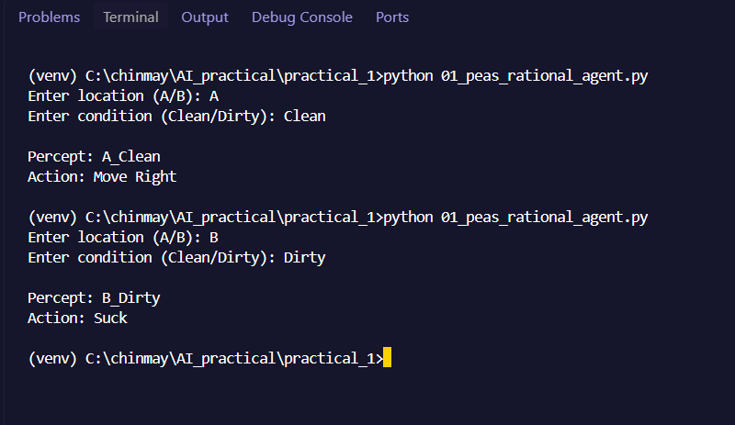

Practical 2 . :- Problem Solving by Searching (Uninformed Search)
1.Given an initial configuration of the 8-puzzle and a goal configuration, write a Python program to find the shortest sequence of moves to reach the goal state using Breadth-First Search (BFS).
Code-
from collections import deque
# Initial state
initial = (1, 2, 3,
4, 0, 6,
7, 5, 8)
# Goal state
goal = (1, 2, 3,
4, 5, 6,
7, 8, 0)
# Function to display puzzle
def display(state):
print(state[0], state[1], state[2])
print(state[3], state[4], state[5])
print(state[6], state[7], state[8])
print()
# BFS function
def bfs(initial, goal):
# Queue contains current state and path
queue = deque()
queue.append((initial, []))
# Store already visited states
visited = set()
visited.add(initial)
while queue:
# Get the first state from queue
current, path = queue.popleft()
# Check whether goal is reached
if current == goal:
return path
# Find position of blank (0)
blank = current.index(0)
row = blank // 3
col = blank % 3
# Store possible movements
moves = []
if row > 0:
moves.append(("Up", blank - 3))
if row < 2:
moves.append(("Down", blank + 3))
if col > 0:
moves.append(("Left", blank - 1))
if col < 2:
moves.append(("Right", blank + 1))
# Generate new states
for move, new_position in moves:
# Make a copy of current state
new_state = list(current)
# Swap blank with adjacent tile
new_state[blank], new_state[new_position] = \
new_state[new_position], new_state[blank]
# Convert list back to tuple
new_state = tuple(new_state)
# Check if state is already visited
if new_state not in visited:
visited.add(new_state)
# Add move to path
new_path = path + [move]
# Add new state to queue
queue.append((new_state, new_path))
return None
# Run BFS
solution = bfs(initial, goal)
# Display initial and goal states
print("Initial State:")
display(initial)
print("Goal State:")
display(goal)
# Display result
if solution is not None:
print("Shortest Sequence of Moves:")
print(solution)
print("Number of Moves:", len(solution))
else:
print("No solution found.")
Output –
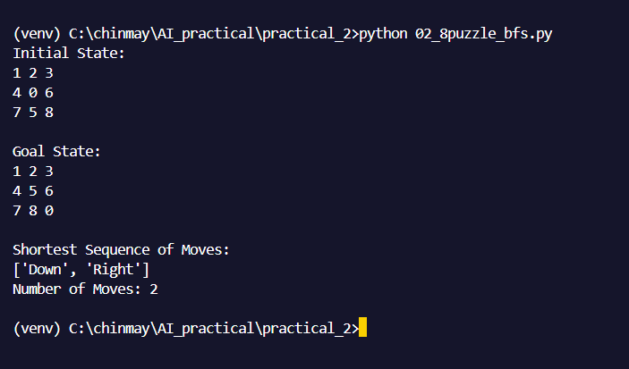

- B . Given two water jugs of 4 litres and 3 litres capacity, write a Python program to obtain exactly 2 litres in one jug using Depth-First Search (DFS). [Vary capacity of jugs] Given a weighted graph representing cities and distances between them, write a Python program to find the least-cost path from Arad to Bucharest using Uniform Cost Search (UCS). [Provide any other weighted graph for applying UCS]
Code-
# Water Jug Problem using Depth First Search (DFS)
# Capacity of the two jugs
jug1 = 4
jug2 = 3
# Required amount of water
target = 2
# DFS function
def dfs(a, b, visited, path):
# If required amount is obtained
if a == target or b == target:
path.append((a, b))
return True
# If state is already visited, do not visit again
if (a, b) in visited:
return False
# Mark current state as visited
visited.add((a, b))
# Add current state to solution path
path.append((a, b))
# 1. Fill Jug 1
if dfs(jug1, b, visited, path):
return True
# 2. Fill Jug 2
if dfs(a, jug2, visited, path):
return True
# 3. Empty Jug 1
if dfs(0, b, visited, path):
return True
# 4. Empty Jug 2
if dfs(a, 0, visited, path):
return True
# 5. Pour Jug 1 into Jug 2
amount = min(a, jug2 - b)
if dfs(a - amount, b + amount, visited, path):
return True
# 6. Pour Jug 2 into Jug 1
amount = min(b, jug1 - a)
if dfs(a + amount, b - amount, visited, path):
return True
# No solution from this state
path.pop()
return False
# Start with both jugs empty
path = []
visited = set()
# Apply DFS
if dfs(0, 0, visited, path):
print("Solution:")
for state in path:
print(state)
else:
print("No solution exists.")

Output –
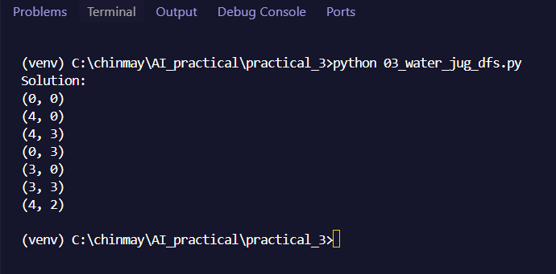
Practical 3 :-
Problem Solving by Searching (Informed Search)
- Given an initial configuration of the 8-puzzle and a goal configuration, write a Python program to find the solution using Greedy Best-First Search with the Manhattan Distance heuristic.
Code-
# 8-Puzzle using Greedy Best-First Search
import heapq
# Initial state
initial = (1, 2, 3,
4, 0, 6,
7, 5, 8)
# Goal state
goal = (1, 2, 3,
4, 5, 6,
7, 8, 0)
# Function to calculate Manhattan Distance
def manhattan(state):
distance = 0
for i in range(9):
# Ignore blank space
if state[i] != 0:
# Current position
row1 = i // 3
col1 = i % 3
# Goal position
goal_pos = goal.index(state[i])
row2 = goal_pos // 3
col2 = goal_pos % 3
# Calculate distance
distance += abs(row1 - row2) + abs(col1 - col2)
return distance
# Function to generate possible moves
def get_moves(state):

moves = []
# Find blank position
blank = state.index(0)
row = blank // 3
col = blank % 3
# Up
if row > 0:
moves.append(("Up", blank - 3))
# Down
if row < 2:
moves.append(("Down", blank + 3))
# Left
if col > 0:
moves.append(("Left", blank - 1))
# Right
if col < 2:
moves.append(("Right", blank + 1))
return moves
# Greedy Best-First Search
def greedy(initial, goal):
# Priority queue contains (heuristic, state, path)
queue = [(manhattan(initial), initial, [])]
visited = set()
while queue:
# Get state with smallest heuristic
h, current, path = heapq.heappop(queue)
# Check goal
if current == goal:
return path
if current in visited:
continue
visited.add(current)
# Generate next states
for move, new_position in get_moves(current):
new_state = list(current)
# Swap blank with tile
blank = current.index(0)
new_state[blank], new_state[new_position] = \
new_state[new_position], new_state[blank]
new_state = tuple(new_state)
if new_state not in visited:
# Add state according to Manhattan Distance
heapq.heappush(
queue,
(manhattan(new_state),
new_state,
path + [move])
)
return None
# Run Greedy Best-First Search
solution = greedy(initial, goal)
# Display result
print("Initial State:")
print(initial)
print("\nGoal State:")
print(goal)
if solution is not None:
print("\nSolution:")
print(" -> ".join(solution))
print("Number of Moves:", len(solution))
else
print("No solution found.")
Output –

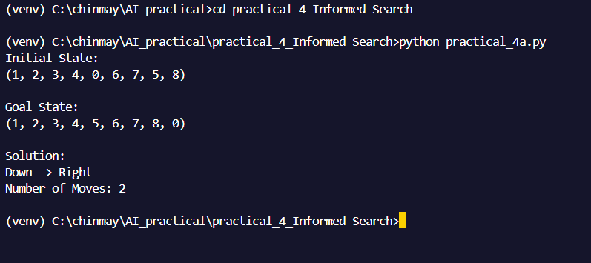

2. Given an initial configuration of the 8-puzzle and a goal configuration, write a Python program to find the shortest path using A* search with the Manhattan Distance heuristic.
Code-
# 8-Puzzle using A* Search
import heapq
# Initial state
initial = (1, 2, 3,
4, 0, 6,
7, 5, 8)
# Goal state
goal = (1, 2, 3,
4, 5, 6,
7, 8, 0)
# Function to calculate Manhattan Distance
def manhattan(state):
distance = 0
for i in range(9):
# Ignore blank space
if state[i] != 0:
row1 = i // 3
col1 = i % 3
goal_pos = goal.index(state[i])
row2 = goal_pos // 3
col2 = goal_pos % 3
distance += abs(row1 - row2) + abs(col1 - col2)
return distance
# Function to generate possible moves
def get_moves(state):
moves = []
blank = state.index(0)
row = blank // 3
col = blank % 3
if row > 0:
moves.append(("Up", blank - 3))
if row < 2:
moves.append(("Down", blank + 3))
if col > 0:
moves.append(("Left", blank - 1))

if col < 2:
moves.append(("Right", blank + 1))
return moves
# A* Search
def astar(initial, goal):
# Priority queue contains:
# (f, g, state, path)
queue = [(manhattan(initial), 0, initial, [])]
visited = set()
while queue:
# Get state with smallest f value
f, g, current, path = heapq.heappop(queue)
# Check goal
if current == goal:
return path
if current in visited:
continue
visited.add(current)
# Generate possible moves
for move, new_position in get_moves(current):
new_state = list(current)
# Find blank position
blank = current.index(0)
# Swap blank with tile
new_state[blank], new_state[new_position] = \
new_state[new_position], new_state[blank]
new_state = tuple(new_state)
if new_state not in visited:
# Cost of reaching new state
new_g = g + 1
# Manhattan Distance
new_h = manhattan(new_state)
# A* formula
new_f = new_g + new_h
# Add new state to queue
heapq.heappush(
queue,
(new_f, new_g, new_state,
path + [move])
)
return None
# Run A*
solution = astar(initial, goal)
# Display result
print("Initial State:")
print(initial)
print("\nGoal State:")
print(goal)
if solution is not None:
print("\nShortest Path:")
print(" -> ".join(solution))
print("Number of Moves:", len(solution))
else:
print("No solution found.")

Output –

3. Given a weighted graph representing cities and distances between them, write a Python program to find the shortest path from Arad to Bucharest using A* search with a heuristic function (straight-line distance to destination).
Code-
# A* Search from Arad to Bucharest
import heapq
# Weighted graph
# Each city contains (neighbor, distance)
graph = {
'Arad': [('Zerind', 75), ('Sibiu', 140), ('Timisoara', 118)],
'Zerind': [('Arad', 75), ('Oradea', 71)],
'Oradea': [('Zerind', 71), ('Sibiu', 151)],
'Sibiu': [('Arad', 140), ('Oradea', 151),
('Fagaras', 99), ('Rimnicu Vilcea', 80)],
'Timisoara': [('Arad', 118), ('Lugoj', 111)],
'Lugoj': [('Timisoara', 111), ('Mehadia', 70)],
'Mehadia': [('Lugoj', 70), ('Drobeta', 75)],
'Drobeta': [('Mehadia', 75), ('Craiova', 120)],
'Craiova': [('Drobeta', 120), ('Rimnicu Vilcea', 146),
('Pitesti', 138)],
'Rimnicu Vilcea': [('Sibiu', 80), ('Craiova', 146),
('Pitesti', 97)],
'Fagaras': [('Sibiu', 99), ('Bucharest', 211)],
'Pitesti': [('Rimnicu Vilcea', 97), ('Craiova', 138),
('Bucharest', 101)],
'Bucharest': [('Fagaras', 211), ('Pitesti', 101)]
}
# Straight-line distance from each city to Bucharest
heuristic = {
'Arad': 366,
'Zerind': 374,
'Oradea': 380,
'Sibiu': 253,
'Timisoara': 329,
'Lugoj': 244,
'Mehadia': 241,
'Drobeta': 242,
'Craiova': 160,
'Rimnicu Vilcea': 193,
'Fagaras': 176,
'Pitesti': 100,
'Bucharest': 0
}
# A* Search function
def astar(start, goal):
# Priority queue contains:
# (f, cost, city, path)
queue = [(heuristic[start], 0, start, [start])]

visited = set()
while queue:
# Get city with lowest f value
f, cost, city, path = heapq.heappop(queue)
# Check if goal is reached
if city == goal:
return cost, path
# Skip already visited cities
if city in visited:
continue
visited.add(city)
# Explore neighboring cities
for next_city, distance in graph[city]:
# Calculate actual cost
new_cost = cost + distance
# Calculate f(n) = g(n) + h(n)
new_f = new_cost + heuristic[next_city]
# Add new path to priority queue
heapq.heappush(
queue,
(new_f, new_cost, next_city,
path + [next_city])
)
return None
# Find shortest path
cost, path = astar('Arad', 'Bucharest')
# Display result
print("Shortest Path:")
print(" -> ".join(path))
print("Total Cost:", cost)

Output –
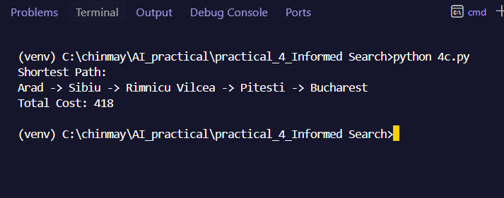

Practical 4 - Bayes’ Rule Application
- Scenario: A medical test is used to detect a particular disease. The probability that a randomly selected person has the disease is 1%. If a person has the disease, the test returns positive with probability 99%. If a person does not have the disease, the test still returns positive with probability 5% (false positive rate). A person takes the test and receives a positive result. Problem Statement: Write a Python program to compute the probability that the person actually has the disease given that the test result is positive.
Code-
#: Bayes' Rule Application
# Probability that a person has the disease
P_D = 0.01
# Probability that a person does not have the disease
P_not_D = 0.99
# Probability of positive test when disease is present
P_positive_D = 0.99
# Probability of positive test when disease is absent
P_positive_not_D = 0.05
# Calculate total probability of getting a positive test
P_positive = (P_positive_D * P_D) + \
(P_positive_not_D * P_not_D)
# Apply Bayes' Rule
P_D_positive = (P_positive_D * P_D) / P_positive
# Display the result
print("Probability of having disease given a positive test:")
print(P_D_positive)
print("Percentage:", P_D_positive * 100, "%")
Output –
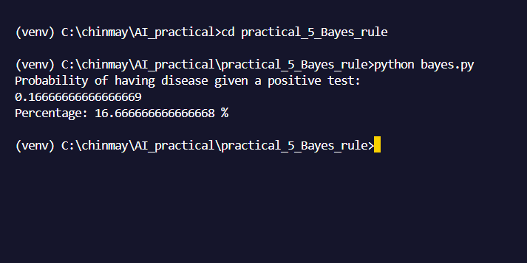
Practical 5 - Naïve Bayes’ Classification 1. Using a small dataset (e.g., weather or spam dataset), implement a Naive Bayes classifier using scikit-learn.
Code-
Practical 5: Naive Bayes Classification
from sklearn.naive_bayes import GaussianNB
# Dataset
# Outlook: 0 = Sunny, 1 = Overcast, 2 = Rainy
# Temperature: 0 = Cool, 1 = Mild, 2 = Hot
# Humidity: 0 = Normal, 1 = High
# Windy: 0 = False, 1 = True
X = [
[0, 2, 1, 0],
[0, 2, 1, 1],
[1, 2, 1, 0],
[2, 1, 1, 0],
[2, 0, 0, 0],
[2, 0, 0, 1],
[1, 0, 0, 1],
[0, 1, 1, 0],
[0, 0, 0, 0],
[2, 1, 0, 0],
[0, 1, 0, 1],
[1, 1, 1, 1],
[1, 2, 0, 0],
[2, 1, 1, 1]
]
# Output
# 0 = No
# 1 = Yes
y = [
0, 0, 1, 1, 1, 0, 1,
0, 1, 1, 1, 1, 1, 0
]
# Create Naive Bayes classifier
model = GaussianNB()
# Train the model
model.fit(X, y)
# Test data
# Sunny, Cool, Normal, False
test = [[0, 0, 0, 0]]
# Predict the result
prediction = model.predict(test)
# Display result
if prediction[0] == 1:
print("Prediction: Play = Yes")
else:
print("Prediction: Play = No")
Output –
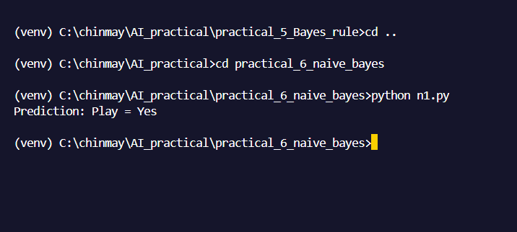

Practical 6 - Probability Reasoning (Bayesian Networks & Inference)
1. Using a simple example (Burglary–Alarm), create a Bayesian Network using pgmpy.
Code-
# Bayesian Network using pgmpy
# Burglary - Alarm Example
from pgmpy.models import DiscreteBayesianNetwork
from pgmpy.factors.discrete import TabularCPD
# 1. Create the structure of Bayesian Network
model = DiscreteBayesianNetwork([
('Burglary', 'Alarm'),
('Earthquake', 'Alarm')
])
# 2. Probability of Burglary
burglary_cpd = TabularCPD(
variable='Burglary',
variable_card=2,
values=[
[0.999], # Burglary = False
[0.001] # Burglary = True
]
)
# 3. Probability of Earthquake
earthquake_cpd = TabularCPD(
variable='Earthquake',
variable_card=2,
values=[
[0.998], # Earthquake = False
[0.002] # Earthquake = True
]
)

# 4. Probability of Alarm
alarm_cpd = TabularCPD(
variable='Alarm',
variable_card=2,
values=[
[0.999, 0.71, 0.06, 0.05], # Alarm = False
[0.001, 0.29, 0.94, 0.95] # Alarm = True
],
evidence=['Burglary', 'Earthquake'],
evidence_card=[2, 2]
)

# 5. Add CPDs to the model
model.add_cpds(
burglary_cpd,
earthquake_cpd,
alarm_cpd
)
# 6. Check whether the model is valid
print("Bayesian Network:")
print(model.edges())
print("\nModel is valid:", model.check_model())
Output –
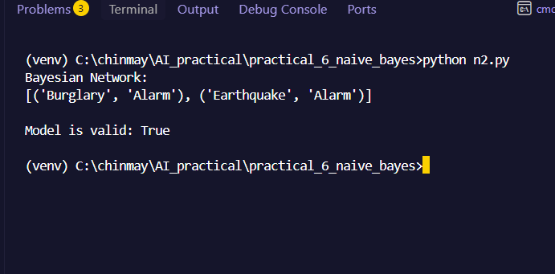
2. Write a program to compute Posterior Probability using Bayesian Networks(Burglar|Alarm = True)
Code-
# Posterior Probability using Bayesian Network
from pgmpy.models import DiscreteBayesianNetwork
from pgmpy.factors.discrete import TabularCPD
from pgmpy.inference import VariableElimination
# 1. Create Bayesian Network
model = DiscreteBayesianNetwork([
('Burglary', 'Alarm'),
('Earthquake', 'Alarm')
])
# 2. CPD for Burglary
burglary_cpd = TabularCPD(
variable='Burglary',
variable_card=2,
values=[
[0.999],
[0.001]
]
)
# 3. CPD for Earthquake
earthquake_cpd = TabularCPD(
variable='Earthquake',
variable_card=2,
values=[
[0.998],
[0.002]
]
)

# 4. CPD for Alarm
alarm_cpd = TabularCPD(
variable='Alarm',
variable_card=2,
values=[
[0.999, 0.71, 0.06, 0.05],
[0.001, 0.29, 0.94, 0.95]
],
evidence=['Burglary', 'Earthquake'],
evidence_card=[2, 2]
)
# 5. Add CPDs to the model
model.add_cpds(
burglary_cpd,
earthquake_cpd,
alarm_cpd
)
# Check model
print("Model is valid:", model.check_model())
# 6. Create inference object
inference = VariableElimination(model)
# 7. Calculate posterior probability
result = inference.query(
variables=['Burglary'],
evidence={'Alarm': 1}
)
print("\nPosterior Probability:")
print(result)
Output –
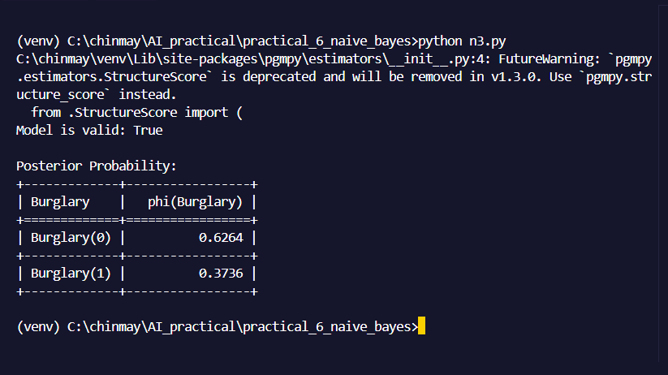
Practical 7 - Machine Learning Practicals :-
1. Using any small dataset (e.g., Iris or a CSV dataset), write a Python program to demonstrate the basic machine learning workflow. a. Load dataset using Pandas. b. Perform basic preprocessing (handling missing values or scaling). c. Split dataset into training and testing sets. d. Train a simple classifier. e. Display training and testing accuracy.
Code-
# Basic Machine Learning Workflow using Iris Dataset
import pandas as pd
from sklearn.datasets import load_iris
from sklearn.model_selection import train_test_split
from sklearn.preprocessing import StandardScaler
from sklearn.neighbors import KNeighborsClassifier
from sklearn.metrics import accuracy_score
# 1. Load Iris dataset
iris = load_iris()
# Convert dataset into Pandas DataFrame
df = pd.DataFrame(iris.data, columns=iris.feature_names)
df["target"] = iris.target
print("First 5 rows of dataset:")
print(df.head())
# 2. Check for missing values
print("\nMissing values:")
print(df.isnull().sum())
# Separate input and output
X = df.drop("target", axis=1)
y = df["target"]
# 3. Split dataset into training and testing data
X_train, X_test, y_train, y_test = train_test_split(
X, y, test_size=0.2, random_state=42
)
# 4. Scale the features
scaler = StandardScaler()
X_train = scaler.fit_transform(X_train)
X_test = scaler.transform(X_test)
# 5. Create and train KNN classifier
model = KNeighborsClassifier(n_neighbors=3)
model.fit(X_train, y_train)
# 6. Make predictions
train_prediction = model.predict(X_train)
test_prediction = model.predict(X_test)
# 7. Calculate accuracy
train_accuracy = accuracy_score(y_train, train_prediction)
test_accuracy = accuracy_score(y_test, test_prediction)
# 8. Display results
print("\nTraining Accuracy:", train_accuracy * 100, "%")
print("Testing Accuracy:", test_accuracy * 100, "%")

Output –
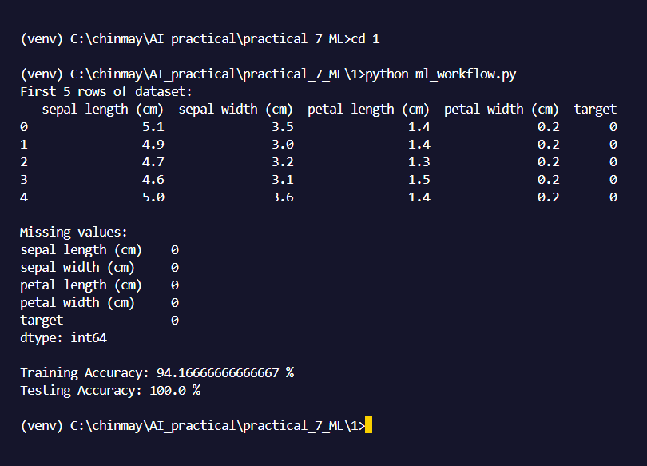

2. Using a suitable regression dataset, implement Linear Regression using scikit learn.
Code-
# Linear Regression using Scikit-learn
import pandas as pd
from sklearn.model_selection import train_test_split
from sklearn.linear_model import LinearRegression
from sklearn.metrics import r2_score
# 1. Create dataset
data = {
"Area": [500, 700, 800, 1000, 1200,
1500, 1800, 2000, 2200, 2500],

"Price": [30, 40, 45, 55, 65,
80, 95, 105, 115, 130]
}

df = pd.DataFrame(data)
print("Dataset:")
print(df)

# 2. Separate input and output
X = df[["Area"]]
y = df["Price"]
# 3. Split data into training and testing sets
X_train, X_test, y_train, y_test = train_test_split(
X, y, test_size=0.2, random_state=42
)
# 4. Create Linear Regression model
model = LinearRegression()
# 5. Train the model
model.fit(X_train, y_train)

# 6. Predict test data
y_pred = model.predict(X_test)
# 7. Calculate R2 score
accuracy = r2_score(y_test, y_pred)
print("\nActual Prices:")
print(y_test.values)
print("\nPredicted Prices:")
print(y_pred)
print("\nR2 Score:", accuracy)
# 8. Predict price of a new house
new_area = [[1600]]
new_price = model.predict(new_area)
print("\nPredicted price for 1600 sq.ft.:")
print(new_price[0], "Lakhs")
Output –
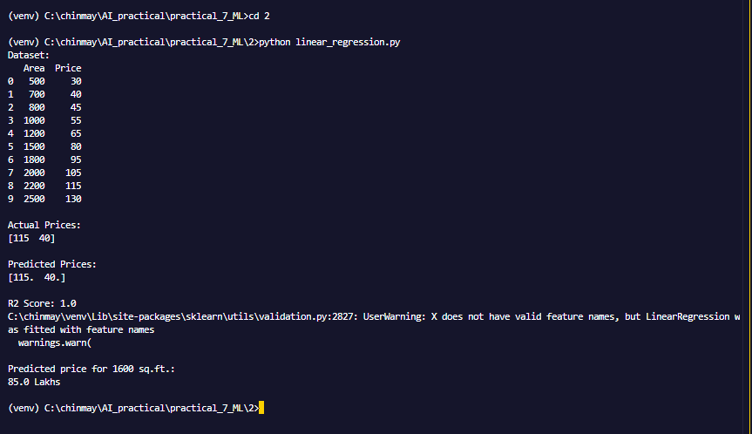

- Using the MNIST dataset (digit vs not digit), implement a binary classifier.
Code-
from sklearn.datasets import load_digits
from sklearn.model_selection import train_test_split
from sklearn.linear_model import LogisticRegression
from sklearn.metrics import accuracy_score, classification_report
# 1. Load the built-in digits dataset (bypasses network restrictions)
print("Loading built-in digits dataset...")
digits = load_digits()
X = digits.data
y = digits.target
# 2. Convert into binary classification (1 = Digit 0, 0 = Not Digit 0)
y_binary = (y == 0).astype(int)
# 3. Split data into training and testing sets
X_train, X_test, y_train, y_test = train_test_split(
X,
y_binary,
test_size=0.2,
random_state=42
)
# 4. Create Logistic Regression classifier
# Added max_iter=1000 to ensure the model has enough time to converge
model = LogisticRegression(max_iter=1000)

# 5. Train the model
print("Training the model...")
# Scaling by 16.0 because load_digits pixel values range from 0 to 16
model.fit(X_train / 16.0, y_train)
# 6. Make predictions
y_pred = model.predict(X_test / 16.0)

# 7. Evaluate
accuracy = accuracy_score(y_test, y_pred)
print("\nBinary Classification (0 vs Not 0)")
print("Testing Accuracy:", f"{accuracy * 100:.2f}%")
print("\nDetailed Classification Report:")
print(classification_report(y_test, y_pred, target_names=["Not 0", "Is 0"]))
Output –
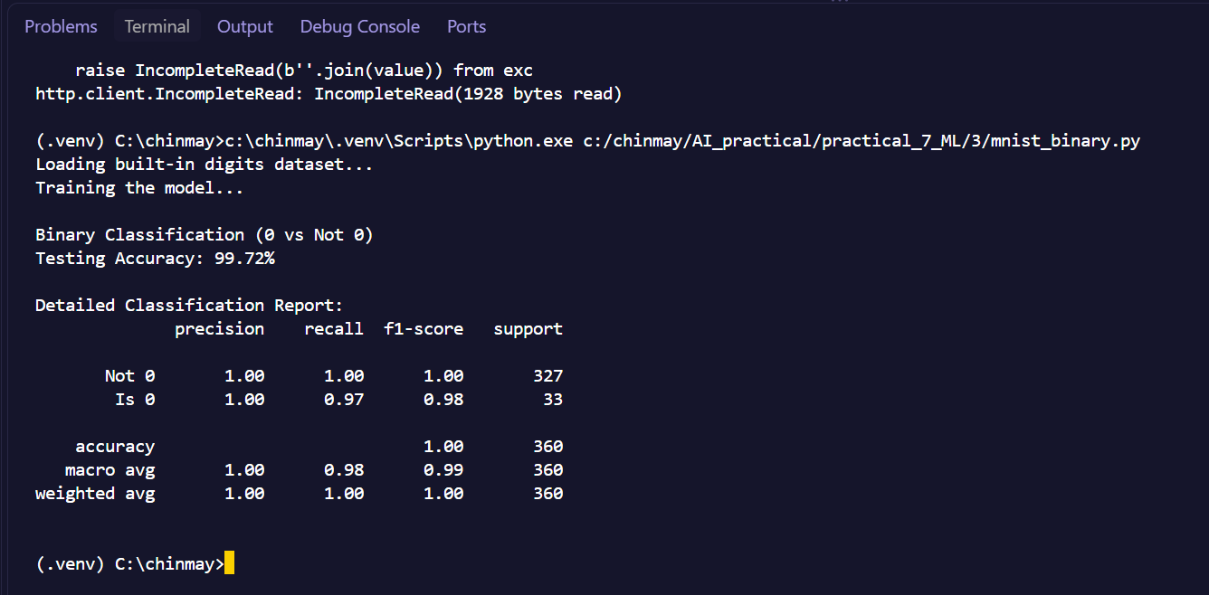

- Implement k-fold cross-validation on a classification model.
Code-
# K-Fold Cross-Validation on Classification Model
from sklearn.datasets import load_iris
from sklearn.neighbors import KNeighborsClassifier
from sklearn.model_selection import KFold, cross_val_score
# 1. Load Iris dataset
iris = load_iris()
X = iris.data
y = iris.targe
# 2. Create KNN classifier
model = KNeighborsClassifier(n_neighbors=3)
# 3. Create 5-Fold Cross-Validation
kfold = KFold(n_splits=5, shuffle=True, random_state=42)
# 4. Perform cross-validation
scores = cross_val_score(
model,
X,
y,
cv=kfold,
scoring="accuracy"

# 5. Display accuracy of each fold
print("Accuracy of each fold:")
for i in range(len(scores)):
print("Fold", i + 1, ":", scores[i] * 100, "%"
# 6. Calculate average accuracy
average = scores.mean(
print("\nAverage Accuracy:", average * 100, "%")

Output –
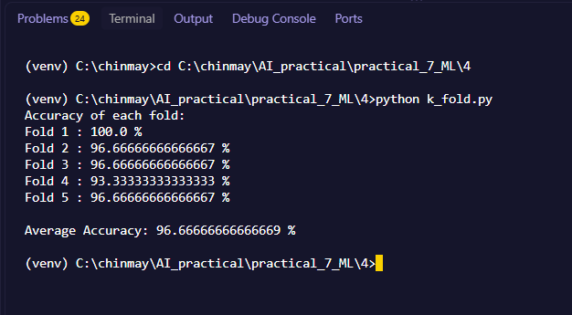
5. Implement a Decision Tree classifier using the Iris or any relevant dataset.
Code-
# Decision Tree Classifier using Iris Dataset
from sklearn.datasets import load_iris
from sklearn.model_selection import train_test_split
from sklearn.tree import DecisionTreeClassifier
from sklearn.metrics import accuracy_score

# 1. Load Iris dataset
iris = load_iris(
X = iris.data
y = iris.target
# 2. Split dataset into training and testing data
X_train, X_test, y_train, y_test = train_test_split(
X, y, test_size=0.2, random_state=42
)
# 3. Create Decision Tree classifier
model = DecisionTreeClassifier(random_state=42)

# 4. Train the model
model.fit(X_train, y_train)

# 5. Predict test data
y_pred = model.predict(X_test)
# 6. Calculate accuracy
accuracy = accuracy_score(y_test, y_pred)
print("Decision Tree Classifier")
print("Training Samples:", len(X_train))
print("Testing Samples:", len(X_test))
print("\nTesting Accuracy:", accuracy * 100, "%")
# 7. Predict a new flower
new_flower = [[5.1, 3.5, 1.4, 0.2]]
prediction = model.predict(new_flower)
print("\nPredicted Class:", iris.target_names[prediction[0]]
Output –
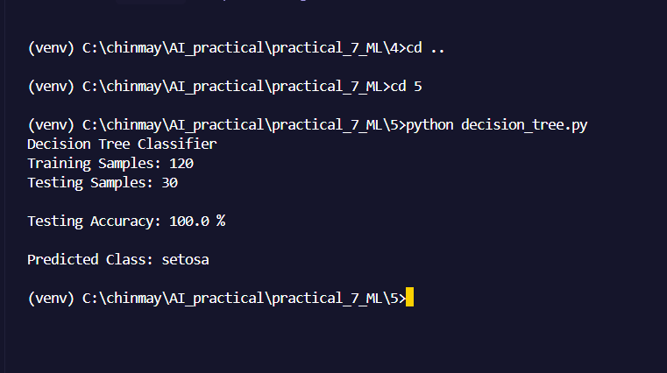

6. Implement Decision Tree regression on a regression dataset.
Code-
# Decision Tree Regressio
import pandas as pd
from sklearn.model_selection import train_test_split
from sklearn.tree import DecisionTreeRegressor
from sklearn.metrics import r2_score
# 1. Create regression dataset
data = {
"Area": [500, 700, 800, 1000, 1200,
1500, 1800, 2000, 2200, 2500],
"Price": [30, 40, 45, 55, 65,
80, 95, 105, 115, 130]
}
df = pd.DataFrame(data)

print("Dataset:")
print(df)
# 2. Separate input and output
X = df[["Area"]]
y = df["Price"]

# 3. Split dataset
X_train, X_test, y_train, y_test = train_test_split(
X, y, test_size=0.2, random_state=42
)
# 4. Create Decision Tree Regressor
model = DecisionTreeRegressor(
max_depth=3,
random_state=42
)
# 5. Train the model
model.fit(X_train, y_train)
# 6. Predict test data
y_pred = model.predict(X_test)
# 7. Calculate R2 score
score = r2_score(y_test, y_pred)
print("\nActual Prices:")
print(y_test.values)
print("\nPredicted Prices:")
print(y_pred)
print("\nR2 Score:", score)

# 8. Predict price for a new house
new_area = [[1600]]
new_price = model.predict(new_area)

print("\nPredicted price for 1600 sq.ft.:")
print(new_price[0], "Lakhs")
Output -
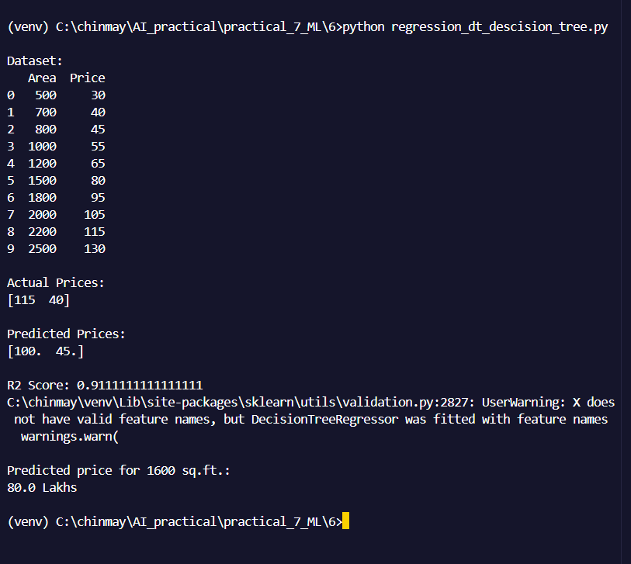
7. Implement k-Nearest Neighbors (kNN) classifier.
Code-
# k-Nearest Neighbors (kNN) Classifier
from sklearn.datasets import load_iris
from sklearn.model_selection import train_test_split
from sklearn.preprocessing import StandardScaler
from sklearn.neighbors import KNeighborsClassifier
from sklearn.metrics import accuracy_score
# 1. Load Iris dataset
iris = load_iris()

X = iris.data
y = iris.target
# 2. Split dataset into training and testing data
X_train, X_test, y_train, y_test = train_test_split(
X, y, test_size=0.2, random_state=42
)

# 3. Scale the features
scaler = StandardScaler()
X_train = scaler.fit_transform(X_train)
X_test = scaler.transform(X_test)

# 4. Create kNN classifier
model = KNeighborsClassifier(n_neighbors=3)
# 5. Train the model
model.fit(X_train, y_train)
# 6. Predict test data
y_pred = model.predict(X_test)
# 7. Calculate accuracy
accuracy = accuracy_score(y_test, y_pred)
print("k-Nearest Neighbors Classifier")
print("K =", 3)
print("\nTesting Accuracy:", accuracy * 100, "%")
# 8. Predict a new flower
new_flower = [[5.1, 3.5, 1.4, 0.2]]

# Scale the new data using the same scaler
new_flower = scaler.transform(new_flower)
prediction = model.predict(new_flower)
print("Predicted Class:", iris.target_names[prediction[0]])

Output –
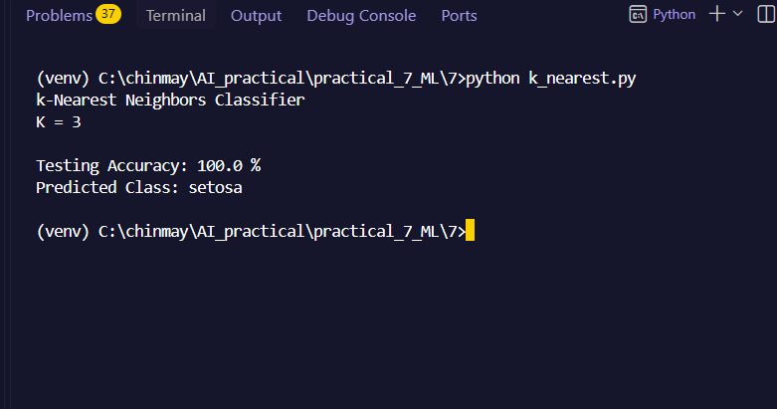

8. Implement multiclass classification using Logistic Regression or Decision Tree. Ethics and Bias Analysis Select any publicly available dataset (for example, Iris, Adult Income, or
a classification dataset of your choice) and analyze it for possible bias and class imbalance

Code-
# Ethics and Bias Analysis using Iris Dataset
import pandas as pd
from sklearn.datasets import load_iris
# 1. Load Iris dataset
iris = load_iris()
# Create Pandas DataFrame
df = pd.DataFrame(
iris.data,
columns=iris.feature_names
)

# Add target column
df["target"] = iris.target

# Add class name
df["class"] = df["target"].map(
{0: "Setosa", 1: "Versicolor", 2: "Virginica"}
)
# 2. Display dataset information
print("Dataset Shape:", df.shape)
# 3. Count samples in each class
class_count = df["class"].value_counts()
print("\nClass Distribution:")
print(class_count)
# 4. Calculate percentage of each class
class_percentage = df["class"].value_counts(
normalize=True
) * 100

print("\nClass Percentage:")
print(class_percentage)
# 5. Check class imbalance
difference = class_count.max() - class_count.min()
print("\nDifference between largest and smallest class:",
difference)
if difference == 0:
print("Result: Dataset is balanced.")
else:
print("Result: Dataset has class imbalance.")
# 6. Display basic statistics
print("\nBasic Statistics:")
print(df[iris.feature_names].describe())
# 7. Display average feature values for each class
print("\nAverage Feature Values by Class:")
print(df.groupby("class")[iris.feature_names].mean())

Output –
