PRACTICAL 1
Environment Setup and JavaScript Basics
a.Install Node.js and Visual Studio Code, and verify installation.
Aim:
To install Node.js and Visual Studio Code and verify their installation.
Procedure:
- Downloaded Node.js LTS version from the official website.
- Installed Node.js using the installation wizard.
- Opened Command Prompt and executed node --version.
- Executed npm --version to verify npm installation.
- Downloaded and installed Visual Studio Code.
- Opened the integrated terminal in Visual Studio Code.
- Verified Node.js and npm versions using the terminal.
Commands:
node –version
npm –version
Output:
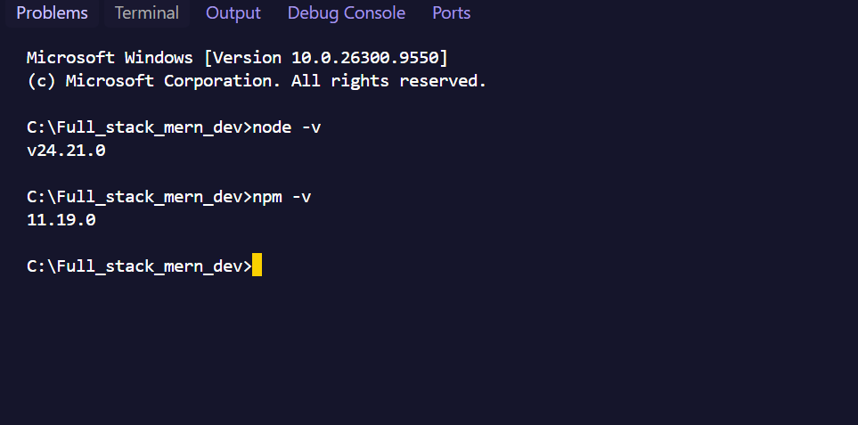
b. Create a simple Node.js file and run it using the terminal.
Aim:
To create and execute a simple Node.js program using the terminal.
Program:
console.log("Hello World!");
console.log("Welcome to MERN Stack Development");
Output:
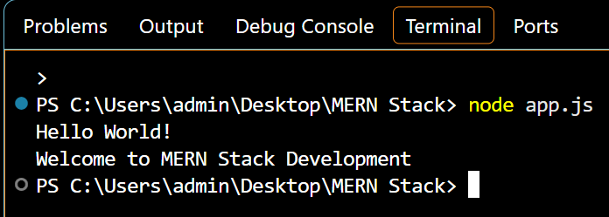
c. Write a Node.js script demonstrating basic JavaScript commands (console log, variables, and arithmetic operations).
Aim:
To write and execute a Node.js program demonstrating console.log(), variables, and arithmetic operations.
Program:

// Variable declarations
const courseName = "B.Sc. IT"; // Constant (cannot be reassigned)
let studentCount = 45; // Variable (can be updated)
// Console logging
console.log("Course:", courseName);
console.log("Initial Students:", studentCount);
// Arithmetic operations
let num1 = 15;
let num2 = 4;
let sum = num1 + num2; // Addition (19)
let difference = num1 - num2; // Subtraction (11)
let product = num1 * num2; // Multiplication (60)
let quotient = num1 / num2; // Division (3.75)
let remainder = num1 % num2; // Modulus/Remainder (3)
console.log("--- Arithmetic Results ---");
console.log("Sum:", sum);
console.log("Difference:", difference);
console.log("Product:", product);
console.log("Quotient:", quotient);
console.log("Remainder:", remainder);

Output:
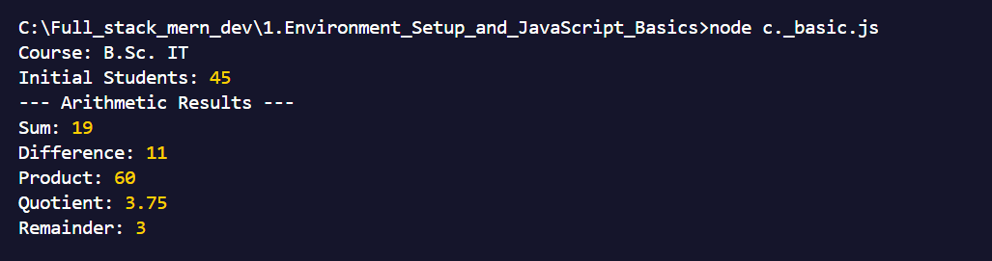
d. Create and run a simple program using variables and functions.
Aim:
To write a JavaScript program using variables and functions.
Program:
// Function Declaration
function calculateRectangleArea(length, width) {
let area = length * width;
return area;
}
// Arrow Function (modern ES6 syntax)
const calculatePerimeter = (length, width) => {
return 2 * (length + width);
};
// Calling the functions
let rectLength = 10;
let rectWidth = 5;
let areaResult = calculateRectangleArea(rectLength, rectWidth);
let perimeterResult = calculatePerimeter(rectLength, rectWidth);
console.log("Rectangle Dimensions:", rectLength, "x", rectWidth);
console.log("Calculated Area:", areaResult);
console.log("Calculated Perimeter:", perimeterResult);

Output:
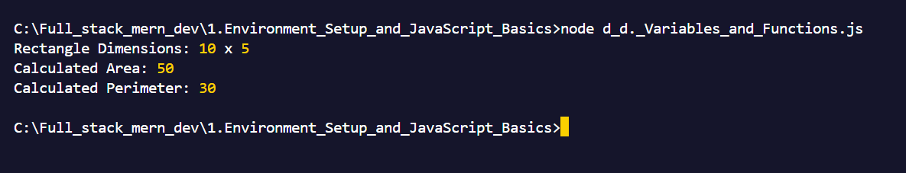
e. Demonstrate use of operators and control statements in JavaScript
Aim:
To demonstrate arithmetic operators, comparison operators and if-else control statements in JavaScript.
Program:
let a = 10;
let b = 5;
// Arithmetic Operators
console.log("Addition:", a + b);
console.log("Subtraction:", a - b);
// Comparison Operators
console.log("Is a greater than b?", a > b);
console.log("Are a and b equal?", a === b);
// Logical Operators
console.log("Logical AND:", a > 5 && b < 10);
console.log(“Logical OR:”, a>10 || b===5);
// If-Else Statement
if (a > b) {
console.log("a is greater than b");
} else {
console.log("a is not greater than b");
}
// Switch Statement
let day = 2;
switch (day) {
case 1:
console.log("Monday");
break;
case 2:
console.log("Tuesday");
break;
default:
console.log("Invalid day");
}
// For Loop
console.log("Numbers from 1 to 5:");
for (let i = 1; i <= 5; i++) {
console.log(i);
}
// While Loop
let count = 1;
while (count <= 3) {
console.log("Count:", count);
count++;
}
Output:
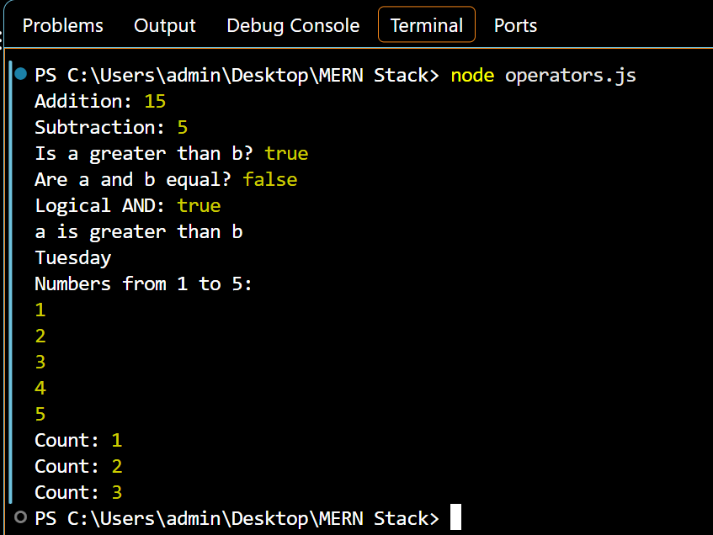
f. Write programs using loops and template literals.
Aim:
To write JavaScript programs using different types of loops and template literals.
Program:
// 1. Template Literals Demo
let firstName = "Chinmay";
let subject = "Mearnstack_development";
let semester = 5;
// Using backticks and \${} placeholders
console.log(`--- Student Profile ---`);
console.log(`Name: ${firstName}`);
console.log(`Enrolled Subject: ${subject}`);
console.log(`Current Semester: ${semester}`);
// 2. For Loop Demo
console.log("\n--- For Loop (Counting 1 to 5) ---");
for (let i = 1; i <= 5; i++) {
console.log(`Count index: ${i}`);
}
// 3. While Loop Demo
console.log("\n--- While Loop (Countdown) ---");
let countdown = 3;
while (countdown > 0) {
console.log(`T-minus: ${countdown}`);
countdown--;
}
console.log("Blast off!");
Output:
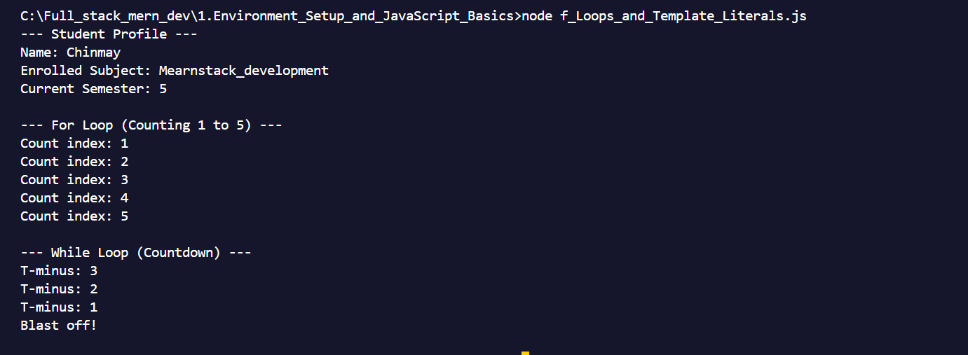

Practical 2

Core JavaScript Concepts for MERN
a. Create functions and call them with parameters.
Aim:
To create JavaScript functions and call them by passing parameters.
Program:
// Function definition with two parameters
function calculateTotal(price, taxRate) {
let taxAmount = price * taxRate;
let total = price + taxAmount;
return total;
}
// Calling the function with different arguments
let item1Total = calculateTotal(500, 0.18); // 18% tax
let item2Total = calculateTotal(1200, 0.05); // 5% tax
console.log(`Item 1 Total (with tax): ₹${item1Total}`);
console.log(`Item 2 Total (with tax): ₹${item2Total}`);
Output:
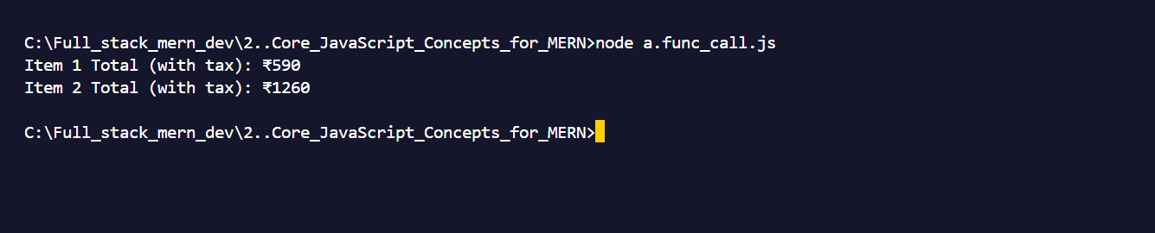
b. Work with arrays and objects in JavaScript.
Aim:
To work with arrays and objects in JavaScript.
Program:
// 1. Working with Arrays
let techStack = ["React", "Node.js", "Express"];
techStack.push("MongoDB"); // Adds an item to the end
techStack.unshift("JavaScript"); // Adds an item to the beginning
console.log("Full Tech Stack:", techStack);
console.log("First technology:", techStack[0]);
console.log("Total technologies:", techStack.length);
// 2. Working with Objects
let developer = {
name: "Chinmay Palshetkar",
role: "Full Stack Developer",
semester: 6,
isAvailableForHire: true
};
// Accessing object properties
console.log("\nDeveloper Profile:");
console.log(`Name: ${developer.name}`);
console.log(`Role: ${developer["role"]}`); // Alternative bracket notation

Output:
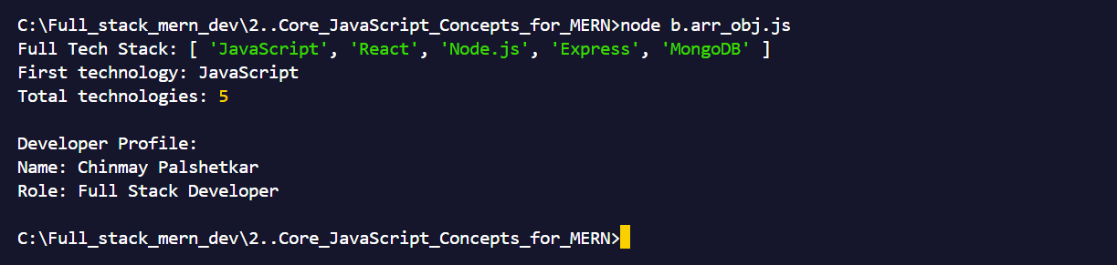
c. Demonstrate use of arrow functions.
Aim:
// Traditional function vs. Arrow function
// 1. Traditional function
function squareTraditional(num) {
return num * num;
}
// 2. Arrow function with a single parameter and implicit return
const squareArrow = num => num * num;
// 3. Arrow function with multiple parameters and a block body
const calculateSalary = (basePay, bonus) => {
let total = basePay + bonus;
return `Total compensation: ₹${total}`;
};
console.log("Square (Traditional):", squareTraditional(4));
console.log("Square (Arrow):", squareArrow(5));
console.log(calculateSalary(45000, 5000));

Output:
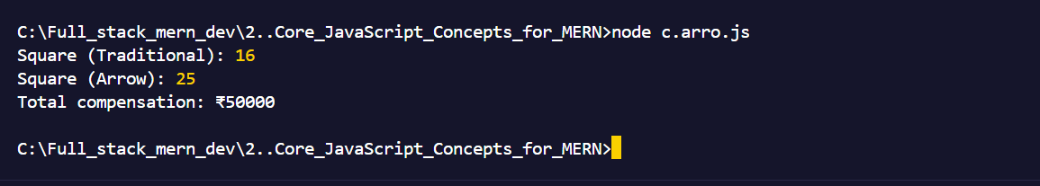
d. Write a program using array methods (map, filter, reduce).
Aim:
To write a JavaScript program using array methods such as map(), filter(), and reduce().
Program:
let numbers = [1, 2, 3, 4, 5];
let products = [
{ id: 1, name: "Laptop", price: 65000, inStock: true },
{ id: 2, name: "Mouse", price: 800, inStock: false },
{ id: 3, name: "Keyboard", price: 2500, inStock: true }
];
// 1. MAP: Transform each element (e.g., square every number)
let squaredNumbers = numbers.map(num => num * num);
console.log("Squared Numbers:", squaredNumbers);
// 2. FILTER: Keep elements that match a condition (e.g., only in-stock products)
let availableProducts = products.filter(product => product.inStock);
console.log("Available Products:", availableProducts);
// 3. REDUCE: Accumulate values into a single result (e.g., total price of all items)
let totalPrice = products.reduce((accumulator, currentItem) => accumulator + currentItem.price, 0);
console.log(`Total Inventory Value: ₹${totalPrice}`);

Output:
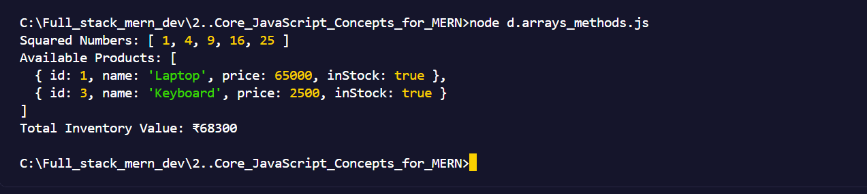
e. Create a program that manipulates objects and displays output.
Aim:
To create a JavaScript program that manipulates objects and displays the output.
Program:
let userProfile = {
username: "dev_Chinmay",
email: "chinmay@example.com",
theme: "dark"
};
// 1. Modifying and adding properties
userProfile.theme = "light"; // Update existing property
userProfile.lastLogin = "2026-10-12"; // Add new property
// 2. Deleting a property
delete userProfile.email;
// 3. Object Destructuring
let { username, theme } = userProfile;
console.log("Updated User Profile Object:", userProfile);
console.log(`Destructured Output -> Username: ${username}, Theme: ${theme}`);
console.log("Object Keys:", Object.keys(userProfile));
console.log("Object Values:", Object.values(userProfile));

Output:
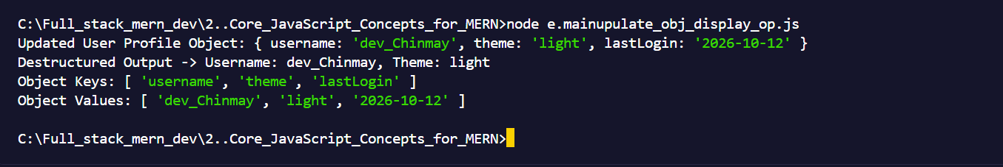
f. Implement a small JavaScript program combining functions, arrays, and objects.
Aim:
To implement a JavaScript program combining functions, arrays, and objects.
Program:
function displayStudents(students) {
for (let student of students) {
console.log(`Name: ${student.name}`);
console.log(`Age: ${student.age}`);
}
}
let students = [
{ name: "Rahul", age: 16 },
{ name: "Priya", age: 17 },
{ name: "Amit", age: 18 }
];
displayStudents(students);
Output:
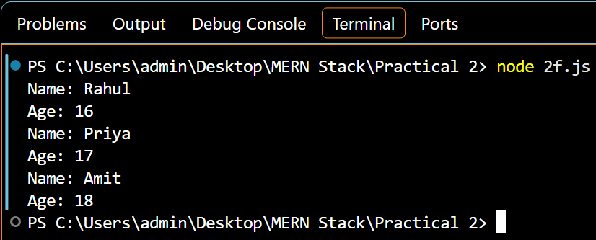

PRACRTICAL 3

React Introduction and JSX
a. Create a React application using Vite/CRA and display “Welcome to MERN Stack Development”.
Aim
To create a React application using Vite and display “Welcome to MERN Stack Development”.
Procedure / Steps
1.Open the VS Code terminal.
2.Create a React application using Vite with the following command:
Command: npm create vite@latest my-app -- --template react
3.Which Linter to use?
Select: ESLint then Enter
4.Install with npm and start now?
Select: Yes
5.Copy the localhost that appears in the terminal and paste it into the chrome.
6.Open my-app folder.
7.Open the src folder and select App.jsx.
8.Write the code in App.jsx.
9.Save the code and see output in chrome.
Program:
function App() {
return (
<div>
<h1>Welcome to MERN Stack Development</h1>
</div>
);
}
export default App;
Output:
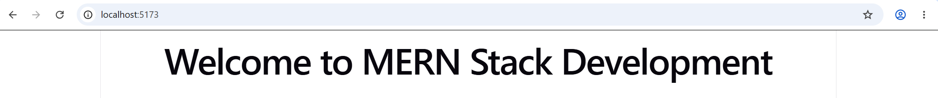
b. Display dynamic data using JSX.
Aim
To display dynamic data in a React application using JSX.
Procedure
1.Open the VS Code terminal.
2.Create a React application using Vite with the following command:
Command: npm create vite@latest my-app -- --template react
3.Which Linter to use?
Select: ESLint then Enter
4.Install with npm and start now?
Select: Yes
5.Copy the localhost that appears in the terminal and paste it into the chrome.
6.Open my-app folder.
7.Open the src folder and select App.jsx.
8.Write the code in App.jsx.
9.Save the code and see output in chrome.
Program:
function App() {
const name = "Rahul";
const age = 20;
const course = "MERN Stack Development";
return (
<div>
<h1>Student Details</h1>
<p>Name: {name}</p>
<p>Age: {age}</p>
<p>Course: {course}</p>
</div>
);
}
export default App;
Output:
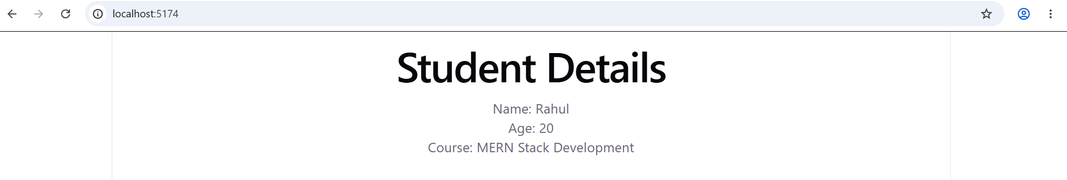
c. Declare variables and write a function to calculate the sum of two numbers and display the result.
Aim:
To declare variables and write a function to calculate the sum of two numbers and display the result.
Procedure
1.Open the VS Code terminal.
2.Create a React application using Vite with the following command:
Command: npm create vite@latest my-app -- --template react
3.Which Linter to use?
Select: ESLint then Enter
4.Install with npm and start now?
Select: Yes
5.Copy the localhost that appears in the terminal and paste it into the chrome.
6.Open my-app folder.
7.Open the src folder and select App.jsx.
8.Write the code in App.jsx.
9.Save the code and see output in chrome.
Program:
function App() {
let a = 10;
let b = 20;
function sum() {
return a + b;
}
return (
<div>
<h1>Sum of Two Numbers</h1>
<p>First Number: {a}</p>
<p>Second Number: {b}</p>
<p>Sum: {sum()}</p>
</div>
);
}
export default App;
Output:
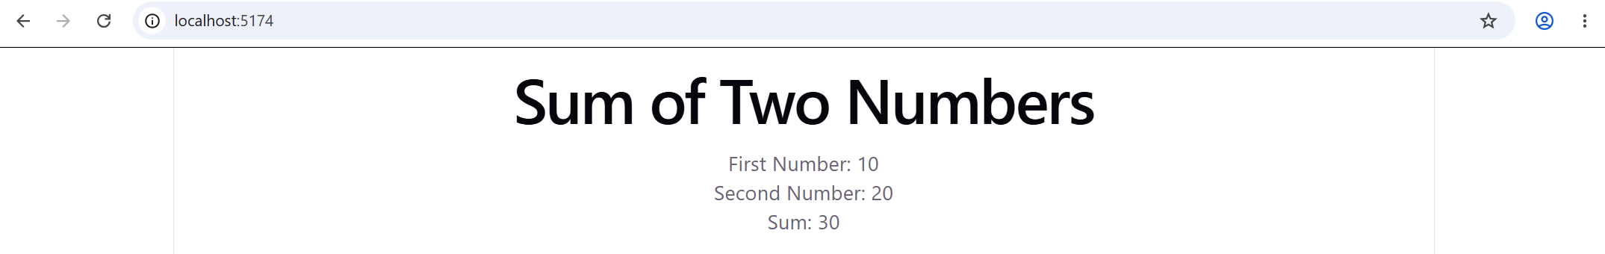
d. Apply basic CSS styling to a React component
Aim:
Apply basic CSS styling to a React component.
1.Open the VS Code terminal.
2.Create a React application using Vite with the following command:
Command: npm create vite@latest my-app -- --template react
3.Which Linter to use?
Select: ESLint then Enter
4.Install with npm and start now?
Select: Yes
5.Copy the localhost that appears in the terminal and paste it into the chrome.
6.Open my-app folder.
7.Open the src folder and select App.jsx.
8.Write the code in App.jsx.
9.Now select App.css
9.Now select App.css in src folder, and write css code in it.
10.Save both the codes and see output in chrome.
App.jsx Program:
import './App.css';
function App() {
return (
<div className="container">
<h1>Welcome to MERN Stack Development</h1>
<p>This is my first styled React component.</p>
<button>Click Me</button>
</div>
);
}
export default App;

App.css Program:
.container {
text-align: center;
background-color: lightblue;
padding: 30px;
margin: 50px auto;
border-radius: 10px;
}
h1 {
color: darkblue;
}
p {
color: black;
font-size: 18px;
}
button {
background-color: darkblue;
color: white;
padding: 10px 20px;
border: none;
border-radius: 5px;
cursor: pointer;
}
Output:
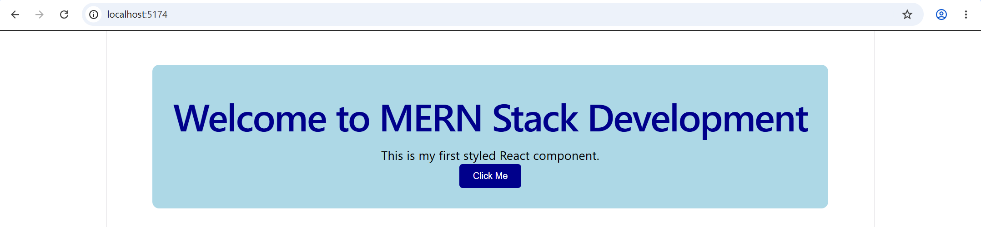
e. Create a simple functional component and render it in App.js.
Aim:
To create a simple functional component and render it in App.js.
Procedure
1.Open the VS Code terminal.
2.Create a React application using Vite with the following command:
Command: npm create vite@latest my-app -- --template react
3.Which Linter to use?
Select: ESLint then Enter
4.Install with npm and start now?
Select: Yes
5.Copy the localhost that appears in the terminal and paste it into the chrome.
6.Open my-app folder.
7.Open the src folder and select App.jsx.
8.Write the code in App.jsx.
9.Save the code and see output in chrome.
Program:
function Welcome() {
return (
<h2>Welcome to React!</h2>
);
}
function App() {
return (
<div>
<h1>My First React Application</h1>
<Welcome />
</div>
);
}
export default App;
Output:
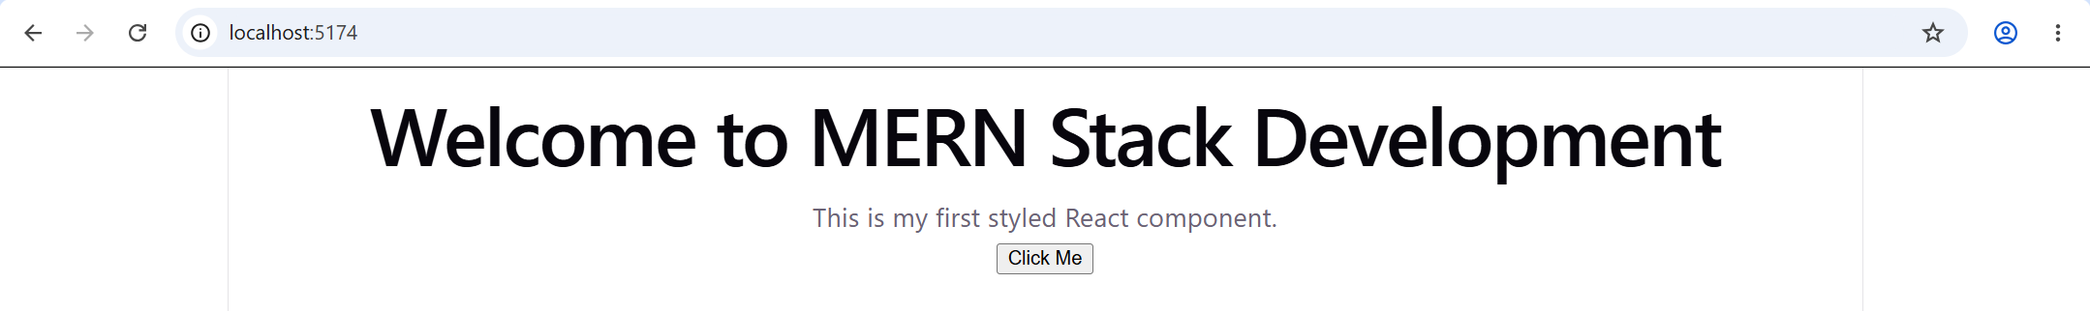
f. Create a React component that displays the current date and time dynamically using JavaScript.
Aim:
To create a React component that displays the current date and time dynamically using JavaScript.

Procedure
1.Open the VS Code terminal.
2.Create a React application using Vite with the following command:
Command: npm create vite@latest my-app -- --template react
3.Which Linter to use?
Select: ESLint then Enter
4.Install with npm and start now?
Select: Yes
5.Copy the localhost that appears in the terminal and paste it into the chrome.
6.Open my-app folder.
7.Open the src folder and select App.jsx.
8.Write the code in App.jsx.
9.Save the code and see output in chrome.
Program:
function App() {
const currentDate = new Date();
return (
<div>
<h1>Current Date and Time</h1>
<p>Date: {currentDate.toLocaleDateString()}</p>
<p>Time: {currentDate.toLocaleTimeString()}</p>
</div>
);
}
export default App;
Output:
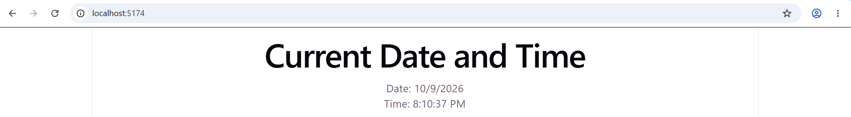

PRACTICAL 4

React Components, Props, and State
a. Create multiple components and render them on a single page.
Aim:
To create multiple React components and render them on a single page.
Procedure
1.Open the VS Code terminal.
2.Create a React application using Vite with the following command:
Command: npm create vite@latest my-app -- --template react
3.Which Linter to use?
Select: ESLint then Enter
4.Install with npm and start now?
Select: Yes
5.Copy the localhost that appears in the terminal and paste it into the chrome.
6.Open my-app folder.
7.Open the src folder and select App.jsx.
8.Write the code in App.jsx.
9.Save the code and see output in chrome.
Program:
function Header() {
return <h1>Welcome to MERN Stack</h1>;
}
function Student() {
return <p>Student Name: Rahul</p>;
}
function Footer() {
return <h3>Thank You!</h3>;
}
function App() {
return (
<div>
<Header />
<Student />
<Footer />
</div>
);
}
export default App;
Output:
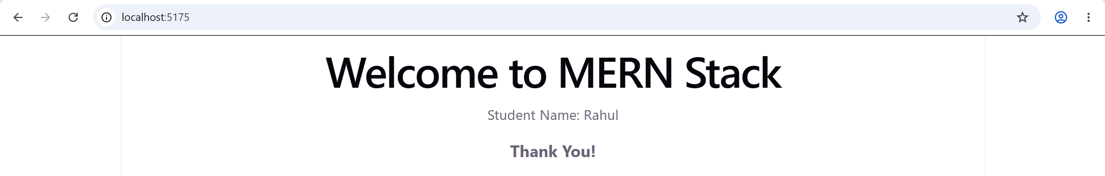
b. Pass data between components using props
Aim:
To pass data between React components using props.
Procedure
1.Open the VS Code terminal.
2.Create a React application using Vite with the following command:
Command: npm create vite@latest my-app -- --template react
3.Which Linter to use?
Select: ESLint then Enter
4.Install with npm and start now?
Select: Yes
5.Copy the localhost that appears in the terminal and paste it into the chrome.
6.Open my-app folder.
7.Open the src folder and select App.jsx.
8.Write the code in App.jsx.
9.Save the code and see output in chrome.
Program:
function Student(props) {
return (
<div>
<h2>Student Details</h2>
<p>Name: {props.name}</p>
<p>Age: {props.age}</p>
</div>
);
}
function App() {
return (
<div>
<h1>Passing Data Using Props</h1>
<Student name="Rahul" age={20} />
<Student name="Priya" age={19} />
</div>
);
}
export default App;
Output:
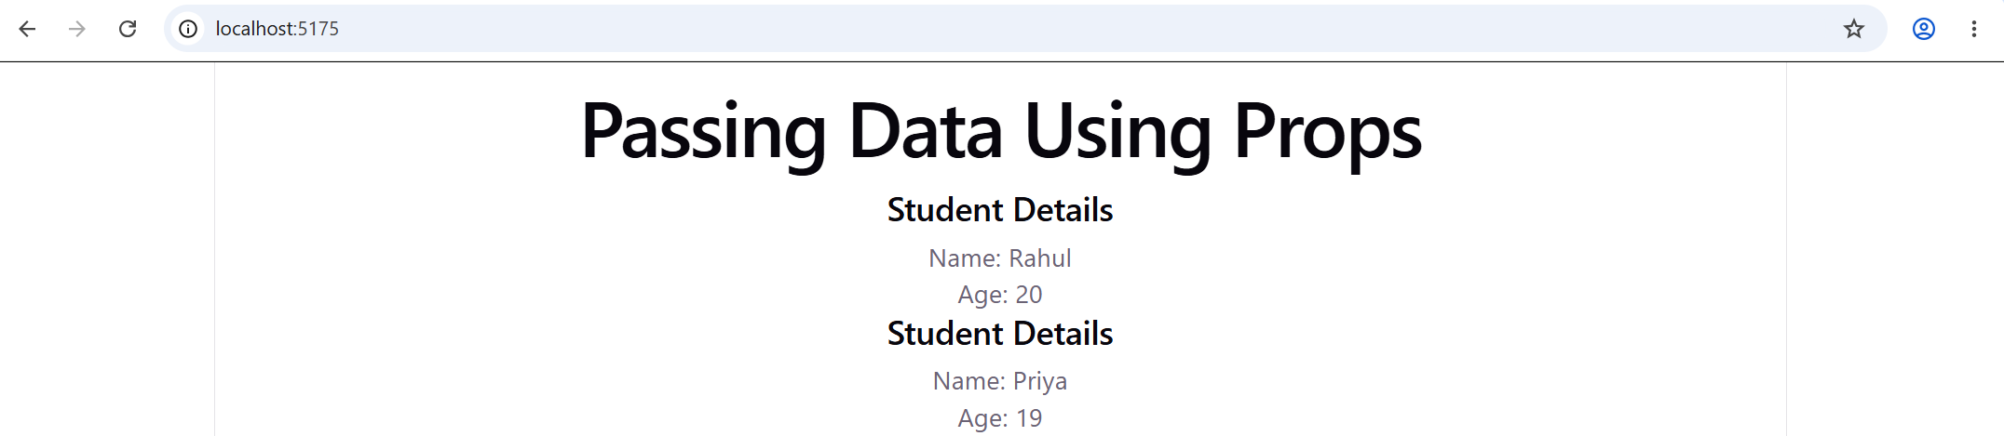

c. Use the useState hook to manage and update data.
Aim:
To use the useState hook in React to manage and update data.
Procedure
1.Open the VS Code terminal.
2.Create a React application using Vite with the following command:
Command: npm create vite@latest my-app -- --template react
3.Which Linter to use?
Select: ESLint then Enter
4.Install with npm and start now?
Select: Yes
5.Copy the localhost that appears in the terminal and paste it into the chrome.
6.Open my-app folder.
7.Open the src folder and select App.jsx.
8.Write the code in App.jsx.
9.Save the code and see output in chrome.
Program:
import { useState } from "react";
function App() {
const [count, setCount] = useState(0);
return (
<div>
<h1>Counter App</h1>
<h2>Count: {count}</h2>
<button onClick={() => setCount(count + 1)}>
Increase
</button>
<button onClick={() => setCount(count - 1)}>
Decrease
</button>
</div>
);
}
export default App;
Output:
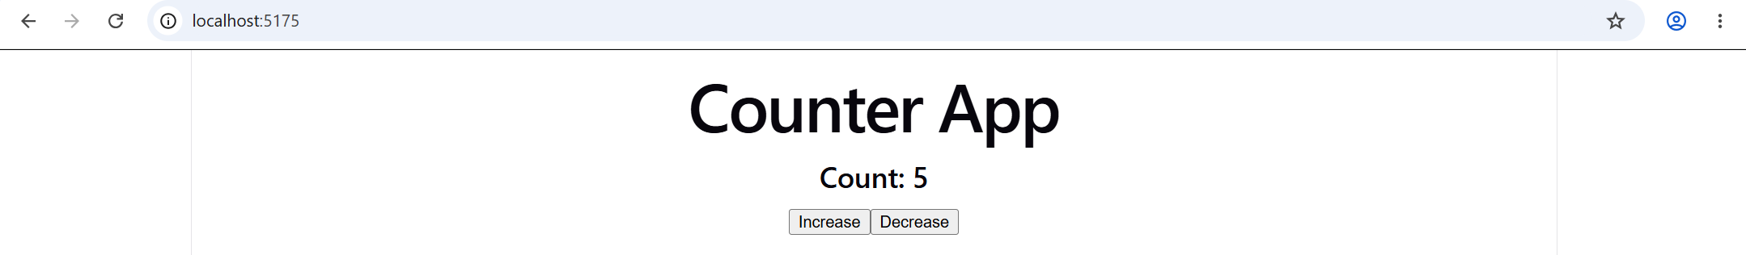
d. Create a form component to accept user input and display it dynamically.
Aim:
To create a React form component that accepts user input and displays it dynamically.

Procedure
1.Open the VS Code terminal.
2.Create a React application using Vite with the following command:
Command: npm create vite@latest my-app -- --template react
3.Which Linter to use?
Select: ESLint then Enter
4.Install with npm and start now?
Select: Yes
5.Copy the localhost that appears in the terminal and paste it into the chrome.
6.Open my-app folder.
7.Open the src folder and select App.jsx.
8.Write the code in App.jsx.
9.Save the code and see output in chrome.
Program:
import React, { useState } from 'react';
function UserForm() {
const [inputValue, setInputValue] = useState("");
return (
<div style={{ border: '1px solid #94a3b8', padding: '15px', borderRadius: '8px', margin: '15px 0' }}>
<h3>Dynamic Form Input</h3>
<input
type="text"
placeholder="Type something here..."
value={inputValue}
onChange={(e) => setInputValue(e.target.value)}
style={{ padding: '8px', width: '80%', marginBottom: '10px' }}
/>
<p>Live Output: <strong>{inputValue ? inputValue : "Waiting for input..."}</strong></p>
</div>
);
}
export default UserForm;

Output:
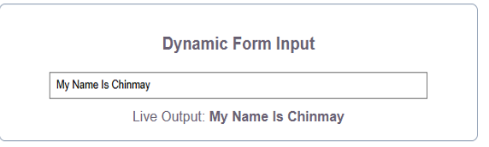

e. Display a list of items stored in the state using map().
Aim:
To create a React component that stores a list of items in state and displays them using the map() method.
Procedure
1.Open the VS Code terminal.
2.Create a React application using Vite with the following command:
Command: npm create vite@latest my-app -- --template react
3.Which Linter to use?
Select: ESLint then Enter
4.Install with npm and start now?
Select: Yes
5.Copy the localhost that appears in the terminal and paste it into the chrome.
6.Open my-app folder.
7.Open the src folder and select App.jsx.
8.Write the code in App.jsx.
9.Save the code and see output in chrome.
Program:
import { useState } from "react";
function App() {
const [items, setItems] = useState([
"Apple",
"Banana",
"Mango",
"Orange"
]);
return (
<div>
<h1>List of Fruits</h1>
<ul>
{items.map((item, index) => (
<li key={index}>{item}</li>
))}
</ul>
</div>
);
}
export default App;
Output:
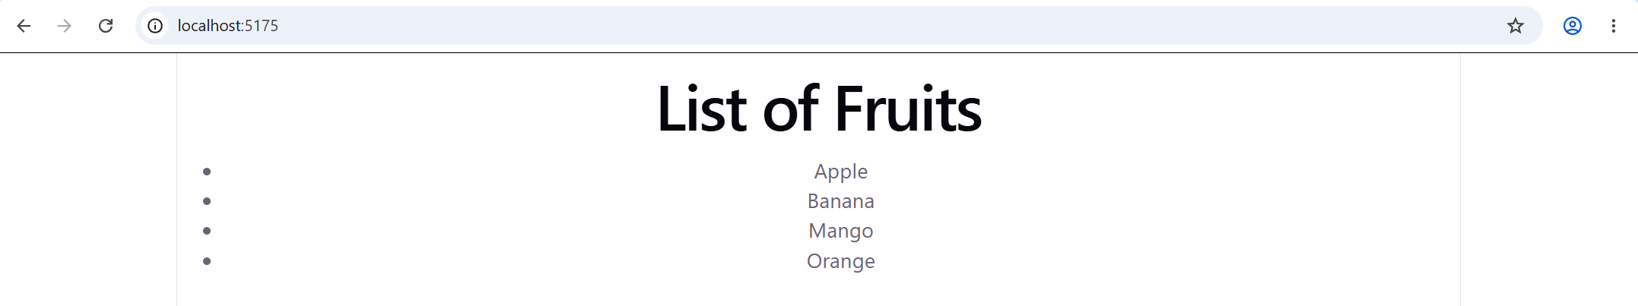
f. Build a small interactive component (e.g., counter or to-do list).
Aim:
To create an interactive React counter component using the useState() hook.
Procedure
1.Open the VS Code terminal.
2.Create a React application using Vite with the following command:
Command: npm create vite@latest my-app -- --template react
3.Which Linter to use?
Select: ESLint then Enter
4.Install with npm and start now?
Select: Yes
5.Copy the localhost that appears in the terminal and paste it into the chrome.
6.Open my-app folder.
7.Open the src folder and select App.jsx.
8.Write the code in App.jsx.
9.Save the code and see output in chrome.
Program:
import { useState } from "react";
function App() {
const [count, setCount] = useState(0);
return (
<div>
<h1>Interactive Counter</h1>
<h2>Count: {count}</h2>
<button onClick={() => setCount(count + 1)}>
Increase
</button>
<button onClick={() => setCount(count - 1)}>
Decrease
</button>
<button onClick={() => setCount(0)}>
Reset
</button>
</div>
);
}
export default App;
Output:
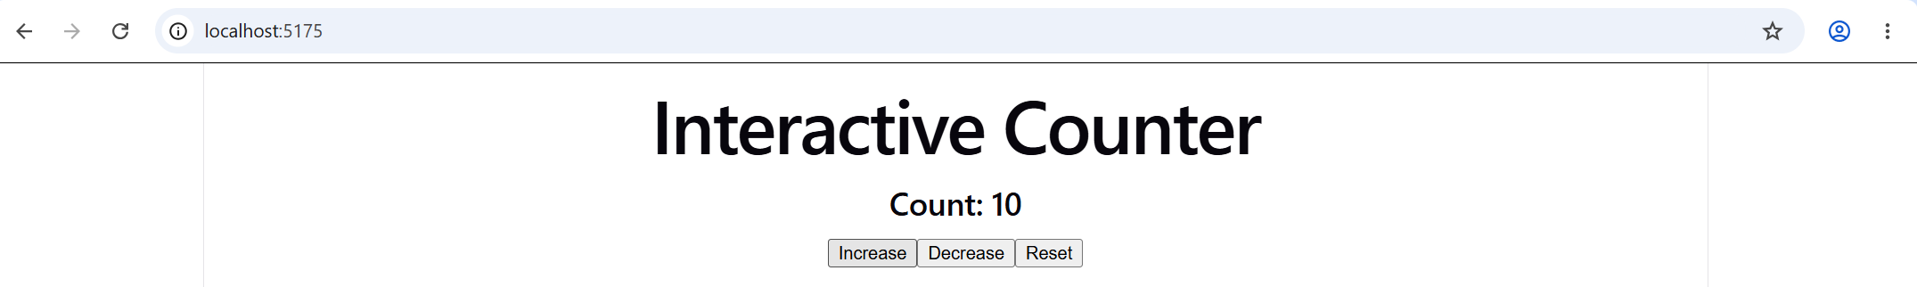

PRACTICAL 5

React Routing and Data Handling
a. Install and configure React Router in the React application.
Aim:
To install and configure React Router in a React application.
Software / Requirements Required:
- Node.js and npm
- Visual Studio Code
- React Application (created using Vite)
- React Router DOM library
Procedure / Steps:
- Open your project folder in Visual Studio Code.
- Open the integrated terminal and run the following command for all the installation.
- npm create vite@latest . -- --template react (For Creating React Project)
- npm install ( for installing Dependencies)
- npm install react-router-dom (For React Router installation)
- Now open my-react-app src main.jsx
- Import BrowserRouter from react-router-dom.
- hen open App.jsx in the src folder and add the required code for routing.
- Then run this command:
- npm run dev
Copy the localhost URL that appears in the terminal, paste it into chrome and see output.
main.jsx Program:
JavaScript
import React from 'react'
import ReactDOM from 'react-dom/client'
import { BrowserRouter } from 'react-router-dom'
import App from './App.jsx'
import './index.css'
ReactDOM.createRoot(document.getElementById('root')).render(
<React.StrictMode>
<BrowserRouter>
<App />
</BrowserRouter>
</React.StrictMode>,
)

App.jsx program:
import React from 'react';
function App() {
return (
<div style={{ padding: '20px', textAlign: 'center' }}>
<h1>Welcome to MERN Stack Development</h1>
<p>Practical 5.a: React Router Setup Successful!</p>
</div>
);
}
export default App;
Output:
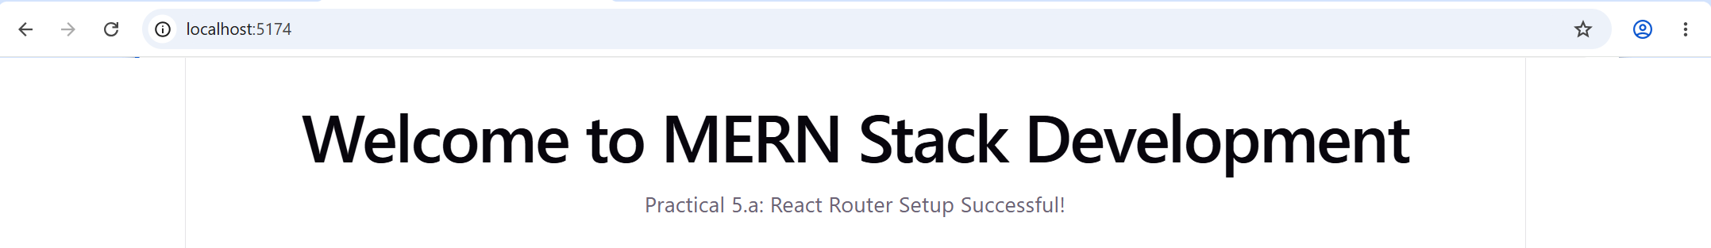
b. Create multiple pages and implement navigation between them.
Aim:
To create multiple pages and implement navigation between them using React Router.
Procedure:
- First, create a React application using Vite.
- Open the project folder in Visual Studio Code.
- Open the terminal and install the required dependencies using the following commands:
npm install
npm install react-router-dom
- Create three component files named Home.jsx, About.jsx, and Contact.jsx inside the src folder.
- Write the JSX code in each component to display the respective page heading and paragraph.
- Open App.jsx and import BrowserRouter, Routes, Route, and Link from react-router-dom.
- Import the Home, About, and Contact components into App.jsx.
- Use the Link component to create navigation links for Home, About, and Contact.
- Use the Routes and Route components to define the paths for each page.
- Open main.jsx and render the App component using ReactDOM.createRoot().
- Run the application using the command npm run dev in the terminal.
- Open the local URL displayed in the terminal in the Chrome browser.
- Click the Home, About, and Contact links to verify that each page displays its heading and paragraph correctly.
App.jsx Program:
import { BrowserRouter, Routes, Route, Link } from "react-router-dom";
function Home() {
return <h2>Home Page</h2>;
}
function About() {
return <h2>About Page</h2>;
}
function Contact() {
return <h2>Contact Page</h2>;
}
function App() {
return (
<BrowserRouter>
<h1>React Router Demo</h1>
<nav>
<Link to="/">Home</Link>{" | "}
<Link to="/about">About</Link>{" | "}
<Link to="/contact">Contact</Link>
</nav>
<Routes>
<Route path="/" element={<Home />} />
<Route path="/about" element={<About />} />
<Route path="/contact" element={<Contact />} />
</Routes>
</BrowserRouter>
);
}
export default App;
main.jsx Program:
import React from "react";
import ReactDOM from "react-dom/client";
import App from "./App.jsx";
ReactDOM.createRoot(document.getElementById("root")).render(
<React.StrictMode>
<App />
</React.StrictMode>
);
Home.jsx:
function Home() {
return (
<div>
<h2>Home Page</h2>
<p>Welcome to the Home Page!</p>
</div>
);
}
export default Home;
About.jsx:
function About() {
return (
<div>
<h2>About Page</h2>
<p>This is the About Page.</p>
</div>
);
}
export default About;
Contact.jsx:
function Contact() {
return (
<div>
<h2>Contact Page</h2>
<p>This is the Contact Page.</p>
</div>
);
}
export default Contact;
Output:
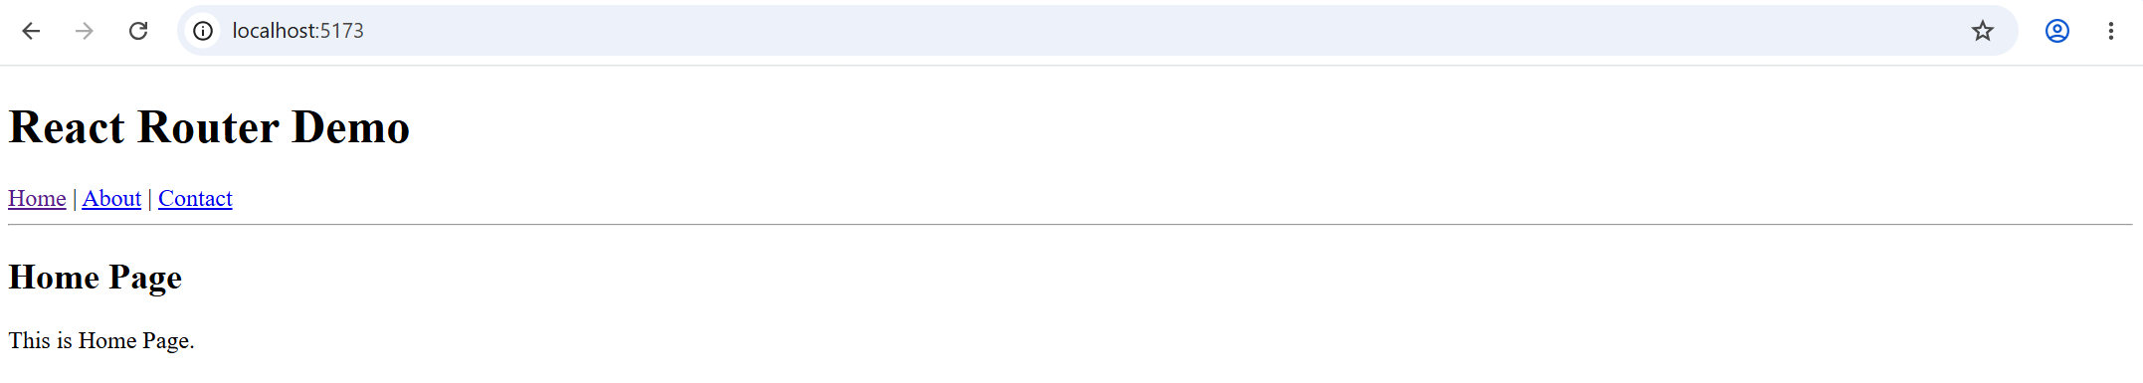
c. Use Link and Routes to move between pages.
Aim:
To use Link and Routes to navigate between different pages in a React application.
Procedure:
- First, create a React application using Vite.
- Open the project folder in Visual Studio Code.
- Open the terminal and install the required dependencies using the following commands:
npm install
npm install react-router-dom
- Create three component files named Home.jsx, About.jsx, and Contact.jsx inside the src folder.
- Write the JSX code in each component to display the respective page heading and paragraph.
- Open App.jsx and import BrowserRouter, Routes, Route, and Link from react-router-dom.
- Import the Home, About, and Contact components into App.jsx.
- Use the Link component to create navigation links for Home, About, and Contact.
- Use the Routes and Route components to define the paths for each page.
- Open main.jsx and render the App component using ReactDOM.createRoot().
- Run the application using the command npm run dev in the terminal.
- Open the local URL displayed in the terminal in the Chrome browser.
- Click the Home, About, and Contact links to verify that each page displays its heading and paragraph correctly.
App.jsx:
import {
BrowserRouter,
Link,
Routes,
Route
} from "react-router-dom";
import Home from "./Home.jsx";
import About from "./About.jsx";
import Contact from "./Contact.jsx";
function App() {
return (
<BrowserRouter>
<div>
<h1>React Router Navigation</h1>
<nav>
<Link to="/">Home</Link>{" | "}
<Link to="/about">About</Link>{" | "}
<Link to="/contact">Contact</Link>
</nav>
<hr />
<Routes>
<Route path="/" element={<Home />} />
<Route path="/about" element={<About />} />
<Route path="/contact" element={<Contact />} />
</Routes>
</div>
</BrowserRouter>
);
}
export default App;
main.jsx:
import React from "react";
import ReactDOM from "react-dom/client";
import App from "./App.jsx";
ReactDOM.createRoot(
document.getElementById("root")
).render(
<React.StrictMode>
<App />
</React.StrictMode>
);
Home.jsx:
function Home() {
return (
<div>
<h2>Home Page</h2>
<p>Welcome to the Home Page!</p>
</div>
);
}
export default Home;
About.jsx:
function About() {
return (
<div>
<h2>About Page</h2>
<p>This is the About Page.</p>
</div>
);
}
export default About;
Contact.jsx:
function Contact() {
return (
<div>
<h2>Contact Page</h2>
<p>This is the Contact Page.</p>
</div>
);
}
export default Contact;
Output:
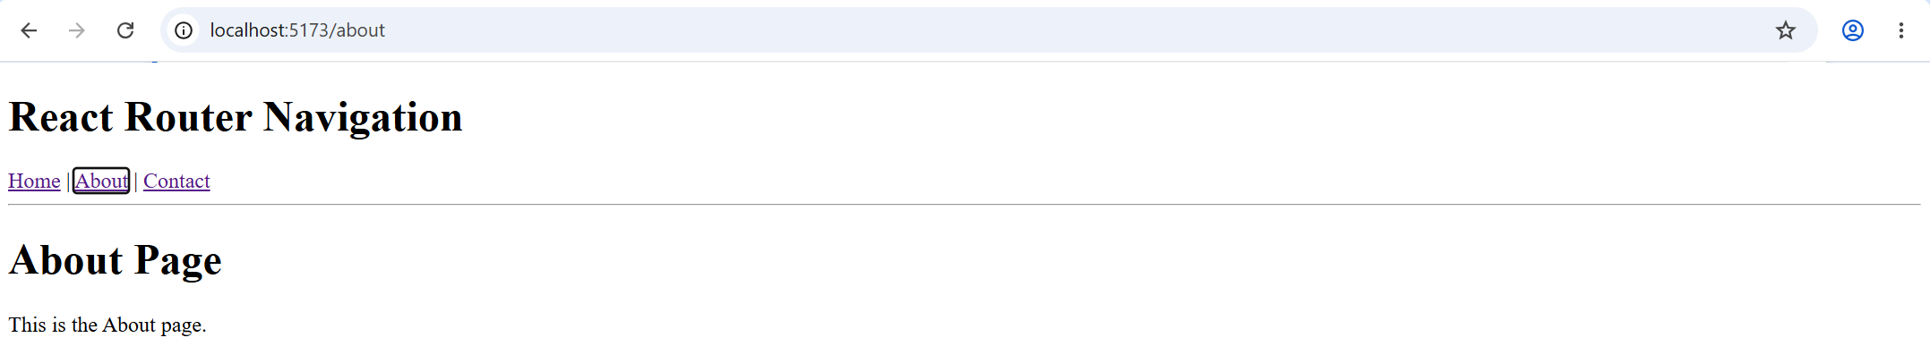
d. Fetch sample data from a public API using Axios.
Aim:
To fetch sample data from a public API using Axios in a React application.
Procedure / Steps:
- Open Visual Studio Code and create a new project folder named my-axios-app.
- Open the project folder in Visual Studio Code.
- Open the integrated terminal and run the following commands for installation.
  - npm create vite@latest . -- --template react (For creating a React project)
  - npm install (For installing dependencies)
  - npm install axios (For Axios installation)
- Now open my-axios-app → src → App.jsx.
- Import useState, useEffect, and axios into the application.
- Write the code to fetch sample data from a public API using Axios.
- Display the fetched data on the webpage using the map() method.
- Save all the files and run the following command in the terminal.
  - npm run dev
- Copy the localhost URL that appears in the terminal, paste it into Chrome, and see the output.
App.jsx Program:
import { useEffect, useState } from "react";
import axios from "axios";
function App() {
const [users, setUsers] = useState([]);
useEffect(() => {
axios
.get("https://jsonplaceholder.typicode.com/users")
.then((response) => {
setUsers(response.data);
})
.catch((error) => {
console.log("Error fetching data:", error);
});
}, []);
return (
<div>
<h1>User Details</h1>
{users.map((user) => (
<div key={user.id}>
<h3>{user.name}</h3>
<p>Email: {user.email}</p>
<p>City: {user.address.city}</p>
<hr />
</div>
))}
</div>
);
}
export default App;

Output:
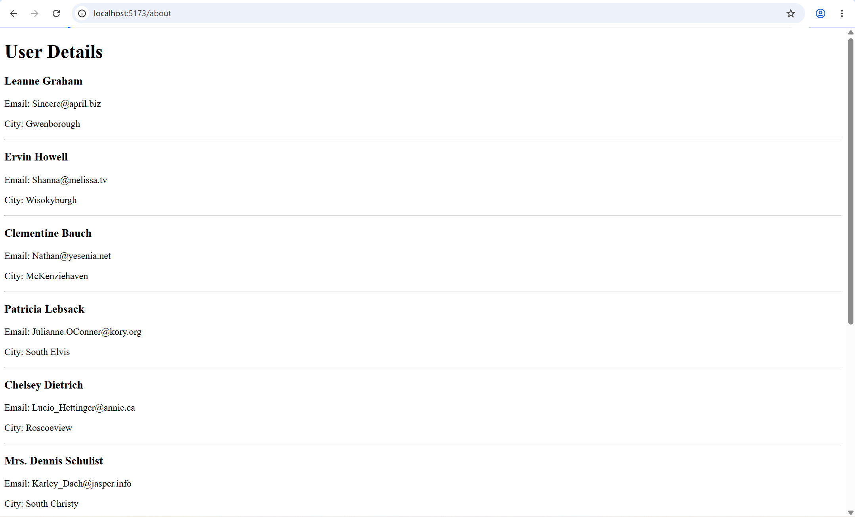
e. Display fetched data in table or list format.
Aim:
To display fetched data in table or list format using React and Axios.
Procedure / Steps:
- Open the React project folder in Visual Studio Code.
- Open the integrated terminal and install Axios using the command npm install axios.
- Open the src folder and then open App.jsx.
- Import useState, useEffect, and axios into the application.
- Fetch user data from a public API using Axios.
- Store the fetched data in the state using useState.
- Use the map() method to display the fetched data in table format.
- Create table headings for ID, Name, Email, and City.
- Save the file and run the application using npm run dev.
- Open the local URL in Chrome and verify that the fetched data is displayed in the table.
App.jsx Program:
import { useState, useEffect } from "react";
import axios from "axios";
function App() {
const [users, setUsers] = useState([]);
useEffect(() => {
axios
.get("https://jsonplaceholder.typicode.com/users")
.then((response) => {
setUsers(response.data);
})
.catch((error) => {
console.log("Error fetching data:", error);
});
}, []);
return (
<div>
<h1>User Details</h1>
<table border="1" cellPadding="10">
<thead>
<tr>
<th>ID</th>
<th>Name</th>
<th>Email</th>
<th>City</th>
</tr>
</thead>
<tbody>
{users.map((user) => (
<tr key={user.id}>
<td>{user.id}</td>
<td>{user.name}</td>
<td>{user.email}</td>
<td>{user.address.city}</td>
</tr>
))}
</tbody>
</table>
</div>
);
}
export default App;
Output:
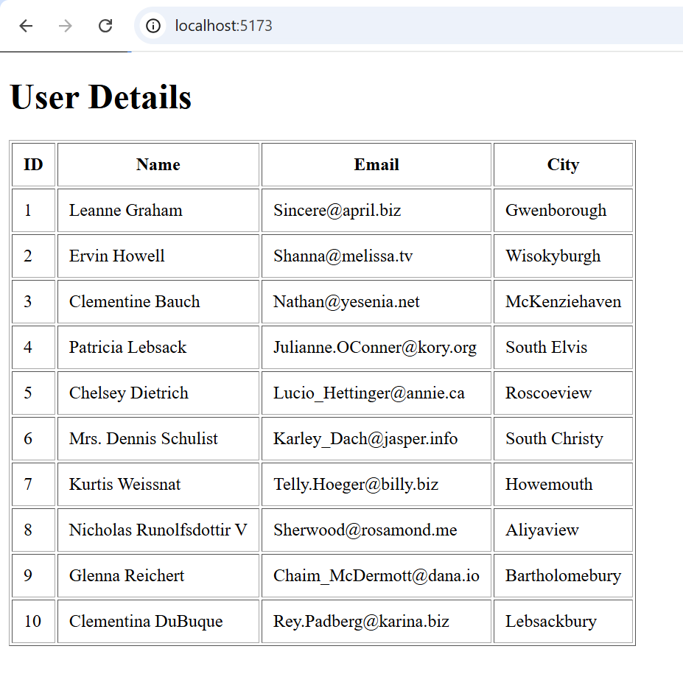
f. Implement search or filter functionality on displayed data.
To implement search or filter functionality on displayed data using React.
Procedure / Steps:
- Open the React project folder in VS Code.
- Install Axios using npm install axios.
- Open the src/App.jsx file.
- Import useState, useEffect, and axios.
- Fetch user data from a public API using Axios.
- Store the fetched data in state using useState.
- Create a search box to enter the user's name.
- Use the filter() method to search users by name.
- Display the filtered data in a table.
- Save the file and run the project using npm run dev.
- Open the local URL in the browser and test the search box.
App.jsx Program:
import { useState, useEffect } from "react";
import axios from "axios";
function App() {
const [users, setUsers] = useState([]);
const [search, setSearch] = useState("");
useEffect(() => {
axios
.get("https://jsonplaceholder.typicode.com/users")
.then((response) => setUsers(response.data))
.catch((error) => console.log(error));
}, []);
const filteredUsers = users.filter((user) =>
user.name.toLowerCase().includes(search.toLowerCase())
);
return (
<div>
<h2>Search Users</h2>
<input
type="text"
placeholder="Search by name"
value={search}
onChange={(e) => setSearch(e.target.value)}
/>
<table border="1" cellPadding="8">
<thead>
<tr>
<th>ID</th>
<th>Name</th>
<th>Email</th>
</tr>
</thead>
<tbody>
{filteredUsers.map((user) => (
<tr key={user.id}>
<td>{user.id}</td>
<td>{user.name}</td>
<td>{user.email}</td>
</tr>
))}
</tbody>
</table>
</div>
);
}
export default App;
Output:
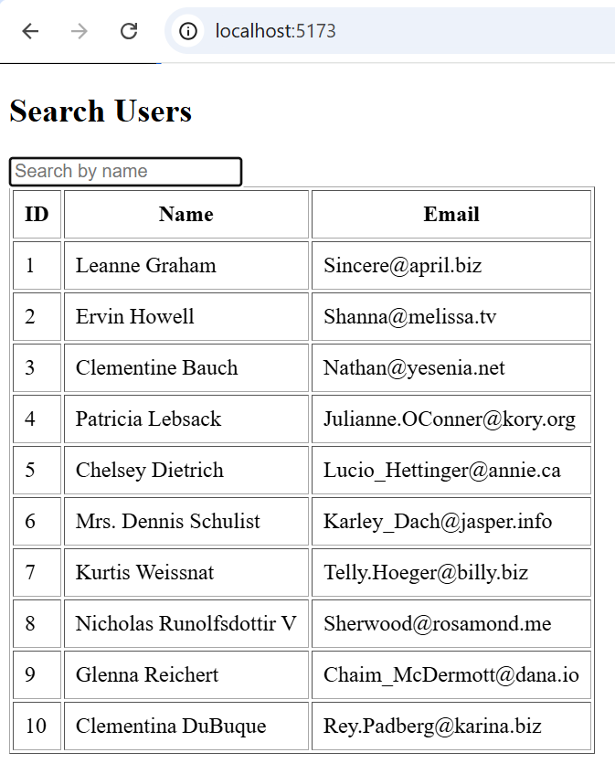

PRACTICAL 6
Node.js and Express Fundamentals
a. Install Express and create a simple server.
Aim:
To install Express.js and create a simple web server using Node.js and Express.
Procedure:
- Open Visual Studio Code.
- Create a folder named Practical 6.
- Open the terminal in VS Code.
- Initialize the Node.js project using the command:
npm init -y
- Install Express.js using the command:
npm install express
- Create a file named server.js.
- Write the following JavaScript code in the file.
- Save the file as server.js.
- Run the program using the command:
Node server.js
- Open a web browser.
- Enter http://localhost:3000 in the address bar.
Program:
const express = require('express');
const app = express();
app.get('/', (req, res) => {
res.send('Welcome to Express Server!');
});
app.listen(3000, () => {
console.log('Server is running on port 3000');
});
Output:
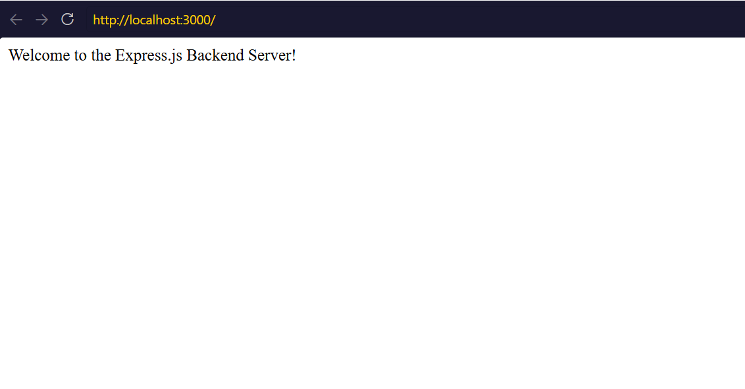
b. Display a message on the browser using the server response.
Title:
Display a Message on the Browser Using the Server Response
Procedure:
- Open Visual Studio Code.
- Open the folder containing the server.js file.
- Write the above code in server.js.
- Save the file.
- Open the terminal and execute the command:
node server.js
- Open a web browser and enter http://localhost:3000.
- Observe the message displayed in the browser.
Program:
const express = require('express');
const app = express();
app.get('/', (req, res) => {
res.send('Hello! Welcome to Node.js and Express.');
});
app.listen(3000, () => {
console.log('Server is running on port 3000');
});
Output:
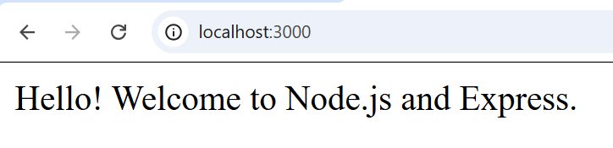
c. Create different routes in Express.
Aim:
To create different routes in Express.js and display different responses for each route.
Procedure:
- Open Visual Studio Code.
- Open the folder containing server.js.
- Write the above program in server.js.
- Save the file.
- Run the server using the command node server.js.
- Open a web browser.
- Visit different URLs to view the corresponding responses
Program:
const express = require('express');
const app = express();
app.get('/', (req, res) => {
res.send('Welcome to Home Page');
});
app.get('/about', (req, res) => {
res.send('This is About Page');
});
app.get('/contact', (req, res) => {
res.send('This is Contact Page');
});
app.listen(3000, () => {
console.log('Server is running on port 3000');
});
Output:
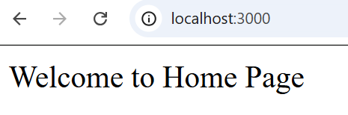

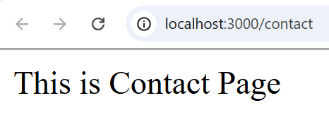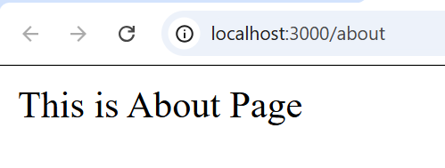
d. Send a JSON response from the server.
Aim:
To create an Express server and send a JSON response to the client.
Procedure:
- Open Visual Studio Code.
- Open the folder containing server.js.
- Write the above program in server.js.
- Save the file.
- Run the server using the command node server.js.
- Open a web browser.
- Enter http://localhost:3000/student in the address bar.
- Observe the JSON response displayed in the browser.
Program:
const express = require('express');
const app = express();
app.get('/student', (req, res) => {
res.json({
name: 'Chinmay Palshetkar',
course: 'B.Sc. IT',
semester: 5,
stack: 'MERN '
});
});
app.listen(3000, () => {
console.log('Server is running on port 3000');
});
Output:
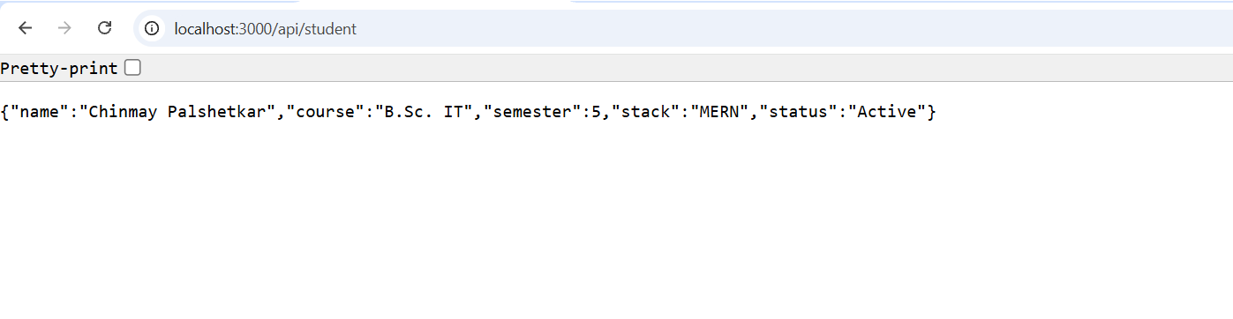
e. Test routes using browser or Postman.
Aim:
To test different routes of an Express server using a web browser or Postman.
Procedure:
- Open Visual Studio Code.
- Create or open the server.js file.
- Write the above Express server program.
- Save the file.
- Start the server using the command node server.js.
- Open a web browser.
- Enter the different route URLs in the address bar.
- Verify the responses displayed by the server.
Program:
const express = require('express');
const app = express();
app.get('/', (req, res) => {
res.send('Welcome to Home Page');
});
app.get('/about', (req, res) => {
res.send('This is About Page');
});
app.get('/student', (req, res) => {
res.json({
name: 'Rahul',
course: 'B.Sc. IT',
semester: 5
});
});
app.listen(3000, () => {
console.log('Server is running on port 3000');
});

Output:
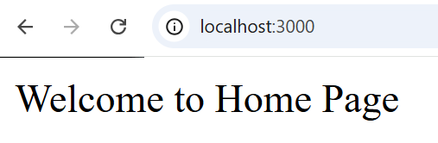
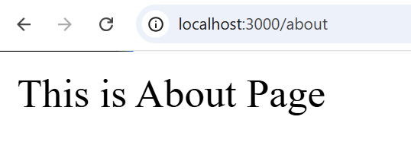
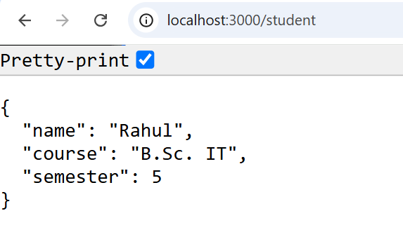
f. Run the server and observe the output in the console.
Aim:
To run an Express server and observe the output in the console.
Procedure:
- Open Visual Studio Code.
- Open the folder containing server.js.
- Write the above program in the file.
- Save the file.
- Open the terminal in VS Code.
- Run the command node server.js.
- Observe the server startup messages in the terminal.
- Open the browser and visit http://localhost:3000.
- Visit http://localhost:3000/about.
- Observe the corresponding route messages in the terminal.
Program:
const express = require('express');
const app = express();
app.get('/', (req, res) => {
console.log('Home route accessed');
res.send('Welcome to Express Server!');
});
app.get('/about', (req, res) => {
console.log('About route accessed');
res.send('This is About Page');
});
app.listen(3000, () => {
console.log('Server started successfully');
console.log('Server is running on port 3000');
});
Output:
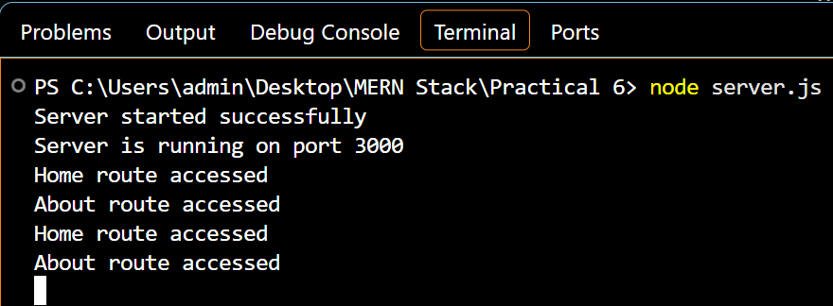
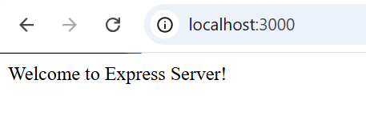
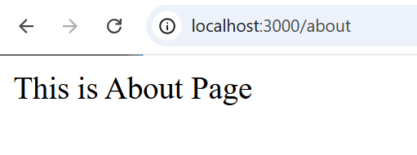

PRACTICAL 7
MongoDB Basics
a. Install and start MongoDB.
Aim:
To install and start MongoDB on a Windows system.
Procedure
- Opened the official MongoDB Community Server website: https://www.mongodb.com/try/download/community
- Selected the appropriate MongoDB version for Windows and downloaded the MSI installer.
- Ran the downloaded installer and completed the MongoDB Server installation.
- Opened File Explorer and navigated to the following path to locate the MongoDB Server installation:
C:\Program Files\MongoDB\Server\8.3
- Opened the bin folder and located the mongod executable file.
- Opened the VS Code terminal and checked the MongoDB Server version using the following command:
& "C:\Program Files\MongoDB\Server\8.3\bin\mongod.exe" --version
- Started the MongoDB Server using the following command:
& "C:\Program Files\MongoDB\Server\8.3\bin\mongod.exe" --dbpath "C:\Program Files\MongoDB\Server\8.3\data"
- Kept the terminal running to ensure that the MongoDB Server remained active.
- Downloaded MongoDB Shell (mongosh) from the official website: https://www.mongodb.com/try/download/shell
- Installed MongoDB Shell and kept the default installation path:
C:\Users\admin\AppData\Local\Programs\mongosh\
- Checked the MongoDB Shell version using the following command:
& "C:\Users\admin\AppData\Local\Programs\mongosh\mongosh.exe" --version
- Launched MongoDB Shell using the following command in a new terminal:
& "C:\Users\admin\AppData\Local\Programs\mongosh\mongosh.exe"
- Verified that MongoDB Shell connected successfully to the running MongoDB Server.
Output:
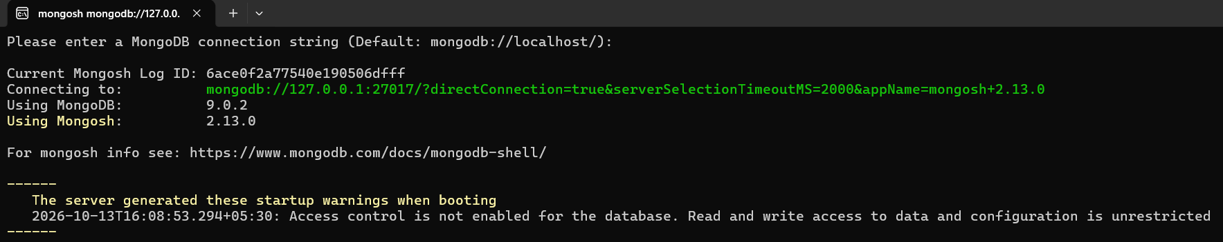
b. Create a database and collection.
Aim:
To create a database and collection in MongoDB.
Procedure
- Started the MongoDB Server using the mongod.exe executable.
- Opened a new terminal in VS Code.
- Started MongoDB Shell using the mongosh.exe executable.
- Created and selected the database named college using the command:
use college
- Created a collection named students using the command:
db.createCollection("students")
- Displayed all available databases using the command:
show dbs
- Verified that the college database appeared in the list.
- Displayed the collections in the current database using the command:
show collections
- Verified that the students collection appeared in the output.
Mongosh
use mern_lab_db
db.createCollection("students")

Output:
c. Insert records in MongoDB.
Aim:
To insert records into a MongoDB collection.
Procedure
- Started the MongoDB Server.
- Opened MongoDB Shell using mongosh.
- Selected the college database using the command:
use college
// Insert a single student record
db.students.insertOne({
name: "Chinmay Palshetkar",
course: "B.Sc. IT",
semester: 5,
skills: ["JavaScript", "Node.js", "React", "MongoDB", "AIML", "GenAI"]
});

// Insert multiple student records
db.students.insertMany([
{ name: "Priya Verma", course: "B.Sc. IT", semester: 6, skills: ["Python", "Machine Learning"] },
{ name: "Amit Patel", course: "B.Sc. IT", semester: 5, skills: ["Java", "SQL"] },
{ name: "Priya Joshi", course: "B.Sc. IT", semester: 6, skills: ["Python", "Machine Learning"] },
{ name: "Amit Patekar", course: "B.Sc. IT", semester: 5, skills: ["Java", "SQL"] },
{ name: "Payal Verma", course: "B.Sc. IT", semester: 6, skills: ["Python", "Machine Learning"] },
{ name: "Arvind Patole", course: "B.Sc. IT", semester: 5, skills: ["Java", "SQL"] }
]);

- Displayed the inserted records using:
db.students.find()
Output:
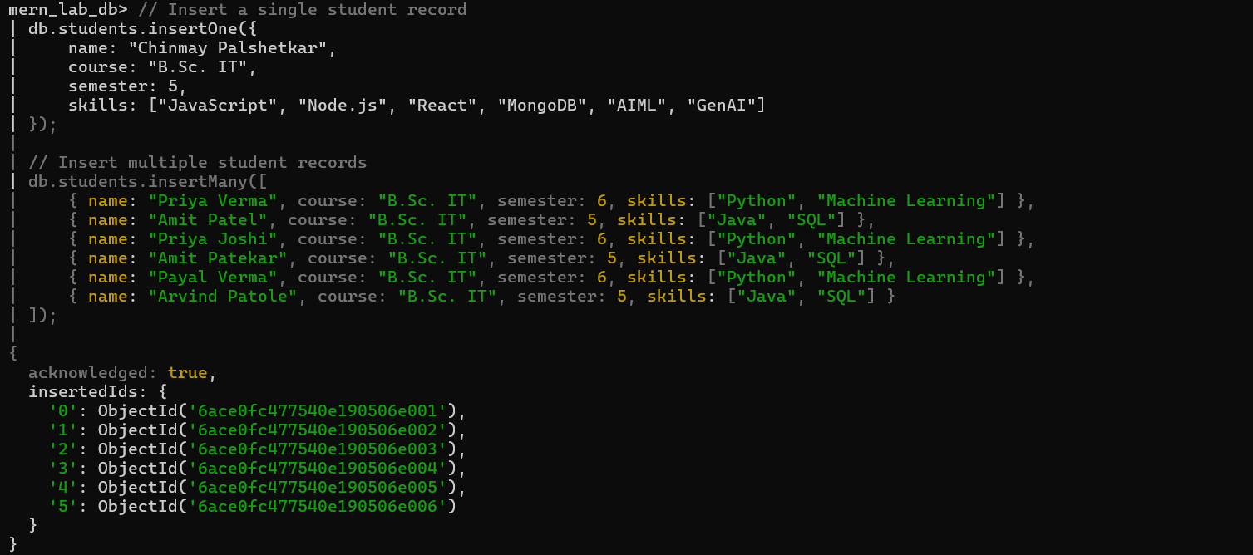

d. View records from the collection.
Aim:
To view records from a collection in MongoDB.
Procedure
- Started the MongoDB Server.
- Opened MongoDB Shell using mongosh.
- Selected the college database using the command:
use college
- Displayed all records from the students collection using the find() method:
db.students.find()
- Displayed the records in a readable format using the pretty() method:
db.students.find().pretty()
- Displayed only one record using the findOne() method:
db.students.findOne()
Output:
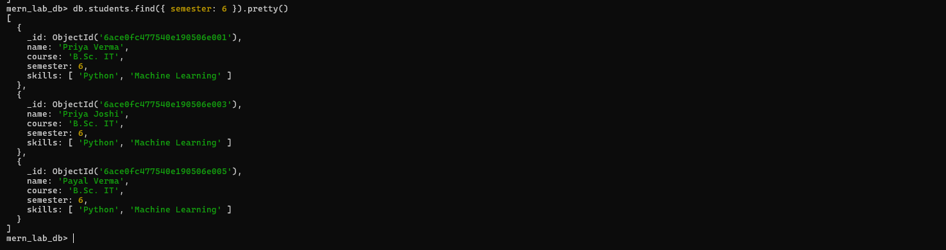
e. Update and delete records.
Aim: To update and delete records in a MongoDB collection.
Procedure
- Started the MongoDB Server and opened MongoDB Shell.
- Selected the college database using:
use college
- Displayed the existing student records using:
db.students.find()
- Update -
db.students.updateOne(
{ name: "Aarav Sharma" },
{ $set: { semester: 7 } }
);
- Delete-
db.students.deleteOne({ name: "Amit Patel" });
Verified the remaining records using:
db.students.find()
Output:
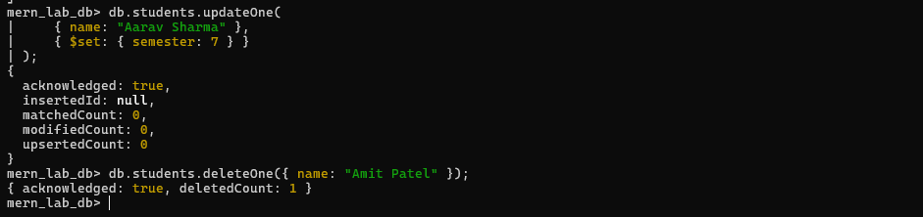

f. Connect MongoDB with Node.js.
Aim:
To connect MongoDB with Node.js.
Procedure
- Opened the Practical 7 folder in Visual Studio Code.
- Opened the terminal and initialized a Node.js project using npm init -y.
- Installed the MongoDB Node.js driver using npm install mongodb.
- Created a JavaScript file named connect.js.
- Imported MongoClient from the MongoDB driver.
- Connected Node.js to the local MongoDB server.
- Selected the college database and displayed a success message.
- Executed the program using node connect.js.
Program

Output:
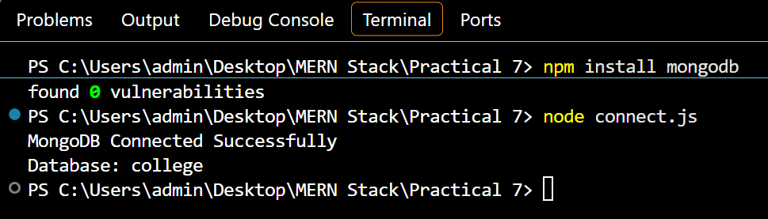

PRACTICAL 8
API Creation and Integration
a. Create a simple REST API using Express
Aim: To create a simple REST API using Express.js.
Procedure
- Opened the Practical 7 project folder in Visual Studio Code.
- Initialized the Node.js project using npm init -y.
- Installed Express.js using npm install express.
- Created a JavaScript file named api.js.
- Imported Express and created an Express application.
- Defined a GET route /api/students to return student records in JSON format.
- Started the server on port 3000.
http://localhost:3000/api/students
- Tested the API using a web browser.
Program
const express = require("express");
const app = express();
const students = [
{ id: 1, name: "Chinmay", course: "BSc IT" },
{ id: 2, name: "Aaryan", course: "BSc IT" }
];
app.get("/api/students", (req, res) => {
res.json(students);
});
app.listen(3000, () => {
console.log("REST API running on port 3000");
});
Output:
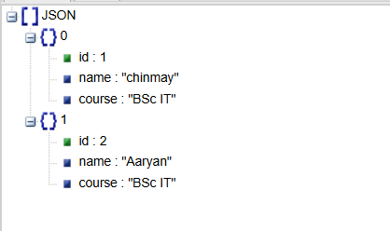

b. Implement a GET API to retrieve data.
Aim: To implement a GET API using Express.js to retrieve student data.

Procedure:
- Create a Node.js project and install Express.js.
- Create a file named get.js.
- Import Express and create an application.
- Define a GET route /api/students.
- Return student data in JSON format.
- Run the server and test the API in a browser
Program:
const express = require("express");
const app = express();
const students = [
{ id: 1, name: "Amit", course: "BSc IT" },
{ id: 2, name: "Neha", course: "BSc IT" }
];
app.get("/api/students", (req, res) => {
res.json(students);
});
app.listen(3001, () => {
console.log("GET API running on port 3001");
});
Output:
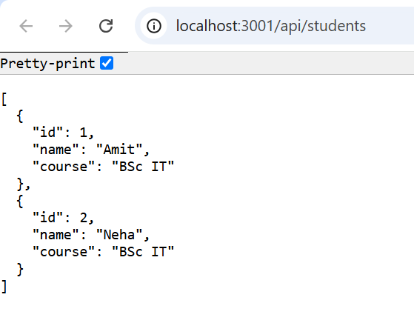

c. Fetch data from the API in a React application.
Aim:
To fetch and display data from an API in a React application.
Procedure:
- Open VS Code and create an Express API in get.js.
- Install Express and CORS using npm install express cors.
- Create a GET route /api/students to return student data in JSON format.
- Run the backend server using node get.js.
- Test the API at http://localhost:3001/api/students.
- Create a React application named react-api using Vite.
- Open src/App.jsx and import useState and useEffect.
- Use the fetch() method to retrieve data from the API.
- Display student details using the map() method.
- Run the React application using npm run dev and check the output in the browser.
Program:
get.js (Express API)
const express = require("express");
const cors = require("cors");
const app = express();
app.use(cors());
const students = [
{ id: 1, name: "Amit", course: "BSc IT" },
{ id: 2, name: "Neha", course: "BSc IT" }
];
app.get("/api/students", (req, res) => {
res.json(students);
});
app.listen(3001, () => {
console.log("GET API running on port 3001");
});

App.jsx (React Application)
import { useState, useEffect } from "react";
function App() {
const [students, setStudents] = useState([]);
useEffect(() => {
fetch("http://localhost:3001/api/students")
.then((response) => response.json())
.then((data) => setStudents(data))
.catch((error) => console.error("Error:", error));
}, []);
return (
<div>
<h1>Student Details</h1>
{students.map((student) => (
<p key={student.id}>
{student.id} - {student.name} - {student.course}
</p>
))}
</div>
);
}
export default App;

Output:
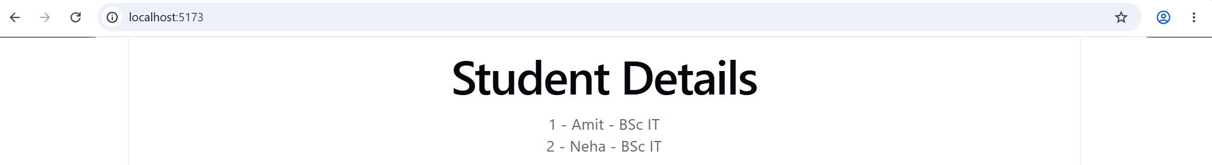
d. Send data from React to the server using a POST request.
Aim:
To send data from a React application to an Express server using a POST request.
Procedure:
- Open the Practical 7 folder and create a file named post.js.
- Install Express and CORS, then write the POST API code in post.js.
- Use express.json() to receive JSON data and create a POST route on port 3002.
- Run the server using node post.js in the terminal.
- Open the react-api folder and write the React form code in src/App.jsx.
- Create input fields for student name and course, along with a Send Data button.
- Run the React application using npm run dev.
- Open the React application in the browser and enter the student name and course.
- Click Send Data to send the form data to the Express server using the fetch() POST request.
- Verify that the message “Student data received successfully” appears on the webpage.
Program:
File 1: post.js
const express = require("express");
const cors = require("cors");
const app = express();
app.use(cors());
app.use(express.json());
app.post("/api/students", (req, res) => {
const student = req.body;hogy
res.json({
message: "Student data received successfully",
student: student
});
});
app.listen(3002, () => {
console.log("POST API running on port 3002");
});
File 2: App.jsx
import { useState } from "react";
function App() {
const [name, setName] = useState("");
const [course, setCourse] = useState("");
const [message, setMessage] = useState("");
const sendData = async (e) => {
e.preventDefault();
const response = await fetch(
"http://localhost:3002/api/students",
{
method: "POST",
headers: {
"Content-Type": "application/json"
},
body: JSON.stringify({ name, course })
}
);
const data = await response.json();
setMessage(data.message);
};
return (
<div>
<h1>Add Student</h1>
<form onSubmit={sendData}>
<input
placeholder="Enter name"
value={name}
onChange={(e) => setName(e.target.value)}
required
/>
<input
placeholder="Enter course"
value={course}
onChange={(e) => setCourse(e.target.value)}
required
/>
<button type="submit">Send Data</button>
</form>
<p>{message}</p>
</div>
);
}
export default App;
Output:
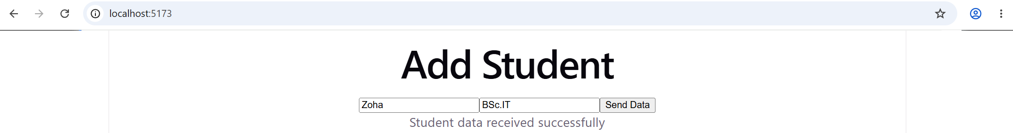
e. Store data in MongoDB.
Aim:
To send data from a React application to an Express server using a POST request.
Procedure:
Procedure:
- Open VS Code and create a store.js file in the Practical 7 folder.
- Paste the Express and MongoDB code into store.js and save the file.
- Start MongoDB using the command:
& "C:\Program Files\MongoDB\Server\8.3\bin\mongod.exe"
- Open a new terminal and run:
cd "C:\Users\admin\Desktop\MERN Stack\Practical 7"
- Start the backend server using:
node store.js
- Open the react-api folder and create or edit src/App.jsx.
- Paste the React form code into App.jsx and save the file.
- Open a new terminal and run:
cd "C:\Users\admin\Desktop\MERN Stack\react-api"
- Start the React application using:
npm run dev
- Open the Local URL in the browser, enter the student name and course, and click Save Student.
- Verify that the success message appears and check that the data is stored in MongoDB.
Program:
Store.js Program:
const express = require("express");
const cors = require("cors");
const { MongoClient } = require("mongodb");
const app = express();
app.use(cors());
app.use(express.json());
const url = "mongodb://127.0.0.1:27017";
const client = new MongoClient(url);
app.post("/api/students", async (req, res) => {
try {
await client.connect();
const db = client.db("college");
const collection = db.collection("students");
const result = await collection.insertOne(req.body);
res.json({
message: "Student data stored successfully",
id: result.insertedId
});
} catch (error) {
res.status(500).json({ error: "Database error" });
}
});
app.listen(3003, () => {
console.log("MongoDB API running on port 3003");
});
App.jsx Program:
import { useState } from "react";
function App() {
const [name, setName] = useState("");
const [course, setCourse] = useState("");
const [message, setMessage] = useState("");
const sendData = async (e) => {
e.preventDefault();
try {
const response = await fetch(
"http://localhost:3003/api/students",
{
method: "POST",
headers: {
"Content-Type": "application/json"
},
body: JSON.stringify({ name, course })
}
);
const data = await response.json();
setMessage(data.message || data.error);
} catch (error) {
setMessage("Error connecting to server");
}
};
return (
<div>
<h1>Store Student Data</h1>
<form onSubmit={sendData}>
<input
placeholder="Enter name"
value={name}
onChange={(e) => setName(e.target.value)}
required
/>
<input
placeholder="Enter course"
value={course}
onChange={(e) => setCourse(e.target.value)}
required
/>
<button type="submit">Save Student</button>
</form>
<p>{message}</p>
</div>
);
}
export default App;
Output:
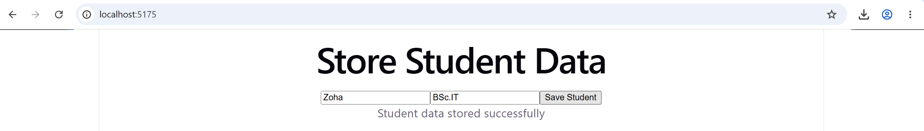
f. Display stored data in React page.
Aim:
To retrieve and display student data stored in MongoDB on a React webpage.
Procedure:
- Open VS Code and create a file named display.js in the Practical 8 folder.
- Paste the Express and MongoDB code to fetch stored student data and save the file.
- Start MongoDB using the command:
& "C:\Program Files\MongoDB\Server\8.3\bin\mongod.exe"
- Open a terminal and run:
cd "C:\Users\admin\Desktop\MERN Stack\Practical 8"
- Start the display server using:
node display.js
- Open react-api/src/App.jsx and paste the React code to fetch and display student records.
- Save the file and open a new terminal.
- Run:
cd "C:\Users\admin\Desktop\MERN Stack\react-api"
- Start React using:
npm run dev
- Open the Local URL in the browser and verify that the stored student names and courses are displayed.
Programs:
Display.js Program:
const express = require("express");
const cors = require("cors");
const { MongoClient } = require("mongodb");
const app = express();
app.use(cors());
const url = "mongodb://127.0.0.1:27017";
const client = new MongoClient(url);
app.get("/api/students", async (req, res) => {
try {
await client.connect();
const db = client.db("college");
const students = await db.collection("students").find().toArray();
res.json(students);
} catch (error) {
res.status(500).json({ error: "Database error" });
}
});
app.listen(3004, () => {
console.log("Display API running on port 3004");
});
App.jsx Program:
import { useState, useEffect } from "react";
function App() {
const [students, setStudents] = useState([]);
useEffect(() => {
fetch("http://localhost:3004/api/students")
.then((response) => response.json())
.then((data) => setStudents(data))
.catch((error) => console.error("Error:", error));
}, []);
return (
<div>
<h1>Student Details</h1>
{students.map((student) => (
<p key={student._id}>
{student.name} - {student.course}
</p>
))}
</div>
);
}
export default App;
Output:
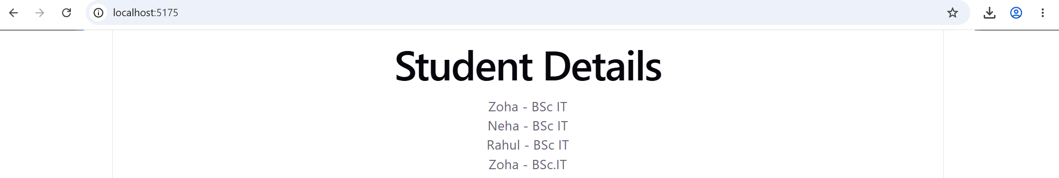

PRACTICAL 9

User Data Management
a. Create an API to add user details using Express and MongoDB.
Aim:
To create an API to add user details using Express.js and MongoDB.
Procedure:
- Open VS Code and create addUser.js in the Practical 9 folder.
- Paste the Express and MongoDB code to create a POST API for adding user details.
- Install the required packages using:
npm install express cors mongodb
- Start MongoDB using:
& "C:\Program Files\MongoDB\Server\8.3\bin\mongod.exe"
- Open a terminal and run:
cd "C:\Users\admin\Desktop\MERN Stack\Practical 9"
- Start the API using:
node addUser.js
- Open react-api/src/App.jsx and paste the React form code to enter user details.
- Save the file and open a new terminal.
- Run:
cd "C:\Users\admin\Desktop\MERN Stack\react-api"
- Start React using:
npm run dev
- Open the Local URL, enter the user's name and email, and click Add User.
- Verify that the success message appears and the user details are stored in MongoDB.
Programs:
addUser.js Program:
const express = require("express");
const cors = require("cors");
const { MongoClient } = require("mongodb");
const app = express();
app.use(cors());
app.use(express.json());
const url = "mongodb://127.0.0.1:27017";
const client = new MongoClient(url);
app.post("/api/users", async (req, res) => {
try {
await client.connect();
const db = client.db("college");
const users = db.collection("users");
await users.insertOne(req.body);
res.json({ message: "User added successfully" });
} catch (error) {
res.status(500).json({ error: "Database error" });
}
});
app.listen(3005, () => {
console.log("User API running on port 3005");
});
App.jsx
import { useState } from "react";
function App() {
const [name, setName] = useState("");
const [email, setEmail] = useState("");
const [message, setMessage] = useState("");
const addUser = async (e) => {
e.preventDefault();
try {
const response = await fetch("http://localhost:3005/api/users", {
method: "POST",
headers: {
"Content-Type": "application/json"
},
body: JSON.stringify({ name, email })
});
const data = await response.json();
setMessage(data.message || data.error);
} catch (error) {
setMessage("Error connecting to server");
}
};
return (
<div>
<h1>Add User Details</h1>
<form onSubmit={addUser}>
<input
placeholder="Enter name"
value={name}
onChange={(e) => setName(e.target.value)}
required
/>
<input
placeholder="Enter email"
type="email"
value={email}
onChange={(e) => setEmail(e.target.value)}
required
/>
<button type="submit">Add User</button>
</form>
<p>{message}</p>
</div>
);
}
export default App;
Output:
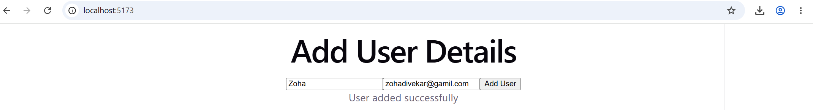
b. Design a React form to send user data to the backend.
Aim:
To design a React form to send user data to the backend.
Procedure:
- Open VS Code and open the react-api folder.
- Open src/App.jsx and design a React form with Name and Email input fields and a Submit button.
- Write the fetch() POST request code to send user data to the backend API.
- Save the file using Ctrl + S.
- Open a new terminal and run:
cd "C:\Users\admin\Desktop\MERN Stack\Practical 9"
- Start the backend using:
node addUser.js
- Open another terminal and run:
cd "C:\Users\admin\Desktop\MERN Stack\react-api"
- Start the React application using:
npm run dev
- Open the Local URL in the browser and enter the user's name and email.
- Click Submit and verify that the success message appears.
App.jsx program:
import { useState } from "react";
function App() {
const [name, setName] = useState("");
const [email, setEmail] = useState("");
const [message, setMessage] = useState("");
const handleSubmit = async (e) => {
e.preventDefault();
try {
const response = await fetch("http://localhost:3005/api/users", {
method: "POST",
headers: {
"Content-Type": "application/json"
},
body: JSON.stringify({ name, email })
});
const data = await response.json();
setMessage(data.message || data.error);
} catch (error) {
setMessage("Error connecting to server");
}
};
return (
<div>
<h1>User Registration Form</h1>
<form onSubmit={handleSubmit}>
<input
type="text"
placeholder="Enter Name"
value={name}
onChange={(e) => setName(e.target.value)}
required
/>
<input
type="email"
placeholder="Enter Email"
value={email}
onChange={(e) => setEmail(e.target.value)}
required
/>
<button type="submit">Submit</button>
</form>
<p>{message}</p>
</div>
);
}
export default App;
Output:
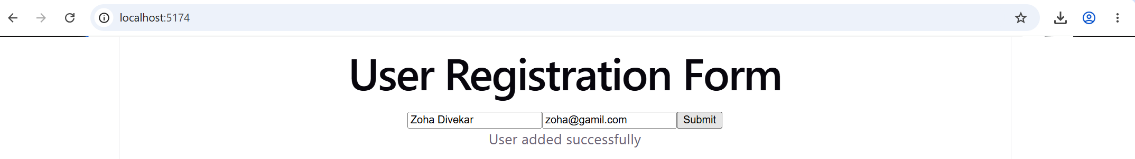
c. Retrieve and display user data from MongoDB.
Aim:
To retrieve user data from MongoDB and display it on a React webpage.
Procedure:
- Open VS Code and create a file named getUsers.js in the Practical 9 folder.
- Paste the Express and MongoDB code to retrieve user records and save the file.
- Start MongoDB using the command:
& "C:\Program Files\MongoDB\Server\8.3\bin\mongod.exe"
- Open a terminal and run:
cd "C:\Users\admin\Desktop\MERN Stack\Practical 9"
- Start the backend server using:
node getUsers.js
- Open react-api/src/App.jsx and paste the React code to fetch and display user details.
- Save the file and open a new terminal.
- Run:
cd "C:\Users\admin\Desktop\MERN Stack\react-api"
- Start React using:
npm run dev
- Open the Local URL in the browser and verify that stored user names and emails are displayed.
Programs:
getUsers.js:
const express = require("express");
const cors = require("cors");
const { MongoClient } = require("mongodb");
const app = express();
app.use(cors());
const url = "mongodb://127.0.0.1:27017";
const client = new MongoClient(url);
app.get("/api/users", async (req, res) => {
try {
await client.connect();
const db = client.db("college");
const users = await db.collection("users").find().toArray();
res.json(users);
} catch (error) {
res.status(500).json({ error: "Database error" });
}
});
app.listen(3006, () => {
console.log("Get Users API running on port 3006");
});
App.jsx:
import { useState, useEffect } from "react";
function App() {
const [users, setUsers] = useState([]);
useEffect(() => {
fetch("http://localhost:3006/api/users")
.then((response) => response.json())
.then((data) => setUsers(data))
.catch((error) => console.error("Error:", error));
}, []);

return (
<div>
<h1>User Details</h1>
{users.map((user) => (
<p key={user._id}>
{user.name} - {user.email}
</p>
))}
</div>
);
}
export default App;
Output:
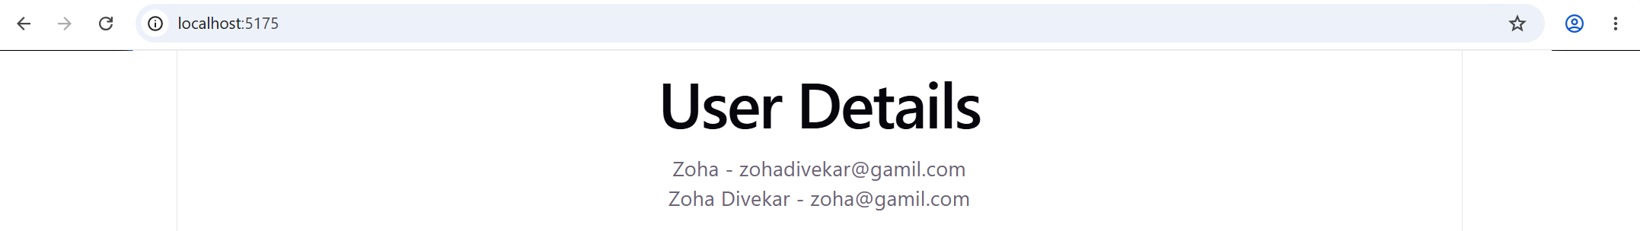
d. Implement an update operation for existing records.
Aim:
To update existing user records in MongoDB using Express and React.
Procedure:
- Open VS Code and create updateUser.js in the Practical 9 folder.
- Paste the Express and MongoDB code to update existing user records and save the file.
- Start MongoDB using:
& "C:\Program Files\MongoDB\Server\8.3\bin\mongod.exe"
- Open a terminal and run:
cd "C:\Users\admin\Desktop\MERN Stack\Practical 9"
- Start the backend using:
node updateUser.js
- Open react-api/src/App.jsx and paste the React form code to update user details.
- Save the file and open MongoDB Shell using:
& "$env:LOCALAPPDATA\Programs\mongosh\mongosh.exe"
- Select the database and display existing users:
use college
db.users.find()
- Copy the user's _id and enter it in the React form along with the updated name and email.
- Start React using npm run dev and open the Local URL in the browser.
- Click Update User and verify the success message.
Programs:
updateUser.js:
const express = require("express");
const cors = require("cors");
const { MongoClient, ObjectId } = require("mongodb");
const app = express();
app.use(cors());
app.use(express.json());
const client = new MongoClient("mongodb://127.0.0.1:27017");
app.put("/api/users/:id", async (req, res) => {
try {
await client.connect();
const db = client.db("college");
const users = db.collection("users");
const result = await users.updateOne(
{ _id: new ObjectId(req.params.id) },
{ $set: req.body }
);
res.json({ message: "User updated successfully" });
} catch (error) {
res.status(500).json({ error: "Update failed. Check user ID." });
}
});
app.listen(3007, () => {
console.log("Update User API running on port 3007");
});

App.jsx:
import { useState } from "react";
function App() {
const [id, setId] = useState("");
const [name, setName] = useState("");
const [email, setEmail] = useState("");
const [message, setMessage] = useState("");
const updateUser = async (e) => {
e.preventDefault();
try {
const response = await fetch(
`http://localhost:3007/api/users/${id}`,
{
method: "PUT",
headers: {
"Content-Type": "application/json"
},
body: JSON.stringify({ name, email })
}
);
const data = await response.json();
setMessage(data.message || data.error);
} catch (error) {
setMessage("Error connecting to server");
}
};
return (
<div>
<h1>Update User Details</h1>
<form onSubmit={updateUser}>
<input
placeholder="Enter User ID"
value={id}
onChange={(e) => setId(e.target.value)}
required
/>
<input
placeholder="Enter New Name"
value={name}
onChange={(e) => setName(e.target.value)}
required
/>
<input
type="email"
placeholder="Enter New Email"
value={email}
onChange={(e) => setEmail(e.target.value)}
required
/>
<button type="submit">Update User</button>
</form>
<p>{message}</p>
</div>
);
}
export default App;
Output:
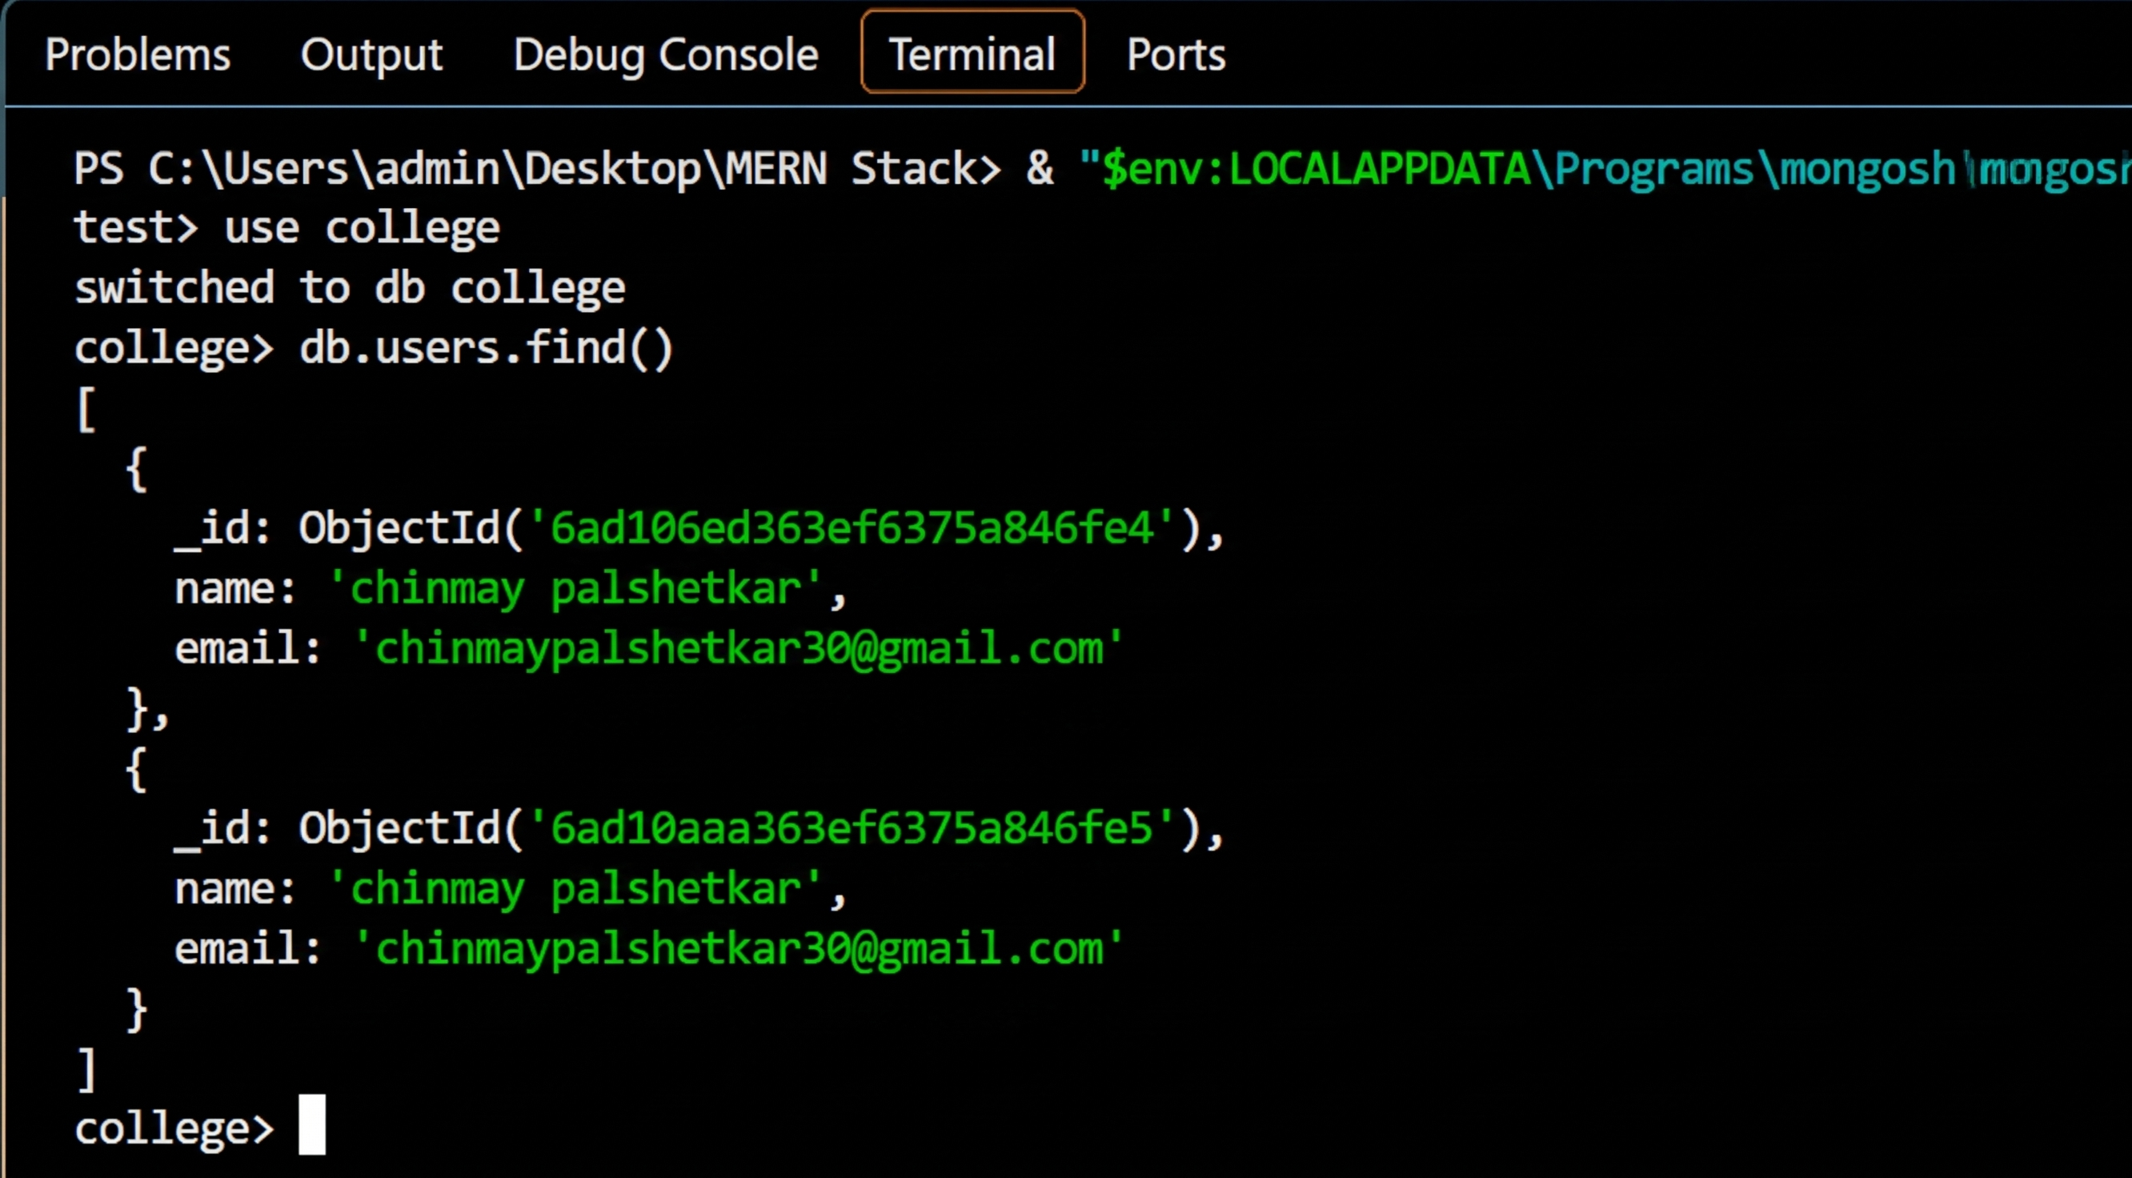

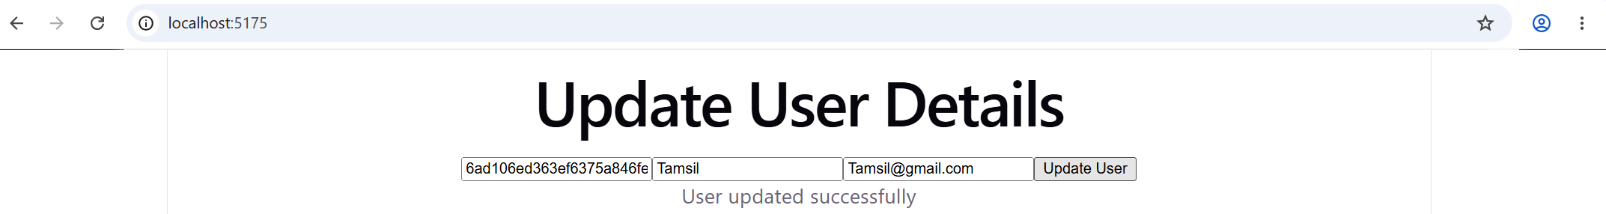

e. Implement the delete operation for selected records.
Aim:
To delete selected user records from MongoDB using Express and React.
Procedure:
- Open VS Code and create deleteUser.js in the Practical 9 folder.
- Write the Express.js code to connect to MongoDB and delete a selected user using the DELETE method and ObjectId.
- Save the file and run the backend server:
node deleteUser.js
- Open react-api/src/App.jsx and create a React form to enter the user ID and delete the record.
- Save the file and start the React application using:
npm run dev
- Open MongoDB Shell and execute:
- use college
db.users.find()
- Copy the _id of the user to be deleted and enter it into the React form.
- Click the Delete User button and verify the success message.
- Verify the deletion in MongoDB using db.users.find().
Programs:
deleteUser.js:
const express = require("express");
const cors = require("cors");
const { MongoClient, ObjectId } = require("mongodb");
const app = express();
app.use(cors());
const client = new MongoClient("mongodb://127.0.0.1:27017");
app.delete("/api/users/:id", async (req, res) => {
try {
await client.connect();
const db = client.db("college");
const users = db.collection("users");
const result = await users.deleteOne({
_id: new ObjectId(req.params.id)
});
if (result.deletedCount === 1) {
res.json({ message: "User deleted successfully" });
} else {
res.status(404).json({ message: "User not found" });
}
} catch (error) {
res.status(400).json({ error: "Invalid user ID or delete failed" });
}
});
app.listen(3008, () => {
console.log("Delete User API running on port 3008");
});
App.jsx:
import { useState } from "react";
function App() {
const [id, setId] = useState("");
const [message, setMessage] = useState("");
const deleteUser = async (e) => {
e.preventDefault();
try {
const response = await fetch(
`http://localhost:3008/api/users/${id}`,
{ method: "DELETE" }
);
const data = await response.json();
setMessage(data.message || data.error);
} catch (error) {
setMessage("Error connecting to server");
}
};
return (
<div>
<h1>Delete User</h1>
<form onSubmit={deleteUser}>
<input
placeholder="Enter User ID"
value={id}
onChange={(e) => setId(e.target.value)}
required
/>
<button type="submit">Delete User</button>
</form>
<p>{message}</p>
</div>
);
}
export default App;
Output:
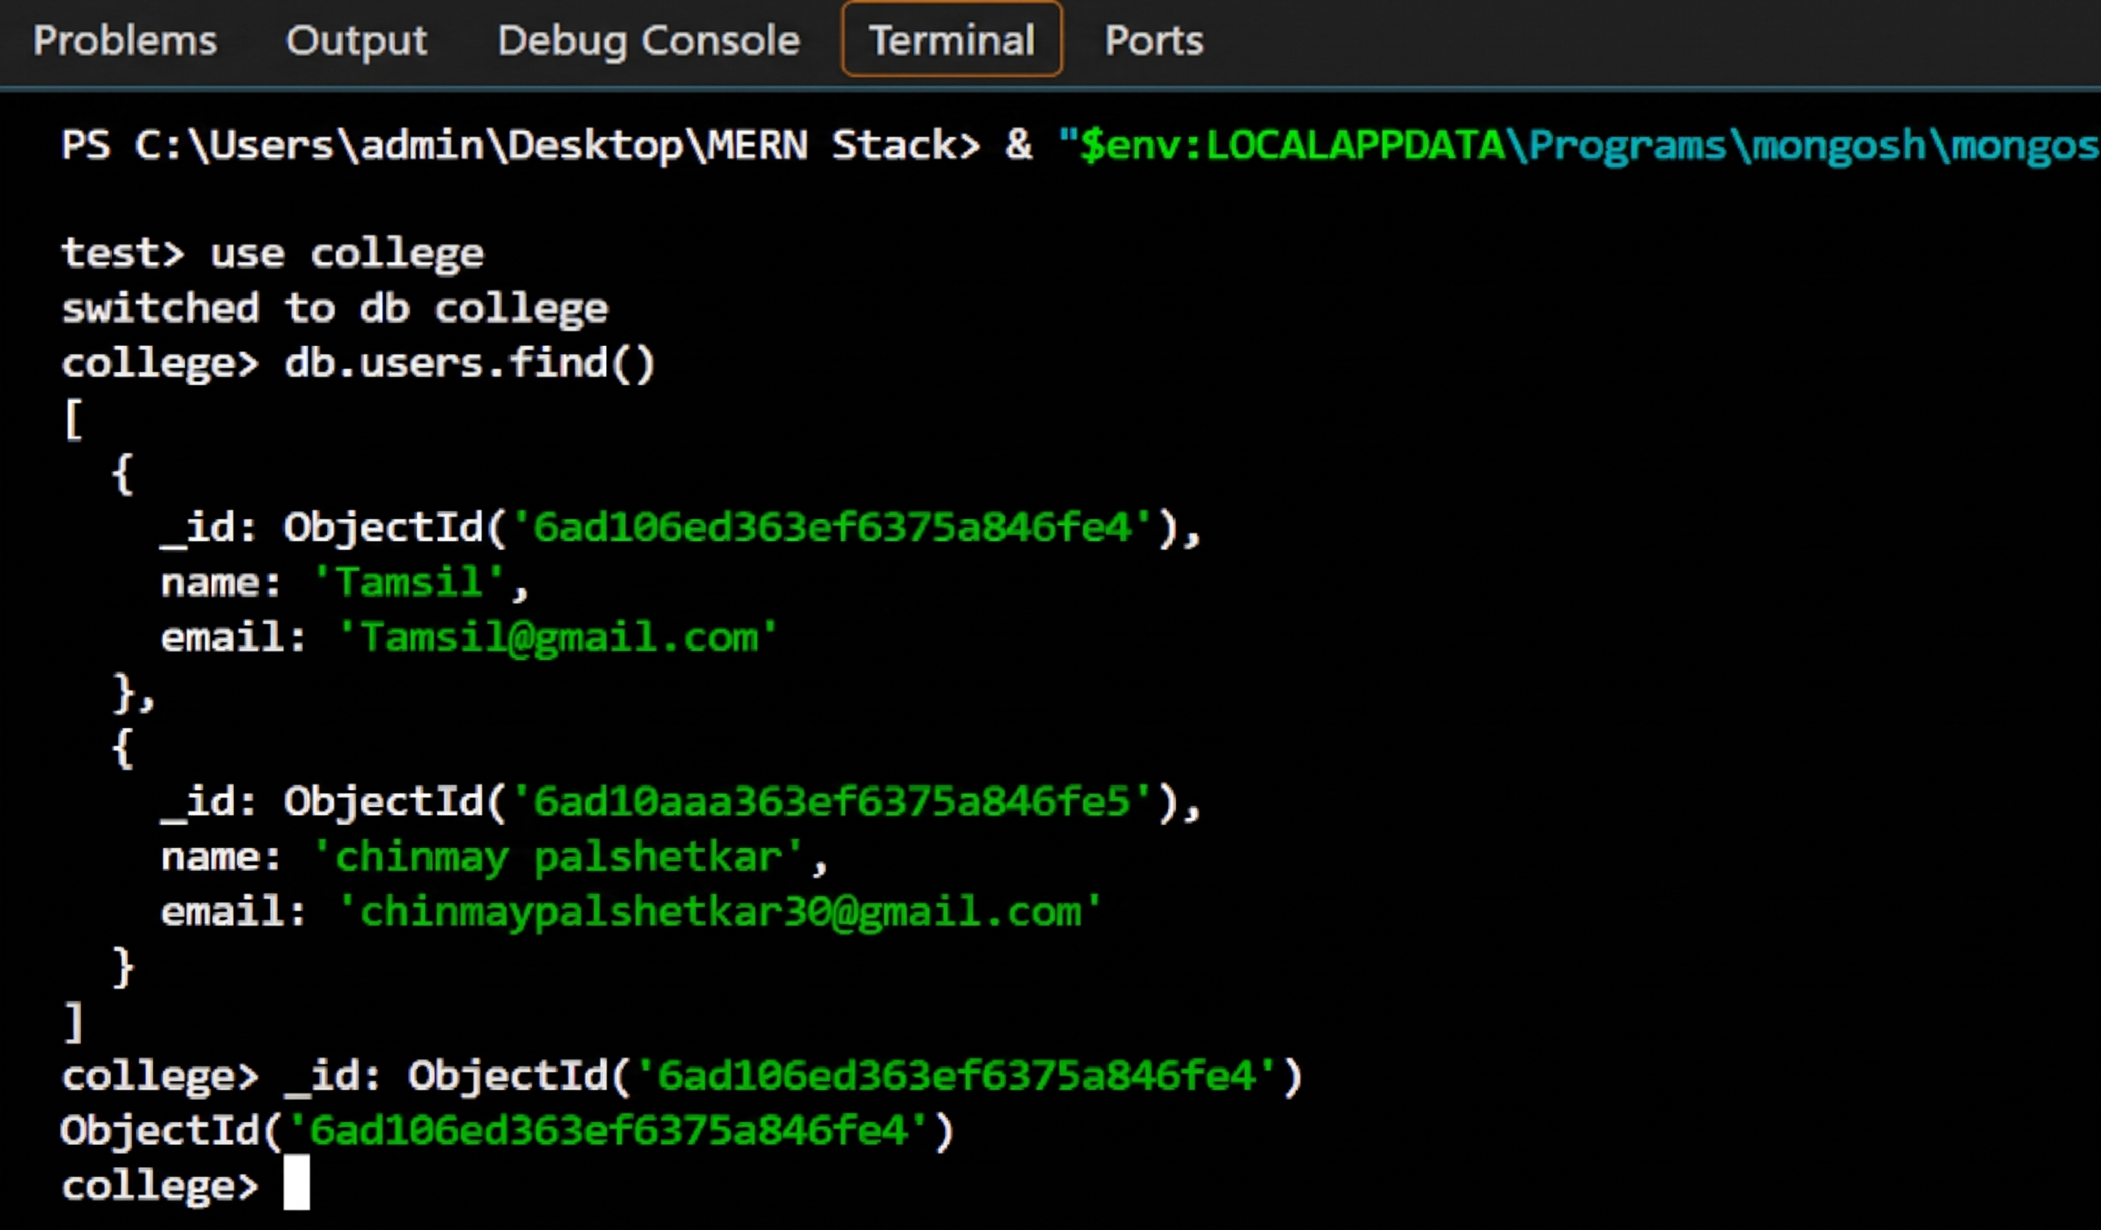

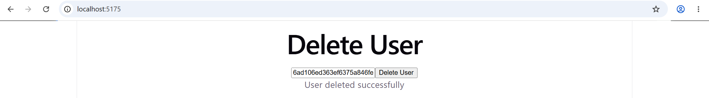
f. Display updated records dynamically in React.
Aim:
To display updated records dynamically in React by fetching data from MongoDB through an Express API.
Procedure
- Open VS Code and create getUpdatedUsers.js in the Practical 9 folder.
- Write Express.js code to connect to MongoDB and retrieve all records from the college database's users collection.
- Create a GET API endpoint /api/users on port 3009.
- Save the file and start the backend server using:
node getUpdatedUsers.js
- Open react-api/src/App.jsx and import useState and useEffect from React.
- Use the fetch() method to retrieve user records from the backend API.
- Store the retrieved records in React state using useState and display them in an HTML table.
- Add a Refresh Records button to fetch the latest records when clicked.
- Save the file and run the React application using:
npm run dev
- Open the application in a browser and verify that user records are displayed. Add, update, or delete a record using the relevant practical, then click Refresh Records to view the latest data.
Programs:
getUpdatedUsers.js:
const express = require("express");
const cors = require("cors");
const { MongoClient } = require("mongodb");
const app = express();
app.use(cors());
const client = new MongoClient("mongodb://127.0.0.1:27017");
app.get("/api/users", async (req, res) => {
try {
await client.connect();
const db = client.db("college");
const users = db.collection("users");
const records = await users.find().toArray();
res.json(records);
} catch (error) {
res.status(500).json({ error: "Failed to fetch users" });
}
});
app.listen(3009, () => {
console.log("Updated Users API running on port 3009");
});
App.jsx:
import { useState, useEffect } from "react";
function App() {
const [users, setUsers] = useState([]);
const [message, setMessage] = useState("Loading users...");
const fetchUsers = async () => {
try {
const response = await fetch("http://localhost:3009/api/users");
const data = await response.json();
if (!response.ok) {
throw new Error("Failed to fetch users");
}
setUsers(data);
setMessage(data.length === 0 ? "No users found." : "");
} catch (error) {
setMessage("Error loading users. Check the backend server.");
}
};
useEffect(() => {
fetchUsers();
}, []);
return (
<div>
<h1>Updated User Records</h1>
<button onClick={fetchUsers}>Refresh Records</button>
<p>{message}</p>
<table border="1" cellPadding="8">
<thead>
<tr>
<th>ID</th>
<th>Name</th>
<th>Email</th>
</tr>
</thead>
<tbody>
{users.map((user) => (
<tr key={user._id}>
<td>{user._id}</td>
<td>{user.name}</td>
<td>{user.email}</td>
</tr>
))}
</tbody>
</table>
</div>
);
}
export default App;
Output:
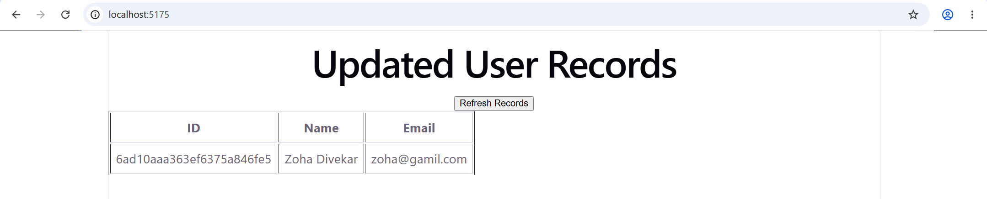

Practical 10

Full Stack Execution and Validation
a. Integrate React frontend with Node and Express backend.
Aim:
To integrate the React frontend with the Node.js and Express backend and verify their communication.
Procedure
- Open VS Code and create a new folder named Practical 10 inside:
C:\Users\admin\Desktop\MERN Stack
- Open the Practical 10 folder in VS Code and open a new terminal.
- Initialize the Node.js project using:
npm init -y
- Install the required packages using:
npm install express cors mongodb
- Create a file named server.js inside the Practical 10 folder.
- Write the Express backend code to create a GET API endpoint /api/message on port 3010. The endpoint returns a JSON message confirming successful frontend-backend communication.
- Save the file and start the backend server using:
node server.js
- Open the existing React project at:
C:\Users\admin\Desktop\MERN Stack\react-api
- Open src/App.jsx and write React code using useState, useEffect, and fetch() to request data from http://localhost:3010/api/message.
- Save the React file and start the frontend in a separate terminal using:
npm run dev
- Open the Local URL displayed in the terminal. Verify that the message “React frontend connected to Express backend successfully!” appears on the webpage.
Programs:
server.js:
const express = require("express");
const cors = require("cors");
const app = express();
app.use(cors());
app.use(express.json());
app.get("/api/message", (req, res) => {
res.json({
message: "React frontend connected to Express backend successfully!"
});
});
app.listen(3010, () => {
console.log("Express server running on port 3010");
});
App.jsx:
import { useState, useEffect } from "react";
function App() {
const [message, setMessage] = useState("Connecting to backend...");
useEffect(() => {
fetch("http://localhost:3010/api/message")
.then((response) => {
if (!response.ok) {
throw new Error("Backend request failed");
}
return response.json();
})
.then((data) => setMessage(data.message))
.catch(() => setMessage("Backend connection failed"));
}, []);
return (
<div>
<h1>Full Stack Integration</h1>
<p>{message}</p>
</div>
);
}
export default App;

Output:
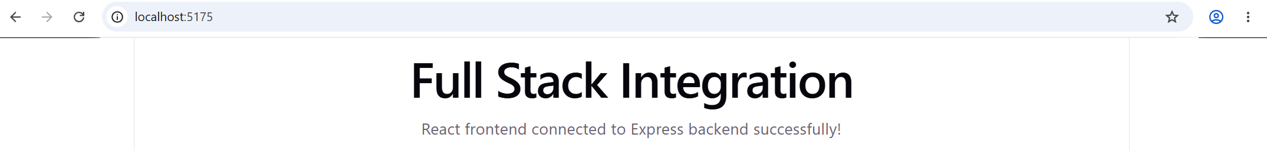
b. Perform insert, update, and delete operations through UI.
Aim:
To perform insert, update, and delete operations through a React user interface using Node.js, Express.js, and MongoDB.
Procedure
- Opened VS Code and opened the existing Practical 10 folder.
- Opened a new terminal and installed the required packages:
npm install express cors mongodb
- Created a new file named crudServer.js inside the Practical 10 folder.
- Pasted the Express.js code to connect to MongoDB and perform insert, update, and delete operations on the college database's users collection.
- Saved the file using Ctrl + S.
- Opened a new terminal and executed the following commands to start the backend server:
- cd "C:\Users\admin\Desktop\MERN Stack\Practical 10"
node crudServer.js
- Opened the existing React project at C:\Users\admin\Desktop\MERN Stack\react-api.
- Opened src/App.jsx, removed the previous code, and pasted the React code containing User ID, Name, and Email fields with Insert User, Update User, and Delete User buttons.
- Saved the React file using Ctrl + S.
- Started the React application in a separate terminal:
- cd "C:\Users\admin\Desktop\MERN Stack\react-api"
npm run dev
- Opened the Local URL displayed in the terminal and tested the operations:
  - Entered a name and email and clicked Insert User.
  - Entered the selected user's ID and new details and clicked Update User.
  - Entered the selected test user's ID and clicked Delete User.
- Verified the success messages displayed after each operation.

Programs:
crudServer.js
const express = require("express");
const cors = require("cors");
const { MongoClient, ObjectId } = require("mongodb");
const app = express();
app.use(cors());
app.use(express.json());
const client = new MongoClient("mongodb://127.0.0.1:27017");
app.post("/api/users", async (req, res) => {
try {
await client.connect();
const db = client.db("college");
const result = await db.collection("users").insertOne(req.body);
res.json({ message: "User inserted successfully", id: result.insertedId });
} catch (error) {
res.status(500).json({ error: "Insert failed" });
}
});
app.put("/api/users/:id", async (req, res) => {
try {
await client.connect();
const db = client.db("college");
const result = await db.collection("users").updateOne(
{ _id: new ObjectId(req.params.id) },
{ $set: req.body }
);
if (result.matchedCount === 0) {
return res.status(404).json({ error: "User not found" });
}
res.json({ message: "User updated successfully" });
} catch (error) {
res.status(400).json({ error: "Update failed. Check user ID." });
}
});
app.delete("/api/users/:id", async (req, res) => {
try {
await client.connect();
const db = client.db("college");
const result = await db.collection("users").deleteOne({
_id: new ObjectId(req.params.id)
});
if (result.deletedCount === 0) {
return res.status(404).json({ error: "User not found" });
}
res.json({ message: "User deleted successfully" });
} catch (error) {
res.status(400).json({ error: "Delete failed. Check user ID." });
}
});
app.listen(3011, () => {
console.log("CRUD server running on port 3011");
});
App.jsx:
import { useState } from "react";
function App() {
const [id, setId] = useState("");
const [name, setName] = useState("");
const [email, setEmail] = useState("");
const [message, setMessage] = useState("");
const insertUser = async (e) => {
e.preventDefault();
try {
const response = await fetch("http://localhost:3011/api/users", {
method: "POST",
headers: { "Content-Type": "application/json" },
body: JSON.stringify({ name, email }),
});
const data = await response.json();
setMessage(data.message || data.error);
if (response.ok) {
setId(data.id);
setName("");
setEmail("");
}
} catch {
setMessage("Server connection failed");
}
};
const updateUser = async () => {
if (!id.trim()) {
setMessage("Enter the user ID to update");
return;
}
try {
const response = await fetch(
`http://localhost:3011/api/users/${id}`,
{
method: "PUT",
headers: { "Content-Type": "application/json" },
body: JSON.stringify({ name, email }),
}
);
const data = await response.json();
setMessage(data.message || data.error);
} catch {
setMessage("Server connection failed");
}
};
const deleteUser = async () => {
if (!id.trim()) {
setMessage("Enter the user ID to delete");
return;
}
try {
const response = await fetch(
`http://localhost:3011/api/users/${id}`,
{ method: "DELETE" }
);
const data = await response.json();
setMessage(data.message || data.error);
if (response.ok) {
setId("");
setName("");
setEmail("");
}
} catch {
setMessage("Server connection failed");
}
};
return (
<div>
<h1>User CRUD Operations</h1>
<form onSubmit={insertUser}>
<input
placeholder="User ID (for update/delete)"
value={id}
onChange={(e) => setId(e.target.value)}
/>
<br /><br />
<input
placeholder="Name"
value={name}
onChange={(e) => setName(e.target.value)}
required
/>
<br /><br />
<input
type="email"
placeholder="Email"
value={email}
onChange={(e) => setEmail(e.target.value)}
required
/>
<br /><br />
<button type="submit">Insert User</button>
</form>
<br />
<button type="button" onClick={updateUser}>
Update User
</button>{" "}
<button type="button" onClick={deleteUser}>
Delete User
</button>
<p>{message}</p>
</div>
);
}
export default App;

Output:
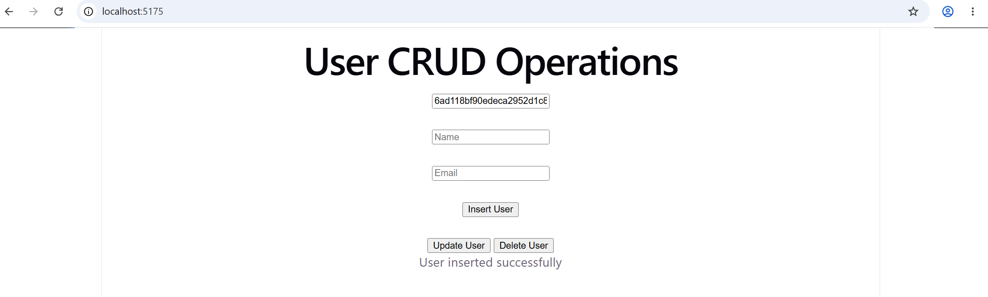
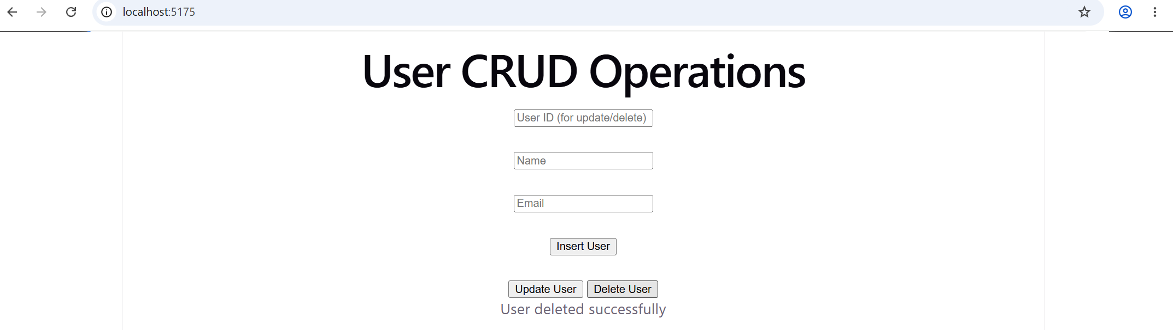
c. Display database records dynamically in React.
Aim:
To display database records dynamically in React by fetching data from MongoDB through an Express backend.
Procedure
- Opened VS Code and opened the existing Practical 10 folder.
- Opened a new terminal and installed the required packages:
npm install express cors mongodb
- Created a new file named displayRecords.js inside the Practical 10 folder.
- Pasted the Express.js code to connect to MongoDB and fetch all records from the college database's users collection using find().toArray().
- Created a GET API endpoint /api/users on port 3012 to send the database records to React in JSON format.
- Saved the file using Ctrl + S.
- Opened a new terminal and started the backend server:
- cd "C:\Users\admin\Desktop\MERN Stack\Practical 10"
node displayRecords.js
- Opened the existing React project at C:\Users\admin\Desktop\MERN Stack\react-api.
- Opened src/App.jsx, removed the previous code, and pasted React code using useState, useEffect, and fetch() to retrieve database records from the backend API.
- Displayed the retrieved records in an HTML table containing ID, Name, and Email columns. Added a Refresh Records button to fetch the latest records.
- Saved the React file and started the application in a separate terminal:
- cd "C:\Users\admin\Desktop\MERN Stack\react-api"
npm run dev
- Opened the Local URL in the browser and verified that database records were displayed dynamically. Clicked Refresh Records to reload the latest data.
Programs:
displayRecords.js:
const express = require("express");
const cors = require("cors");
const { MongoClient } = require("mongodb");
const app = express();
app.use(cors());
const client = new MongoClient("mongodb://127.0.0.1:27017");
app.get("/api/users", async (req, res) => {
try {
await client.connect();
const db = client.db("college");
const users = db.collection("users");
const records = await users.find().toArray();
res.json(records);
} catch (error) {
res.status(500).json({ error: "Failed to fetch records" });
}
});
app.listen(3012, () => {
console.log("Display Records API running on port 3012");
});
App.jsx:
import { useState, useEffect } from "react";
function App() {
const [users, setUsers] = useState([]);
const [message, setMessage] = useState("Loading records...");
const fetchUsers = async () => {
try {
const response = await fetch("http://localhost:3012/api/users");
const data = await response.json();
if (!response.ok) {
throw new Error("Failed to fetch records");
}
setUsers(data);
setMessage(data.length === 0 ? "No records found." : "");
} catch (error) {
setMessage("Error connecting to backend");
}
};
useEffect(() => {
fetchUsers();
}, []);
return (
<div>
<h1>Database Records</h1>
<button onClick={fetchUsers}>Refresh Records</button>
<p>{message}</p>
<table border="1" cellPadding="8">
<thead>
<tr>
<th>ID</th>
<th>Name</th>
<th>Email</th>
</tr>
</thead>
<tbody>
{users.map((user) => (
<tr key={user._id}>
<td>{user._id}</td>
<td>{user.name}</td>
<td>{user.email}</td>
</tr>
))}
</tbody>
</table>
</div>
);
}
export default App;
Output:
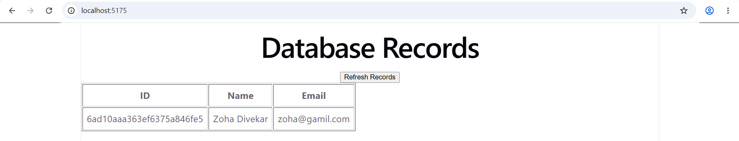
d. Implement frontend form validation.
Aim:
To implement frontend form validation in React to ensure that users enter valid details before submitting a form.
Procedure
- Opened VS Code and opened the existing React project at:
C:\Users\admin\Desktop\MERN Stack\react-api
- Opened the src folder and selected the App.jsx file.
- Removed the previous code and wrote React code to create a form with Name and Email fields.
- Imported useState from React to manage form inputs, validation errors, and success messages.
- Implemented validation to check that the Name and Email fields are not empty.
- Added email format validation using a regular expression to ensure that the entered email address is valid.
- Displayed appropriate error messages when the user entered empty or invalid details.
- Displayed a success message when all validation checks passed.
- Saved the file using Ctrl + S.
- Opened a terminal and started the React application:
- cd "C:\Users\admin\Desktop\MERN Stack\react-api"
npm run dev
- Opened the Local URL in the browser and tested the form with empty fields, an invalid email address, and valid details.
- Verified that the validation errors and success message appeared correctly.
Programs:

App.jsx:
import { useState } from "react";
function App() {
const [name, setName] = useState("");
const [email, setEmail] = useState("");
const [errors, setErrors] = useState({});
const [message, setMessage] = useState("");
const handleSubmit = (e) => {
e.preventDefault();
const newErrors = {};
if (!name.trim()) {
newErrors.name = "Name is required";
}
if (!email.trim()) {
newErrors.email = "Email is required";
} else if (!/^[^\s@]+@[^\s@]+\.[^\s@]+$/.test(email)) {
newErrors.email = "Enter a valid email address";
}
setErrors(newErrors);
if (Object.keys(newErrors).length === 0) {
setMessage("Form submitted successfully!");
setName("");
setEmail("");
} else {
setMessage("");
}
};
return (
<div>
<h1>Frontend Form Validation</h1>
<form onSubmit={handleSubmit} noValidate>
<div>
<label>Name: </label>
<input
type="text"
value={name}
onChange={(e) => setName(e.target.value)}
placeholder="Enter your name"
/>
<p>{errors.name}</p>
</div>
<div>
<label>Email: </label>
<input
type="text"
value={email}
onChange={(e) => setEmail(e.target.value)}
placeholder="Enter your email"
/>
<p>{errors.email}</p>
</div>
<button type="submit">Submit</button>
</form>
<p>{message}</p>
</div>
);
}
export default App;
Output:
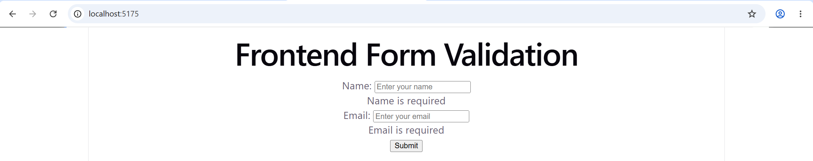
e. Test all APIs using Postman.
Aim:
To test REST APIs using Postman.

Procedure
- Opened Postman and created HTTP requests to test the APIs.
- Tested the GET API using http://localhost:3010/api/message and verified the response message.
- Tested the POST API using http://localhost:3011/api/users and inserted a test user by sending JSON data.
- Tested the PUT API using the inserted user's ID and updated the user's name and email.
- Tested the DELETE API using the same user ID and verified that the test user was deleted successfully.
- Tested the GET API using http://localhost:3012/api/users and displayed the existing users stored in MongoDB.
- Verified the API responses displayed by Postman.
Output:
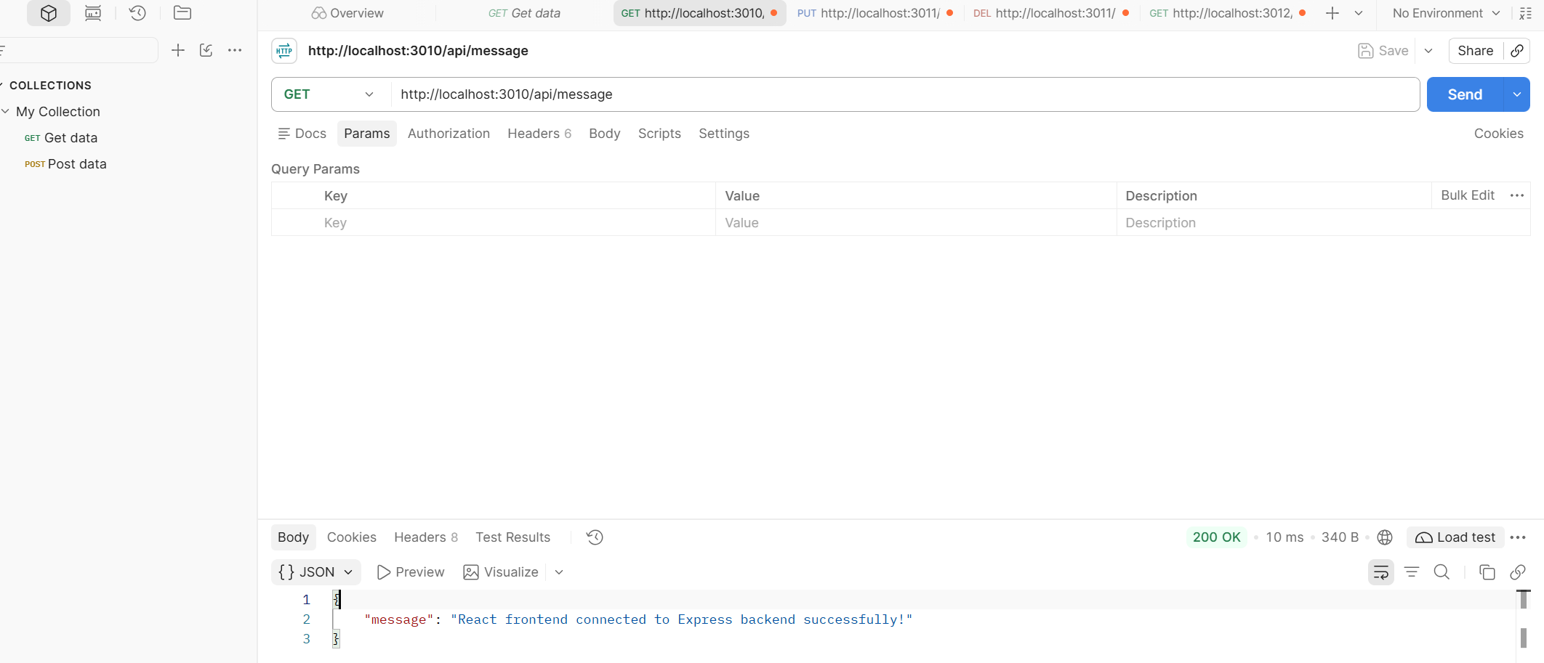
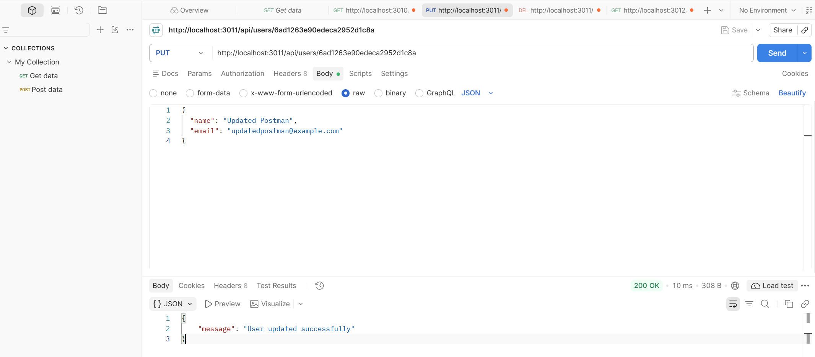
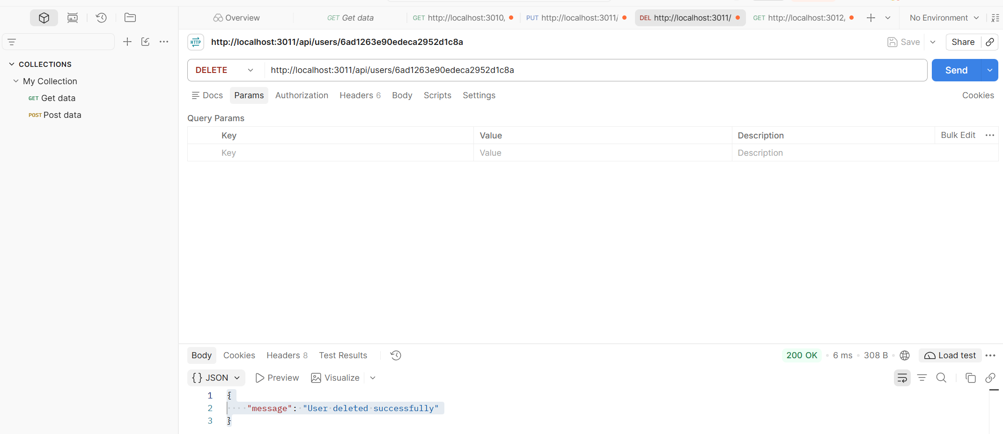
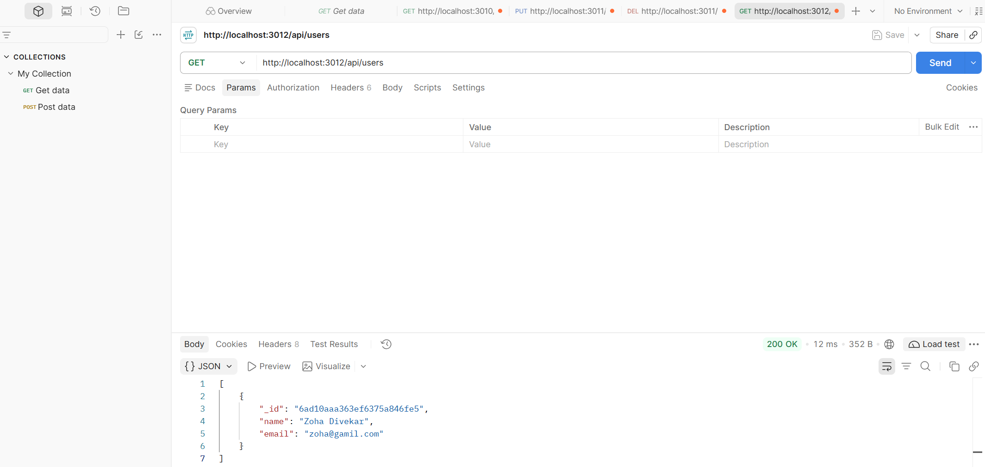
f. Execute and verify the complete working of the frontend, backend, and database together.
Aim:
To execute and verify the complete working of the frontend, backend, and database together.
Procedure:
- Opened VS Code and started the MongoDB server using the following command in the terminal:
& "C:\Program Files\MongoDB\Server\8.3\bin\mongod.exe"
- Opened a new terminal and navigated to the Practical 10 folder:
cd "C:\Users\admin\Desktop\MERN Stack\Practical 10"
- Started the Express backend server using:
node server.js
- Opened another terminal and navigated to the React project folder:
cd "C:\Users\admin\Desktop\MERN Stack\react-api"
- Started the React frontend using:
npm run dev
- Opened the Local URL displayed in the terminal in the web browser.
- Opened src/App.jsx in VS Code and implemented a React form containing Name and Email fields with a Submit button.
- Connected the React form to the Express backend using the Fetch API and the following endpoint:
http://localhost:3011/api/users
Used the POST method and sent the form data in JSON format.
- Started the CRUD API server in a separate terminal:
- cd "C:\Users\admin\Desktop\MERN Stack\Practical 10"
node crudServer.js
- Entered the student's name and email in the React form and clicked the Submit button.
- Verified that the success message appeared on the frontend after the data was submitted.
- Opened MongoDB Shell using:
& "C:\Users\admin\AppData\Local\Programs\mongosh\mongosh.exe"
- Selected the college database using:
use college
- Retrieved the stored user records using:
db.users.find()
- Verified that the submitted student record was stored successfully in the MongoDB users collection.
Programs:
App.jsx:
import { useState } from "react";
function App() {
const [name, setName] = useState("");
const [email, setEmail] = useState("");
const [message, setMessage] = useState("");
const handleSubmit = async (e) => {
e.preventDefault();
try {
const response = await fetch(
"http://localhost:3011/api/users",
{
method: "POST",
headers: {
"Content-Type": "application/json",
},
body: JSON.stringify({ name, email }),
}
);
const data = await response.json();
if (!response.ok) {
throw new Error(data.message || "Failed to save user");
}
setMessage("User saved successfully in MongoDB!");
setName("");
setEmail("");
} catch (error) {
setMessage("Error: " + error.message);
}
};
return (
<div style={{ padding: "30px" }}>
<h1>Student Registration</h1>
<form onSubmit={handleSubmit}>
<div>
<label>Name: </label>
<input
type="text"
value={name}
onChange={(e) => setName(e.target.value)}
required
/>
</div>
<br />
<div>
<label>Email: </label>
<input
type="email"
value={email}
onChange={(e) => setEmail(e.target.value)}
required
/>
</div>

<br />
<button type="submit">Submit</button>
</form>
<p>{message}</p>
</div>
);
}
export default App;
Output:
