Practical 1.Write the program for the following:
a. Create an MVC application to perform basic Arithmetic Operations.
- Open Visual Studio and create a new ASP.NET Core Web App (Model-View-Controller).
- Name the project MvcArithmeticApp.
ArithmeticModel.cs -
namespace MvcArithmeticApp.Models
{
public class ArithmeticModel
{
public double Number1 { get; set; }
public double Number2 { get; set; }
public double Result { get; set; }
public string? Operation { get; set; }
}
}
ArithmeticController.cs -
using Microsoft.AspNetCore.Mvc;
using MvcArithmeticApp.Models;
namespace MvcArithmeticApp.Controllers
{
public class ArithmeticController : Controller
{
// GET: Loads the initial form
[HttpGet]
public IActionResult Index()
{
return View(new ArithmeticModel());
}
// POST: Handles the calculation when the form is submitted
[HttpPost]
public IActionResult Index(ArithmeticModel model)
{
switch (model.Operation)
{
case "Add":
model.Result = model.Number1 + model.Number2;
break;
case "Subtract":
model.Result = model.Number1 - model.Number2;
break;
case "Multiply":
model.Result = model.Number1 * model.Number2;
break;
case "Divide":
if (model.Number2 != 0)
model.Result = model.Number1 / model.Number2;
else
ViewBag.Error = "Cannot divide by zero.";
break;
}
return View(model);
}
}
}
Index.cshtml -
@model MvcArithmeticApp.Models.ArithmeticModel
<h2>Basic Arithmetic Calculator</h2>
<form asp-controller="Arithmetic" asp-action="Index" method="post">
<div>
<label>Enter Number 1:</label>
<input type="number" asp-for="Number1" step="any" required />
</div>
<br />
<div>
<label>Enter Number 2:</label>
<input type="number" asp-for="Number2" step="any" required />
</div>
<br />
<div>
<label>Select Operation:</label>
<select asp-for="Operation">
<option value="Add">Add (+)</option>
<option value="Subtract">Subtract (-)</option>
<option value="Multiply">Multiply (*)</option>
<option value="Divide">Divide (/)</option>
</select>
</div>
<br />
<button type="submit">Calculate</button>
</form>
<hr />
@if (ViewBag.Error != null)
{
<h3 style="color:red">@ViewBag.Error</h3>
}
else if (ViewData.ModelState.IsValid && Context.Request.Method == "POST")
{
<h3 style="color:green">Result: @Model.Result</h3>
}
Output:-
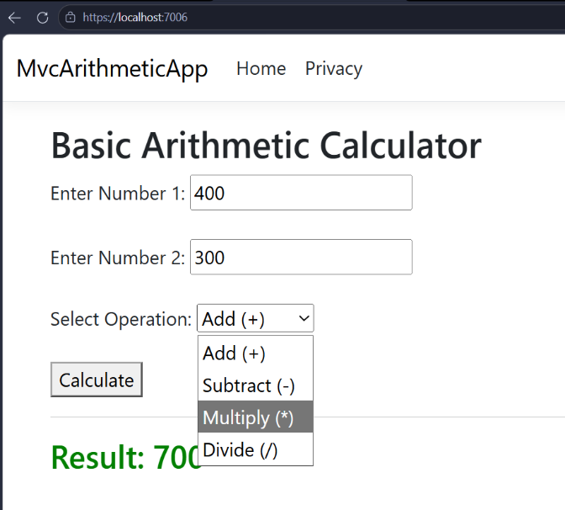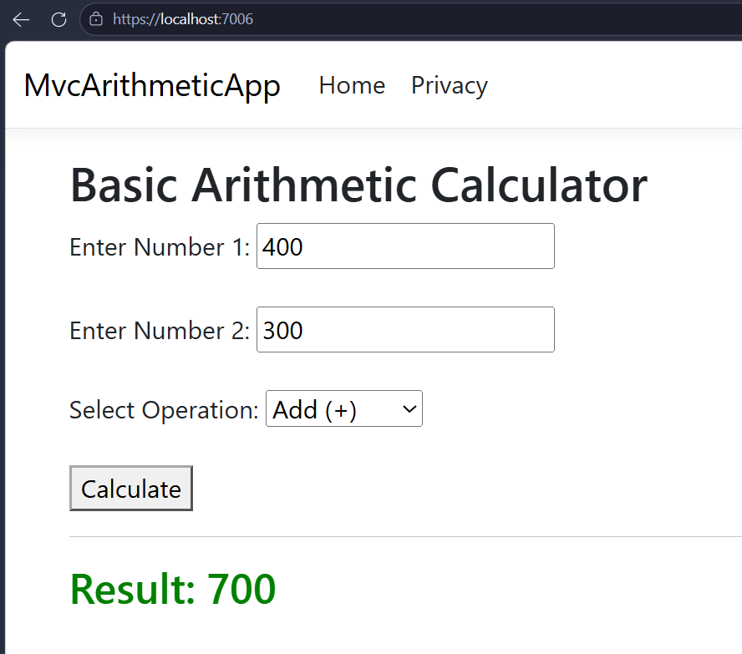
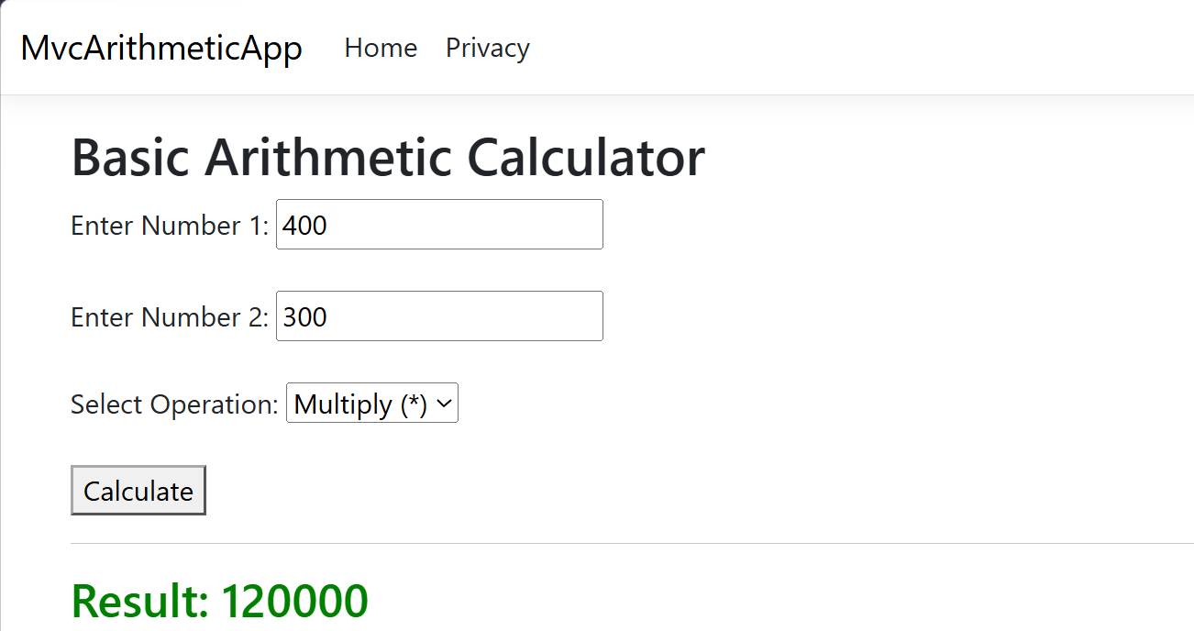

b. Create an application to print Floyd’s triangle till n rows in C#.
Floyd’s Triangle in C#
Setup: Open Visual Studio and create a new Console App (.NET Core or .NET Framework).
Code:
using System;
namespace FloydsTriangle
{
class Program
{
static void Main(string[] args)
{
Console.Write("Enter the number of rows for Floyd's Triangle: ");

// Read input and convert to integer
if (int.TryParse(Console.ReadLine(), out int n))
{
int number = 1; // Starting number
// Outer loop handles the rows
for (int i = 1; i <= n; i++)
{
// Inner loop handles the columns per row
for (int j = 1; j <= i; j++)
{
Console.Write(number + " ");
number++;
}
Console.WriteLine(); // Move to the next line after each row
}
}
else
{
Console.WriteLine("Invalid input. Please enter a valid number.");
}
Console.ReadLine(); // Keep console open
}
}
Output:-
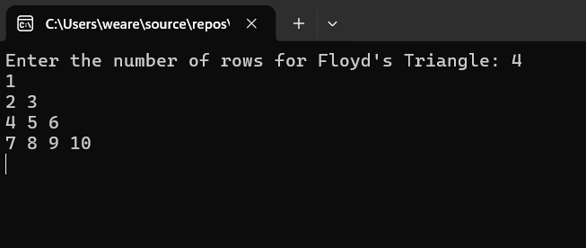
c. Write C# code to arrange the name of cities in sorted order. Accept name of 10 cities from the user
1c. Sort Name of 10 Cities in C#
Setup: Create a new Console App.
Code:
using System;

namespace SortCities
{
class Program
{
static void Main(string[] args)
{
// Initialize an array to hold 10 string values
string[] cities = new string[10];

Console.WriteLine("Enter the names of 10 cities:");

// Loop to accept 10 inputs from the user
for (int i = 0; i < cities.Length; i++)
{
Console.Write($"City {i + 1}: ");
cities[i] = Console.ReadLine();
}

// The Array.Sort() method automatically sorts strings alphabetically
Array.Sort(cities);

Console.WriteLine("\n-------------------------");
Console.WriteLine("Cities in Sorted Order:");
Console.WriteLine("-------------------------");

// Loop to display the sorted array
foreach (string city in cities)
{
Console.WriteLine(city);
}

Console.ReadLine(); // Keep console open
}
}
}
Output:-
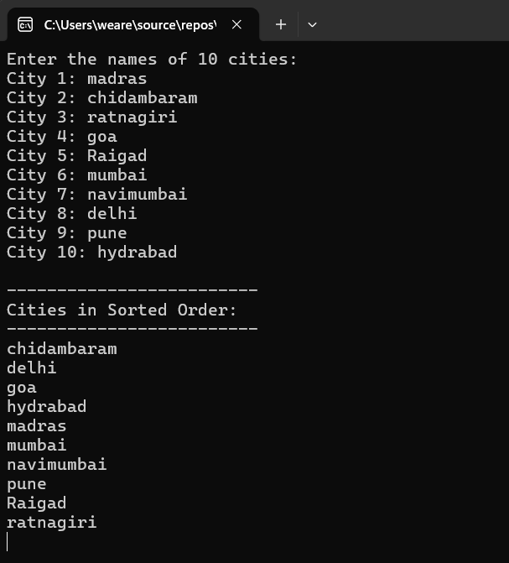

Practical 2. Write the program with different features of C#
- Function Overloading
Code:
using System;
namespace FunctionOverloading
{
class MathOperations
{
// Overload 1: Adds two integers
public int Add(int a, int b)
{
return a + b;
}
// Overload 2: Adds three integers
public int Add(int a, int b, int c)
{
return a + b + c;
}
// Overload 3: Adds two double values
public double Add(double a, double b)
{
return a + b;
}
}
class Program
{
static void Main(string[] args)
{
MathOperations math = new MathOperations();
Console.WriteLine("Add two integers (10 + 20): " + math.Add(10, 20));
Console.WriteLine("Add three integers (10 + 20 + 30): " + math.Add(10, 20, 30));
Console.WriteLine("Add two doubles (10.5 + 20.3): " + math.Add(10.5, 20.3));
}
}
}
Output:-
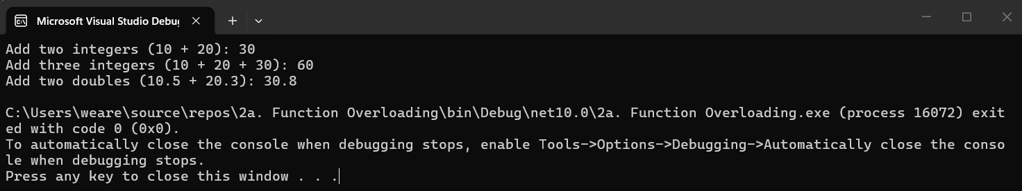
- Inheritance (all types)
Code:
using System;
namespace InheritanceExample
{
// Base Class
class Animal
{
public void Eat() => Console.WriteLine("Animal is eating.");
}
// 1. Single Inheritance (Dog inherits from Animal)
class Dog : Animal
{
public void Bark() => Console.WriteLine("Dog is barking.");
}
// 2. Multilevel Inheritance (Puppy inherits from Dog)
class Puppy : Dog
{
public void Weep() => Console.WriteLine("Puppy is weeping.");
}
// 3. Hierarchical Inheritance (Cat inherits directly from Animal, just like Dog)
class Cat : Animal
{
public void Meow() => Console.WriteLine("Cat is meowing.");
}
class Program
{
static void Main(string[] args)
{
Console.WriteLine("--- Multilevel Inheritance ---");
Puppy myPuppy = new Puppy();
myPuppy.Eat(); // From Animal
myPuppy.Bark(); // From Dog
myPuppy.Weep(); // From Puppy

Console.WriteLine("\n--- Hierarchical Inheritance ---");
Cat myCat = new Cat();
myCat.Eat(); // From Animal
myCat.Meow(); // From Cat
}
}
}
Output:-
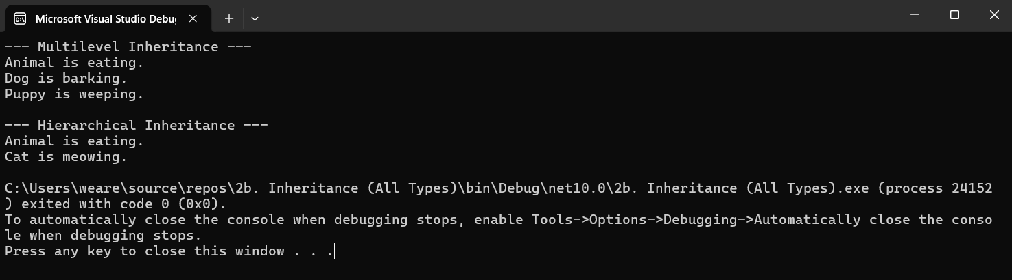
- Constructor overloading
Code:
using System;

namespace ConstructorOverloading
{
class Student
{
public string Name;
public int Age;

// Constructor 1: Default constructor
public Student()
{
Name = "Unknown";
Age = 0;
}
// Constructor 2: One parameter
public Student(string name)
{
Name = name;
Age = 0;
}
// Constructor 3: Two parameters
public Student(string name, int age)
{
Name = name;
Age = age;
}
public void DisplayInfo()
{
Console.WriteLine($"Name: {Name}, Age: {Age}");
}
}
class Program
{
static void Main(string[] args)
{
Student s1 = new Student();
Student s2 = new Student("Rahul");
Student s3 = new Student("Sneha", 21);

s1.DisplayInfo();
s2.DisplayInfo();
s3.DisplayInfo();
}
}
}
Output:-
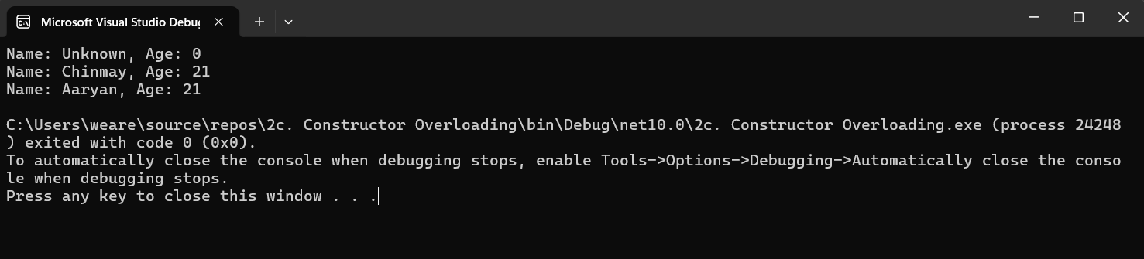
- Interfaces
Code:
using System;
namespace InterfaceExample
{
// Define the interface
interface IShape
{
void CalculateArea();
}
// Class implementing the interface
class Circle : IShape
{
double radius = 5.0;
public void CalculateArea()
{
Console.WriteLine($"Area of Circle: {Math.PI * radius * radius:F2}");
}
}
// Another class implementing the same interface
class Rectangle : IShape
{
double length = 10.0, width = 4.0;
public void CalculateArea()
{
Console.WriteLine($"Area of Rectangle: {length * width}");
}
}
class Program
{
static void Main(string[] args)
{
IShape myCircle = new Circle();
myCircle.CalculateArea();

IShape myRectangle = new Rectangle();
myRectangle.CalculateArea();
}
}
}
Output:-
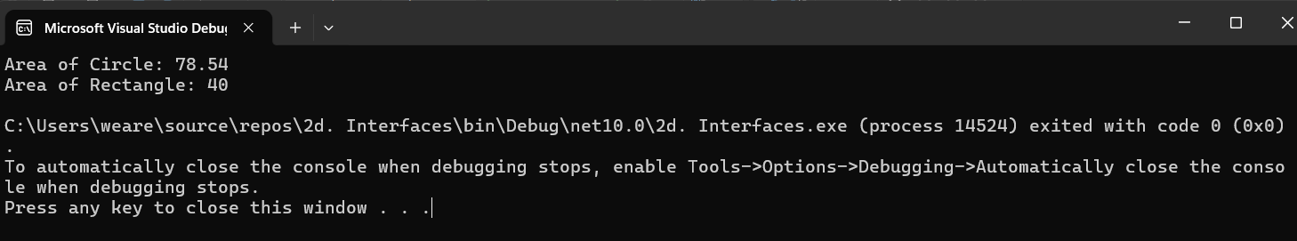
e. Using Delegates and events
Code:
using System;
namespace DelegatesAndEvents
{
// 1. Declare a Delegate
public delegate void ProcessCompletedEventHandler(string message);
class ProcessBusinessLogic
{
// 2. Declare an Event of the delegate type
public event ProcessCompletedEventHandler ProcessCompleted;
public void StartProcess()
{
Console.WriteLine("Process started...");
System.Threading.Thread.Sleep(2000); // Simulate some work
Console.WriteLine("Process completed.");

// 3. Raise the Event
OnProcessCompleted("Success!");
}
protected virtual void OnProcessCompleted(string message)
{
// Check if anyone is subscribed to the event
ProcessCompleted?.Invoke(message);
}
}
class Program
{
static void Main(string[] args)
{
ProcessBusinessLogic process = new ProcessBusinessLogic();

// 4. Subscribe to the event
process.ProcessCompleted += Process_ProcessCompleted;

process.StartProcess();
}
// Event handler method
static void Process_ProcessCompleted(string message)
{
Console.WriteLine($"Event Received! Message: {message}");
}
}
}
Output:-
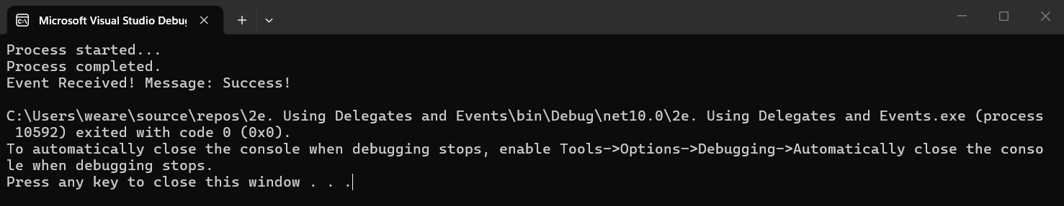
- Exception handling
Code:
using System;
namespace ExceptionHandling
{
class Program
{
static void Main(string[] args)
{
int number1 = 10;
int number2 = 0;

try
{
// This will cause a DivideByZeroException
Console.WriteLine("Attempting division...");
int result = number1 / number2;
Console.WriteLine("Result: " + result); // This line is skipped
}
catch (DivideByZeroException ex)
{
Console.WriteLine("Error: Cannot divide a number by zero.");
Console.WriteLine("System Message: " + ex.Message);
}
catch (Exception ex)
{
// Catches any other unforeseen exceptions
Console.WriteLine("An unexpected error occurred: " + ex.Message);
}
finally
{
// This block always executes, regardless of success or failure
Console.WriteLine("Execution of try-catch block is complete.");
}
}
}
}
Output:-
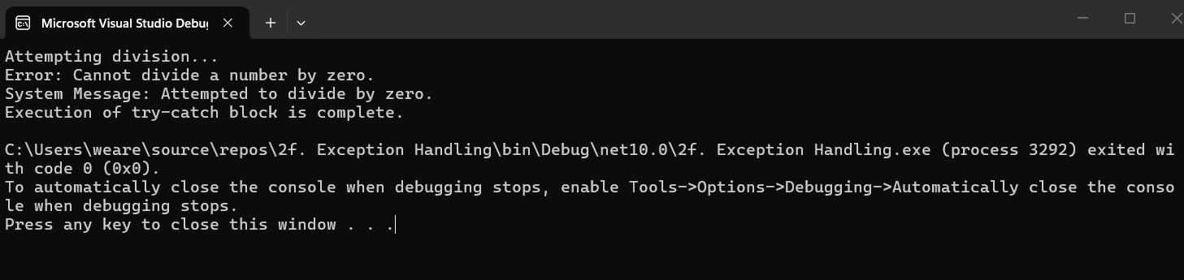

Practical 3. Write the program for the following:
a. Create methods add(). multiply(), substract() ,divide() with suitable parameters and call these methods using concept of C# delegate.
Code:
using System;
namespace DelegateArithmetic
{
// 1. Declare a delegate that takes two doubles and returns a double
public delegate double ArithmeticDelegate(double num1, double num2);
class Program
{
// 2. Create methods matching the delegate signature
static double Add(double a, double b) => a + b;
static double Subtract(double a, double b) => a - b;
static double Multiply(double a, double b) => a * b;
static double Divide(double a, double b)
{
if (b == 0)
{
Console.WriteLine("Cannot divide by zero.");
return 0;
}
return a / b;
}
static void Main(string[] args)
{
double x = 20;
double y = 5;
// 3. Instantiate the delegate for each operation
ArithmeticDelegate delAdd = new ArithmeticDelegate(Add);
ArithmeticDelegate delSub = new ArithmeticDelegate(Subtract);
ArithmeticDelegate delMul = new ArithmeticDelegate(Multiply);
ArithmeticDelegate delDiv = new ArithmeticDelegate(Divide);
// 4. Call the methods via the delegates
Console.WriteLine($"Addition (20 + 5) = {delAdd(x, y)}");
Console.WriteLine($"Subtraction (20 - 5) = {delSub(x, y)}");
Console.WriteLine($"Multiplication (20 * 5) = {delMul(x, y)}");
Console.WriteLine($"Division (20 / 5) = {delDiv(x, y)}");
Console.ReadLine();
}
}
}

Output:-
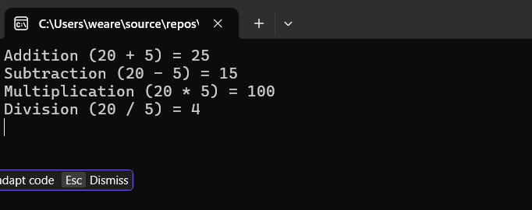

b. Write a program using multicast delegate.
Code:
using System;
namespace MulticastDelegateExample
{
// 1. Declare the delegate
public delegate void MathAction(int a, int b);
class Program
{
// 2. Create methods
static void Add(int a, int b)
{
Console.WriteLine($"Executing Add: {a} + {b} = {a + b}");
}
static void Multiply(int a, int b)
{
Console.WriteLine($"Executing Multiply: {a} * {b} = {a * b}");
}
static void Main(string[] args)
{
// 3. Instantiate the delegate with the first method
MathAction action = Add;
// 4. Add another method to the delegate using +=
action += Multiply;
Console.WriteLine("Invoking the multicast delegate:");
// 5. Calling this will execute both Add and Multiply
action(10, 5);
Console.ReadLine();
}
}
}
Output:-
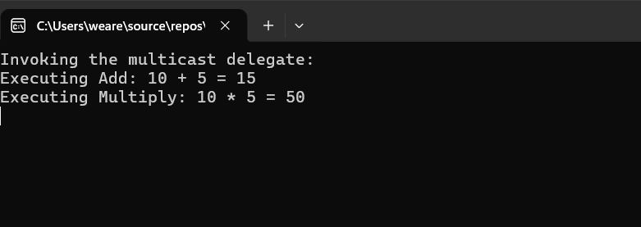
c. Create a class BankAccount with AccountNumber and Balance. Implement property for Balance with validation (Balance cannot be negative).
Code:
using System;
namespace BankAccountApp
{
class BankAccount
{
// Auto-implemented property for AccountNumber
public string AccountNumber { get; set; }
// Private backing field for Balance
private double _balance;
// Property for Balance with validation
public double Balance
{
get
{
return _balance;
}
set
{
// Validation: Balance cannot be negative
if (value < 0)
{
Console.WriteLine($"Validation Error: Attempted to set balance to {value}. Balance cannot be negative.");
}
else
{
_balance = value;
Console.WriteLine($"Balance successfully updated to: {_balance}");
}
}
}
}

class Program
{
static void Main(string[] args)
{
BankAccount myAccount = new BankAccount();
myAccount.AccountNumber = "ACC123456789";
Console.WriteLine($"Account Number: {myAccount.AccountNumber}");
// Valid balance assignment
Console.WriteLine("\nDepositing 5000...");
myAccount.Balance = 5000;
// Invalid balance assignment (will trigger validation error)
Console.WriteLine("\nAttempting to set balance to -1000...");
myAccount.Balance = -1000;
// Print final valid balance
Console.WriteLine($"\nFinal Account Balance: {myAccount.Balance}");
Console.ReadLine();
}
}
}

Output:-
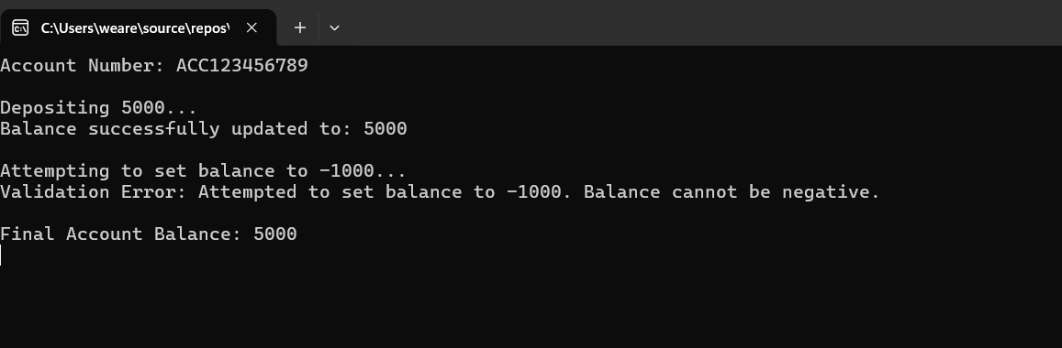

Practical 4. Create an ASP.NET Web Forms application using simple server controls.
a. Design a Student Registration Form using the following ASP.NET controls: i. Label and TextBox to accept Student Name ii. RadioButton to select Gender (Male/Female) iii. DropDownList to select Course (BSc IT, BSc CS, BCA) iv. CheckBox for accepting Terms & Conditions v. Calendar control to select Date vi. Button control to submit the form vii. Label control to display the output
Code:
Registration.aspx
<%@ Page Language="C#" AutoEventWireup="true" CodeBehind="Registration.aspx.cs" Inherits="pr4WebFormsLab.Registration" %>
<!DOCTYPE html>
<html>
<head runat="server">
<title>Student Registration</title>
<style>
/* Modern Font and Background */
body {
font-family: 'Segoe UI', Tahoma, Geneva, Verdana, sans-serif;
background-color: #f0f2f5;
display: flex;
justify-content: center;
align-items: center;
min-height: 100vh;
margin: 0;
padding: 20px;
}
/* Centered Card Container */
.form-container {
background-color: #ffffff;
padding: 40px;
border-radius: 12px;
box-shadow: 0 8px 20px rgba(0, 0, 0, 0.08);
width: 100%;
max-width: 450px;
}

.form-container h2 {
text-align: center;
color: #1a1a1a;
margin-top: 0;
margin-bottom: 30px;
font-size: 24px;
}
/* Form Group Spacing */
.form-group {
margin-bottom: 20px;
}
.form-group label {
display: block;
font-weight: 600;
margin-bottom: 8px;
color: #444;
font-size: 14px;
}
/* Styling Textboxes and Dropdowns */
.form-control {
width: 100%;
padding: 12px;
border: 1px solid #ccc;
border-radius: 6px;
box-sizing: border-box;
font-size: 15px;
transition: border-color 0.3s;
}
.form-control:focus {
border-color: #0056b3;
outline: none;
box-shadow: 0 0 5px rgba(0, 86, 179, 0.2);
}
/* Styling Radio Buttons and Checkboxes */
.radio-group label, .checkbox-group label {
font-weight: normal;
display: inline;
margin-right: 20px;
color: #333;
cursor: pointer;
}
/* Calendar Wrapper */
.calendar-wrapper {
margin-top: 10px;
border: 1px solid #e0e0e0;
border-radius: 6px;
overflow: hidden;
}
/* Submit Button */
.btn-submit {
width: 100%;
padding: 14px;
background-color: #0056b3;
color: white;
border: none;
border-radius: 6px;
font-size: 16px;
font-weight: 600;
cursor: pointer;
transition: background-color 0.3s ease;
margin-top: 10px;
}

.btn-submit:hover {
background-color: #004494;
}

/* Output Label */
.output-container {
margin-top: 20px;
text-align: center;
font-size: 15px;
line-height: 1.5;
}
</style>
</head>
<body>
<form id="form1" runat="server">
<div class="form-container">
<h2>Student Registration Form</h2>

<div class="form-group">
<asp:Label ID="lblName" runat="server" Text="Student Name:"></asp:Label>
<asp:TextBox ID="txtName" runat="server" CssClass="form-control" placeholder="Enter full name"></asp:TextBox>
</div>

<div class="form-group radio-group">
<asp:Label ID="lblGender" runat="server" Text="Gender:"></asp:Label>
<div>
<asp:RadioButton ID="rbMale" runat="server" Text="Male" GroupName="Gender" />
<asp:RadioButton ID="rbFemale" runat="server" Text="Female" GroupName="Gender" />
</div>
</div>
<div class="form-group">
<asp:Label ID="lblCourse" runat="server" Text="Course:"></asp:Label>
<asp:DropDownList ID="ddlCourse" runat="server" CssClass="form-control">
<asp:ListItem Text="Select Course" Value="" />
<asp:ListItem Text="BSc IT" Value="BSc IT" />
<asp:ListItem Text="BSc CS" Value="BSc CS" />
<asp:ListItem Text="BCA" Value="BCA" />
</asp:DropDownList>
</div>
<div class="form-group">
<asp:Label ID="lblDate" runat="server" Text="Select Date of Admission:"></asp:Label>
<div class="calendar-wrapper">
<!-- Added ASP.NET Calendar styling properties to make it match the modern theme -->
<asp:Calendar ID="calDate" runat="server" BackColor="White" BorderColor="White"
BorderWidth="1px" DayNameFormat="Shortest" Font-Names="Segoe UI" Font-Size="10pt"
ForeColor="#333333" Height="220px" Width="100%">
<DayHeaderStyle BackColor="#f0f2f5" Font-Bold="True" Height="10pt" />
<NextPrevStyle Font-Size="9pt" ForeColor="White" />
<OtherMonthDayStyle ForeColor="#b0b0b0" />
<SelectedDayStyle BackColor="#0056b3" Font-Bold="True" ForeColor="White" />
<SelectorStyle BackColor="#0056b3" />
<TitleStyle BackColor="#0056b3" Font-Bold="True" ForeColor="White" Height="30px" />
<TodayDayStyle BackColor="#e6f0fa" ForeColor="Black" />
</asp:Calendar>
</div>
</div>
<div class="form-group checkbox-group">
<asp:CheckBox ID="chkTerms" runat="server" Text=" I accept the Terms & Conditions" />
</div>
<asp:Button ID="btnSubmit" runat="server" Text="Submit Registration" CssClass="btn-submit" OnClick="btnSubmit_Click" />
<div class="output-container">
<asp:Label ID="lblOutput" runat="server" Font-Bold="true"></asp:Label>
</div>
</div>
</form>
</body>
</html>

Registration.aspx.cs
Code:
using System;
namespace pr4WebFormsLab
{
public partial class Registration : System.Web.UI.Page
{
protected void Page_Load(object sender, EventArgs e)
{
}
protected void btnSubmit_Click(object sender, EventArgs e)
{
if (chkTerms.Checked)
{
string name = txtName.Text;
string gender = rbMale.Checked ? "Male" : (rbFemale.Checked ? "Female" : "Not Selected");
string course = ddlCourse.SelectedValue;
string date = calDate.SelectedDate.ToString("dd-MM-yyyy");
lblOutput.Text = $"Registration Successful! <br/> Name: {name} <br/> Gender: {gender} <br/> Course: {course} <br/> Date: {date}";
lblOutput.ForeColor = System.Drawing.Color.Green;
}
else
{
lblOutput.Text = "Please accept the Terms & Conditions.";
lblOutput.ForeColor = System.Drawing.Color.Red;
}
}
}
}
Output:-
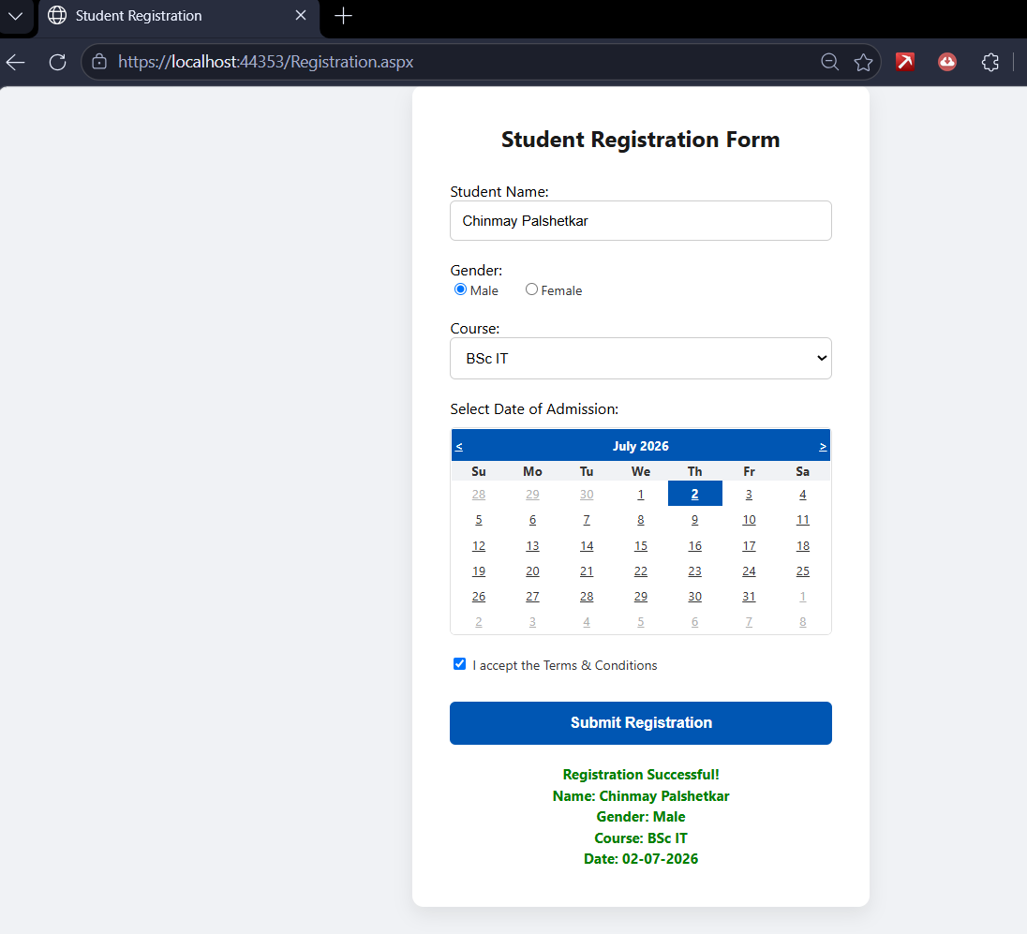
b. Create a Registration form to demonstrate use of various Validation controls.
Code:
ValidationDemo.aspx
<%@ Page Language="C#" AutoEventWireup="true" %>
<!DOCTYPE html>
<html>
<head runat="server">
<title>Validation Demo</title>

<!-- C# Logic placed directly in the page to bypass linking errors -->
<script runat="server">
protected void Page_Load(object sender, EventArgs e)
{
ValidationSettings.UnobtrusiveValidationMode = System.Web.UI.UnobtrusiveValidationMode.None;
}
protected void btnValidate_Click(object sender, EventArgs e)
{
if (Page.IsValid)
{
lblResult.Text = "Registration Successful! All validations passed.";
}
}
</script>
<style>
body { font-family: 'Segoe UI', Tahoma, Geneva, Verdana, sans-serif; background-color: #f0f2f5; display: flex; justify-content: center; align-items: center; min-height: 100vh; margin: 0; }
.form-container { background-color: #ffffff; padding: 40px; border-radius: 12px; box-shadow: 0 8px 20px rgba(0, 0, 0, 0.08); width: 100%; max-width: 400px; }
h2 { text-align: center; color: #1a1a1a; margin-top: 0; margin-bottom: 20px; }
.form-group { margin-bottom: 18px; }
.form-group label { display: block; font-weight: 600; margin-bottom: 5px; color: #444; font-size: 14px; }
.form-control { width: 100%; padding: 10px; border: 1px solid #ccc; border-radius: 6px; box-sizing: border-box; }
.form-control:focus { border-color: #28a745; outline: none; box-shadow: 0 0 5px rgba(40, 167, 69, 0.2); }
.btn-submit { width: 100%; padding: 12px; background-color: #28a745; color: white; border: none; border-radius: 6px; font-weight: 600; font-size: 15px; cursor: pointer; margin-top: 10px; }
.btn-submit:hover { background-color: #218838; }
.error-msg { font-size: 13px; margin-top: 4px; display:block; }
.val-summary { color: #dc3545; font-size: 14px; margin-bottom: 15px; padding: 10px; border: 1px solid #f5c6cb; background-color: #f8d7da; border-radius: 5px; }
</style>
</head>
<body>
<form id="form1" runat="server">
<div class="form-container">
<h2>Account Registration</h2>
<asp:ValidationSummary ID="ValidationSummary1" runat="server" CssClass="val-summary" HeaderText="Please fix the following errors:" />
<div class="form-group">
<label>Name:</label>
<asp:TextBox ID="txtVName" runat="server" CssClass="form-control" placeholder="Enter your name"></asp:TextBox>
<asp:RequiredFieldValidator ID="rfvName" runat="server" ControlToValidate="txtVName" ErrorMessage="Name is required" ForeColor="#dc3545" CssClass="error-msg" Display="Dynamic">* Name is required</asp:RequiredFieldValidator>
</div>
<div class="form-group">
<label>Age (18-50):</label>
<asp:TextBox ID="txtAge" runat="server" CssClass="form-control" placeholder="Enter your age"></asp:TextBox>
<asp:RangeValidator ID="rvAge" runat="server" ControlToValidate="txtAge" MinimumValue="18" MaximumValue="50" Type="Integer" ErrorMessage="Age must be between 18 and 50" ForeColor="#dc3545" CssClass="error-msg" Display="Dynamic">* Age must be between 18 and 50</asp:RangeValidator>
</div>
<div class="form-group">
<label>Email:</label>
<asp:TextBox ID="txtEmail" runat="server" CssClass="form-control" placeholder="example@mail.com"></asp:TextBox>
<asp:RegularExpressionValidator ID="revEmail" runat="server" ControlToValidate="txtEmail" ValidationExpression="^\w+@[a-zA-Z_]+?\.[a-zA-Z]{2,3}$" ErrorMessage="Invalid Email format" ForeColor="#dc3545" CssClass="error-msg" Display="Dynamic">* Invalid Email format</asp:RegularExpressionValidator>
</div>
<div class="form-group">
<label>Password:</label>
<asp:TextBox ID="txtPass" runat="server" TextMode="Password" CssClass="form-control"></asp:TextBox>
</div>
<div class="form-group">
<label>Confirm Password:</label>
<asp:TextBox ID="txtConfirm" runat="server" TextMode="Password" CssClass="form-control"></asp:TextBox>
<asp:CompareValidator ID="cvPass" runat="server" ControlToValidate="txtConfirm" ControlToCompare="txtPass" ErrorMessage="Passwords do not match" ForeColor="#dc3545" CssClass="error-msg" Display="Dynamic">* Passwords do not match</asp:CompareValidator>
</div>
<asp:Button ID="btnValidate" runat="server" Text="Register Account" CssClass="btn-submit" OnClick="btnValidate_Click" />
<div style="text-align: center; margin-top: 15px;">
<asp:Label ID="lblResult" runat="server" ForeColor="#28a745" Font-Bold="true"></asp:Label>
</div>
</div>
</form>
</body>
</html>

ValidationDemo.aspx.cs
using System;
namespace pr4WebFormsLab
{
public partial class ValidationDemo : System.Web.UI.Page
{
protected void Page_Load(object sender, EventArgs e)
{
ValidationSettings.UnobtrusiveValidationMode = System.Web.UI.UnobtrusiveValidationMode.None;
}
protected void btnValidate_Click(object sender, EventArgs e)
{
if (Page.IsValid)
{
lblResult.Text = "All validations passed successfully!";
}
}
}
}
Output:-

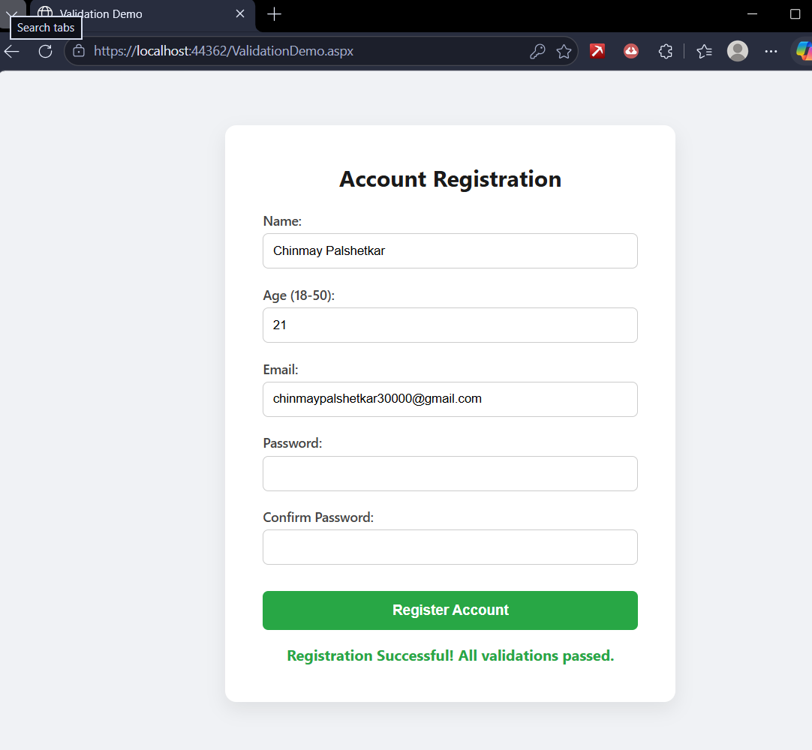
c. Create Web Form to demonstrate use of Adrotator Control.
AdRotatorDemo.aspx
<%@ Page Language="C#" %>
<!DOCTYPE html>
<html>
<head runat="server">
<title>AdRotator Demo</title>
<style>
body {
font-family: 'Segoe UI', Tahoma, Geneva, Verdana, sans-serif;
background-color: #f0f2f5;
text-align: center;
padding-top: 50px;
}
.container {
background-color: #ffffff;
padding: 40px;
border-radius: 12px;
box-shadow: 0 8px 20px rgba(0, 0, 0, 0.08);
display: inline-block;
}
h2 { color: #1a1a1a; margin-top: 0; }
p { color: #666; }
</style>
</head>
<body>
<form id="form1" runat="server">
<div class="container">
<h2>AdRotator Control Demonstration</h2>
<p>Refresh the page (F5) to see the ads rotate!</p>
<hr style="border: 0; height: 1px; background: #ddd; margin-bottom: 20px;" />

<!-- Ensure you have your AdsData.xml file created in your project! -->
<asp:AdRotator ID="AdRotator1" runat="server" AdvertisementFile="~/AdsData.xml" Target="_blank" />
</div>
</form>
</body>
</html>
Output:-
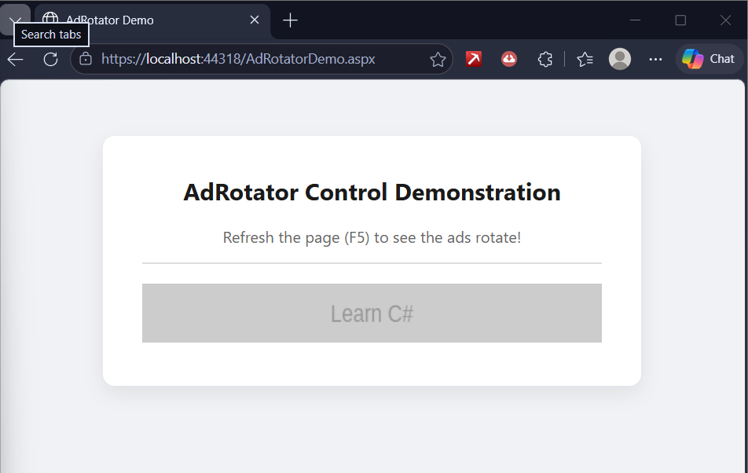

Practical 5. Create the following application:
a. Create a web application to demonstrate the use of different types of Cookies.
Code
1. The Controller: Right-click the Controllers folder > Add > Controller... > MVC Controller - Empty. Name it CookiesController.cs. Replace the code with:
C#
using Microsoft.AspNetCore.Mvc;
using System;
namespace Pr5CoreApp.Controllers
{
public class CookiesController : Controller
{
public IActionResult Index()
{
// 1. Session Cookie (Deleted when browser closes)
CookieOptions sessionCookie = new CookieOptions();
Response.Cookies.Append("SessionCookie", "I am a temporary session cookie!", sessionCookie);
// 2. Persistent Cookie (Lasts for 7 days)
CookieOptions persistentCookie = new CookieOptions { Expires = DateTime.Now.AddDays(7) };
Response.Cookies.Append("PersistentCookie", "I am a persistent cookie!", persistentCookie);

// Read the cookies to display on the page
ViewBag.SessionData = Request.Cookies["SessionCookie"] ?? "No Session Cookie";
ViewBag.PersistentData = Request.Cookies["PersistentCookie"] ?? "No Persistent Cookie";
return View();
}
}
}
2. The View: Inside CookiesController.cs, right-click on the word Index > Add View... > Razor View - Empty. Name it Index.cshtml.
HTML
@{
ViewData["Title"] = "Cookies Demo";
}
<h2>Cookies Demonstration</h2>
<hr />
<div style="background-color: #e9ecef; padding: 20px; border-radius: 8px;">
<h4>Data retrieved from your browser's cookies:</h4>
<p><strong>Session Cookie:</strong> @ViewBag.SessionData</p>
<p><strong>Persistent Cookie:</strong> @ViewBag.PersistentData</p>
</div>
<p style="margin-top: 15px; color: green;">✔ Cookies have been successfully created in
Output
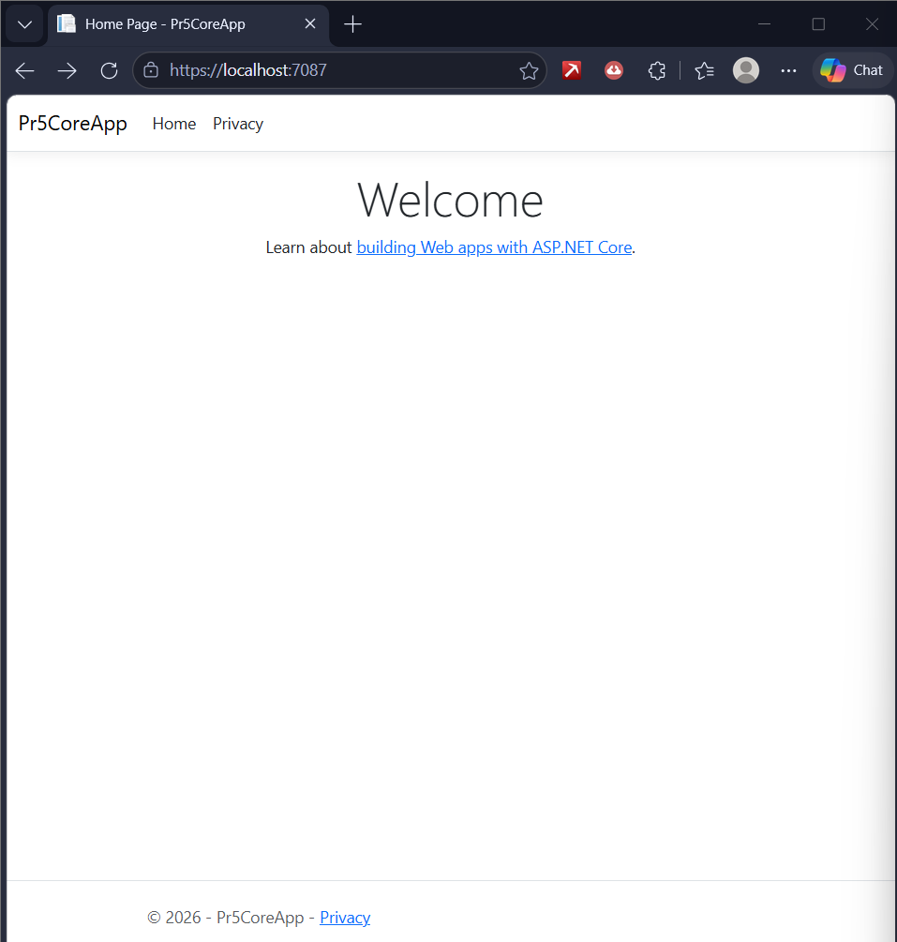
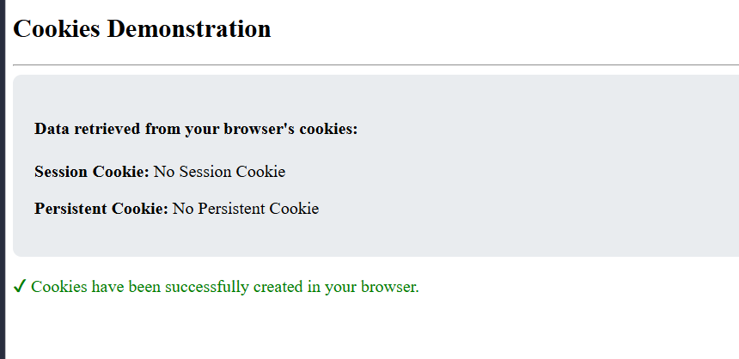
b. Create a Product Table in SQL Server and perform Insert Operation using Entity Framework Core.
Code
1. Controllers/ProductsController.cs
(Right-click Controllers > Add > Controller > MVC Controller - Empty. Name it ProductsController)
using Microsoft.AspNetCore.Mvc;
using Microsoft.EntityFrameworkCore;
using Pr5CoreApp.Models;
using System.Threading.Tasks;
namespace Pr5CoreApp.Controllers
{
public class ProductsController : Controller
{
private readonly AppDbContext _context;

public ProductsController(AppDbContext context)
{
_context = context;
}

// 1. Shows the list of products (To verify your insert worked)
public async Task<IActionResult> Index()
{
var products = await _context.Products.ToListAsync();
return View(products);
}

// 2. Shows the empty HTML form to the user
[HttpGet]
public IActionResult Create()
{
return View();
}
// 3. Performs the actual Insert Operation into SQL Server
[HttpPost]
[ValidateAntiForgeryToken]
public async Task<IActionResult> Create(Product product)
{
if (ModelState.IsValid)
{
_context.Products.Add(product); // Add to EF Core
await _context.SaveChangesAsync(); // Save to SQL Server Database

return RedirectToAction(nameof(Index)); // Redirect to the list
}
return View(product);
}
}
}
Razor View - Empty (or just Razor View), name it Create.cshtml
@model Pr5CoreApp.Models.Product
@{
ViewData["Title"] = "Insert Product";
}
<h2>Insert New Product (Module 5b)</h2>
<hr />
<form asp-action="Create" method="post" style="max-width: 400px;">
<div class="mb-3" style="margin-bottom: 15px;">
<label class="form-label font-weight-bold">Product Name:</label>
<input asp-for="Name" class="form-control" required placeholder="e.g. Wireless Keyboard" />
</div>
<div class="mb-3" style="margin-bottom: 15px;">
<label class="form-label font-weight-bold">Price (₹):</label>
<input asp-for="Price" type="number" step="0.01" class="form-control" required placeholder="e.g. 1500" />
</div>

<button type="submit" class="btn btn-success">Insert into Database</button>
<a asp-action="Index" class="btn btn-secondary" style="margin-left: 10px;">Cancel</a>
</form>
2. Views/Products/Index.cshtml
(Create a folder named Products inside the Views folder. Inside that folder, add a Razor View named Index.cshtml)
@model IEnumerable<Pr5CoreApp.Models.Product>
@{
ViewData["Title"] = "Product Database";
<h2>Product Database</h2>
<p style="margin-top: 15px; margin-bottom: 15px;">
<a asp-action="Create" class="btn btn-primary">➕ Insert New Product</a>
</p>
<table class="table table-bordered table-striped">
<thead class="table-dark" style="background-color: #212529; color: white;">
<tr>
<th>Product ID</th>
<th>Product Name</th>
<th>Price</th>
</tr>
</thead>
<tbody>
@foreach (var item in Model) {
<tr>
<td>@item.Id</td>
<td>@item.Name</td>
<td>₹@item.Price</td>
</tr>
}
</tbody>
Output

<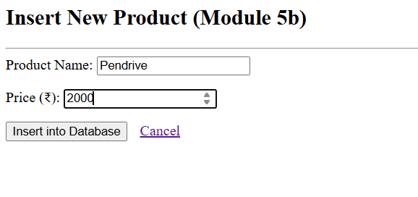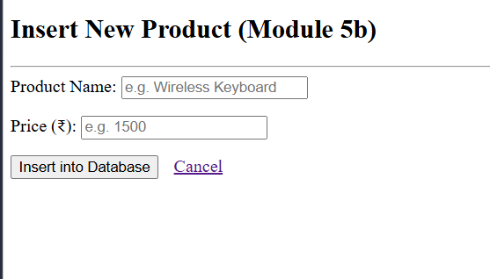
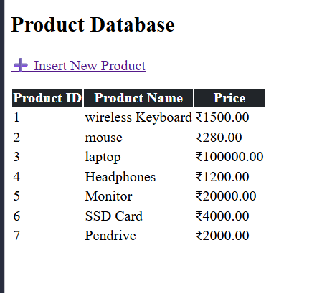

c. Develop a web application to perform CRUD Operations (Create, Read, Update, Delete) on Employee table using EF Core.
Code
the Solution Explorer, right-click the Controllers folder > Add > Controller...
Choose MVC Controller - Empty and click Add.
Name it exactly EmployeesController.cs
using Microsoft.AspNetCore.Mvc;
using Microsoft.EntityFrameworkCore;
using Pr5CoreApp.Models;
using System.Threading.Tasks;
namespace Pr5CoreApp.Controllers
{
public class EmployeesController : Controller
{
private readonly AppDbContext _context;
public EmployeesController(AppDbContext context)
{
_context = context;
}
// 1. READ: Display all employees
public async Task<IActionResult> Index()
{
return View(await _context.Employees.ToListAsync());
}
// 2. CREATE: Show the empty form
[HttpGet]
public IActionResult Create()
{
return View();
}
// 2. CREATE: Save data to SQL Server
[HttpPost]
[ValidateAntiForgeryToken]
public async Task<IActionResult> Create(Employee employee)
{
if (ModelState.IsValid)
{
_context.Employees.Add(employee);
await _context.SaveChangesAsync();
return RedirectToAction(nameof(Index));
}
return View(employee);
}
// 3. UPDATE: Show the form with existing data
[HttpGet]
public async Task<IActionResult> Edit(int? id)
{
if (id == null) return NotFound();
var employee = await _context.Employees.FindAsync(id);
if (employee == null) return NotFound();
return View(employee);
}
// 3. UPDATE: Save the updated data to SQL Server
[HttpPost]
[ValidateAntiForgeryToken]
public async Task<IActionResult> Edit(int id, Employee employee)
{
if (id != employee.Id) return NotFound();

if (ModelState.IsValid)
{
_context.Employees.Update(employee);
await _context.SaveChangesAsync();
return RedirectToAction(nameof(Index));
}
return View(employee);
}
// 4. DELETE: Show the confirmation page
[HttpGet]
public async Task<IActionResult> Delete(int? id)
{
if (id == null) return NotFound();
var employee = await _context.Employees.FirstOrDefaultAsync(m => m.Id == id);
if (employee == null) return NotFound();

return View(employee);
}
// 4. DELETE: Actually remove it from SQL Server
[HttpPost, ActionName("Delete")]
[ValidateAntiForgeryToken]
public async Task<IActionResult> DeleteConfirmed(int id)
{
var employee = await _context.Employees.FindAsync(id);
if (employee != null)
{
_context.Employees.Remove(employee);
await _context.SaveChangesAsync();
}
return RedirectToAction(nameof(Index));
}
}
}
Views/Employees
Index.cshtml
@model IEnumerable<Pr5CoreApp.Models.Employee>
@{ ViewData["Title"] = "Employees Database"; }
<h2>Employee Directory (Module 5c - CRUD)</h2>
<p style="margin-top: 15px; margin-bottom: 15px;">
<a asp-action="Create" class="btn btn-primary">➕ Add New Employee</a>
</p>
<table class="table table-striped table-bordered">
<thead class="table-dark" style="background-color: #212529; color: white;">
<tr>
<th>ID</th>
<th>Employee Name</th>
<th>Department</th>
<th>Actions</th>
</tr>
</thead>
<tbody>
@foreach (var item in Model) {
<tr>
<td>@item.Id</td>
<td>@item.Name</td>
<td>@item.Department</td>
<td>
<a asp-action="Edit" asp-route-id="@item.Id" class="btn btn-sm btn-warning">Edit</a> |
<a asp-action="Delete" asp-route-id="@item.Id" class="btn btn-sm btn-danger">Delete</a>
</td>
</tr>
}
</tbody>
</table>
Create.cshtml
@model Pr5CoreApp.Models.Employee
@{ ViewData["Title"] = "Create Employee"; }

<h2>Add New Employee</h2>
<hr />
<form asp-action="Create" method="post" style="max-width: 400px;">
<div class="mb-3" style="margin-bottom: 15px;">
<label class="form-label font-weight-bold">Employee Name:</label>
<input asp-for="Name" class="form-control" required />
</div>
<div class="mb-3" style="margin-bottom: 15px;">
<label class="form-label font-weight-bold">Department:</label>
<input asp-for="Department" class="form-control" required />
</div>
<button type="submit" class="btn btn-success">Save Employee</button>
<a asp-action="Index" class="btn btn-secondary" style="margin-left: 10px;">Cancel</a>
</form>

Edit.cshtml
@model Pr5CoreApp.Models.Employee
@{ ViewData["Title"] = "Edit Employee"; }
<h2>Edit Employee Data</h2>
<hr />
<form asp-action="Edit" method="post" style="max-width: 400px;">
<input type="hidden" asp-for="Id" />
<div class="mb-3" style="margin-bottom: 15px;">
<label class="form-label font-weight-bold">Employee Name:</label>
<input asp-for="Name" class="form-control" required />
</div>
<div class="mb-3" style="margin-bottom: 15px;">
<label class="form-label font-weight-bold">Department:</label>
<input asp-for="Department" class="form-control" required />
</div>
<button type="submit" class="btn btn-primary">Update Data</button>
<a asp-action="Index" class="btn btn-secondary" style="margin-left: 10px;">Cancel</a>
</form
Delete.cshtml
@model Pr5CoreApp.Models.Employee
@{ ViewData["Title"] = "Delete Employee"; }

<h2 style="color: #dc3545;">Delete Confirmation</h2>
<h4>Are you sure you want to delete this employee?</h4>
<hr />
<div style="background-color: #f8d7da; padding: 20px; border-radius: 8px; border: 1px solid #f5c6cb; max-width: 500px;">
<dl class="row">
<dt class="col-sm-4">Employee ID:</dt>
<dd class="col-sm-8">@Model.Id</dd>
<dt class="col-sm-4">Name:</dt>
<dd class="col-sm-8"><strong>@Model.Name</strong></dd>
<dt class="col-sm-4">Department:</dt>
<dd class="col-sm-8">@Model.Department</dd>
</dl>
<form asp-action="Delete" method="post" style="margin-top: 20px;">
<input type="hidden" asp-for="Id" />
<button type="submit" class="btn btn-danger">Yes, Delete Employee</button>
<a asp-action="Index" class="btn btn-secondary" style="margin-left: 10px;">Cancel</a>
</form>
</div>
Output

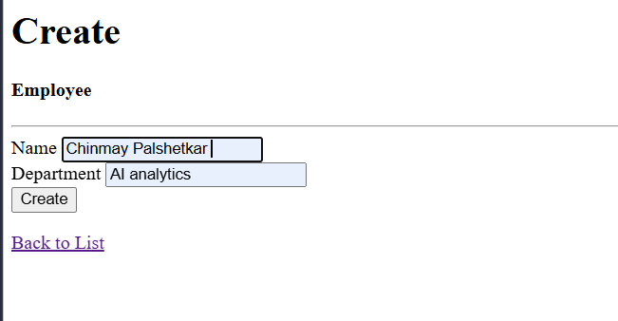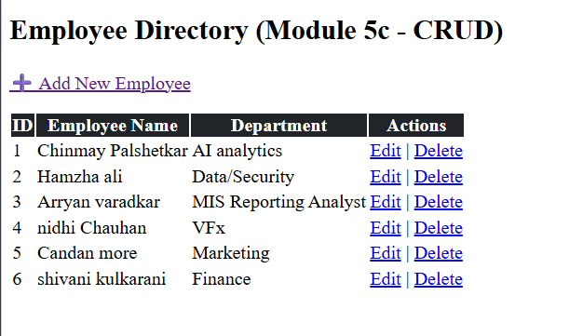
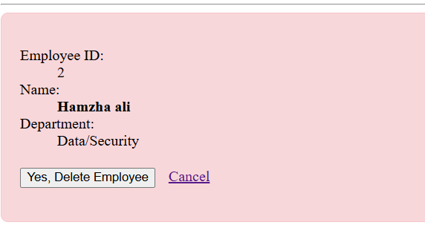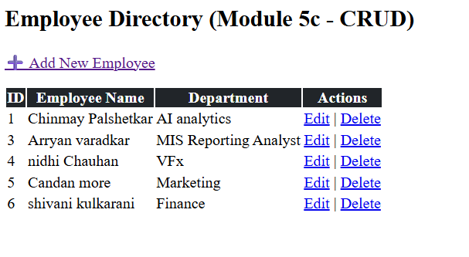
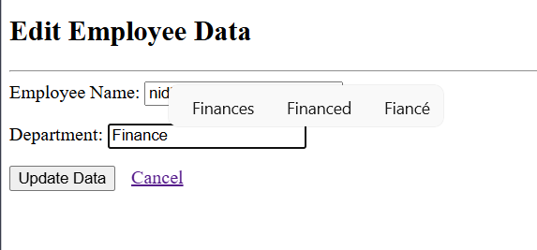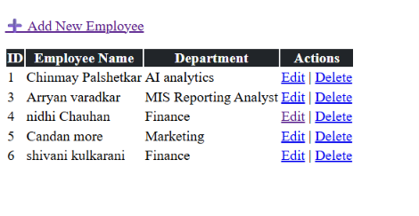

Module 2:
Practical 6 a. Create a simple website for a College Information Portal and convert it into a Progressive
Web Application.
Code:-
index.html :-
<!DOCTYPE html>
<html lang="en">
<head>
<meta charset="UTF-8">
<meta name="viewport" content="width=device-width, initial-scale=1.0">
<title>KBD College Portal</title>
<link rel="manifest" href="manifest.json">
<meta name="theme-color" content="#1e3c72">
<style>
:root {
--primary: #1e3c72;
--secondary: #2a5298;
--bg: #f4f7f6;
--text: #333;
}
body {
font-family: 'Segoe UI', system-ui, -apple-system, sans-serif;
background-color: var(--bg);
color: var(--text);
margin: 0;
padding-bottom: 40px;
}
/* Modern Gradient Header */
header {
background: linear-gradient(135deg, var(--primary), var(--secondary));
color: white;
padding: 60px 20px 80px;
text-align: center;
border-bottom-left-radius: 40px;
border-bottom-right-radius: 40px;
box-shadow: 0 4px 20px rgba(0,0,0,0.15);
}
header h1 {
margin: 0;
font-size: 2.8rem;
font-weight: 800;
letter-spacing: 1px;
}
header p {
margin: 10px 0 0;
font-size: 1.2rem;
opacity: 0.9;
}
/* Grid Layout for Cards */
.container {
max-width: 1000px;
margin: -40px auto 0;
padding: 0 20px;
display: grid;
grid-template-columns: repeat(auto-fit, minmax(300px, 1fr));
gap: 25px;
}
/* Hover-Animated Floating Cards */
.card {
background: white;
padding: 30px;
border-radius: 16px;
box-shadow: 0 10px 30px rgba(0,0,0,0.08);
transition: transform 0.3s ease, box-shadow 0.3s ease;
position: relative;
overflow: hidden;
border-top: 5px solid var(--secondary);
}
.card:hover {
transform: translateY(-8px);
box-shadow: 0 15px 35px rgba(0,0,0,0.12);
}
.card h2 {
margin-top: 0;
color: var(--primary);
font-size: 1.4rem;
display: flex;
align-items: center;
gap: 10px;
}
.card p {
line-height: 1.6;
color: #555;
}
/* Stylish Badges */
.badge {
display: inline-block;
background: #e0eafc;
color: var(--primary);
padding: 6px 14px;
border-radius: 20px;
font-size: 0.85rem;
font-weight: bold;
margin-bottom: 15px;
}
.btn {
display: inline-block;
margin-top: 15px;
padding: 10px 20px;
background: var(--secondary);
color: white;
text-decoration: none;
border-radius: 8px;
font-weight: bold;
transition: background 0.3s ease;
}
.btn:hover { background: var(--primary); }
</style>
</head>
<body>
<header>
<h1>KBD College, Guhagar</h1>
<p>Advanced Student Information Portal</p>
</header>
<div class="container">
<!-- Academics Card -->
<div class="card">
<span class="badge">Current Term</span>
<h2>📚 BSc IT (NEP) Academics</h2>
<p>Access your 3rd-year, 5th-semester syllabus, practical schedules, and project submission guidelines. Stay updated with the latest university notices.</p>
<a href="#" class="btn">View Timetable</a>
</div>
<!-- Placements Card -->
<div class="card">
<span class="badge">Future Goals</span>
<h2>🎓 Honors & Placements</h2>
<p>Planning for your 4th-year Honors title? Explore upcoming campus placement drives, resume-building workshops, and internship opportunities.</p>
<a href="#" class="btn">Placement Cell</a>
</div>
<!-- Higher Education Card -->
<div class="card">
<span class="badge">Global Reach</span>
<h2>✈️ PG & Specializations</h2>
<p>Get exclusive guidance on pursuing CDAC courses for advanced IT specializations, and access resources for securing postgraduate admissions abroad.</p>
<a href="#" class="btn">Explore Options</a>
</div>
</div>
<script>
// PWA Service Worker Registration
if ('serviceWorker' in navigator) {
window.addEventListener('load', () => {
navigator.serviceWorker.register('sw.js')
.then(reg => console.log('SW Registered!', reg))
.catch(err => console.error('SW Failed!', err));
});
}
</script>
</body>
</html>
sw.js (The Service Worker)
const CACHE_NAME = 'college-cache-v1';
const FILES_TO_CACHE = [
'/',
'/index.html',
'/offline.html',
'/manifest.json',
'/icon-192.png'
];
// Step 1: Install and Cache files
self.addEventListener('install', (event) => {
event.waitUntil(
caches.open(CACHE_NAME).then((cache) => {
return cache.addAll(FILES_TO_CACHE);
})
);
});
// Step 2: Intercept network requests
self.addEventListener('fetch', (event) => {
if (event.request.mode === 'navigate') {
event.respondWith(
fetch(event.request).catch(() => {
// If internet is off, return the offline.html page
return caches.match('/offline.html');
})
);
}
});
manifest.json:-
{
"name": "College Information Portal",
"short_name": "CollegeApp",
"start_url": "index.html",
"display": "standalone",
"background_color": "#f4f4f9",
"theme_color": "#0056b3",
"icons": [
{
"src": "icon-192.png",
"sizes": "192x192",
"type": "image/png"
}
]
}
Output:-
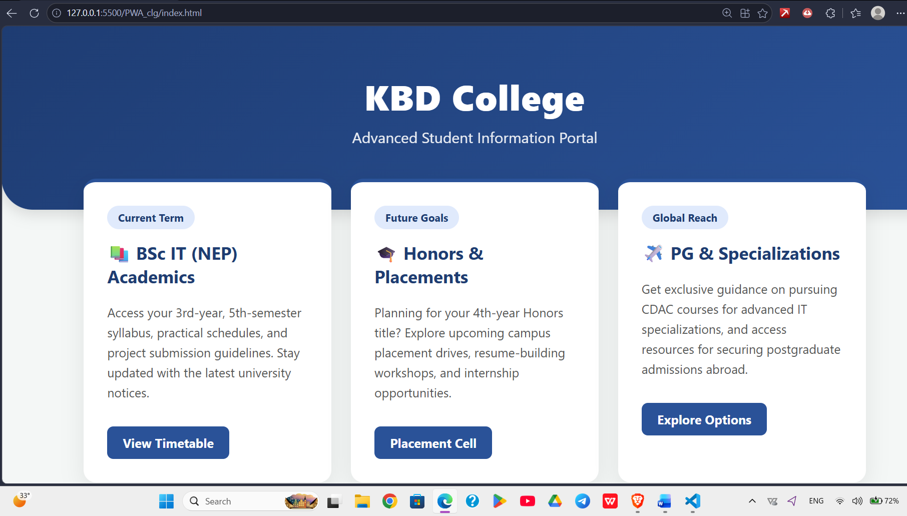
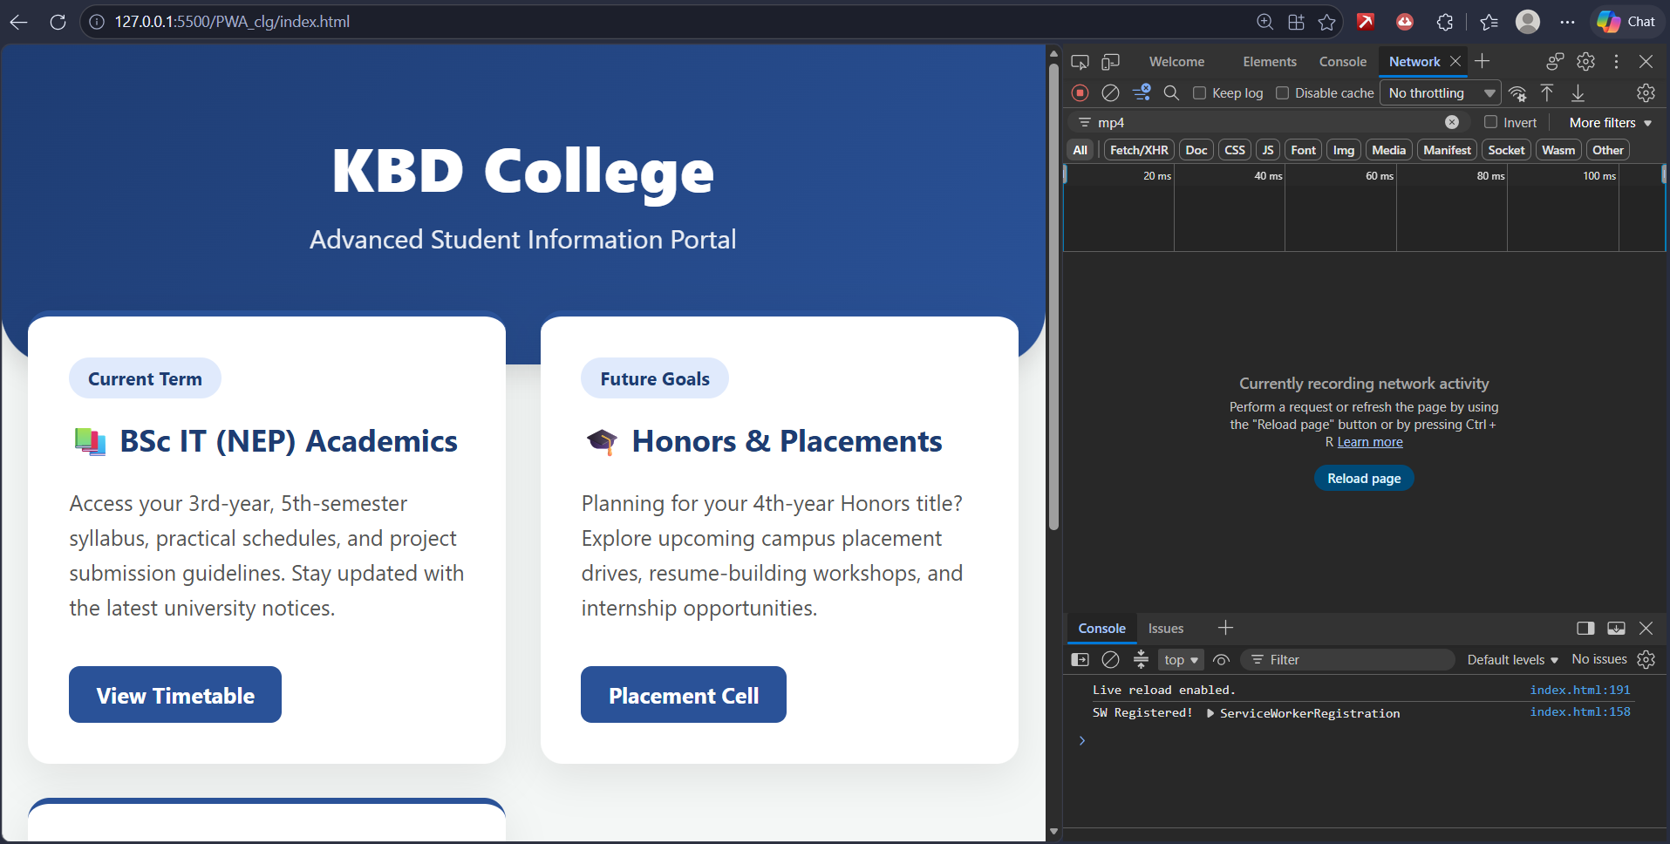

b. Create a PWA that displays a custom offline page when the user is not connected to the internet.
Code:-
offline.html :-
<!DOCTYPE html>
<html lang="en">
<head>
<meta charset="UTF-8">
<meta name="viewport" content="width=device-width, initial-scale=1.0">
<title>Connection Lost - KBD College</title>
<style>
body {
font-family: 'Segoe UI', system-ui, sans-serif;
background: linear-gradient(135deg, #fdfbfb 0%, #ebedee 100%);
display: flex;
justify-content: center;
align-items: center;
height: 100vh;
margin: 0;
color: #333;
}
.offline-container {
background: white;
padding: 50px 40px;
border-radius: 20px;
box-shadow: 0 15px 35px rgba(0,0,0,0.1);
text-align: center;
max-width: 400px;
border-top: 6px solid #ff6b6b;
}
.icon {
font-size: 60px;
margin-bottom: 10px;
animation: pulse 2s infinite;
}
h1 {
margin: 10px 0;
color: #2d3436;
font-size: 24px;
}
p {
color: #636e72;
line-height: 1.5;
margin-bottom: 25px;
}
.retry-btn {
background: #1e3c72;
color: white;
border: none;
padding: 12px 25px;
border-radius: 8px;
font-size: 16px;
font-weight: bold;
cursor: pointer;
transition: background 0.3s;
}
.retry-btn:hover {
background: #2a5298;
}
@keyframes pulse {
0% { transform: scale(1); opacity: 1; }
50% { transform: scale(1.1); opacity: 0.7; }
100% { transform: scale(1); opacity: 1; }
}
</style>
</head>
<body>
<div class="offline-container">
<div class="icon">📡</div>
<h1>Connection Lost</h1>
<p>You are currently offline. Please check your Wi-Fi or mobile data to reconnect to the KBD College Portal.</p>
<button class="retry-btn" onclick="window.location.reload()">Try Again</button>
</div>
</body>
</html>
Output:-
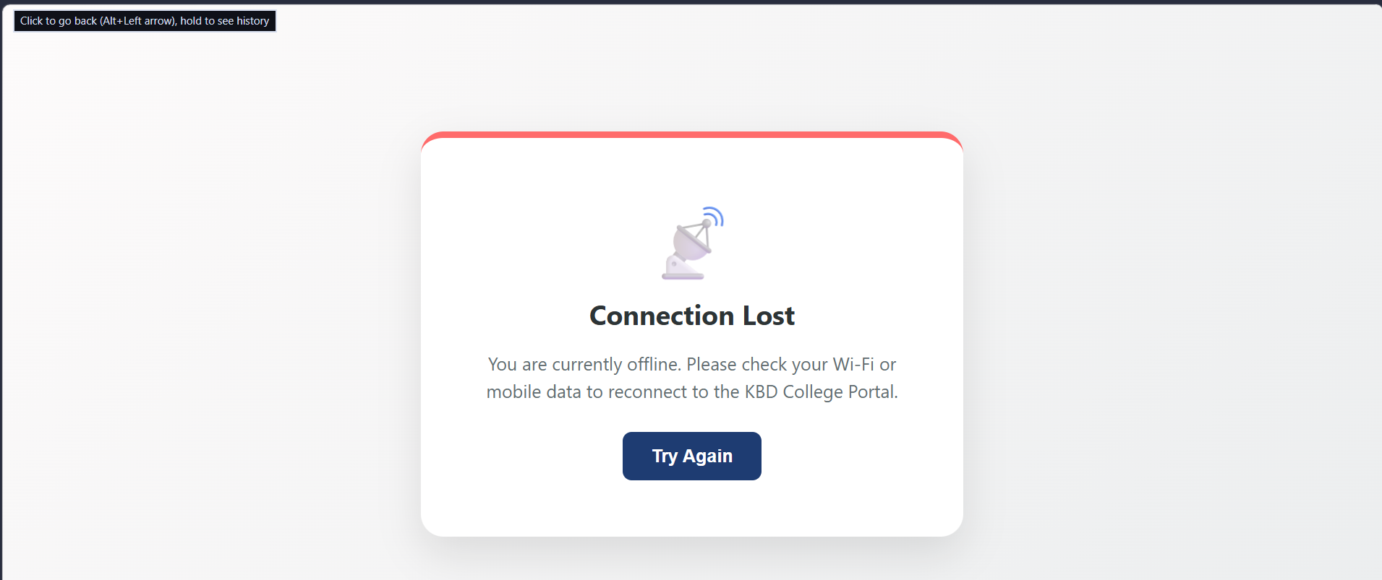

Practical 7. a. Develop a PWA that works in offline mode using Service Worker.
Code:-
manifest.json
{
"name": "Student Manager PWA",
"short_name": "RecordsPWA",
"start_url": "index.html",
"display": "standalone",
"background_color": "#f8f9fa",
"theme_color": "#28a745",
"icons": [
{
"src": "icon-192.png",
"sizes": "192x192",
"type": "image/png"
}
]
}
sw.js (The Service Worker)
const CACHE_NAME = 'offline-cache-v1';
const ASSETS_TO_CACHE = [
'/',
'/index.html',
'/manifest.json'
];
// Install Event: Cache all required assets
self.addEventListener('install', (event) => {
event.waitUntil(
caches.open(CACHE_NAME).then((cache) => {
return cache.addAll(ASSETS_TO_CACHE);
})
);
});
// Fetch Event: Serve from cache if offline
self.addEventListener('fetch', (event) => {
event.respondWith(
caches.match(event.request).then((cachedResponse) => {
// Return the cached version if it exists, otherwise fetch from the network
return cachedResponse || fetch(event.request);
})
);
});
// Activate Event: Cleanup old caches
self.addEventListener('activate', (event) => {
event.waitUntil(
caches.keys().then((cacheNames) => {
return Promise.all(
cacheNames.map((cache) => {
if (cache !== CACHE_NAME) {
return caches.delete(cache);
}
})
);
})
);
});
Output:-
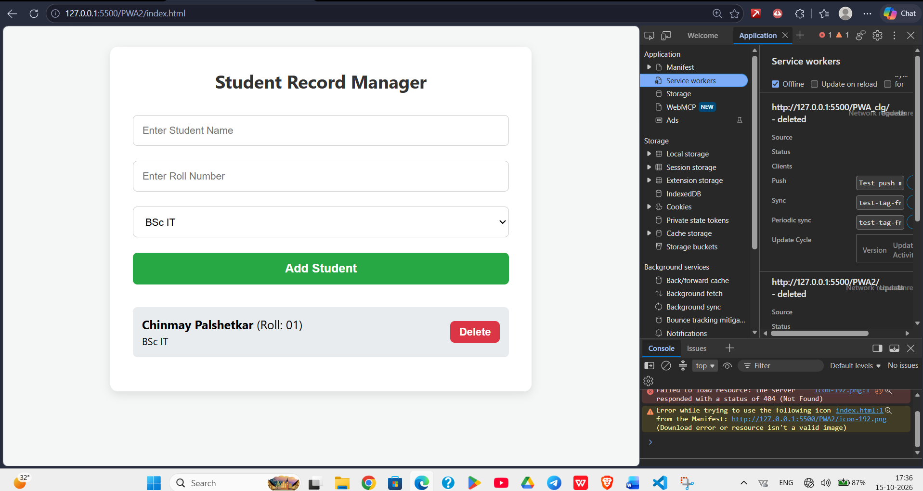
b. Create a Student Record Management PWA.
Code:-
index.html
<!DOCTYPE html>
<html lang="en">
<head>
<meta charset="UTF-8">
<meta name="viewport" content="width=device-width, initial-scale=1.0">
<title>Student Records PWA</title>
<link rel="manifest" href="manifest.json">
<meta name="theme-color" content="#28a745">
<style>
body { font-family: 'Segoe UI', Tahoma, Geneva, Verdana, sans-serif; background: #f4f7f6; padding: 20px; }
.container { max-width: 500px; margin: auto; background: white; padding: 30px; border-radius: 10px; box-shadow: 0 4px 12px rgba(0,0,0,0.1); }
h2 { text-align: center; color: #333; margin-top: 0; }
input, select, button { width: 100%; padding: 12px; margin: 10px 0; box-sizing: border-box; border: 1px solid #ccc; border-radius: 6px; }
button { background-color: #28a745; color: white; border: none; cursor: pointer; font-size: 16px; font-weight: bold; }
button:hover { background-color: #218838; }
ul { list-style-type: none; padding: 0; margin-top: 20px; }
li { background: #e9ecef; margin: 8px 0; padding: 12px; display: flex; justify-content: space-between; align-items: center; border-radius: 6px; }
.delete-btn { background: #dc3545; width: auto; padding: 6px 12px; margin: 0; font-size: 14px; }
.delete-btn:hover { background: #c82333; }
</style>
</head>
<body>
<div class="container">
<h2>Student Record Manager</h2>
<!-- Input Form -->
<input type="text" id="stuName" placeholder="Enter Student Name" required>
<input type="text" id="stuRoll" placeholder="Enter Roll Number" required>
<select id="stuCourse">
<option value="BSc IT">BSc IT</option>
<option value="BSc CS">BSc CS</option>
<option value="BCA">BCA</option>
</select>
<button onclick="addStudent()">Add Student</button>
<!-- Student List -->
<ul id="studentList"></ul>
</div>
<script>
// Load existing students from LocalStorage when the app opens
document.addEventListener("DOMContentLoaded", loadStudents);
function addStudent() {
const name = document.getElementById('stuName').value.trim();
const roll = document.getElementById('stuRoll').value.trim();
const course = document.getElementById('stuCourse').value;
if (name === "" || roll === "") {
alert("Please fill in all fields!");
return;
}
const student = { name, roll, course };
let students = JSON.parse(localStorage.getItem('students')) || [];
students.push(student);
// Save to browser's local storage
localStorage.setItem('students', JSON.stringify(students));
// Clear inputs
document.getElementById('stuName').value = '';
document.getElementById('stuRoll').value = '';
loadStudents();
}
function loadStudents() {
const studentList = document.getElementById('studentList');
studentList.innerHTML = '';
let students = JSON.parse(localStorage.getItem('students')) || [];
students.forEach((stu, index) => {
const li = document.createElement('li');
li.innerHTML = `<span><strong>${stu.name}</strong> (Roll: ${stu.roll}) <br><small>${stu.course}</small></span>
<button class="delete-btn" onclick="deleteStudent(${index})">Delete</button>`;
studentList.appendChild(li);
});
}
function deleteStudent(index) {
let students = JSON.parse(localStorage.getItem('students'));
students.splice(index, 1);
localStorage.setItem('students', JSON.stringify(students));
loadStudents();
}
// Register the Service Worker
if ('serviceWorker' in navigator) {
window.addEventListener('load', () => {
navigator.serviceWorker.register('sw.js')
.then(reg => console.log('SW Registered!', reg))
.catch(err => console.error('SW Failed!', err));
});
}
</script>
</body>
</html>
Output:-
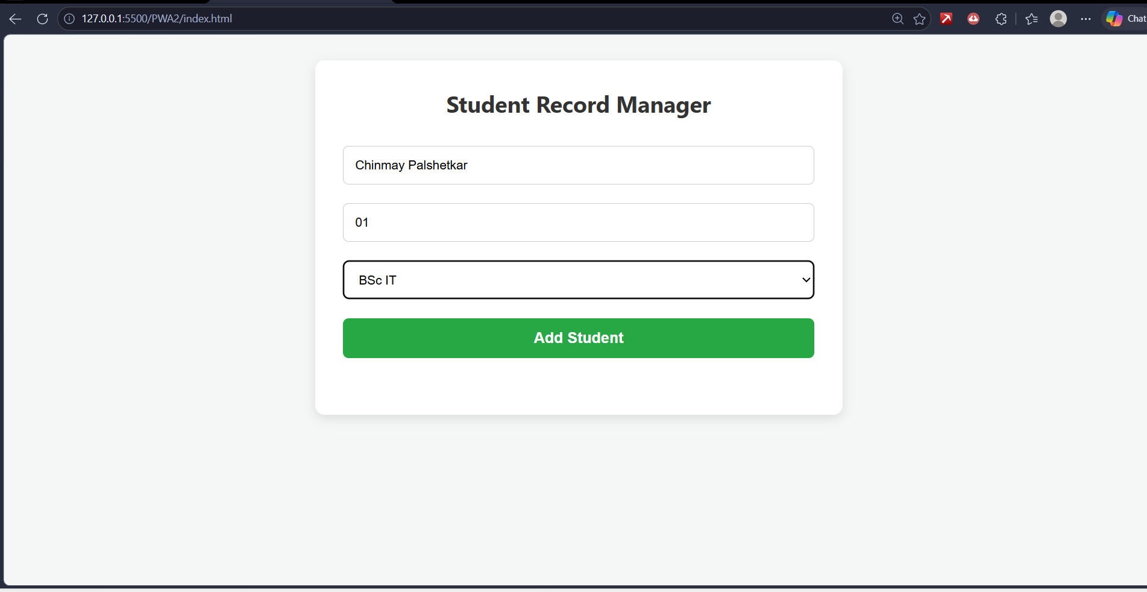
Practical 8 . a. Create an HTML page that would be the starting point of the application. This HTML will contain a link to the file named manifest.json. This is an important file that would be created in the next step.
Code:-
Index.html
<!DOCTYPE html>
<html lang="en">
<head>
<meta charset="UTF-8">
<meta name="viewport" content="width=device-width, initial-scale=1.0">
<title>KBD College App</title>
<!-- IMPORTANT: Linking the manifest.json file -->
<link rel="manifest" href="manifest.json">
<style>
body {
font-family: 'Segoe UI', Tahoma, sans-serif;
background-color: #f4f7f6;
display: flex;
justify-content: center;
align-items: center;
height: 100vh;
margin: 0;
}
.card {
background: white;
padding: 40px;
border-radius: 12px;
box-shadow: 0 4px 15px rgba(0,0,0,0.1);
text-align: center;
border-top: 5px solid #1e3c72;
}
h1 { color: #333; margin-bottom: 10px; }
p { color: #666; }
</style>
</head>
<body>
<div class="card">
<h1>Welcome to KBD College</h1>
<p>This is the starting point of the PWA application.</p>
<p><i>The <b>manifest.json</b> file has been successfully linked in the background!</i></p>
</div>
</body>
</html>
Output:-
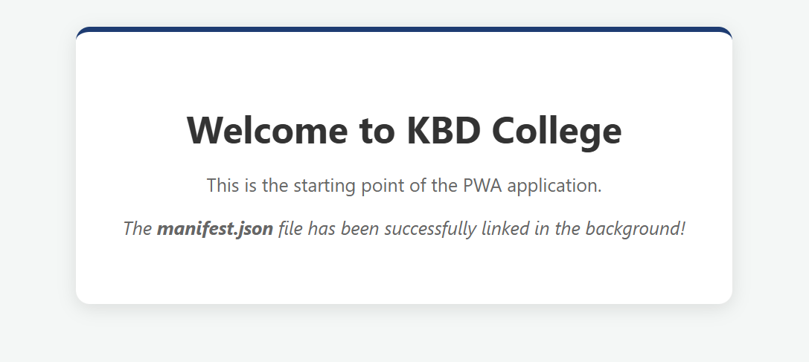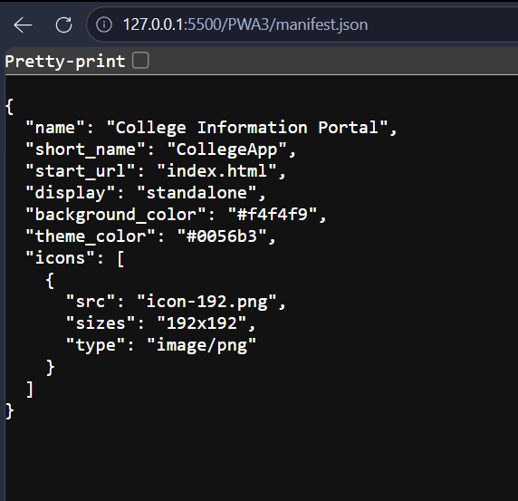

b. Create a simple Web API that returns Student data in JSON format.
Code:-
Student.cs
namespace WebApplication3.Models
{
public class Student
{
public int RollNo { get; set; }
public string Name { get; set; }
public string Course { get; set; }
}
}
StudentController.cs
using Microsoft.AspNetCore.Mvc;
using WebApplication3.Models;
namespace WebApplication3.Controllers
{
[Route("api/[controller]")]
[ApiController]
public class StudentController : ControllerBase
{
[HttpGet]
public ActionResult<IEnumerable<Student>> GetStudents()
{
var students = new List<Student>
{
new Student { RollNo = 1, Name = "Chinmay Palshetkar", Course = "BSc IT" },
new Student { RollNo = 2, Name = "Aisha Khan", Course = "BSc CS" },
new Student { RollNo = 3, Name = "Rahul Sharma", Course = "BCA" }
};
return Ok(students);
}
}
}
Output:-

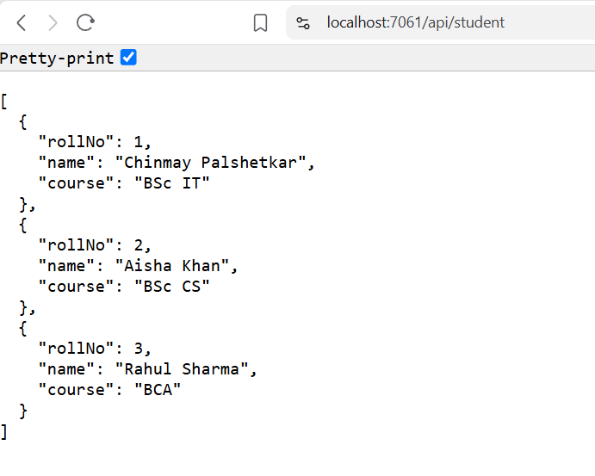

Practical 9 . a. Develop CRUD operations using ASP.NET Core Web API and Entity Framework Core.
Code:-
Step 1: Install EF Core InMemory Package
In Visual Studio, open Tools > NuGet Package Manager > Manage NuGet Packages for Solution, search for and install:
- Microsoft.EntityFrameworkCore.InMemory
Step 2: Student.cs (Model inside Models folder)
namespace WebApplication3.Models
{
public class Student
{
public int Id { get; set; }
public string Name { get; set; } = string.Empty;
public string Course { get; set; } = string.Empty;
}
}
AppDbContext.cs
using Microsoft.EntityFrameworkCore;
namespace WebApplication3.Models
{
public class AppDbContext : DbContext
{
public AppDbContext(DbContextOptions<AppDbContext> options) : base(options) { }
public DbSet<Student> Students { get; set; } = null!;
}
}
Program.cs
using Microsoft.EntityFrameworkCore;
using WebApplication3.Models;
var builder = WebApplication.CreateBuilder(args);
// Register In-Memory Database
builder.Services.AddDbContext<AppDbContext>(options =>
options.UseInMemoryDatabase("StudentDb"));
builder.Services.AddControllers();
builder.Services.AddEndpointsApiExplorer();
builder.Services.AddSwaggerGen();
var app = builder.Build();

if (app.Environment.IsDevelopment())
{
app.UseSwagger();
app.UseSwaggerUI();
}
app.UseAuthorization();
app.MapControllers();
app.Run();
StudentsController.cs
using Microsoft.AspNetCore.Mvc;
using Microsoft.EntityFrameworkCore;
using WebApplication3.Models;
namespace WebApplication3.Controllers
{
[Route("api/[controller]")]
[ApiController]
public class StudentsController : ControllerBase
{
private readonly AppDbContext _context;

public StudentsController(AppDbContext context)
{
_context = context;
}
// 1. READ ALL: GET api/students
[HttpGet]
public async Task<ActionResult<IEnumerable<Student>>> GetStudents()
{
return await _context.Students.ToListAsync();
}
// 2. READ BY ID: GET api/students/1
[HttpGet("{id}")]
public async Task<ActionResult<Student>> GetStudent(int id)
{
var student = await _context.Students.FindAsync(id);
if (student == null) return NotFound();
return student;
}
// 3. CREATE: POST api/students
[HttpPost]
public async Task<ActionResult<Student>> PostStudent(Student student)
{
_context.Students.Add(student);
await _context.SaveChangesAsync();
return CreatedAtAction(nameof(GetStudent), new { id = student.Id }, student);
}

// 4. UPDATE: PUT api/students/1
[HttpPut("{id}")]
public async Task<IActionResult> PutStudent(int id, Student student)
{
if (id != student.Id) return BadRequest();
_context.Entry(student).State = EntityState.Modified;
try
{
await _context.SaveChangesAsync();
}
catch (DbUpdateConcurrencyException)
{
if (!_context.Students.Any(e => e.Id == id)) return NotFound();
else throw;
}
return NoContent();
}
// 5. DELETE: DELETE api/students/1
[HttpDelete("{id}")]
public async Task<IActionResult> DeleteStudent(int id)
{
var student = await _context.Students.FindAsync(id);
if (student == null) return NotFound();
_context.Students.Remove(student);
await _context.SaveChangesAsync();
return NoContent();
}
}
}
Output:-
CREATE (POST): Sending a POST request to https://localhost:7061/api/students with body:
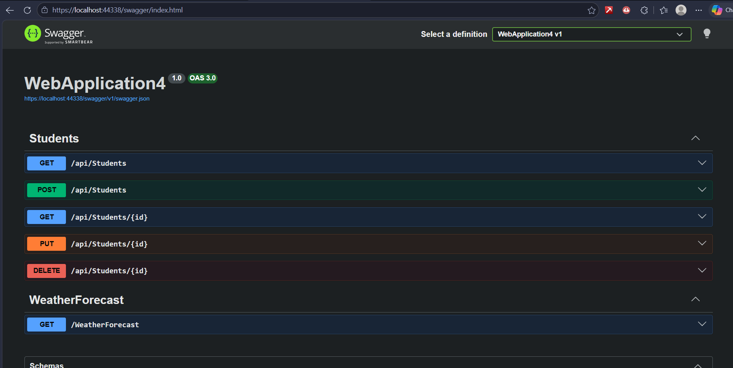
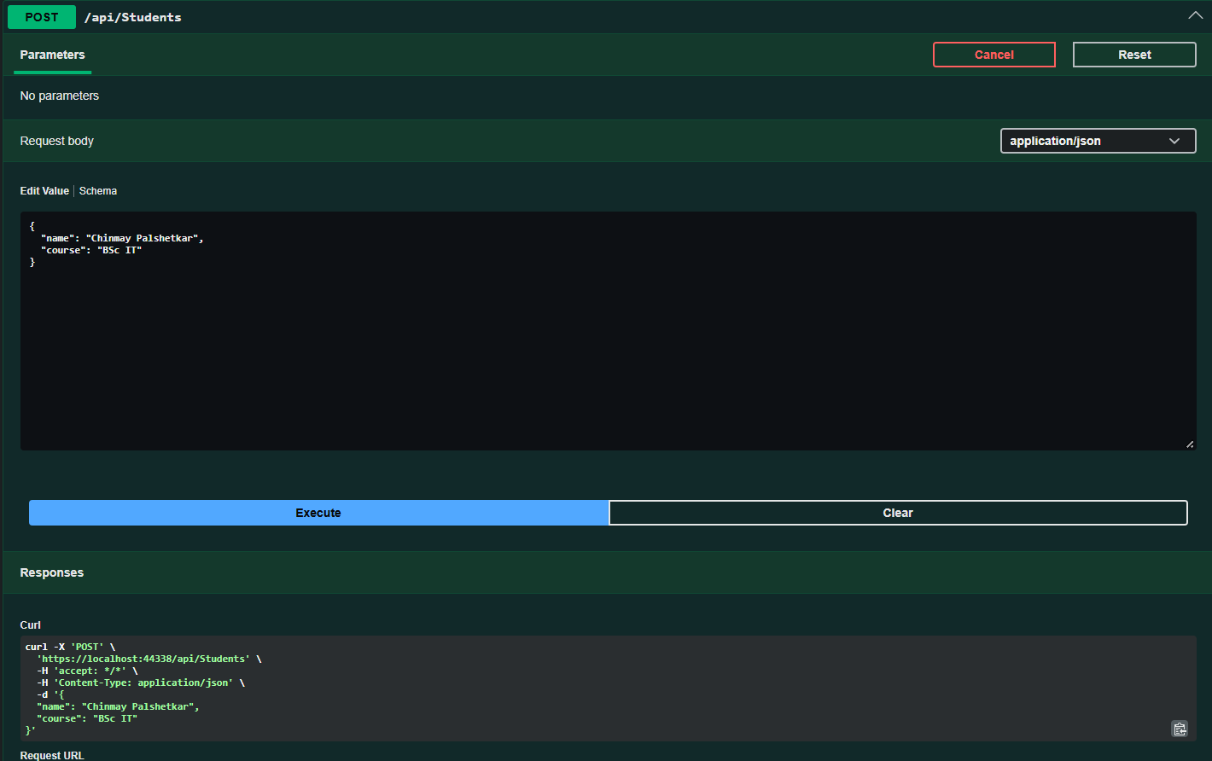
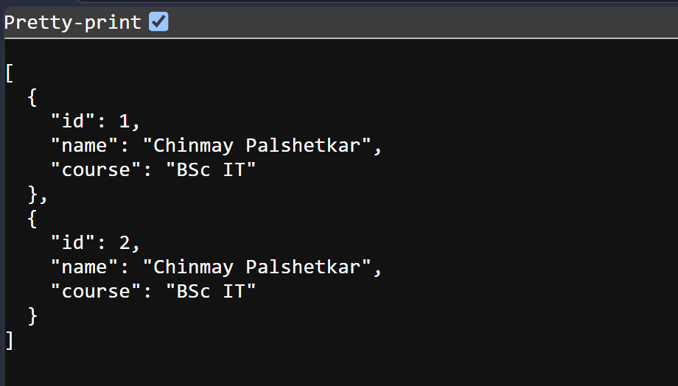
b. Create an API endpoint to calculate Factorial of a Number and test it using Postman.
Code:-
FactorialController.cs
using Microsoft.AspNetCore.Mvc;
namespace WebApplication4.Controllers
{
[Route("api/[controller]")]
[ApiController]
public class FactorialController : ControllerBase
{
// GET: api/factorial/5
[HttpGet("{number}")]
public IActionResult CalculateFactorial(int number)
{
if (number < 0)
{
return BadRequest(new { message = "Number must be a non-negative integer." });
}
long factorial = 1;
for (int i = 1; i <= number; i++)
{
factorial *= i;
}
return Ok(new
{
number = number,
factorial = factorial
});
}
}
}

Output:-
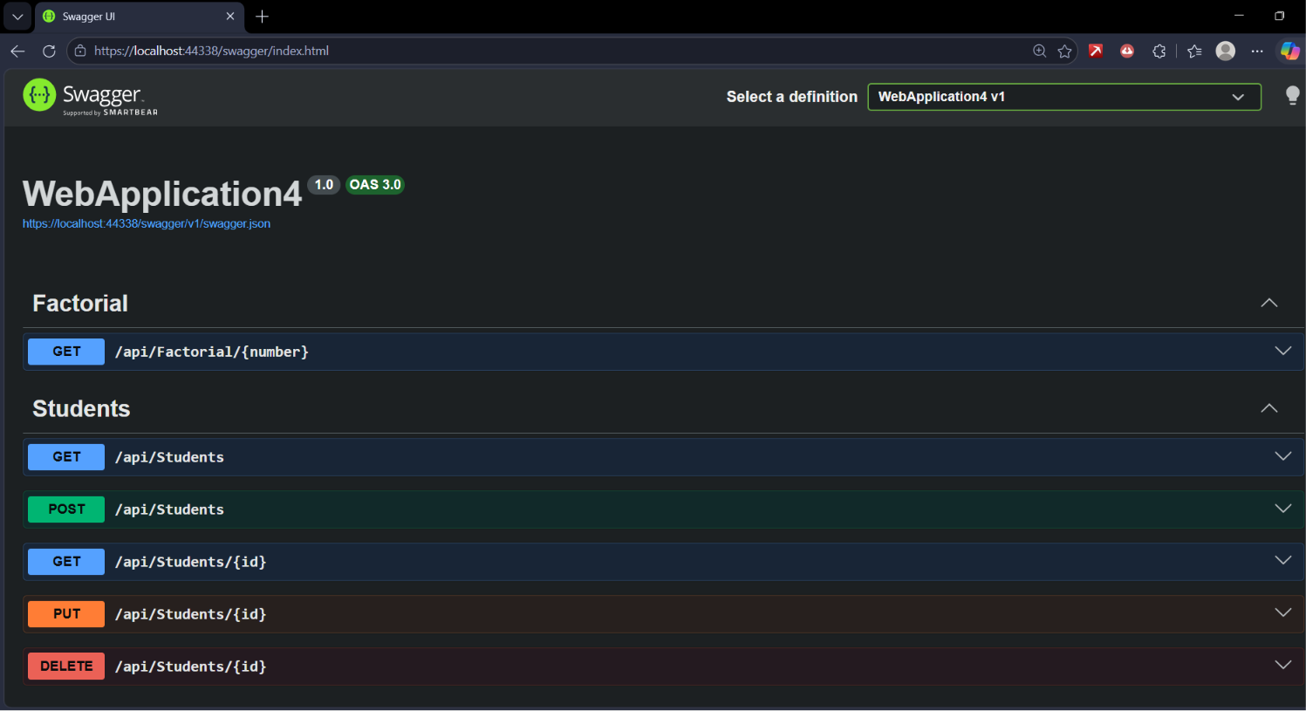
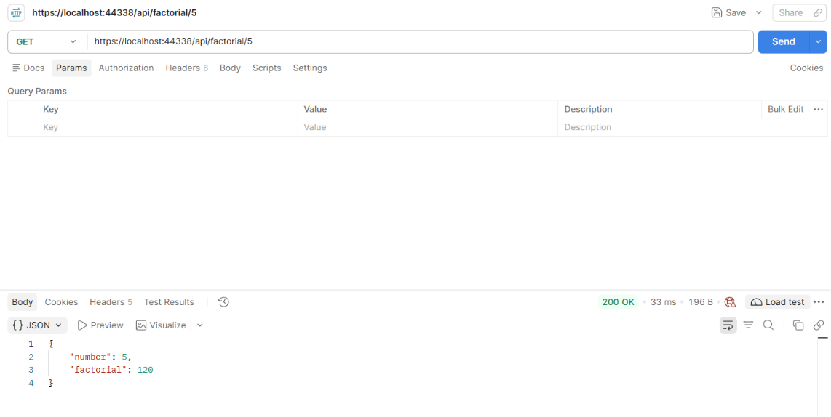

Practical 10. a. Create a PWA with a Web App Manifest file including: App name Icons Start URL Display mode Implement Push Notifications in a PWA.
Code:-
manifest.json
{
"name": "KBD College Notification Portal",
"short_name": "KBD Alerts",
"start_url": "index.html",
"display": "standalone",
"background_color": "#ffffff",
"theme_color": "#1e3c72",
"icons": [
{
"src": "icon-192.png",
"sizes": "192x192",
"type": "image/png"
}
]
}
sw.js (Service Worker)
const CACHE_NAME = 'notification-pwa-v1';
const ASSETS = ['/', '/index.html', '/manifest.json'];
self.addEventListener('install', (event) => {
event.waitUntil(
caches.open(CACHE_NAME).then((cache) => cache.addAll(ASSETS))
);
});
self.addEventListener('fetch', (event) => {
event.respondWith(
caches.match(event.request).then((cached) => cached || fetch(event.request))
);
});
// Listener for push events
self.addEventListener('push', (event) => {
const options = {
body: event.data ? event.data.text() : 'New notification from KBD College!',
icon: 'icon-192.png',
badge: 'icon-192.png'
};
event.waitUntil(
self.registration.showNotification('KBD Portal Alert', options)
);
});
index.html
<!DOCTYPE html>
<html lang="en">
<head>
<meta charset="UTF-8">
<meta name="viewport" content="width=device-width, initial-scale=1.0">
<title>PWA Push Notifications</title>
<link rel="manifest" href="manifest.json">
<style>
body { font-family: 'Segoe UI', sans-serif; background: #f4f7f6; padding: 40px; text-align: center; }
.card { background: white; max-width: 450px; margin: 50px auto; padding: 30px; border-radius: 12px; box-shadow: 0 4px 15px rgba(0,0,0,0.1); border-top: 5px solid #1e3c72; }
h2 { color: #1e3c72; }
button { background: #1e3c72; color: white; border: none; padding: 12px 20px; font-size: 15px; border-radius: 6px; cursor: pointer; margin: 8px; font-weight: bold; }
button:hover { background: #2a5298; }
.secondary { background: #28a745; }
.secondary:hover { background: #218838; }
</style>
</head>
<body>
<div class="card">
<h2>KBD Notification Center</h2>
<p>Enable permissions to receive real-time updates and practical exam schedules.</p>
<button onclick="requestPermission()">Enable Notifications</button>
<button class="secondary" onclick="triggerNotification()">Test Notification</button>
</div>
<script>
// Register Service Worker
if ('serviceWorker' in navigator) {
window.addEventListener('load', () => {
navigator.serviceWorker.register('sw.js')
.then(reg => console.log('Service Worker Registered!', reg))
.catch(err => console.error('SW Registration Failed!', err));
});
}
// Request Notification Permission
function requestPermission() {
Notification.requestPermission().then(permission => {
if (permission === 'granted') {
alert('Notification permission granted!');
} else {
alert('Permission denied.');
}
});
}
// Trigger Local Notification via Service Worker
function triggerNotification() {
if (Notification.permission === 'granted') {
navigator.serviceWorker.ready.then(registration => {
registration.showNotification('KBD College Portal', {
body: 'BSc IT 5th Semester Practical Exam timetable is live!',
icon: 'icon-192.png'
});
});
} else {
alert('Please enable notification permissions first!');
}
}
</script>
</body>
</html>
Output:-
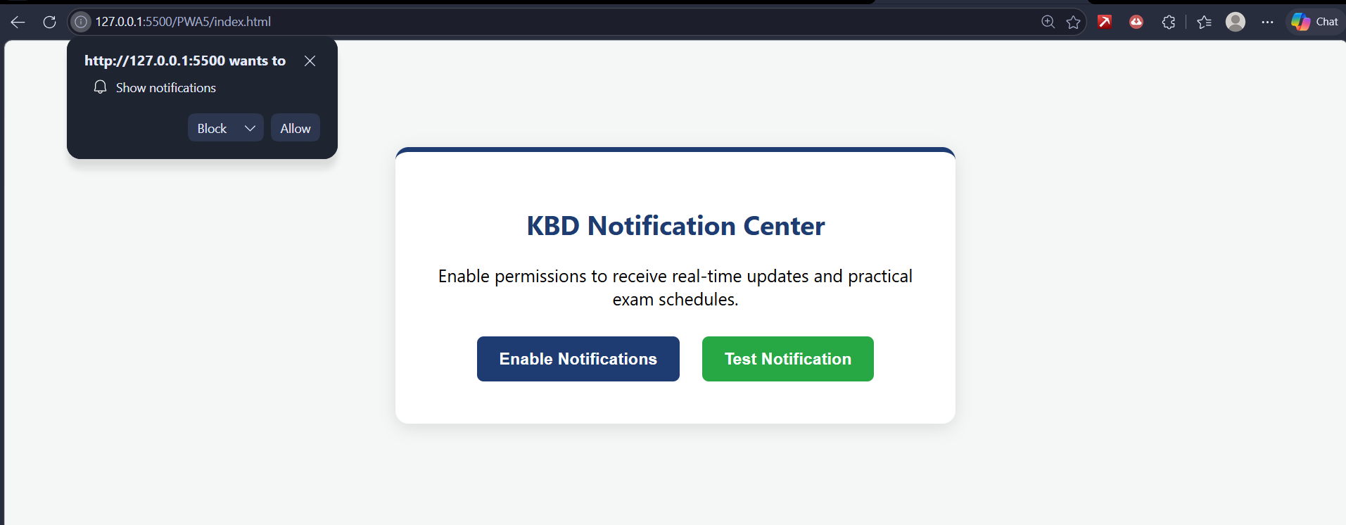
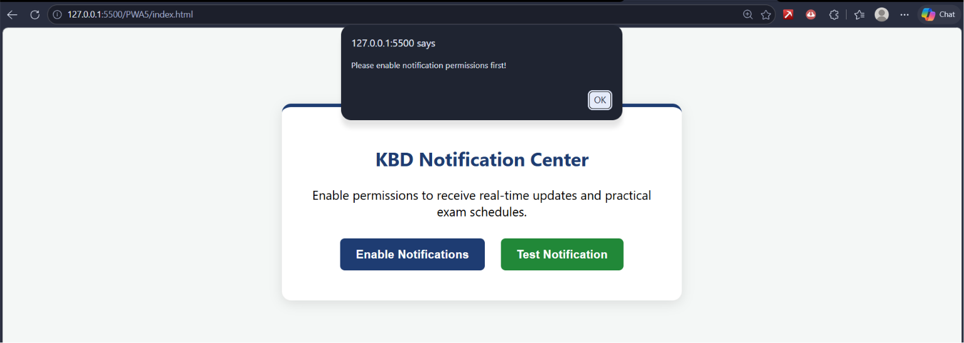
b. Develop an E-Commerce PWA with product listing and offline cart functionality.
Code:-
manifest.json
{
"name": "KBD Campus Store",
"short_name": "KBD Store",
"start_url": "index.html",
"display": "standalone",
"background_color": "#f8f9fa",
"theme_color": "#28a745",
"icons": [
{
"src": "icon-192.png",
"sizes": "192x192",
"type": "image/png"
}
]
}
sw.js (Service Worker)
const CACHE_NAME = 'kbd-store-v1';
const ASSETS_TO_CACHE = ['/', '/index.html', '/manifest.json'];
self.addEventListener('install', (event) => {
event.waitUntil(
caches.open(CACHE_NAME).then((cache) => cache.addAll(ASSETS_TO_CACHE))
);
});

self.addEventListener('fetch', (event) => {
event.respondWith(
caches.match(event.request).then((response) => response || fetch(event.request))
);
});
index.html
<!DOCTYPE html>
<html lang="en">
<head>
<meta charset="UTF-8">
<meta name="viewport" content="width=device-width, initial-scale=1.0">
<title>KBD Campus Store</title>
<link rel="manifest" href="manifest.json">
<style>
body { font-family: 'Segoe UI', sans-serif; background-color: #f4f7f6; margin: 0; padding-bottom: 40px; }
header { background: #1e3c72; color: white; padding: 20px; text-align: center; }
.container { max-width: 900px; margin: 30px auto; padding: 0 20px; display: grid; grid-template-columns: 2fr 1fr; gap: 20px; }
.product-grid { display: grid; grid-template-columns: repeat(auto-fit, minmax(200px, 1fr)); gap: 15px; }
.product-card { background: white; padding: 20px; border-radius: 10px; box-shadow: 0 4px 10px rgba(0,0,0,0.08); text-align: center; }
.product-card h3 { margin: 10px 0 5px; }
.price { color: #28a745; font-weight: bold; font-size: 1.1rem; }
button { background: #28a745; color: white; border: none; padding: 8px 15px; border-radius: 5px; cursor: pointer; font-weight: bold; width: 100%; margin-top: 10px; }
button:hover { background: #218838; }
.cart-card { background: white; padding: 20px; border-radius: 10px; box-shadow: 0 4px 10px rgba(0,0,0,0.08); height: fit-content; }
.cart-item { display: flex; justify-content: space-between; border-bottom: 1px solid #eee; padding: 8px 0; }
.clear-btn { background: #dc3545; margin-top: 15px; }
.clear-btn:hover { background: #c82333; }
</style>
</head>
<body>
<header>
<h1>🛒 KBD Campus Store</h1>
<p>Offline-Capable E-Commerce PWA</p>
</header>
<div class="container">
<!-- Product Catalog -->
<div>
<h2>Products</h2>
<div class="product-grid">
<div class="product-card">
<h3>📘 C# & ASP.NET Book</h3>
<p class="price">₹450</p>
<button onclick="addToCart('C# & ASP.NET Book', 450)">Add to Cart</button>
</div>
<div class="product-card">
<h3>💻 Wireless Mouse</h3>
<p class="price">₹650</p>
<button onclick="addToCart('Wireless Mouse', 650)">Add to Cart</button>
</div>
<div class="product-card">
<h3>💾 64GB USB Drive</h3>
<p class="price">₹500</p>
<button onclick="addToCart('64GB USB Drive', 500)">Add to Cart</button>
</div>
</div>
</div
<!-- Offline Cart -->
<div class="cart-card">
<h2>Shopping Cart</h2>
<div id="cartItems"></div>
<p><strong>Total: ₹<span id="cartTotal">0</span></strong></p>
<button class="clear-btn" onclick="clearCart()">Clear Cart</button>
</div>
</div>
<script>
document.addEventListener("DOMContentLoaded", renderCart);
function getCart() {
return JSON.parse(localStorage.getItem('kbd_cart')) || [];
}
function addToCart(name, price) {
const cart = getCart();
cart.push({ name, price });
localStorage.setItem('kbd_cart', JSON.stringify(cart));
renderCart();

function renderCart() {
const cart = getCart();
const container = document.getElementById('cartItems');
const totalSpan = document.getElementById('cartTotal');
container.innerHTML = '';
let total = 0;
if (cart.length === 0) {
container.innerHTML = '<p><i>Cart is empty</i></p>';
} else {
cart.forEach(item => {
total += item.price;
const div = document.createElement('div');
div.className = 'cart-item';
div.innerHTML = `<span>${item.name}</span><span>₹${item.price}</span>`;
container.appendChild(div);
});
}
totalSpan.textContent = total;
}
function clearCart() {
localStorage.removeItem('kbd_cart');
renderCart();
}
// Service Worker Registration
if ('serviceWorker' in navigator) {
window.addEventListener('load', () => {
navigator.serviceWorker.register('sw.js');
});
}
</script>
</body>
</html>
Output:-
