1. Grade Checker
Take a score as input and print the grade based on the following:
90+ : "A"
80-89 : "B"
70-79 : "C"
60-69 : "D"
Below 60 : "F"
here we used a basic if else statement to carry out marks and all.

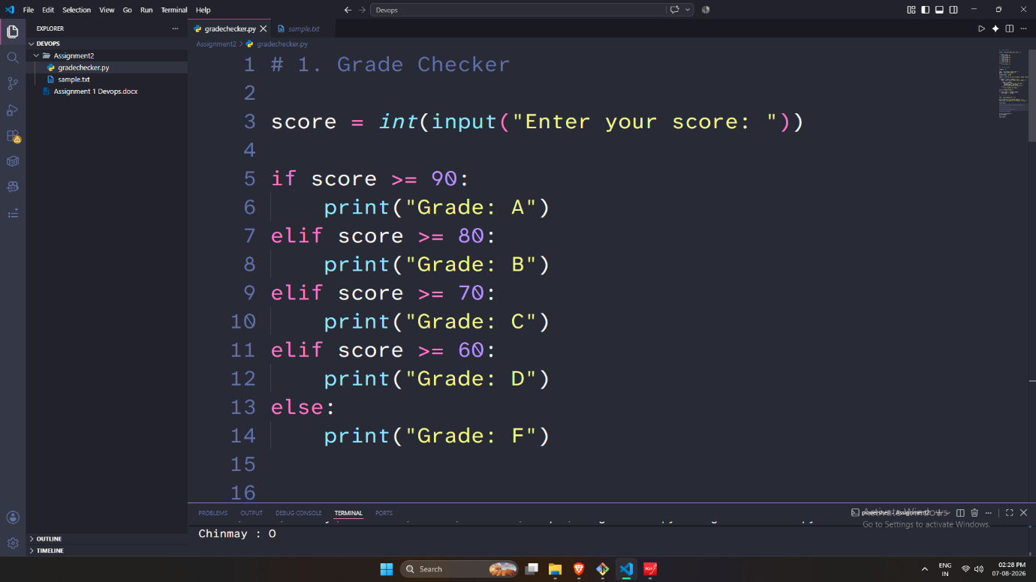
2 Student Grades
Create a dictionary where the keys are student names and the values are their grades. Allow the user to:
Add a new student and grade.
Update an existing student’s grade.
Print all student grades.

Used dictionary and basic operations. Using if else:

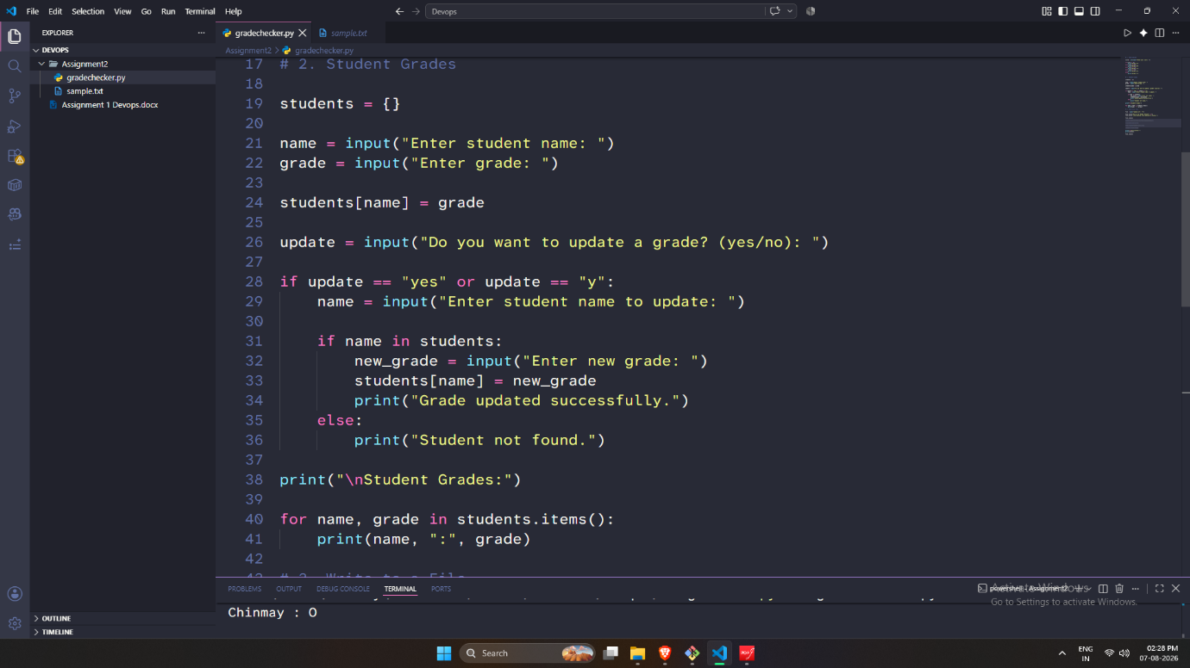
3.Write to a File
Write a program to create a text file and write some content to it.

Using file functions like write and open.
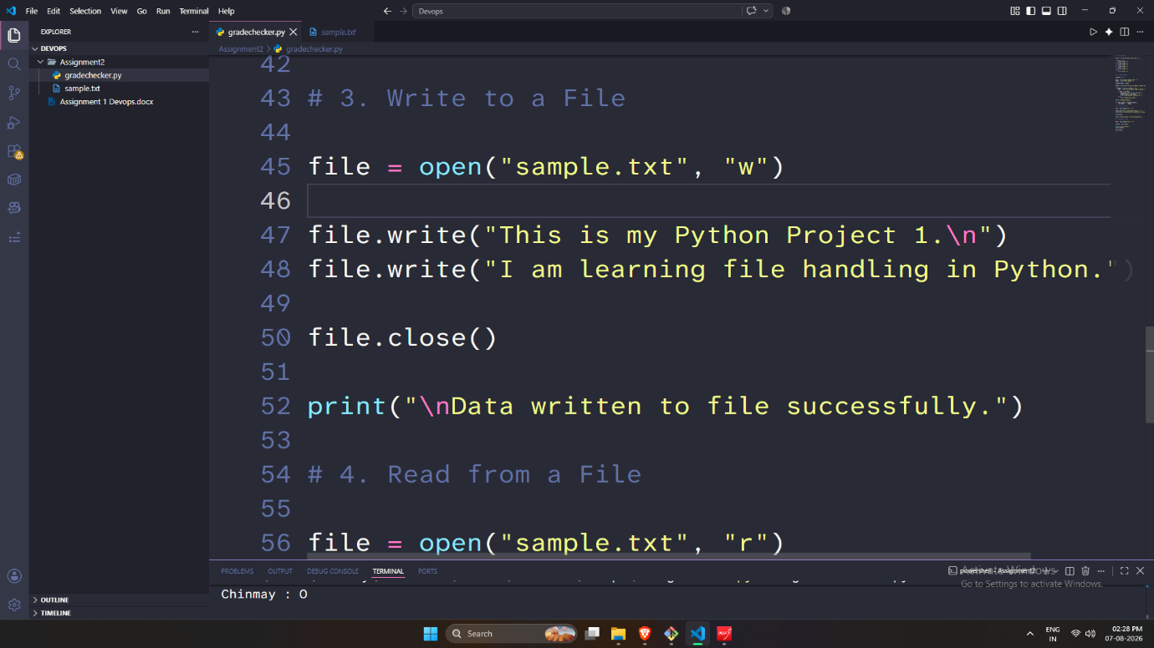
4. Read from a File
We used open in read mode and file.read to read and print to display.


