**CHATBOT Creation using Python**

**Phase 3:**

**Dataset link :** [Dataset for chatbot (kaggle.com)](https://www.kaggle.com/datasets/grafstor/simple-dialogs-for-chatbot/code)

**Sample Code:**

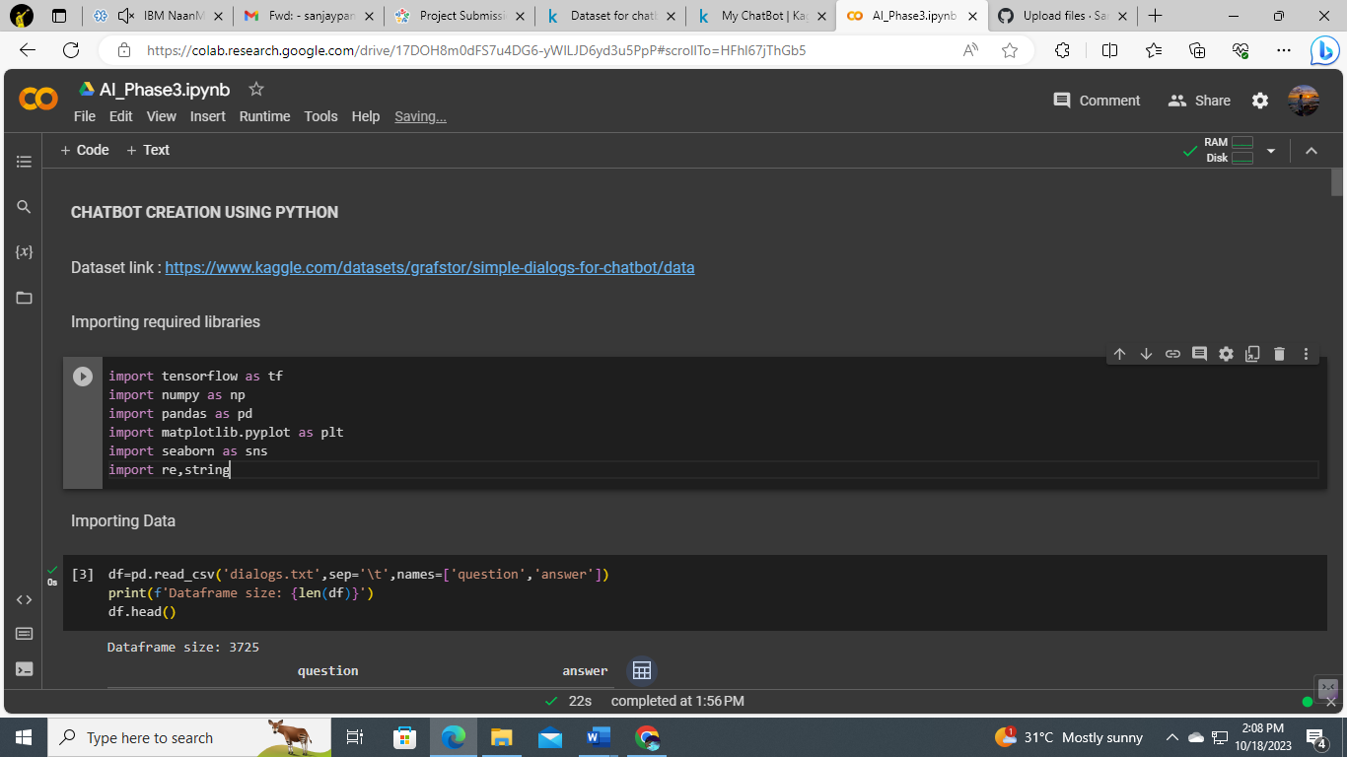

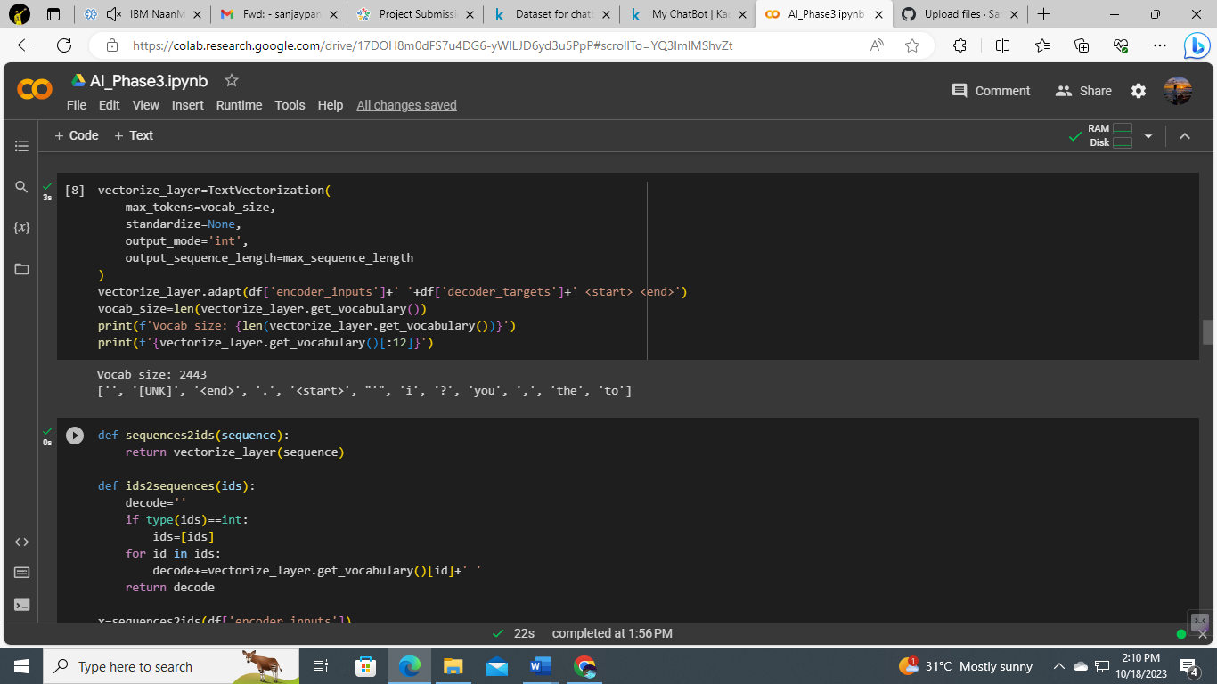

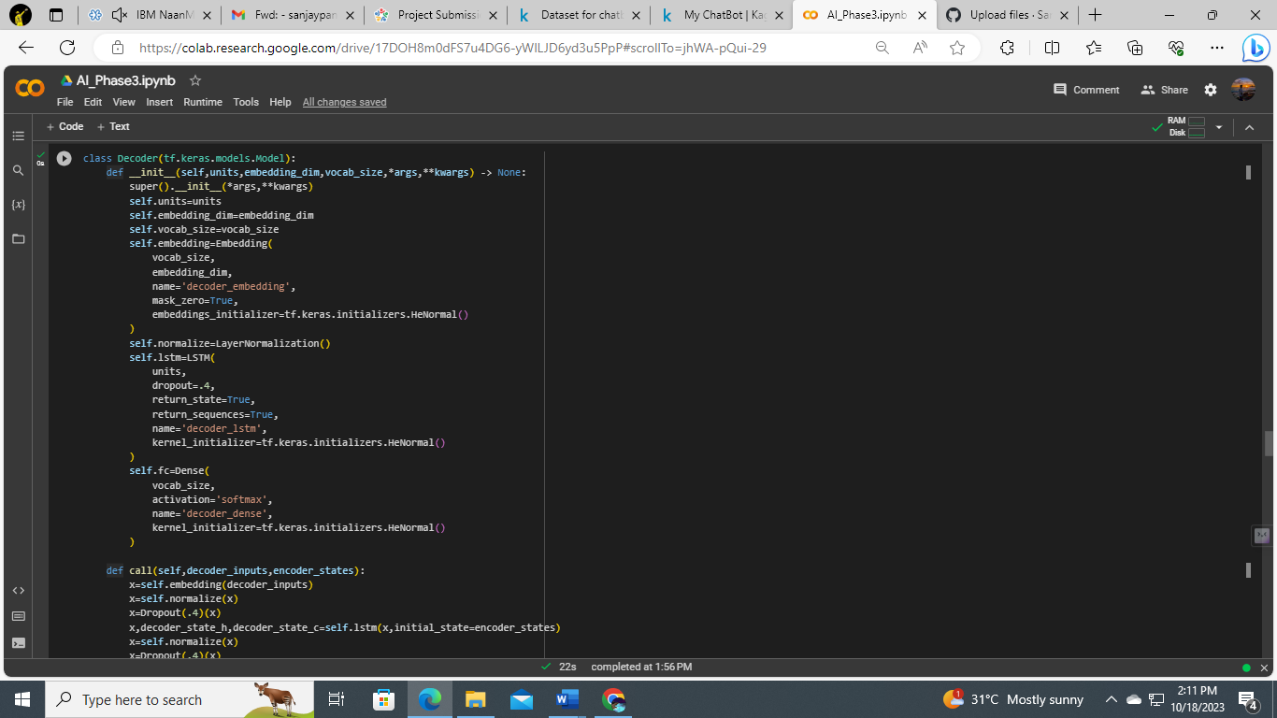

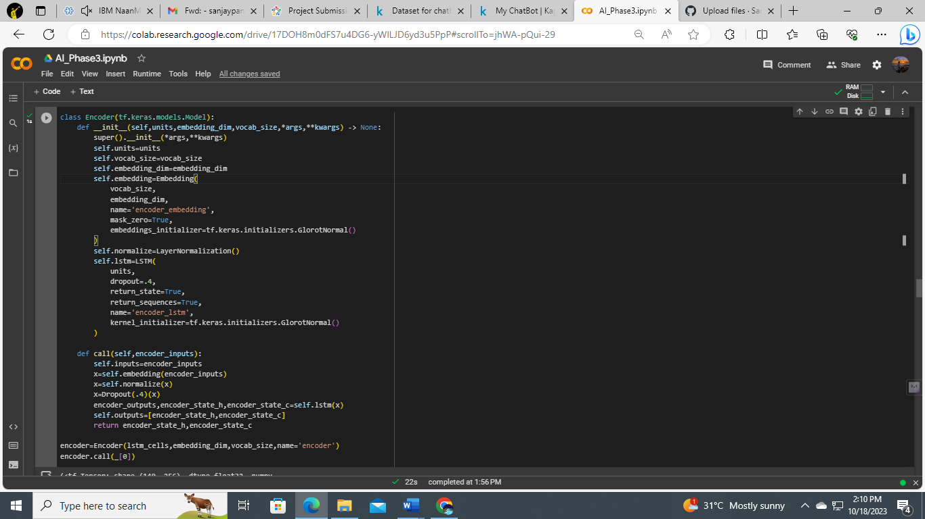

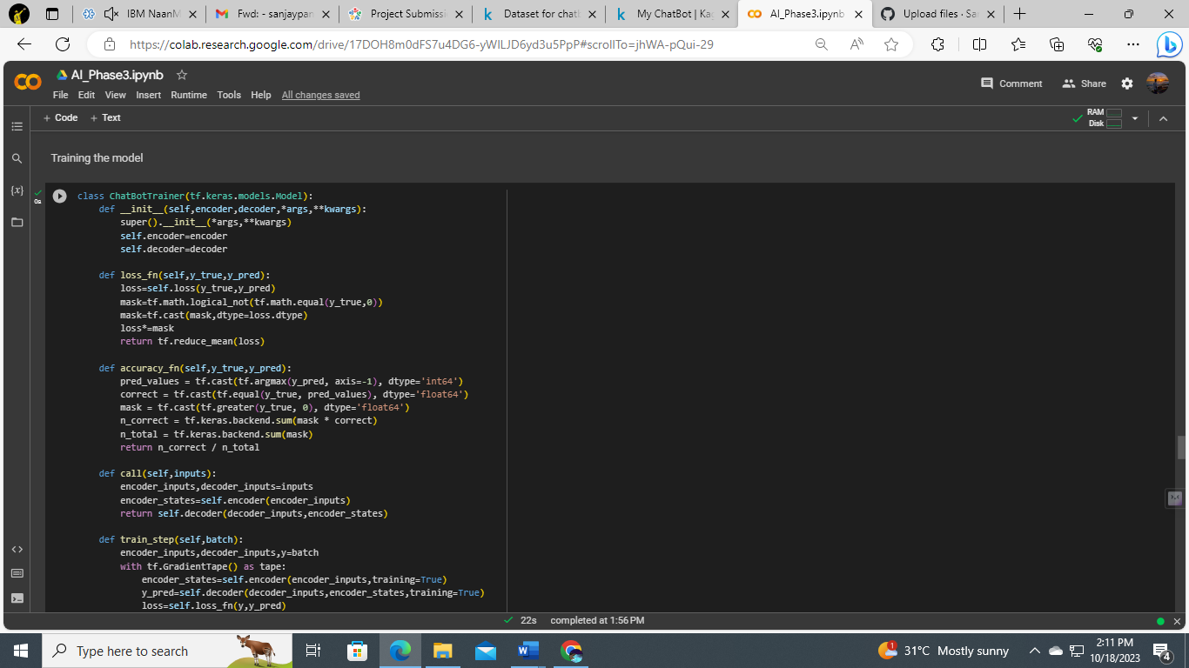

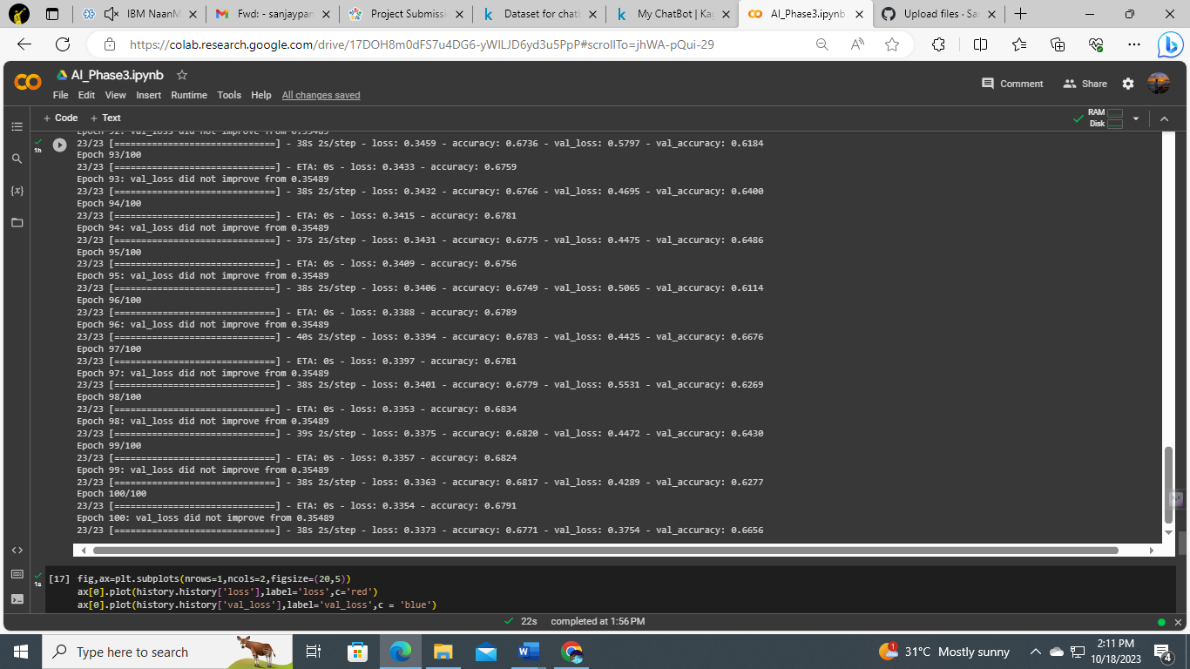

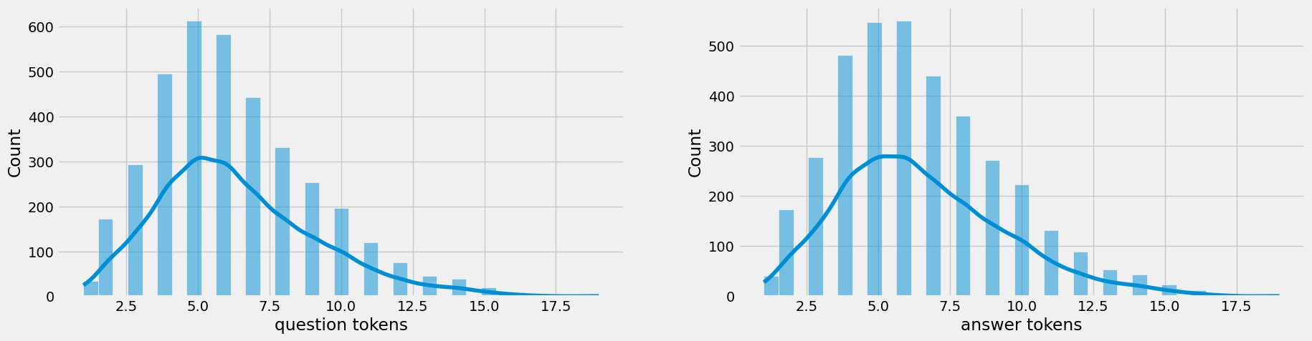

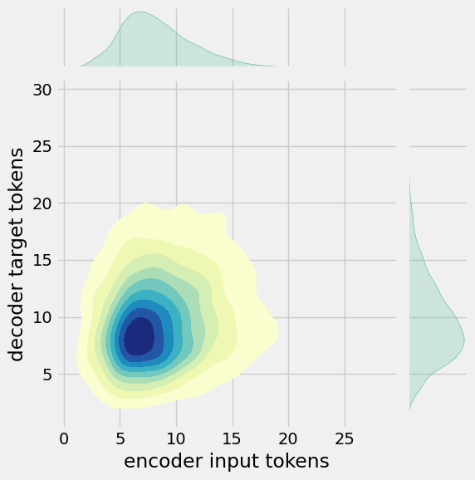

**Accuracy and Loss of the Model:**

