# Phase 2: Org Setup & Configuration (E-Commerce Project)

## Create a New Lightning App

Go to App Manager → New Lightning App  
Name: Smart E-Commerce CRM  
Description: “A Salesforce solution for Customer Engagement & Order Management.”

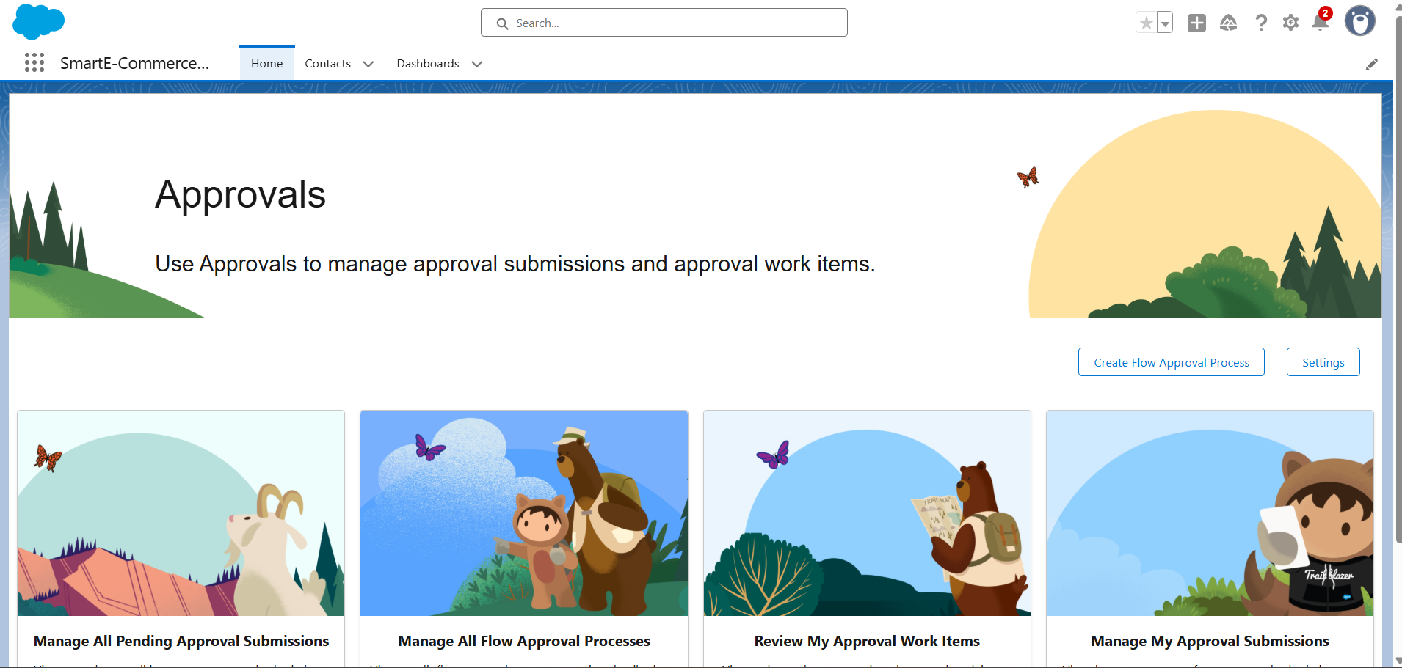

## Custom Objects

* Order__c – Manage customer orders
* Return_Request__c – Handle returns, refunds, and replacements
* Loyalty_Points__c – Track loyalty points and rewards
* Delivery__c – Track shipment and delivery details
* Campaign_Engagement__c – Track customer interactions with marketing campaigns

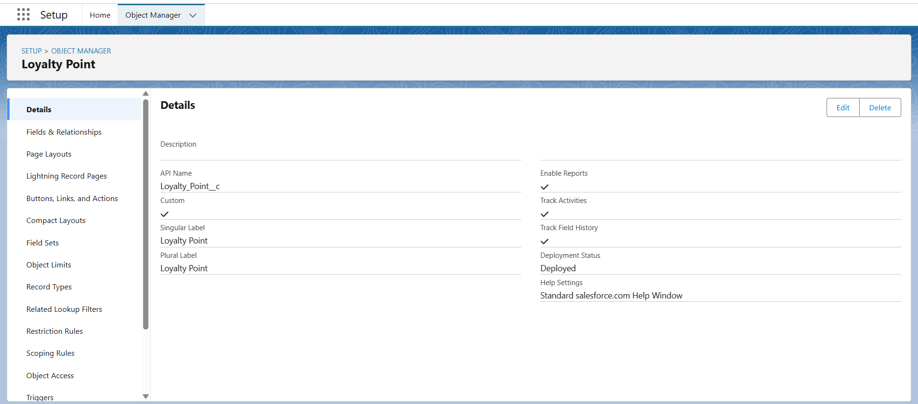

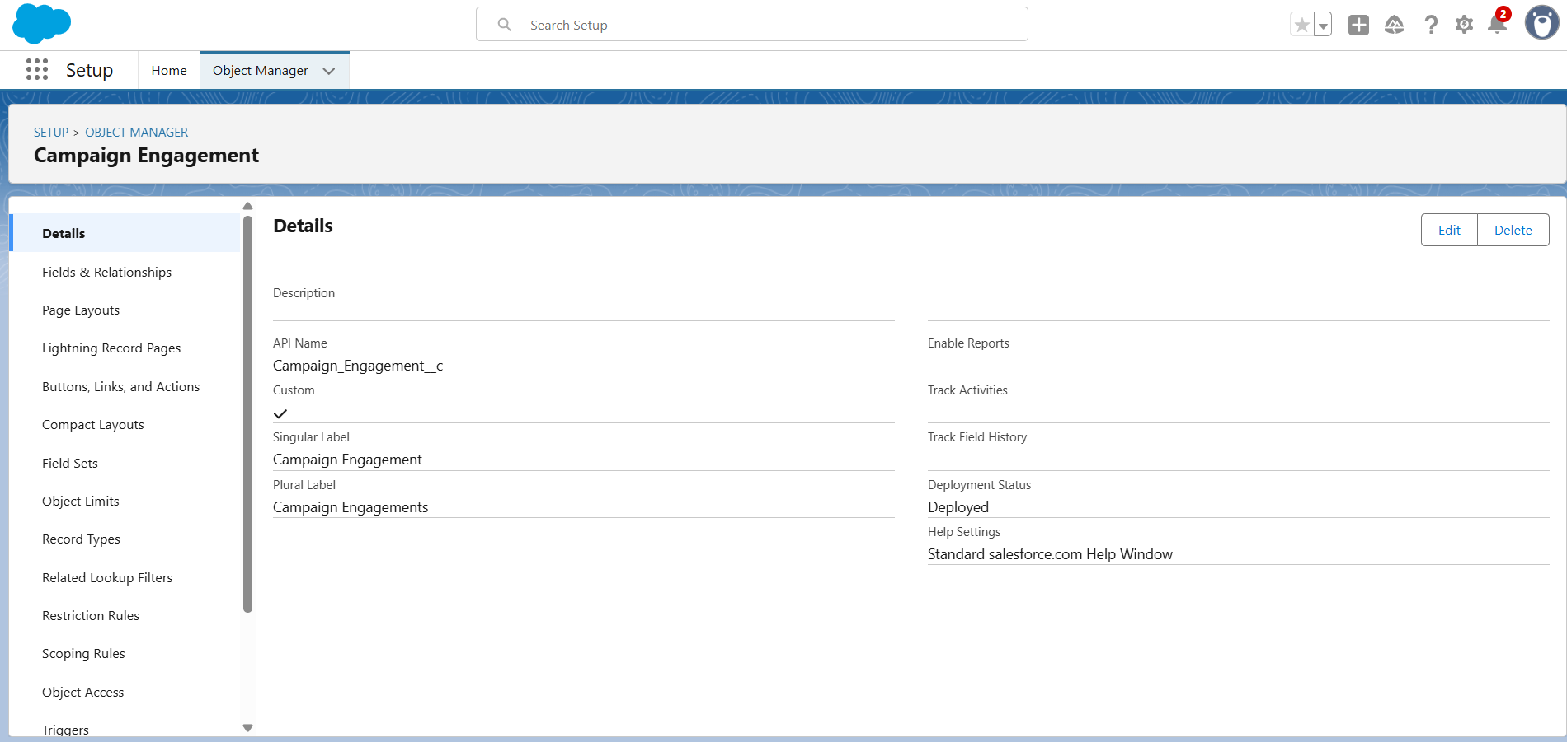

## Custom Fields

### On Order__c

* Order_Date__c (Date)
* Status__c (Picklist: Placed, Packed, Shipped, Delivered, Returned)
* Payment_Status__c (Picklist: Pending, Paid, Refunded)
* Total_Amount__c (Currency)
* Customer__c (Lookup → Contact)
* Delivery__c (Lookup → Delivery__c)

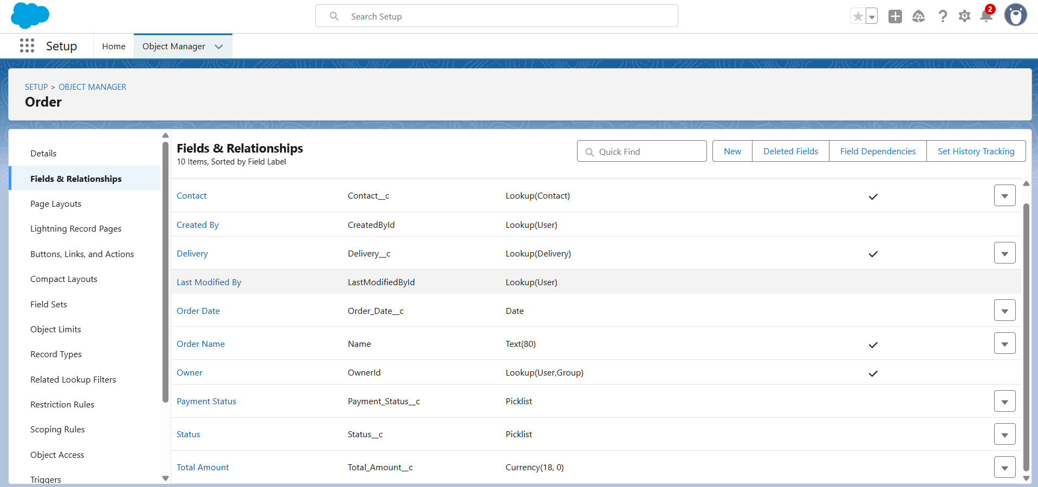

### On Return_Request__c

* Request_Date__c (Date)
* Reason__c (Picklist: Damaged, Wrong Item, Size Issue, Other)
* Approval_Status__c (Picklist: Pending, Approved, Rejected)
* Refund_Amount__c (Currency)
* Order__c (Lookup → Order__c)

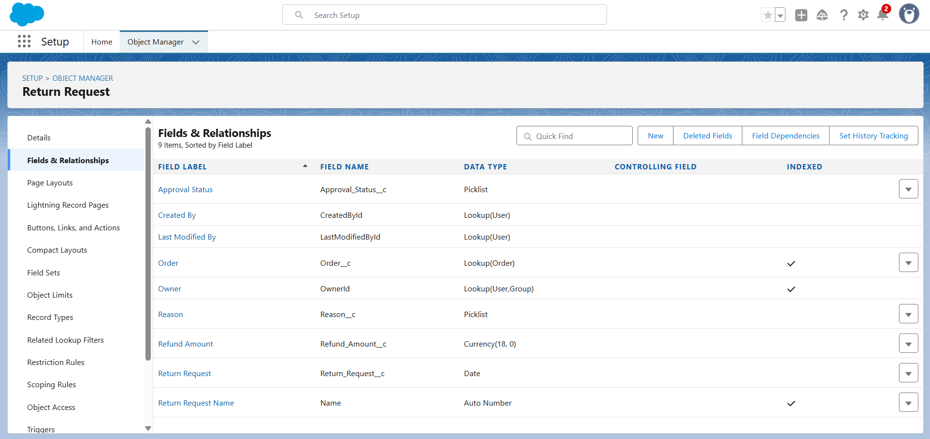

### On Loyalty_Points__c

* Points_Earned__c (Number)
* Points_Redeemed__c (Number)
* Balance__c (Formula: Points_Earned__c - Points_Redeemed__c)
* Customer__c (Lookup → Contact)

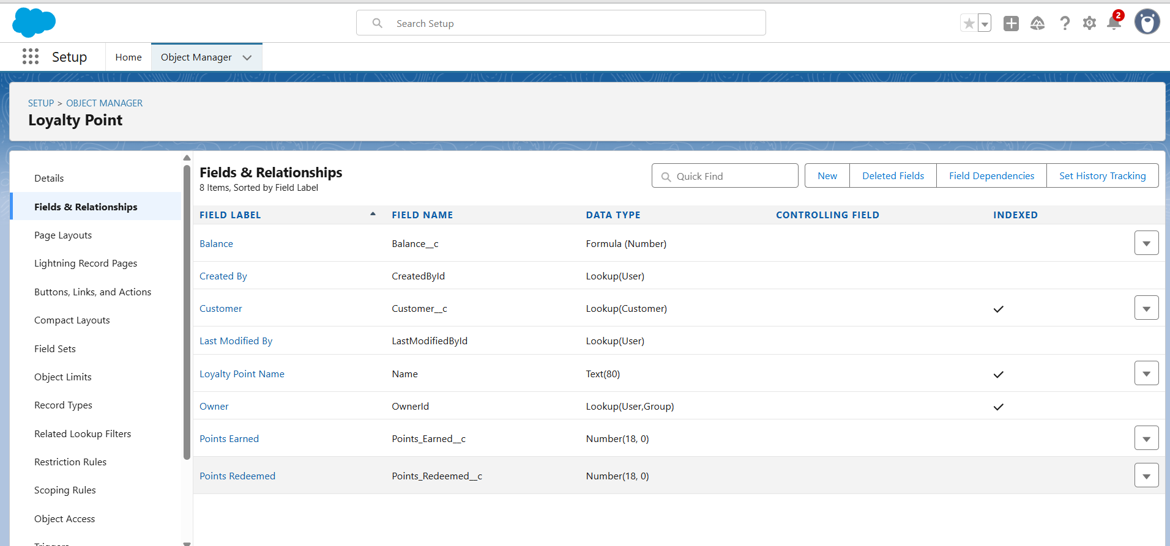

### On Delivery__c

* Tracking_ID__c (Text)
* Courier_Service__c (Picklist: FedEx, DHL, BlueDart, Others)
* Delivery_Status__c (Picklist: In Transit, Out for Delivery, Delivered, Failed)
* Estimated_Delivery__c (Date)

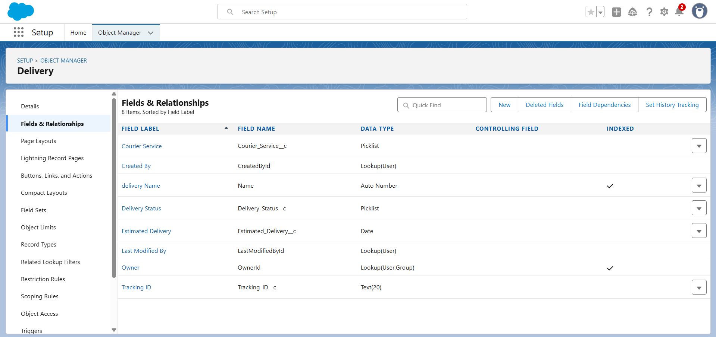

## Tabs for Custom Objects

* Orders
* Return Requests
* Loyalty Points
* Deliveries
* Campaign Engagement

