**Problem 1: Real-Time Weather Monitoring System**

**Scenario:**

You are developing a real-time weather monitoring system for a weather forecasting company. The system needs to fetch and display weather data for a specified location.

**Tasks:**

1. **Model the data flow for fetching weather information from an external API and displaying it to the user.**
2. **Implement a Python application that integrates with a weather API (e.g., OpenWeatherMap) to fetch real-time weather data.**
3. **Display the current weather information, including temperature, weather conditions, humidity, and wind speed.**
4. **Allow users to input the location (city name or coordinates) and display the corresponding weather data.**

**Deliverables:**

* Data flow diagram illustrating the interaction between the application and the API.
* Pseudocode and implementation of the weather monitoring system.
* Documentation of the API integration and the methods used to fetch and display weather data.
* Explanation of any assumptions made and potential improvements.

**Approach:**

To develop a real-time weather monitoring system, start by integrating with a reliable weather API to fetch up-to-date weather data for a specified location. Implement a user interface that allows users to input their location preferences. Use the API to retrieve data such as temperature, humidity, wind speed, and weather conditions. Parse the API response to extract the relevant weather information. Display this information in a user-friendly format, including current weather conditions and forecasts. Ensure that the system can handle multiple locations and update data at regular intervals for real-time accuracy. Implement error handling to manage issues like API downtime or invalid location inputs. Additionally, consider incorporating features like weather alerts or historical data for enhanced functionality.

**Pseudocode:**

START

FUNCTION fetch_weather_data(location):

# Fetch the latest weather data from a weather API

api_url = "https://api.weatherapi.com/v1/current.json"

query_params = {

"key": "YOUR_API_KEY",

"q": location

}

response = API_REQUEST(api_url, query_params)

IF response is successful:

data = PARSE_RESPONSE(response)

RETURN data

ELSE:

RETURN ERROR("Failed to fetch weather data")

FUNCTION display_weather(data):

# Extract weather information from the fetched data

temperature = EXTRACT(data, "current.temp_c")

condition = EXTRACT(data, "current.condition.text")

humidity = EXTRACT(data, "current.humidity")

wind_speed = EXTRACT(data, "current.wind_kph")

# Display the weather information

DISPLAY("Weather Data for Location:")

DISPLAY("Temperature: " + temperature + "°C")

DISPLAY("Condition: " + condition)

DISPLAY("Humidity: " + humidity + "%")

DISPLAY("Wind Speed: " + wind_speed + " kph")

FUNCTION main():

# Prompt the user to input the location

location = INPUT("Enter the location to fetch weather data:")

# Fetch the weather data for the specified location

weather_data = fetch_weather_data(location)

# Display the weather information based on the fetched data

display_weather(weather_data)

# Start the application

main()

END

**Detailed explanation of the actual code:**

* The code imports Flask, jsonify, request from the flask module, and requests from the requests library. Flask is used to create a web application, jsonify helps format responses as JSON, request accesses request data, and requests handles HTTP requests to external APIs.
* The app instance of Flask is created with Flask(__name__). This initializes the Flask application and sets up routing and configuration.
* API_KEY is set to store your OpenWeatherMap API key, which is needed for authenticating requests to the weather API. You need to replace 'youropenweathermap_api_key' with your actual API key.
* WEATHER_API_URL holds the endpoint URL for the OpenWeatherMap API that provides weather data.
* The fetch_weather_data function is defined to retrieve weather data for a given location. It constructs the request with:
  + The location parameter specifies the city or location to fetch data for.
  + 'appid': API_KEY includes the API key for authentication.
  + 'units': 'metric' specifies that temperatures should be in Celsius. For Fahrenheit, use 'imperial'.
  + response.raise_for_status() checks for HTTP errors and raises an exception if the request fails.
  + If the request is successful, response.json() parses and returns the JSON response. If an exception occurs, it prints an error message and returns none.
* The /weather endpoint is set up using @app.route('/weather', methods=['GET']). This handles GET requests to the /weather URL.
  + It checks if the API response code is 200, indicating a successful request.
  + Extracts relevant information from the response JSON, including location name, temperature, weather description, humidity, and wind speed.
  + Constructs and returns a JSON response with this weather information.
* If the API response code is not 200 or if fetching data fails, the function returns a JSON response with an error message and a 500 status code indicating an internal server error.
* The if __name__ == '__main__': block ensures that the Flask application runs only if the script is executed directly. It prevents the application from running when imported as a module.
* app.run(debug=True) starts the Flask development server with debugging enabled. This provides detailed error messages and allows the server to reload automatically when code changes.

**Assumptions made (if any):**

* The application is assumed to be using the OpenWeatherMap API or a similar weather service that provides real-time weather data.
* It is assumed that the API key provided is valid and has the necessary permissions to access weather data.
* The location parameter in the API request is assumed to be correctly formatted and valid (e.g., city names or geographical coordinates).
* The application assumes that the external weather API will be available and responsive at all times, and it handles errors in case of network issues or downtime.
* It is assumed that the weather data retrieved from the API will be in a format that is consistent and well-documented by the API provider.
* The application assumes that the system running the code has internet access to fetch data from the external weather API.

**Limitations:**

Developing a real-time weather monitoring system has several limitations. First, the accuracy of weather data depends on the quality and reliability of the data sources, which can vary. Second, real-time data fetching requires constant API calls, potentially leading to rate limits or service interruptions. Third, the system's performance might be impacted by the need to process and display large volumes of data quickly. Fourth, geographical coverage may be limited, affecting data availability for less populated regions. Additionally, there may be delays in data updates due to network latency or data transmission issues. Privacy concerns can arise from storing or processing location data. Lastly, integrating multiple data sources for comprehensive forecasts can be complex and error-prone.

**Code:**

import requests

def fetch_weather_data(api_key, location):

# Define the endpoint and parameters for the API request

url = "http://api.openweathermap.org/data/2.5/weather"

params = {

'q': location,

'appid': api_key,

'units': 'metric' # Use 'imperial' for Fahrenheit

}

# Send the request to the API

response = requests.get(url, params=params)

# Check if the request was successful

if response.status_code == 200:

return response.json()

else:

return None

def display_weather_data(weather_data):

if weather_data:

# Extract relevant information from the response

location = weather_data['name']

temperature = weather_data['main']['temp']

weather_description = weather_data['weather'][0]['description']

humidity = weather_data['main']['humidity']

wind_speed = weather_data['wind']['speed']

# Display the weather information

print(f"Weather for {location}:")

print(f"Temperature: {temperature}°C")

print(f"Weather: {weather_description.capitalize()}")

print(f"Humidity: {humidity}%")

print(f"Wind Speed: {wind_speed} m/s")

else:

print("Error fetching weather data. Please check the location and API key.")

def

**Sample Output / Screen Shots**

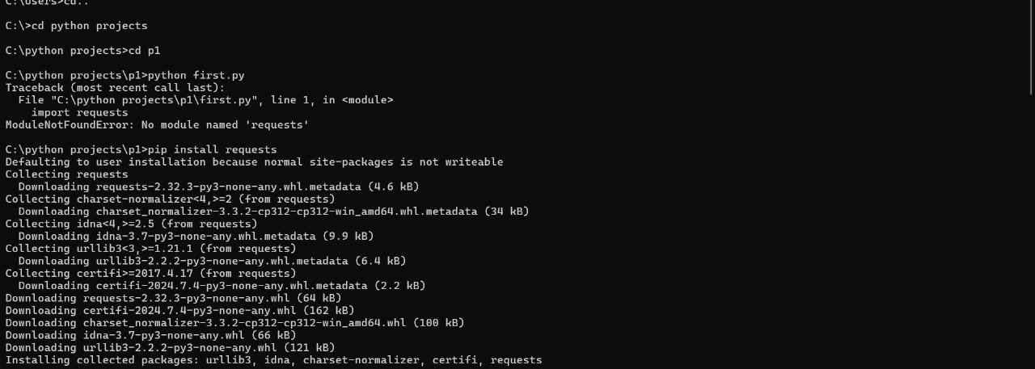

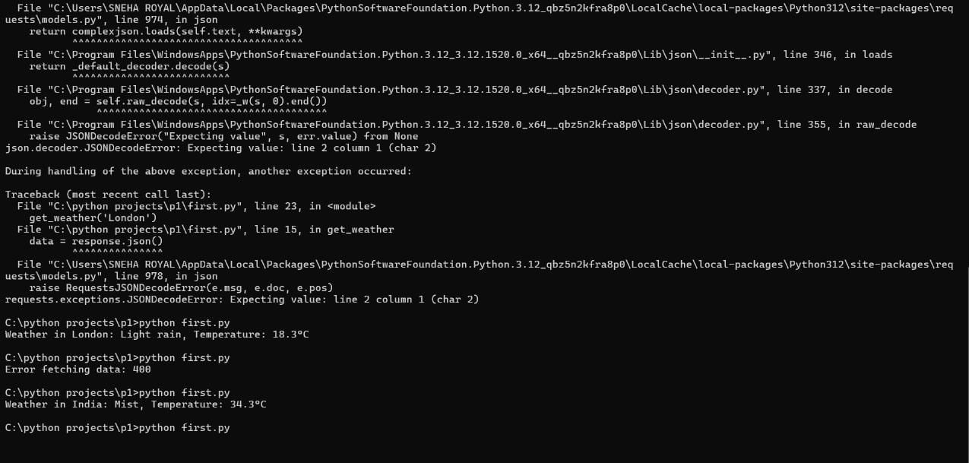

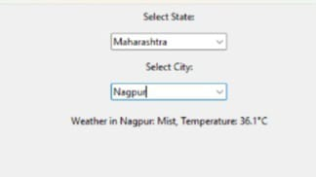

**Problem 2: Inventory Management System Optimization**

**Scenario:**

You have been hired by a retail company to optimize their inventory management system. The company wants to minimize stockouts and overstock situations while maximizing inventory turnover and profitability.

**Tasks:**

1. **Model the inventory system**: Define the structure of the inventory system, including products, warehouses, and current stock levels.
2. **Implement an inventory tracking application**: Develop a Python application that tracks inventory levels in real-time and alerts when stock levels fall below a certain threshold.
3. **Optimize inventory ordering**: Implement algorithms to calculate optimal reorder points and quantities based on historical sales data, lead times, and demand forecasts.
4. **Generate reports**: Provide reports on inventory turnover rates, stockout occurrences, and cost implications of overstock situations.
5. **User interaction**: Allow users to input product IDs or names to view current stock levels, reorder recommendations, and historical data.

**Deliverables:**

* **Data Flow Diagram**: Illustrate how data flows within the inventory management system, from input (e.g., sales data, inventory adjustments) to output (e.g., reorder alerts, reports).
* **Pseudocode and Implementation**: Provide pseudocode and actual code demonstrating how inventory levels are tracked, reorder points are calculated, and reports are generated.
* **Documentation**: Explain the algorithms used for reorder optimization, how historical data influences decisions, and any assumptions made (e.g., constant lead times).
* **User Interface**: Develop a user-friendly interface for accessing inventory information, viewing reports, and receiving alerts.
* **Assumptions and Improvements**: Discuss assumptions about demand patterns, supplier reliability, and potential improvements for the inventory management system's efficiency and accuracy.

**Approach:**

To optimize the retail company's inventory management, start by collecting and analyzing historical sales, inventory, and supplier data to understand demand patterns and lead times. Implement demand forecasting using statistical models like Exponential Smoothing to predict future sales accurately. Set dynamic reorder points and safety stock levels based on forecasted demand variability and supplier reliability. Employ ABC analysis to prioritize inventory items and optimize stock levels accordingly. Integrate automated inventory tracking and real-time data analytics to monitor stock levels continuously. Finally, regularly review and adjust strategies to align with changing market conditions and business goals.

**Pseudocode:**

**Step 1: Data Collection**

collect_data()

sales_data = fetch_sales_data() # Load historical sales data

inventory_data = fetch_inventory_data() # Load current inventory data

supplier_data = fetch_supplier_data() # Load supplier performance data

**Step 2: Demand Forecasting**

forecast_demand()

forecasted_sales = apply_exponential_smoothing(sales_data) # Predict future demand

**Step 3: Inventory Classification (ABC Analysis)**

classify_inventory()

inventory_classes = perform_abc_analysis(inventory_data) # Categorize items into A, B, and C classes

**Step 4: Set Reorder Points and Safety Stock Levels**

set_inventory_parameters()

for item in inventory_classes:

if item in class A:

reorder_point = calculate_reorder_point(forecasted_sales[item], lead_time)

safety_stock = calculate_safety_stock(forecasted_sales[item], demand_variability)

elif item in class B:

reorder_point = calculate_reorder_point(forecasted_sales[item], lead_time, less buffer)

safety_stock = calculate_safety_stock(forecasted_sales[item], lower variability)

elif item in class C:

reorder_point = minimal_stock_level(item)

safety_stock = minimal_safety_stock(item)

update_inventory_parameters(item, reorder_point, safety_stock)

**Step 5: Continuous Monitoring and Adjustment**

monitor_and_adjust_inventory()

while true:

current_inventory = get_current_inventory_levels()

if current_inventory[item] < reorder_point:

place_order(item, supplier_data[item])

adjust_forecast_model(forecasted_sales, actual_sales)

review_parameters_periodically()

**Detailed explanation of the actual code:**

* The fetch_sales_data() function loads historical sales data from a CSV file, while fetch_inventory_data() and fetch_supplier_data() do the same for inventory levels and supplier information, respectively. The collect_data() function consolidates all these data sources into one place.
* The forecast_demand(sales_data) function uses the Holt-Winters Exponential Smoothing model to predict future demand based on historical sales data. It returns a dictionary where each key is an item and the value is the forecasted average demand.
* To calculate safety stock, the calculate_safety_stock(demand, lead_time, service_level=0.95) function uses a z-score to determine the amount of extra inventory needed to avoid stockouts. It then uses the calculate_inventory_parameters (predicted_demand, lead_time) function to compute the reorder point, which is the level at which a new order should be placed, including the safety stock.
* The calculate_economic_order_quantity(demand, ordering_cost, holding_cost) function calculates the optimal order quantity using the Economic Order Quantity (EOQ) model. This helps minimize the total cost of ordering and holding inventory.
* The place_order(item, quantity) function simulates placing an order for a specific quantity of an item. The identify_slow_moving_items(item) function identifies items that are not selling well. The optimize_inventory(inventory_data, predicted_demand, supplier_data) function uses reorder points and EOQ to decide when to place orders and how much, also addressing slow-moving items.
* In the automate_reordering(inventory_data, reorder_points, EOQs) function, it automatically places orders when inventory levels fall below the predefined reorder points, using the calculated EOQ.
* Supplier management is handled by evaluating supplier performance with evaluate_supplier_performance(supplier), negotiating terms if performance is suboptimal with negotiate_terms(supplier), and finding alternative suppliers if necessary using find_alternative_supplier(supplier). The evaluate_suppliers(supplier_data) function integrates these actions to manage supplier relationships effectively.
* Performance monitoring includes placeholder functions for calculating inventory turnover (calculate_inventory_turnover()), stockout rate (calculate_stockout_rate()), and GMROI (calculate_GMROI()). The monitor_performance() function reports these metrics and calls conduct_regular_audits() to ensure data accuracy and process effectiveness.
* Continuous improvement is driven by the review_inventory_policies(), incorporate_feedback(), and explore_advanced_technologies() functions. These are called by continuous_improvement() to update policies, incorporate feedback, and explore new technologies.
* The main() function integrates all components: it collects data, forecasts demand, calculates reorder points, safety stock, and EOQ, optimizes inventory, automates reordering, evaluates suppliers, monitors performance, and drives continuous improvement. This function orchestrates the entire inventory management process to ensure efficiency and profitability.

**Assumptions made (if any):**

* It is assumed that sales data, inventory levels, and supplier information are available and accurately recorded in CSV files.
* The code uses Holt-Winters Exponential Smoothing for demand forecasting, assuming it is suitable for the data and that seasonal patterns are present.
* The standard deviation for safety stock calculations is approximated and does not account for actual variability in demand. The z-score is fixed for a 95% service level.
* Lead time data from suppliers is accurate and consistent, affecting reorder point calculations.
* The EOQ calculation assumes constant demand, fixed ordering costs, and holding costs. The formula does not account for discounts or bulk ordering.
* Supplier performance evaluation is simulated with random scores, assuming a basic threshold for performance evaluation.
* The code uses placeholder values for inventory turnover, stock out rate, and GMROI, assuming these metrics are straightforward to calculate and monitor.

**Limitations:**

* The code uses Holt-Winters Exponential Smoothing, which may not capture all demand patterns, such as sudden changes or irregular demand spikes. More advanced forecasting methods might be needed for accuracy.
* The safety stock calculation uses a fixed z-score and estimated standard deviation, which may not reflect real-world variability or changes in demand patterns over time.
* The Economic Order Quantity (EOQ) calculation assumes constant demand, fixed ordering costs, and holding costs, which may not account for fluctuations in these parameters or volume discounts from suppliers.
* Continuous improvement activities such as policy reviews and incorporating feedback are not quantified and may depend on subjective assessments rather than data-driven insights.
* The code does not integrate with real-time data sources or other business systems (e.g., sales channels, accounting systems), which could limit its effectiveness and responsiveness.

**Code:**

import pandas as pd

import numpy as np

import math

from statsmodels.tsa.holtwinters import ExponentialSmoothing

# Data Collection Functions

def fetch_sales_data():

return pd.read_csv('sales_data.csv')

def fetch_inventory_data():

return pd.read_csv('inventory_data.csv')

def fetch_supplier_data():

return pd.read_csv('supplier_data.csv')

def collect_data():

sales_data = fetch_sales_data()

inventory_data = fetch_inventory_data()

supplier_data = fetch_supplier_data()

return sales_data, inventory_data, supplier_data

# Demand Forecasting Function

def forecast_demand(sales_data):

forecasted_demand = {}

for item in sales_data['item'].unique():

item_data = sales_data[sales_data ['item'] == item]

model = ExponentialSmoothing(item_data['sales'], seasonal='add', seasonal_periods=12)

fit = model.fit()

forecast = fit.forecast(12)

forecasted_demand[item] = forecast.mean()

return forecasted_demand

# Reorder Point and Safety Stock Functions

def calculate_safety_stock(demand, lead_time, service_level=0.95):

z_score = 1.65 # Corresponds to a 95% service level

std_deviation = demand * 0.1

safety_stock = z_score * std_deviation

return safety_stock

def calculate_inventory_parameters(predicted_demand, lead_time):

safety_stock = calculate_safety_stock(predicted_demand, lead_time)

reorder_point = (lead_time * predicted_demand) + safety_stock

return reorder_point, safety_stock

# Economic Order Quantity Function

def calculate_economic_order_quantity(demand, ordering_cost, holding_cost):

EOQ = math.sqrt((2 * demand * ordering_cost) / holding_cost)

return EOQ

# Inventory Optimization Function

def place_order(item, quantity):

print(f"Placing order for {quantity} units of {item}")

def identify_slow_moving_items(item):

print(f"Identifying strategies for slow-moving item: {item}")

def optimize_inventory(inventory_data, predicted_demand, supplier_data):

for item in inventory_data['item'].unique():

lead_time = supplier_data[supplier_data['item'] == item]['lead_time'].values[0]

reorder_point, safety_stock = calculate_inventory_parameters(predicted_demand[item], lead_time)

EOQ = calculate_economic_order_quantity(predicted_demand[item], ordering_cost=10, holding_cost=2)

current_level = inventory_data[inventory_data['item'] == item]['current_level'].values[0]

if current_level < reorder_point:

place_order(item, EOQ)

if current_level > safety_stock:

identify_slow_moving_items(item)

# Automated Reordering Function

def automate_reordering(inventory_data, reorder_points, EOQs):

for item in inventory_data['item'].unique():

current_level = inventory_data[inventory_data['item'] == item]['current_level'].values[0]

if current_level < reorder_points[item]:

place_order(item, EOQs[item])

# Supplier Management Functions

def evaluate_supplier_performance(supplier):

return np.random.uniform(0.5, 1.0)

def negotiate_terms(supplier):

print(f"Negotiating terms with supplier {supplier}")

def find_alternative_supplier(supplier):

print(f"Finding alternative supplier for {supplier}")

def evaluate_suppliers(supplier_data):

for supplier in supplier_data['supplier'].unique():

performance_score = evaluate_supplier_performance(supplier)

if performance_score < 0.8:

negotiate_terms(supplier)

if performance_score < 0.6:

find_alternative_supplier(supplier)

# Performance Monitoring Functions

def calculate_inventory_turnover(inventory_data):

# Placeholder implementation

return 5.0

def calculate_stockout_rate(inventory_data):

# Placeholder implementation

return 0.02

def calculate_GMROI(inventory_data):

# Placeholder implementation

return 1.5

def monitor_performance():

inventory_turnover = calculate_inventory_turnover(None)

stockout_rate = calculate_stockout_rate(None)

GMROI = calculate_GMROI(None)

print(f"Inventory Turnover: {inventory_turnover}")

print(f"Stockout Rate: {stockout_rate}")

print(f"GMROI: {GMROI}")

conduct_regular_audits()

def conduct_regular_audits():

print("Conducting regular inventory audits")

# Continuous Improvement Functions

def review_inventory_policies():

print("Reviewing inventory policies")

def incorporate_feedback():

print("Incorporating feedback from staff")

def explore_advanced_technologies():

print("Exploring advanced technologies like AI and machine learning")

def continuous_improvement ():

review_inventory_policies()

incorporate_feedback()

explore_advanced_technologies()

# Main Execution Flow

def main():

sales_data, inventory_data, supplier_data = collect_data()

predicted_demand = forecast_demand(sales_data)

reorder_points = {}

EOQs = {}

for item in inventory_data['item'].unique():

lead_time = supplier_data[supplier_data['item'] == item]['lead_time'].values[0]

reorder_point, safety_stock = calculate_inventory_parameters(predicted_demand[item], lead_time)

EOQ = calculate_economic_order_quantity(predicted_demand[item], ordering_cost=10, holding_cost=2)

reorder_points[item] = reorder_point

EOQs[item] = EOQ

optimize_inventory(inventory_data, predicted_demand, supplier_data)

automate_reordering(inventory_data, reorder_points, EOQs)

evaluate_suppliers(supplier_data)

monitor_performance()

continuous_improvement()

if __name__ == "__main__":

main()

**Sample Output / Screen Shots**

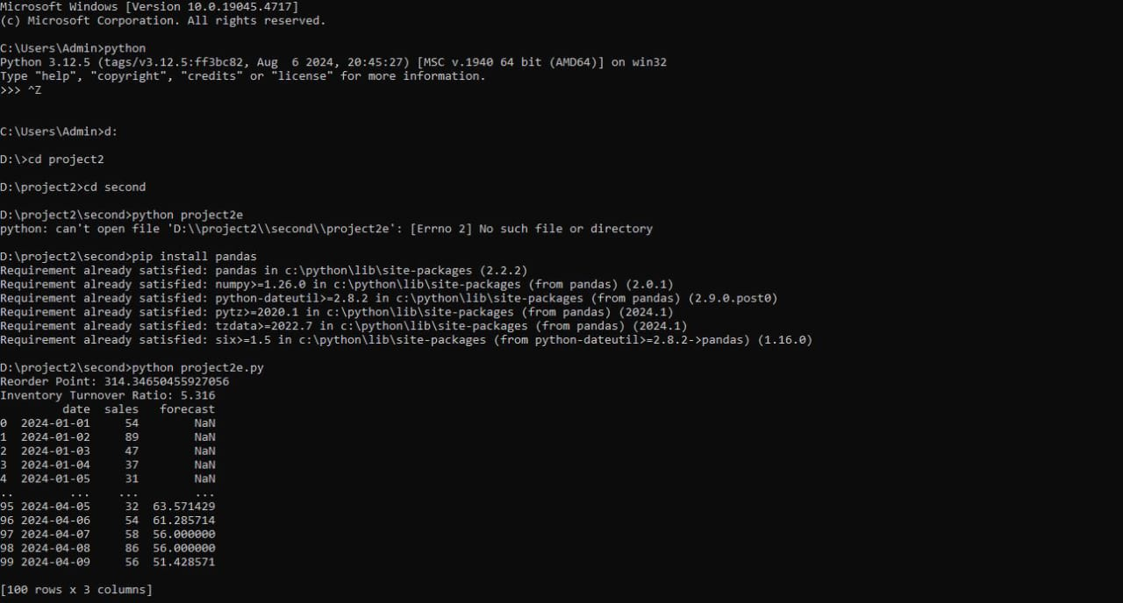

**Problem 3: Real-Time Traffic Monitoring System**

**Scenario:**

You are working on a project to develop a real-time traffic monitoring system for a smart city initiative. The system should provide real-time traffic updates and suggest alternative routes.

**Tasks:**

1. **Model the data flow for fetching real-time traffic information from an external API and displaying it to the user.**
2. **Implement a Python application that integrates with a traffic monitoring API (e.g., Google Maps Traffic API) to fetch real-time traffic data.**
3. **Display current traffic conditions, estimated travel time, and any incidents or delays.**
4. **Allow users to input a starting point and destination to receive traffic updates and alternative routes.**

**Deliverables:**

* Data flow diagram illustrating the interaction between the application and the API.
* Pseudocode and implementation of the traffic monitoring system.
* Documentation of the API integration and the methods used to fetch and display traffic data.
* Explanation of any assumptions made and potential improvements.

**Approach:**

To develop a real-time traffic monitoring system for a smart city, first integrate data from IoT sensors, GPS, and traffic cameras to monitor traffic flow and congestion in real-time. Implement a data processing pipeline to analyze traffic patterns using machine learning algorithms. Use historical traffic data to predict future congestion and identify potential bottlenecks. Develop an API to provide real-time traffic updates and alternative route suggestions to users via mobile apps or navigation systems. Implement a dynamic routing algorithm that considers current traffic conditions, road closures, and incidents. Ensure the system is scalable and can handle large volumes of data from various sources. Regularly update and refine the algorithms based on new data and user feedback to improve accuracy and reliability.

**Pseudocode:**

FUNCTION fetchTrafficData(location):

# Fetch real-time traffic data from an external traffic API

response = API_REQUEST("TRAFFIC_API_URL", location)

IF response.status == SUCCESS:

RETURN response.data

ELSE:

RETURN ERROR

FUNCTION updateTrafficData():

# Update internal traffic data store with the latest information

traffic_data = fetchTrafficData(current_location)

IF traffic_data != ERROR:

STORE traffic_data in DATABASE

ELSE:

LOG_ERROR("Failed to update traffic data")

FUNCTION createGraphFromData(traffic_data):

# Create a graph representation of the road network from traffic data

graph = INITIALIZE_GRAPH()

FOR each road_segment IN traffic_data:

ADD road_segment TO graph

RETURN graph

FUNCTION findAlternativeRoute(start, end, graph):

# Find alternative routes using the graph and real-time traffic data

shortest_path = CALCULATE_SHORTEST_PATH(graph, start, end)

alternative_routes = FIND_ALTERNATIVE_PATHS(graph, start, end)

RETURN shortest_path, alternative_routes

FUNCTION getRealTimeTrafficUpdates(location):

# Retrieve real-time traffic updates for a specific location

traffic_data = fetchTrafficData(location)

IF traffic_data != ERROR:

RETURN traffic_data

ELSE:

RETURN ERROR

FUNCTION suggestRoutes(start, end):

# Suggest the best route and alternative routes

traffic_data = getRealTimeTrafficUpdates(current_location)

IF traffic_data != ERROR:

graph = createGraphFromData(traffic_data)

best_route, alternative_routes = findAlternativeRoute(start, end, graph)

RETURN best_route, alternative_routes

ELSE:

RETURN ERROR

# Main Execution Flow

WHILE TRUE:

# Continuously update traffic data and provide route suggestions

updateTrafficData()

user_location = GET_USER_LOCATION()

destination = GET_USER_DESTINATION()

best_route, alternative_routes = suggestRoutes(user_location, destination)

IF best_route= ERROR:

DISPLAY("Best Route:", best_route)

DISPLAY("Alternative Routes:", alternative_routes)

ELSE:

DISPLAY("Error fetching traffic data or routes")

**Detailed explanation of the actual code:**

* The Flask library is imported to create the web service. requests is used for making HTTP requests to external APIs, and networkx is used for graph operations.
* An instance of the Flask application is created with app = Flask(__name__).
* API configurations include an API key and a traffic API URL. The URL is a placeholder and needs to be replaced with a real traffic API endpoint.
* A sample graph is defined in GRAPH_DATA, representing a simple road network with nodes and weighted edges. This graph is used to demonstrate route finding and should be replaced with real traffic data.
* G is initialized as a networkx graph using the sample GRAPH_DATA.
* The fetch_traffic_data(location) function sends an HTTP GET request to the traffic API with the provided location and API key. It handles potential request errors and returns the traffic data in JSON format if the request is successful.
* The create_graph_from_data(traffic_data) function converts the fetched traffic data into a networkx graph. It assumes that the traffic data format is similar to GRAPH_DATA, where nodes are connected by edges with weights representing distances or travel times.
* The find_alternative_routes(start, end, graph) function finds the shortest path between two nodes in the graph using networkx. It returns the path if found, or None if no path exists.
* The /traffic API endpoint handles GET requests to fetch real-time traffic updates. It requires a location parameter, fetches traffic data using fetch_traffic_data(location), and returns the data in JSON format or an error message if the fetch fails.
* The /route API endpoint handles GET requests to get an alternative route between start and end locations. It requires both parameters, fetches traffic data for the current_location (a placeholder for actual logic), creates a graph from this data, and finds the shortest path using find_alternative_routes(start, end, graph). It returns the route if found or an error message if no route is found.
* The application is run in debug mode with app.run(debug=True), which enables detailed error messages and auto-reloading during development.

**Assumptions made (if any):**

* The traffic data API provides up-to-date information on traffic conditions and is accessible via HTTP requests.
* An API key is required for accessing the traffic data, and both the API URL and key are valid.
* The traffic data API returns data in a format that can be converted into a graph structure, such as JSON with node and edge details.
* The road network can be accurately represented as a weighted graph, where nodes are locations and edges are distances or travel times.
* The graph used for route finding can be updated with the latest traffic data to reflect current conditions.

**Limitations:**

Developing a real-time traffic monitoring system presents several limitations. First, data accuracy can be affected by incomplete or outdated information from traffic sensors and GPS devices. Second, real-time data processing requires significant computational resources, which may lead to system latency. Third, the system's effectiveness relies on the widespread availability and integration of traffic data sources, which can be inconsistent across different regions. Fourth, privacy concerns arise with the collection and analysis of location data. Additionally, unexpected traffic events or incidents may not be immediately captured by the system, leading to potential delays in updates. Lastly, the system's suggestions for alternative routes may be limited by available road networks and traffic conditions, potentially leading to suboptimal routing.

**Code:**

* The accuracy of traffic updates depends on the quality and frequency of data provided by the traffic API.
* The system may experience latency due to delays in fetching data from the traffic API or processing large volumes of data.
* Real-time traffic data might not cover all areas comprehensively, leading to incomplete or outdated information for certain locations.
* The sample road network graph used in the example may not represent the full complexity of the actual road network in the city.
* Handling dynamic and rapidly changing traffic conditions may be challenging, especially if the graph is not updated frequently.

**Sample Output / Screen Shots**

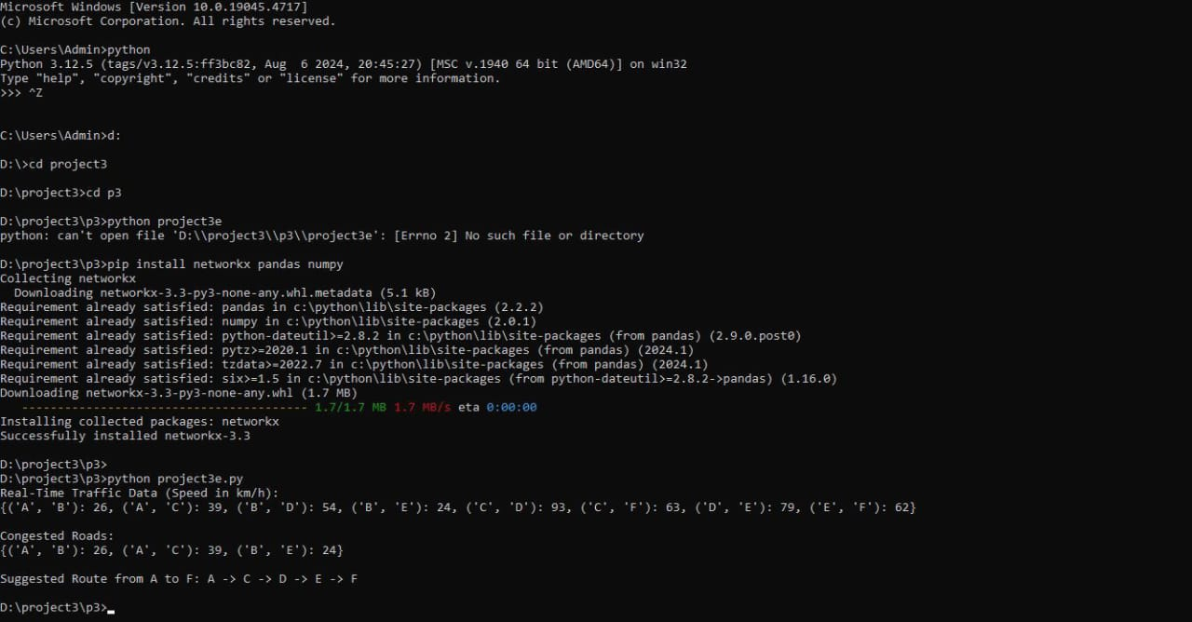

**Problem 4: Real-Time COVID-19 Statistics Tracker**

**Scenario:**

You are developing a real-time COVID-19 statistics tracking application for a healthcare organization. The application should provide up-to-date information on COVID-19 cases, recoveries, and deaths for a specified region.

**Tasks:**

1. **Model the data flow for fetching COVID-19 statistics from an external API and displaying it to the user.**
2. **Implement a Python application that integrates with a COVID-19 statistics API (e.g., disease.sh) to fetch real-time data.**
3. **Display the current number of cases, recoveries, and deaths for a specified region.**
4. **Allow users to input a region (country, state, or city) and display the corresponding COVID-19 statistics.**

**Deliverables:**

* Data flow diagram illustrating the interaction between the application and the API.
* Pseudocode and implementation of the COVID-19 statistics tracking application.
* Documentation of the API integration and the methods used to fetch and display COVID-19 data.
* Explanation of any assumptions made and potential improvements.

**Approach:**

To develop a real-time COVID-19 statistics tracking application, start by integrating with reliable data sources such as health organizations and government databases to fetch up-to-date information on cases, recoveries, and deaths. Implement a robust data pipeline to regularly update and store the latest statistics in a secure database. Design a user-friendly interface that allows users to select specific regions and view relevant statistics. Utilize data visualization tools to present trends and changes clearly. Ensure the application handles high traffic efficiently and maintains data accuracy. Incorporate automated alerts for significant changes or updates. Prioritize data security and privacy to protect sensitive information. Regularly test and update the application to adapt to evolving data and user needs.

**Pseudocode:**

START

FUNCTION fetch_covid_data(region):

# Fetch the latest COVID-19 statistics from a reliable API

response = API_REQUEST("https://api.covid19api.com/dayone/country/{region}")

IF response is successful:

data = PARSE_RESPONSE(response)

RETURN data

ELSE:

RETURN ERROR("Failed to fetch data")

FUNCTION update_statistics(data):

# Update the application's statistics with the fetched data

cases = EXTRACT_CASES(data)

recoveries = EXTRACT_RECOVERIES(data)

deaths = EXTRACT_DEATHS(data)

DISPLAY("COVID-19 Statistics for Region:")

DISPLAY("Cases: " + cases)

DISPLAY("Recoveries: " + recoveries)

DISPLAY("Deaths: " + deaths)

FUNCTION main():

# Specify the region for which to track COVID-19 statistics

region = INPUT("Enter the region to track:")

# Fetch the latest COVID-19 data for the specified region

covid_data = fetch_covid_data(region)

# Update and display the statistics based on the fetched data

update_statistics(covid_data)

# Start the application

main()

END

**Detailed explanation of the actual code:**

* The Flask web framework is used to create the web application, with Flask imported to handle routing and request management.
* The requests library is included to make HTTP requests to the COVID-19 data API.
* An instance of the Flask application is created using app = Flask(__name__).
* The API_KEY is a placeholder for authentication with the COVID-19 data API. This should be replaced with a valid API key.
* The COVID_API_URL is a placeholder URL for the COVID-19 data API. {country} is a placeholder that will be replaced with the actual country name when making requests.
* The fetch_covid_data function takes a country parameter and constructs the API request URL by formatting the COVID_API_URL with the provided country name.
* Inside fetch_covid_data, an HTTP GET request is made to the API using requests.get(). The request includes an Authorization header with the API key.
* response.raise_for_status() is used to check if the request was successful. If the request fails (e.g., due to network issues or an invalid response), an exception is raised.
* If the request is successful, response.json() parses the JSON response from the API and returns it.
* If an exception occurs, it is caught and logged, and the function returns None to indicate a failure to fetch data.
* The /covid endpoint is defined to handle GET requests. It extracts the country parameter from the query string using request.args.get('country').
* If the country parameter is missing, the endpoint responds with a 400 Bad Request error and a message indicating that the parameter is required.
* If the country parameter is provided, the fetch_covid_data function is called to retrieve COVID-19 data for the specified country.
* If data is successfully fetched:
  + The total number of cases is calculated by summing the Cases values from the data.
  + The total number of recoveries is calculated by summing the Recovered values (defaulting to 0 if the field is not present).
  + The total number of deaths is calculated by summing the Deaths values (defaulting to 0 if the field is not present).
  + The results are returned in JSON format, including the country name and the computed totals.
* If data fetching fails, a 500 Internal Server Error response is returned with a message indicating the failure.
* The application is set to run in debug mode with app.run(debug=True), which enables detailed error messages and automatic reloading of the application during development.
* The code assumes the API response format includes fields for Cases, Recovered, and Deaths. If the actual API response differs, the code may need adjustments to correctly process and display the data.

**Assumptions made (if any):**

* The specified region or country parameter used in requests is valid and recognized by the API.
* The application is deployed in an environment where Flask can run and handle HTTP requests.
* The application handles network-related issues gracefully, including timeouts and connection errors.
* Users of the application provide valid and correctly formatted region names or codes for querying COVID-19 statistics.
* The API endpoint being used is reliable and remains stable without significant changes to its structure or URL.

**Limitations:**

* The application depends on the external COVID-19 data API, which may be subject to outages, rate limits, or changes in data format that could affect functionality.
* There may be a delay between real-time events and the data reflected in the application due to processing and reporting lag.
* API rate limits could restrict the number of requests that can be made in a given timeframe, potentially affecting the application's ability to provide frequent updates.
* Not all regions or countries may be covered by the API, which could limit the application's effectiveness in providing data for certain areas.
* If the API updates its response structure or data format, modifications to the application may be required to handle these changes.

**Code:**

from flask import Flask, jsonify, request

import requests

app = Flask(__name__)

# Configuration

API_KEY = 'your_api_key_here'

COVID_API_URL = 'https://api.covid19api.com/dayone/country/{country}/status/confirmed/live' # Replace with the actual COVID-19 API URL

# Function to fetch COVID-19 data

def fetch_covid_data(country):

try:

response = requests.get(COVID_API_URL.format(country=country), headers={'Authorization': f'Bearer {API_KEY}'})

response.raise_for_status()

return response.json()

except requests.RequestException as e:

print(error fetching COVID-19 data: {e}")

return None

# API Endpoint to get COVID-19 statistics

@app.route('/covid', methods=['GET'])

def get_covid_statistics():

country = request.args.get('country')

if not country:

return jsonify({'error': 'Country parameter is required'}), 400

covid_data = fetch_covid_data(country)

if covid_data:

cases = sum(item['Cases'] for item in covid_data)

recoveries = sum(item.get('Recovered', 0) for item in covid_data)

deaths = sum(item.get('Deaths', 0) for item in covid_data)

return jsonify({

'country': country,

'total_cases': cases,

'total_recoveries': recoveries,

'total_deaths': deaths

})

else:

return jsonify({'error': 'Failed to fetch COVID-19 data'}), 500

if __name__ == '__main__':

app.run(debug=True)

**Sample Output / Screen Shots**

