Quick Guide - Submitting a Panopto Assignment on Moodle

Contents

The Submission Point 1

Uploading a video 2

Submitting 3

 **NOTE: This document is 3 pages long (and about 500 words, including this title page), however, most of this guide is made up of images which make the page count higher, we have tried to streamline and make this guide as short and simple as possible.**

# The Submission Point

* Locate the Panopto submission point on the module page and click on it. It should be in the **Assessment and Feedback** section. You should be able to identify it by the **green** Panopto logo.

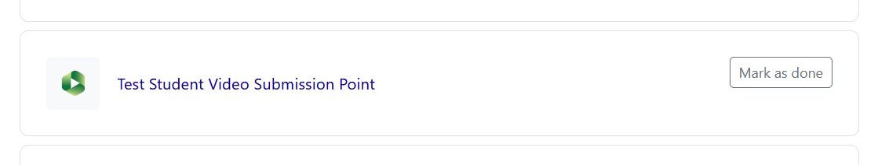

* On the next page, you will see the **due date** and the **cut-off date** (last date that late submissions can be accepted). Click on the ‘**Add Panopto submission**’ button.

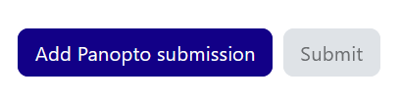

* A pop-up window will open with three options.
  + The first - **‘Choose’** is not needed in this scenario. (unless you have already uploaded a video)
  + **Upload**: add an audio or video recording from your device.
  + **Record:** Use Panopto to record your submission – this is the best option if you want to capture your screen, as well as your camera and microphone.

 **NOTE: If you would like to use the ‘Record’ option, please see our separate guidance on recording with Panopto capture.**

# Uploading a video

If you have recorded your presentation using a different piece of software, for example, in PowerPoint, you will want to click on the ‘**Upload**’ option.

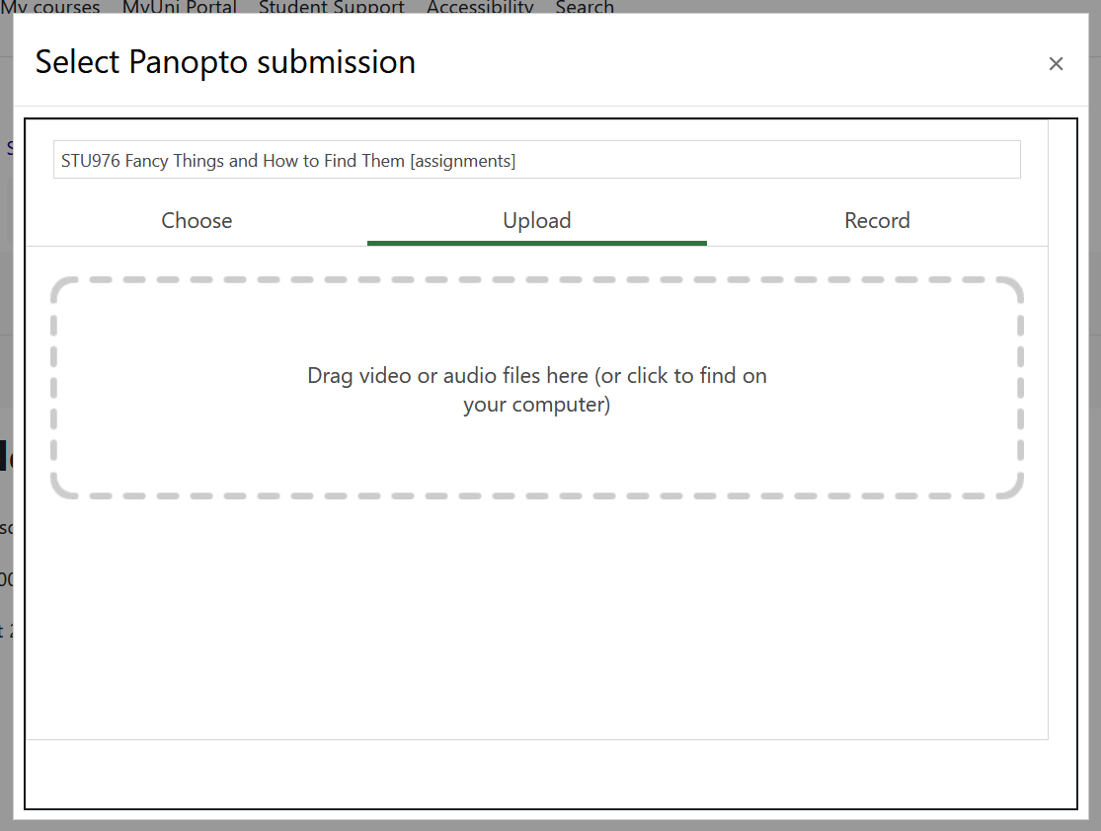

When the tab loads, you can either **click on the box** and locate the recording on your computer, or, you can open your **file explorer** window and **drag and drop** the recording into the box.

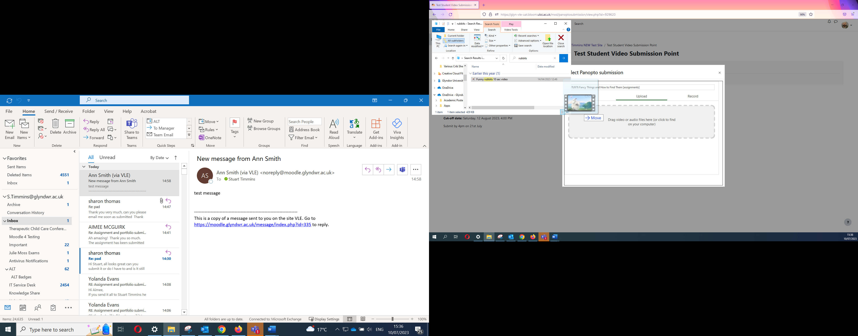

Your recording will begin uploading, and you can see its progress via a bar that will gradually become green.

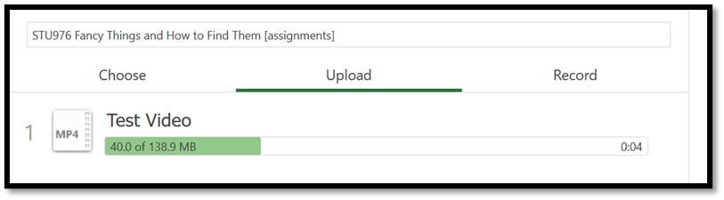

Whilst it is uploading you can click on the title and change it if you need to. You can also click on the bin icon to remove the upload should you need to.

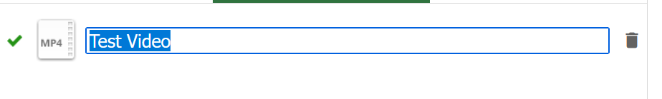

Once the progress bar is all green, you will be able to click the **Insert** button.

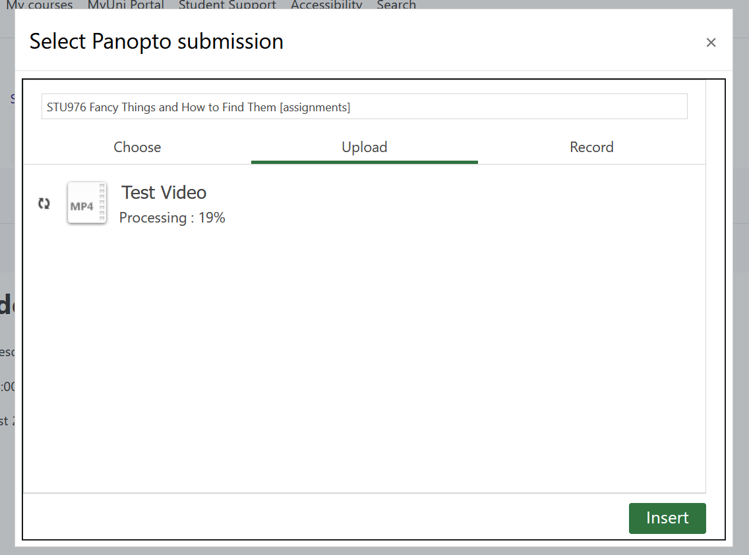

 **Hint:** **You may notice the upload begins ‘processing’, but you do not need to wait for it to reach 100% before clicking the ‘Insert’ button.**

 **NOTE: The length of the recording will determine how long it takes to upload and process.**





# Submitting

After clicking the ‘**Insert**’ button, the box will close, and you will be able to see the first page again with a thumbnail of the video added.

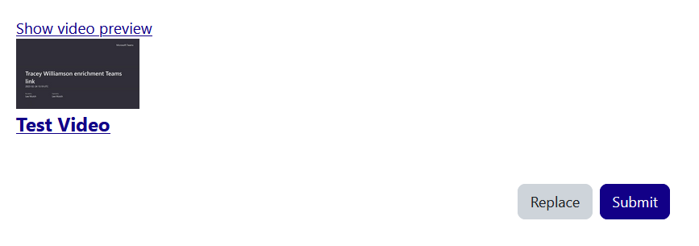

 **NOTE: Before submitting, it is always best practice to double-check you are happy with the video.**

Click ‘**Show video preview**’to enlarge the video and then click the play button in the middle of the video preview to watch the video back and check it.

If you change your mind, click on the ‘**Replace**’ button if you decide that you would like to **repeat the previous steps** and submit a different recording.

When you are ready, click on the **Submit** button.

Finally, you will see a notification that your assignment has been successfully submitted.

