

Module title: International Entrepreneurship
Module code: BUS7C5

Module leader: Janette Williams

Student Name: Rama Koteswara Rao Mangineni
Student ID: S24013995
Task 1:

Task 2: Infographic + Commentary
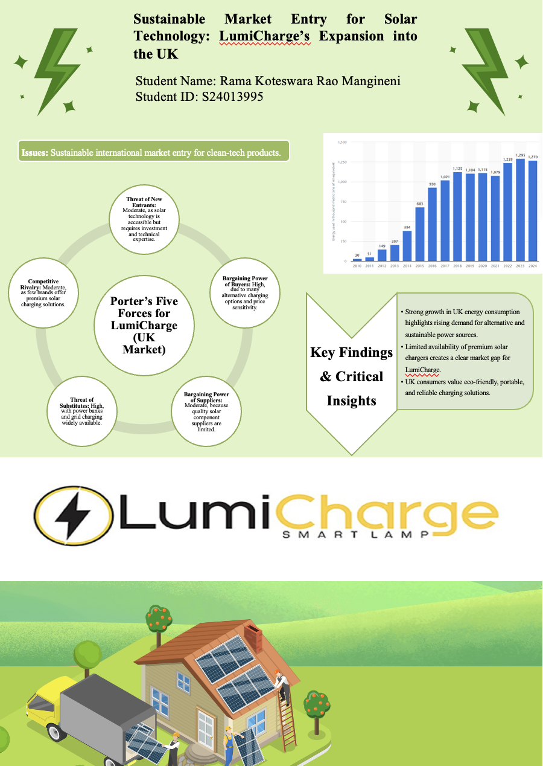
“Sustainable Market Entry for Solar Technology: LumiCharge’s Expansion into the UK”
Commentary
Introduction
Chosen Issue / Concept: This is a project on sustainable international market entry into clean-tech products and in this case, LumiCharge solar-powered charge pods are the business case.
Why This Matters: This is a problem as foreign entrepreneurs have to juggle through market requirements, cultural expectations and sustainability objectives entering foreign countries. The increasing eco-consciousness, abundant smartphone use, and need to have a portable energy supply in the UK make the solar technology developed by LumiCharge commercially feasible and socially beneficial.
Research Process
To collect information to support this project, I used academic periodicals, industry reports, and valid databases of market research. The most important scholarly resources were the discussion of solar cell technologies by Hirwani (2025), allowing one to understand the current developments and their effects on sustainability, and an article by Michail (2021), presenting the examples of efficient solar-powered mobile charging. These are peer-reviewed publications that provide established technical principles of solar innovation. There was a steep increase in energy use in UK, which grew by 149 thousand Mtoe in 2012 to 1,270 thousand Mtoe in 2024, although there was small decline in 2020 (1,115) and 2021 (1,079) (Statista, 2024). The gradual escalation since 2015 (683) can be attributed to the growth in energy demand due to the growing use of digitalisation, mobility and technology which proves that sustainable and alternative energy sources like solar-powered appliances are a necessity.
Theoretical Framework
Porter’s Five Forces Model: In this project, the Five Forces of Porter are practically used to assess the competitive position of LumiCharge in the UK solar charging market critically. The threat of the new entrants is medium as though the technology is available reliable and efficient production of solar necessitates technical skills and financial input. The bargaining of buyers is strong as there are multiple alternative charging products, which compel LumiCharge to focus on differentiation strategy based on sustainability and innovation. The supplier power is moderate as solar components can be sourced worldwide but quality suppliers are scarce (Heaton et al., 2023). The intensity of threat of substitutes is high (power banks and public charging points) and exert more pressure on the competition. Lastly, the level of rivalry in the industry is moderate because there are not many companies providing high-quality solar chargers, and LumiCharge will be able to take an advantageous position.
Insights and Analysis
Key Research Insights: The three main messages in the research are identified. To begin with, the increasing demand of green technology in the UK indicates the presence of a good market in solar-powered charging solutions. Secondly, quality and innovation can be used to fill in a competitive gap as there are no high-end solar chargers among competitors (Rieder et al., 2025). Third, the consumer lifestyles based on mobility, tourism and outdoor activities create more requirements to portable energy.
Entrepreneurial Relevance: These lessons are relevant to international entrepreneurs as they can show that by matching a product with the local sustainability aspects, lifestyle, as well as unsatisfied needs, the likelihood of entering the market and enhancing its adoption can be lowered (Mehdi Veisi, 2025). By integrating business models that provide entrepreneurs with insights into the market and cultural and competitive analysis, there is a better chance of developing differentiated business models that are scalable globally.
Conclusion
The following infographic adds a clear and visually interesting insight into the influence of sustainability, consumer demand, and competitive forces to the entry of LumiCharge into the UK market. Integrating Porter's Five Forces, market research and consumer intelligence, it demonstrates why a high-end solar-powered charging option can prove commercially and ecologically successful. The images distil complicated international business theory and present it in a way that an entrepreneur is able to grasp how strategic analysis aids informed decision-making in introducing clean-technology products into international markets.

Task 3:

Task 4: Individual Case Study Analysis
Introduction
LumiCharge is a start-up clean-tech company in the UK focused on a mission of sustainability and portable charging pods that run on solar energy intended to offer sustainable energy to modern on-the-go lifestyles. The company is responding to the rising world need of environmentally-friendly products as dependence of mobile devices rises, and grid-based charging remains minimal (Curran et al., 2022). This research is timely, as it analyses the potentials and limitations of entering a mature market such as the UK which is highly beginning to focus on sustainability and convenience.
Relevance: The market in the UK forms an effective entry point because of high smartphone penetration, outdoor and tourism-based lifestyles, and favourable environmental policies. There is increasing demand of high-quality solar-powered products and few competitors a clear gap of niche in the LumiCharge case (Lumicharge, 2025). The analysis of this entry offers an understanding of international expansion and entry, consumer behaviour and sustainable product adoption.
Strategy Overview
Mode of Entry: The internationalisation strategy entailed in the expansion of LumiCharge to the United Kingdom will embark on direct exporting and strategic alliance concept that will tap the support of local distributors and online shops to pioneer the sale of solar-powered charging pods of LumiCharge. Through collaborating with the UK clean-tech retailers, electronic chains, and outside lifestyle stores, LumiCharge will be able to overcome entry barriers and establish in the market fast (Martiny, 2025). This entry mode is a balance between cost-effectiveness and local market knowledge, as the company can grow to scale without incurring high fixed costs in manufacturing plants within the UK.
Timing: The time of entry into the market is strategic. The UK renewable energy industry feels the momentum: the share of renewables in the electricity production levels was highest in the UK in 2024, at 50.8 percent, and solar energy played a substantial part in the increase in clean energy production (Renewable UK, 2019). The solar capacity also saw a major increase to about 18GW in the year 2025 due to residential and small-scale installations, which were an indicator of increasing acceptance of solar technology by people.
Scale of Operations: LumiCharge will begin rolling out its pilot launch in key cities around the UK (London, Manchester, and Edinburgh) with high-foot traffic elements, including transport hubs, university campuses, and outdoor leisure facilities. The facts will be first spread in B2C distribution (e-commerce, retail partners) and B2B cooperation (tourism brands, event organisers) to achieve early sales and brand recognition.
Strengths
What Worked Well: The success of LumiCharge in entering the UK market was brought about by its innovative solar-powered charging pods that fulfilled a definite consumer requirement of portable energy system solutions, which could be eco-friendly (RenewableUK, 2025). AI energy optimisation and longevity of the design set the product above the low-end competition as it established a first-mover in the high-end solar charger market. Brand acceptance was enhanced by market conformity to the trends of UK sustainability and culturally oriented marketing communications to the youth, commuters, as well as outdoor consumers. Alliances with retailers and e-commerce platforms were able to provide fast distribution and exposure (LETOUT and GEORGAKAKI, 2024). This collaboration established LumiCharge as a trustworthy, high-quality clean-tech brand, facilitating market penetration and early adoption.
Blue Ocean Strategy: LumiCharge uses a Blue Ocean Strategy by establishing an uncontested market in the UK portable charging industry. Compared to other market power banks that offer regular grids or of low-quality solar chargers, LumiCharge presents a combination of sustainability, portability and AI energy optimisation, the needs of which have not been fulfilled by other competitors. This strategic positioning lowers the direct competition so that the brand would be able to create a differentiation in terms of innovation, high-quality economy and sustainable design. LumiCharge creates a new demand curve by focusing on the youth and commuters, tourists, and environmentally-conscious locals, and creating a visually appealing marketing plan (which is in accordance with UK cultural values) (Mónica Castañeda et al., 2019). The plan revolutionises the market by combining renewable energy technology and starting at the daily shopping mobile convenience, creating commercial and environmental influence.
Weaknesses of LumiCharge’s UK Market Entry
Limited Market Knowledge: Little knowledge of the UK market and, specifically, its regional consumer preferences, regulatory specifics, and distribution dynamics can be listed among the main challenges faced by LumiCharge. With a startup history based in the GCC region, it needs to adjust to the competitive retail market and consumer demands of high-quality products and the UK and its sophisticated logistics networks as potential obstacles (Su et al., 2025). Underestimating local tastes or oversupplying in particular segments might slack adoption and slow first sales.
High Dependence on External Suppliers: LumiCharge depends on outside sources regarding solar panels, batteries, and electronics and it leaves it vulnerable to disruption by the supply chain or inconsistency in quality (Curran et al., 2022). Increasing the cost of imports, currency fluctuations, or delays in shipping can influence the prices and delivery time, affecting the brand credibility in a market where customers are demanding reliability and high-quality service.
Uppsala Model
Gradual Internationalisation: The Uppsala Model is based on the idea that companies increase their foreign expansion by beginning low risk small-scale operations. The strategy that LumiCharge adopts is to begin in a few cities in the UK like London, Manchester, and Edinburgh and after experiencing the practicalities of the market, the company can invest heavily (LETOUT and GEORGAKAKI, 2024).
Learning and Market Knowledge
The model emphasizes on practical knowledge. LumiCharge captures consumer preference, buying behaviour, and distribution issues that will allow it to make informed decisions to extend into the broader market (GOV.UK, 2025).
Risk Management: The entry into LumiCharge will minimize the exposure to financial, operating, and cultural risks. The pace of expansion of LumiCharge is determined with the collected knowledge about the market. This model is favourable to the sustainable long-term development of the UK (Martiny, 2025).
Recommendations for LumiCharge’s UK Market Expansion
Strengthen Local Market Knowledge Through Partnerships and Market Research: A prime suggestion is that LumiCharge invests in substantial local market research and alliances with UK firms. Although the pilot launch is limited by exposure, collaborating with retailers, universities, tourism operators, and tech hubs can offer more knowledge about consumer behaviour, regional needs and buying trends (Su et al., 2025). Uppsala Model evidence suggests that organizations that have less experience in experiential knowledge could use incremental learning to minimize the uncertainty levels and make better decisions. Co-operations might also provide advice on regulatory compliance, warranty expectations and optimisation of logistics (Hellman, 2025). Through local knowledge, LumiCharge will be able to customize marketing campaigns, product characteristics and distribution models in line with the expectations of UK consumers thus enhancing adoption and minimising entry risk.
Diversify Supply Chain and Enhance Brand Visibility: The other suggestion is to have diversified suppliers and increase brand awareness in form of integrated marketing campaigns. The existing reliance on several suppliers’ subjects LumiCharge to risks of delay, quality, and currency fluctuations. The use of several suppliers in several locations maintains continuity of supply and operational risk mitigation (GOV.UK, 2025). The multi-channel marketing approach consisting of influencer utilization, social media, outdoor, and experience events is likely to reinforce the brand name and reputation.
Justification
The rationality of these recommendations lies in that they deal not only with the fundamental flaws outlined in the entry of LumiCharge, namely, the lack of local knowledge and operational vulnerability, but also improve the resource-based strengths of the company. Increased market wisdom lowers the chances of poor strategic choices and diversification of the supply chain and appropriate branding to improve reliability and market share. Altogether, these measures enhance competitive placement, lessen risk, and help in the long-term development of the UK clean-tech sector in a sustainable way.
Conclusion
The LumiCharge UK case study illustrates why strategic planning, market orientation, and incremental internationalisation is vital to the start-ups venturing on international markets. Such lessons as the importance of making use of inimitable resources, with AI-optimised solar technology, are important in developing competitive advantage. Such importance of cultural adjustment and market research is also represented in the study, in which it is indicated that the study of consumer behaviour, sustainability trends, distribution dynamics is of paramount importance to ensure effective entry. Cautious risk management by slow expansion, diversification of the supply chain, and brand-building guarantees long-term growth.

Task 5: Individual Reflective Practice for LumiCharge UK Market Entry
Description and Introduction
In this reflection, I have selected Gibbs Model, which focuses on learning by description, feelings, evaluation, analysis, conclusion and plan of action. Using this framework will enable me to analyse in a critical manner my involvement in the LumiCharge UK market entry project and how the practical activities provided some insight into international business strategy, market research and enterprise-level decision making.
Feelings and Experiences
During Tasks 1-4, I actively participated in the market research, strategy development and design of marketing campaigns towards LumiCharge. I helped in the creation of the Vodcast presentation, forming data-driven insights into the infographic and aiding in the making of the case study analysis. Among the major issues were organizing group work in various time zones, the interpretation of UK market information and how theoretical concepts such as Porter's Five Forces, and Uppsala could be aligned with real-life strategies. It was essential to balance planning and agility to work around these challenges, especially when it came to settling differences between team views on entry strategy and marketing plans.
Analysis
The project had some areas that worked well. Data-driven insights contributed to our market justification whereas culturally-adapted concepts of marketing raised the level of project relevance among the UK market. The application of Uppsala models assisted in putting in perspective strategic decisions and predicting possible risks. Nonetheless, some areas of weakness were recognised such as the balancing of theoretical framework with practical application and a lack of appreciation of the intricacy of multi-channel campaign integration early on (Hernandez et al., 2019). As I reflected through the model by Kolb, I realised that practical exposure to the market research and strategy testing played a key role in relating theory and practice.
Professional Development and Evaluation
The project greatly improved my teamwork, communication, creativity skills. The completion of Tasks 1 and 3 helped me to practice my skills in expressing thoughts well, organizing group tasks, and compromising on conflicting opinions. The clean-tech market research in the UK reinforced critical thinking and interpretation of data, whereas marketing strategy development enhanced creative problem-solving (Srivastav, 2022). These would be transferred directly to the future business career in the international business, especially those such as expansion of market, cross-cultural strategy, and sustainable innovation. Additionally, the process of adopting theoretical knowledge into practical deliverables has added strength to my capacity to apply theoretical knowledge into practice as emerging business knowledge (Roddis et al., 2020). I will not only enhance my competencies technically, but I will also ensure my competencies are upheld in international business projects in the future.
Action Plan
I will enhance by ensuring that I become better at project management through more effective delegation and schedule management. I will develop the ability to perform quantitative analyses in order to analyse the data in the market more effectively and use more advanced digital marketing tools to develop campaigns. Moreover, I will strive to enquire about structured feedback at an earlier point in group projects to enhance the efficiency of collaboration.
Conclusion
The LumiCharge project taught the valuable experience of strategic planning, entering the foreign market and sustainable business. The implementation of the Gibbs model enabled me to take a critical approach, note the strengths and weaknesses and find realistic solutions to developing as an international business.

References
Task 2
Heaton, A.G., Sung, K. and Patrick (2023). ACCESSIBLE SOLAR ENERGY TECHNOLOGY FOR DOMESTIC APPLICATIONS IN THE UK: EDGE SOLAR. Proceedings of the Design Society, 3, pp.445–454. doi:https://doi.org/10.1017/pds.2023.45.
Hirwani (2025). ADVANCEMENTS IN SOLAR CELL TECHNOLOGIES AND THEIR MULTIFACETED APPLICATIONS IN A SUSTAINABLE FUTURE. [online] Available at: https://www.ijprems.com/uploadedfiles/paper/issue_5_may_2025/41252/final/fin_ijprems1747920612.pdf.
Mehdi Veisi (2025). Stochastic economic placement and sizing of electric vehicles charging station with renewable units and battery bank in smart distribution network. Scientific Reports, [online] 15(1). doi:https://doi.org/10.1038/s41598-025-10391-6.
Rieder, D., Louis, J. and Wilfried Elmenreich (2025). Life cycle assessment of portable charging technologies—a case study of a solar charger and a power bank. The International Journal of Life Cycle Assessment. doi:https://doi.org/10.1007/s11367-025-02453-8.
Sanitha Michail, C. (2021). An Innovative Way Of Implementing Efficient Mobile Charger Powered By Solar Energy. IOP Conference Series: Materials Science and Engineering, 1070(1), p.012091. doi:https://doi.org/10.1088/1757-899x/1070/1/012091.
Statista (2024). UK: solar energy use for electricity and heat 2024| Statista. [online] Statista. Available at: https://www.statista.com/statistics/556228/solar-energy-used-for-electricity-heat-uk/?srsltid=AfmBOoqhn41x8CLRPM-1KDthJZIO94wDYO6cY9_CQBnQzXA0Is2IQtev [Accessed 10 Jan. 2026].
Task 4
Curran, B., Martin, R., Muller, S., Nguyen-Tien, V., Cunha, O., Serin, E., Shah, A., Valero, A. and Verhoeven, D. (2022). Growing clean: identifying and investing in sustainable growth opportunities across the UK - LSE Research Online. Lse.ac.uk. [online] doi:http://eprints.lse.ac.uk/117343/1/Oliveira_Cunha_growing_clean_published.pdf.
GOV.UK (2025). SOLAR ROADMAP United Kingdom Powered by Solar. [online] Available at: https://assets.publishing.service.gov.uk/media/685d6e483e6b7941f4e00afb/35.87_DESNZ_UK_Solar_Roadmap_final.pdf.
Hellman, E. (2025). Suitability of Equity Funding Options for Cleantech Startups. [online] Aalto.fi. Available at: https://aaltodoc.aalto.fi/items/8be0bd8d-6595-4246-abdd-42827030030a [Accessed 10 Jan. 2026].
LETOUT, S. and GEORGAKAKI, A. (2024). Role of corporate investors in the funding and growth of clean energy tech ventures. [online] JRC Publications Repository. Available at: https://publications.jrc.ec.europa.eu/repository/handle/JRC135443 [Accessed 10 Jan. 2026].
Lumicharge (2025). Lumicharge. [online] Lumicharge. Available at: https://thelumicharge.com/?srsltid=AfmBOoo74G0nmJl7Z6zsahZRT7pdc3TA7W-GRVcmHu0WlwvP0XqTwFEt [Accessed 10 Jan. 2026].
Martiny, E. (2025). The Cleantech Startup Sector: a study on the impact of factors influencing the birth and growth of cleantech companies - Webthesis. Polito.it. [online] doi:https://webthesis.biblio.polito.it/secure/35590/1/tesi.pdf.
Mónica Castañeda, Zapata, S., Aurelio, J. and Dyner, I. (2019). Solar power business in the UK: A bright or cloudy future ahead? International Journal of Renewable Energy Research, [online] 9(2), p.923. Available at: https://www.researchgate.net/publication/334286240_Solar_power_business_in_the_UK_A_bright_or_cloudy_future_ahead.
Renewable UK (2019). Official stats show renewables generated over half UK’s electricity for the first time in 2024. [online] Renewableuk.com. Available at: https://www.renewableuk.com/news-and-resources/press-releases/official-stats-show-renewables-generated-over-half-uk-s-electricity-for-the-first-time-in-2024/.
RenewableUK (2025). A sector overview 2024. [online] Available at: https://www.renewableuk.com/media/umikstau/climate-adapation-sector-overview-2024.pdf.
Su, Q., Zhang, H., Gou, Q., Sun, H., Fang, M., Zhang, X., Hu, R., Kang, Y., Hsieh, C.-Y., Wang, J. and Hou, T. (2025). LumiCharge: Spherical Harmonic Convolutional Networks for Atomic Charge Prediction in Drug Discovery. The Journal of Physical Chemistry Letters, [online] 16(25), pp.6334–6344. doi:https://doi.org/10.1021/acs.jpclett.5c01025.
Task 5
Hernandez, R.R., Armstrong, A., Burney, J., Ryan, G., Moore-O’Leary, K., Diédhiou, I., Grodsky, S.M., Saul-Gershenz, L., Davis, R., Macknick, J., Mulvaney, D., Heath, G.A., Easter, S.B., Hoffacker, M.K., Allen, M.F. and Kammen, D.M. (2019). Techno–ecological synergies of solar energy for global sustainability. Nature Sustainability, [online] 2(7), pp.560–568. doi:https://doi.org/10.1038/s41893-019-0309-z.
Roddis, P., Roelich, K., Tran, K., carver, S., Dallimer, M. and Ziv, G. (2020). What shapes community acceptance of large-scale solar farms? A case study of the UK’s first ‘nationally significant’ solar farm. Solar Energy, [online] 209, pp.235–244. doi:https://doi.org/10.1016/j.solener.2020.08.065.
Srivastav, S. (2022). The story of solar power in the UK. [online] LSE Business Review. Available at: https://eprints.lse.ac.uk/117547/.

