**Design Patterns:**

1. **Singleton Pattern:**

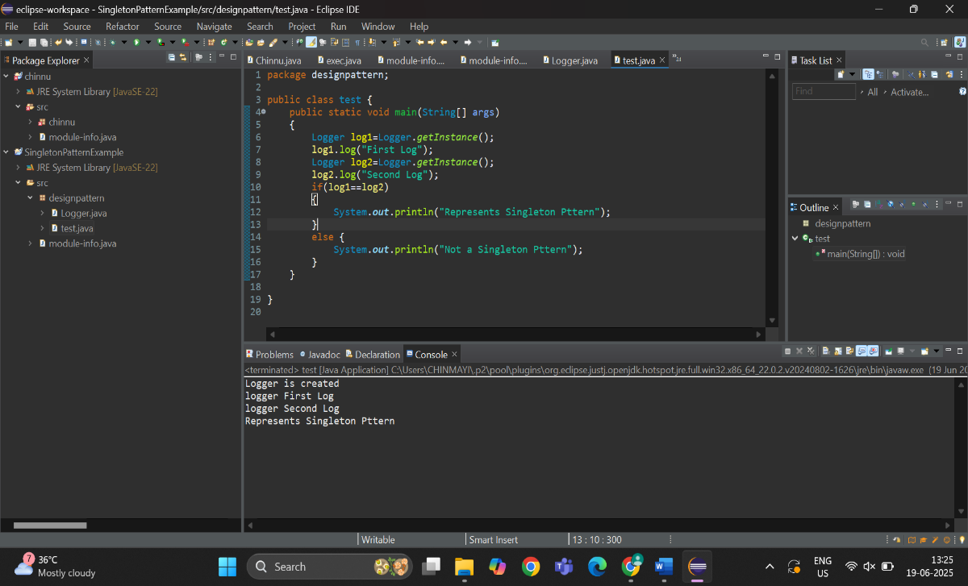

1. **Factory methodPattern:**

