**Junit-Testing**

1. **Setting Up Junit:**

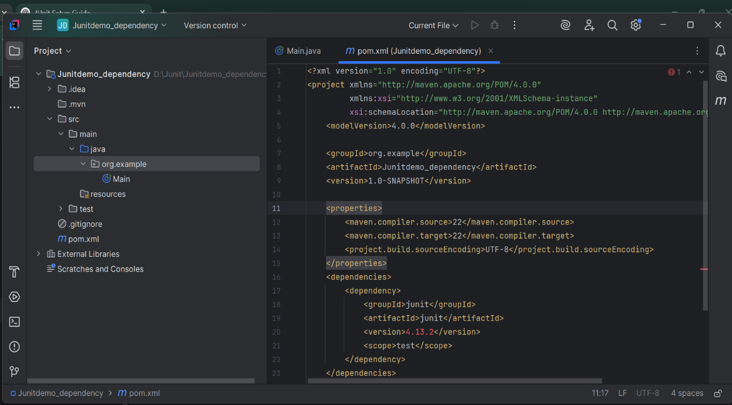

1. **Assertions in Junit:**

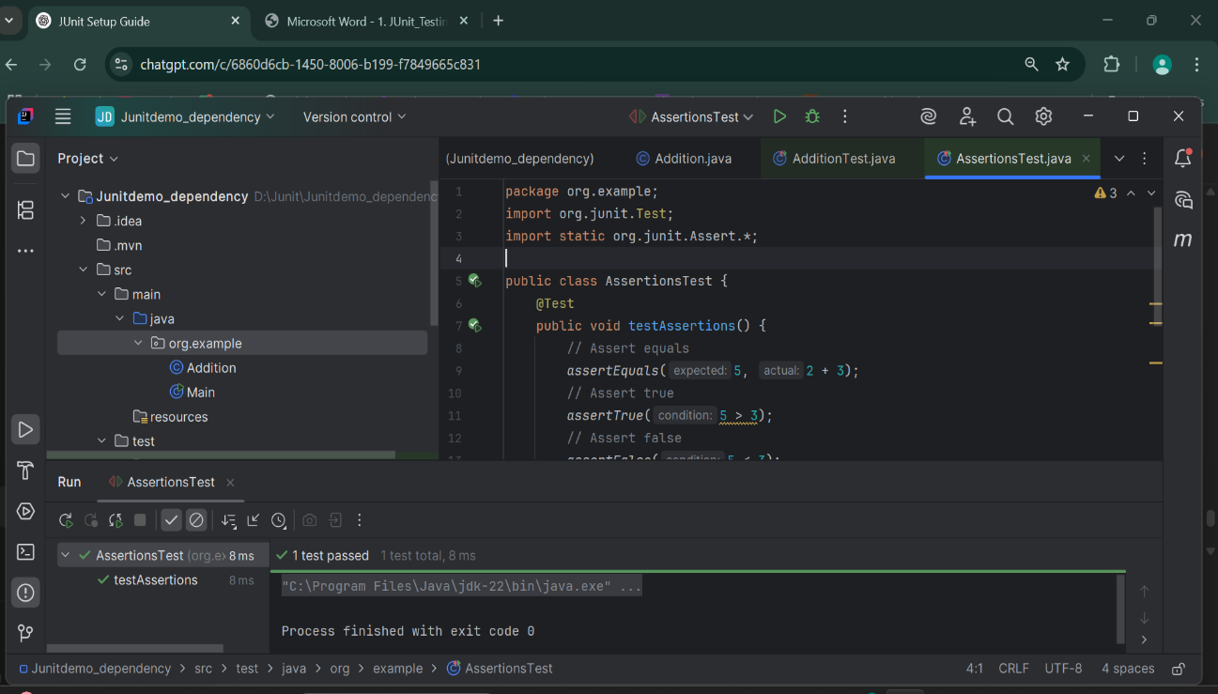

1. **AAA Pattern, Setup:**

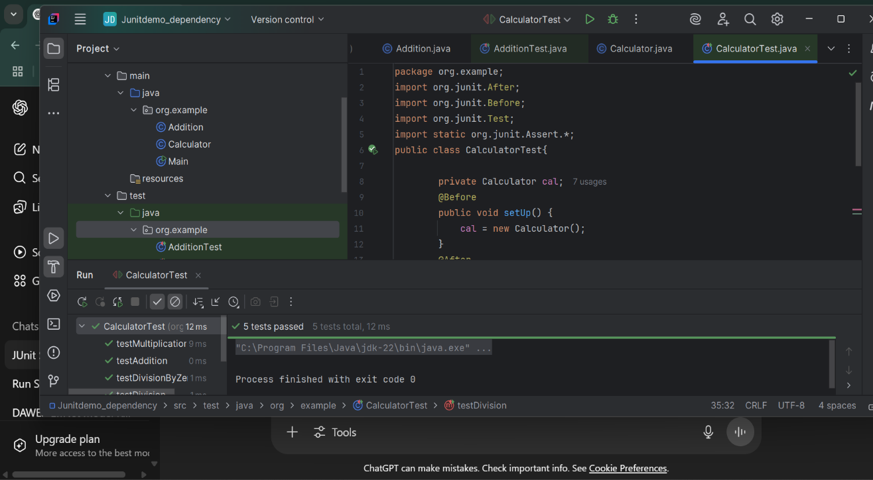

1. **Mocking and Stubbing:**

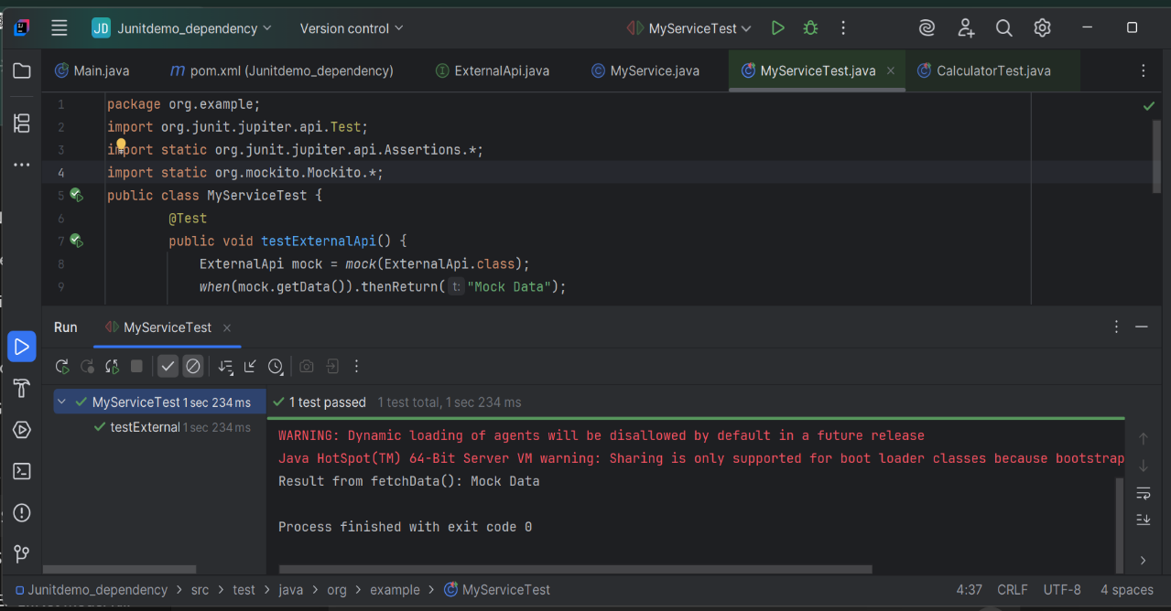

1. **Verifying Interactions:**

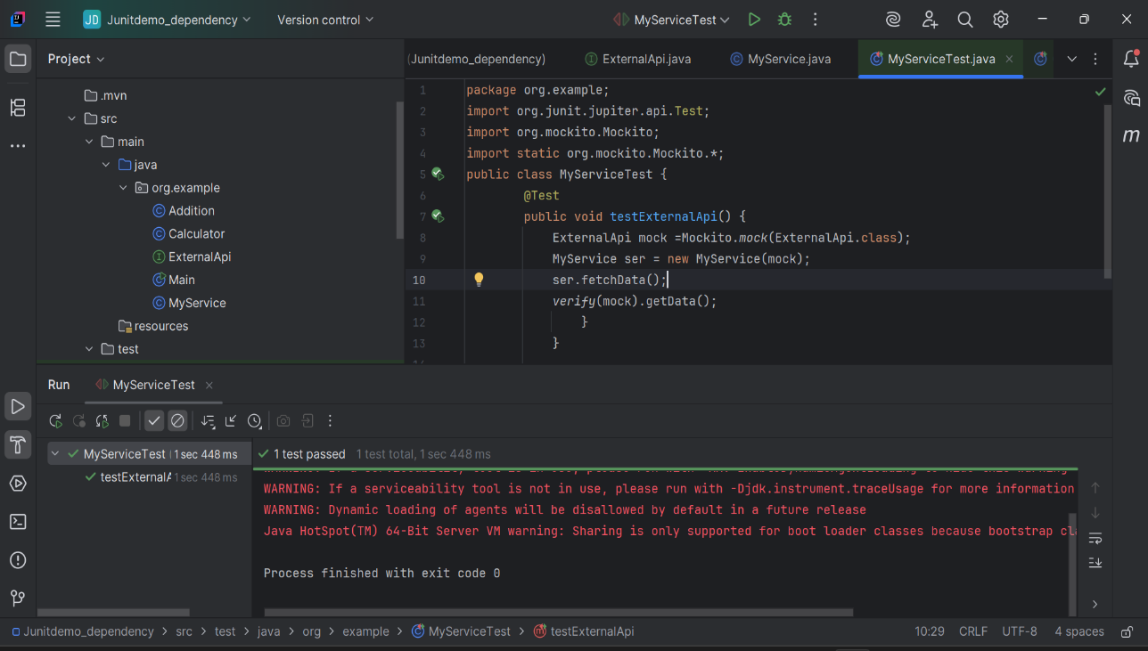

1. **Logging Error messages and Warning levels:**

