**PL/SQL solutions:**

1. **Control structures:**

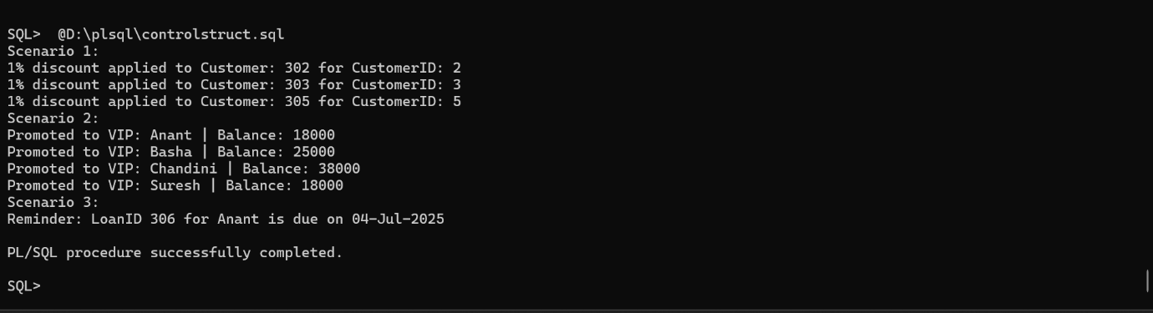

1. **Stored procedures:**

