**Spring data JPA with Hibernate:**

**Spring data JPA -Quick example:**

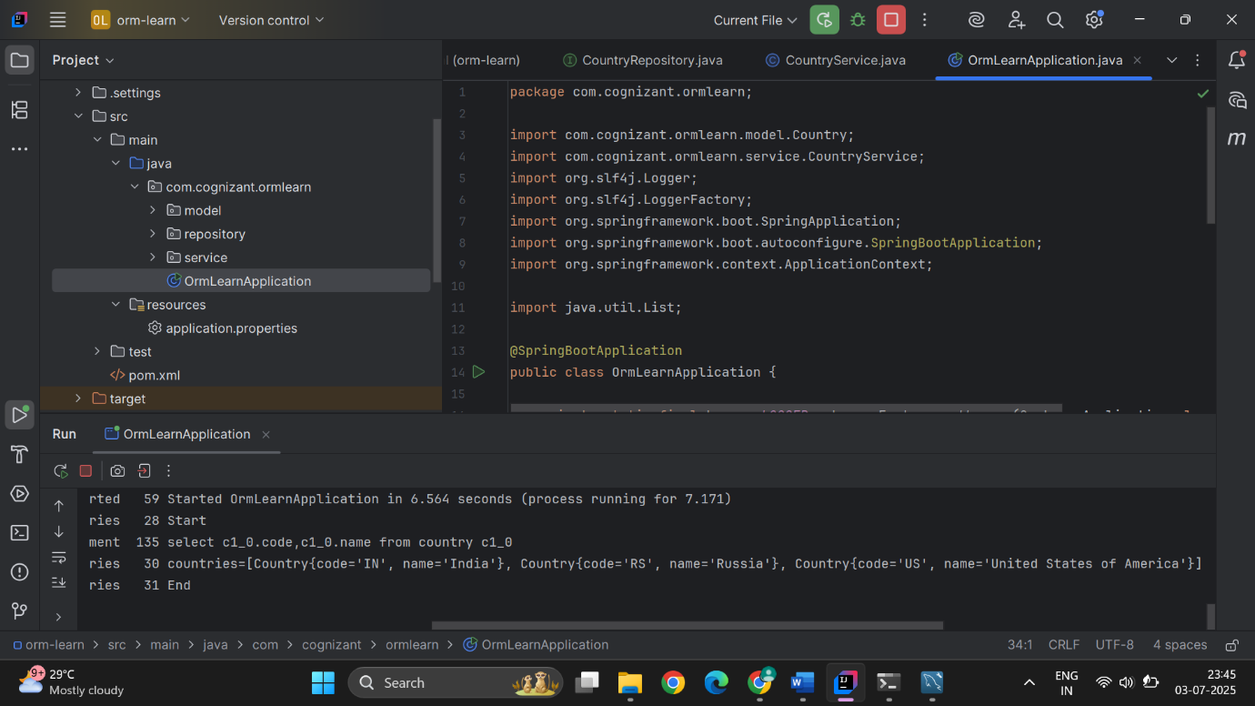

**Difference between JPA, Hibernate and Spring data JPA:**

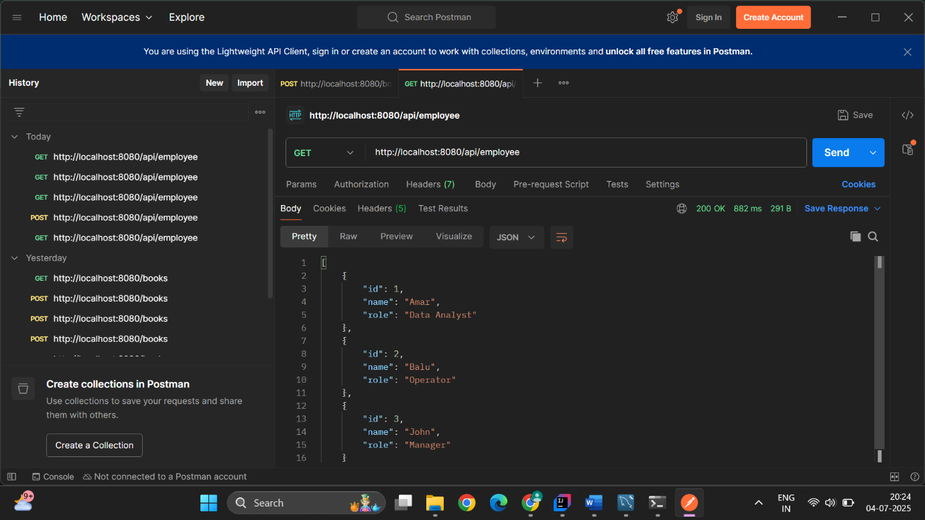

**Implement services for managing country:**

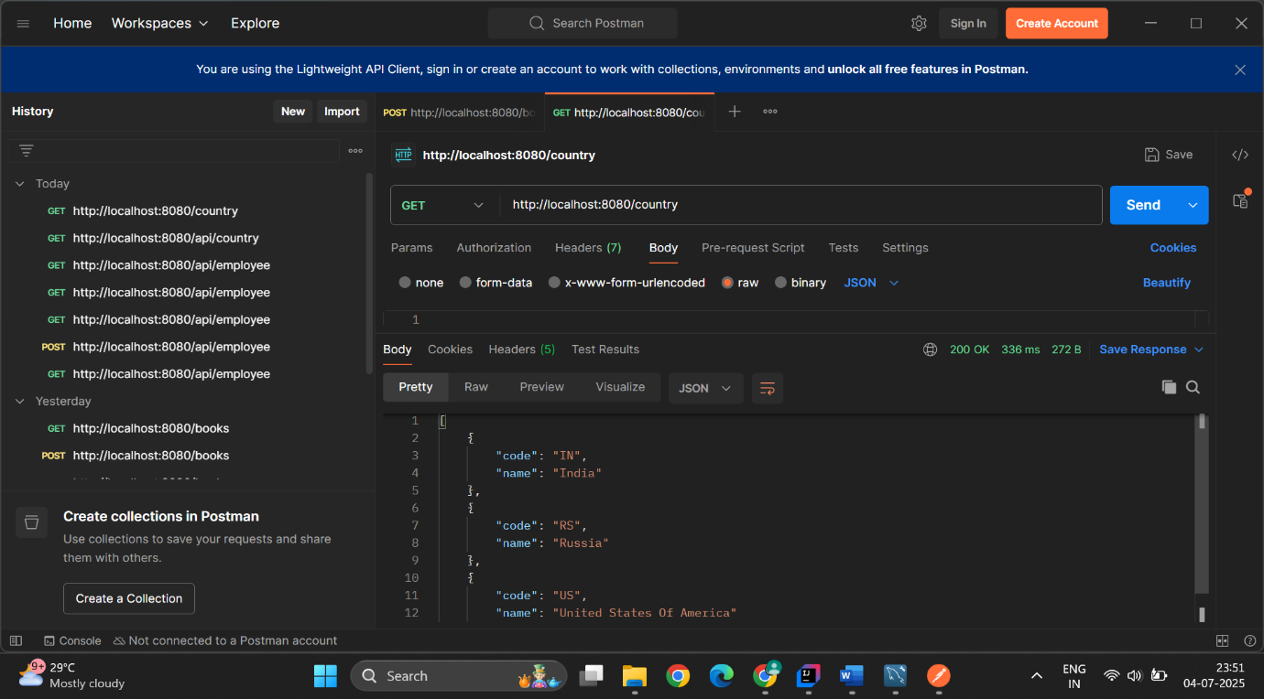

**Find a country based on the code:**

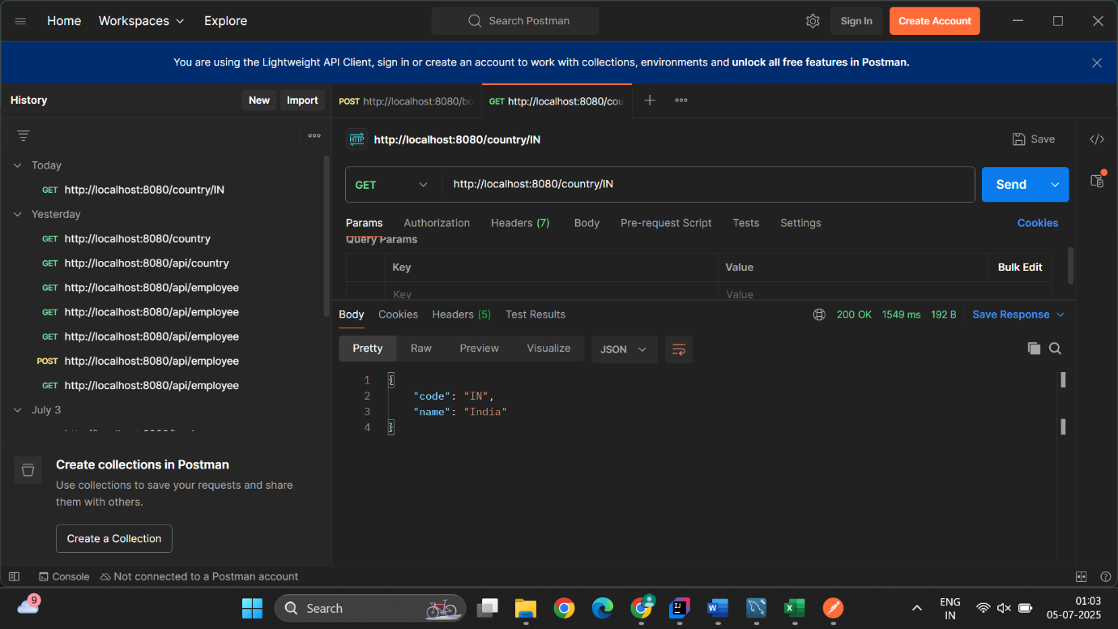

**Demonstrate implementation of query methods with spring JPA:**

