**Spring Core and Maven**

1. **Configuring Spring application:**

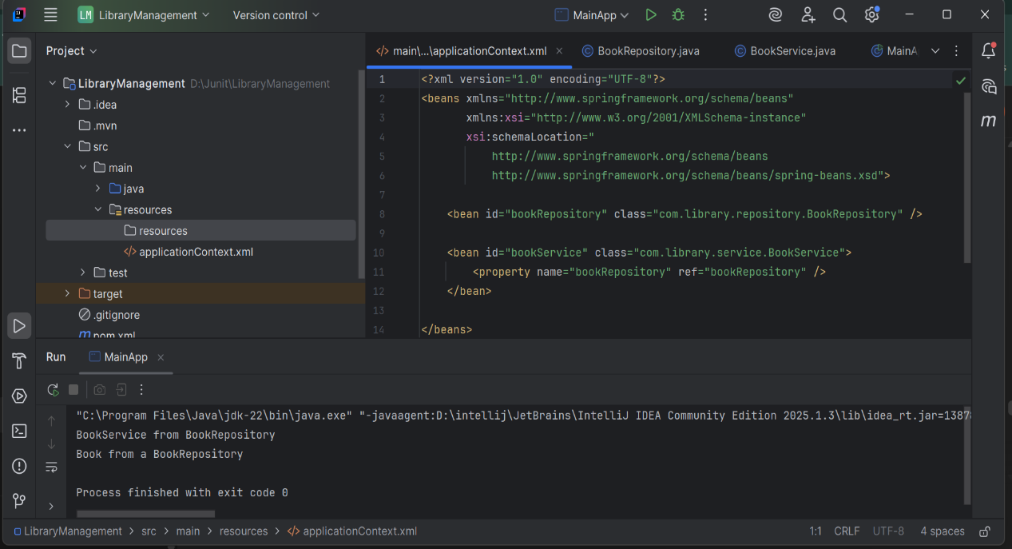

1. **Implementing dependency Injection:**

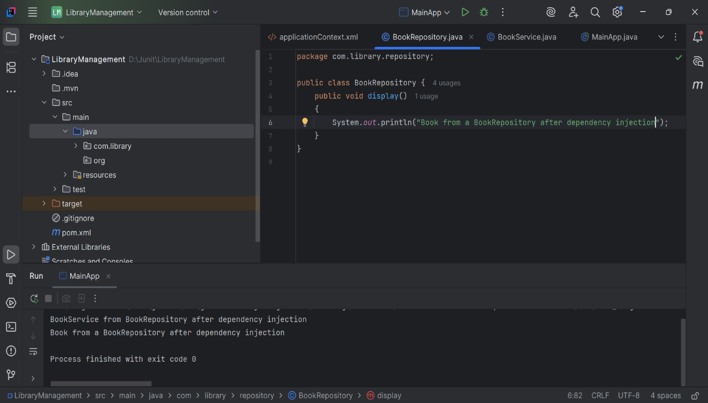

1. **Creating and configuring a maven project:**

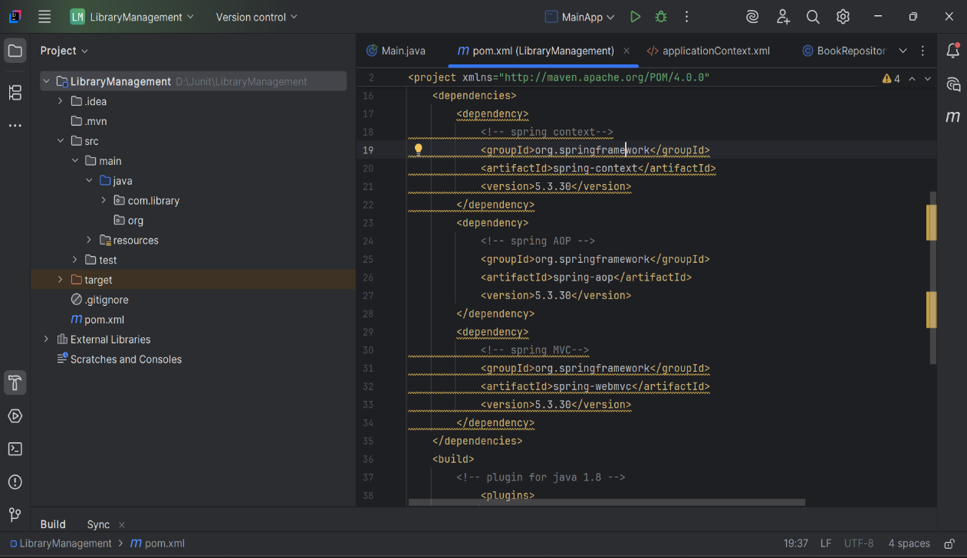

1. **Configuring the spring IOC:**

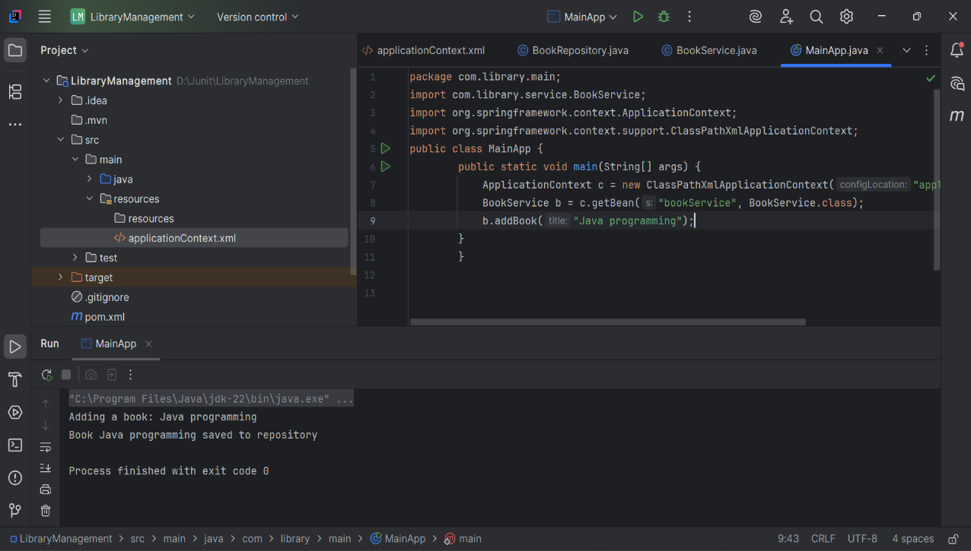

1. **Implementing constructor and setter injection:**

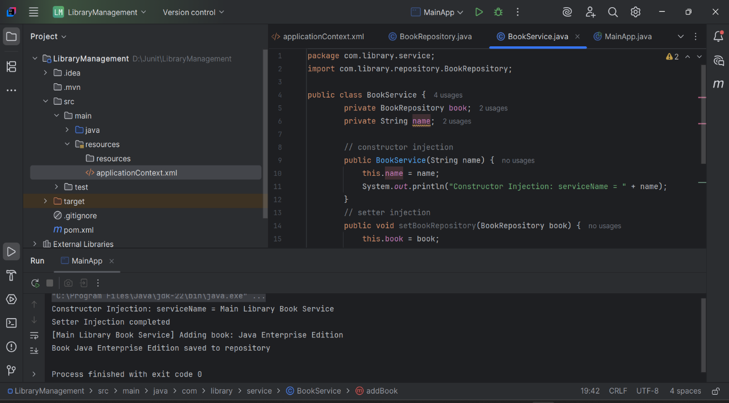

1. **Creating a spring boot Application:**

