**Spring REST using spring boot 3:**

1. **Create spring web project using Maven:**

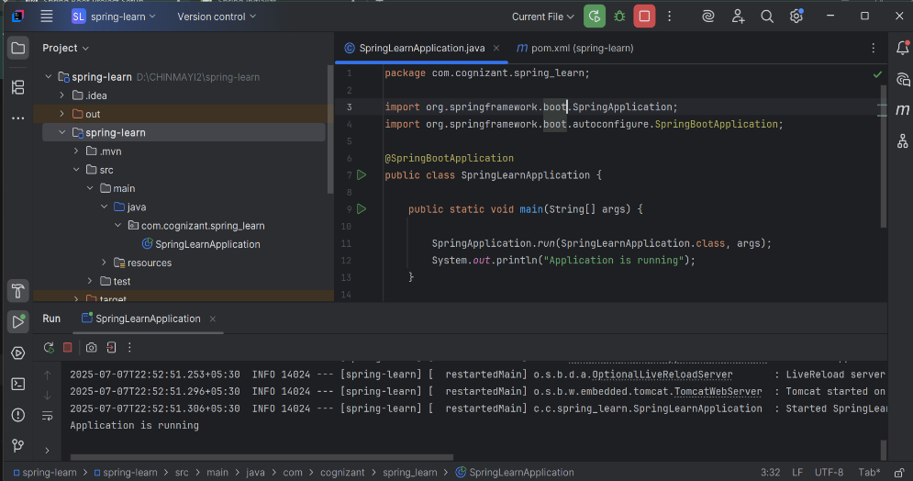

1. **Spring core-load country from spring configuration XML:**

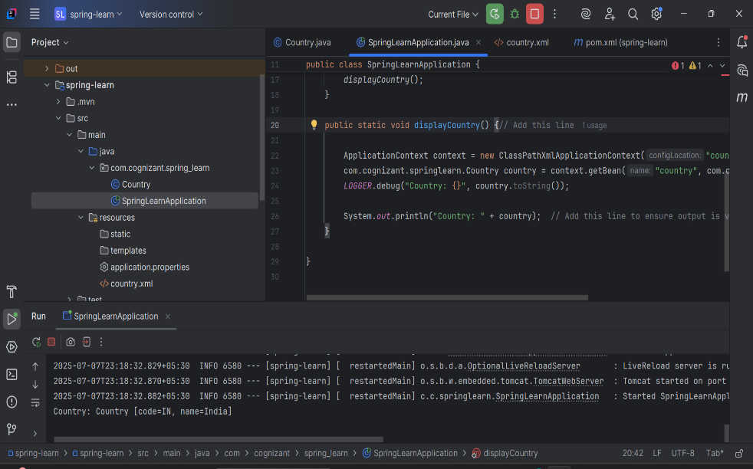

1. **Hello world RESTful web service:**

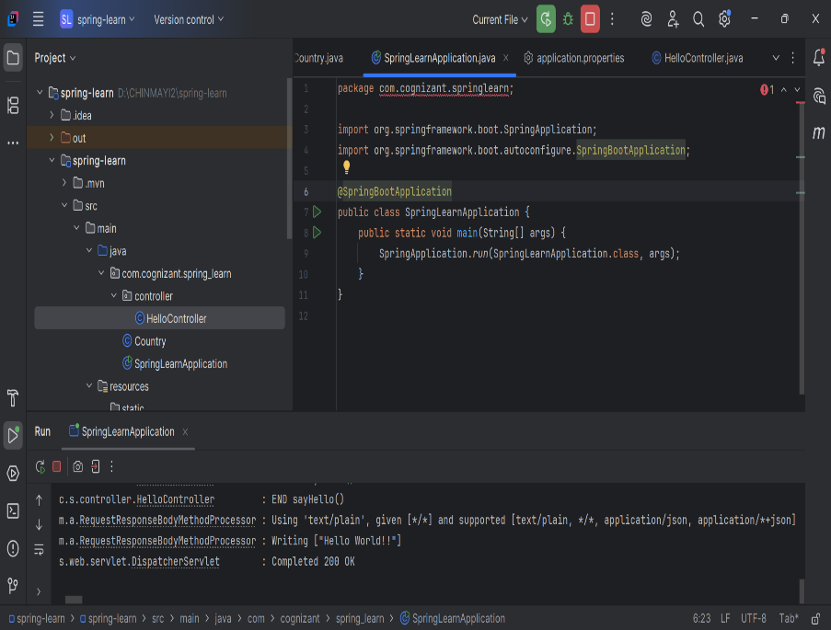

**4. REST-country web service:**

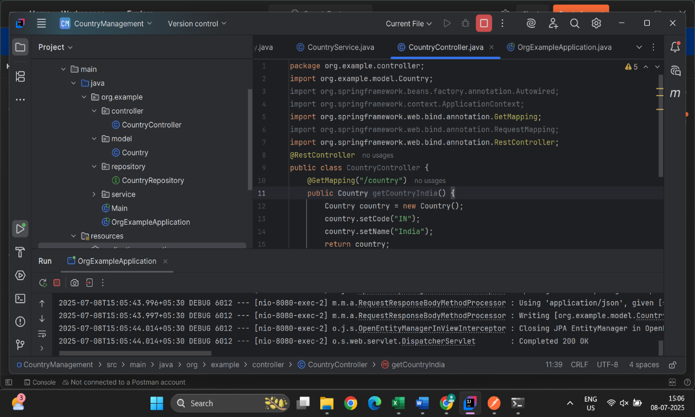

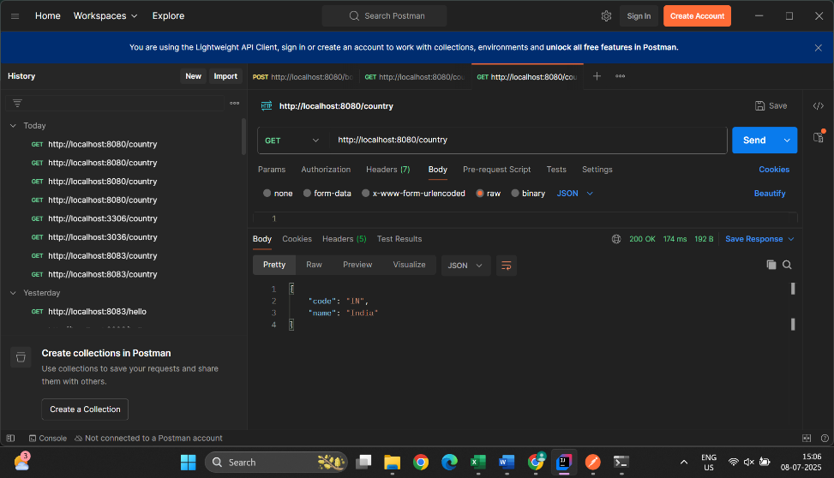

1. **REST-get country based on Country code:**

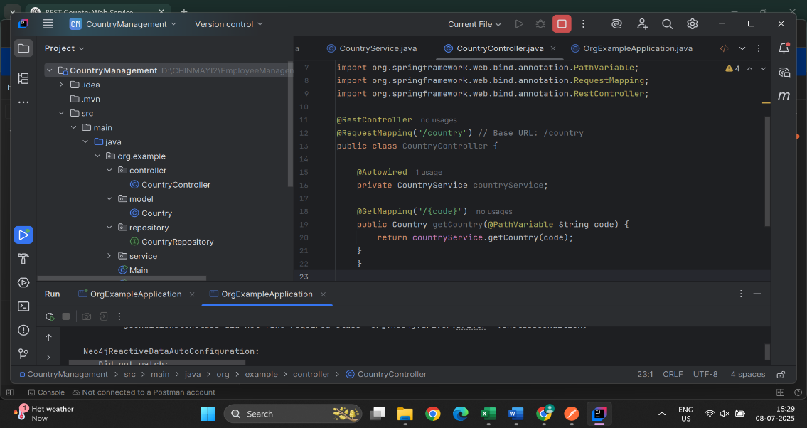

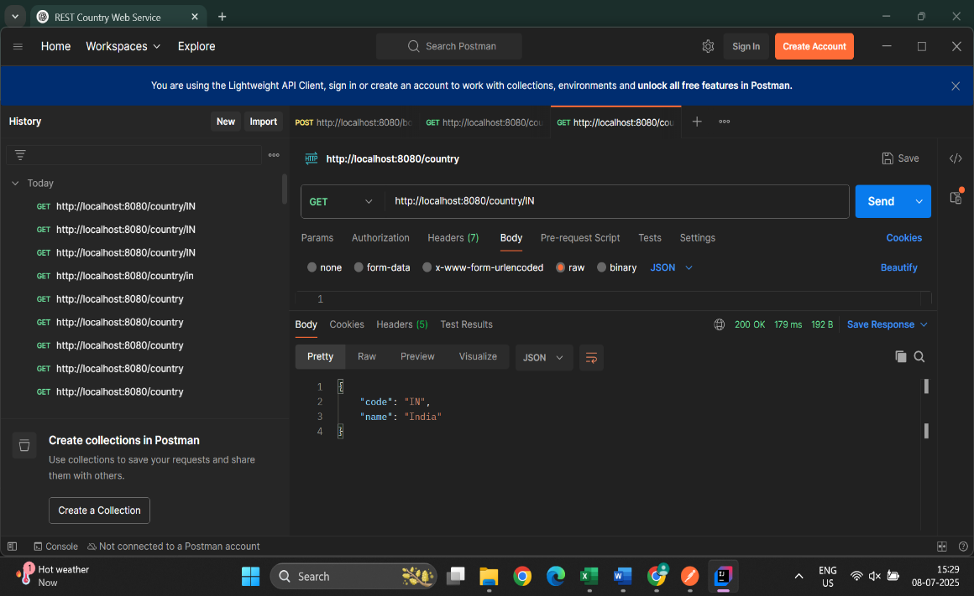

1. **Create Authentication service that returns JWT:**

