**Intel College Excellence Program   
Project Synopsis**

**“ DHCP Server ”**

|  |  |  |  |
| --- | --- | --- | --- |
| **Team member’s detail** | | | |
| **S. No.** | **Participant Name** | **Mobile No.** | **Email ID** |
| 1 | Chintada Pradeep kumar swami | 6305707880 | ***chintadapradeepkumarswami123@gmail.com*** |
| **Faculty(college) mentor detail** | | | |
| **S. No.** | **Mentor Name** | **Mobile No.** | **Email ID** |
| 1 | Dr. Shelej Khera | 9466731632 | ***shelej.22390@lpu.co.in*** |
| **College/University Name** | | | |
| ***Lovely Professional University*** | | | |

**BACKGROUND**

The Dynamic Host Configuration Protocol (DHCP) is a network management protocol that simplifies the process of assigning IP addresses to devices on a network. Before DHCP, network administrators manually assigned static IP addresses, a process that was time-consuming and prone to errors, especially in large or dynamic networks. DHCP was developed as an evolution of the Bootstrap Protocol (BOOTP) and was first officially defined in 1997 in RFC 2131 to automate IP distribution. When a device connects to a network, it sends a DHCP Discover message to find an available DHCP server. The server replies with an offer containing an IP address and network configuration details like the subnet mask and DNS server. The device then requests the offered address, and the server confirms it, enabling the device to use that IP. The assigned IP is typically leased for a temporary period, after which the device must renew the lease. DHCP is widely used in home networks, where routers assign IP addresses to devices like phones and laptops, as well as in larger corporate and ISP networks. By automating IP configuration, DHCP minimizes administrative tasks, prevents IP conflicts, and enhances network scalability, making it essential for modern network management.

**PROBLEM IDENTIFICATION**

DHCP server is crucial for maintaining efficient network operations. Common issues can arise from various sources, including server configuration errors, network connectivity problems, and device compatibility issues. One frequent problem is the server’s failure to assign IP addresses, which can occur if the IP address pool is exhausted. When there are more devices trying to connect than available IP addresses, new devices cannot obtain an address, leading to connectivity issues. Another common issue is misconfiguration of the DHCP server settings, such as incorrect subnet masks or default gateways, which can result in clients being unable to communicate effectively within the network. In some cases, clients may receive incorrect configurations, causing them to connect to the wrong network or fail to reach critical resources. Network devices, such as routers or switches, may also cause DHCP-related problems if they do not support DHCP relay, preventing DHCP requests from reaching the server. Additionally, hardware failures or software bugs on the DHCP server can lead to intermittent failures in IP address assignment. Firewall settings can also impact DHCP operations, as they may block DHCP traffic between clients and the server. In some cases, rogue DHCP servers may be introduced into the network, leading to IP address conflicts and unreliable connectivity. Clients may also face issues related to their network interfaces, such as disabled network cards or outdated drivers, which can prevent them from properly communicating with the DHCP server. Time synchronization problems can lead to lease expiration issues, causing clients to lose their IP addresses unexpectedly. Furthermore, DHCP snooping features on network switches, if misconfigured, can prevent legitimate DHCP traffic from passing through, further complicating connectivity issues. Identifying and diagnosing these problems involves systematic troubleshooting, including checking server logs for errors, monitoring network traffic for DHCP messages, and verifying the configuration settings of both the DHCP server and the network infrastructure. Addressing these issues promptly is essential for ensuring reliable network connectivity and maintaining overall network performance.

**PROPOSED SOLUTION**

To address the challenges associated with IP address management in dynamic networks, the proposed solution involves the implementation of an advanced Dynamic Host Configuration Protocol (DHCP) server that enhances the efficiency and reliability of IP address allocation. This solution emphasizes several key features to improve the functionality of traditional DHCP servers. Firstly, the server should incorporate intelligent algorithms that enable it to manage IP address pools more effectively, allowing for real-time adjustments based on network usage patterns. This proactive approach will minimize address conflicts and ensure optimal utilization of available IP addresses.

Additionally, the proposed DHCP server should integrate robust monitoring and reporting tools to track network device connections and disconnections. By maintaining an updated inventory of devices, the server can provide valuable insights into network performance and usage trends. This data can inform administrators about peak usage times and help them make informed decisions regarding network capacity and expansion. Moreover, the solution should support advanced features like Dynamic DNS integration, enabling automatic updates of DNS records whenever devices connect or disconnect, thus ensuring that name resolution remains accurate and efficient.

Security is also a critical aspect of the proposed solution. The DHCP server should implement measures such as DHCP snooping, which allows network administrators to prevent unauthorized devices from obtaining IP addresses, thereby protecting the network from potential security threats. Additionally, the server should support authentication mechanisms to verify the identity of devices requesting IP addresses.

Furthermore, the proposed DHCP server should be capable of handling a wide range of network environments, from small home networks to large corporate infrastructures. This scalability ensures that organizations of all sizes can benefit from automated IP address management. The solution should also offer a user-friendly interface that simplifies configuration and management tasks, allowing network administrators to deploy and manage the server with minimal effort.

Lastly, the proposed solution should include a failover mechanism to ensure continuous availability. By implementing a secondary DHCP server that can take over in case of primary server failure, network reliability is significantly enhanced. This ensures that devices can always obtain necessary IP configuration, minimizing downtime and disruptions in network connectivity. Overall, this comprehensive approach to DHCP server design aims to create a more efficient, secure, and user-friendly system that meets the demands of modern network environments.

**Setup Essentials**

Setting up a DHCP server involves several essential components and configurations to ensure it functions correctly. Here’s a detailed overview of the key setup essentials:

1. Server Hardware and OS

- Hardware: Ensure the server has sufficient resources (CPU, RAM, and storage) to handle the expected network load.

- Operating System: Choose a compatible operating system (Windows Server, Linux distributions, etc.) that supports DHCP services.

2. DHCP Server Software

- Install DHCP server software. This may be included in the OS (like Windows Server) or installed separately (such as ISC DHCP for Linux).

3. IP Address Pool (Scope)

- Define a range of IP addresses that the DHCP server can assign to clients. This is known as the DHCP scope.

- Set the starting and ending IP address within the subnet. For example, if your subnet is 192.168.1.0/24, you might assign addresses from 192.168.1.100 to 192.168.1.200.

4. Subnet Mask

- Specify the subnet mask for the IP addresses in the scope (e.g., 255.255.255.0 for a standard home network).

5. Default Gateway

- Configure the default gateway (router) IP address that clients will use to communicate outside their local network. This is often the router's IP address, such as 192.168.1.1.

6. DNS Servers

- Specify one or more DNS server IP addresses to assist clients in resolving domain names. This could be your local DNS server or public DNS servers (e.g., Google DNS: 8.8.8.8).

7. Lease Duration

- Set the lease duration for the assigned IP addresses, which determines how long a client can use an IP address before it must renew the lease. Common durations range from hours to days.

8. Reservation (Optional)

- Configure DHCP reservations for specific devices that need a fixed IP address. This is useful for printers or servers that require consistent network settings.

9. Options Configuration

- Configure additional DHCP options as needed, such as:

- Router options: To specify multiple gateways.

- WINS server: If using Windows networking.

- Domain Name: To specify the local domain name for the network.

Example of a Basic DHCP Configuration:

- Scope: 192.168.1.100 to 192.168.1.200

- Subnet Mask: 255.255.255.0

- Default Gateway: 192.168.1.1

- DNS Server: 8.8.8.8, 8.8.4.4

- Lease Duration: 24 hours

By ensuring these essential components and configurations are in place, you can effectively set up and manage a DHCP server that meets the needs of your network.

**DESCRIPTION**

DHCP Server

This guide walks you through the process of installing DHCP Server on Ubuntu, setting up media folders, and ensuring proper permissions for both DHCP and the user.

Table of Contents

1. Prerequisites

2. Step 1: System Update

3. Step 2: Install Required Packages

4. Step 3: Install the DHCP server

5. Step 4: Starting the DHCP server

6. Step 5: DHCP server on a specific interface

7. Step 6: Configure the DHCP server

8. Step 7: Restart the DHCP server after making changes to the configuration.

9. Future scope

10. Conclusion

**Prerequisites:**

**Before starting, ensure you have:**

- Ubuntu system (20.04 or later recommended)

- Sudo privileges

- Stable internet connection

**Step 1: System Update:**

Make sure your system is up to date before installing Plex.

> sudo apt update && sudo apt upgrade -y

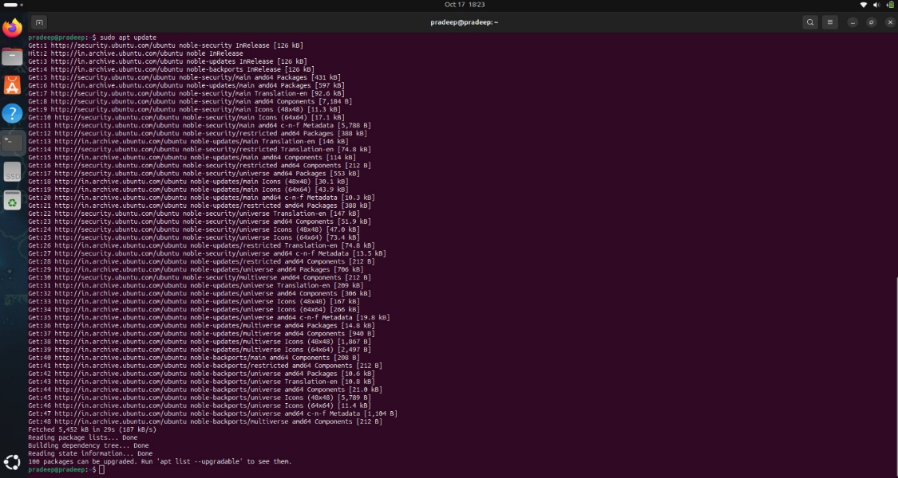

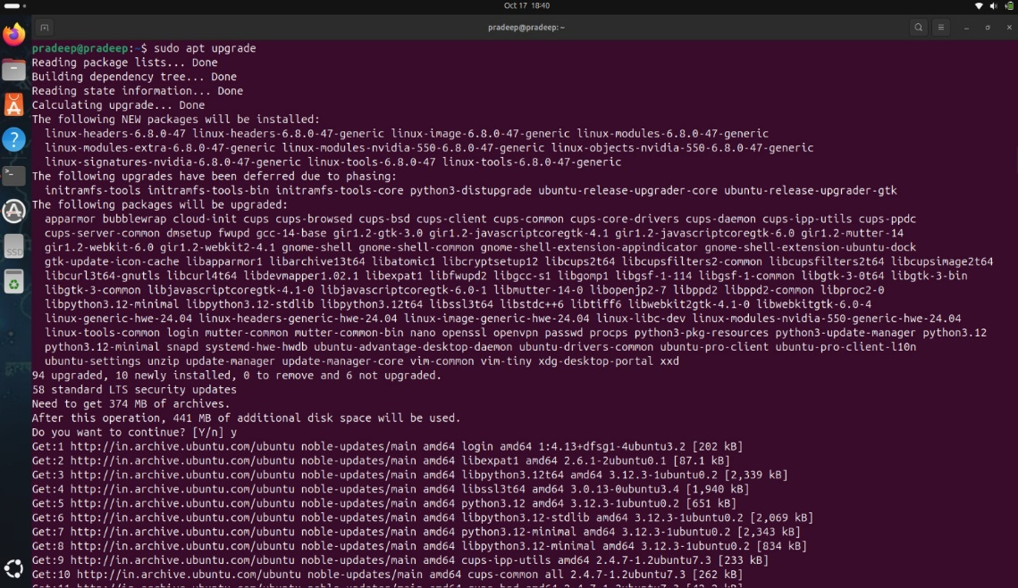

**Step 2: Install Required Packages:**

> sudo apt install wget apt-transport-https gnupg2 software-properties-common -y

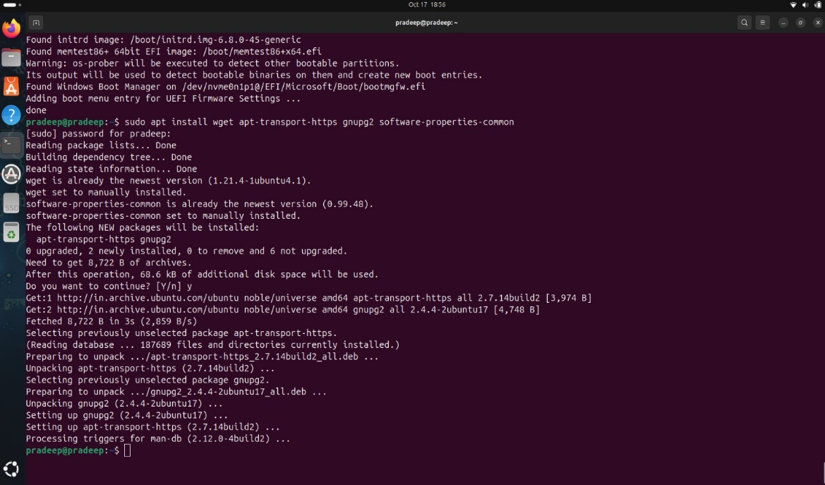

Explanation of the Command:

* Sudo : Runs the command with superuser privileges.
* apt install: Command to install packages.
* Wget : Tool for downloading files from the internet.
* apt-transport-https: Enables APT to fetch packages over HTTPS.
* gnupg2: Provides encryption and signing capabilities.
* software-properties-common: Contains scripts for managing software repositories.
* -y: Automatically confirms that you want to install the listed packages.

**Step 3: Install the DHCP server packages:**

> sudo apt-get install isc-dhcp-server -y

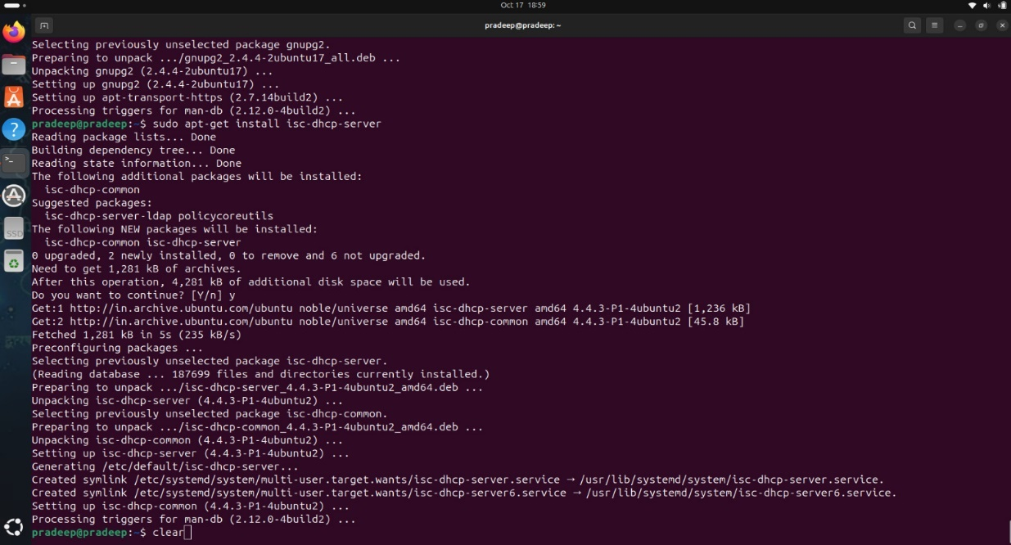

Understanding the Command:

* sudo: This command allows you to run programs with the security privileges of another user, typically the superuser (root). It’s necessary for installing software.
* apt-get: This is a command-line tool used for handling packages in Debian-based distributions (like Ubuntu). It can install, upgrade, or remove software packages.
* install: This argument tells apt-get that you want to install a package.
* isc-dhcp-server: This is the name of the DHCP server package developed by the Internet Systems Consortium (ISC). It is a widely used implementation of the DHCP protocol.

**Step 4: Starting the DHCP Service :**

**Start the DHCP Server**  & **Enable the service to start on boot .**

**> sudo systemctl start isc-dhcp-server**

**> sudo systemctl enable isc-dhcp-server**

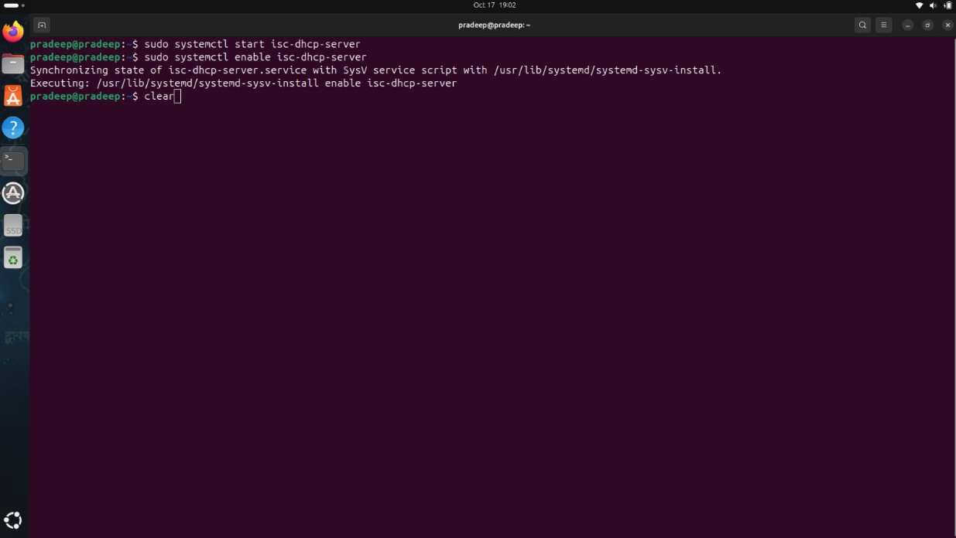

**Step 5: DHCP server on a specific interface :**

Open the Configuration File: You can use the nano text editor to edit the configuration file. Open your terminal and run the following command:

> sudo nano /etc/default/isc-dhcp-server

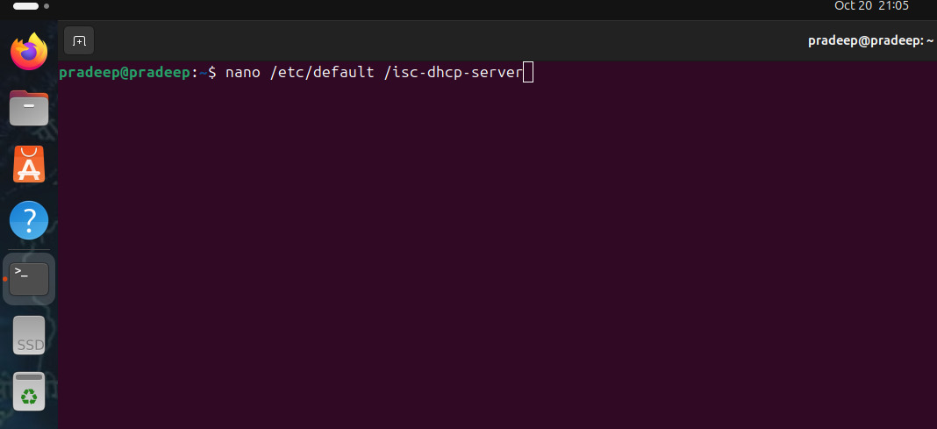

**Step-by-Step Configuration :**

* Find the INTERFACES Variable: In the isc-dhcp-server configuration file, look for the line that starts with INTERFACES. This line specifies which network interfaces the DHCP server will listen on.
* Edit the INTERFACES Variable: Modify the line to specify the interface you want the DHCP server to listen on. For example, if your interface is eth0, change it to. If you have multiple interfaces, you can specify them all, separated by spaces .
* Note : You can use this command to check interface on your machine “IP link show”

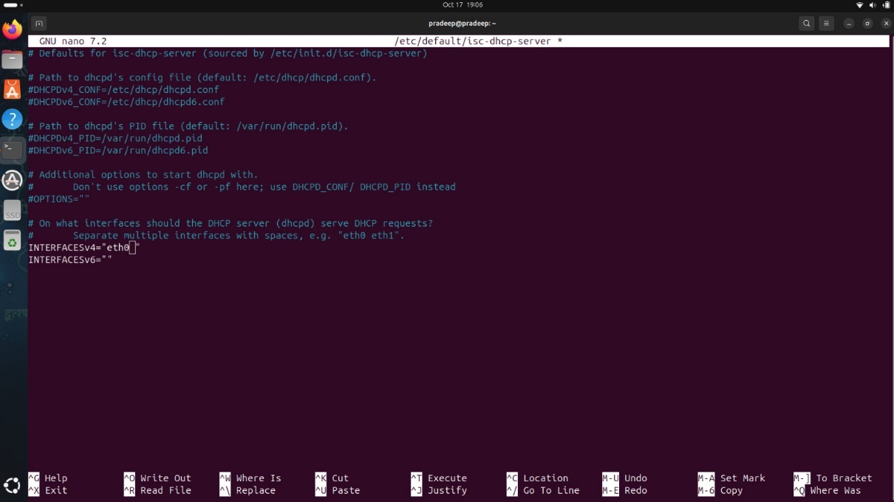

**Step 6: Configure the DHCP Server :**

Open the Configuration File

> sudo nano /etc/dhcp/dhcpd.conf

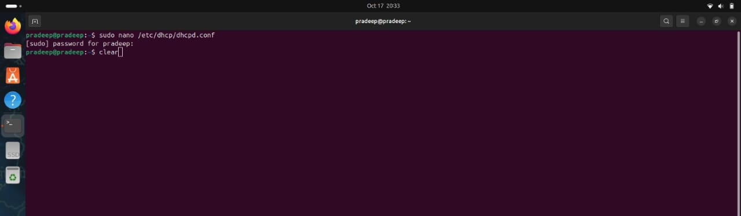

**Step-by-Step Guide to Specify IP Address Range :**

* Identify the Subnet Declaration: Within the configuration file, locate the subnet declaration for the network you want to configure. If it’s not already present, you can create one.
* Define the IP Address Range: Use the range directive to specify the start and end of the IP address range that the DHCP server can assign to clients.

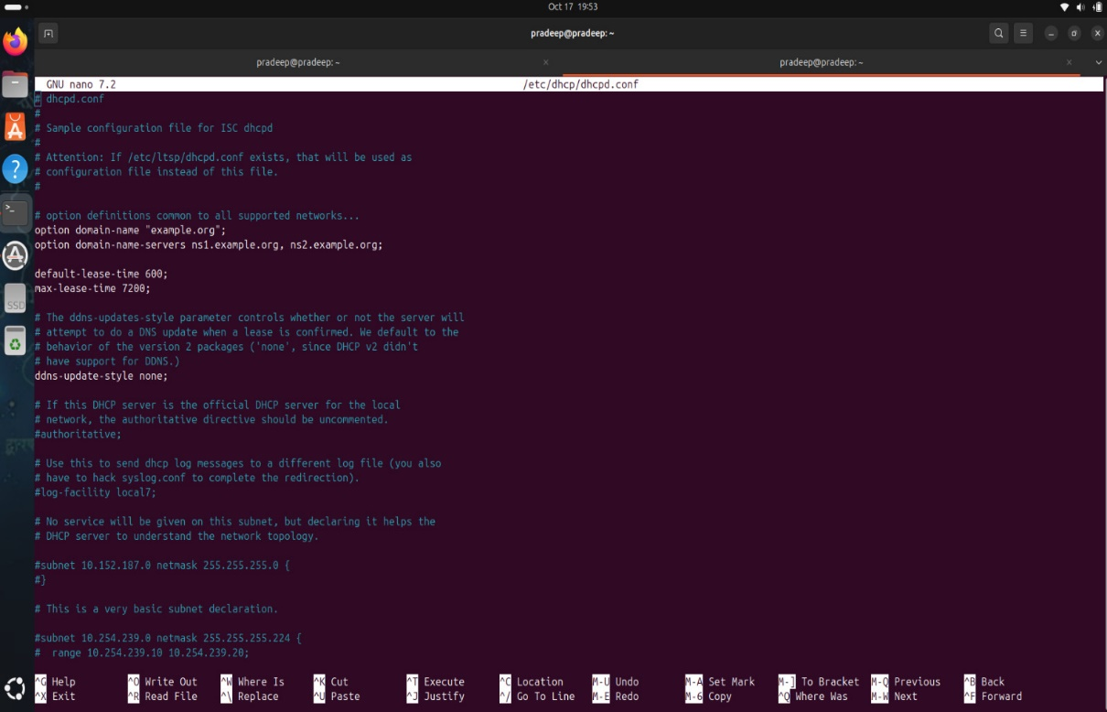

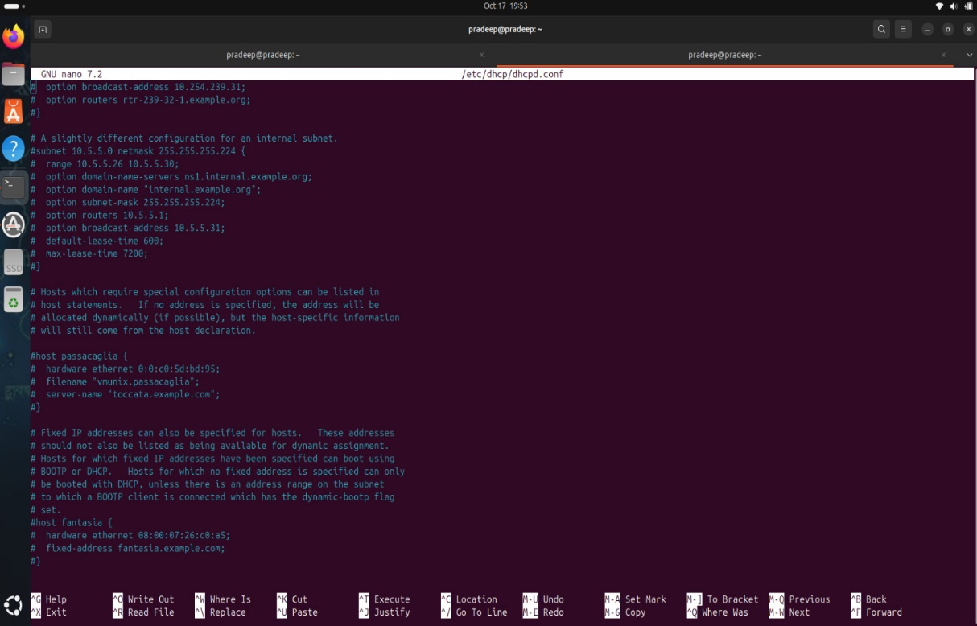

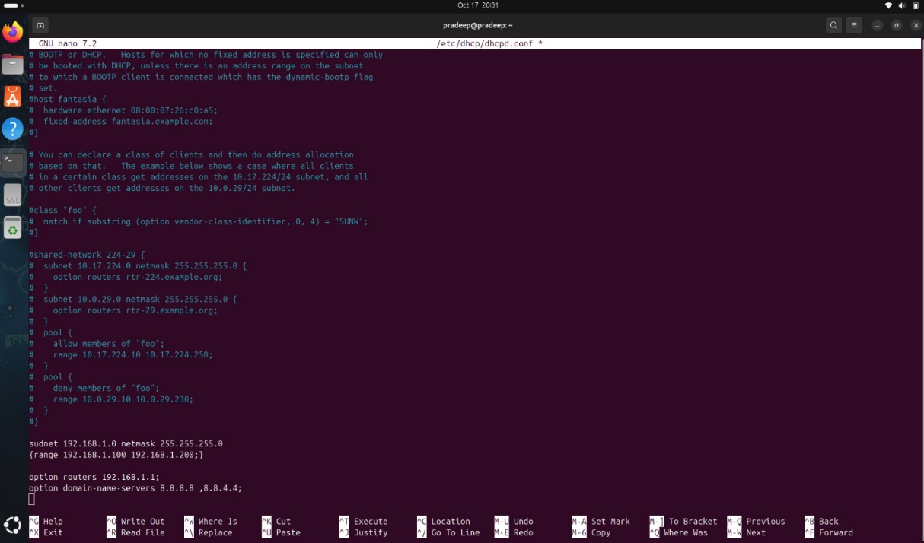

* Specify the default gateway and DNS server that a DHCP server assigns to clients.

**Step 7: Restart the DHCP server after making changes to the configuration :**

Restart the ISC DHCP

> sudo systemctl restart isc-dhcp-server

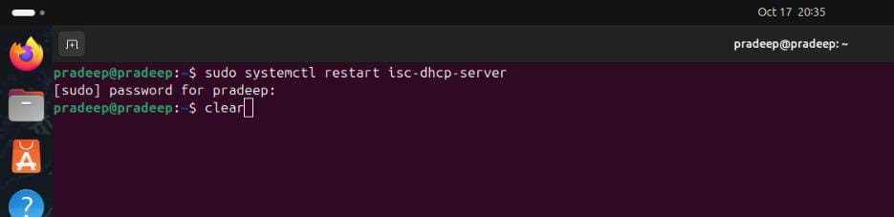

Before restarting the DHCP server, verify the configuration for errors, back it up, and notify users. After restarting, check the server status and test DHCP functionality to ensure the changes are applied correctly.

**To check the DHCP server Active or Not :**

**> Sudo systemctl enable isc-dhcp-server**

**> sudo systemctl status ssh**

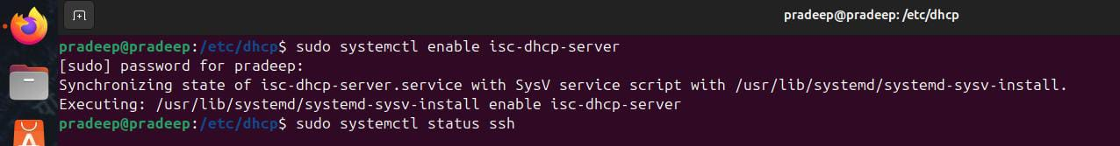

**Output :**

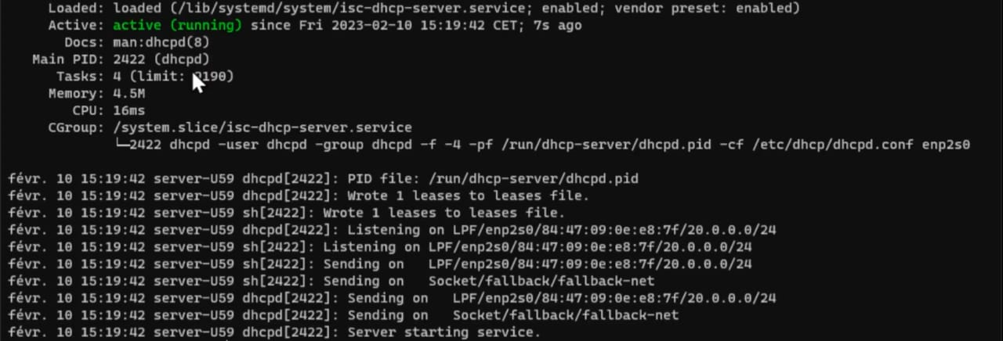

Checking whether a service, like a DHCP server, is active is crucial for maintaining network functionality and reliability. An active DHCP server ensures that devices on the network can automatically receive IP addresses, enabling them to access the internet and communicate with other devices. Regularly monitoring the service helps detect failures early, preventing user disruptions and maintaining system performance. Additionally, it allows for better resource management by stopping unnecessary services and enhances security by ensuring that only essential services are running. Overall, verifying the status of critical services like DHCP is vital for a stable and secure network environment.

**FUTURE SCOPE**

In DHCP servers is poised for significant evolution as technology advances. With the ongoing shift towards IPv6 due to IPv4 address exhaustion, future DHCP solutions will need to fully embrace IPv6 functionalities, including DHCPv6 support. The rise of cloud computing will likely lead to an increase in cloud-based DHCP services, allowing for easier management of IP addresses across multiple locations. Additionally, the growing number of IoT devices will necessitate DHCP servers that can efficiently handle dynamic IP assignments in such environments. Enhanced security measures will also become crucial to protect against emerging cyber threats, while automation and orchestration will streamline network configurations. Integration with network monitoring tools will provide real-time insights into IP address usage, and the application of AI and machine learning may enable predictive adjustments to address assignments. Furthermore, as organizations adopt hybrid cloud strategies, DHCP servers will need to support seamless management across both on-premises and cloud environments. Ultimately, the focus will be on improving user experience and ensuring compliance with regulatory standards, making DHCP servers an essential component of future network management.

**CONCLUSION**

In conclusion, the role of DHCP servers in modern network infrastructure is set to expand significantly as technology continues to evolve. With the global shift towards IPv6 due to the exhaustion of IPv4 addresses, DHCP servers will need to fully embrace new protocols like DHCPv6 to ensure efficient IP address allocation in larger networks. As businesses increasingly adopt cloud computing and hybrid cloud environments, cloud-based DHCP services will become more prevalent, allowing for flexible and scalable IP management across various locations. The rise of IoT will further drive the need for DHCP servers that can handle the dynamic allocation of addresses to an ever-growing number of connected devices. In response to evolving cyber threats, security will become a key focus, with future DHCP servers incorporating stronger protection against attacks like DHCP spoofing and man-in-the-middle breaches. Automation and orchestration will also play a major role, as DHCP solutions become more integrated with network management tools to enable seamless and efficient configuration. AI and machine learning may enhance the capabilities of DHCP servers by predicting network traffic and optimizing IP assignments automatically. Additionally, the need for compliance with regulatory standards will likely lead to more advanced reporting and auditing features in DHCP solutions. Overall, DHCP servers will continue to be an essential component of network operations, ensuring reliable, secure, and scalable IP address management as networks grow more complex and diverse.

**REFERENCES**

Github link:

https://github.com/ChintadaPradeep/DHCP-server